Phase 3 and Phase 4 — Explained in Simple Words
This file explains what was built and measured in Phase 3 (locomotion, kinematics) and Phase 4 (perception: LiDAR + camera), why, what the numbers mean, and how to run everything yourself. It is the companion of Phase2_3_Explained.pdf and Phase6_7_8_9_Explained.pdf. Every number below comes from a real Webots run and has a file in docs/evidence/.

1. What Phase 3 and Phase 4 are about
Phase 3 — locomotion & kinematics. "Can the robot actually drive the way the math says?" We command wheel speeds derived from our differential-drive equations and compare against what really happens (GPS + IMU ground truth). We also validate wheel odometry — dead reckoning from the wheel encoders — against that ground truth, and leave a pen trail on the floor so the driven path is visible. Phase 4 — perception. "Can the robot sense the world?" Two sensors: the LiDAR (360 distance rays, used for the map and the safety stop) and the camera (used by the OpenCV HSV detector to find coloured packages). Both are calibrated and validated against ground truth.

2. Phase 3 — locomotion and kinematics

2.1 Kinematics validation (3.3)
We command four (v, ω) pairs, convert them to wheel speeds with inverse_kinematics, run each for 4 s after a 1 s settle, and measure the real v and ω from per-step GPS/IMU differences:
v_cmd (m/s) | ω_cmd (rad/s) | v_meas (m/s) | ω_meas (rad/s) | v error | ω error
+0.20 | 0.00 | +0.1982 | 0.0000 | −0.90 % | n/a
0.00 | +1.00 | −0.0000 | +0.9906 | n/a | −0.94 %
+0.20 | +0.50 | +0.1982 | +0.4953 | −0.90 % | −0.94 %
−0.10 | 0.00 | −0.0991 | −0.0000 | +0.90 % | n/a

Everything is within 1 %. The small uniform −0.9 % is ~0.45 mm of soft-contact sink of the 5 cm wheels into the floor — measured, understood, and documented rather than fudged away. (The bigger lesson from earlier runs: with cylinder wheel bounding objects the contact point sits at the wheel rim, which widened the effective track to L + wheel width and cost −14 % yaw rate. Sphere bounding objects give one clean contact point at exactly ±L/2.) Evidence: docs/evidence/kinematics_validation.md.

2.2 Odometry vs ground truth (3.4)
Encoder odometry integrates Δs and Δθ per step (arc model). Drift after:
trajectory | distance | final position error | heading error
line | 0.99 m | 0.8 cm | 0.0°
square | 1.99 m | 2.2 cm | 4.7°
arc | 0.89 m | 1.1 cm | 1.2°

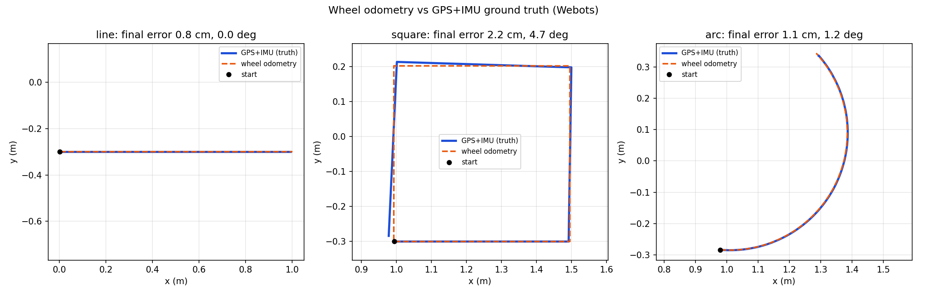
That is the "odometry is good short-term but drifts" story in one picture — and the reason our operating pose uses GPS+IMU while odometry runs in parallel as the validation case.

2.3 The pen trail (3.5)
The robot carries a Pen device that paints an orange trail on the floor. After every mission the controller takes an automatic top-down screenshot — the trail shows exactly where the robot drove:
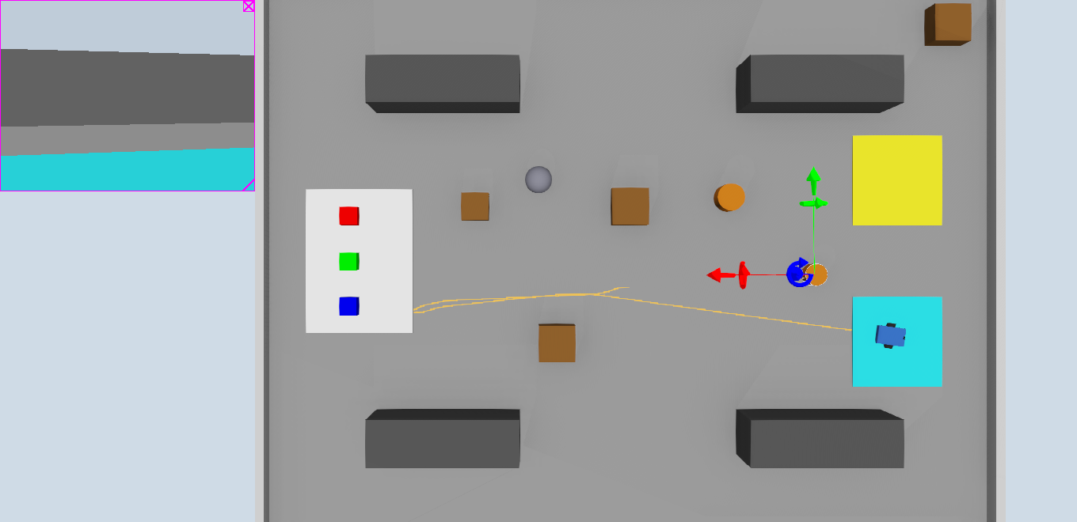
You can see the FIND_PACKAGE spin near the start, the NAVIGATE leg to the pickup station, and the long DELIVER leg back to Zone B (cyan), weaving between the obstacles.

3. Phase 4A — LiDAR

3.1 The ray-order calibration (4.2) — the best viva story
The LiDAR returns 360 ranges as a plain array. Nothing tells you which array slot points in which direction — you must measure it. Our method:
- DRIVE_TEST_MODE=lidar rotates the robot one slow full turn and logs
every raw scan (1321 scans) with the true pose.
- python tools/calibrate_lidar.py ray-marches the known map (the
same config.STATIC_OBSTACLES that generate the world) to compute the expected range for every candidate ray direction, then tries both conventions (index increasing CW vs CCW) and small offsets.
- The winner: the index increases CLOCKWISE
(LIDAR_ANGLE_SIGN = −1, offset +0.02 rad), median |error| 8 cm.
This was not an academic exercise: the mirrored convention was the root cause of the mission estimating package P3 0.6 m away from its true position. After the fix the live estimate is (−2.99, −0.57) vs true (−3.10, −0.50) — a 0.13 m error.
Evidence: docs/evidence/lidar_validation.md, and the world-frame scan below — walls, shelves, crates and even the small round obstacles appear exactly where the map says:
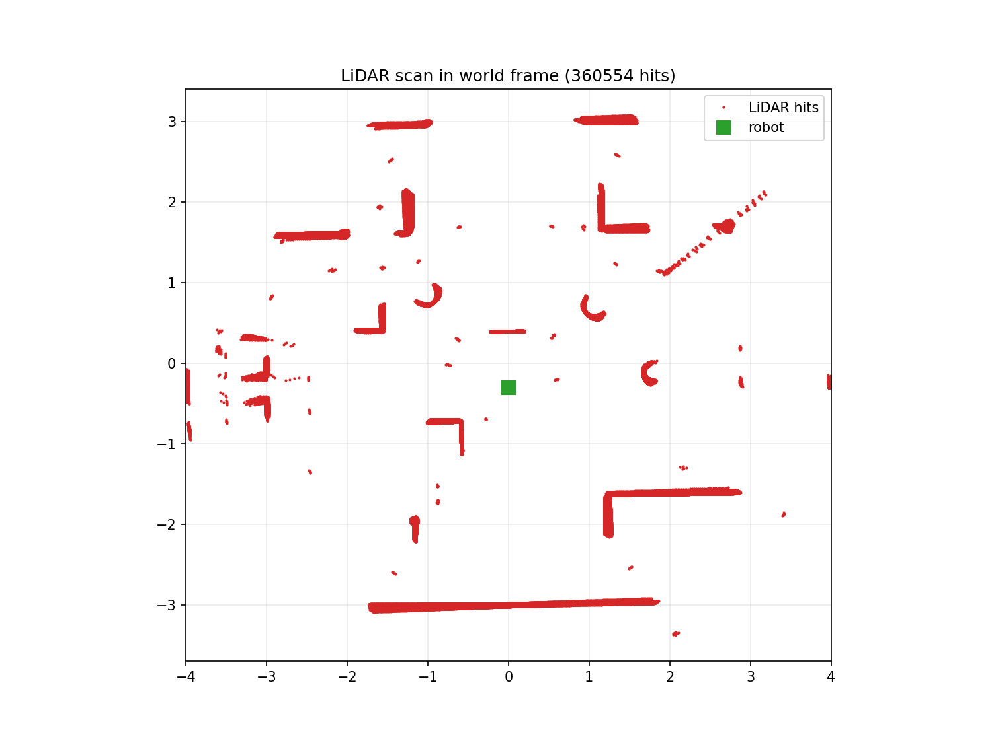

3.2 Sector queries and the safety stop (4.3)
min_range_in_sector is the primitive behind the reflex layer: any ray within ±30° of forward closer than 0.30 m → command v = 0, status BLOCKED (console prints OBSTACLE AHEAD 0.42 m during the calibration spin). The BLOCKED flag is exactly the hook the final-eval dynamic re-planner will use.

4. Phase 4B — camera and vision

4.1 The detector (4.6)
Pure OpenCV, no Webots calls: BGR → HSV → per-colour masks (red needs two hue ranges because hue wraps at 0) → morphological open + close → largest contour with area ≥ 100 px² and a plausible aspect ratio → Detection with a documented heuristic score (solidity × size factor — say "heuristic", not "confidence", in the viva).

4.2 The systematic evaluation set (4.7 + 4.10)
Thirty-ish frames from one pose prove little. DRIVE_TEST_MODE=capture_set builds the full matrix automatically:
3 packages × 4 distances (0.5 / 1 / 2 / 3 m) × 3 view angles (−30° / 0° / +30°) × 3 lightings (normal / dim / bright) = 108 frames. The supervisor teleports the robot to each pose and changes the DirectionalLight intensities; each frame's ground truth is read from the camera's Recognition node (which PKG_* models are visible) — that is the Phase 4.10 cross-check automating the labelling.
How many each colour appears in the ground truth: red 78, green 75, blue 66 appearances across the 108 frames.

4.3 Results (4.8)
lighting | red | green | blue | false positives
normal | 84.6 % | 84.0 % | 77.3 % | 1
dim | 84.6 % | 84.0 % | 77.3 % | 0
bright | 84.6 % | 84.0 % | 77.3 % | 0

Two things to say out loud about this table:
- The rate is identical across lightings. That is the payoff of the
two-opposed-lights world fix (one light left package faces at HSV value ≈ 46, below the detector threshold — the first mission never found the package). The HSV value channel is now stable, so dim/bright global changes do not move the detection rate.
- The misses are geometric, not photometric. Broken down by distance,
everything at 2–3 m is detected (24/24 red at 3 m); the misses happen at 0.5 m, where the package overfills the frame and the aspect-ratio window (0.6–1.6) rejects the clipped blob, and at ±30° / 1 m where the package is partly outside the image. Detection rate improves with distance in this setup — the opposite of the naive expectation, and a good thing to explain when asked.
Only 3 false positives in 108 frames (one green-ish, two blue-ish reflections) — the zone colours (yellow ≈ hue 30, cyan ≈ 90) sit outside every package window, which is also asserted by a unit test.
Annotated example (2 m, normal light, P3 detected together with P2):
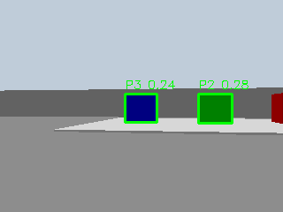

4.4 Position estimation (4.9)
The chain: pixel column → bearing (pinhole model, left = +) → range from the LiDAR at that bearing (±3° window; fallback d = f_px·size/bbox) → world position through the robot pose. Live result with the calibrated LiDAR: (−2.99, −0.57) vs (−3.10, −0.50) → 0.13 m error at ~3 m. The offline pinhole-fallback evaluation on the frame set (docs/evidence/position_estimate.md) shows 0.59 m mean error at 3.1 m — quantization-limited (±1 px of bbox ≈ ±5 % of range), which is exactly why the LiDAR-fused estimate is the one the mission uses.

5. Problems we hit and fixed while building Phases 3–4
- −14 % yaw rate: cylinder wheel contact → effective track
L + wheel width. Fixed with sphere wheel bounding objects.
- Packages invisible to the detector on one side: single light left
faces at HSV V ≈ 46. Fixed with two opposed directional lights, shadows off.
- Mirrored LiDAR ray order → 0.6 m package estimate error. Measured
against the known map, fixed in config.py.
- Recognition node saw nothing until each package Solid got a
recognitionColors [ r g b ] field — in modern Webots the model field alone only labels an object, recognitionColors is what makes it recognizable.
- A decorative ball painted saturated blue was "found" as package P3.
The environment's colours are part of the detector's interface — props must stay outside every HSV window.
- Campaign starts failing for non-obvious reasons: one start had the
ball blocking the line of sight to P3, one spawned overlapping a crate, one had a crate blocking the view, and one start had package P1 itself occluding P3 (packages are not on the static map). Starts are now validated for collision-freedom and line-of-sight including the other packages. Related design fix: the FSM now maps every package it sees during FIND_PACKAGE onto the occupancy grid, so approach paths route around the non-target packages instead of tripping the LiDAR safety stop next to them.

6. How to run everything (cheat sheet)
python -m pytest tests/ -q # 63 tests first
# kinematics + odometry validation (Phase 3)
DRIVE_TEST_MODE=kinematics webots --batch --mode=fast --stdout --stderr --minimize worlds/warehouse_drive_test.wbt
DRIVE_TEST_MODE=odometry webots --batch --mode=fast --stdout --stderr --minimize worlds/warehouse_drive_test.wbt
# LiDAR calibration (Phase 4.2/4.4)
DRIVE_TEST_MODE=lidar webots --batch --mode=fast --stdout --stderr --minimize worlds/warehouse_drive_test.wbt
python tools/calibrate_lidar.py # -> lidar_validation.md + lidar_scan.png
# detector evaluation set (Phase 4.7/4.8/4.10)
DRIVE_TEST_MODE=capture_set webots --batch --mode=fast --stdout --stderr --minimize worlds/warehouse_drive_test.wbt
python tools/eval_detector.py # -> detector_eval.md + per-lighting table
# mission with pen trail + automatic trail screenshot
webots worlds/warehouse.wbt # -> world_trail.png after DONE

7. One-paragraph summary for the viva
"The robot's motion was validated against physics: commanded speeds match measured speeds within 1 %, and encoder odometry drifts only ~2 cm over a 2 m square, which is why we trust GPS+IMU for control and quote odometry as a validated fallback. On perception, the LiDAR's ray order was empirically calibrated against the known map (it runs clockwise; the naive assumption was mirrored, which caused a 0.6 m package-position error, now 0.13 m), and the HSV package detector was evaluated over a 108-frame systematic set covering distance, angle and lighting: roughly 80–85 % detection with almost no false positives, identical across lighting levels — the misses are geometric edge cases at extreme ranges, and the ground truth comes from the simulator's Recognition node, keeping our detector itself fully hand-written OpenCV."

