

IcyAdmin – a Minecraft admin panel

Screenshots:

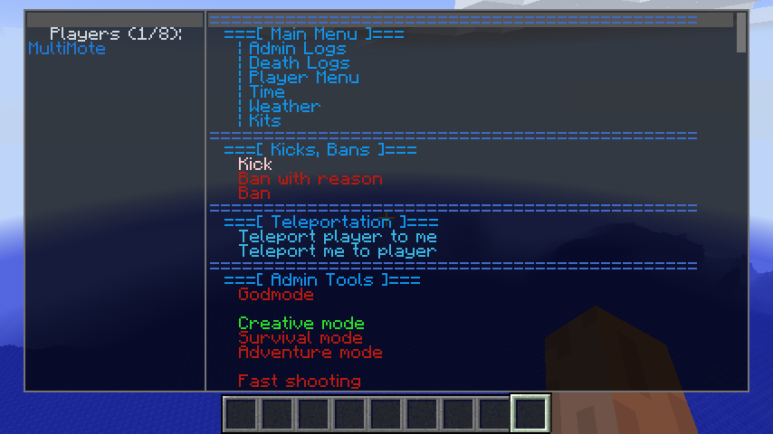 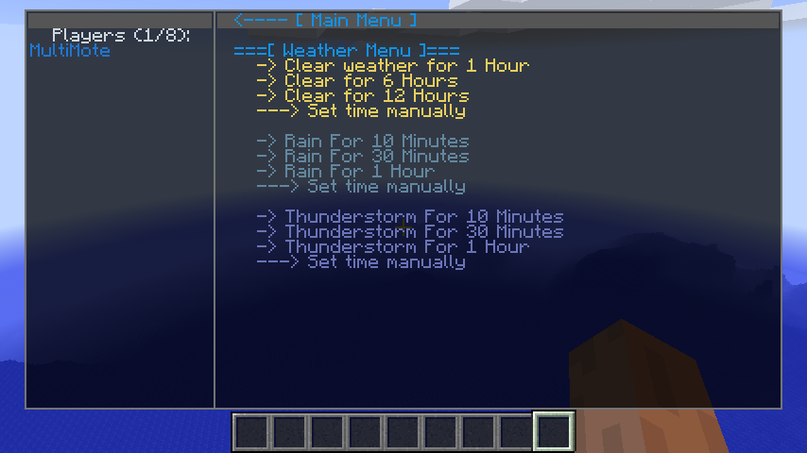

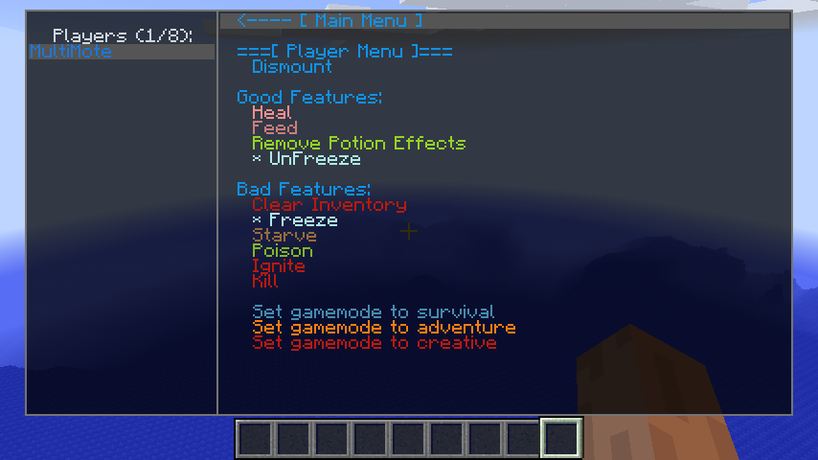

Features

* Fully customizable menus with own syntax
* Popup window for command parameters
* Command parameters are saved
* Permissions and Cauldron integration
* Server sends custom menu to player
* Admin and death logs

Menu editing, syntax

Menu structure:

**menu_file_begin**

**begin MAIN_PAGE**

**add "Menu Title" as TITLE**

**#you can use comments that starts with # или \\**

**add "Page link" as PAGE to SAMPLE_PAGE**

**end MAIN_PAGE**

**begin SAMPLE_PAGE**

**add " < Back" as PAGE to MAIN_PAGE color #1092E8**

**add SEPARATOR**

**add "It’s our page" as TITLE**

**end SAMPLE_PAGE**

Menu must contain **menu_file_begin** keyword, parser reads menu after this line.

Main page must be named **MAIN_PAGE**, other pages can have any name.

This template is used for adding actions:

**add “Action Title” as SOME_ACTION**

# Available actions list

|  |  |  |  |
| --- | --- | --- | --- |
| Action | Description | Requires target player | Can listen prop |
| **CMD_EXEC** | Execute chat command (see below) | **?** | **?** |
|  |  |  |  |
| **PAGE** | Page link |  |  |
| **TITLE** | Simple label |  |  |
| **LINK** | Open URL in browser |  |  |
|  |  |  |  |
| **KILL** | Kill player | **+** |  |
| **POISON** | Poison player for 30 seconds | **+** |  |
| **HEAL** | Heal player | **+** |  |
| **FEED** | Feed player | **+** |  |
| **STARVE** | Set player hunger level to max | **+** |  |
| **DISMOUNT** | Throw player out of vehicle | **+** |  |
| **IGNITE** | Sep layer on fire for 8 seconds | **+** |  |
| **FREEZE** | Freeze player movement | **+** |  |
| **UNFREEZE** | Unfreeze player | **+** |  |
| **CLEAR_INVENTORY** | Clear player inventory | **+** |  |
| **UNPOTION** | Clear player active potion effects | **+** |  |
| **INVULNERABILITY_TOGGLE** | Switch self-invulnerability |  | **+** |
| **INVISIBILITY_TOGGLE** | Switch self-invisibility |  | **+** |
| **NAMEPLATE_TOGGLE** | Switch own nameplate |  | **+** |
| **MOB_AURA_TOGGLE** | Switch hostile mob removal (5m) every 2 seconds |  | **+** |
| **FAST_SHOOTING_TOGGLE** | Switch fast and automatic bow shooting |  | **+** |
| **FLY_TOGGLE** | Switch flight |  | **+** |

General actions info

Every action has **color** parameter. Listenable actions have **activeColor** parameter. Example:

add "Godmode" as INVULNERABILITY_TOGGLE listens PROP activeColor #2DDB2C color #B81A0F

Listenable actions keyword is **listens**.

List if available **listens** parameters:

* **PROP**
* **GAMEMODE_CREATIVE**
* **GAMEMODE_SURVIVAL**
* **GAMEMODE_ADVENTURE**
* **FLY**

To add blank line you can use **add SEPARATOR**

**PAGE** action

You must define a page name with **to** keyword for this action and define the page.

Example:

**@other actions@**

**add «Open page» as PAGE to OUR_PAGE**

**@ other actions @**

**begin OUR_PAGE**

**add «Back» as PAGE to MAIN_PAGE**

**end OUR_PAGE**

*Always add a link to the home page for additional pages.*

**LINK** action

You must define a link to the page with **to** keyword for this action.

Example:

**add «Open Google» as LINK to «http://google.com»**

**CMD_EXEC** action

You must **cmd**.

Examples:

**add «Simple command» as CMD_EXEC cmd «say It works!»**

**add «Command with me as parameter» as CMD_EXEC cmd «say My name is %me%!»**

**add «Commend with target player» as CMD_EXEC cmd «say %player%, I am %me%!»**

**add «Command with variable» as CMD_EXEC cmd «say $What_to_say»**

**add «Multiple commands» as CMD_EXEC cmd «say One(>>)say Two(>>)say Three»**

Notes:

* There is no restrictions on the number of variables
* Variable **$What_to_say** will look like as **What to say: [ ]**
* Listenable commands are marked with blue color.

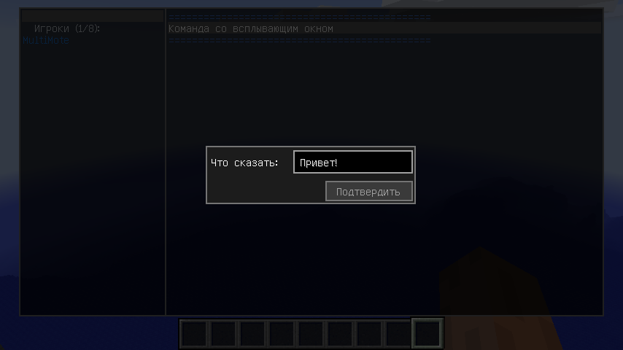

**Include** keyword

Allows include various lists.

Examples:

**include ADMIN_LOGS**

**include DEATH_LOGS**

Logs are stored in **config/IcyAdmin/logs** dir.

Custom menus

Custom menu are sent to players if are not match with server menus.

You can create menu with **custom.menu** name in **config/IcyAdmin/menus/defined** dir for this feature.

Commands

/icyadmin add <Username> - **Give panel permissions to player.**

/icyadmin rem <Username> - **Remove player panel permissions.**

Note: Command permissions of **CMD_EXEC** action do not depend on panel permissions.

Cauldron support

For panel usage you can use ***icyadmin.use*** permission

***Cauldron support is still in development, but almost all works (KILL and death logs are unworking).***