Exercises in Multimedia Web Design
INTRODUCTION TO JAVASCRIPT (Week 9)
Fetch API & DOM Deep Dive

Eda Selmani (CE) – ID:1006689

Solo Exercise 6.5 — Comments viewer with status handling
Use the JSONPlaceholder comments endpoint:
https://jsonplaceholder.typicode.com/comments?postId=1

Write an async function loadComments(postId) that:
1. Fetches comments for the given postId.
2. Checks response.ok and throws a custom error if it fails.
3. Renders each comment as a <li> showing: name — email
4. Displays a count: "5 comments loaded" in the <h1 id="title">.
5. Shows an error message in the list if the fetch fails.
6. Call the function with postId 1 when the page loads.

Bonus: Add three buttons (Post 1, Post 2, Post 3). Each button calls
loadComments() with its postId, replacing the current list.

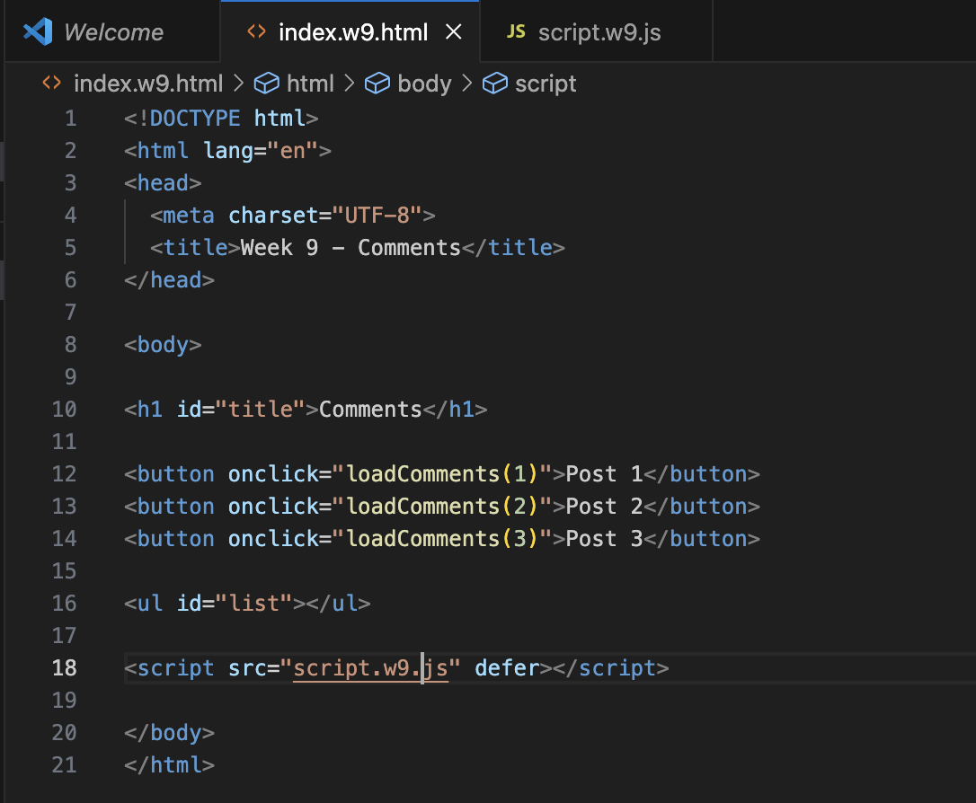

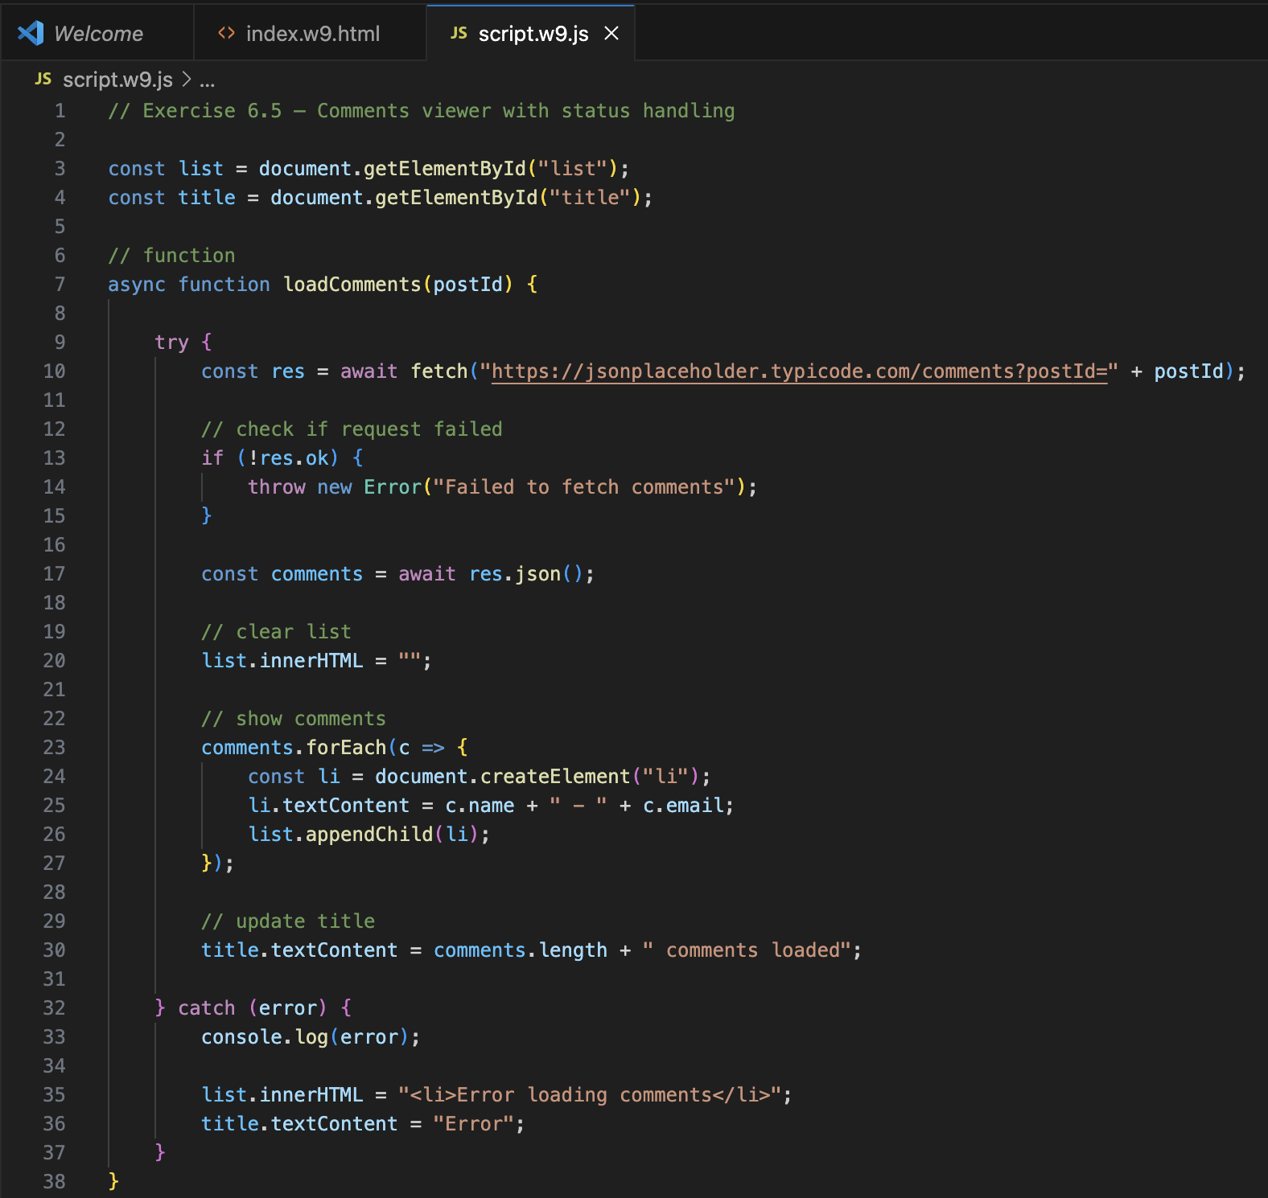

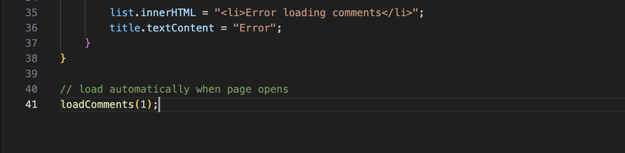

OUTPUT:
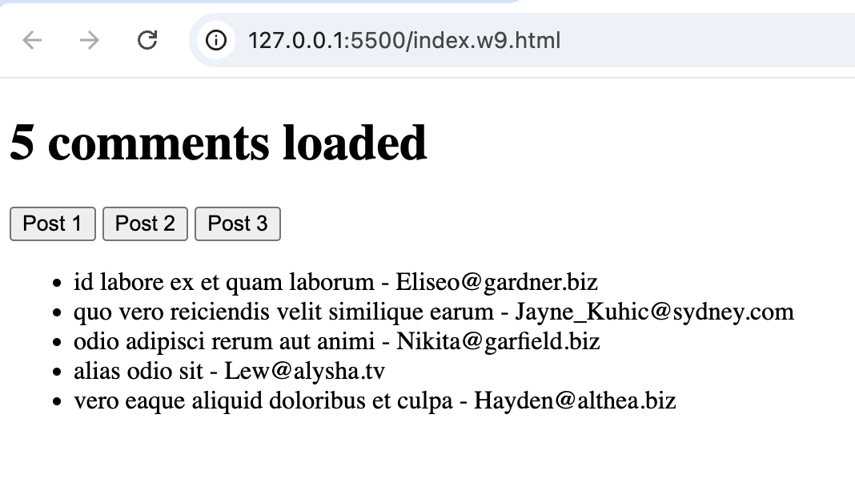
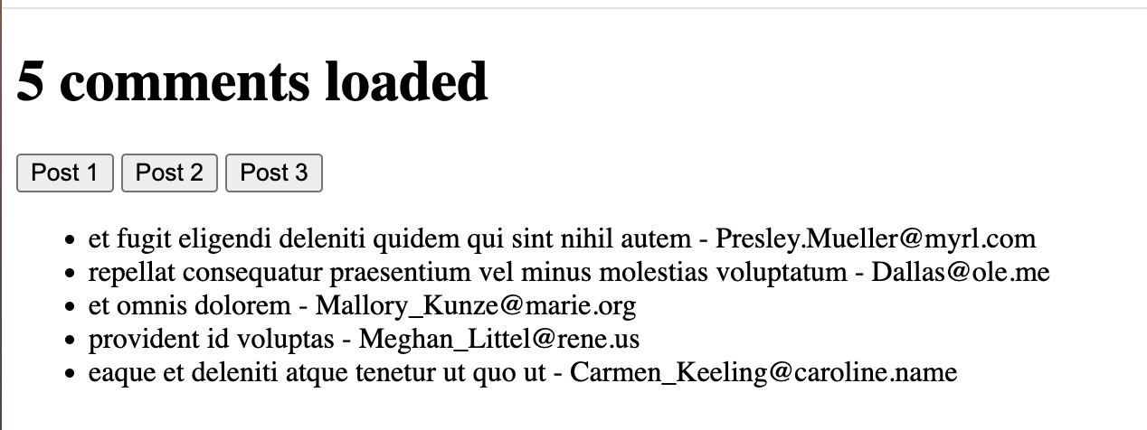

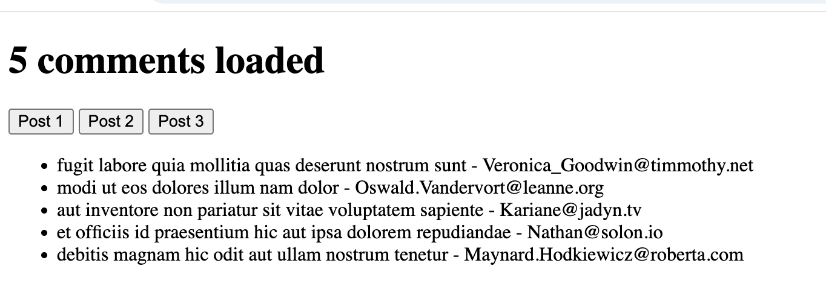

Solo Exercise 7.5 — Interactive photo gallery
Use the JSONPlaceholder photos endpoint (returns 5000 photos):
https://jsonplaceholder.typicode.com/photos?albumId=1

Write JavaScript that:
1. Fetches all photos from albumId 1 (50 results).
2. Creates a <li> for each photo displaying its title.
3. Adds a data-url attribute to each <li> with the photo's thumbnailUrl.
4. Uses event delegation on the list: clicking a photo title logs its
thumbnail URL to the console using e.target.dataset.url.
5. Updates the <h1> to show "Album 1 — 50 Photos".

Bonus: Instead of logging the URL, create an <img> element and append it
to <p id="output"> each time a photo is clicked, so the thumbnail appears.

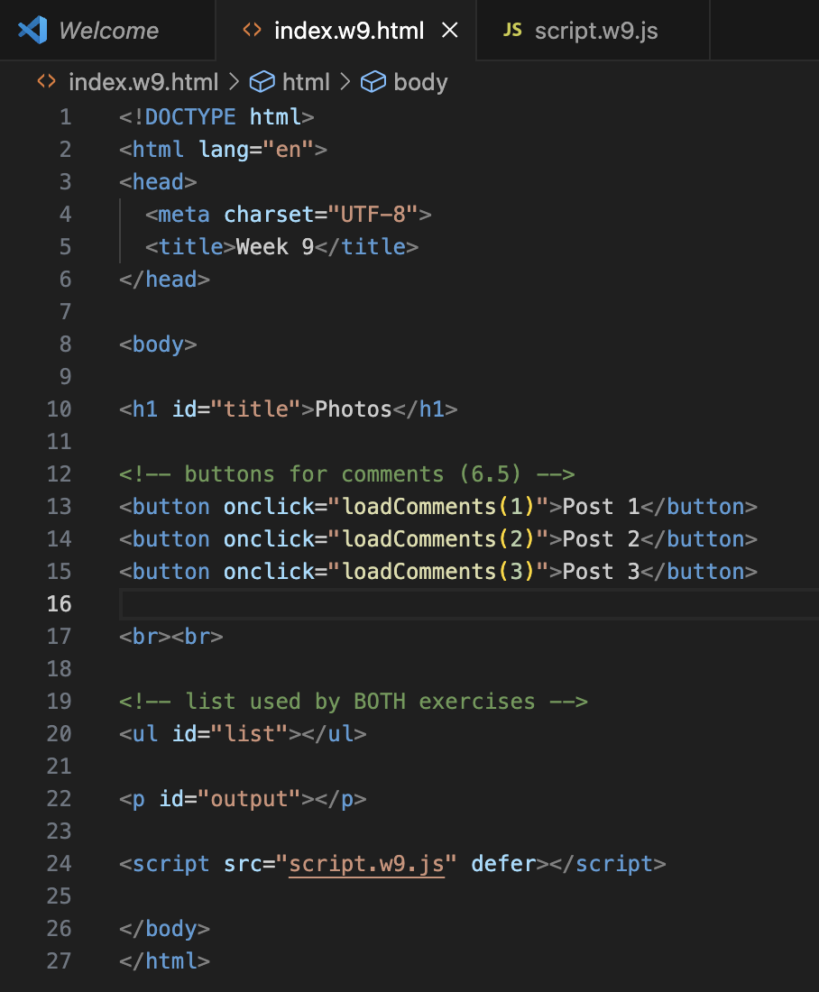

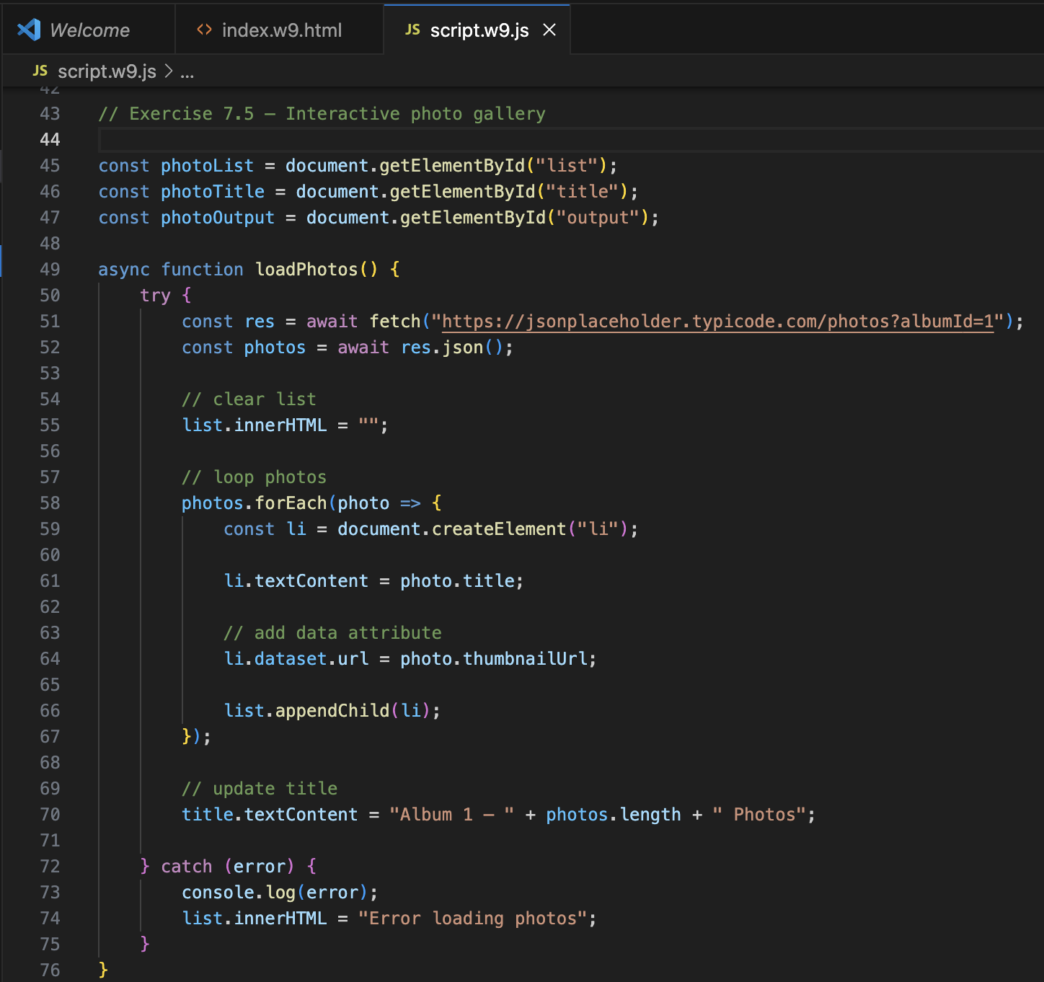

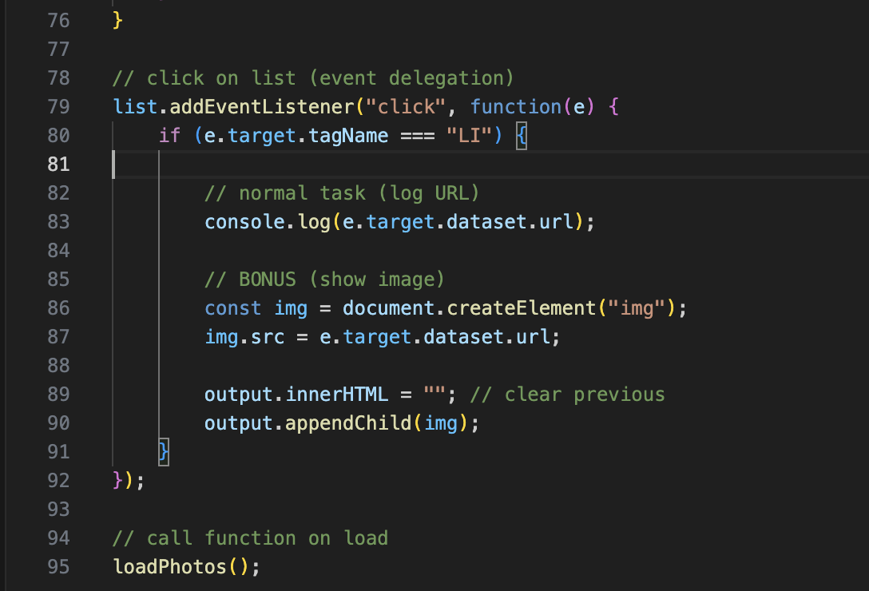

OUTPUT:
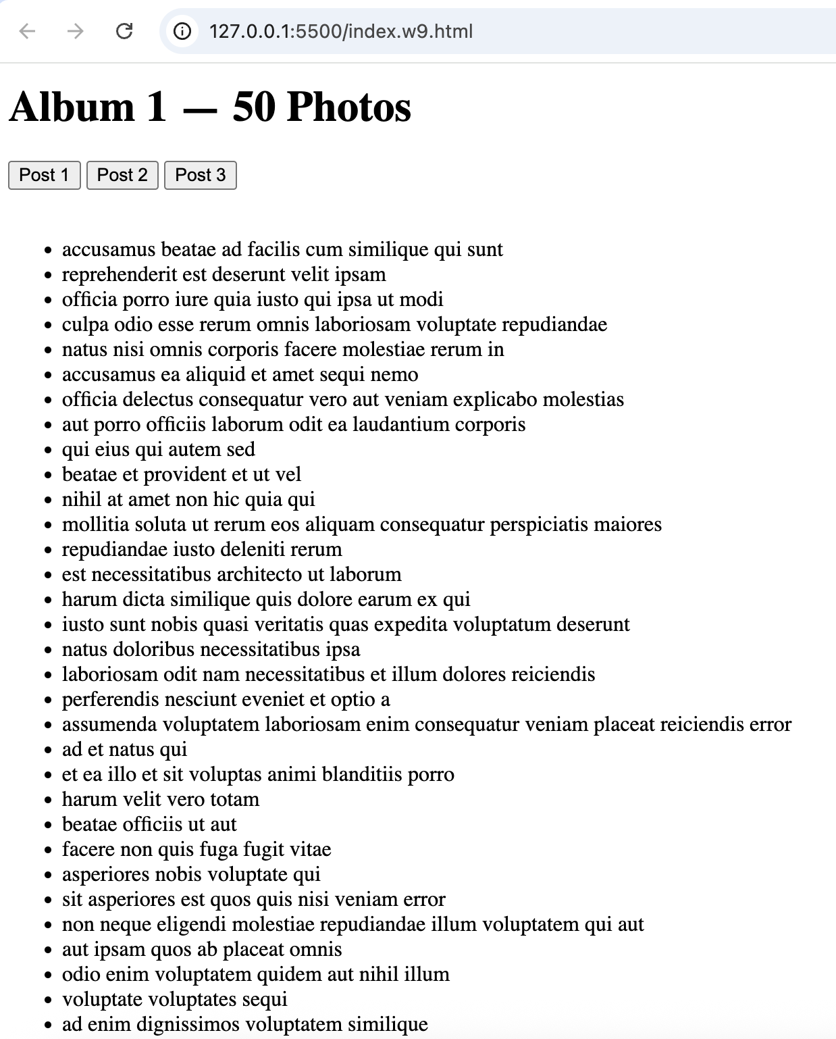

Solo Exercise 8.5 — API inspector
Use the REST Countries API (no auth required):
https://restcountries.com/v3.1/region/europe?fields=name,capital,population

Write an async function exploreAPI() that:
1. Fetches all European countries from the endpoint above.
2. Logs the response status code and content-type header.
3. Parses the JSON and logs how many countries were returned.
4. Uses filter() to keep only countries with population > 5,000,000.
5. Uses map() to extract just the common name: country.name.common.
6. Renders the filtered country names as <li> items in the DOM.
7. Wraps everything in try/catch with a response.ok check.

Bonus: Sort the countries alphabetically before rendering using .sort().
Bonus: Add a URLSearchParams object and log the full constructed URL.

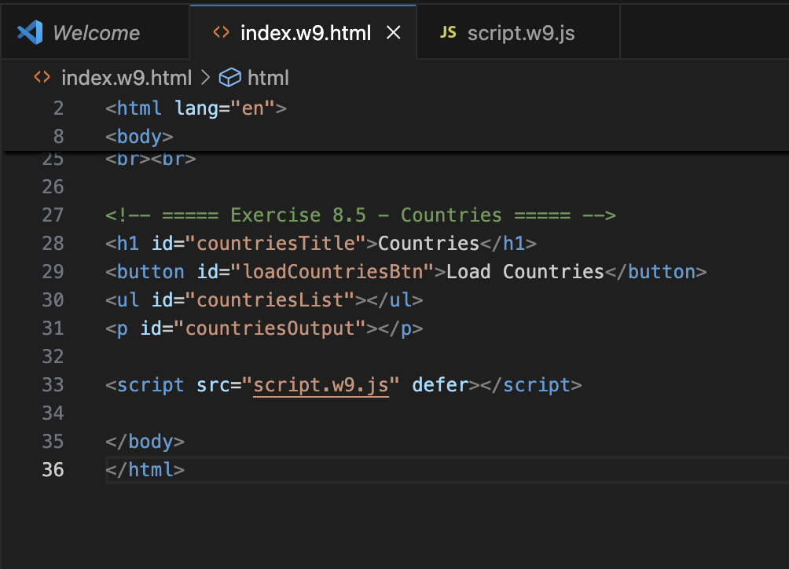

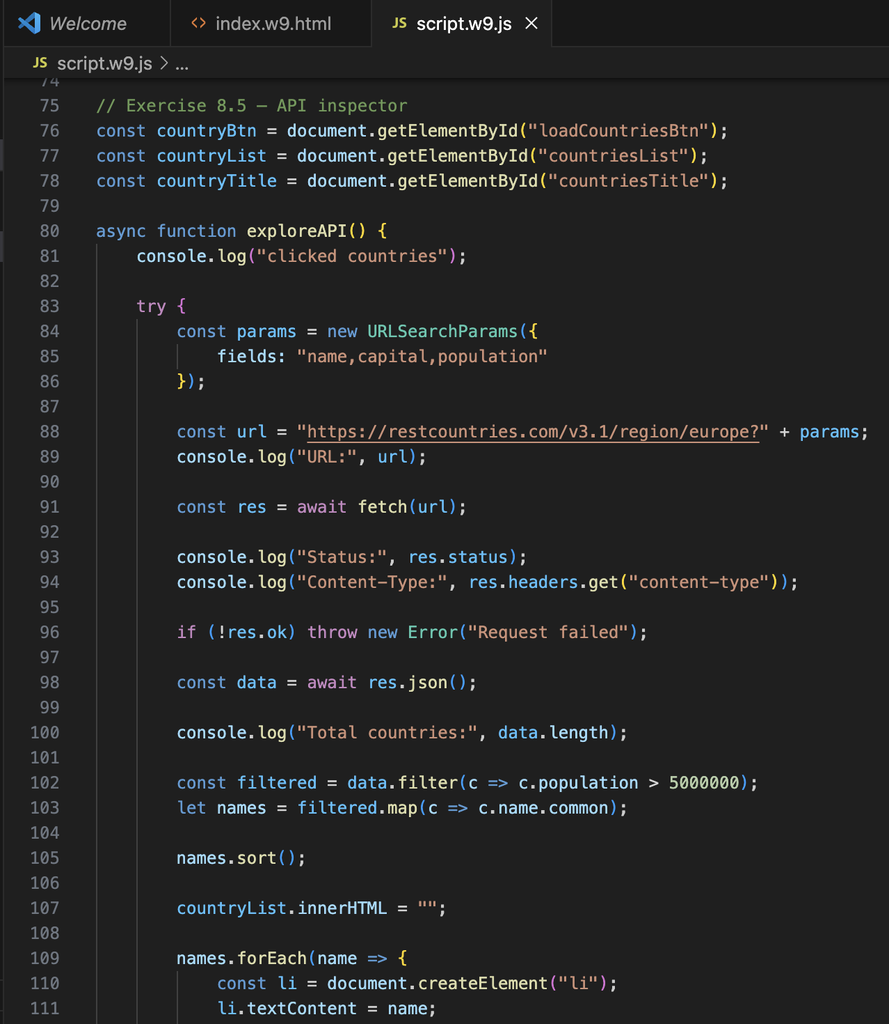

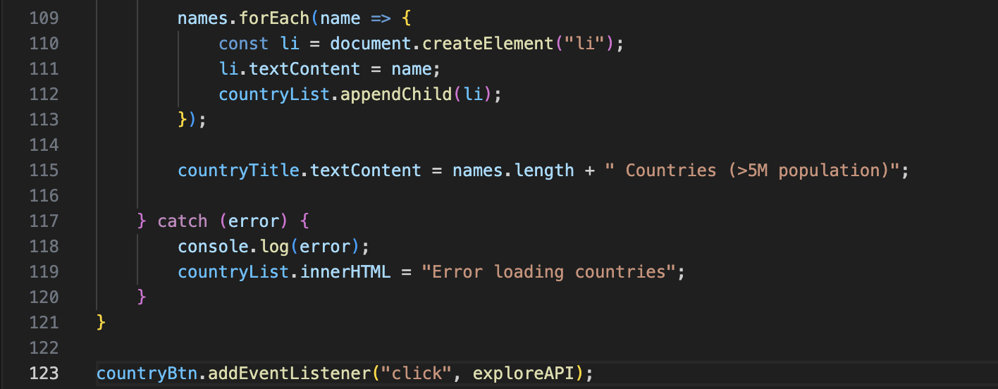

OUTPUT:
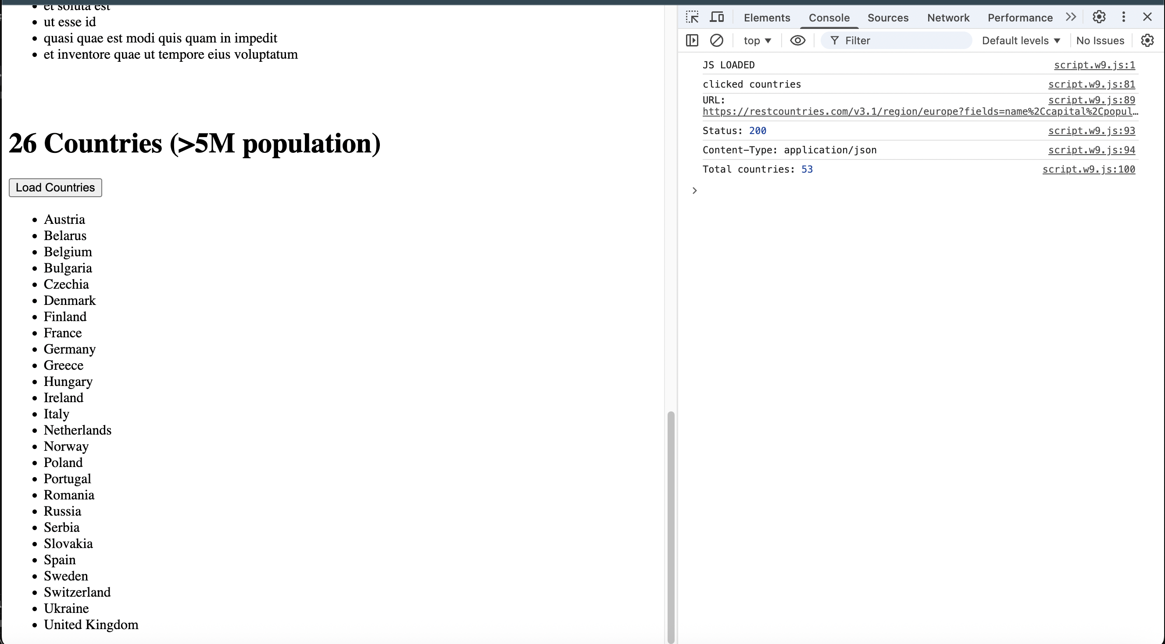

Solo Exercise 9.5 — Vanilla to React translation
Below is a vanilla JS feature. Your task is NOT to convert it — but to annotate it:
let items = [];
function addItem(text) {
items.push(text);
renderList();
}
function renderList() {
const ul = document.getElementById('list');
ul.innerHTML = '';
items.forEach(item => {
const li = document.createElement('li');
li.textContent = item;
ul.appendChild(li);
});
}
For each of the following framework concepts, write one sentence explaining
which part of the code above is the vanilla equivalent:
1. State 2. Re-render 3. Component 4. Props

Bonus: Rewrite this as a React component using useState. Use the counter
example from Exercise 9.1 as a template.

Annotations:
- State - let items = [] is the vanilla equivalent of state. It's the data that the app remembers and that can change over time.
- Re-render - renderList() is the vanilla equivalent of re-rendering. Every time the data changes, it manually clears the DOM and rebuilds it from scratch, which is exactly what React does automatically when state updates.
- Component - the combination of addItem() and renderList() together act as the vanilla equivalent of a component — they manage a piece of UI and its behaviour as one unit.
- Props - the text parameter in addItem(text) is the vanilla equivalent of props. It's data passed in from outside to influence what gets added/displayed.

Bonus — Rewritten as a React component with useState:

import { useState } from "react";

function ItemList() {
const [items, setItems] = useState([]);
const [inputValue, setInputValue] = useState("");

function addItem() {
if (!inputValue.trim()) return;
setItems([...items, inputValue]);
setInputValue("");
}

return (
<div>
<h2>Item List</h2>

<input
type="text"
value={inputValue}
onChange={(e) => setInputValue(e.target.value)}
placeholder="Enter item"
/>

<button onClick={addItem}>Add Item</button>

<ul>
{items.map((item, index) => (
<li key={index}>{item}</li>
))}
</ul>
</div>
);
}

export default ItemList;

*The biggest difference is that in vanilla JS you have to manually call renderList() every time. In React, updating state with setItems() triggers the re-render automatically.

