bambooBSC 0.7

Manual de Usuario bambooBSC

Autor: Chen Xin Nien
Traducción: Herson Cruz
Contacto: info@multisistemas.com.sv Código del proyecto: https://github.com/Multisistemas/bsc

Overview 3
Basic Operations 3
Step sourcecard established 4
1. Vision 5
2. Perspectives 6
3. Strategy objective 7
4. KPI 8
5. Measure-data 12
6. KPI Report 13
7. Personal Report 14
8. Department Report 15
9. Strategy Map 16
9. Strategy MAP Double click Strategy-objective item , will show detail 17
10. SWOT 18
11. Report signature 19
12. Query Charts 21
13. Analytics ( OLAP ) 24
14. bambooBSC mobile version 28
15. PDCA ( Plan / Do / Check / Action ) 32
16. Audit settings ( if PDCA Project or 360 Project edit page cannot click “Confirm audit” button ) 42

Introducción
bambooBSC es una plataforma de código abierto para gestión de Balanced Scorecard (BSC), provee análisis del desempeño a nivel de usuario, departamento y toda la organización.

Funciones clave:
Sourcecard:
Tarjeta de origen: Establecer y mantener la información de las tarjetas de origen y mantenimiento de los datos de medición de los KPI y el Mapa Estratégico.

Reportes:
Los reportes incluyen: Reportes de KPI, Reportes de Tarjetas por departamento/organización, reportes de tarjetas personales, reportes FODA y PHVA.

Operaciones básicas
Ver figura-A.
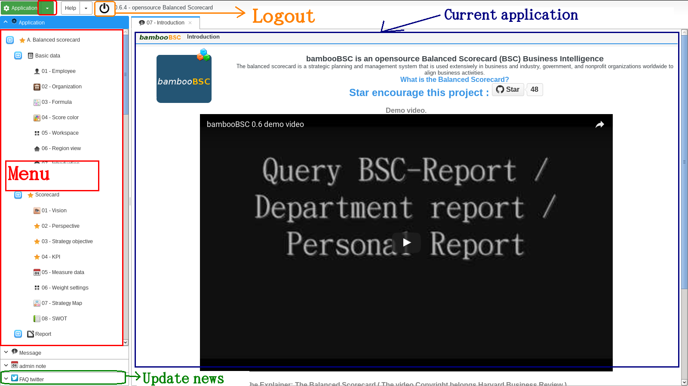

Pasos para establecer el Scoredard
¿Cómo establecer los datos del Scorecard?, Videos de referencia: https://www.youtube.com/watch?v=N5BsWZL8bxQ

1. Establecer una Visión
Completar objetivos propuestos y visión.

2. Establecer Perspectivas
Establecer las cuatro perspectivas BSC, información de referencia acerca de las perspectivas BSC: http://en.wikipedia.org/wiki/Balanced_scorecard
Las perspectivas deben ser definidas y aceptas por los responsables de cumplirlas en cada área de la organización, de lo contrario se consideran inválidas.

3. Establecer Objetivos Estratégicos
Cada conjunto de objetivos debe estar asociado con una perspectiva.
El objetivo principal de los objetivos estratégicos es definir una dirección narrativa.

4. Establecer KPI (Key Performance Indicators)
El establecimiento de indicadores clave desempeño (KPI), son actividades más concretas y detalladas que contribuyen a lograr los objetivos estratégicos.

5. Mantener actualizados los datos de medición.
Cada elemento de un KPI necesita mantener sus datos actualizados, si esta información no es actualizada, no se podrá calcular el desempeño de los KPI.

1. Visión
Primero hacer click en la opción de menú “ 01 – Vision “. Ver figura 1-01, 1-02
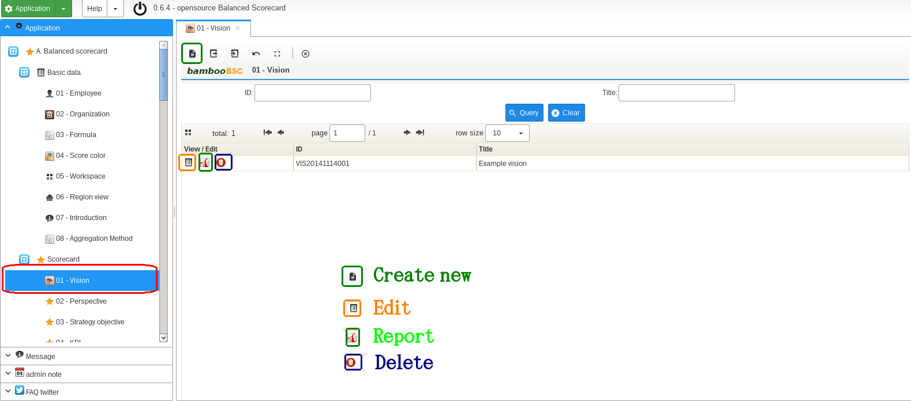

figura 1-01

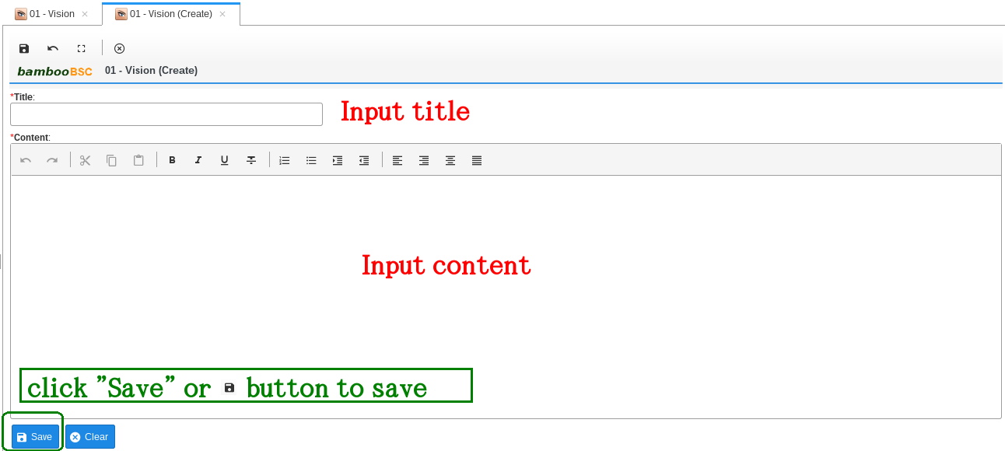

figura 1-02

2. Perspectivas
Hacer click en la opción “ 02 – Perspective “. Ver figura 2-01 , 2-02
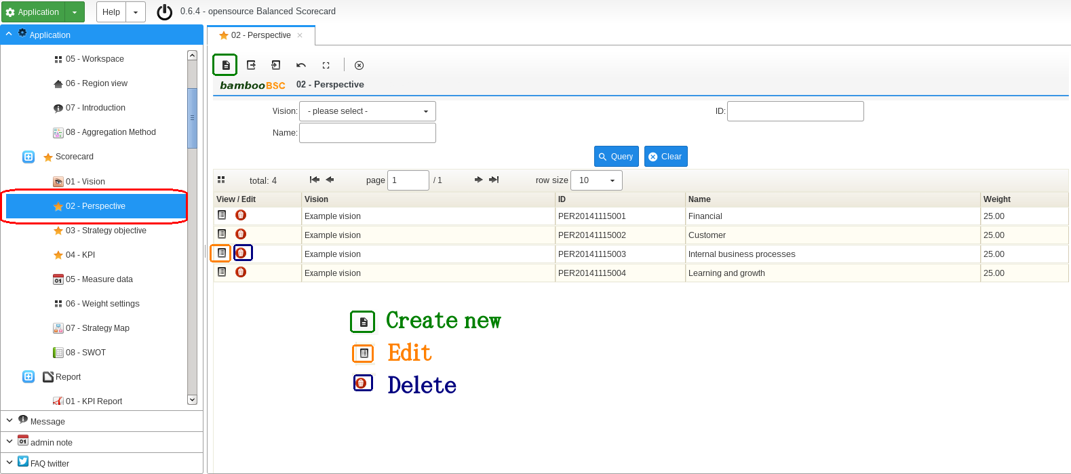

figura 2-01

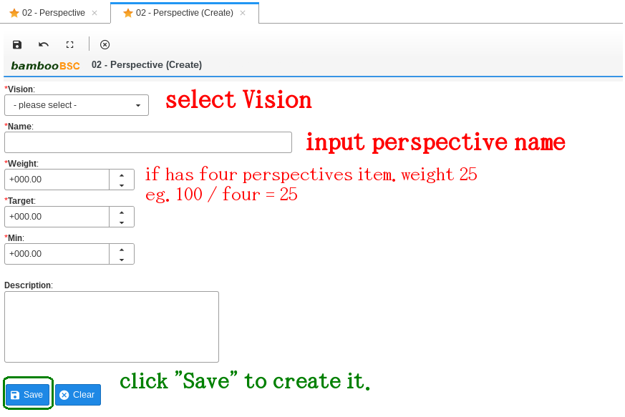

figure 2-02

3. Objetivos estratégicos
Hacer click en la opción “ 03 – Strategy objective “. Ver figura 3-01, 3-02
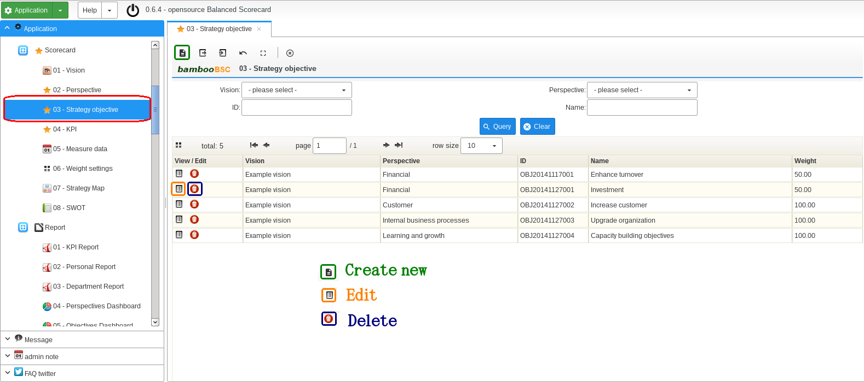

figura 3-01

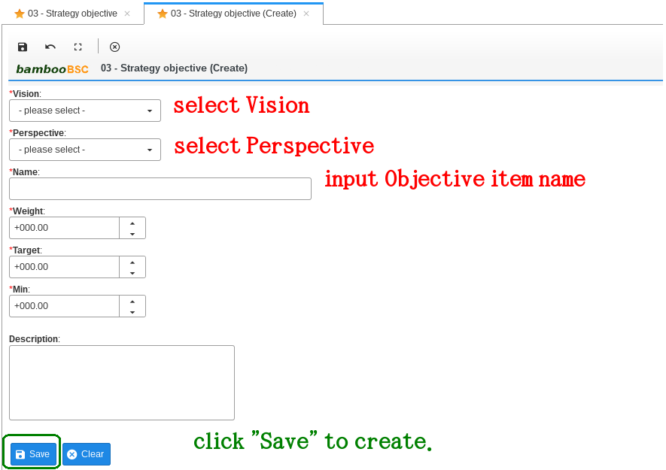

figura 3-02

4. KPI (Indicadores Clave de Desempeño)
Hacer click en “ 04 – KPI “. Ver figura 4-01, 4-02

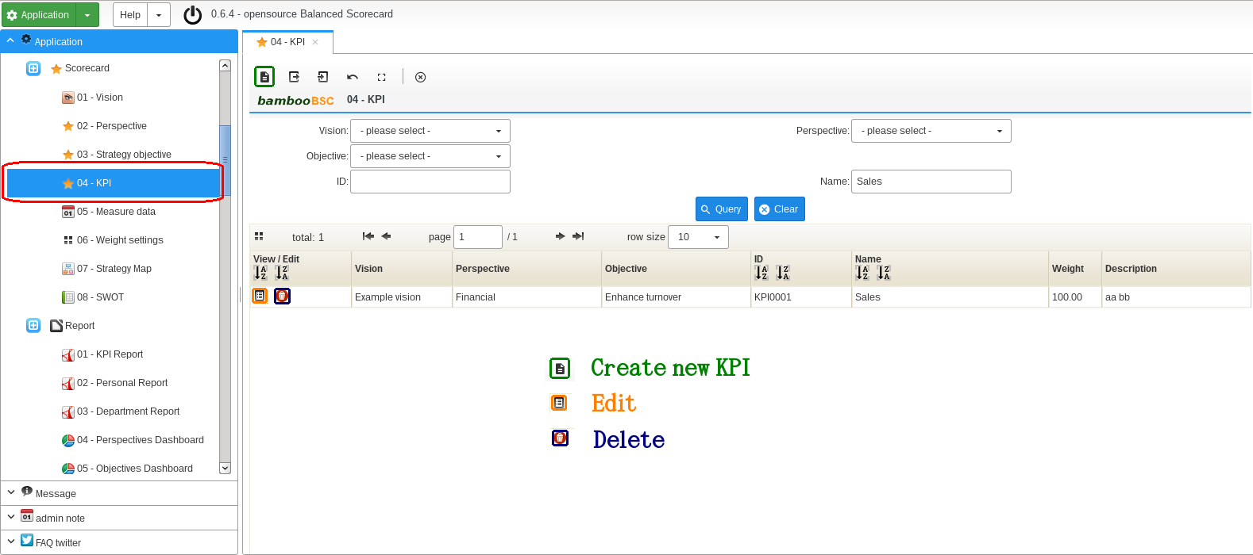

figura 4-01

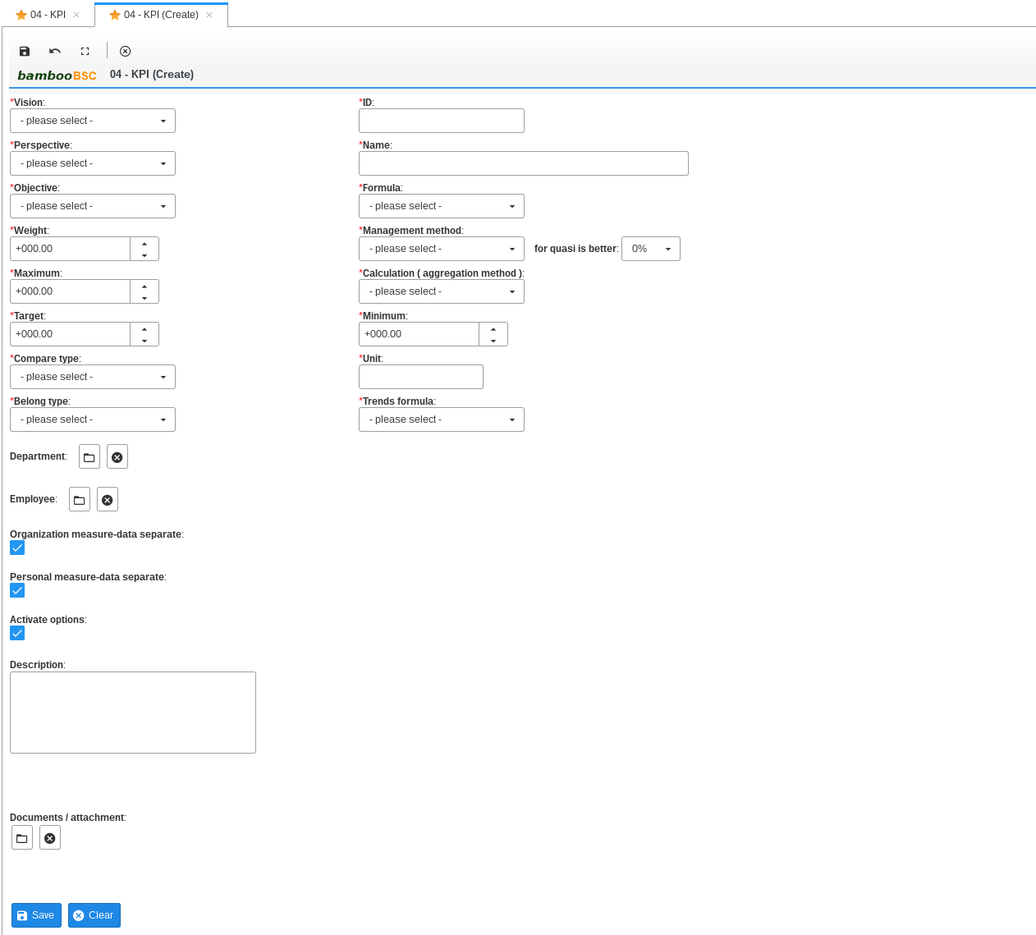

figura 4-02

Visión: Seleccionar visión del KPI.
Perspectiva: Seleccionar perspectiva del KPI
Objetivo: Seleccionar objetivo del KPI
Id: identificador del KPI.
Name: Nombre del KPI
Formula: Fórmula del KPI, Afectará al cálculo de las puntuaciones, Para crear o editar fórmulas ir a “Basic data / 03 – Formula”
Fórmula de tendencias: Solo es necesaria para calcular las puntuaciones el reporte 07 - KPI Period Trends report.
Peso: Debe ser mayor que CERO. Si se establece a CERO no tiene sentido.
Máximo: Valor máximo, Debe ser un valor mayor al ingresado en el campo meta.
Meta: Valor meta.
Mínimo: Valor mínimo.
Tipo de comparación: Con meta (las puntuaciones KPI se comparan con el valor meta) , con mínimo (las puntuaciones KPI se comparan con el valor mínimo)
Unidad: Unidad del KPI (por ejemplo: %, USD, TWD, millon, pieza, etc.)
Método de gestión: Mayor(puntuación mayor es mejor) / Menor (Puntuación menor es mejor) / Casi(puntuación casi es mejor)
Cálculo (método de agregación): Promedio, Total, Max, Min, se define en 08 – Método de agregación (Afectará el cálculo de las puntuaciones)
Ejemplos de KPI que tienen DOS datos de medición y su Cálculo es Promedio
A. 2014 dato de medición es 50
B. 2015 dato de medición es 80
rango 2014 ~ 2015
Puntuación promedio = (50 + 80) / 2 = 65
Pertenencia (Belong tipo): Se recomienda seleccionar “Both”

Department: click open pop-window to select ( figure 4-03 )

click clear select value
Employee: click open pop-window to select ( figure 4-04 )
click clear select value
Calcular puntuaciones de organización por separados (Organización métricas datos separados): Se recomienda chequeado / habilitado.
Calcular puntuaciones personales por separado (personales métricas datos separados): Se recomienda chequeado / habilitado.
Activar opciones: Se recomienda chequeado / habilitado, Se se deshabilita, el KPI no aparecerá en los reportes.
Descripción: Descripción del KPI
Documentos / adjuntos: Se pueden subir archivos adjuntos.

Selección de departamento
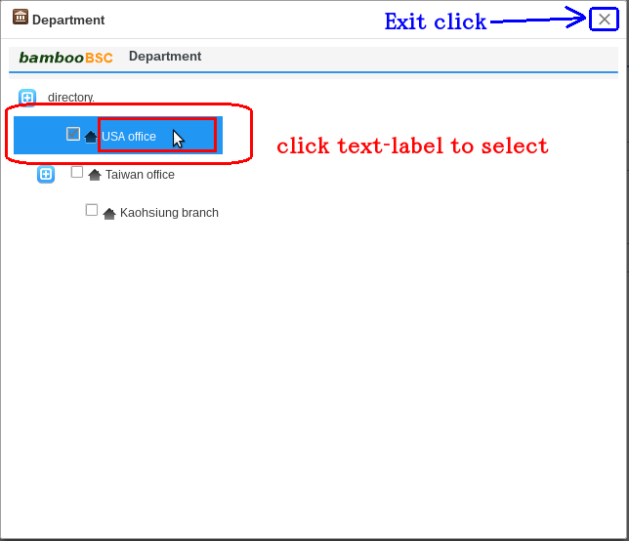

Figura 4-03

Selección de empleado
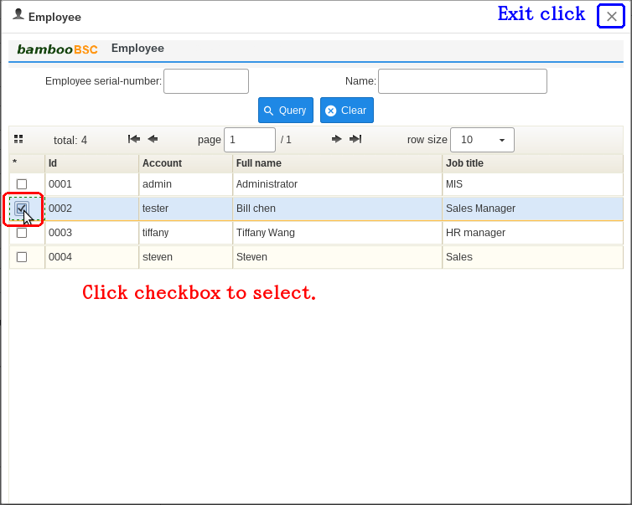

figure 4-04

5. Datos de medición
Estos datos necesitan actualizaciones frecuentes y mantenimiento, Si no se ingresan datos para poder calcular los KPI, los KPI mostrados en los reportes no tendrán sentido.
Hacer click “ 05 – Datos de medida“ . Ver figura 5-01
1. Seleccionar un elemento KPI
2. Seleccionar las opciones y hacer click en Consulta
3. Ingresar los datos de medición, hacer click en Guardar para actualizar.
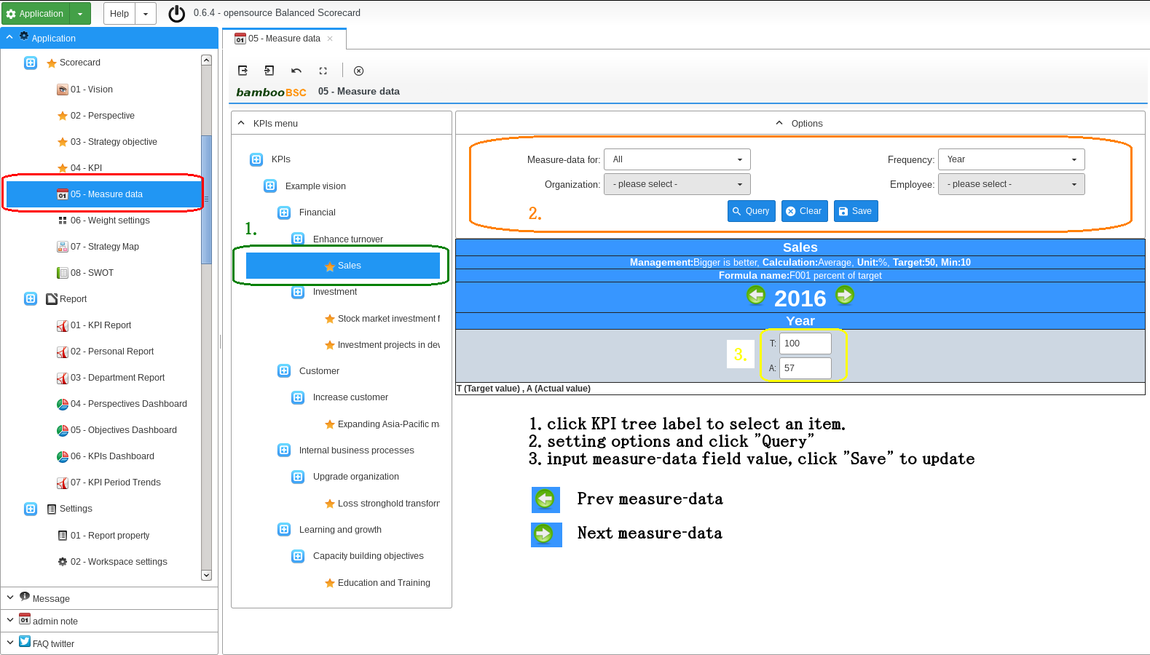

figura 5-01

6. KPI Report
Query organization/Department or Employee 's performance score . first click Report “ 01 – KPI Report ” look figure 6-01
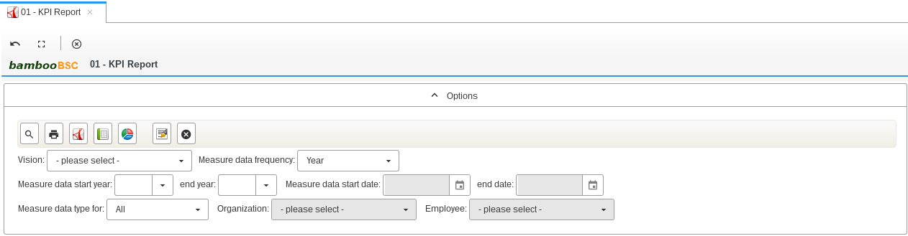

figure 6-01

ICON | Description
 | Query report content
 | Export query report as PNG image, ( used IE browser the function failure )
 | Export query report as PDF file, ( used IE browser the function failure )
 | Export query report as Excel file, ( used IE browser the function failure )
 | Select an Vision
 | Select frequency
 | If Frequency is “ Year” , “ Half of year ” , “ Quarter ” , must input start year and end year
 | If Frequency is “ Month” , “ Week ” , “ Day “ , must input start day and end day
All: Measure data type is non-departmental and non-employee class
Organization: Measure data type only for an organization/Department
Employee: Measure data type only for an employee
 | If measure data for organization type. Need select the option
 | If measure data for employee type. Need select the option

7. Personal Report
Query employee's BSC report. first click Report “ 02 – Personal Report ” look figure 7-01
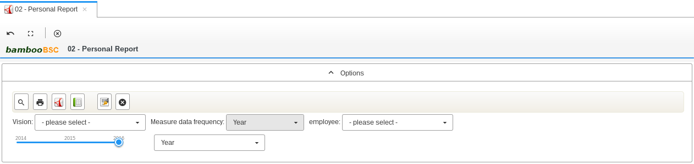

figure 7-01

ICON | Description
 | Query report content
 | Export query report as PNG image, ( used IE browser the function failure )
 | Export query report as PDF file, ( used IE browser the function failure )
 | Export query report as Excel file, ( used IE browser the function failure )
 | Select an Vision
 | No need select, system auto settings.
 | Select an employee
 | Select report year.
In the first half: measure-data frequency basic of first half
In the second half: measure-data frequency basic of second half
Year: measure-data frequency basic of Year

8. Department Report
Query organization/Department BSC report. first click Report “ 03 – Department Report ” look figure 8-01
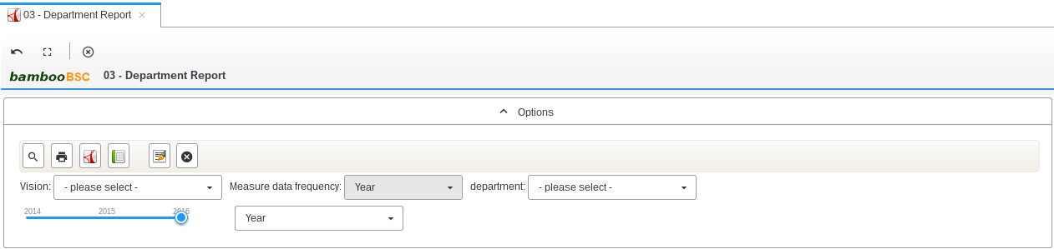

figure 08-001

ICON | Description
 | Query report content
 | Export query report as PNG image, ( used IE browser the function failure )
 | Export query report as PDF file, ( used IE browser the function failure )
 | Export query report as Excel file, ( used IE browser the function failure )
 | Select an Vision
 | No need select, system auto settings.
 | Select an organization/Department
 | Select report year.
In the first half: measure-data frequency basic of first half
In the second half: measure-data frequency basic of second half
Year: measure-data frequency basic of Year

9. Strategy Map
Query or edit the strategy map. First click “ 07 – Strategy Map ” look figure 9-01
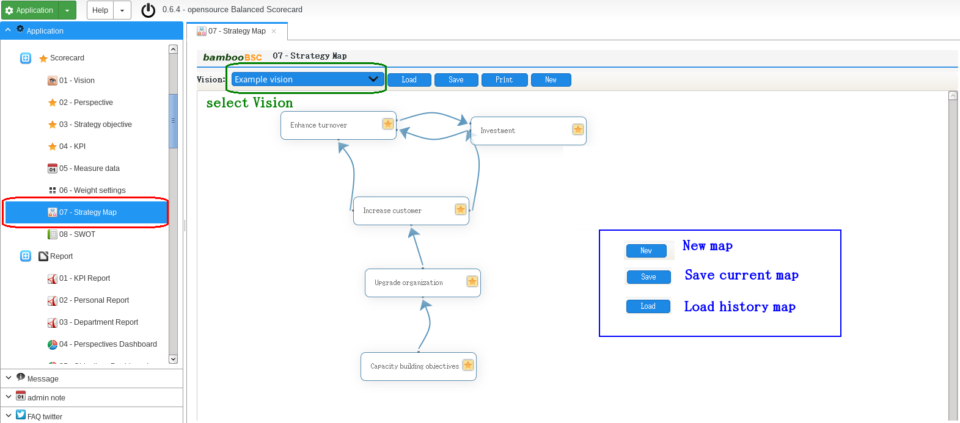

figure 9-01
How to drag Line on MAP

9. Strategy MAP Double click Strategy-objective item , will show detail
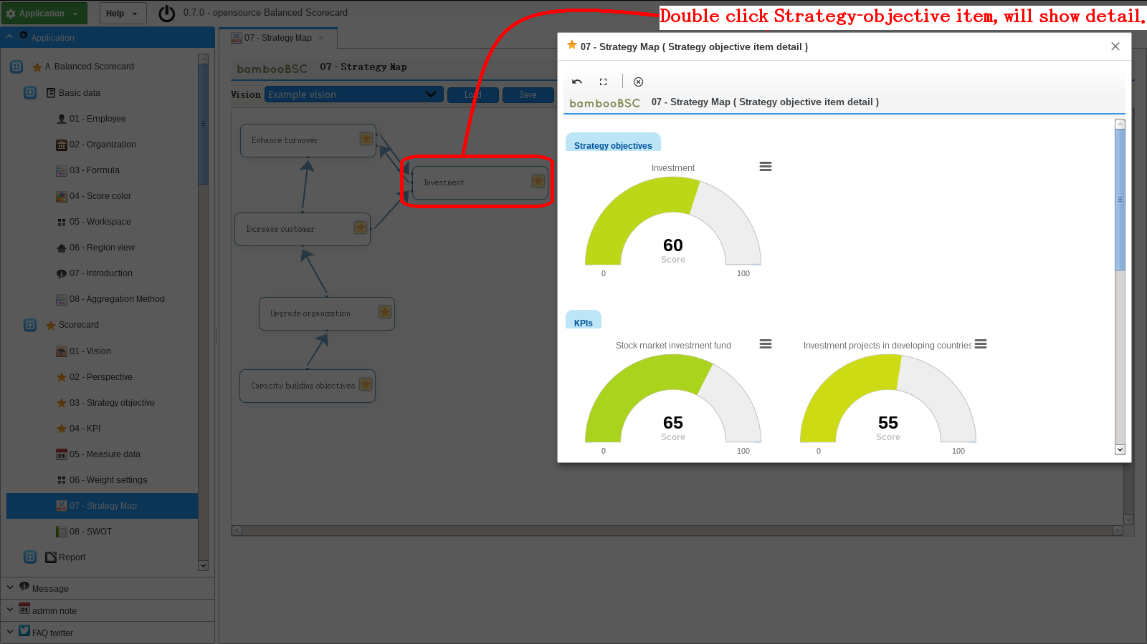

10. SWOT
Query or edit BSC S.W.O.T. first click “ 08 – SWOT ” look figure 10-01
1. first select an Vision and department/Organization
2. Query
3. input content on text-box
4. click save
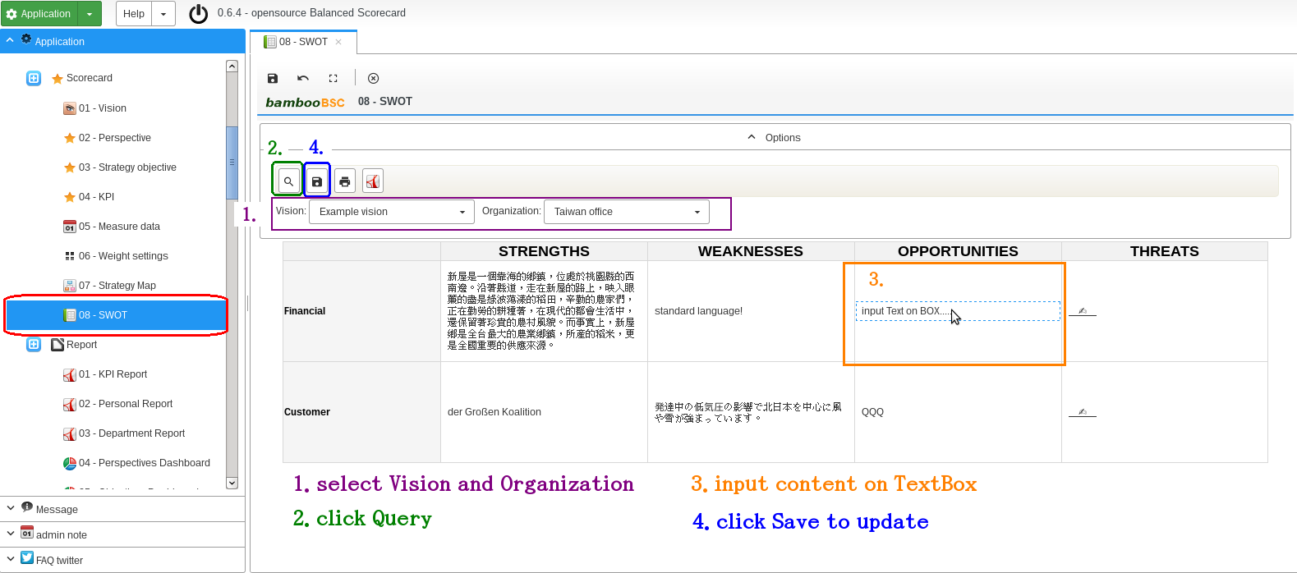

figure 10-01

ICON | Description
 | Query content
 | Save content
 | Export query report as PNG image, ( used IE browser the function failure )
 | Export query report as PDF file, ( used IE browser the function failure )
 | Select an Vision
 | Select an department/Organization

11. Report signature
Managers signature on the report for “01 – KPI Report” / “02 – Personal Report” / “03 – Department Report” . Only export Excel or PDF found signature picture.

ICON | Description
 | Open signature pop-window.
 | Clear current signature picture.
1. first click

2. drawing name on signature pop-window . Look figure 11-01

figure 11-01

3. click export PDF or Excel button , result look figure 11-02

figure 11-02

12. Query Charts
The main function is SQL query to chart .

12-1. Settings datasource
please use “01 – Data source config” to create or modify Datasource settings.
If you want to provide other DB connection driver( SQL-Server or Oracle, pqSQL ... ), please put Driver LIB jar file to WEB-INF/lib and add config of table named qc_data_source_driver . Currently, the system only provides MySQL Driver .

12-2. Settings data mapped
Settings Charts's Label and Value mapped. Click “02 – Data query mapper” on menu . Create new items please look ( figure 12-01 )

figure 12 - 01

Name: Please input mapped item name.
Description: memo or explain
Mapper Label: sql query's fields name
Mapper Value: sql query's fields name

12-3. Query expression to Charts
Charts have provided BAR, PIE, LINE, AREA and html table. Click “01 – Basic query” on menu tree. Look ( figure 12-02 ) , Example results Look ( figure 12-03 )

figure – 12-02

ICON | Description
 | Query results show as HTML table.
 | Query results show as Pie charts
 | Query results show as Bar charts
 | As Line charts
 | As Area charts
 | Save query expression to history data.
 | Clear
 | Delete history data.
 | Select history data.
 | Select datasource.
 | input query name when need Save query
 | Select mapped item for query Charts
 | Select mapped items for Pie charts
 | input SQL query expression

The is Area Charts example.

figure 12-03

13. Analytics ( OLAP )
This feature is to provide a simple OLAP . MDX Query results can be exported into HTML file or EXCEL file .

13-1. Settings datasource
click “03 - Analytics config “ on menu tree. And to create mode look ( figure 13 – 01 ) .

figure 13 – 01

Id: input config Id.
Name: input config name.
Drivers: input jdbc driver class name. ( If you want to provide other DB connection driver( SQL-Server or Oracle, pqSQL ... ), please put Driver LIB jar file to WEB-INF/lib )
Jdbc url: jdbc url. ( url string parameter must include the account and password )
Description: memo or explain

13-2. Upload Mondrian Catalog file
Upload Mondrian catalog file and management. How to build catalog xml file please download mondrian schema workbench ( http://sourceforge.net/projects/mondrian/files/schema%20workbench/ ) now vision is 3.9.0 , use workbench create catalog example ( figure 13-02 )

figure 13 - 02

After the schema workbench output of the catalog xml file using the " 04 - Analytics Catalog " to upload it . Look ( figure 13 – 03 )

figure 13 – 03

Id: input catalog Id.
Name: input catalog name.
Mondrian Catalog: select an catalog xml file to upload.
Description: memo or explain

13-3. Analytics MDX query
Execute MDX query and display or output results. Click “02 - Analytics ” on menu tree. Look ( figure 13 – 04 )

figure 13 – 04

ICON | Description
 | Query results show as HTML results.
 | Export HTML results as a file.
 | Export results as a Excel file.
 | Save MDX to history data.
 | Clear
 | Delete current select history data.
 | Select history data.
 | Query name.
 | Check show Title.
 | Check show members.
 | Select OLAP datasource config.
 | Select OLAP catalog config.
 | input MDX query string.

14. bambooBSC mobile version
14-1. Mobile web.
Click link to mobile version on Login page.
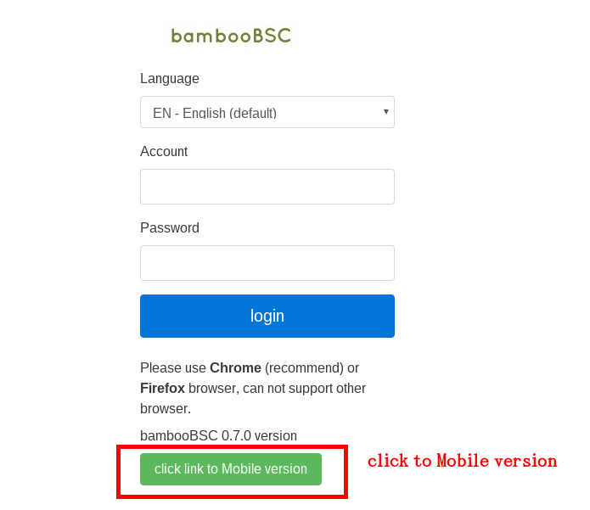

Menu item, 1.Scorecard, 2. Dashboard, 3. Strategy MAP, if want logout please click Logout

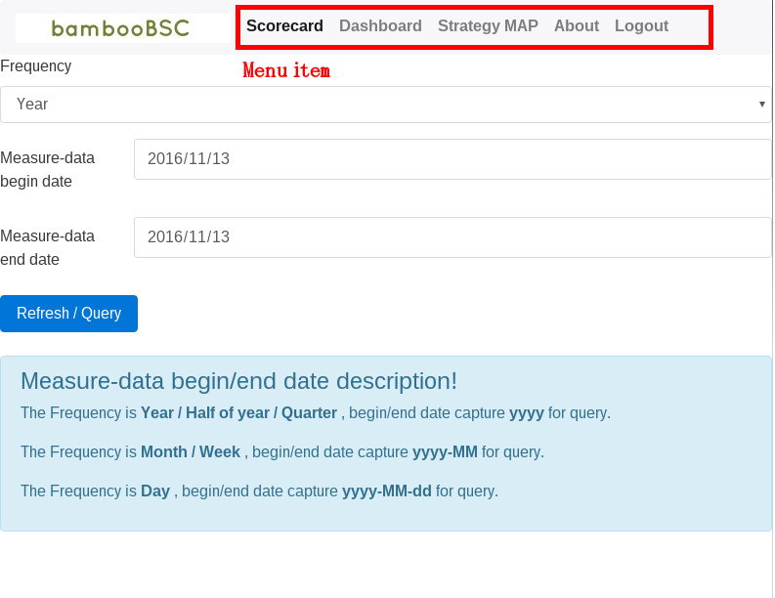

14-2. Mobile web base operation

Mobile Scorecard
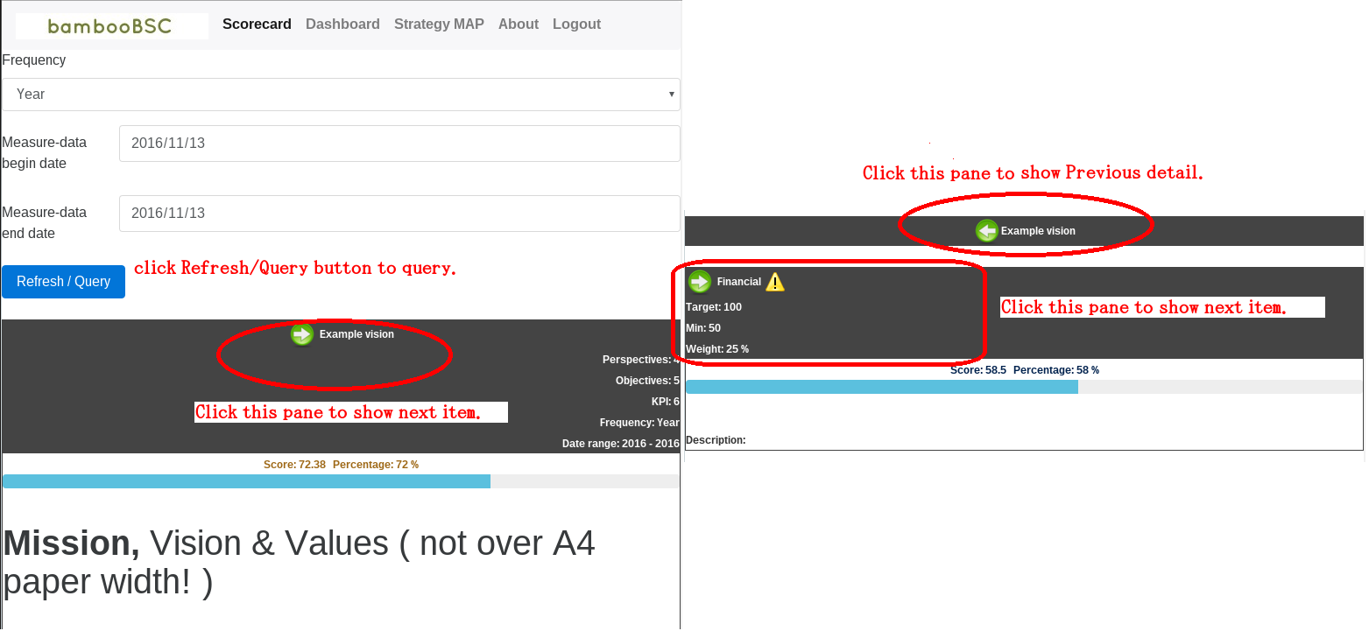

Mobile dashboard please view next page image.

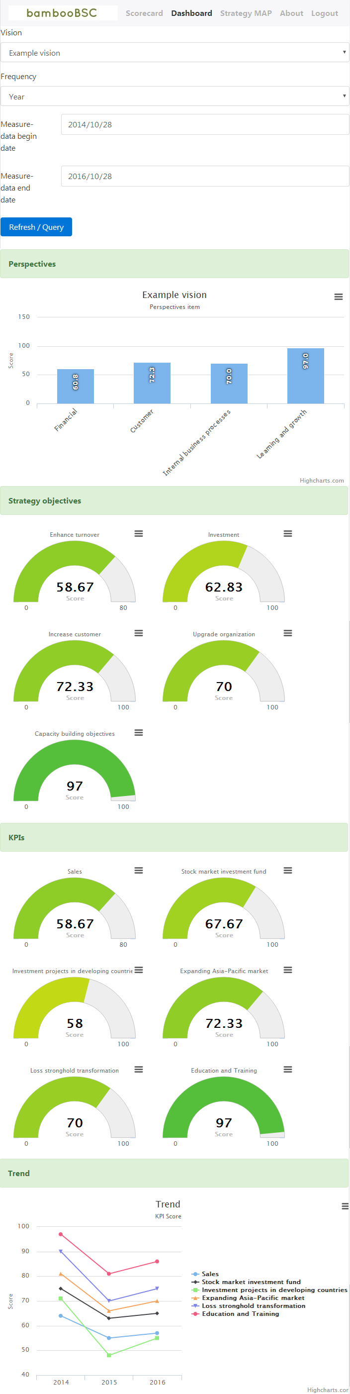

Mobile Strategy MAP
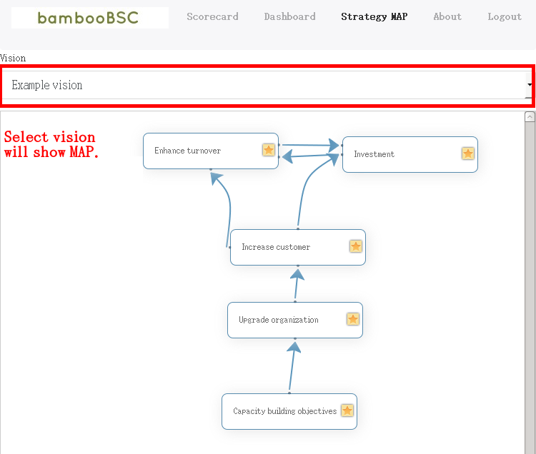

15. PDCA ( Plan / Do / Check / Action )

Create new PDCA Project

PDCA Project department pick.

PDCA Project owner/Employee pick.

PDCA KPIs tree pick

PDCA Project item add.

Audit project.

View now audit step of PDCA Project

Confirm audit for PDCA Project

PDCA Report query operation

16. Audit settings ( if PDCA Project or 360 Project edit page cannot click “Confirm audit” button )
Please use “05 – BPMN Resource role” to management. Add an task audit for an user Role.
The default account has permission to audit. Later new added account, please set audit permission by self (admin can do it).

360 Degree feedback project audit process.
Resource ID | Task icon | Task name
DFProjectPublishProcess |  | To apply
DFProjectPublishProcess |  | HR Manager Approval

PDCA project audit process.
Resource ID | Task icon | Task name
PDCAProjectProcess |  | Plan
PDCAProjectProcess |  | Do
PDCAProjectProcess |  | Check
PDCAProjectProcess |  | Action

