CHAPTER 3
3. MEASURES OF CENTERAL TENDENCY
Introduction
- When we want to make comparison between groups of numbers it is good to have a single value that is considered to be a good representative of each group. This single value is called the average of the group. Averages are also called measures of central tendency.
- An average which is representative is called typical average and an average which is not representative and has only a theoretical value is called a descriptive average. A typical average should posses the following:
- It should be rigidly defined.
- It should be based on all observation under investigation.
- It should be as little as affected by extreme observations.
- It should be capable of further algebraic treatment.
- It should be as little as affected by fluctuations of sampling.
- It should be ease to calculate and simple to understand.

Objectives:
- To comprehend the data easily.
- To facilitate comparison.
- To make further statistical analysis.

The Summation Notation:
- Let X_{1,} X_{2 ,}X_{3 …}X_{N} be a number of measurements where N is the total number of observation and X_{i} is i^{th} observation.
- Very often in statistics an algebraic expression of the form X₁+X₂+X₃+...+X_{N} is used in a formula to compute a statistic. It is tedious to write an expression like this very often, so mathematicians have developed a shorthand notation to represent a sum of scores, called the summation notation.
- The symbol 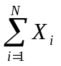is a mathematical shorthand for X₁+X₂+X₃+...+X_{N} 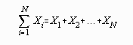
The expression is read, "the sum of X sub i from i equals 1 to N." It means "add up all the numbers."
Example: Suppose the following were scores made on the first homework assignment for five students in the class: 5, 7, 7, 6, and 8. In this example set of five numbers, where N=5, the summation could be written:
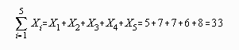
The "i=1" in the bottom of the summation notation tells where to begin the sequence of summation. If the expression were written with "i=3", the summation would start with the third number in the set. For example:
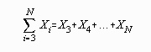
In the example set of numbers, this would give the following result:
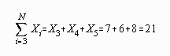
The "N" in the upper part of the summation notation tells where to end the sequence of summation. If there were only three scores then the summation and example would be:
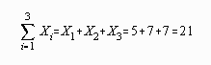
Sometimes if the summation notation is used in an expression and the expression must be written a number of times, as in a proof, then a shorthand notation for the shorthand notation is employed. When the summation sign "" is used without additional notation, then "i=1" and "N" are assumed.
For example:
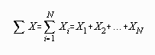
PROPERTIES OF SUMMATION
- 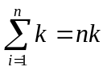 where k is any constant
- 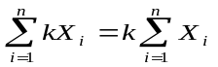 where k is any constant
- 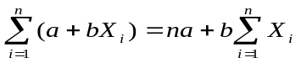 where a and b are any constant
- 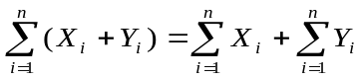
The sum of the product of the two variables could be written:
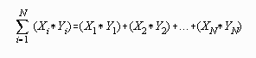

Example: considering the following data determine
X | Y
5 | 6
7 | 7
7 | 8
6 | 7
8 | 8
- 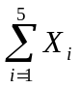
- 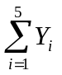
- 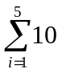
- 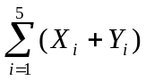
- 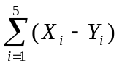
- 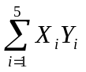
- 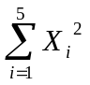
- 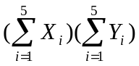
Solutions:
- 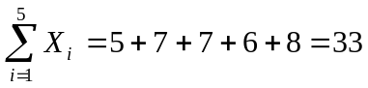
- 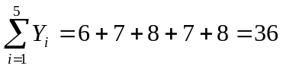
- 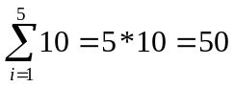
- 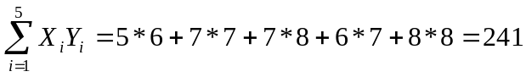
- 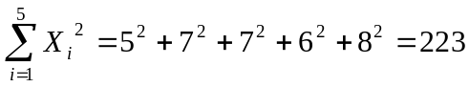
- 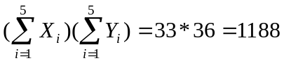

Types of measures of central tendency
There are several different measures of central tendency; each has its advantage and disadvantage.
- The Mean (Arithmetic, Geometric and Harmonic)
- The Mode
- The Median
- Quantiles (Quartiles, Deciles and Percentiles)
The choice of these averages depends up on which best fit the property under discussion.

The Arithmetic Mean
- Is defined as the sum of the magnitude of the items divided by the number of items.
- The mean of X₁, X₂ ,X₃ …X_{n} is denoted by A.M ,m or and is given by:
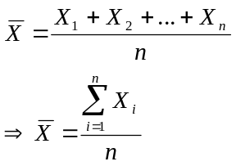
- If X₁ occurs f₁ times
- If X₂occurs f₂ times
- .
- .
- If X_{n} occurs f_{n} times
Then the mean will be 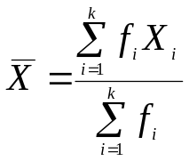 , where k is the number of classes and 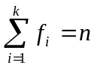
Example: Obtain the mean of the following number
2, 7, 8, 2, 7, 3, 7
Solution:
X_{i} | f_{i} | X_{i}f_{i}
2 | 2 | 4
3 | 1 | 3
7 | 3 | 21
8 | 1 | 8
Total | 7 | 36

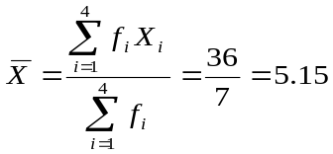
Arithmetic Mean for Grouped Data

If data are given in the shape of a continuous frequency distribution, then the mean is obtained as follows:
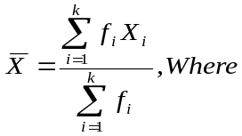 X_{i} =the class mark of the i^{th} class and f_{i} = the frequency of the i^{th} class
Example: calculate the mean for the following age distribution.
Class | frequency
6- 10 | 35
11- 15 | 23
16- 20 | 15
21- 25 | 12
26- 30 | 9
31- 35 | 6

Solutions:
- First find the class marks
- Find the product of frequency and class marks
- Find mean using the formula.
Class | f_{i} | X_{i} | X_{i}f_{i}
6- 10 | 35 | 8 | 280
11- 15 | 23 | 13 | 299
16- 20 | 15 | 18 | 270
21- 25 | 12 | 23 | 276
26- 30 | 9 | 28 | 252
31- 35 | 6 | 33 | 198
Total | 100 |  | 1575
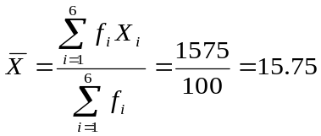
Exercises:
- Marks of 75 students are summarized in the following frequency distribution:

Marks | No. of students
40-44 | 7
45-49 | 10
50-54 | 22
55-59 | f₄
60-64 | f₅
65-69 | 6
70-74 | 3
If 20% of the students have marks between 55 and 59
- Find the missing frequencies f₄ and f₅.
- Find the mean.
  - If the values in a series or mid values of a class are large enough, coding of values is a good device
to simplify the calculations.
  - For raw data suppose we have used the following coding system.
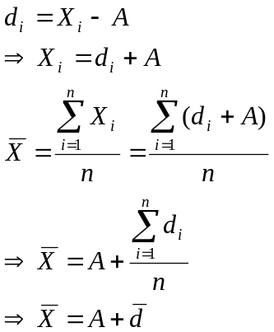
Where A is an assumed mean and 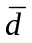 is the mean of the coded data.
- If the data are expressed in terms of ungrouped frequency distribution
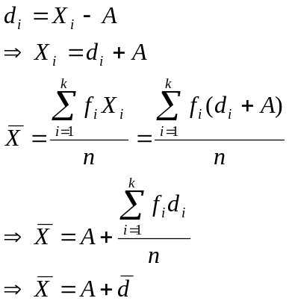
  - In both cases the true mean is the assumed mean plus the average of the deviations from the assumed mean.
  - Suppose the data is given in the shape of continuous frequency distribution with a constant class size of w then the following coding is appropriate.
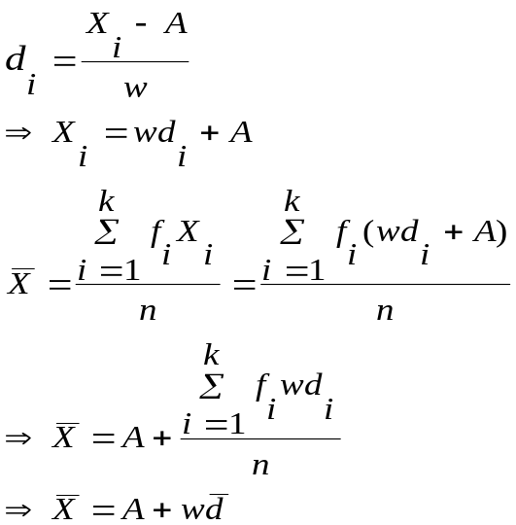
Where: X_{i} is the original class mark for the i^{th} class.
d_{i} is the transformed class mark for the i^{th} class.
A is an assumed mean usually the mean of the class marks.
(i =1, 2… k)
Example:
- Suppose the deviations of the observations from an assumed mean of 7 are: 1, -1, -2, -2, 0, -3, -2, 2, 0, -3.
- Find the true mean
- Find the original observation.
Solutions:
- 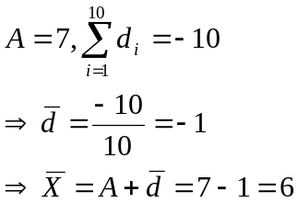
The true mean is 6.
- Using X_{i}=A+d_{i} we obtain the following original observations:
8, 6, 5, 5, 7, 4, 5, 9, 7, 4.

Special properties of Arithmetic mean
- The sum of the deviations of a set of items from their mean is always zero. i.e.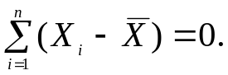
- The sum of the squared deviations of a set of items from their mean is the minimum. i.e.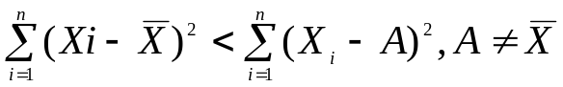
- If 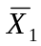 is the mean of 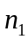observations
If 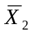 is the mean of 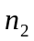observations
.
.
If 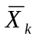 is the mean of 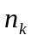observations
Then the mean of all the observation in all groups often called the combined mean is given by:
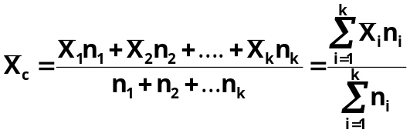
Example: In a class there are 30 females and 70 males. If females averaged 60 in an examination and boys averaged 72, find the mean for the entire class.
Solutions:

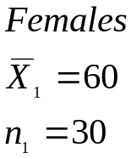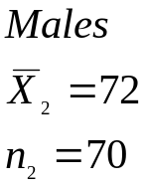
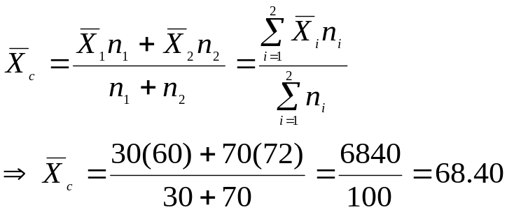

- If a wrong figure has been used when calculating the mean the correct mean can be obtained with out repeating the whole process using:
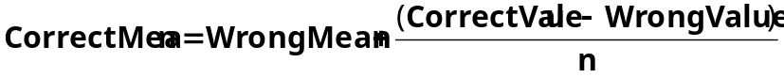
Where n is total number of observations.
Example: An average weight of 10 students was calculated to be 65.Latter it was discovered that one weight was misread as 40 instead of 80 k.g. Calculate the correct average weight.
Solutions:
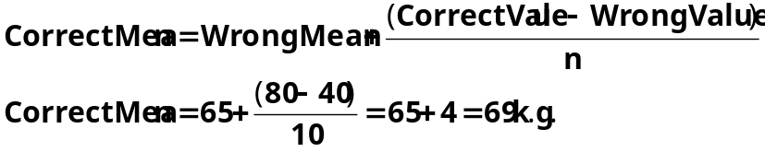

- The effect of transforming original series on the mean.
  - If a constant k is added/ subtracted to/from every observation then the new mean will be the old mean± k respectively.
  - If every observations are multiplied by a constant k then the new mean will be k*old mean
Example:
- The mean of n Tetracycline Capsules X₁, X₂, …,X_{n} are known to be 12 gm. New set of capsules of another drug are obtained by the linear transformation Y_{i} = 2X_{i} – 0.5 ( i = 1, 2, …, n ) then what will be the mean of the new set of capsules
Solutions:

- The mean of a set of numbers is 500.
- If 10 is added to each of the numbers in the set, then what will be the mean of the new set?
- If each of the numbers in the set are multiplied by -5, then what will be the mean of the new set?
Solutions:
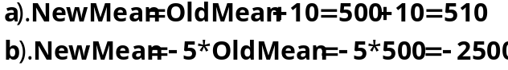

Weighted Mean
- When a proper importance is desired to be given to different data a weighted mean is appropriate.
- Weights are assigned to each item in proportion to its relative importance.
- Let X₁, X₂, …X_{n} be the value of items of a series and W₁, W₂, …W_{n} their corresponding weights , then the weighted mean denoted 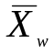is defined as:
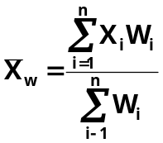
Example:
A student obtained the following percentage in an examination:
English 60, Biology 75, Mathematics 63, Physics 59, and chemistry 55.Find the students weighted arithmetic mean if weights 1, 2, 1, 3, 3 respectively are allotted to the subjects.
Solutions:
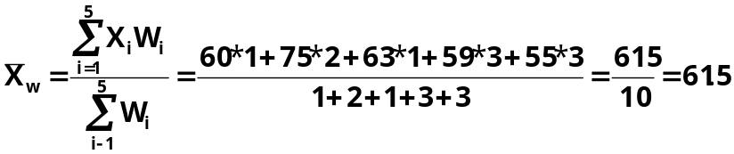

Merits and Demerits of Arithmetic Mean
Merits:
- It is rigidly defined.
- It is based on all observation.
- It is suitable for further mathematical treatment.
- It is stable average, i.e. it is not affected by fluctuations of sampling to some extent.
- It is easy to calculate and simple to understand.
Demerits:
- It is affected by extreme observations.
- It can not be used in the case of open end classes.
- It can not be determined by the method of inspection.
- It can not be used when dealing with qualitative characteristics, such as intelligence, honesty, beauty.
- It can be a number which does not exist in a serious.
- Some times it leads to wrong conclusion if the details of the data from which it is obtained are not available.
- It gives high weight to high extreme values and less weight to low extreme values.

The Geometric Mean

  - The geometric mean of a set of n observation is the n^{th} root of their product.
  - The geometric mean of X₁, X₂ ,X₃ …X_{n} is denoted by G.M and given by:

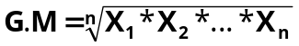
  - Taking the logarithms of both sides
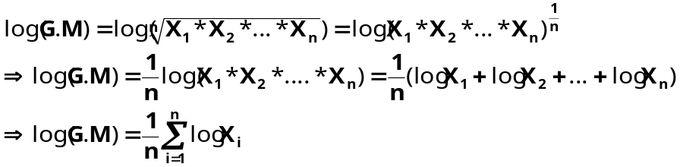
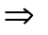The logarithm of the G.M of a set of observation is the arithmetic mean of
their logarithm.
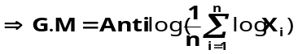
Example:
Find the G.M of the numbers 2, 4, 8.
Solutions:
Remark: The Geometric Mean is useful and appropriate for finding averages of
ratios.
The Harmonic Mean

The harmonic mean of X₁, X₂ , X₃ …X_{n} is denoted by H.M and given by:
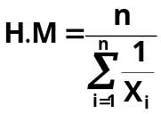, This is called simple harmonic mean.
In a case of frequency distribution:

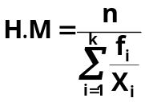 , 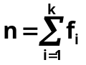
If observations X₁, X₂, …X_{n} have weights W₁, W₂, …W_{n} respectively, then their harmonic mean is given by

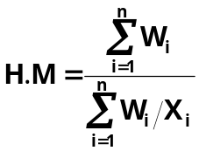, This is called Weighted Harmonic Mean.

Remark: The Harmonic Mean is useful and appropriate in finding average speeds and average rates.

Example: A cyclist pedals from his house to his college at speed of 10 km/hr and back from the college to his house at 15 km/hr. Find the average speed.
Solution: Here the distance is constant
➔The simple H.M is appropriate for this problem.
X₁= 10km/hr X₂=15km/hr
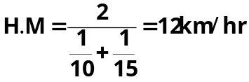

The Mode
- Mode is a value which occurs most frequently in a set of values
- The mode may not exist and even if it does exist, it may not be unique.
- In case of discrete distribution the value having the maximum frequency is the model value.

Examples:
  - Find the mode of 5, 3, 5, 8, 9
Mode =5
  - Find the mode of 8, 9, 9, 7, 8, 2, and 5.
It is a bimodal Data: 8 and 9
  - Find the mode of 4, 12, 3, 6, and 7.
No mode for this data.
- The mode of a set of numbers X₁, X₂, …X_{n} is usually denoted by 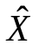 .

Mode for Grouped data

If data are given in the shape of continuous frequency distribution, the mode is defined as:
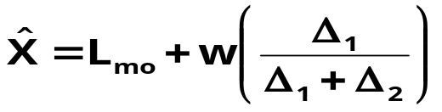

Where:
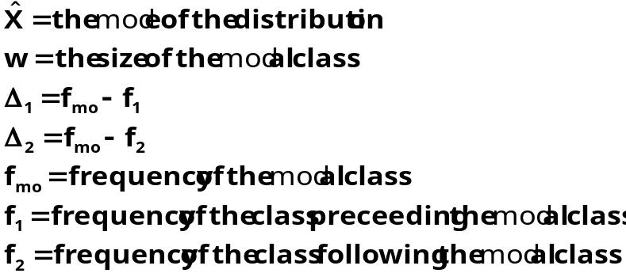

Note: The modal class is a class with the highest frequency.

Example: Following is the distribution of the size of certain farms selected at random from a district. Calculate the mode of the distribution.

Size of farms | No. of farms
5-15 | 8
15-25 | 12
25-35 | 17
35-45 | 29
45-55 | 31
55-65 | 5
65-75 | 3

Solutions:

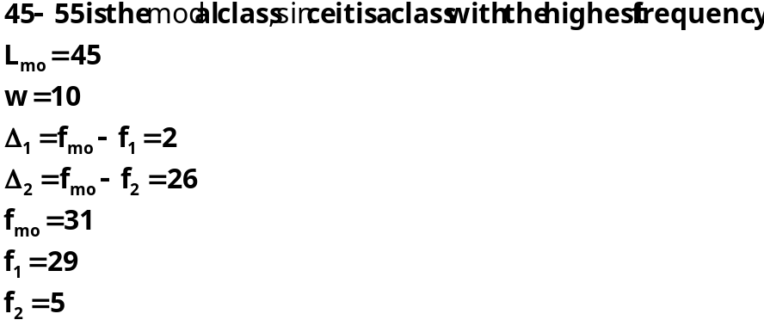

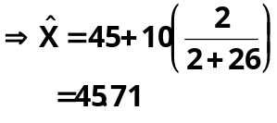

Merits and Demerits of Mode

Merits:
- It is not affected by extreme observations.
- Easy to calculate and simple to understand.
- It can be calculated for distribution with open end class
Demerits:
- It is not rigidly defined.
- It is not based on all observations
- It is not suitable for further mathematical treatment.
- It is not stable average, i.e. it is affected by fluctuations of sampling to some extent.
- Often its value is not unique.
Note: being the point of maximum density, mode is especially useful in finding the most popular size in studies relating to marketing, trade, business, and industry. It is the appropriate average to be used to find the ideal size.

The Median
- In a distribution, median is the value of the variable which divides it in to two equal halves.
- In an ordered series of data median is an observation lying exactly in the middle of the series. It is the middle most value in the sense that the number of values less than the median is equal to the number of values greater than it.
-If X₁, X₂, …X_{n} be the observations, then the numbers arranged in ascending order will be X_{[1]}, X_{[2]}, …X_{[n]}, where X_{[i]} is i^{th} smallest value.
X_{[1]}< X_{[2]}< …<X_{[n]}
-Median is denoted by.

Median for ungrouped data

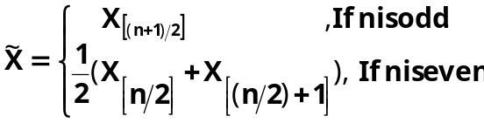

Example: Find the median of the following numbers.
- 6, 5, 2, 8, 9, 4.
- 2, 1, 8, 3, 5, 8.

Solutions:
- First order the data: 2, 4, 5, 6, 8, 9
Here n=6
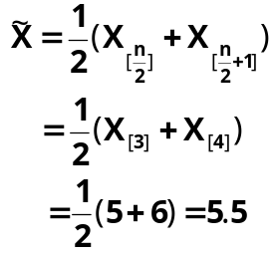
- Order the data :1, 2, 3, 5, 8
Here n=5
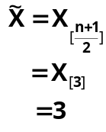

Median for grouped data

If data are given in the shape of continuous frequency distribution, the median is defined as: 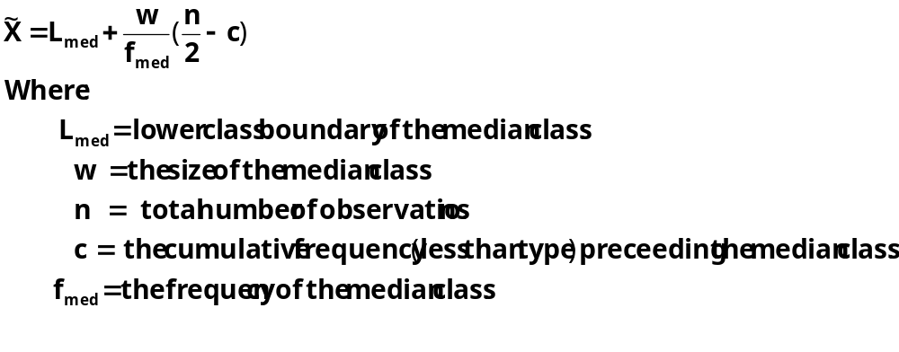
Remark:
The median class is the class with the smallest cumulative frequency (less than type) greater than or equal to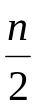.
Example: Find the median of the following distribution.

Class | Frequency
40-44 | 7
45-49 | 10
50-54 | 22
55-59 | 15
60-64 | 12
65-69 | 6
70-74 | 3

Solutions:
- First find the less than cumulative frequency.
- Identify the median class.
- Find median using formula.

Class | Frequency | Cumu.Freq(less than type)
40-44 | 7 | 7
45-49 | 10 | 17
50-54 | 22 | 39
55-59 | 15 | 54
60-64 | 12 | 66
65-69 | 6 | 72
70-74 | 3 | 75

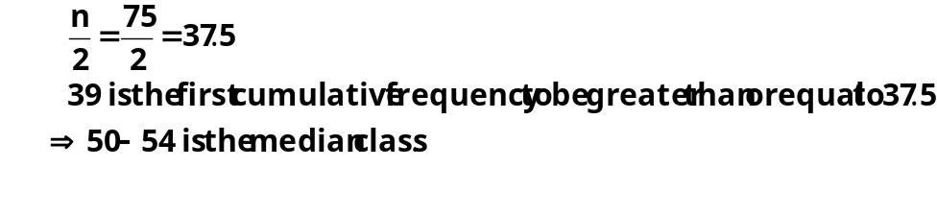
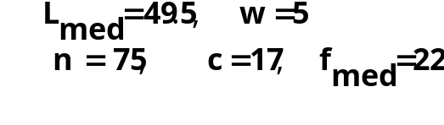

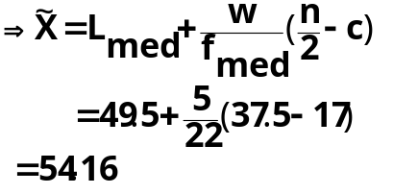

Merits and Demerits of Median
Merits:
- Median is a positional average and hence not influenced by extreme observations.
- Can be calculated in the case of open end intervals.
- Median can be located even if the data are incomplete.

Demerits:
- It is not a good representative of data if the number of items is small.
- It is not amenable to further algebraic treatment.
- It is susceptible to sampling fluctuations.

Quantiles

When a distribution is arranged in order of magnitude of items, the median is the value of the middle term. Their measures that depend up on their positions in distribution quartiles, deciles, and percentiles are collectively called quantiles.

Quartiles:
- Quartiles are measures that divide the frequency distribution in to four equal parts.
- The value of the variables corresponding to these divisions are denoted Q₁, Q₂, and Q₃ often called the first, the second and the third quartile respectively.
- Q₁ is a value which has 25% items which are less than or equal to it. Similarly Q₂ has 50%items with value less than or equal to it and Q₃ has 75% items whose values are less than or equal to it.
- To find Q_{i} (i=1, 2, 3) we count 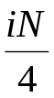of the classes beginning from the lowest class.

- For grouped data: we have the following formula

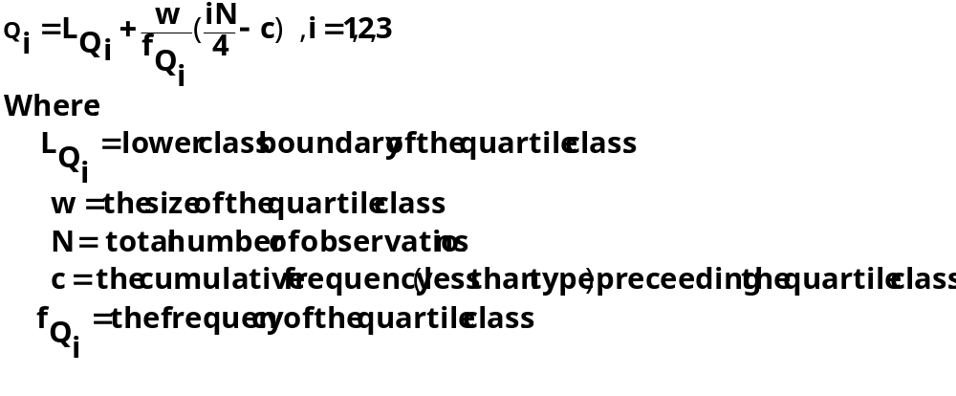

Remark:
The quartile class (class containing Q_{i} ) is the class with the smallest cumulative frequency (less than type) greater than or equal to.
Deciles:
- Deciles are measures that divide the frequency distribution in to ten equal parts.
- The values of the variables corresponding to these divisions are denoted D₁, D₂,.. D₉ often called the first, the second,…, the ninth decile respectively.
- To find D_{i} (i=1, 2,..9) we count 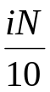of the classes beginning from the lowest class.

- For grouped data: we have the following formula

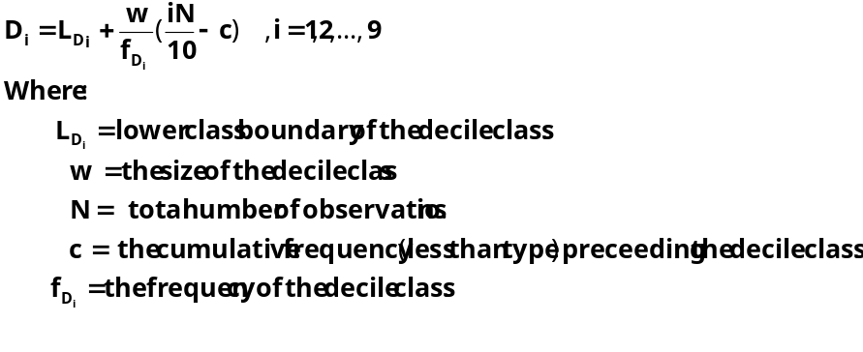

Remark:
The decile class (class containing D_{i} )is the class with the smallest cumulative frequency (less than type) greater than or equal to.

Percentiles:
- Percentiles are measures that divide the frequency distribution in to hundred equal parts.
- The values of the variables corresponding to these divisions are denoted P₁, P₂,.. P₉₉ often called the first, the second,…, the ninety-ninth percentile respectively.
- To find P_{i} (i=1, 2,..99) we count 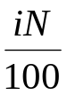of the classes beginning from the lowest class.

- For grouped data: we have the following formula
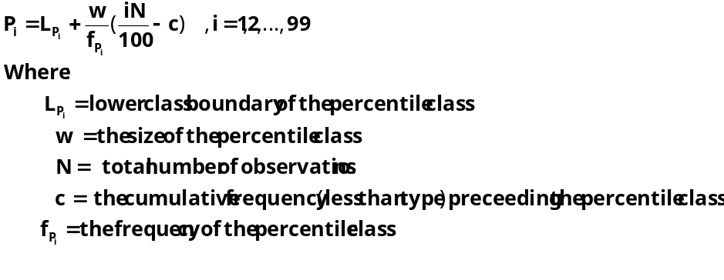
Remark:
The percentile class (class containing P_{i} )is the class with the smallest cumulative frequency (less than type) greater than or equal to.
Example: Considering the following distribution
Calculate:
- All quartiles.
- The 7th decile.
- The 90th percentile.

Values | Frequency
140- 150 | 17
150- 160 | 29
160- 170 | 42
170- 180 | 72
180- 190 | 84
190- 200 | 107
200- 210 | 49
210- 220 | 34
220- 230 | 31
230- 240 | 16
240- 250 | 12

Solutions:
- First find the less than cumulative frequency.
- Use the formula to calculate the required quantile.

Values | Frequency | Cum.Freq(less than type)
140- 150 | 17 | 17
150- 160 | 29 | 46
160- 170 | 42 | 88
170- 180 | 72 | 160
180- 190 | 84 | 244
190- 200 | 107 | 351
200- 210 | 49 | 400
210- 220 | 34 | 434
220- 230 | 31 | 465
230- 240 | 16 | 481
240- 250 | 12 | 493

- Quartiles:
  - Q₁
- determine the class containing the first quartile.
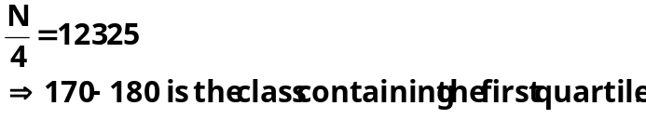

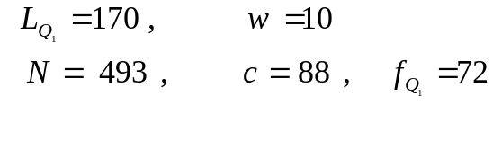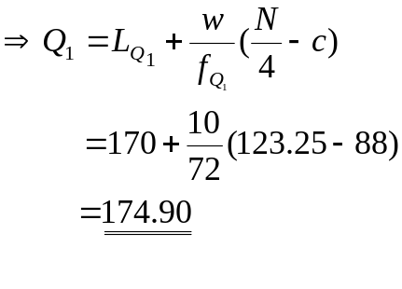

  - Q₂
- determine the class containing the second quartile.
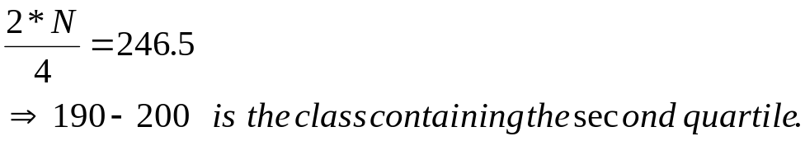

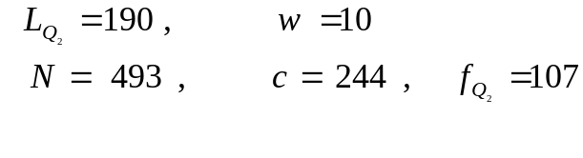
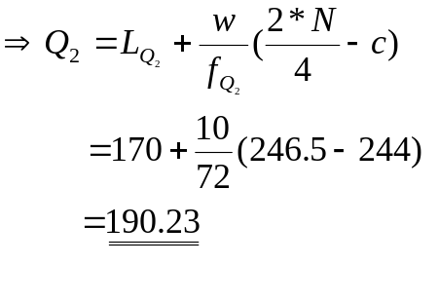
  - Q₃
- determine the class containing the third quartile.
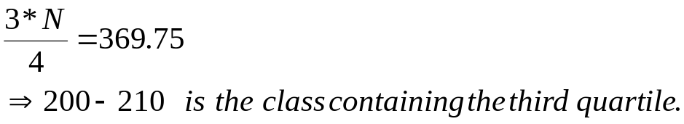

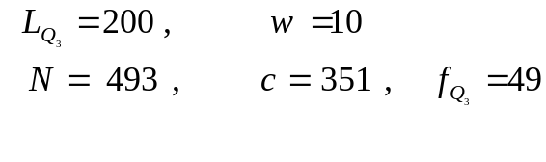
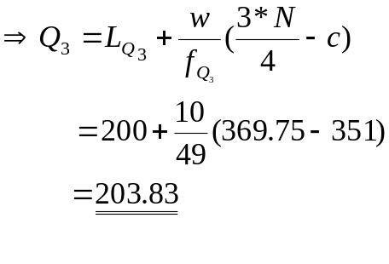

- D₇
- determine the class containing the 7th decile.
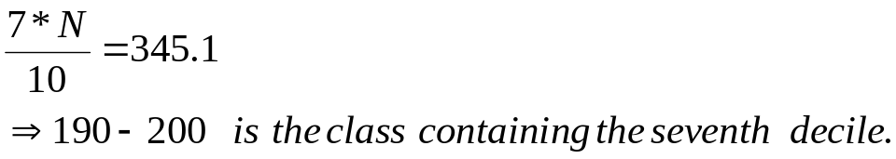
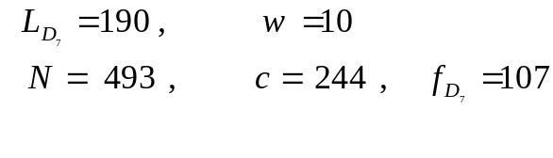
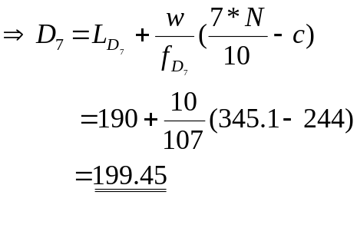
- P₉₀
- determine the class containing the 90th percentile.
