FACTORIAL CODE, PSEUDO AND WORKFLOW.
PYTHON CODE
def factorial(n):
if n < 0:
return "Error: Negative number"
elif n == 0 or n == 1:
return 1
else:
result = 1
for i in range(1, n + 1):
result *= i
return result

# Example usage
print(factorial(5)) # Output: 120

PSEUDO CODE
FUNCTION factorial(n):
IF n < 0:
RETURN "Error: Negative number"
ELSE IF n == 0 OR n == 1:
RETURN 1
ELSE:
result = 1
FOR i FROM 1 TO n:
result = result * i
RETURN result
END FUNCTION
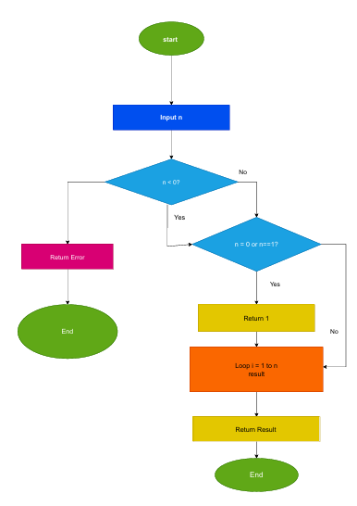
FIBONACCI CODE, PSEUDO CODE
PYTHON CODE
def fibonacci(n):
if n < 0:
return "Error: Negative number"
elif n == 0:
return 0
elif n == 1:
return 1
else:
a, b = 0, 1
for i in range(2, n + 1):
a, b = b, a + b
return b
# Example usage
print(fibonacci(7)) # Output: 13
PSEUDO CODE
FUNCTION fibonacci(n):
IF n < 0:
RETURN "Error: Negative number"
ELSE IF n == 0:
RETURN 0
ELSE IF n == 1:
RETURN 1
ELSE:
a = 0
b = 1
FOR i FROM 2 TO n:
c = a + b
a = b
b = c
RETURN b
END FUNCTION

