Se-Sp_analysis
Mumbua Mutunga
2024-09-03

Se, Sp, NPV, PPV
## Outcome + Outcome - Total
## Test + 90 6 96
## Test - 14 2 16
## Total 104 8 112
##
## Point estimates and 95% CIs:
## --------------------------------------------------------------
## Apparent prevalence * 0.86 (0.78, 0.92)
## True prevalence * 0.93 (0.86, 0.97)
## Sensitivity * 0.87 (0.78, 0.92)
## Specificity * 0.25 (0.03, 0.65)
## Positive predictive value * 0.94 (0.87, 0.98)
## Negative predictive value * 0.12 (0.02, 0.38)
## Positive likelihood ratio 1.15 (0.77, 1.73)
## Negative likelihood ratio 0.54 (0.15, 1.97)
## False T+ proportion for true D- * 0.75 (0.35, 0.97)
## False T- proportion for true D+ * 0.13 (0.08, 0.22)
## False T+ proportion for T+ * 0.06 (0.02, 0.13)
## False T- proportion for T- * 0.88 (0.62, 0.98)
## Correctly classified proportion * 0.82 (0.74, 0.89)
## --------------------------------------------------------------
## * Exact CIs

PCR +VE and -VE of the relevant variables
##
## Abnormal_vocalization aggressive Anorexia biting_objects Diarrhoea
## 0 0 10 3 8 1
## 1 4 65 9 52 2
##
## excessive_salivation groaning high_libido hydrophobia paralysis
## 0 10 0 5 3 5
## 1 53 2 22 29 28
##
## protrusion_of_the_tongue Rabid_animal_bite running_aimlessly
## 0 1 1 6
## 1 2 1 43
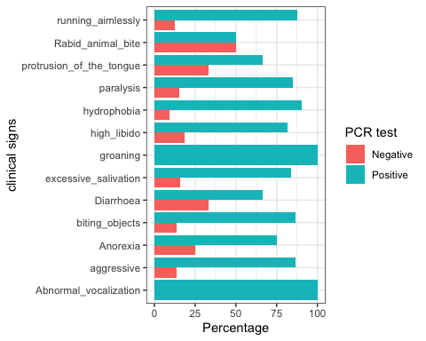
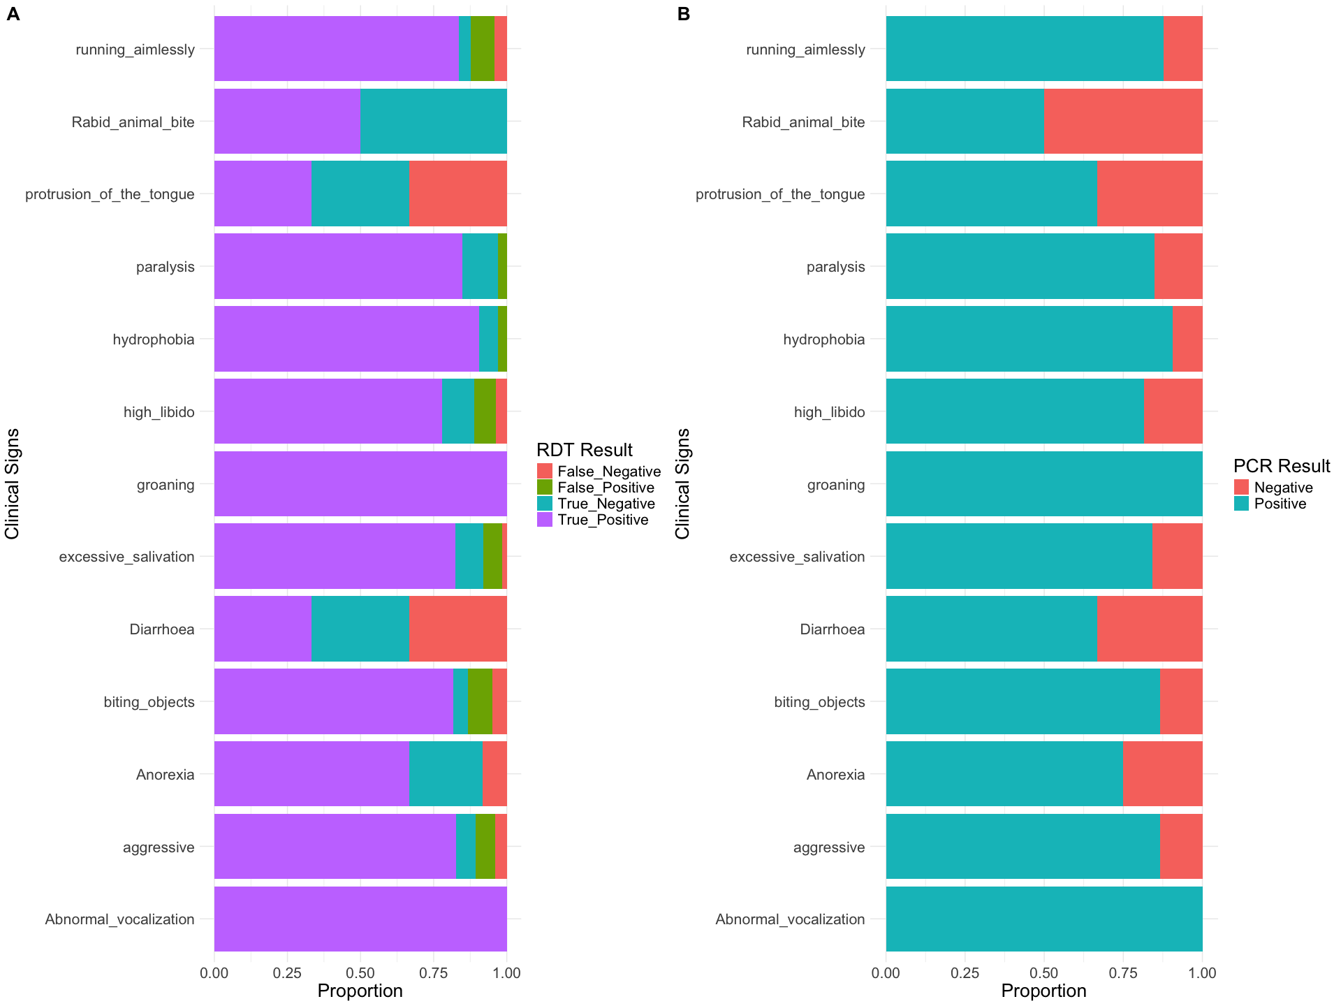

Table species vs the symptoms
species | Anorexia | Diarrhoea | aggressive | biting_objects | excessive_salivation | groaning | high_libido | hydrophobia | paralysis | protrusion_of_the_tongue | running_aimlessly | Abnormal_vocalization | Rabid_animal_bite
Dog | 3 | 3 | 58 | 48 | 44 | 2 | 18 | 17 | 24 | 3 | 39 | 0 | 0
Goat | 6 | 0 | 11 | 11 | 5 | 0 | 5 | 4 | 2 | 0 | 4 | 3 | 1
Cattle | 3 | 0 | 5 | 0 | 13 | 0 | 3 | 10 | 7 | 0 | 5 | 1 | 0
Sheep | 0 | 0 | 1 | 1 | 1 | 0 | 1 | 1 | 0 | 0 | 1 | 0 | 1
Total | 12 | 3 | 75 | 60 | 63 | 2 | 27 | 32 | 33 | 3 | 49 | 4 | 2

GLM
reg_model <- table(test$clinical_signs_, test$test_result)
chisq.test(reg_model)
## Warning in stats::chisq.test(x, y, ...): Chi-squared approximation may be
## incorrect
##
## Pearson's Chi-squared test
##
## data: reg_model
## X-squared = 41.994, df = 36, p-value = 0.2272
model1 <- glm(lab_diagnostics_pcr_ ~ clinical_signs_ , family = binomial(link = 'logit'), data = test)
plot(model1) #To examine the residuals of the GLM which can help identify outliers or patterns that may be affecting convergence.
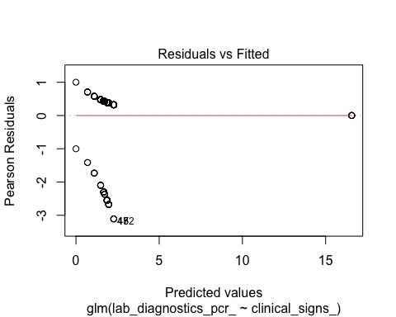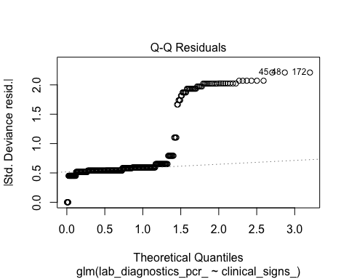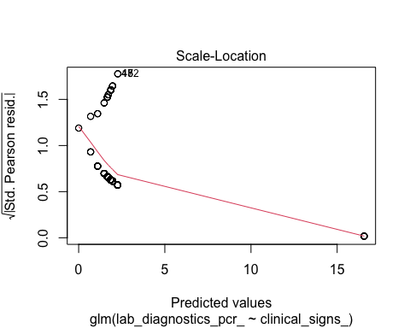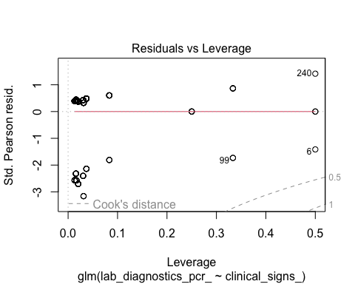
summary(model1)
##
## Call:
## glm(formula = lab_diagnostics_pcr_ ~ clinical_signs_, family = binomial(link = "logit"),
## data = test)
##
## Coefficients:
## Estimate Std. Error z value Pr(>|z|)
## (Intercept) 1.657e+01 1.200e+03 0.014 0.989
## clinical_signs_aggressive -1.469e+01 1.200e+03 -0.012 0.990
## clinical_signs_Anorexia -1.547e+01 1.200e+03 -0.013 0.990
## clinical_signs_biting_objects -1.469e+01 1.200e+03 -0.012 0.990
## clinical_signs_Diarrhoea -1.587e+01 1.200e+03 -0.013 0.989
## clinical_signs_excessive_salivation -1.490e+01 1.200e+03 -0.012 0.990
## clinical_signs_groaning 9.624e-09 2.078e+03 0.000 1.000
## clinical_signs_high_libido -1.508e+01 1.200e+03 -0.013 0.990
## clinical_signs_hydrophobia -1.430e+01 1.200e+03 -0.012 0.990
## clinical_signs_paralysis -1.484e+01 1.200e+03 -0.012 0.990
## clinical_signs_protrusion_of_the_tongue -1.587e+01 1.200e+03 -0.013 0.989
## clinical_signs_Rabid_animal_bite -1.657e+01 1.200e+03 -0.014 0.989
## clinical_signs_running_aimlessly -1.460e+01 1.200e+03 -0.012 0.990
##
## (Dispersion parameter for binomial family taken to be 1)
##
## Null deviance: 302.44 on 364 degrees of freedom
## Residual deviance: 295.35 on 352 degrees of freedom
## AIC: 321.35
##
## Number of Fisher Scoring iterations: 15
model2 <- glm(lab_diagnostics_pcr_ ~ clinical_signs_ + test_result, family = binomial(link = 'logit'), data = test)
## Warning: glm.fit: algorithm did not converge
plot(model2)
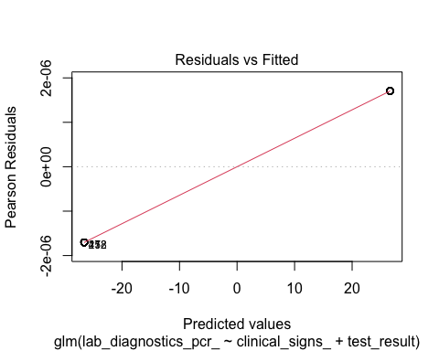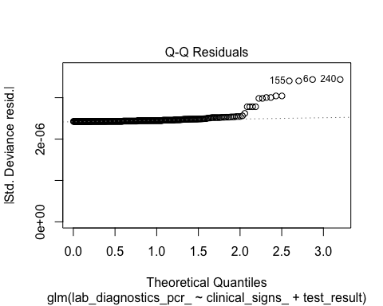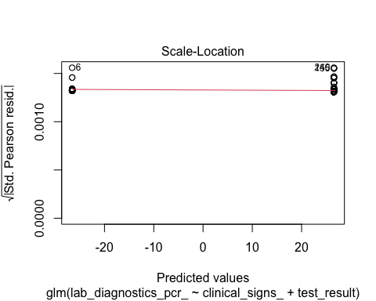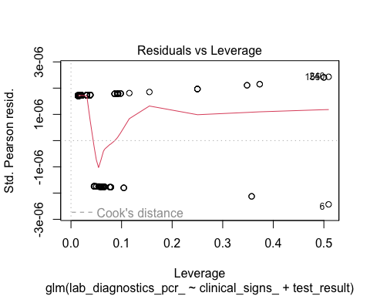
summary(model2)
##
## Call:
## glm(formula = lab_diagnostics_pcr_ ~ clinical_signs_ + test_result,
## family = binomial(link = "logit"), data = test)
##
## Coefficients:
## Estimate Std. Error z value Pr(>|z|)
## (Intercept) 2.657e+01 2.062e+05 0 1
## clinical_signs_aggressive -3.777e-06 1.830e+05 0 1
## clinical_signs_Anorexia -6.964e-07 2.066e+05 0 1
## clinical_signs_biting_objects -4.464e-07 1.842e+05 0 1
## clinical_signs_Diarrhoea -2.076e-06 2.754e+05 0 1
## clinical_signs_excessive_salivation -4.987e-07 1.838e+05 0 1
## clinical_signs_groaning -1.766e-07 3.084e+05 0 1
## clinical_signs_high_libido -5.608e-07 1.911e+05 0 1
## clinical_signs_hydrophobia -3.696e-07 1.889e+05 0 1
## clinical_signs_paralysis -3.947e-07 1.888e+05 0 1
## clinical_signs_protrusion_of_the_tongue -2.076e-06 2.754e+05 0 1
## clinical_signs_Rabid_animal_bite -2.062e-06 3.103e+05 0 1
## clinical_signs_running_aimlessly -4.574e-07 1.854e+05 0 1
## test_resultFalse_Positive -5.313e+01 1.272e+05 0 1
## test_resultTrue_Negative -5.313e+01 1.195e+05 0 1
## test_resultTrue_Positive 3.499e-06 1.040e+05 0 1
##
## (Dispersion parameter for binomial family taken to be 1)
##
## Null deviance: 3.0244e+02 on 364 degrees of freedom
## Residual deviance: 2.1176e-09 on 349 degrees of freedom
## AIC: 32
##
## Number of Fisher Scoring iterations: 25

