INTRODUCTION:
VOLTAGE COMPARATOR:
A voltage comparator is an electronic circuit that compares two input voltages and lets you know which of the two is greater. It’s easy to create a voltage comparator from an op amp, because the polarity of the op-amp’s output circuit depends on the polarity of the difference between the two input voltages.
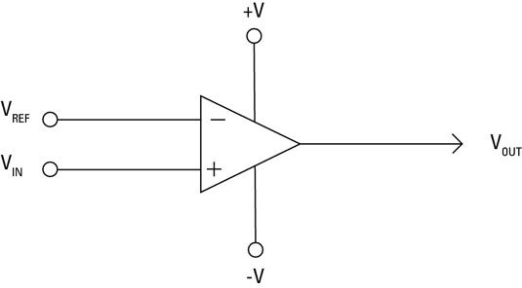

Non inverting comparator:
In non inverting comparator the reference voltage is applied to the inverting input and the voltage to be compared is applied to the non inverting input. Whenever the voltage to be compared (Vin) goes above the reference voltage , the output of the op amp swings to positive saturation (V+) and vice versa. Actually what happens is that, the difference between Vin and Vref, (Vin – Vref) will be a positive value and is amplified to infinity by the op amp. Since there is no feedback resistor Rf, the op amp is in open loop mode and so the voltage gain (Av) will be close to infinity. So the output voltage swings to the maximum possible value ie; V+. Remember the equation Av = 1 + (Rf/R1). When the Vin goes below Vref, the reverse occurs.
Inverting comparator:
In the case of an inverting comparator, the reference voltage is applied to the non inverting input and voltage to be compared is applied to the inverting input. Whenever the input voltage (Vin) goes above the Vref, the output of the opamp swings to negative saturation. Here the difference between two voltages (Vin-Vref) is inverted and amplified to infinity by the opamp. Remember the equation Av = -Rf/R1. The equation for voltage gain in the inverting mode is Av = -Rf/R1.Since there is no feedback resistor, the gain will be close to infinity and the output voltage will be as negative as possible ie; V-.

Practical voltage comparator circuit:
A practical non inverting comparator based on uA741 opamp is shown below. Here the reference voltage is set using the voltage divider network comprising of R1 and R2. The equation is Vref = (V+/ (R1 + R2)) x R2. Substituting the values given in the circuit diagram into this equation gives Vref = 6V. Whenever Vin goes above 6V, the output swings to ~+12V DC and vice versa. The circuit is powered from a +/- 12V DC dual supply.
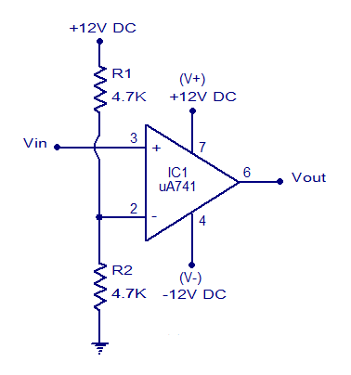
Working:
A dedicated voltage comparator will generally be faster than a general-purpose operational amplifier used as a comparator, and may also contain additional features such as an accurate, internal reference voltage, adjustable hysteresis, and a clock gated input.
A dedicated voltage comparator chip such as LM339 is designed to interface with a digital logic interface (to a TTL or a CMOS). The output is a binary state often used to interface real world signals to digital circuitry (see analog-to-digital converter). If there is a fixed voltage source from, for example, a DC adjustable device in the signal path, a comparator is just the equivalent of a cascade of amplifiers. When the voltages are nearly equal, the output voltage will not fall into one of the logic levels, thus analog signals will enter the digital domain with unpredictable results. To make this range as small as possible, the amplifier cascade is high gain. The circuit consists of mainly Bipolar transistors. For very high frequencies, the input impedance of the stages is low. This reduces the saturation of the slow, large P-N junction bipolar transistors that would otherwise lead to long recovery times. Fast small Schottky diodes, like those found in binary logic designs, improve the performance significantly though the performance still lags that of circuits with amplifiers using analog signals. Slew rate has no meaning for these devices. For applications in flash ADCs the distributed signal across eight ports matches the voltage and current gain after each amplifier, and resistors then behave as level-shifters.
The LM339 accomplishes this with an open collector output. When the inverting input is at a higher voltage than the non inverting input, the output of the comparator connects to the negative power supply. When the non inverting input is higher than the inverting input, the output is 'floating' (has a very high impedance to ground). The gain of op amp as comparator is given by this equation V(out)=V(in).

Multi Sim:
Multisim is industry standard SPICE simulation and circuit design software for analog, digital, and power electronics in education and research.
Multisim integrates industry standard SPICE simulation with an interactive schematic environment to instantly visualize and analyze electronic circuit behavior. Multisim has an intuitive interface that helps educators reinforce circuit theory and improve retention of theory throughout engineering curriculum. Researchers and designers use Multisim to reduce PCB prototype iterations and save development costs by adding powerful circuit simulation and analyses to the design flow.
Designning of Voltage Comparator:
Op-Amp Circuits can be simulated using Multisim. Once you have created a new design and have access to the schematic page, you can click on the “Place Analog” icon located near the upper left corner of the window. Once the component window pops up, select the OPAMP family, then type in and search for “741.” Although there are several types of LM741 available in the Multisim Part Database, we will use the simple 741 model. This is the actual part included in your ECE 2110 parts kit.
The pin definition of the LM741 in Multisim is identical to the pin definition given . Op-Amp Circuits can be constructed by connecting components to the different pins. Figure 4 shows the final Multisim schematic for a Non-Inverting Amplifier with Vin = 200mV and K = 2. Keep in mind that for VCC-, the negative terminal of the power supply goes into pin 4. For VCC+, the positive terminal of the power supply goes into pin 7.
Multisim DC Simulation:
The output of an Op-Amp Circuit using only DC input voltages can be simulated quickly and easily. Once your circuit is complete, click the green arrow to run the simulation. Once the simulation is running, click on the “Measurement Probe” button and place a probe at Vout, or any other location on the circuit where you would like to make a measurement. Initially, the probe will show much more information than is currently necessary. Double-click the probe information to bring up the window. Notice that under the Show column, every property starts with a Yes. Deselect all properties by clicking the red check mark at the top of the Show column, then proceed to select the desired properties. In this case, we will only need the top voltage property V. We can also change the Precision to how six significant figures.
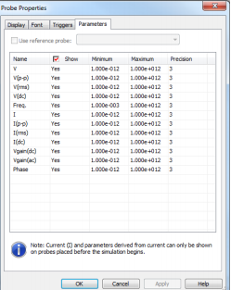
Circuit:
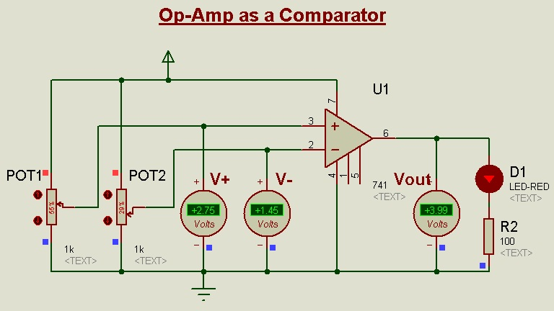
The LF411 op amp is selected from the component library, and you need not concern yourself with the model's internal make-up just yet. This particular model includes the effects of power supply limitations (i.e., output saturation) that the very simple dependent-source model presented earlier does not. Individual DC sources are used for the input signals. Although no AC signals are applied, it is perfectly valid to run a transient-mode simulation. The first millisecond of the output voltage is shown. It verifies the manual calculation, indicating a DC level of slightly more than 13.5 V.

Output Waveform:
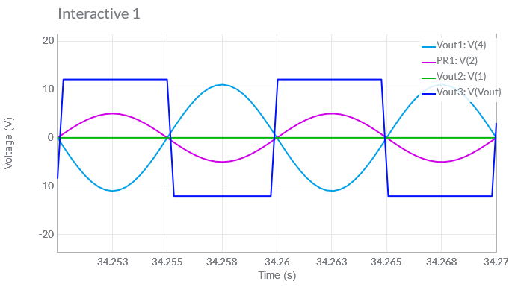
There are a few limitations with our simple op amp comparator. For very fast signal changes, a typical op amp will not be able to accurately track its output. Also, the output signal range is rather wide and is bipolar. It is not at all compatible with normal TTL logic circuits. Extra limiting circuitry is required for proper interfacing.

