1. Create form and style it according to below mentioned image.

Form should be in center with total width of form is: 700px.

Font-family: use google font.

Consider all the styling and colours.

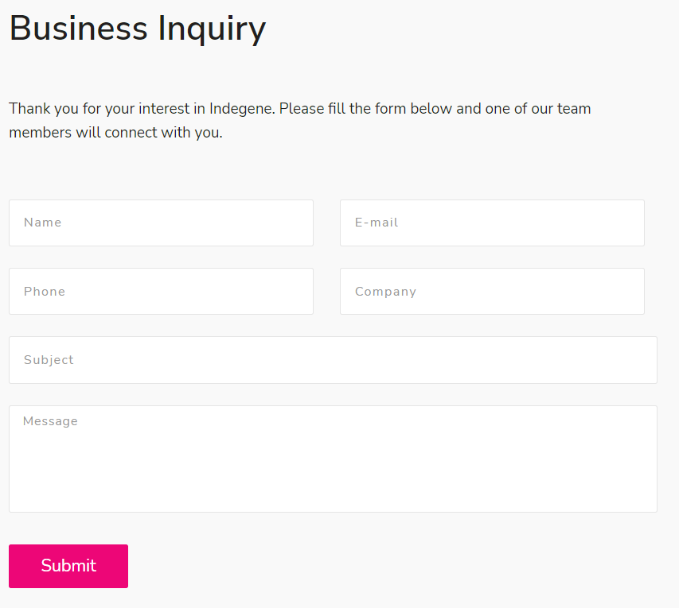

1. Create 4 cards, they should come from all the 4 directions (top center, right center, bottom center, left center) and merged into one in center. (add different color on all cards and after merging 1 color should come).

Size: 120px \* 120px, color go for hexa colors, style cards, style backgrounds of UI and cards.

1. Replicate the below UI.

You can choose styling the way you want. Kindly consider colour palate. For content, add any dummy content.

Add any sample YouTube video and image.

Create a footer like below image. My Account will have link.

