Requirement

Website design

1. Home
2. User login through social media (any like facebook, gmail, insta, twitter etc..) or by mobile number and password.

Following tabs are there in Home Page

भारतीय इतिहास

संविधान

भूगोल

सामान्य विज्ञान -> जनरल साइंस , भौतिक विज्ञान , रसायन विज्ञान

मध्य प्रदेश G.K

समसामयिकी

When user clicks on any if the tab he will be displayed two options

Marathon quiz

Time Quiz

**marathon quiz**

All compiled question and answer series.

User clicks on answer , immediately he will be displayed true answer.

User will get question dashboard in the right corner, where he can see all question numbers

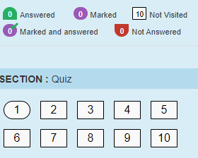

Where user can jump on to any question.

**Time quiz**

Topic wise quiz with time ticker.

It will have some limited number of question with question dashboard with timer for quiz.