**Android Program for Login Page**

|  |
| --- |
|  |

Activity_login.xml

|  |
| --- |
| *<?***xml version="1.0" encoding="utf-8"***?>* <**android.support.constraint.ConstraintLayout xmlns:android="http://schemas.android.com/apk/res/android"  xmlns:app="http://schemas.android.com/apk/res-auto"  xmlns:tools="http://schemas.android.com/tools"  android:layout_width="match_parent"  android:layout_height="match_parent"  tools:context=".Login"**>   <**RelativeLayout  android:layout_width="368dp"  android:layout_height="495dp"  tools:layout_editor_absoluteX="8dp"  tools:layout_editor_absoluteY="8dp"**>   <**EditText  android:id="@+id/username"  android:layout_width="wrap_content"  android:layout_height="wrap_content"  android:layout_alignParentStart="true"  android:layout_alignParentLeft="true"  android:layout_alignParentTop="true"  android:layout_marginStart="78dp"  android:layout_marginLeft="78dp"  android:layout_marginTop="31dp"  android:ems="10"  android:hint="Username"  android:inputType="textPersonName"** />   <**EditText  android:hint="Password"  android:id="@+id/password"  android:layout_width="wrap_content"  android:layout_height="wrap_content"  android:layout_alignParentTop="true"  android:layout_centerHorizontal="true"  android:layout_marginTop="105dp"  android:ems="10"  android:inputType="textPersonName"  android:text="Password"** />   <**Button  android:id="@+id/btn1"  android:layout_width="wrap_content"  android:layout_height="wrap_content"  android:layout_alignParentStart="true"  android:layout_alignParentLeft="true"  android:layout_alignParentTop="true"  android:layout_marginStart="46dp"  android:layout_marginLeft="46dp"  android:layout_marginTop="193dp"  android:text="Login"** />   <**Button  android:id="@+id/btn2"  android:layout_width="wrap_content"  android:layout_height="wrap_content"  android:layout_alignBottom="@+id/btn1"  android:layout_alignParentEnd="true"  android:layout_alignParentRight="true"  android:layout_marginEnd="102dp"  android:layout_marginRight="102dp"  android:text="Cancel"** />  </**RelativeLayout**> </**android.support.constraint.ConstraintLayout**> |

MainActivity.java

|  |
| --- |
| **package** com.example.students.loginapp;  **import** android.support.v7.app.AppCompatActivity; **import** android.os.Bundle; **import** android.view.View; **import** android.widget.Button; **import** android.widget.EditText; **import** android.widget.Toast;  **public class** Login **extends** AppCompatActivity {    EditText **uname**;  EditText **pass**;  String **un**=**""**,**up**=**""**;  @Override  **protected void** onCreate(Bundle savedInstanceState) {  **super**.onCreate(savedInstanceState);  setContentView(R.layout.***activity_login***);    **uname** = (EditText) findViewById(R.id.***username***);  **pass** = (EditText) findViewById(R.id.***password***);  Button b1 = (Button) findViewById(R.id.***btn1***);  Button b2 = (Button) findViewById(R.id.***btn2***);   b1.setOnClickListener(**new** View.OnClickListener() {  @Override  **public void** onClick(View v)  {  **un** = **uname**.getText().toString();  **up** = **pass**.getText().toString();   **if**(**un**.equals(**"abc"**) && **up**.equals(**"123"**))  {  Toast.*makeText*(Login.**this**,**"User and Password is correct"**,  Toast.***LENGTH_SHORT***).show();  }  **else** {  Toast.*makeText*(Login.**this**,**"User and Password is Incorrect"**,  Toast.***LENGTH_SHORT***).show();  }   }  });   b2.setOnClickListener(**new** View.OnClickListener() {  @Override  **public void** onClick(View v)  {  **uname**.setText(**" "**);  **pass**.setText(**" "**);  **uname**.setFocusable(**true**);  }  });    }   } |

Intent Example

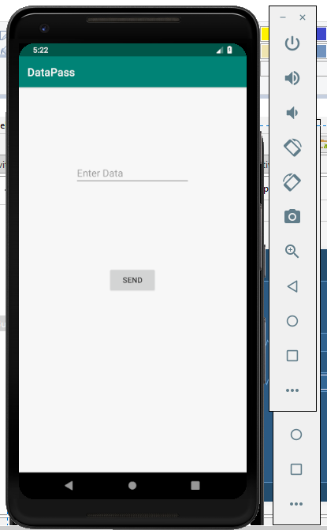

|  |
| --- |
| Activity_main.xml  *<?***xml version="1.0" encoding="utf-8"***?>* <**RelativeLayout xmlns:android="http://schemas.android.com/apk/res/android"  xmlns:app="http://schemas.android.com/apk/res-auto"  xmlns:tools="http://schemas.android.com/tools"  android:layout_width="match_parent"  android:layout_height="match_parent"  tools:context=".MainActivity"**>   <**EditText  android:id="@+id/txt1"  android:layout_width="wrap_content"  android:layout_height="wrap_content"  android:layout_alignParentTop="true"  android:layout_centerHorizontal="true"  android:layout_marginTop="132dp"  android:ems="10"  android:hint="Enter Data"  android:inputType="textPersonName"** />   <**Button  android:id="@+id/btn1"  android:layout_width="wrap_content"  android:layout_height="wrap_content"  android:layout_centerInParent="true"  android:text="Send"** /> </**RelativeLayout**> |

Main_Activity.java

|  |
| --- |
| **package** com.org.datapass.datapass;  **import** android.content.Intent; **import** android.support.v7.app.AppCompatActivity; **import** android.os.Bundle; **import** android.view.View; **import** android.widget.Button; **import** android.widget.EditText;  **public class** MainActivity **extends** AppCompatActivity {   EditText **t1**;  Button **b1**;  @Override  **protected void** onCreate(Bundle savedInstanceState) {  **super**.onCreate(savedInstanceState);  setContentView(R.layout.***activity_main***);  **t1**=(EditText)findViewById(R.id.***txt1***);  **b1**=(Button)findViewById(R.id.***btn1***);  **b1**.setOnClickListener(**new** View.OnClickListener() {  @Override  **public void** onClick(View v) {  String data=**t1**.getText().toString();  Intent intent=**new** Intent(getApplicationContext(),DataRecieve.**class**);  intent.putExtra(**"data"**,data);  startActivity(intent);  }  });  } } |

Activity_data_receive.xml

|  |
| --- |
| *<?***xml version="1.0" encoding="utf-8"***?>* <**RelativeLayout xmlns:android="http://schemas.android.com/apk/res/android"  xmlns:app="http://schemas.android.com/apk/res-auto"  xmlns:tools="http://schemas.android.com/tools"  android:layout_width="match_parent"  android:layout_height="match_parent"  tools:context=".DataRecieve"**>    <**TextView  android:id="@+id/tv1"  android:layout_width="100dp"  android:layout_height="50dp"  android:layout_alignParentStart="true"  android:layout_alignParentLeft="true"  android:layout_alignParentTop="true"  android:layout_alignParentEnd="true"  android:layout_alignParentRight="true"  android:layout_marginStart="152dp"  android:layout_marginLeft="152dp"  android:layout_marginTop="161dp"  android:layout_marginEnd="132dp"  android:layout_marginRight="132dp"** /> </**RelativeLayout**> |

Data_Receive.java

|  |
| --- |
| **package** com.org.datapass.datapass;  **import** android.content.Intent; **import** android.support.v7.app.AppCompatActivity; **import** android.os.Bundle; **import** android.widget.TextView;  **public class** DataRecieve **extends** AppCompatActivity {  TextView **t1**;  @Override  **protected void** onCreate(Bundle savedInstanceState) {  **super**.onCreate(savedInstanceState);  setContentView(R.layout.***activity_data_recieve***);  **t1**=(TextView)findViewById(R.id.***tv1***);  Intent intent=getIntent();  String data=intent.getStringExtra(**"data"**);  **t1**.setText(data);   } } |

Output

|  |  |
| --- | --- |
|  |  |