**Lab 3: Practice of Assistive Technology (AT) tools at Algonquin AT Lab**

Practice 1: Dragon Speech Recognition (Speech Input)

Questions

* Which specific Dragon commands did you use to activate a link and fill a form element?

The command that was used to activate the link was the “tab” command. This command iterates through all the clickable elements on the page and selects them when saying the command “click”, resulting in activating the element. To activate the first link, the command “tab 1 time” was said. To activate the second link, the command “tab 2 times” was said.

The command that was used to fill in the form was “mouse grid”. This command displays a grid over the page with numbers corresponding to each cell. Saying the cell number will focus on that area of the page. When mouse grid displays over the item you want to select, say “click”. To activate and fill in the form element, the command “click edit box” was said.

* Were there any interactive elements that you initially failed to interact with? If so, how did you address the issues with workarounds?

While trying to navigate the website, we had a very difficult time using the “mouse grid” feature. The audio on the machine kept saying “Low audio quality” so using the Dragon software was a challenge. After speaking with Jason and Chris, they mentioned using the keyboard as a means of navigating the site but also mentioned that someone using this software could have a motor/physical disability that would hinder them from using the keyboard only features. A workaround I found effective was to speak the link or button and it would activate. This was a difficult task because of the low audio quality on the machine. I believe it would’ve worked better with an external microphone hooked up.

* Describe the code fixes you implemented in the HTML to improve accessibility.

Some code fixes we implemented are different WAI-ARIA initiatives like aria-level, aria-label and aria-labeledby. We also made the background darker and the text lighter for more accessibility for people with vision disabilities.

* Include the HTML code snippet of the improved code.



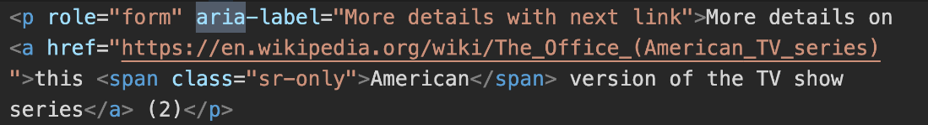



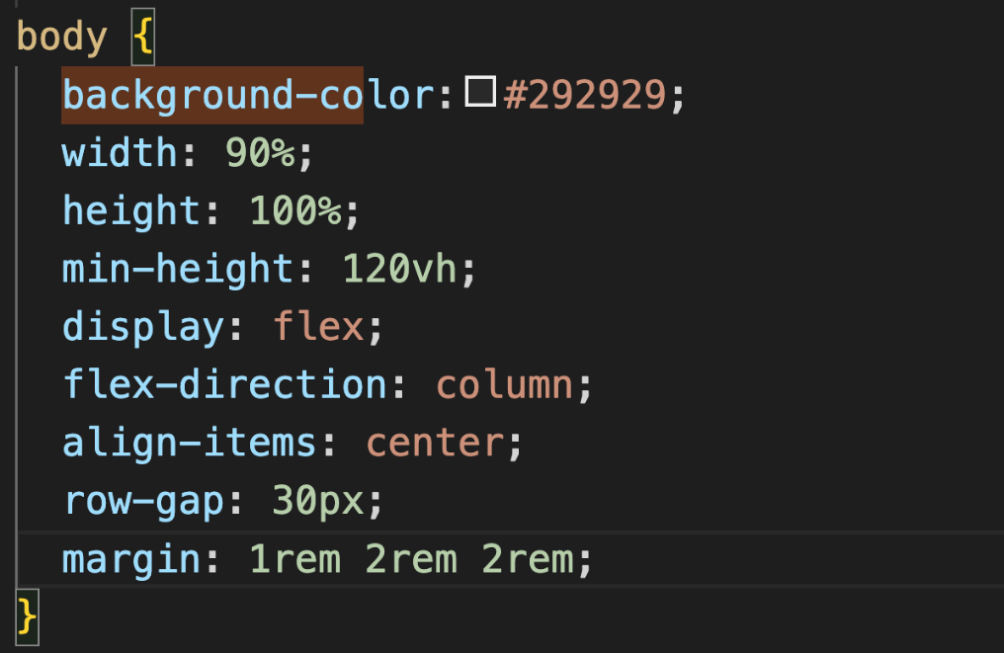

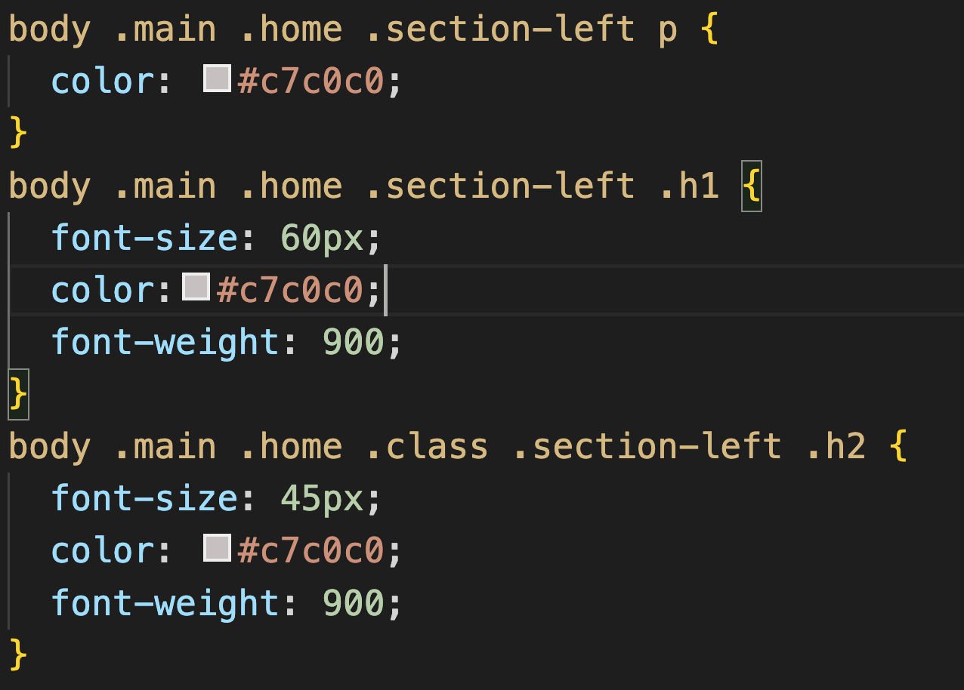

Conclusion

“Dragon Speech Recognition” converts speech into text and allows users to navigate through content using spoken commands. By improving the accessibility of the code, interactive elements get recognized by Dragon to support the needs of users with motor disabilities. Speech input tools are used primarily by users with motor disabilities but used as well by people with other disabilities (i.e., cognitive). “Voice Access” is another speech text AT on Windows.

**Practice 2: ZoomText (Screen magnification)**

Questions

* How much longer did it take you to complete the task using ZoomText?

Starting off with the AT “ZoomText” made the images, and text larger on the screen but it made it harder for our group to navigate the e-flyer. It took us 14 minutes to complete the task using ZoomText.

* Recommend one change on the page that can reduce the time a ZoomText user takes to complete this activity.

Autocomplete Suggestions in the search bar can be a powerful addition to helping people using screen magnifiers because it can help in refining your search terms and finding products more accurately. It can also greatly reduce the search time by promptly suggesting the item a customer is searching for.

Conclusion

ZoomText Magnifier/Reader is a fully integrated magnification and reading program tailored for low-vision users. Users with low vision face several challenges when navigating e-flyers on the web. Addressing these challenges requires creating e-flyers with a focus on accessibility.

Practice 3: Read&Write (Cognitive support tool)

Alex is a bright student who faces challenges with reading, writing, and spelling due to dyslexia. To support Alex's learning needs and address these difficulties, the school has decided to introduce Read&Write, an inclusive literacy software. You will explore the different features of Read&Write that can empower Alex to achieve academic success despite their challenges.

Steps

Questions

* Reflect on one feature in Read&Write that can help a student with dyslexia like Alex:

Our group decided to reflect on the “Highlight” feature. Highlighting text can help Alex (and people like him) to focus on the exact text they want to read, without being distracted by all the other text. This can also help people with attention (ADHD) or coordination (dyspraxia) difficulties.

* How to use it

Highlight text with the mouse, then press the desired colour on the toolbar. It didn’t work immediately, so one of the instructors had to guide me through installing the browser extension required for it to work.

Conclusion

Read&Write is a support tool designed to help the neurodiverse; dyslexia, dyspraxia, ADHD or autism, low literacy, and English as a second language individuals. By embracing assistive technologies like Read&Write, we can foster a more inclusive and supportive learning environment for all students, regardless of their diverse learning needs.