**QUESTION NO 1 :** write the query joining tables orders, orderdetails, products, customers, payments and produce the below output

SELECT orders.orderNumber, products.productName, customers.customerName, payments.amount, payments.checkNumber

FROM orders

INNER JOIN orderdetails

ON orders.orderNumber = orderdetails.orderNumber

INNER JOIN products

ON orderdetails.productCode = products.productCode

INNER JOIN customers

ON orders.customerNumber = customers.customerNumber

INNER JOIN payments

ON payments.customerNumber = customers.customerNumber

WHERE orders.orderNumber=10100;

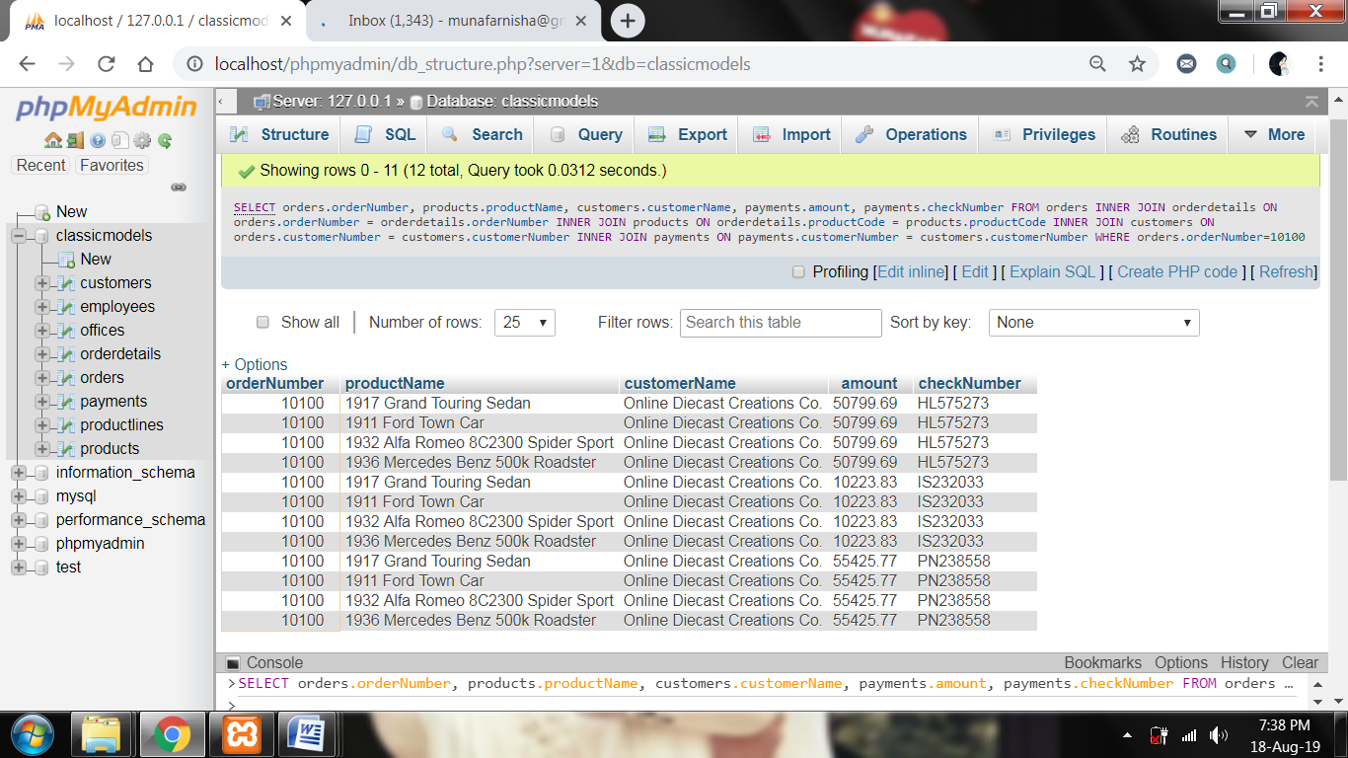

**QUESTION NO 2 :** write the query to find the total paid amount for the order 10100

SELECT o.orderNumber, SUM(pa.amount) as total_paid_amount_for_the_order_10100

FROM orders as o

INNER JOIN orderdetails

ON o.orderNumber=orderdetails.orderNumber

INNER JOIN products as p on orderdetails.productcode=p.productcode

INNER JOIN customers as c on o.customerNumber=c.customernumber

INNER JOIN payments as pa on pa.customerNumber =c.customerNumber

WHERE o.orderNumber=10100;

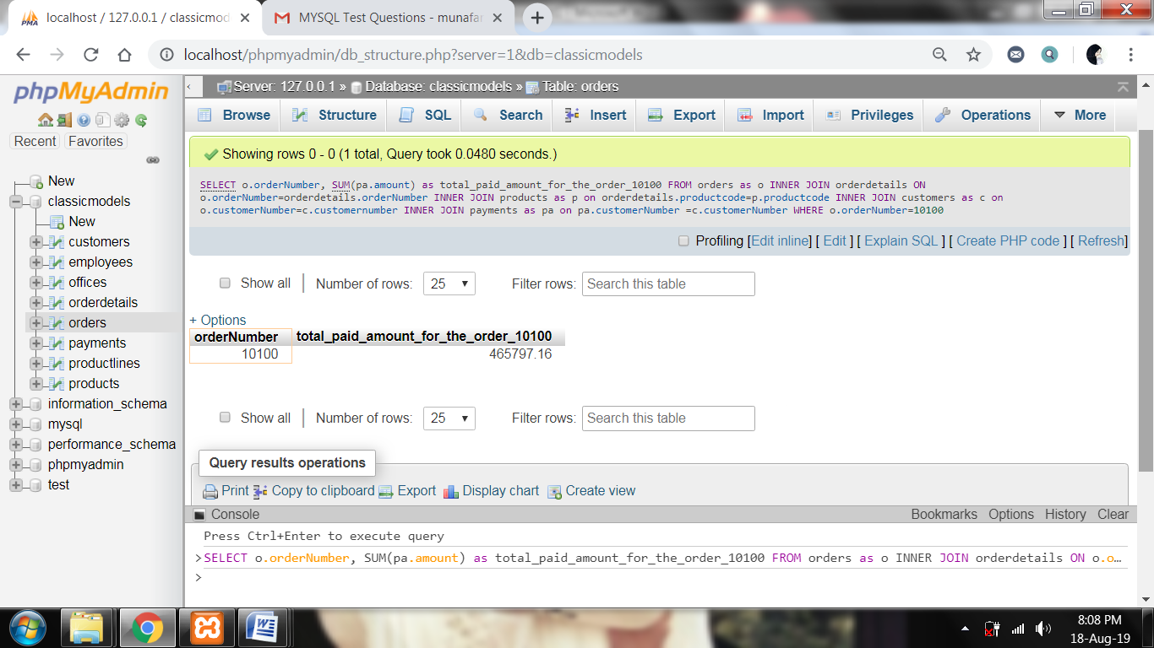

**QUESTION NO 3 :** write the query to find all the check Number using which payment has done for the order 10100

SELECT DISTINCT orders.orderNumber, payments.checkNumber

FROM orders

INNER JOIN orderdetails

ON orders.orderNumber = orderdetails.orderNumber

INNER JOIN products

ON orderdetails.productCode = products.productCode

INNER JOIN customers

ON orders.customerNumber = customers.customerNumber

INNER JOIN payments

ON payments.customerNumber = customers.customerNumber

WHERE orders.orderNumber=10100;

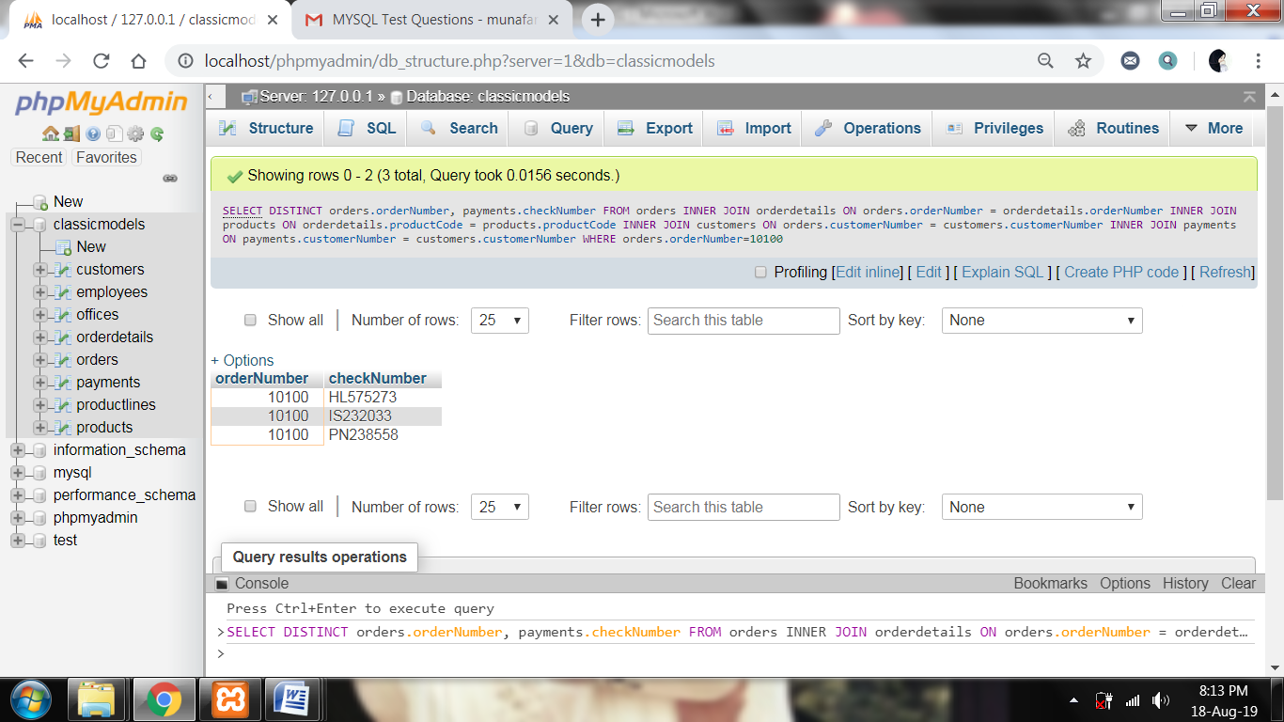

**QUESTION NO 4 :** In the table products write the query to find least value in the column quantity In Stock, and also the maximum value in

SELECT MIN(quantityInStock) AS min_value_in_quantityInStock, MAX(quantityInStock) AS max_value_in_quantityInStock FROM products;

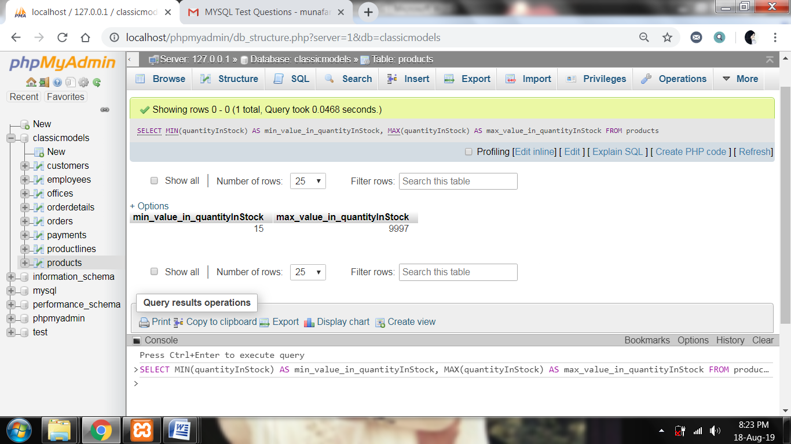

**QUESTION NO 5 :** write the sql to join products, productlines using subquery and reproduce the below output

SELECT products.productCode, products.productLine, productLines.htmlDescription

FROM `products`

INNER JOIN productlines

ON products.productLine = productlines.productLine

WHERE products.productLine = (SELECT productLine FROM productlines WHERE productLine = 'Classic Cars')

AND (productCode='S12_3380'OR productCode = 'S12_3891' OR productCode='S12_3990');

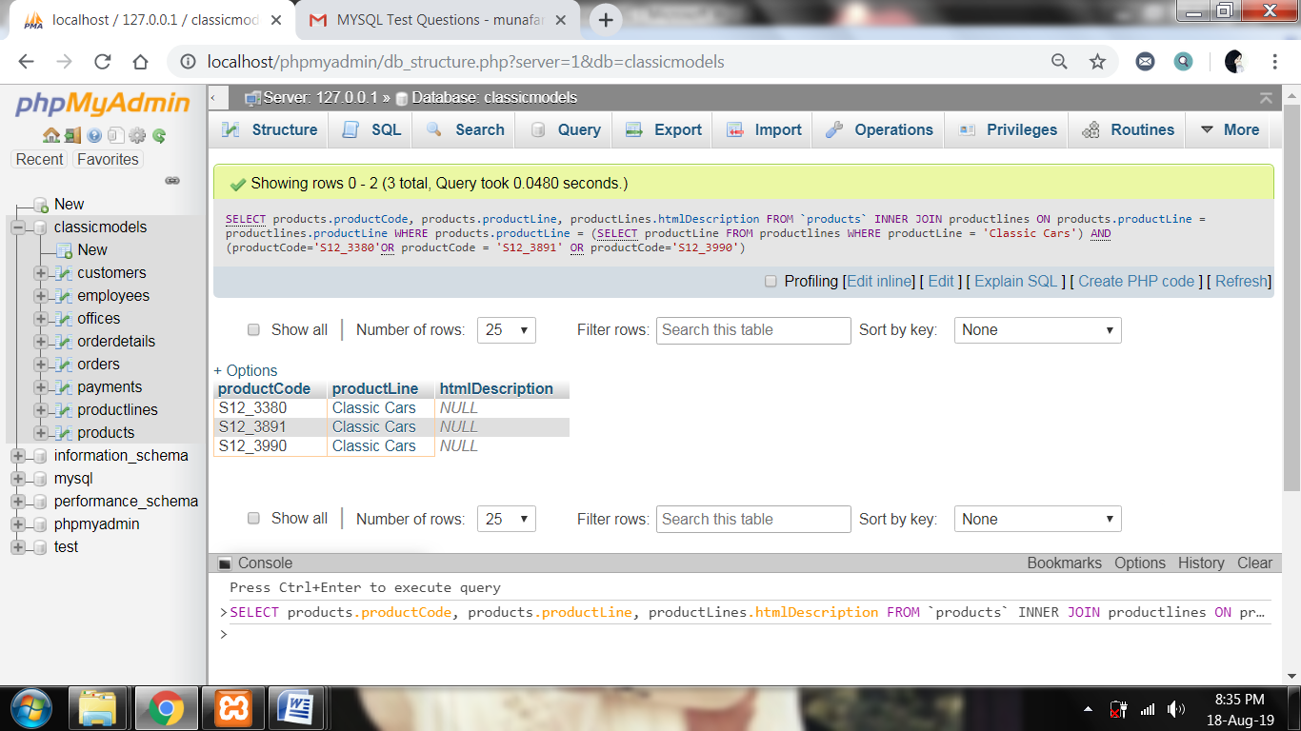

**QUESTION NO 6 :** write the sql to find count of records in productliness where htmlDescription matches NULL ;

1. SELECT COUNT(*) FROM productLines;

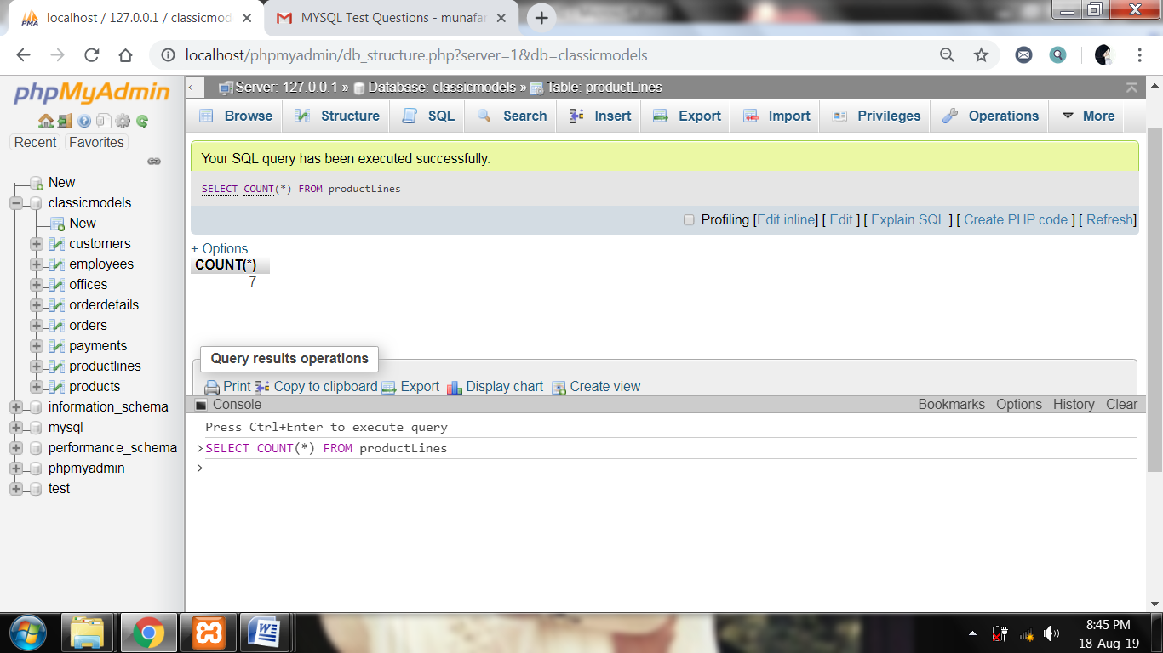

1. SELECT * FROM productLines;

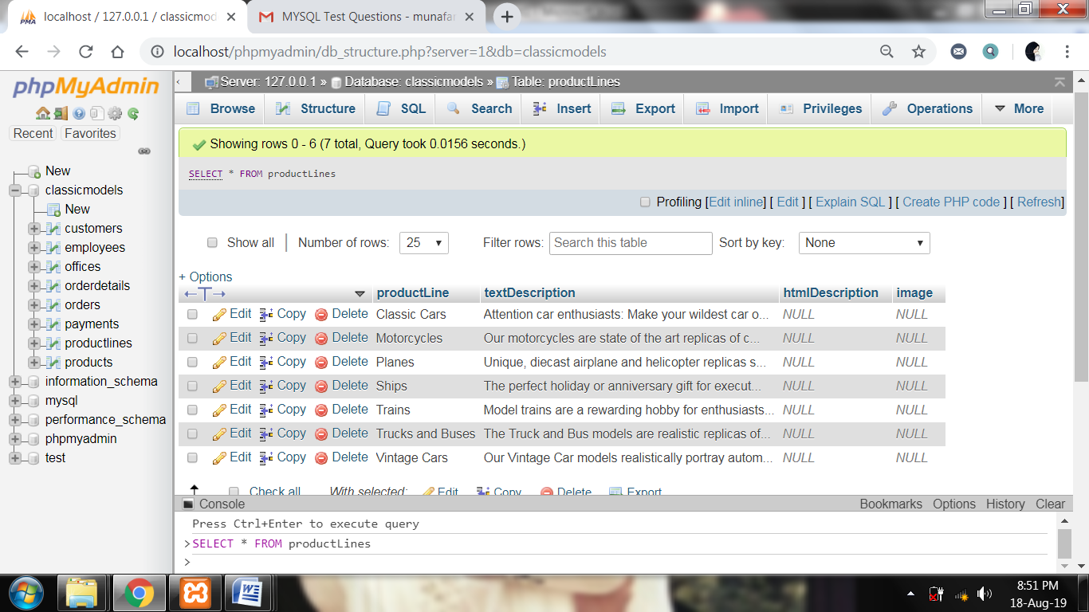

1. SELECT COUNT(*) FROM productLines WHERE htmlDescription=NULL;

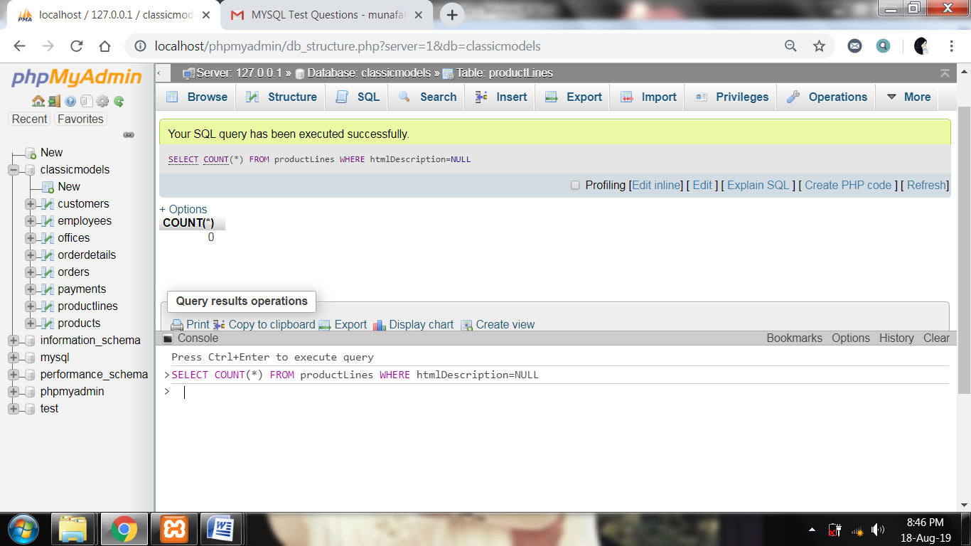

**QUESTION NO 7 :** convert the date '2019-07-18 12:49:24' to the format 18-Jul-Thu

SELECT DATE_FORMAT('2019-07-18 12:49:24' ,'%d %b %a') AS output;

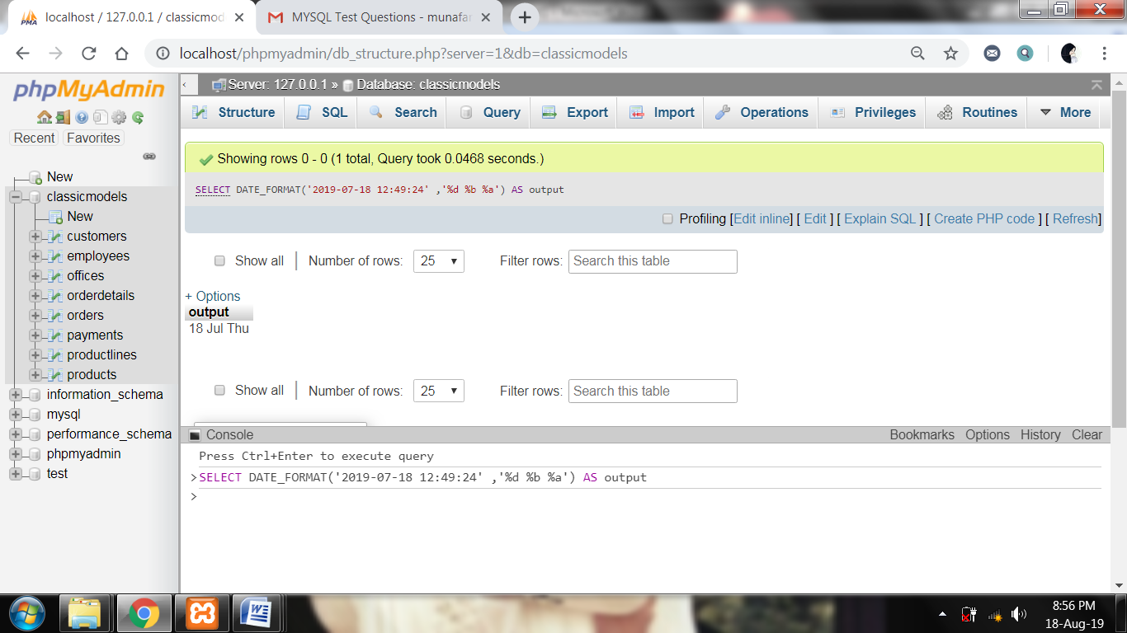

**QUESTION NO 8 :** write a query to find 3rd highest amount in the table payments

SELECT amount FROM payments ORDER BY amount DESC LIMIT 2,1;

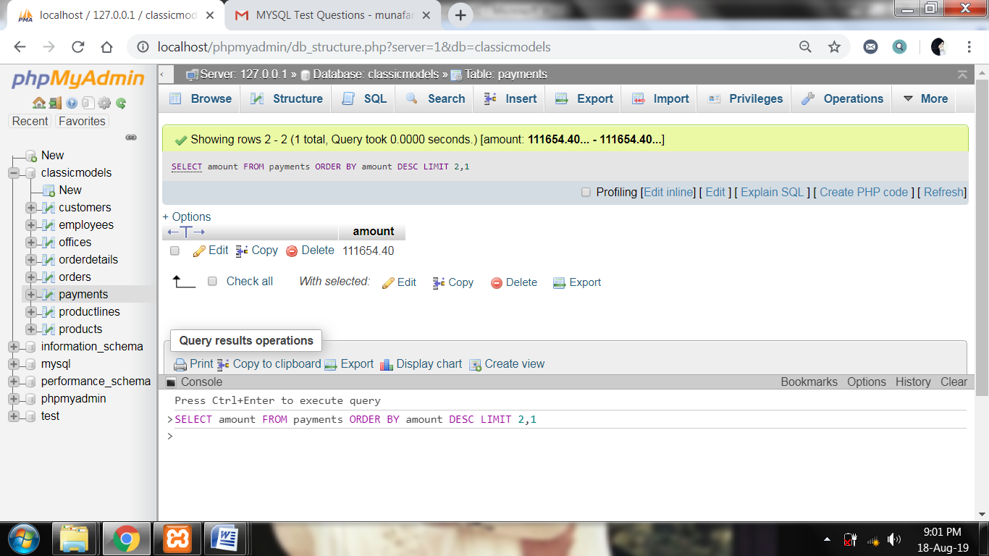

**QUESTION NO 9 :** write a query to find contactFirstName in customers table that starts with 'C' and ends with 'a'

SELECT contactFirstName FROM customers WHERE contactFirstName LIKE 'C%a ';

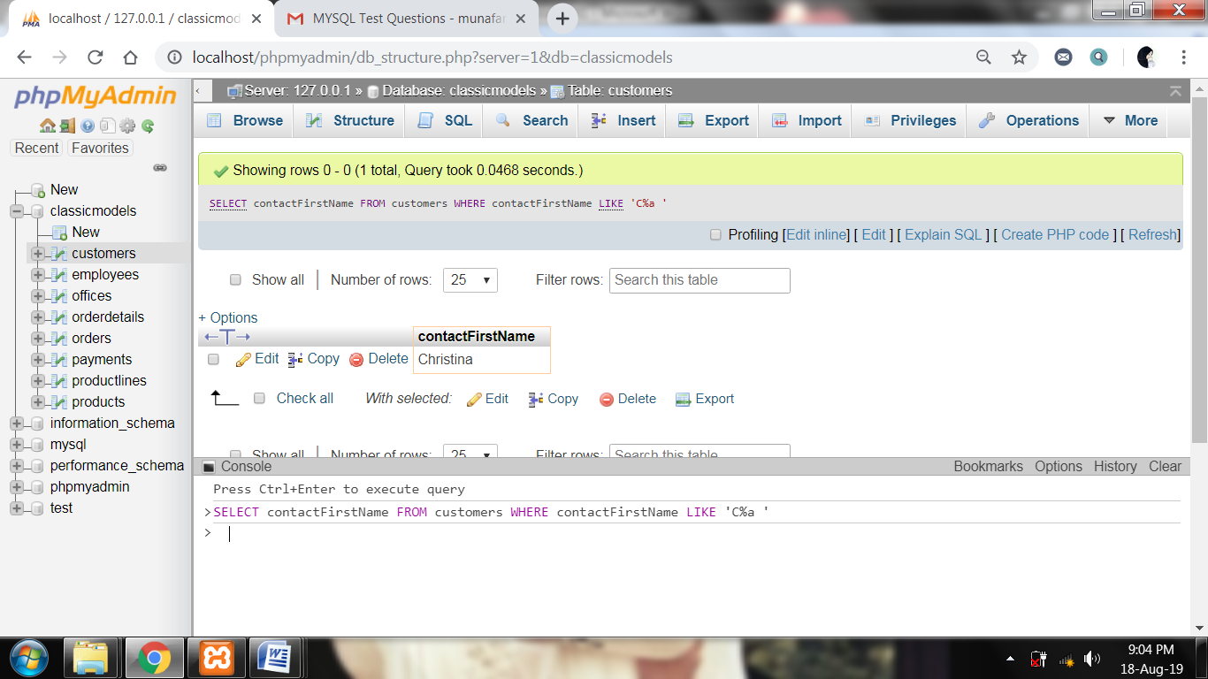

**QUESTION NO 10 :** write a query to find a record in productlines that is not mapped to any record in products

SELECT productLines.productLine, productLines.textDescription, productLines.htmlDescription, productLines.image

FROM `productlines`

INNER JOIN products

ON products.productLine = productlines.productLine

WHERE productLines.productLine <> products.productLine;

