✅ Mini Project: Incident Management System in ServiceNow

**✅ Project Objective**

To design and configure a fully functional **Incident Management System** within the ServiceNow platform. The application tracks incidents throughout their lifecycle, enforces policies using business rules and UI policies, automates workflows, and ensures appropriate handling and closure of incidents.

**🧩 Step 1: Use Global Application Scope**

Since Incident is part of the ServiceNow Global scope:

* No need to create a new scoped app.
* Work directly within the existing **Incident** table and associated modules.

**🗃️ Step 2: Configure Fields & Form Layout**

* **Table Used:** incident

Key Fields Added / Configured:

✅ Added the "Root Cause" field to the form layout.

| **Field Name** | **Type** | **Description** |
| --- | --- | --- |
| Root Cause | Multi Line Text | Explanation of the root cause of issue |
| State | Choice | Follows ITIL lifecycle (New → Closed) |
| Assigned To | Reference | Person assigned to resolve incident |

**📝 Step 3: Implement UI Policies**

**✅ UI Policy 1 – Root Cause Mandatory on Resolved**

* **Table:** Incident
* **Condition:** State is Resolved
* **Action:** Root Cause → Mandatory = ✅

**✅ UI Policy 2 – Assigned To Read-Only on Closed**

* **Table:** Incident
* **Condition:** State is Closed
* **Action:** Assigned To → Read-Only = ✅

**⚙️ Step 4: Implement Business Rules**

**✅ Business Rule – Auto-Update State to "In Progress" When Assigned**

* **Name:** Auto Move to In Progress
* **Table:** Incident
* **When:** Before → Update
* **Script (Advanced):**

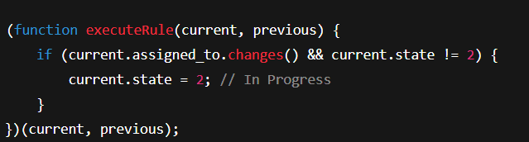**🔁 Step 5: Configure Incident Lifecycle Workflow**

No Flow Designer required since the Incident table already supports standard lifecycle.

Lifecycle stages:

* **New** – Ticket logged
* **In Progress** – Assigned and being worked on
* **On Hold** – Awaiting response
* **Resolved** – Fix applied
* **Closed** – Verified by user
* **Canceled** – No longer required

Custom logic added via Business Rules/UI Policies.

🧪 Step 6: Testing the Flow

| **Test Case** | **Action** | **Expected Result** | **✅** |
| --- | --- | --- | --- |
| Create new Incident | Submit form with short description | State = New | ✅ |
| Assign user | Change Assigned To | State auto changes to In Progress | ✅ |
| State = Resolved | Set state | Root Cause becomes mandatory | ✅ |
| State = Closed | Set state | Assigned To becomes read-only | ✅ |
| Cancel Incident | Change state to Canceled | No required fields prompt | ✅ |