Mini Project : Transform Map Automation in ServiceNow

**Transform Map**

● **Description:**

○ Load bulk data from external sources like Excel to reduce manual

effort.

○ Implement duplication restriction mechanisms to ensure data

integrity.

**✅ Objective:**

Load bulk data from Excel to reduce manual effort and ensure no duplicate records are created during the import.

**🔹 STEP 1: Prepare Your Excel File**

* Create a simple Excel file with sample data.
* Example file name: StudentData.xlsx
* Columns: Name, Email, Phone, Course

Save it locally on your computer.

**🔹 STEP 2: Create a Custom Table in ServiceNow**

1. Go to **System Definition > Tables**
2. Click **New**
3. Fill in:
   * Label: Student Records
   * Table Name: u_student_records
   * Columns:
     + Name (String)
     + Email (String)
     + Phone (String)
     + Course (String)
4. Save the table.

**🔹 STEP 3: Import Excel File Using Import Set**

1. Navigate to **System Import Sets > Load Data**
2. Click **Load Data**
3. Fill in:
   * **Import Set Table**: New Table (e.g., u_import_student_data)
   * **File**: Upload your StudentData.xlsx
4. Click **Submit**
5. Click on the **Loaded Data** link that appears after loading

**🔹 STEP 4: Create a Transform Map**

1. Go to **System Import Sets > Create Transform Map**
2. Fill in:
   * **Name**: Transform Student Data
   * **Source Table**: u_import_student_data
   * **Target Table**: u_student_records
3. Check **Run business rules**
4. Submit

**🔹 STEP 5: Map Fields**

1. In the Transform Map, scroll to the **Field Maps** related list
2. Click **Auto Map Matching Fields**
   * Or manually map:
     + Name → Name
     + Email → Email
     + etc.
3. Save all mappings

**🔹 STEP 6: Add Duplicate Prevention (Key Part!)**

To prevent duplicates:

1. Go to the **Transform Map** you created
2. Click **Advanced** tab → Check **Use Script**
3. Add a **Transform Script** like this:

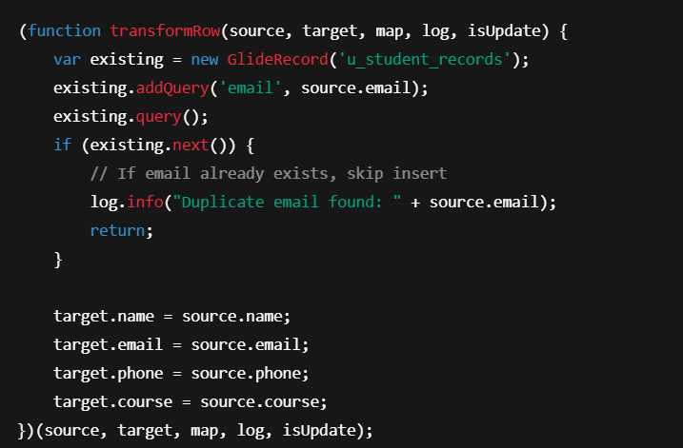

✅ This prevents inserting duplicate entries based on **email**.

**🔹 STEP 7: Run the Transform**

1. Return to the **Import Set Table**
2. Click **Transform**
3. Choose the **Transform Map**
4. Click **Transform**

**✅ BONUS: View Results**

* Go to the **Student Records** table (u_student_records)
* You’ll see only **unique** entries imported from Excel
* Duplicates based on email are skipped

| **Step** | **Task** |
| --- | --- |
| 1 | Create Excel data |
| 2 | Create custom table |
| 3 | Import data as Import Set |
| 4 | Create and configure Transform Map |
| 5 | Auto-map or manually map fields |
| 6 | Write script to restrict duplicates |
| 7 | Run transformation and verify |

**Prepare Your Test Data**

1. **Create an Excel File** with sample data to upload. Here’s a sample:

| **Name** | **Email** | **Phone** | **Course** |
| --- | --- | --- | --- |
| Alice | alice@example.com | 1234567890 | Computer Science |
| Bob | bob@example.com | 2345678901 | Business Admin |
| Charlie | charlie@example.com | 3456789012 | Mechanical Engg |

1. Save the file as **StudentData.xlsx** or **StudentData.csv**.

**Load Data into ServiceNow**

1. **Navigate to Import Sets**:
   * Go to **System Import Sets > Load Data**.
2. **Upload Excel File**:
   * In the **Import Set Table**, select **u_import_student_data**.
   * Choose the **StudentData.xlsx** file you want to upload and click **Submit**.
3. **Verify Loaded Data**:
   * After the data is loaded, go to the **Loaded Data** tab in the **Import Set** and confirm that your data is visible.

**Map Fields in Transform Map**

1. **Verify Field Mapping**:
   * Go to **System Import Sets > Transform Maps**.
   * Open your **Transform Map** (e.g., Transform Student Data).
   * Ensure that the fields are mapped correctly (e.g., Name to Name, Email to Email, etc.).
2. **Check for Duplicate Handling**:
   * Review the **Transform Script** to confirm that duplicates (based on **Email**) will be skipped.

**Run the Transform**

1. **Transform the Data**:
   * Go to **System Import Sets > Loaded Data**.
   * Select the record(s) you want to transform.
   * Click **Transform** to run the transformation.
2. **Verify the Transformation**:
   * Go to the **Target Table** (u_student_records).
   * Ensure that the records are **successfully inserted** and **duplicates** are prevented based on the email.
   * Example: If **Alice’s email** is uploaded twice, only the first entry should be in the **u_student_records** table.

**Test Duplicate Prevention**

1. **Test 1: Upload Duplicate Data**:
   * Modify the Excel file and add another row with an email already present in the previous data (e.g., alice@example.com).
   * Re-upload the modified Excel and run the transform again.
2. **Expected Result**:
   * Alice's second entry should **not be inserted** into the table (due to the duplicate email check in the Transform Script).