**🔧 Mini Project: Student Management Application in ServiceNow**

**✅ Project Objective:**

To build a custom scoped application in ServiceNow that stores student data, with configurable forms and layouts, and use update sets to move the customization from one instance to another.

**🧩 Step 1: Create a New Scoped Application**

1. **Navigate to**: System Applications > Studio
2. Click **"Create Application"**
3. Provide:
   * **Name**: Student Management
   * **Scope**: Automatically generated
   * **Description**: An app to manage and store student records.
   * Click **Create**
4. Enter **Studio** once the app is created.

**🗃️ Step 2: Create a Table to Store Student Data**

1. Inside Studio > **Create Application File**
2. Choose **Data Model > Table**
3. Configure:
   * **Label**: Student
   * **Name**: x_your_scope_student
   * **Create module**: ✅ Yes (makes it visible in the navigator)
4. Add fields:
   * Student ID (String, unique)
   * Full Name (String)
   * Email (Email)
   * Department (Choice or String)
   * Year (Integer or Choice)
   * Phone Number (Phone)
   * Enrollment Date (Date/Time)
5. Save the table.

**📝 Step 3: Configure the Form and List Layout**

1. Go to **Student Table > Open in Platform View**
2. Navigate to:
   * Student > All → Open any record → Right-click header → **Configure > Form Layout**
   * Rearrange the fields as needed.
3. For List View:
   * Configure > List Layout → Add required columns.

🎨 **Step 4: Add a UI Policy or Business Rule**

**✅ Option 1: UI Policy – Make "Phone Number" mandatory if "Year" > 1**

**🧩 Steps:**

1. Go to **System UI > UI Policies**
2. Click **New**
3. Fill in the form:
   * **Table**: Select your student table (e.g., x_your_scope_student)
   * **Short Description**: Make phone number mandatory for Year > 1
   * **Conditions**:
     + **Year** > 1
   * **Active**: ✅ Checked
4. Under the UI Policy, go to the **UI Policy Actions** related list and click **New**:
   * **Field name**: Phone Number
   * **Mandatory**: True
   * **Visible**: (optional – set as needed)
   * **Read Only**: (optional)
5. Click **Submit** and then **Update** your UI Policy.

✅ Now when **Year > 1**, the **Phone Number** field will become mandatory.

**🔁 Option 2: Business Rule – Auto-generate Student ID**

Let’s say you want a Student ID like: STU20250001, STU20250002, etc.

**🧩 Steps:**

1. Go to **System Definition > Business Rules**
2. Click **New**
3. Fill in:
   * **Name**: Auto-generate Student ID
   * **Table**: Your student table
   * **When**: before insert
   * **Advanced**: ✅ Check this
4. In the **Script** tab, use this sample script:

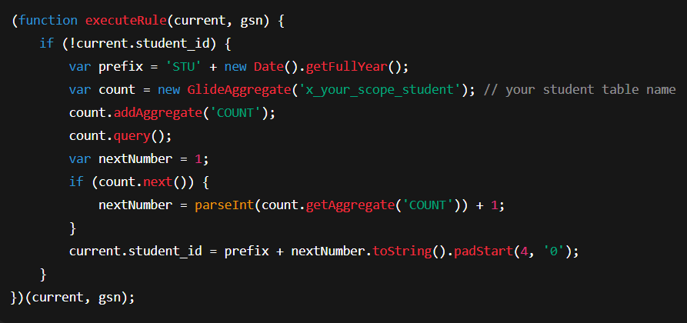

1. Click **Submit**.

✅ Now, each time a new student record is inserted, a unique **Student ID** will be auto-generated.

🚀 **Step 5: Test and Validate**

**👩‍💻 1. Create Test Student Records**

**🔹 Method 1: Using the Form**

1. Navigate to your **Student** table:
   * Go to: **Application Navigator** > type your table name (e.g., Student or x_your_scope_student)
2. Click **New** to create a new record.
3. Fill in sample values:
   * Name: *John Doe*
   * Year: *2*
   * Phone Number: (Leave blank to test UI Policy)
4. Click **Submit** or **Save**.

**📋 2. Test List View**

1. After submitting a few test records, go back to the **Student list view**.
   * Application Navigator → Student → Open the module (or table view)
2. Confirm:
   * Student ID shows properly
   * Phone Numbers display (or not) as expected
   * Sorting and filtering work correctly
3. **🎯 3. Test UI Policy Functionality**
4. Make sure your **UI Policy** works by trying these tests:

| **Year Value** | **Expected Outcome for Phone Number** |
| --- | --- |
| 1 | Phone Number is **optional** |
| 2+ | Phone Number becomes **mandatory** |

1. 👉 Try editing the record with Year = 2 and leaving Phone Number empty — it should **block submission**.

**🛠 4. Test Business Rule (Auto-ID Generation)**

* Add multiple records and check if the **Student ID** is:
  + Generated only if empty
  + Unique and incremented (e.g., STU20250001, STU20250002)

**🔐 5. Validate Field Rules**

* Try removing the Phone Number when editing a student with Year > 1.
* Check if form submission is **blocked** without mandatory data.
* Add logs or use the **Debug Business Rule** module (System Logs > All) to troubleshoot.

**📦 Step 6: Use Update Sets to Move Application**

Update sets allow you to **track changes** (like table creation, forms, etc.) and **move them from dev to test or prod instances.**

**Create and Track Update Set:**

1. Go to: System Update Sets > Local Update Sets
2. Click **New**:
   * Name: Student Management Setup
3. Set it as **Current**
4. Perform your development/configurations
5. Once done:
   * Open the update set → Click **Complete**
   * Then **Export** the update set XML

**Import on Target Instance:**

1. Go to target instance > System Update Sets > Retrieved Update Sets
2. Click **Import Update Set from XML** and upload the file
3. Preview & Commit