

**Software Requirements**

**Specification**

**for**

**Job Fair Management System**

**at FAST University**

**Version 1.0 approved**

**Prepared by <author>**

**<organization>**

**<date created>**

***Copyright © 1999 by Karl E. Wiegers. Permission is granted to use, modify, and distribute this document.***

# Table of Contents

**Table of Contents ii**

**Revision History ii**

1. **Introduction 1**
   1. Purpose 1
   2. Document Conventions 1
   3. Intended Audience and Reading Suggestions 1
   4. Product Scope 1
   5. References 1
2. **Overall Description 2**
   1. Product Perspective 2
   2. Product Functions 2
   3. User Classes and Characteristics 2
   4. Operating Environment 2
   5. Design and Implementation Constraints 2
   6. User Documentation 2
   7. Assumptions and Dependencies 3
3. **External Interface Requirements 3**
   1. User Interfaces 3
   2. Hardware Interfaces 3
   3. Software Interfaces 3
   4. Communications Interfaces 3
4. **System Features 4**
   1. System Feature 1 4
   2. System Feature 2 (and so on) 4
5. **Other Nonfunctional Requirements 4**
   1. Performance Requirements 4
   2. Safety Requirements 5
   3. Security Requirements 5
   4. Software Quality Attributes 5
   5. Business Rules 5
6. **Diagrams 5**
   1. Use Case Diagram 5
   2. Activity Diagram 5
   3. Sequence Diagram 6

**Appendix A: Glossary 6**

**Appendix B: Analysis Models 6**

**Appendix C: To Be Determined List 6**

# Revision History

| **Name** | **Date** | **Reason For Changes** | **Version** |
| --- | --- | --- | --- |
|  |  |  |  |
|  |  |  |  |

# Introduction

## Purpose

*The purpose of this Software Requirements Specification (SRS) document is to outline the functional and nonfunctional requirements for the development of the Job Fair Management System at FAST University. This document specifies the scope of the system, including the features and functionalities to be implemented in order to streamline the organization and management of the university's annual job fair event. It serves as a guide for developers, stakeholders, and project teams involved in the design, implementation, and testing phases of the project.*

## Document Conventions

*This Software Requirements Specification (SRS) document follows standard conventions for clarity and consistency. Requirements are presented in a structured format with clear headings and subheadings for easy navigation. Functional requirements are indicated using imperative language, while non-functional requirements are specified with relevant attributes such as performance, usability, and security. Each requirement statement includes a unique identifier for easy reference and tracking. Additionally, priorities for requirements are assigned based on their importance to the overall system functionality and are indicated where applicable.*

## Intended Audience and Reading Suggestions

*This Software Requirements Specification (SRS) document is intended for various stakeholders involved in the development, implementation, and use of the Job Fair Management System at FAST University. The primary audience includes:*

* ***Developers:*** *Who will be responsible for implementing the system according to the specified requirements.*
* ***Project Managers:*** *Who will oversee the project's progress and ensure that it aligns with the defined requirements and objectives.*
* ***University Management:*** *Who will provide input on system functionalities and overall project direction.*
* ***Students:*** *Who will use the system to register for the job fair, schedule interviews, and access resources.*
* ***Employers:*** *Who will use the system to register for the job fair, view student profiles, and schedule interviews.*

*The SRS contains detailed information about the functional and nonfunctional requirements of the Job Fair Management System. It is organized into sections covering various aspects of the system, including:*

1. ***Introduction:*** *Provides an overview of the document and the purpose of the Job Fair Management System.*
2. ***Scope:*** *Describes the scope of the system, including the features and functionalities to be included.*
3. ***Functional Requirements:*** *Details the specific functions and capabilities of the system.*
4. ***Non-functional Requirements:*** *Outlines the quality attributes and constraints of the system, such as performance, usability, and security.*
5. ***User Stories:*** *Presents a set of user stories that describe the interactions between users and the system.*
6. ***Use Cases:*** *Illustrates the system's behavior in different scenarios through detailed use case descriptions.*
7. ***Glossary:*** *Provides definitions of key terms and concepts used throughout the document.*

*For readers seeking an overview of the document, it is recommended to start with the Introduction and Scope sections. Developers and project managers may find the Functional Requirements and Non-functional Requirements sections most pertinent to their roles, while users and testers may be interested in the User Stories and Use Cases sections for understanding system functionality and behavior.*

## Product Scope

*The Job Fair Management System at FAST University is a comprehensive software solution designed to streamline and enhance the organization and management of the university's annual job fair event. The primary purpose of the system is to facilitate seamless interactions between graduating students and potential employers from the IT industry, ultimately leading to increased job placement opportunities for students.*

*Key objectives and goals of the Job Fair Management System include:*

* ***Efficient Employer Engagement:*** *Providing tools for employers to register for the job fair, manage their participation, and interact with students effectively.*
* ***Streamlined Interviewee Management:*** *Enabling students to schedule interviews with preferred companies and facilitating the allocation of interview slots.*
* ***Centralized Record Keeping:*** *Maintaining a centralized repository of student resumes, interview schedules, and feedback to track student participation and employer engagement.*
* ***Student Preparation Resources:*** *Offering workshops, resume templates, and interview tips to help students prepare for the job fair and improve their employability.*
* ***Structured Feedback Mechanism:*** *Facilitating the collection and analysis of feedback from employers to help students identify areas for improvement and enhance their job-seeking skills.*

*By providing these functionalities, the Job Fair Management System aligns with FAST University's goals of fostering student success, promoting industry-academia collaboration, and enhancing the overall quality of education and employment opportunities for its students.*

## References

*<List any other documents or Web addresses to which this SRS refers. These may include user interface style guides, contracts, standards, system requirements specifications, use case*

*documents, or a vision and scope document. Provide enough information so that the reader could access a copy of each reference, including title, author, version number, date, and source or*

*location.>*

# Overall Description

## Product Perspective

*The Job Fair Management System at FAST University is a new, self-contained software product designed specifically to address the organization and management of the university's annual job fair event. It is not a replacement for any existing systems but rather serves as an independent solution to streamline the job fair process.*

*The system interacts with various stakeholders, including students, employers, and university management, to facilitate the coordination of job fair activities. While the Job Fair Management System is a standalone product, it may interface with other systems within the university's ecosystem, such as student information systems or event management platforms, to exchange relevant data and integrate functionality seamlessly.*

*A diagram illustrating the major components of the overall system, subsystem interconnections, and external interfaces will be included in the diagram portion, the SRS, to provide a visual representation of the product perspective and its relationships with other systems or components.*

## Product Functions

*The Job Fair Management System at FAST University will include the following major functions:*

* *Employer Registration and Management*
* *Student Registration and Profile Management*
* *Interview Scheduling and Management*
* *Resume Submission and Management*
* *Workshop Scheduling and Management*
* *Feedback Submission and Viewing*
* *Analytics Reporting and Data Visualization*
* *Automated Notifications and Reminders*
* *On-Site Support and Assistance*

*These functions will be further detailed in Section 3 of the SRS document to provide a comprehensive understanding of the system's capabilities and user interactions.*

## User Classes and Characteristics

*The Job Fair Management System at FAST University is anticipated to be used by the following user classes:*

1. ***Students:***

* ***Characteristics:*** *Graduating students seeking job opportunities in the IT industry.*
* ***Frequency of Use:*** *High, especially during job fair registration, interview scheduling, and workshop participation.*
* ***Technical Expertise:*** *Varied, ranging from basic computer literacy to advanced usage of online platforms.*
* ***Security/Privilege Levels:*** *Limited access to personal profiles and job fair-related functionalities.*

1. ***Employers:***

* ***Characteristics:*** *Representatives from IT companies participating in the job fair to recruit potential employees.*
* ***Frequency of Use:*** *Moderate, mainly during employer registration, candidate search, and interview scheduling.*
* ***Technical Expertise:*** *Moderate to high, as they need to navigate the system to manage job postings and interview schedules.*
* ***Security/Privilege Levels:*** *Access to employer-specific functionalities such as posting job openings and reviewing candidate profiles.*

1. ***Job Fair Organizers:***

* **Characteristics:** *Staff or faculty members responsible for coordinating and managing the job fair event.*
* ***Frequency of Use:*** *High, especially during event planning, employer engagement, and student coordination.*
* ***Technical Expertise:*** *Moderate to high, as they need to oversee the system's operation and troubleshoot any issues.*
* ***Security/Privilege Levels:*** *Elevated access levels to system administration and event management functionalities.*

*The most important user classes for this product are Students and Job Fair Organizers, as they are the primary users who will heavily interact with the system to participate in and manage the job fair event. Employers are also important users, but their interactions with the system may be less frequent compared to students and organizers.*

## Operating Environment

*The Job Fair Management System at FAST University will operate in the following environment:*

* ***Hardware Platform:*** *The system will be deployed on servers hosted by FAST University's IT infrastructure or on a cloud-based platform. It should be accessible from standard computing devices such as desktops, laptops etc.*
* ***Operating System:*** *The software should be compatible with common operating systems such as Windows, macOS, and Linux. Additionally, it should support mobile operating systems such as iOS and Android for mobile device access.*
* ***Web Browsers:*** *The system will be accessed primarily through web browsers. It should be compatible with popular web browsers such as Google Chrome, Mozilla Firefox, Microsoft Edge, and Safari.*
* ***Database Management System (DBMS):*** *The system will utilize a relational database management system (RDBMS) such as MySQL, PostgreSQL, or Microsoft SQL Server for data storage and retrieval.*
* ***Development Frameworks/Libraries:*** *The system may be developed using web development frameworks and libraries such as Django, Ruby on Rails, AngularJS, React, or Vue.js.*
* ***Network Connectivity:*** *The system should be accessible over a stable internet connection to ensure smooth operation and real-time communication between users and the application servers.*

*Overall, the Job Fair Management System should be designed to operate seamlessly in a diverse computing environment, accommodating various hardware configurations, operating systems, web browsers, and network conditions commonly found within FAST University's IT infrastructure and among its users.*

## Design and Implementation Constraints

*The design and implementation of the Job Fair Management System at FAST University are subject to the following constraints:*

* ***Corporate Policies:*** *The system must comply with FAST University's policies and guidelines regarding data privacy, security, and usage of university resources.*
* ***Regulatory Requirements:*** *The system should adhere to relevant regulatory standards and guidelines, such as data protection regulations and accessibility standards.*
* ***Hardware Limitations:*** *The system should be designed to accommodate potential hardware limitations, such as varying processing capabilities and memory constraints of end-user devices accessing the application.*
* ***Interface Compatibility:*** *The system should integrate smoothly with existing university systems, such as student information systems and authentication systems, to facilitate data exchange and user authentication.*
* ***Technology Stack:*** *The system's development should adhere to predefined technology stacks and frameworks, as determined by FAST University's IT department. This may include specific programming languages, development frameworks, databases, and server environments.*
* ***Security Considerations:*** *The system must implement robust security measures to protect sensitive data, prevent unauthorized access, and mitigate potential security threats such as SQL injection, cross-site scripting (XSS), and session hijacking.*
* ***Design and Programming Standards:*** *The system should follow established design conventions, coding standards, and best practices to ensure maintainability, scalability, and extensibility. The customer's organization may be responsible for maintaining the delivered software, necessitating clear documentation and adherence to organizational coding standards.*
* ***Communications Protocols:*** *The system should support standard communication protocols for data exchange between server and client components, such as HTTP/HTTPS for web-based interactions and TCP/IP for network communication.*

*Adhering to these constraints will ensure that the Job Fair Management System meets the functional requirements while maintaining compatibility with existing systems, ensuring security and compliance, and facilitating future maintenance and scalability.*

## User Documentation

*The following user documentation components will be delivered along with the Job Fair Management System at FAST University:*

* ***User Manual:*** *A comprehensive guide outlining the system's features, functionalities, and usage instructions. It will include step-by-step instructions, screenshots, and examples to help users navigate the system effectively.*
* ***Online Help:*** *Context-sensitive help resources accessible within the system interface to provide on-the-spot assistance to users. It will cover common tasks, troubleshooting tips, and frequently asked questions (FAQs).*
* ***Tutorials:*** *Interactive tutorials or walkthroughs to guide users through key processes and workflows within the system. These tutorials will provide hands-on training and demonstrate best practices for using the system efficiently.*

*The user documentation will be delivered in digital format, accessible online through the Job Fair Management System's interface. It will adhere to industry standards for user documentation, including clear language, organized structure, and user-friendly formatting. Additionally, the documentation will be periodically updated to reflect changes in system functionality, user feedback, and emerging best practices.*

## Assumptions and Dependencies

***Assumptions:***

1. ***Availability of Internet Connectivity:*** *It is assumed that users will have access to stable internet connectivity to interact with the Job Fair Management System. Any disruptions in internet connectivity may affect the usability and functionality of the system.*
2. ***Compliance with Regulatory Requirements:*** *It is assumed that the system will comply with relevant regulatory requirements, including data protection laws and accessibility standards. Failure to comply with these regulations could result in legal implications and affect the project's progress.*
3. ***Timely User Feedback:*** *It is assumed that users will provide timely and constructive feedback during the system's development and testing phases. Feedback from users is crucial for identifying issues, refining features, and ensuring user satisfaction.*

***Dependencies:***

1. ***External APIs:*** *The project depends on the availability and functionality of external APIs for integrating with third-party services such as email delivery, authentication, and mapping services. Any changes or disruptions in these APIs may impact the system's functionality.*
2. ***University Infrastructure:*** *The project relies on FAST University's IT infrastructure for hosting the system, database management, and network connectivity. Any issues or limitations within the university's infrastructure may affect the system's performance and availability.*
3. ***Stakeholder Collaboration:*** *The success of the project depends on active collaboration and communication with stakeholders, including university management, students, and employers. Delays or lack of cooperation from stakeholders may reflect the project's progress and implementation.*
4. ***Availability of Development Resources:*** *The project depends on the availability of skilled developers, designers, and testers to complete the development and testing phases within the specified timeline. Any shortages or constraints in resource availability may affect project timelines and deliverables.*

*Addressing these assumptions and dependencies proactively will help mitigate risks and ensure the successful development and deployment of the Job Fair Management System at FAST University.*

# External Interface Requirements

## User Interfaces

*The Job Fair Management System at FAST University will feature intuitive and user-friendly interfaces to facilitate interactions between users and the software. The following describes the logical characteristics of each interface:*

1. *Employer Interface:*

* ***Dashboard:*** *Provides an overview of employer-specific activities such as job postings, interview schedules, and candidate interactions.*
* ***Job Posting Form:*** *Allows employers to submit job openings with details such as job title, description, requirements, and application deadlines.*
* ***Candidate Search:*** *Enables employers to search and filter student profiles based on criteria such as skills, education, and experience.*
* ***Interview Schedule:*** *Allows employers to view and manage interview schedules with selected candidates.*

1. *Student Interface:*

* ***Dashboard:*** *Displays personalized information including upcoming interviews, workshop schedules, and feedback notifications.*
* ***Profile Management:*** *Enables students to create and update their profiles with educational background, skills, projects, and employment history.*
* ***Job Search:*** *Allows students to search and apply for job openings posted by employers participating in the job fair.*
* ***Interview Scheduling:*** *Allows students to view available interview slots and schedule interviews with preferred employers.*

1. *Job Fair Organizer Interface:*

* ***Admin Dashboard:*** *Provides access to system administration functionalities including user management, event configuration, and analytics reporting.*
* ***Event Management:*** *Allows organizers to configure event details such as date, venue, registration deadlines, and workshop schedules.*
* ***User Management:*** *Enables organizers to manage user accounts, permissions, and access levels within the system.*
* ***Analytics Dashboard:*** *Displays statistical data and visualizations related to employer engagement, student participation, and event outcomes.*

*The user interfaces will adhere to established GUI standards and best practices for consistency and usability. Common elements such as navigation menus, buttons, forms, and error message displays will follow standard conventions to ensure familiarity and ease of use for users. Additionally, detailed design specifications for each interface component will be documented in a separate User Interface Specification document.*

## Hardware Interfaces

*The Job Fair Management System at FAST University interacts with various hardware components to support its functionality. The following describes the logical and physical characteristics of each hardware interface:*

1. ***Supported Device Types:***

* *Desktop Computers: The system is accessible through web browsers on desktop computers running operating systems such as Windows, macOS, and Linux.*
* *Laptops: Users can access the system using laptops with compatible web browsers.*
* *Mobile Devices: The system supports access from smartphones and tablets running mobile operating systems such as iOS and Android.*

1. ***Nature of Data and Control Interactions:***

* *Input Devices: Users interact with the system using input devices such as keyboards, mice, touchpads, and touchscreens to enter data and control system functions.*
* *Output Devices: The system provides feedback and output to users through display screens (monitors, laptop screens, mobile device screens) and audio output devices (speakers, headphones).*

1. ***Communication Protocols:***

* *Internet Protocol (IP): The system communicates with external servers and services over the internet using standard communication protocols such as HTTP and HTTPS.*
* *Transmission Control Protocol (TCP)/Internet Protocol (IP): The system may utilize TCP/IP for network communication between client devices and server components.*
* *Hypertext Transfer Protocol (HTTP)/Secure HTTP (HTTPS): Web-based interactions between users and the system are facilitated using HTTP/HTTPS protocols for data exchange.*

1. ***Data Storage Devices:***

* *Server Storage: The system's data is stored on server storage devices, which may include hard disk drives (HDDs), solid-state drives (SSDs), or cloud-based storage solutions.*
* *Backup Devices: Backup devices such as external hard drives or cloud-based backup services may be used to ensure data integrity and disaster recovery capabilities.*

*The Job Fair Management System's hardware interfaces are designed to accommodate a diverse range of devices and facilitate seamless interactions between users and the software across various platforms and environments. Communication protocols and data exchange mechanisms adhere to industry standards to ensure compatibility and interoperability with different hardware components and systems.*

## Software Interfaces

*The Job Fair Management System at FAST University interacts with various software components to support its functionality. The following describes the connections between this product and other specific software components:*

1. ***Database Management System (DBMS):***

* ***Name:*** *MySQL (version X.X), PostgreSQL (version X.X), or Microsoft SQL Server (version X.X)*
* ***Purpose:*** *The system interacts with the DBMS to store and retrieve data related to user profiles, job postings, interview schedules, feedback submissions, and event configurations.*
* ***Data Items:*** *User profiles, job postings, interview schedules, feedback submissions, event configurations.*
* ***Services Needed:*** *CRUD operations (Create, Read, Update, Delete) for data manipulation, transaction management, and query execution.*
* ***Communication:*** *The system communicates with the DBMS using structured query language (SQL) statements via database connection protocols such as JDBC (Java Database Connectivity) or ODBC (Open Database Connectivity).*

1. ***Operating System:***

* ***Name:*** *Windows, macOS, Linux, iOS, Android*
* ***Purpose:*** *The system is compatible with various operating systems to support access from desktop computers, laptops, tablets, and smartphones.*
* ***Data Items:*** *N/A*
* ***Services Needed:*** *N/A*
* ***Communication:*** *The system runs on top of the underlying operating system, utilizing its resources and capabilities for execution and user interaction.*

1. ***Web Browser:***

* ***Name:*** *Google Chrome, Mozilla Firefox, Microsoft Edge, Safari*
* ***Purpose:*** *Users interact with the system through web browsers to access web-based interfaces and functionalities.*
* ***Data Items:*** *HTML, CSS, JavaScript files for rendering user interfaces and processing user inputs.*
* ***Services Needed:*** *Rendering web pages, executing JavaScript code, handling HTTP requests and responses.*
* ***Communication:*** *The system communicates with web browsers using HTTP/HTTPS protocols for data exchange and rendering of user interfaces.*

1. ***Third-Party APIs:***

* ***Name:*** *Google Maps API, SendGrid API, OAuth 2.0 for authentication*
* ***Purpose:*** *The system may integrate with third-party APIs to provide additional functionalities such as mapping services, email delivery, and user authentication.*
* ***Data Items:*** *API requests and responses, authentication tokens, configuration parameters.*
* ***Services Needed:*** *Accessing third-party services, handling API requests, processing responses.*
* ***Communication:*** *The system communicates with third-party APIs using HTTP-based request-response mechanisms, adhering to API-specific protocols and authentication mechanisms.*

*Data sharing across software components is facilitated through structured data formats such as JSON (JavaScript Object Notation) or XML (eXtensible Markup Language). Implementation constraints may include data consistency requirements, concurrency control mechanisms, and security measures to ensure data integrity and confidentiality across software components. Detailed application programming interface (API) protocols and documentation will be referenced for integrating with external software components and services.*

## Communications Interfaces

*The Job Fair Management System at FAST University requires various communications functions to facilitate interactions between users and the system. The following describes the requirements associated with communications functions:*

1. ***Email Communication:***

* ***Purpose:*** *The system sends email notifications to users for activities such as interview scheduling, workshop reminders, feedback submissions, and system updates.*
* ***Message Formatting:*** *Email messages will be formatted using HTML or plain text, including relevant information such as event details, interview schedules, and feedback links.*
* ***Communication Standards:*** *Email communication will utilize SMTP (Simple Mail Transfer Protocol) for sending outgoing emails and IMAP (Internet Message Access Protocol) or POP3 (Post Office Protocol version 3) for receiving incoming emails.*
* ***Communication Security:*** *Emails may be transmitted over secure channels using TLS (Transport Layer Security) or SSL (Secure Sockets Layer) encryption protocols to ensure confidentiality and integrity of email content.*

1. ***Web Browser Communication:***

* ***Purpose:*** *Users interact with the system through web browsers to access web-based interfaces and functionalities.*
* ***Message Formatting:*** *Web pages will be rendered using HTML, CSS, and JavaScript for displaying user interfaces and processing user inputs.*
* ***Communication Standards:*** *Web browser communication will utilize HTTP (Hypertext Transfer Protocol) or HTTPS (HTTP Secure) for exchanging data between client devices and the system's web servers.*
* ***Communication Security:*** *Web browser communication over HTTPS ensures encrypted data transmission and secure interactions between users and the system.*

1. ***Network Server Communication Protocols:***

* ***Purpose:*** *The system communicates with external servers and services over the network for tasks such as data synchronization, API integration, and third-party service interactions.*
* ***Message Formatting:*** *Data exchange between the system and external servers/services will follow standard data formats such as JSON (JavaScript Object Notation) or XML (eXtensible Markup Language).*
* ***Communication Standards:*** *Network server communication will utilize standard protocols such as HTTP, HTTPS, FTP (File Transfer Protocol), or WebSocket for data transmission and interaction with external systems.*
* ***Communication Security:*** *Secure communication protocols such as HTTPS or TLS may be employed to ensure encrypted data transmission and protect against unauthorized access or data interception.*

1. ***Data Transfer Rates and Synchronization Mechanisms:***

* ***Data Transfer Rates:*** *The system should support efficient data transfer rates to minimize latency and ensure timely communication between users and the system's servers.*
* ***Synchronization Mechanisms:*** *For real-time interactions and data synchronization, the system may implement push notification mechanisms or polling intervals to update user interfaces and data in near real-time.*

*Addressing these communication interface requirements will ensure seamless and secure interactions between users and the Job Fair Management System, enhancing user experience and system reliability.*

# System Features

*use case, mode of operation, user class, object class, functional hierarchy, or combinations of these, whatever makes the most logical sense for your product.>*

## Employer Registration

### **4.1.1** **Description and Priority:** Allows employers to register their company for participation in

### the job fair. High priority.

### **4.1.2 Stimulus/Response Sequences:**

### User navigates to the registration page.

### User fills out the registration form with company details.

### System validates the information and creates a new employer account.

### System sends a confirmation email to the registered email address.

### **4.1.3 Functional Requirements:**

### **REQ-1:** Provide a registration form with fields for company name, contact person, email, phone number, and password.

### **REQ-2:** Validate email format and ensure uniqueness of email address.

### **REQ-3:** Verify phone number format and validate against duplicate entries.

### **REQ-4:** Generate a unique identifier for the company as a registration confirmation.

### **REQ-5:** Send a confirmation email to the registered email address with a link to activate the account.

### **REQ-6:** Display appropriate error messages for invalid inputs or duplicate registrations.

### 

## Job Posting:

**4.2.1 Description and Priority:** Allows employers to post job openings for the job fair attendees. High priority.

**4.2.2 Stimulus/Response Sequences:**

* Employer logs in to their account.
* Employer navigates to the job posting section.
* Employer fills out the job posting form with job details.
* System validates the information and publishes the job posting.
* System notifies registered students about the new job posting.

**4.2.3 Functional Requirements:**

* **REQ-1:** Provide a job posting form with fields for job title, description, requirements, application deadline, and contact details.
* **REQ-2:** Validate job posting details to ensure completeness and accuracy.
* **REQ-3:** Allow employers to preview the job posting before final submission.
* **REQ-4:** Publish the job posting to the job board upon successful submission.
* **REQ-5:** Notify registered students about new job postings via email or system notification.
* **REQ-6:** Enable employers to edit or remove job postings as needed.
  1. **Candidate Registration:**

**4.3.1 Description and Priority:** Allows students to register for participation in the job fair. High priority.

**4.3.2 Stimulus/Response Sequences:**

* Students access the registration page.
* Students fill out the registration form with personal details.
* System validates the information and creates a new student account.
* System sends a confirmation email to the registered email address.

**4.3.3 Functional Requirements:**

* **REQ-1:** Provide a registration form with fields for student name, email, university ID, major, and graduation year.
* **REQ-2:** Validate email format and ensure uniqueness of email address.
* **REQ-3:** Verify university ID format and validate against duplicate entries.
* **REQ-4:** Generate a unique identifier for the student as a registration confirmation.
* **REQ-5:** Send a confirmation email to the registered email address with a link to activate the account.
* **REQ-6:** Display appropriate error messages for invalid inputs or duplicate registrations.
  1. **Resume Submission:**

**4.4.1 Description and Priority:** Allows students to submit their resumes for potential employers to review. High priority.

**4.4.2 Stimulus/Response Sequences:**

* Students log in to their account.
* Students navigate to the resume submission section.
* Students upload their resume file.
* System validates the file format and saves the resume to the student's profile.
* System notifies employers about new resume submissions.

**4.4.3 Functional Requirements:**

* **REQ-1:** Provide a resume submission form with a file upload option.
* **REQ-2:** Validate the file format to ensure compatibility (e.g., PDF, DOCX).
* **REQ-3:** Save the uploaded resume file to the student's profile.
* **REQ-4:** Notify employers about new resume submissions via email or system notification.
  1. **Interview Scheduling:**

**4.5.1 Description and Priority:** Allows employers and students to schedule interviews during the job fair. High priority.

**4.5.2Stimulus/Response Sequences:**

* Employer selects candidates for interviews.
* Employer proposes interview slots.
* Students receive interview invitations and select available slots.
* System confirms interview schedules and notifies both parties.

**4.5.3 Functional Requirements:**

* **REQ-1:** Provide employers with an interface to propose interview slots for selected candidates.
* **REQ-2:** Notify students about interview invitations and allow them to accept or propose alternative slots.
* **REQ-3:** Confirm interview schedules and notify both parties about the finalized schedule.
  1. **Workshop Scheduling:**

**4.6.1 Description and Priority:** Enables the scheduling and management of workshops to prepare students for the job fair. Medium priority.

**4.6.2 Stimulus/Response Sequences:**

Admin or organizers create workshop sessions with topics, dates, and times.

Students register for workshops of interest.

System confirms workshop registrations and sends reminders before the scheduled sessions.

**4.6.3 Functional Requirements:**

* **REQ-1:** Provide an interface for admins to create workshop sessions with details such as title, description, date, time, and location.
* **REQ-2:** Allow students to browse available workshops and register for sessions of interest.
* **REQ-3:** Confirm workshop registrations and send email reminders to registered students before the scheduled sessions.
* **REQ-4:** Generate attendance reports for workshop organizers.
  1. **Feedback Submission:**

**4.7.1 Description and Priority:** Facilitates the submission of feedback from both employers and students about their experience at the job fair. Medium priority.

**4.7.2 Stimulus/Response Sequences:**

* After the job fair, participants (employers and students) access the feedback submission section.
* Participants provide feedback on various aspects such as organization, facilities, quality of candidates, and overall experience.
* System collects and aggregates feedback for analysis and improvement purposes.

**4.7.3 Functional Requirements:**

* **REQ-1:** Provide a feedback submission form with fields for rating different aspects of the job fair experience.
* **REQ-2:** Allow participants to provide comments and suggestions for improvement.
* **REQ-3:** Collect and store feedback data securely for analysis.
* **REQ-4:** Generate reports and analytics based on feedback data to identify strengths and areas for improvement.

# Other Nonfunctional Requirements

## Performance Requirements

*The Job Fair Management System at FAST University must meet the following performance requirements to ensure efficient operation and responsiveness under various circumstances:*

1. ***System Response Time:***

* *The system should respond to user actions (e.g., page navigation, form submission) within 2 seconds under normal load conditions.*
* *Rationale: Quick response times enhance user experience and productivity, reducing frustration and improving engagement.*

1. ***Concurrent User Handling:***

* *The system should support concurrent access by at least 1000 users during peak usage periods (e.g., registration deadlines, event days).*
* *Rationale: The job fair may experience high traffic volumes, especially during critical stages, requiring the system to handle multiple user interactions simultaneously without degradation in performance.*

1. ***Job Posting Latency:***

* *Job postings should be processed and displayed on the job board within 5 seconds of submission by employers.*
* *Rationale: Employers expect timely posting of job openings to attract potential candidates, and delays in posting may impact recruitment efforts.*

1. ***Interview Scheduling Efficiency:***

* *The system should process interview scheduling requests and confirmations instantly, with scheduling conflicts resolved within 1 minute.*
* *Rationale: Efficient interview scheduling is crucial for both employers and students to manage their time effectively during the job fair, maximizing opportunities for meaningful interactions.*

1. ***Workshop Registration Responsiveness:***

* *Workshop registration requests should be processed immediately upon submission, with confirmation emails sent within 30 seconds.*
* *Rationale: Students need prompt confirmation of workshop registrations to plan their schedules and ensure attendance at valuable preparatory sessions.*

1. ***Feedback Submission Processing:***

* *Feedback submissions should be processed and stored securely within 5 seconds of submission by participants.*
* *Rationale: Timely processing of feedback allows organizers to promptly assess the success of the job fair and identify areas for improvement for future events.*
* *These performance requirements aim to optimize the efficiency, reliability, and usability of the Job Fair Management System, ensuring a seamless experience for both organizers and participants throughout the event lifecycle.*

## Safety Requirement

*The Job Fair Management System at FAST University must adhere to the following safety requirements to mitigate potential risks and ensure the well-being of users:*

1. ***Data Security and Privacy:***

* *The system must employ robust encryption protocols (e.g., SSL/TLS) to protect sensitive user data, including personal information, resumes, and feedback submissions, during transmission over the network.*
* *Safeguards must be implemented to prevent unauthorized access, modification, or disclosure of user data by unauthorized parties.*
* *Compliance with relevant data protection regulations such as GDPR (General Data Protection Regulation) and local privacy laws is mandatory.*

1. ***System Reliability:***

* *The system must undergo rigorous testing to identify and mitigate software bugs, vulnerabilities, and potential system failures that could compromise the integrity and availability of services.*
* *Regular system backups and disaster recovery plans should be in place to ensure data integrity and minimize downtime in the event of system failures or cyber attacks.*

1. ***User Authentication and Access Control:***

* *Strong authentication mechanisms, such as password hashing and multi-factor authentication, must be implemented to verify the identity of users and prevent unauthorized access to system functionalities.*
* *Role-based access control (RBAC) should be enforced to limit user privileges based on their roles and responsibilities within the system.*

1. ***Error Handling and Reporting:***

* *The system should provide clear error messages and notifications to users in case of unexpected errors or system malfunctions, guiding them on appropriate actions to resolve issues.*
* *Critical errors and security incidents must be logged and reported to system administrators or designated personnel for timely investigation and remediation.*

1. ***Compliance with Regulatory Requirements:***

* *The system must comply with relevant industry standards, regulations, and legal requirements related to job fair management, data protection, and online services.*
* *Compliance certifications, if applicable (e.g., ISO 27001 for information security management), should be obtained to demonstrate adherence to industry best practices and standards.*

*By adhering to these safety requirements, the Job Fair Management System aims to ensure the security, reliability, and compliance of its operations, safeguarding the interests and privacy of all stakeholders involved.*

## Security Requirements

*To ensure the security and privacy of users and data within the Job Fair Management System at FAST University, the following security requirements must be met:*

1. ***User Authentication:***

* *The system must implement secure user authentication mechanisms, such as password-based authentication, multi-factor authentication (MFA), or biometric authentication, to verify the identity of users before granting access to system functionalities.*
* *Password policies should enforce strong password complexity requirements (e.g., minimum length, combination of alphanumeric characters and symbols) and periodic password changes to mitigate the risk of unauthorized access due to compromised credentials.*
* *User sessions should be securely managed using techniques like session tokens or JWT (JSON Web Tokens) to prevent session hijacking or unauthorized access to user accounts.*

1. ***Data Encryption:***

* *All sensitive data stored within the system, including user credentials, personal information, resumes, and feedback submissions, must be encrypted using industry-standard encryption algorithms (e.g., AES) to protect data confidentiality.*
* *Data transmission over the network should be encrypted using secure communication protocols like SSL/TLS to prevent eavesdropping or data interception by unauthorized entities.*

1. ***Access Control:***

* *Role-based access control (RBAC) should be enforced to restrict access to system resources and functionalities based on users' roles and privileges.*
* *Access permissions should be granularly defined to ensure that users can only access the data and features relevant to their roles and responsibilities within the system.*
* *Administrative accounts with elevated privileges should be carefully managed, and access should be restricted to authorized personnel only.*

1. ***Security Monitoring and Logging:***

* *The system must implement robust logging mechanisms to record and monitor user activities, system events, and security-related incidents for audit and forensic purposes.*
* *Security logs should capture critical security events, such as login attempts, access control changes, and suspicious activities, and should be regularly reviewed by system administrators or security personnel.*

1. ***Compliance with Regulatory Standards:***

* *The system must comply with relevant security and privacy regulations, such as GDPR, HIPAA (Health Insurance Portability and Accountability Act), and local data protection laws.*
* *Obtaining security certifications, such as SOC 2 (Service Organization Control 2) or ISO 27001 (Information Security Management System), may be necessary to demonstrate compliance with industry best practices and standards.*

*By adhering to these security requirements, the Job Fair Management System aims to safeguard sensitive information, prevent unauthorized access, and ensure the confidentiality, integrity, and availability of its services and data.*

## Software Quality Attributes

*The Job Fair Management System at FAST University must exhibit the following software quality attributes to meet the expectations of both customers and developers:*

1. ***Usability:***

* *The system should have an intuitive and user-friendly interface, allowing users to navigate and perform tasks efficiently without extensive training.*
* *Usability testing should be conducted with representative users to ensure that the system meets usability standards and addresses user needs and preferences.*

1. ***Reliability:***

* *The system should be reliable and available for use during critical periods, such as registration deadlines and event days, with minimal downtime.*
* *Reliability metrics, such as mean time between failures (MTBF) and mean time to repair (MTTR), should be defined and measured to assess system reliability.*

1. ***Maintainability:***

* *The system should be designed and implemented in a modular and maintainable manner, allowing for easy troubleshooting, bug fixes, and updates.*
* *Code maintainability metrics, such as cyclomatic complexity and code churn, should be monitored to ensure that the system remains maintainable over time.*

1. ***Scalability:***

* *The system should be able to accommodate increasing numbers of users, job postings, and workshop registrations without degradation in performance or functionality.*
* *Scalability testing should be conducted to evaluate the system's ability to handle growing loads and to identify potential scalability bottlenecks.*

1. ***Security:***

* *The system should adhere to industry-standard security practices and protocols to protect user data, prevent unauthorized access, and mitigate security risks.*
* *Security testing, including penetration testing and vulnerability assessments, should be performed regularly to identify and address security vulnerabilities.*

1. ***Testability:***

* *The system should be designed with testability in mind, allowing for comprehensive testing of individual components, modules, and system functionalities.*
* *Testability metrics, such as code coverage and defect detection rate, should be measured to assess the effectiveness of testing efforts and the overall quality of the system.*

1. ***Interoperability:***

* *The system should be interoperable with other relevant systems and technologies used in the university environment, such as student information systems and email services.*
* *Interoperability testing should be conducted to verify seamless integration and communication between different systems and components.*

*By prioritizing these software quality attributes, the Job Fair Management System aims to deliver a reliable, user-friendly, and secure platform that meets the needs and expectations of its stakeholders while ensuring ease of maintenance and future scalability.*

## Business Rules

*The Job Fair Management System at FAST University must adhere to the following business rules governing the operation and use of the system:*

1. ***Employer Registration:***

* *Only authorized representatives of IT companies registered with FAST University are allowed to create employer accounts and post job openings on the platform.*
* *Each employer account must be verified and approved by system administrators before job postings can be published on the job board.*

1. ***Student Registration:***

* *Only registered students of FAST University are allowed to create student accounts and access the features of the Job Fair Management System.*
* *Student accounts may require verification through official university email addresses or student identification numbers to ensure eligibility.*

1. ***Interview Scheduling:***

* *Students are responsible for scheduling interviews with employers through the system based on available time slots and employer preferences.*
* *Employers may specify preferred interview durations, locations, and interviewers, which students must adhere to when scheduling interviews.*

1. ***Workshop Enrollment:***

* *Students are encouraged to enroll in preparatory workshops offered through the system to enhance their skills and readiness for the job fair.*
* *Workshop enrollment may be subject to availability and may require confirmation from workshop organizers or system administrators.*

1. ***Feedback Submission:***

* *Both employers and students are encouraged to provide constructive feedback on their experiences with the job fair, including the quality of candidates, event organization, and overall satisfaction.*
* *Feedback submissions must adhere to community guidelines and standards of professionalism, and inappropriate or offensive content may be subject to moderation.*

1. ***Data Privacy and Confidentiality:***

* *The system must comply with relevant data protection laws and university policies regarding the collection, storage, and use of personal information and user data.*
* *Personal data collected through the system, such as resumes and contact information, must be kept confidential and used only for the purposes outlined in the system's privacy policy.*

*These business rules govern the interaction and behavior of users within the Job Fair Management System, ensuring fair and secure access to system functionalities while upholding standards of professionalism and data privacy. Compliance with these rules is essential for maintaining the integrity and effectiveness of the system.*

# Diagrams

## 

## Use Case Diagram

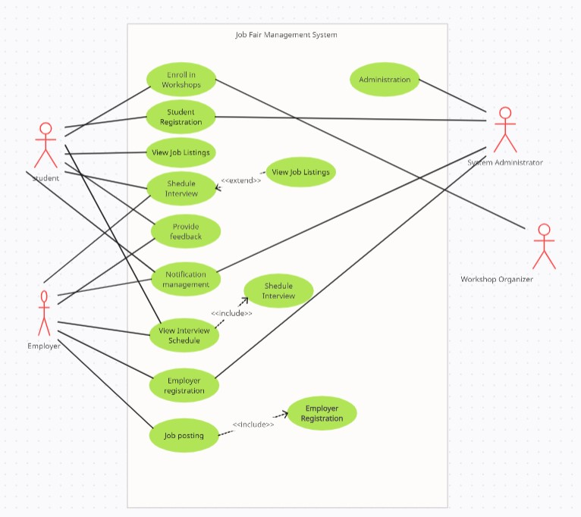

## Activity Diagram

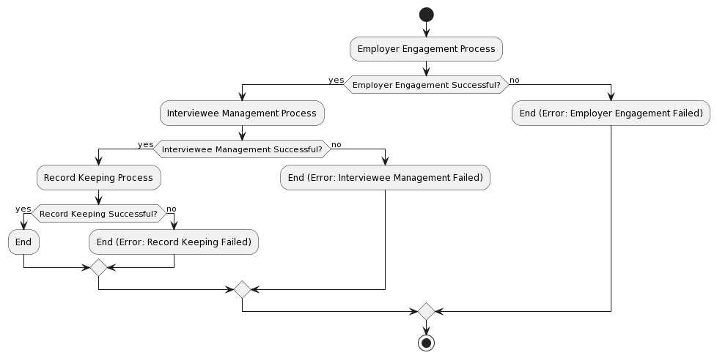

## Sequence Diagram

**1)-**

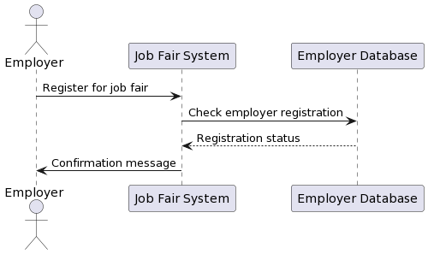

**2)-**

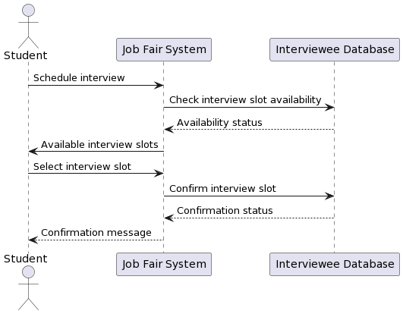

**3)-**

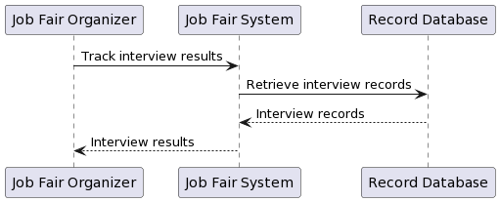

## 6.4 Class Diagram

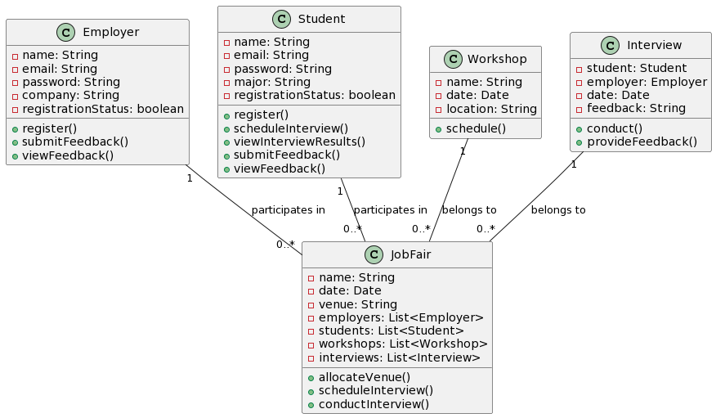

# Appendix A: Glossary

1. ***SRS:*** *Software Requirements Specification. A document that outlines the functional and nonfunctional requirements of a software system.*
2. ***IT:*** *Information Technology. The use of computers, software, networks, and other technologies to manage and process information.*
3. ***GDPR:*** *General Data Protection Regulation. A regulation in EU law on data protection and privacy for all individuals within the European Union and the European Economic Area.*
4. ***HIPAA:*** *Health Insurance Portability and Accountability Act. A United States legislation that provides data privacy and security provisions for safeguarding medical information.*
5. ***SSL/TLS:*** *Secure Sockets Layer/Transport Layer Security. Protocols used for establishing encrypted links between a web server and a browser in online communication.*
6. ***RBAC:*** *Role-Based Access Control. A security model that restricts system access based on the roles of individual users within an organization.*
7. ***JWT:*** *JSON Web Token. A compact, URL-safe means of representing claims to be transferred between two parties.*
8. ***MTBF:*** *Mean Time Between Failures. A reliability metric that measures the average time elapsed between system failures.*
9. ***MTTR:*** *Mean Time To Repair. A reliability metric that measures the average time required to repair a failed system component.*
10. ***SOC 2:*** *Service Organization Control 2. A report based on the AICPA’s Trust Services Criteria, evaluating controls relevant to security, availability, processing integrity, confidentiality, and privacy.*
11. ***ISO 27001:*** *International Organization for Standardization 27001. A specification for an information security management system (ISMS).*
12. ***GDPR:*** *General Data Protection Regulation. A regulation in EU law on data protection and privacy for all individuals within the European Union and the European Economic Area.*
13. ***API:*** *Application Programming Interface. A set of rules and protocols that allows different software applications to communicate with each other.*
14. ***GUI:*** *Graphical User Interface. A type of user interface that allows users to interact with electronic devices using graphical icons and visual indicators.*
15. ***FTP:*** *File Transfer Protocol. A standard network protocol used for the transfer of computer files between a client and server on a computer network.*
16. ***HTTP:*** *Hypertext Transfer Protocol. An application protocol for distributed, collaborative, hypermedia information systems.*
17. ***GDPR:*** *General Data Protection Regulation. A regulation in EU law on data protection and privacy for all individuals within the European Union and the European Economic Area.*

*This glossary provides definitions for terms and acronyms used throughout the Software Requirements Specification (SRS) document for the Job Fair Management System at FAST University, facilitating a better understanding of the content presented.*

# Appendix B: Analysis Models



# Appendix C: To Be Determined List

*The following list includes TBD (to be determined) references found within the Software Requirements Specification (SRS) document for the Job Fair Management System at FAST University:*

1. *TBD: Performance requirements for specific functional requirements.*
2. *TBD: Safety certifications and standards to be satisfied.*
3. *TBD: Security certifications and standards to be satisfied.*
4. *TBD: Testability metrics for assessing system testability.*
5. *TBD: Interoperability standards and protocols to be followed.*
6. *TBD: Business rules related to specific user roles and functions.*
7. *TBD: Additional software quality attributes to be considered.*
8. *TBD: Security measures for data transmission and encryption.*
9. *TBD: Specific communication protocols and standards to be implemented.*
10. *TBD: Additional system features and functionalities.*
11. *TBD: Requirements related to system scalability and resource management.*
12. *TBD: User interface design standards and guidelines.*
13. *TBD: Hardware components and devices supported by the system.*
14. *TBD: Software components and applications integrated with the system.*
15. *TBD: Additional performance requirements for real-time operations.*
16. *TBD: Additional safety requirements for user interactions.*
17. *TBD: Specific security requirements for data protection and privacy.*
18. *TBD: Usability testing results and user feedback for interface improvements.*
19. *TBD: Reliability metrics and targets for system uptime and availability.*
20. *TBD: Maintainability measures and strategies for codebase management.*
21. *TBD: Specific hardware and software constraints affecting system design.*
22. *TBD: Documentation formats and standards for user manuals and guides.*
23. *TBD: Assumptions regarding system dependencies and external factors.*
24. *TBD: Implementation constraints related to technology choices and platforms.*
25. *TBD: Additional user classes and characteristics to be defined.*

*This list serves as a tracking mechanism for unresolved TBD references within the SRS, ensuring that all outstanding items are addressed and finalized in subsequent revisions of the document.*

***Trello Screenshots:***

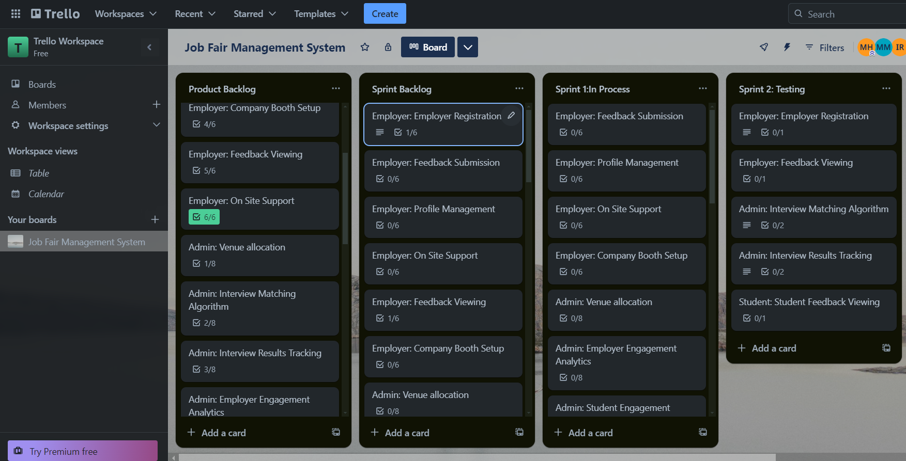

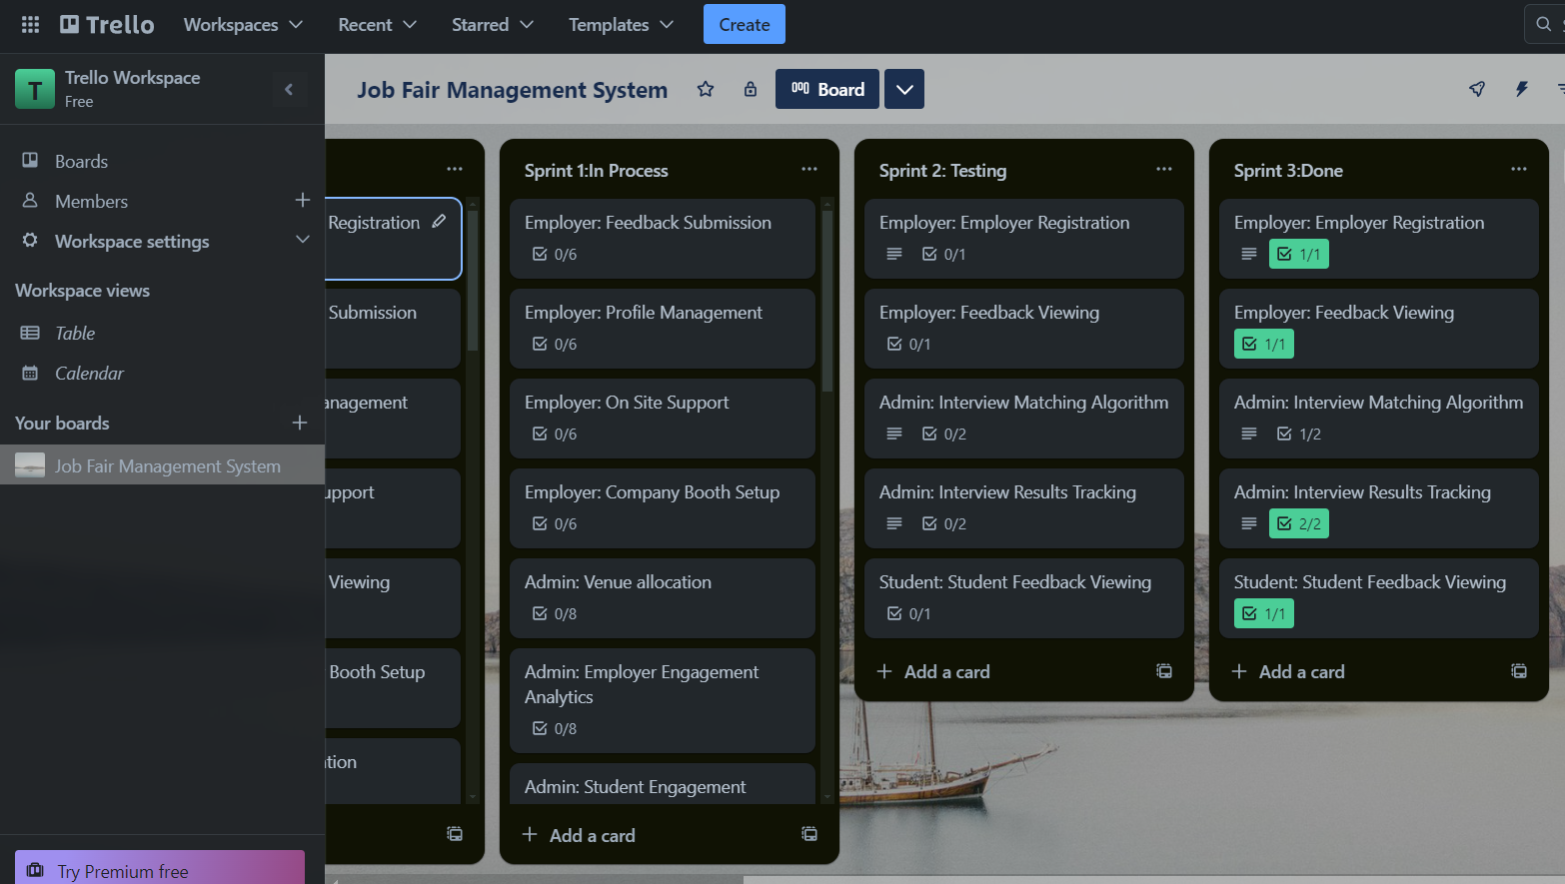

***GitHub:***