TMDB Movie Analytics Lakehouse
Phase 1: Project Proposal
End-to-end Medallion Architecture (Bronze → Silver → Gold) pipeline built on Apache Spark, ingesting movie catalog data from The Movie Database (TMDB) API.
Team Member 1: Munam Ansari
Team Member 2: Sanan Zahid
Section: BDS-5A
GitHub Repository Link: https://github.com/MunamAnsari/tmdb-movie-lakehouse/tree/main

1. Domain & Source Identification

1.1 Project Concept
Domain: Entertainment / media analytics — tracking movie budgets, revenue, ratings, genres, and production companies to answer business questions such as "which genres deliver the best ROI?" and "how has the average movie budget changed over the last decade?"

1.2 Data Source
Source Name: TMDB API v3
Source URL / API Endpoint: https://developer.themoviedb.org/reference/intro/getting-started
Access Method: REST API (JSON responses), authenticated with a TMDB API key

1.3 Ingestion Pattern
TMDB's API natively supports both load types required for this pipeline:
Load Type | How it will be extracted
Full Load | /discover/movie (paginated, sorted by popularity), enriched per movie with /movie/{id}?append_to_response=credits,keywords,reviews
Incremental Load | /movie/changes (returns movie IDs changed within a configurable date window), each changed ID re-fetched via /movie/{id}

2. Data Samples & Volume

2.1 Sample Files
Both sample payloads were collected using the project's fetch scripts and are pushed to the data/ folder of the GitHub repository:
- Full Load sample: 200 movies (10 discover pages), enriched with credits, keywords, and reviews — generated by scripts/fetch_full_load.py, saved under data/full_load/
- Incremental Load sample: 35,585 movies reported as changed in the last 7 days; sample capped to the first 300 for repo size, with 2 IDs skipped (deleted between listing and fetch — handled gracefully) — generated by scripts/fetch_incremental_load.py, saved under data/incremental_load/

2.2 Volume & Frequency Estimation
Metric | Actual / Estimate
Full Load sample size | 200 movies (10 discover pages), each enriched with credits, keywords, and reviews sub-resources - total sample file size: 21.6MB
Incremental window (7 days) | 35,585 movie IDs reported as changed; sample capped to the first 300 IDs for repo size (2 IDs skipped — deleted between listing and fetch, handled gracefully) - total sample file size: 6.8MB
Production-scale implication | ~35,585 IDs / 7 days ≈ 5,000+ changed movies per day at full scale — the daily incremental job must be designed to re-fetch and merge this volume without exhausting free-tier compute

Figure — Data Pipeline Volume Growth (7-Day Incremental Tracking)
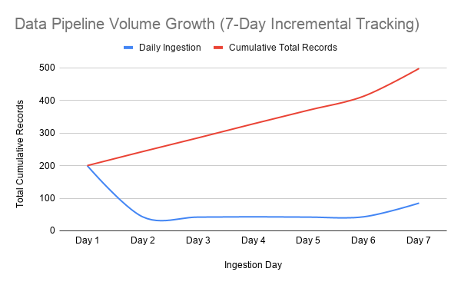

3. Security & Compliance

3.1 Identify PII and Sensitive Data
TMDB movie metadata (titles, cast/crew, genres, financials, production companies) is public catalog data and does not constitute PII. The one exception is the author_username field nested inside the reviews sub-resource, which identifies a real TMDB reviewer:
Column Name | PII? (Y/N) | Notes
author_username (inside reviews) | Y | Identifies a real TMDB reviewer. Masked (SHA-256 hash) before the Silver layer, as a precaution.
review content (free text) | Y (partial) | May incidentally embed emails or URLs typed by the reviewer. Scrubbed via regex before Silver.
movie / financial fields (titles, cast, crew, genres, budget, revenue, production companies) | N | Public catalog data about films and companies, not individuals. No PII risk.

3.2 Handling Strategy
The pipeline applies a privacy-scrubbing step during the Bronze-to-Silver transformation, before any reviewer-related data reaches the Silver or Gold layers:
- Masking: author_username is masked via a SHA-256 hash before the Silver layer, so reviews remain analyzable (e.g., grouping, deduplication) without exposing the original TMDB username.
- Scrubbing: Review content is passed through regexp_replace to detect and remove any incidentally embedded email addresses or URLs before it is written to Silver.
- Movie and studio metadata require no PII handling, since it describes public entities (films, companies) rather than individuals, and is passed to Silver unchanged aside from normal type casting and cleansing.
- Credential handling: TMDB API keys are never committed to the repository. The fetch notebook (notebooks/tmdb_data_fetch.ipynb) reads the key from Colab Secrets at runtime instead of storing it in code.

4. High-Level Medallion Data Modeling

4.1 Bronze Layer (Raw Ingestion)
The Bronze layer acts as an append-only landing zone in Delta Lake (format("delta")). Raw JSON responses from TMDB API endpoints are saved directly without altering the underlying nested structures, and are partitioned by load_type and ingestion_date so full-load and incremental-load batches can be queried and reprocessed independently. System metadata columns are appended during ingestion to maintain data lineage and auditability:
- _ingested_at (TimestampType): System UTC timestamp recorded when the raw record landed.
- _source_file (StringType): Name of the source endpoint or batch extraction payload file.
- _batch_id (StringType): Unique UUID generated per pipeline execution run.

Figure — Medallion Pipeline Flow Diagram (Bronze → Silver → Gold)
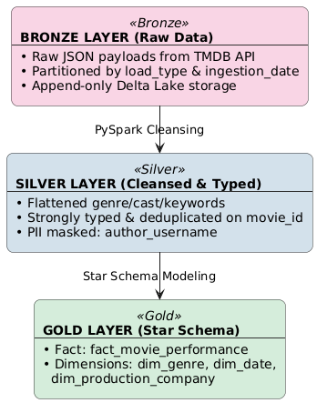

4.2 Ingestion Processing: Bronze to Silver Transition
Moving raw data from Bronze to Silver involves several cleansing, unnesting, typing, and validation steps executed in PySpark:
1. Struct Flattening & Array Explosion
- Deeply nested JSON arrays (such as genres, production_companies, and cast) are unnested using PySpark's explode() function and struct dot-notation, converting raw tree structures into relational table layouts.
2. Type Enforcement & Casting
- String dates are cast to DateType (release_date).
- Financial figures are cast to DoubleType (budget, revenue).
- Durations and vote totals are cast to IntegerType and LongType (runtime, vote_count).
3. Data Quality & Sanitation Filters
- Null or negative budgets and revenues are standardized (negative values set to null or filtered out).
- Incomplete records missing critical identifiers (movie_id or title) are routed to a quarantined error path.
4. Derived Financial Metric Calculation
- Profit = Revenue − Budget
- ROI = (Revenue − Budget) / Budget, when Budget > 0; otherwise ROI is set to NULL.
5. Deduplication & Change Data Capture (CDC)
- Incremental daily updates can introduce duplicate records for the same movie. Deduplication is handled via PySpark window functions to isolate and retain only the latest record state per movie_id:

windowSpec = Window.partitionBy("movie_id").orderBy(col("_ingested_at").desc())
silver_df = bronze_df.withColumn("row_num", row_number().over(windowSpec)) \
.filter(col("row_num") == 1) \
.drop("row_num")

6. Privacy Scrubbing (PII Sanitation)
- User review handles are transformed into cryptographic hashes using SHA-256 with a salt: reviewer_hash_id = SHA256(author + SALT).
- Regular expressions (regexp_replace) are executed on review content to scrub embedded email addresses and web URLs.

4.3 Planned Silver Data Model
The Silver layer consists of normalized, cleansed, and partitioned Delta tables:
- silver_movies_cleansed: Primary entity table containing deduplicated movie attributes, financial figures, derived metrics, and release metadata (Partitioned by release_year).
- silver_movie_genres: Normalized bridge table linking movie_id to individual genre_id and genre_name attributes.
- silver_movie_studios: Normalized table linking movie_id to production studios (company_id, company_name, origin_country).
- silver_reviews_cleansed: Anonymized user review data where reviewer handles are replaced with SHA-256 hashes and content is scrubbed of PII.

4.4 Gold Layer (Business Analytics Schema)
The Gold layer models the cleansed Silver data into a Star Schema optimized for OLAP analytical queries and Business Intelligence (BI) tools such as Power BI, Tableau, or Databricks SQL Dashboards. In the implemented pipeline these are named fact_movie_performance, joined with dim_genre, dim_production_company, and dim_date; the entity/measure breakdown below elaborates this same model in more detail.

Figure — Gold Layer Star Schema ERD (with aggregate tables)
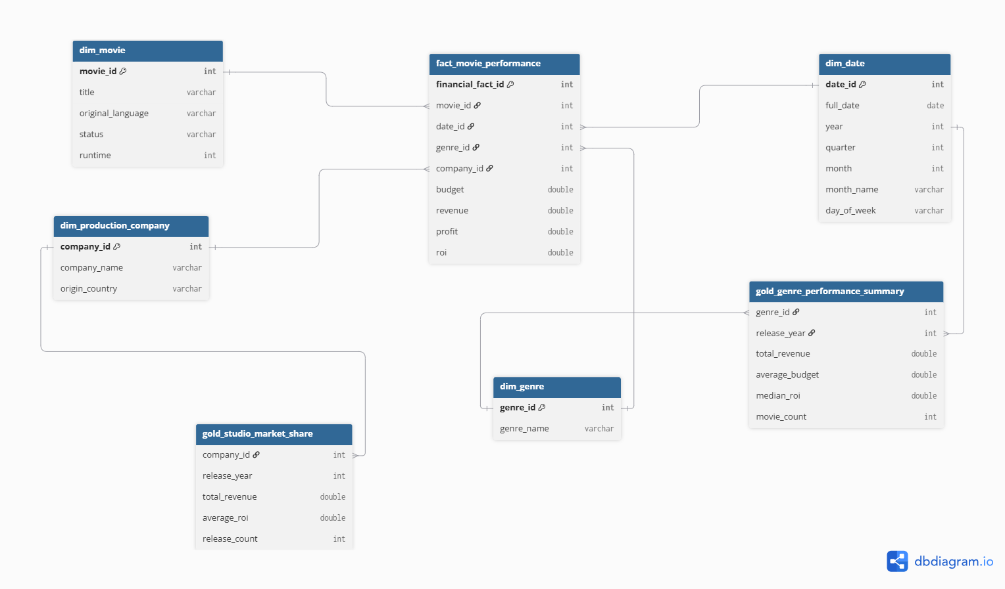

4.5 Dimensional Star Schema Architecture
Fact Tables:
- Fact_MovieFinancials: Stores financial metrics at the individual film release level. Keys: financial_fact_id (PK), movie_id (FK), date_id (FK), genre_id (FK), company_id (FK). Measures: budget, revenue, profit, roi.
- Fact_DailyRatings: Stores time-series snapshots of audience ratings and momentum. Keys: rating_fact_id (PK), movie_id (FK), date_id (FK). Measures: vote_average, vote_count, popularity_score.
Dimension Tables:
- Dim_Movie: movie_id (PK), title, original_language, status, runtime.
- Dim_Genre: genre_id (PK), genre_name.
- Dim_ProductionCompany: company_id (PK), company_name, origin_country.
- Dim_Date: date_id (PK, YYYYMMDD), full_date, year, quarter, month, month_name, day_of_week.
Consolidated Analytical Aggregations:
- Gold_Genre_Performance_Summary: Pre-calculates total_revenue, average_budget, median_roi, and movie_count grouped by genre_name and release_year.
- Gold_Studio_Market_Share: Aggregates cumulative global box office gross, average ROI, and release portfolio size grouped by company_name and release_year.

5. Business Intelligence & Dashboards

5.1 Core Business Questions
The executive dashboard will address three core business questions for studio strategists and financial analysts:
- Genre Profitability & Capital Efficiency: Which film genres yield the highest Return on Investment (ROI) relative to production risk, and how has genre profitability shifted over time?
- Audience Sentiment Decay: How do user rating scores decay across release weeks post-premiere, and does initial rating volume correlate with long-term revenue retention?
- Studio Market Leaders: Which production studios control the largest market share of total box office revenue, and which studios operate with the highest average ROI per release?

5.2 Visual 1: Movie Genre Risk vs. Return
Figure — Visual 1: Movie Genre Risk vs. Return
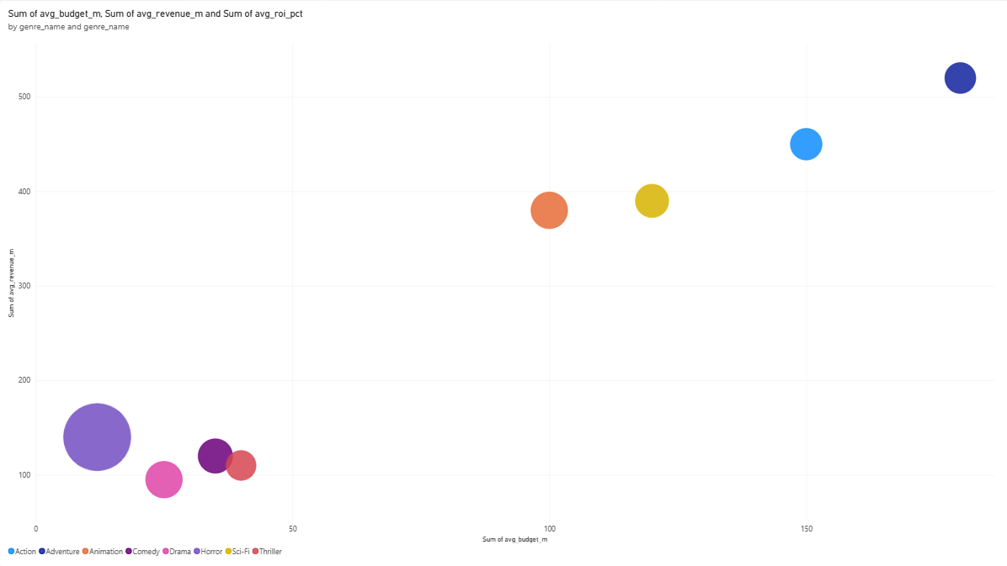

5.3 Visual 2: Audience Rating Decay Trajectory
Figure — Visual 2: Audience Rating Decay Trajectory
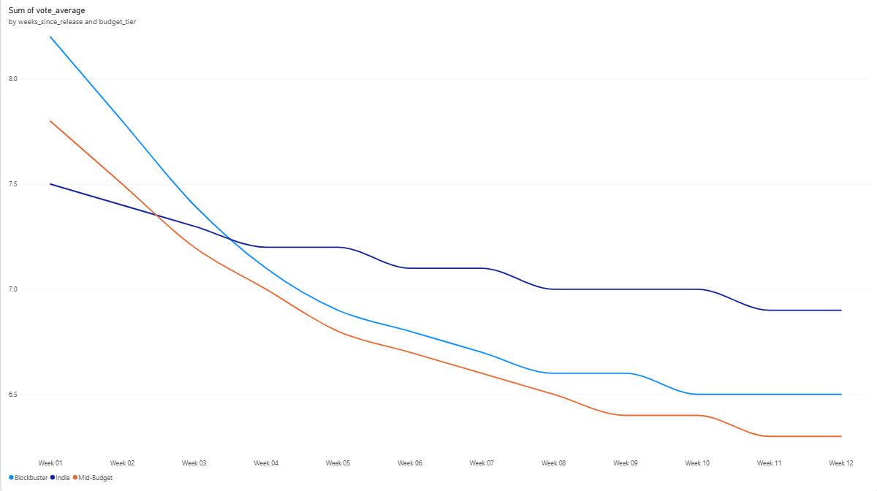

5.4 Visual 3: Top 10 Film Studio Leaders
Figure — Visual 3: Top 10 Film Studio Leaders
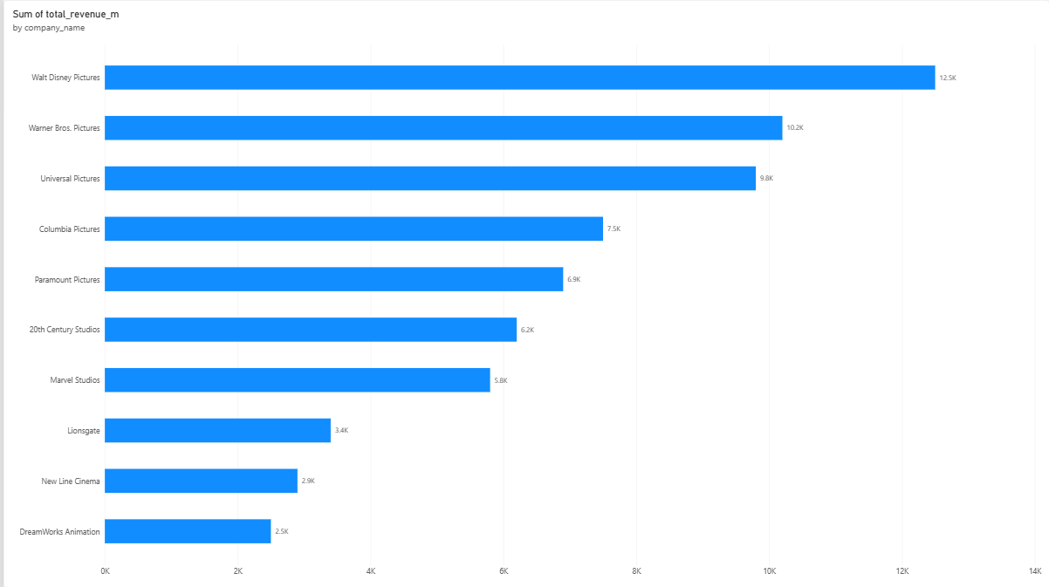

5.5 Full Dashboard Mockup
Figure — Full Executive Dashboard (Power BI)
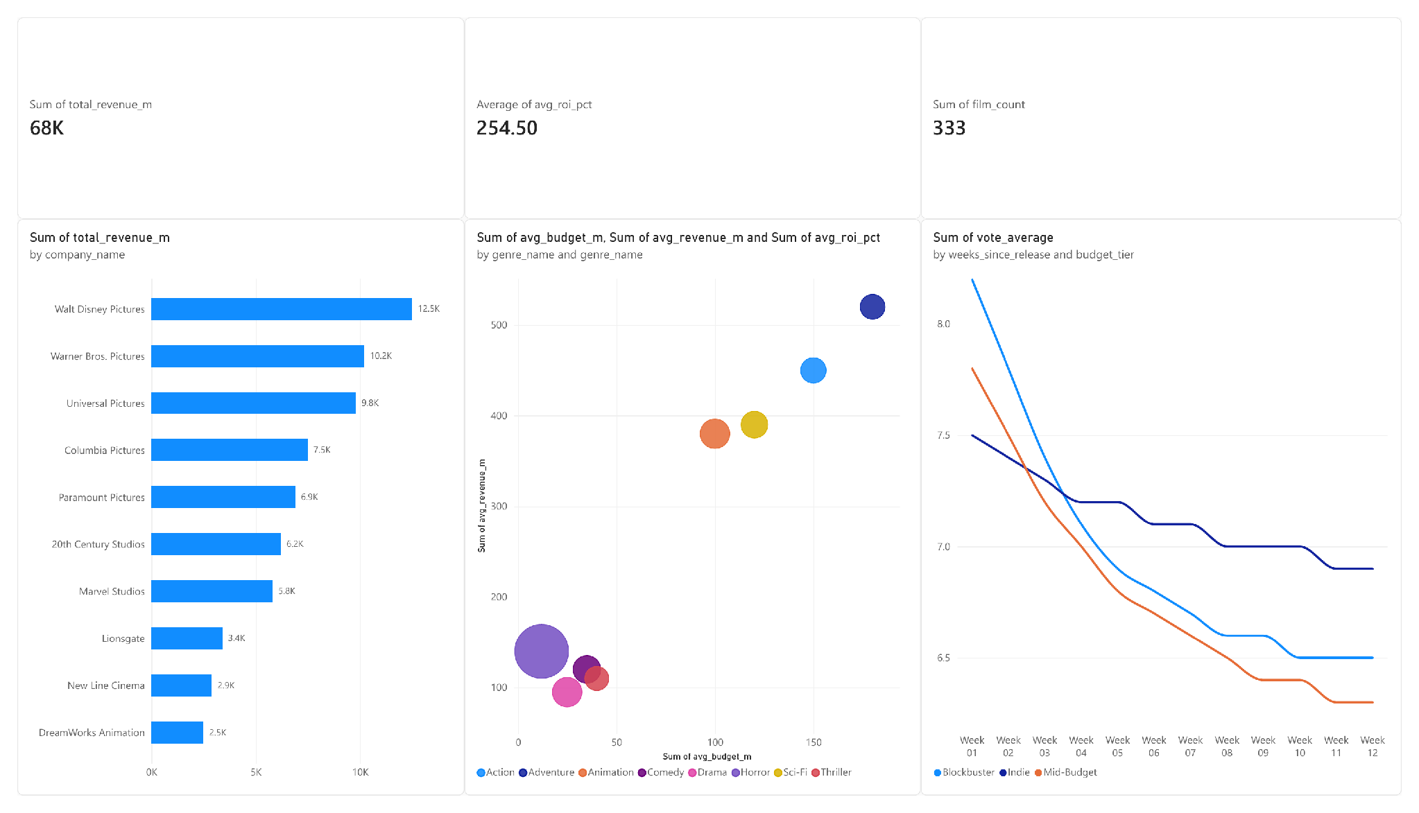

6. Engineering Setup & FinOps

6.1 Version Control
GitHub Repository Link: https://github.com/MunamAnsari/tmdb-movie-lakehouse/tree/main
The repository follows this structure:
- data/
  - full_load/
  - incremental_load/
- scripts/
  - fetch_full_load.py
  - fetch_incremental_load.py
  - requirements.txt
- notebooks/
  - tmdb_data_fetch.ipynb
- docs/
  - phase1_proposal.pdf

Both the Full Load sample (200 movies) and the Incremental Load sample (300 movies, capped from 35,585 changed IDs) have been generated by the scripts above and pushed under data/.

6.2 Infrastructure
Data fetching (scripts/fetch_full_load.py, scripts/fetch_incremental_load.py, and notebooks/tmdb_data_fetch.ipynb) was built and tested in Google Colab, with the TMDB API key read from Colab Secrets at runtime rather than stored in code. Spark processing for the Bronze, Silver, and Gold layers is built and tested on Databricks Community Edition (free tier), running on a single-node cluster with auto-termination enabled after a short idle period to avoid wasting compute hours.

6.3 Cost / FinOps Awareness
- Sample sizes were capped intentionally (200 full-load records, 300 incremental records) to stay well within free compute/storage limits while testing the pipeline.
- Enable cluster auto-termination on Databricks and always manually stop clusters after a work session instead of leaving them idle.
- Cache and reuse Silver/Gold Delta tables between test runs instead of re-running the full Bronze ingestion each time, to minimize redundant API calls and compute.
- Awareness of scale: a 7-day incremental window returning 35,585 changed IDs implies roughly 5,000+ changed movies per day at full production scale, so the daily incremental job will need batching/rate-limit handling rather than a single unbounded fetch, once deployed beyond this capped sample.

