Overview of Graduation Age of AMA Cadets
  - (May be shared)
The following data comes from the AMA Museum dataset. The data has been standardized, and empty or useless values have been omitted from it. The goal of this was to find out what the age of the AMA cadets were when they left the academy. Although the data and its derived values are accurate, the last names of the cadets have been randomized for anonymity.
In the original data set, there were columns labeled; ‘Name,Custom.Year,Other No,Id No,Places & Date of Birth & Death’. Some of these values are not clear; For instance, Custom.Year’ and ‘Other No’ are the same number, and we found out through sources that they represent the years that they exited the academy. ‘Name’ is the last name of the cadet, and ‘Id’ is their id number. The last column ‘Places & Date of Birth & Death’ is a messy column; it has both date of birth and date of death. It’s very inconsistent with missing data, so for simplicity we changed it to birth year. The cleaned version has standardized values with the columns; ‘Last_Name,Exit_Year,Id_Number,Birth_Year,Age_At_Exit’, with ‘Age_At_Exit’ being the difference of ‘Exit_Year’ to ‘Birth_Year’.

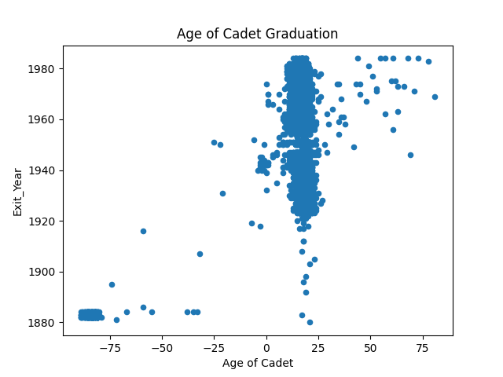Figure 1

This graph is meant to represent the average age of those who’ve graduated from the academy. The values which are negative or near zero can be ignored, this is likely due to the irregularities still present in the dataset. It is impossible to be born after you graduate so it can be assumed some data has been wrongly inserted. Nonetheless, we find a large sum of graduating cadets around the 12-25 age range from the 1920s and beyond, with some older outliers. The calculated mean is 15.3 years old, however significant outliers like -75 or 75 (likely due to bad input), may distort the true value.

