**Toshiba 5 TB Desktop Solid State Drive**

**Interline: Calculates optimum seek speeds to lower power consumption, noise and vibration- 7200 RPM SATA 6 Gb/s 16MB Cache 3.5 Inch - WD5000AAKX.**

**US$30.00-US$35.00/ Piece 1.0 Pieces(MOQ)**

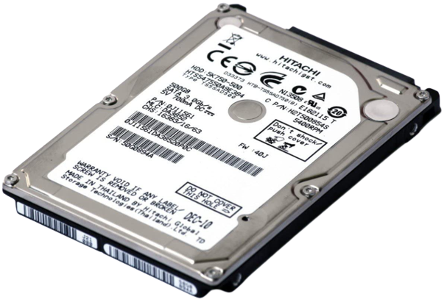

Digital Storage: 5 TB

Capacity: SATA 4 Git/s

Brand: Toshiba

Product: USB 7.0

Color : Silver Blue

**About this item**

Note: Products with electrical plugs are designed for use in the US. Outlets and voltage differ internationally and this product may require an adapter or converter for use in your destination. Please check compatibility before purchasing USB 2.0 Interface,Up to 60 hours of HD video storage,2.5" Form Factor,Up to 480 Mbps Data Transfer Rate.

**Product Dimensions : 5.02 x 2.80 x 0.37 inches**

**Item Weight: 5 ounces**

**ASIN B001F9LY14**

**Item model number WDME5000TN**

**Digital Storage 5 TB**

**Manufacturer Silver Blue**