Key Advantages[1]

**Image Perfect™ firmware** is designed to ensure seamless video footage capture in 24×7 surveillance workloads that record video from 64 HD cameras.

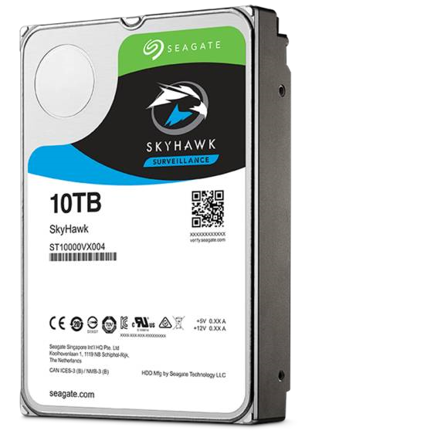

**Best-Fit Applications**

Network video recorders (NVR)

Embedded surveillance DVRs

(

SDVR

)

Hybrid surveillance DVRs

Surveillance DVRs



**Sky Hawk Health Management** actively helps protect your surveillance storage by focusing on prevention, intervention and recovery options.[2]

**NVR-ready design** allows drives to maintain performance in multi-bay systems, giving customers the flexibility to scale their systems when more storage is needed.



3.5

HARD DRIVE DATA SHEET

Smart. Safe. Secure.

Seagate Surveillance-Specialized Storage

SkyHawk

™

leverages Seagate's extensive experience in designing

drives purpose-built for surveillance applications.



**ATA streaming support** enables recordings from up to 64 HD cameras for smooth, uninterrupted footage.

**Up to 10TB or over 2000 hours of HD video storage** support an increased number of HD cameras and allows longer data retention periods.

**1M hours MTBF, 3-year limited warranty[3]** represents an improved total cost of ownership (TCO) with reduced maintenance costs.

**Lower power consumption** means a reduction in heat emissions, which improves reliability in surveillance solutions. Tarnish-resistant components help protect drive from environmental elements, increasing field reliability.

Sky Hawk surveillance drives are designed for always-on, low transaction workloads (20% duty cycle) of 180TB/year. For higher transaction workloads, see Seagate's enterprise-class drive offerings.

Contact your Seagate sales representative for further information.

Sky Hawk surveillance drives are designed to operate under ambient operating temperatures of 0°C to 60°C and normal environments.

Usage of drives in higher temperatures or other extreme environmental conditions will reduce useful life

|  |  |  |  |  |  |
| --- | --- | --- | --- | --- | --- |
|  | 10TB | 8TB | 6TB | 4TB | 3TB |
| Standard Model Numbers | ST10000VX0004 | ST8000VX0022 | ST6000VX0003,  ST6000VX0023 | ST4000VX007 | ST3000VX010 |
| ™ 1  SkyHawk Health Management Included | Yes | Yes | Yes | Yes | — |
| Interface | SATA 6Gb/s | SATA 6Gb/s | SATA 6Gb/s | SATA 6Gb/s | SATA 6Gb/s |
| Features and Performance |  |  |  |  |  |
| Drive Bays Supported | 8+ | 8+ | 8+ | 8+ | 1 to 8 |
| Cameras Supported | Up to 64 | Up to 64 | Up to 64 | Up to 64 | Up to 64 |
| Max. Sustained Transfer Rate OD (MB/s) | 210MB/s | 210MB/s | 195MB/s | 190MB/s | 180MB/s |
| Cache (MB) | 256 | 256 | 256 | 64 | 64 |
| Reliability/Data Integrity |  |  |  |  |  |
| Tarnish Resistant | Yes | Yes | Yes | Yes | No |
| Load/Unload Cycles | 300,000 | 300,000 | 300,000 | 300,000 | 300,000 |
| Nonrecoverable Read Errors per Bits Read, Max | 1 per 10E15 | 1 per 10E15 | 1 per 10E15 | 1 per 10E14 | 1 per 10E14 |
| Power-On Hours per Year (24×7) | 8760 | 8760 | 8760 | 8760 | 8760 |
| 2 Workload Rate Limit (WRL) | 180 | 180 | 180 | 180 | 180 |
| MTBF | 1,000,000hr | 1,000,000hr | 1,000,000hr | 1,000,000hr | 1,000,000hr |
| 3 Warranty, Limited (years) | 3 | 3 | 3 | 3 | 3 |
| Power Management |  |  |  |  |  |
| Startup Current, Typical (12V, A) | 1.8 | 2 | 2 | 1.8 | 1.8 |
| Average Operating Power (W) | 6.8W | 9W | 9W | 5.5W | 5.6W |
| Idle Average (W) | 4W | 8W | 7W | 3W | 4W |
| Standby Mode/Sleep Mode, Typical (W) | 0.8/0.8 | 0.6/0.6 | 0.6/0.6 | 0.25/0.25 | 0.5/0.5 |
| Voltage Tolerance (5V) | ±5% | ±5% | ±5% | ±5% | ±5% |
| Voltage Tolerance (12V) | ±10% | ±10% | ±10% | ±10% | ±10% |
| Environmental/Temperature |  |  |  |  |  |
| Operating (ambient, min °C) | 5 | 5 | 5 | 0 | 0 |
| 4 Operating (drive case, max °C) | 70 | 70 | 70 | 70 | 70 |
| Nonoperating (ambient, min °C) | -40 | -40 | -40 | -40 | -40 |
| Physical |  |  |  |  |  |
| Height (mm/in, max) | 26.11mm/1.028in | 26.11mm/1.028in | 26.11mm/1.028in | 26.11mm/1.028in | 26.11mm/1.028in |
| Width (mm/in, max) | 101.85mm/4.01in | 101.85mm/4.01in | 101.85mm/4.01in | 101.85mm/4.01in | 101.85mm/4.01in |
| Depth (mm/in, max) | 146.99mm/5.787in | 146.99mm/5.787in | 146.99mm/5.787in | 146.99mm/5.787in | 146.99mm/5.787in |
| Weight (g/lb) | 650g/1.433lb | 780g/1.72lb | 705g/1.55lb | 635g/1.40lb | 610g/1.35lb |
| Carton Unit Quantity | 20 | 20 | 20 | 20 | 20 |
| Cartons per Pallet/Cartons per Layer | 40/8 | 40/8 | 40/8 | 40/8 | 40/8 |

1. 10TB model available in early CY2018.
2. SkyHawk surveillance drives are designed for always-on workloads of 180TB/year. For higher transaction workloads, see Seagate’s enterprise-class drive offerings.
3. Extended warranty options available. Consult your distributor for details.
4. Seagate does not recommend operating at sustained extreme temperatures. Operating at higher temperatures will reduce useful life of the products.



2

|  |  |  |
| --- | --- | --- |
| Specifications | 2TB | 1TB |
| Standard Model Numbers | ST2000VX008 | ST1000VX005 |
| ™ 1  Sky Hawk Health Management Included | — | — |
| Interface | SATA 6Gb/s | SATA 6Gb/s |
| Features and Performance |  |  |
| Drive Bays Supported | 1 to 8 | 1 to 8 |
| Cameras Supported | Up to 64 | Up to 64 |
| Max. Sustained Transfer Rate OD (MB/s) | 180MB/s | 180MB/s |
| Cache (MB) | 64 | 64 |
| Reliability/Data Integrity |  |  |
| Tarnish Resistant | No | No |
| Load/Unload Cycles | 300,000 | — |
| Nonrecoverable Read Errors per Bits Read, Max | 1 per 10E14 | 1 per 10E14 |
| Power-On Hours per Year (24×7) | 8760 | 8760 |
| 2 Workload Rate Limit (WRL) | 180 | 180 |
| MTBF | 1,000,000hr | 1,000,000hr |
| 3 Warranty, Limited (years) | 3 | 3 |
| Power Management |  |  |
| Startup Current, Typical (12V, A) | 1.8 | 1.8 |
| Average Operating Power (W) | 5.6W | 5.6W |
| Idle Average (W) | 4W | 4W |
| Standby Mode/Sleep Mode, Typical (W) | 0.5/0.5 | 0.5/0.5 |
| Voltage Tolerance (5V) | ±5% | ±5% |
| Voltage Tolerance (12V) | ±10% | ±10% |
| Environmental/Temperature |  |  |
| Operating (ambient, min °C) | 0 | 0 |
| 4 Operating (drive case, max °C) | 70 | 70 |
| Nonoperating (ambient, min °C) | -40 | -40 |
| Physical |  |  |
| Height (mm/in, max) | 26.11mm/1.028in | 20.20mm/0.795in |
| Width (mm/in, max) | 101.85mm/4.01in | 101.85mm/4.01in |
| Depth (mm/in, max) | 146.99mm/5.787in | 146.99mm/5.787in |
| Weight (g/lb) | 610g/1.35lb | 415g/0.915lb |
| Carton Unit Quantity | 20 | 25 |
| Cartons per Pallet/Cartons per Layer | 40/8 | 40/8 |
|  |  |  |

1. 10TB model available in early CY2018.
2. Sky Hawk surveillance drives are designed for always-on workloads of 180TB/year. For higher transaction workloads, see Seagate’s enterprise-class drive offerings.
3. Extended warranty options available. Consult your distributor for details.
4. Seagate does not recommend at sustained extreme temperatures. Operating at higher temperatures reduce useful life of the products.



1.
2.
3.