**DETAIL’S SHEET 3.5-INCH ENTERPRISE 7200 RPM HARD DISK DRIVES**

|  |  |  |
| --- | --- | --- |
|  | |  | | --- | | **Ultrastar® 7K6000** | |

# Highlights

* Excellent random & sequential performance
* Reliable, field-proven, 7th generation 5-disk design
* Compared to prior generation 7K4000 — 50% more capacity1 (6TB vs. 4TB)

— 30% better power efficiency (Watts/TB)

— Up to 3X faster random write performance using media cache technology

— 25% faster sequential read/write performance

* 12Gb/s SAS & 6Gb/s SATA

— 12Gb/s SAS compatible with next gen data centers; backwards compatible with 6Gb/s SAS

* 128MB cache buffer improves response time and data management
* Instant Secure Erase (ISE) & Self-Encrypting Drive (SED) options
* Advanced format 4Kn and 512e models up to 6TB; 512n format available in 4TB and 2TB capacities
* 2M hours MTBF2 rating & 5-year limited warranty

# Applications/ Environments

* Cloud & Hyperscale storage
* Distributed Files Systems like Ceph™ and Hadoop® to support Big Data Analytics
* Video surveillance & content distribution
* Direct & Network Attached Storage

(DAS & NAS)

* RAID arrays

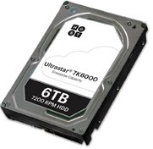

6

TB, 5TB, 4TB and 2TB | 7200 RPM

SATA 6Gb/s and SAS 12Gb/s



•

Reduces rebuild time for a failed drive and maintains system

performance during rebuild in a RAID configuration

•

Provides compatibility and easy integration with high-

performance data centers

•

Maintains drive performance in high rotational vibration

environments and multi-drive systems

Reliability

•

2

M hours MTBF and 0.44% AFR

•

5-

year limited warranty

•

One of the highest reliability ratings for Capacity

Enterprise hard drives

Data Security

•

Instant Secure Erase

•

Optional Bulk Data Encryption (SATA)

& TCG Enterprise_A (SAS)

•

Enables swift and efficient drive redeployment and

retirement

•

Hardware-based encryption protects data from

unauthorized use

## Increasing Capacity Density by 50%

As petabyte (PB) growth continues to increase at a rapid pace, corporate and cloud data centers are under extreme pressure to improve the efficiency of storage. To address this data center challenge, HGST introduces Ultrastar® 7K6000, delivering up to 6TB of capacity in an industrystandard, 3.5-inch hard drive, for capacity-optimized enterprise applications. Ultrastar 7K6000 provides 50% more capacity and 30% better power efficiency in terms of Watts per terabyte (W/TB) than its predecessor, Ultrastar 7K4000. The 7K6000 is designed for all traditional and rapidly growing scale-out storage applications, including object, block and file storage architectures, providing huge capacity, fast 7,200 RPM performance and economical $/TB acquisition cost.

## Technology Innovation Improves Storage Efficiency

Ultrastar 7K6000 also delivers greater storage efficiency through high performance, achieving up to 3X higher random write performance, thanks to HGST media cache architecture, a diskbased caching technology, which provides a large non-volatile cache on the disk. Media cache also allows for improved reliability and data integrity during unexpected power loss. Other performance-enhancing features include higher areal density for 25% faster sequential performance vs. 7K4000, and a 128MB cache buffer. Designed to handle workloads up to 550TB per year, Ultrastar 7K6000 offers a 12Gb/s SAS (6Gb/s SATA) interface for easy integration into high performance data centers. As drive capacities increase, so does the time required to recover a failed drive in a RAID configuration. Dramatically reduce RAID rebuild times and maintain system performance during the rebuild process with the new Rebuild Assist. Learn more in our Rebuild Assist technical brief. For legacy systems that require native 512 formatting, models are available at 4TB and 2TB capacity points.

## Data Security with Trusted Quality, Reliability

Compliance and privacy requirements drive the need for increased data security. Ultrastar

7K6000 helps protect data from unauthorized use by offering security and encryption options. Instant Secure Erase (ISE) models expedite drive redeployment and retirement. Encryption models protect data with hardware-based encryption, including a Trusted Computing Group (TCG) Enterprise_A, TCG with FIPS 140-2 certification, Level 2. The Ultrastar 7K6000 is a seventh generation, 5-platter design, field proven by top server and storage OEMs, and Internet giants, and extends HGST’s long-standing tradition of reliability leadership with a 2M-hour MTBF rating and a 5-year limited warranty.

# Features & Benefits

Feature / Function Benefits

Capacity • 6TB, 5TB, 4TB, and 2TB • Represents 50% more capacity than prior generation for

* Advanced Format up to 6TB lower TCO in the data center • 512n Format available on 4TB and 2TB • Enables higher capacities
* Compatibility with legacy systems

Power 30% lower Watts per terabyte (W/TB) Improved power efficiency compared to prior generation

Efficiency

Performance • Increased Areal Density (Gbits/sq. in) • Enables 25% higher sequential performance (6TB) vs. prior

* Media cache architecture generation Ultrastar 7K4000
* Rebuild Assist mode • Up to 3X better random write performance vs. prior
* SAS 12Gb/s and SATA 6Gb/s generation
* Rotational Vibration Safeguard (RVS)
* Massive scale-out data centers (MSO)

**DETAIL’S SHEET 3.5-INCH ENTERPRISE 7200 RPM HARD DISK DRIVES**

|  |  |  |
| --- | --- | --- |
|  | |  | | --- | | **Ultrastar® 7K6000** | |

# Specifications

**SATA Models SAS Models SATA Models SAS Models**

Model / Part No. HUS7260xxALN61y HUS7260xxAL421y Environmental (operating)

HUS7260xxALE61y HUS7260xxAL521y

HUS7260xxALA61y HUS7260xxALS21y

Ambient temperature 5o to 60o C

←

Configuration Shock (half-sine wave 2 ms, G) 70 ←

Vibration (G RMS, 5 to 500 Hz) 0.67 (XYZ)

Interface SATA 6Gb/s SAS 12Gb/s ←  Capacity (TB)1 6TB / 5TB / 4TB / 2TB ← Environmental (non-operating)

Sector size (bytes)3 4Kn: 4096, 4Kn: 4096, 4112, 4160, 4224 Ambient temperature -40o to 70o C ←

512n*/512e: 512 512n*/512e: 512, 520, 528

Shock (half-sine wave, 1ms, G) 300 ←

Max. areal density 512e/4Kn: 703 (6TB), 599 (<6TB) ←

Vibration (G RMS, 5 to 500 Hz) 1.04 (XYZ)

(Gbits/sq. in) 512n*: 623 ←

Performance 1 One MB is equal to one million bytes, one GB is equal to one billion bytes and one TB equals 1,000GB (one

trillion bytes) when referring to hard drive capacity. Accessible capacity will vary from the stated capacity due

Data buffer (MB)4 128 ← to formatting and partitioning of the hard drive, the computer’s operating system, and other factors.

1. MTBF and AFR specifications are based on a sample population and are estimated by statistical measurements

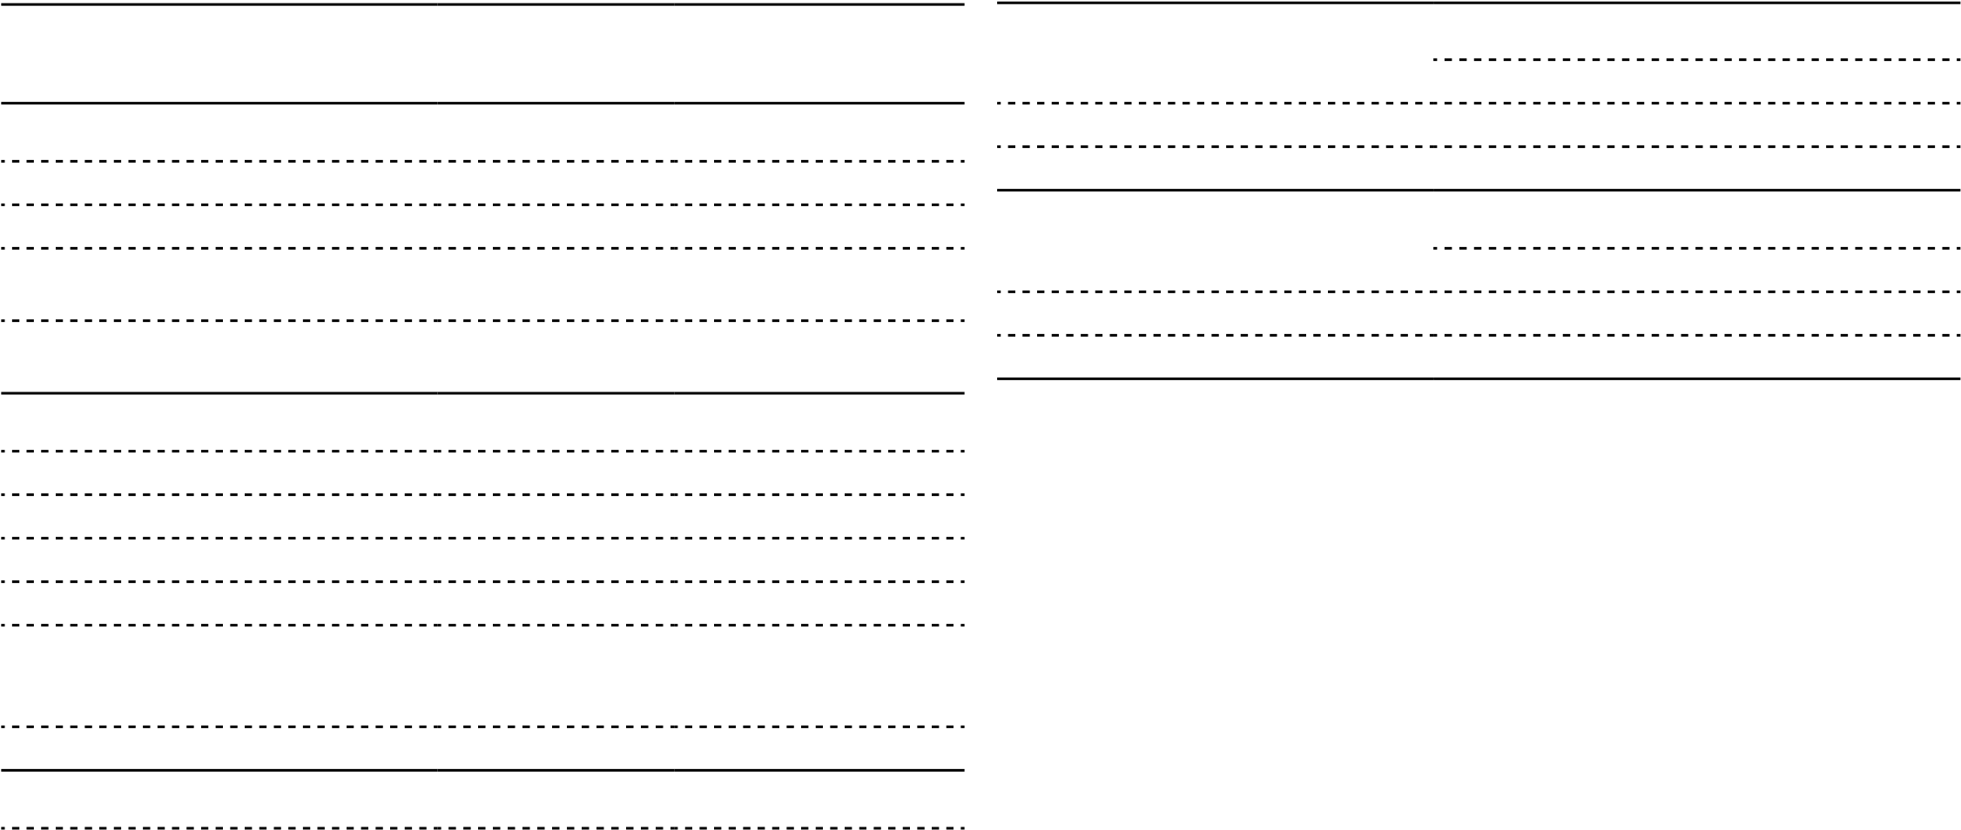 Rotational speed (RPM) 7200 ← and acceleration algorithms under typical operating conditions for this drive model. MTBF and AFR ratings do Latency average, (ms) 4.16 ← not predict an individual drive’s reliability and do not constitute a warranty.

1. Advanced Format drive: 4K (4096-byte) physical sec

Interface transfer rate (MB/s, max) 600 1200 4  Portion of buffer capacity used for drive firmware

Sustained transfer rate5  5  MiB/s is 220 bytes, MB/s is 106 bytes

(MiB/sec, typ.) 216 (6TB), 192 (<6TB) ← 6 Excludes command overhead

(MB/sec, typ.) 227 (6TB), 202 (<6TB) ← 7 SATA models: 8K Queue Depth = 1 @ 40 IOPS, SAS models: 4K Queue Depth = 4

8  Idle specification is based on use of Idle_A

Seek time (read/write, ms, typical)6 7.6 / 8.0 ←

Reliability **How to read the Ultrastar model number**

Error rate (non-recoverable, bits read) 1 in 1015 ← Example:HUS7260xxAL421y = xTB, 4Kn SAS 12Gb/s

52 = 512e SAS 12Gb/s

E6 = 512e SATA 6Gb/s

N6 = 4Kn SATA 6Gb/s

A6*= 512n SATA 6Gb/s

S2*= 512n SAS 12Gb/s 1 = 128MB buffer y = Data Security Mode

1. = Instant Secure Erase
2. = Bulk Data Encryption (SATA),

TCG SED encryption (SAS)

1. = Secure Erase (overwrite only)
2. = TCG encryption with FIPS (SAS)

**NOTE:** See “How to read the Ultrastar model number” for possible values for xx and y