# Introduction

This document describes the specifications and capabilities of the Intel® Solid-State Drive 530 Series (Intel® SSD 530 Series).

The Intel SSD 530 Series delivers the next generation storage solution with new low power features designed for Ultrabook™. The next generation Intel SSD continues to provide high performance expected for Serial Advanced Technology Attachment (SATA)-based computers.

The industry-standard 2.5-inch form factor enables interchangeability with existing hard disk drives (HDDs) and native SATA HDD drop-in replacement with the enhanced performance, reliability, and ruggedness offered by an SSD.

The latest feature addition is the DevSleep functionality, a low power drive state controlled by the host via the DevSleep pin. The drive will consume a mere 5 mW while in this state.

As compared to standard SATA HDDs, Intel SSD 530 Series offers these key features:

* High I/O and throughput performance
* Low power consumption
* Increased system responsiveness
* High reliability
* Enhanced ruggedness
* High I/O and throughput performance
* Low power consumption
* Increased system responsiveness
* High reliability
* Enhanced ruggednes

The Intel SSD 530 Series also offers additional key features such as:

* Advanced Encryption Standard (AES) 256-bit Encryption

AES 256-bit encryption is an industry standard in data security, providing a hardware-based mechanism for encryption and decryption of user data. Utilizing a 256-bit encryption key, AES encryption—when combined with an ATA drive password—helps protect user data.

* End-to-End Data Protection

End-to-end data protection helps protect data from being corrupted across the data path by using cyclic redundancy check (CRC), parity, and error correction code (ECC) checks in the data path from the host interface to the NAND, and back.

* Data Compression

Data compression helps improve performance and endurance by automatically compressing information sent to the SSD so that less data has to be processed and stored on the NAND. The amount of data that can be compressed depends on the

## Hot Plug Support

Hot Plug insertion and removal is supported in the presence of a proper connector and appropriate operation system, as described in the SATA 3.0 specification.

This product supports asynchronous signal recovery and issues an unsolicited COMINIT when first mated with a powered connector to guarantee reliable detection by a host system without hardware device detection.

# Mechanical Information

The figure below shows the mechanical information for the full size 2.5 inch Intel® SSD 530 Series SSD. All dimensions are in millimeters.

**Figure**

**1**

**:**

**Dimensions for**

**Full Size**

**2.5**

**inch**

**Drives**

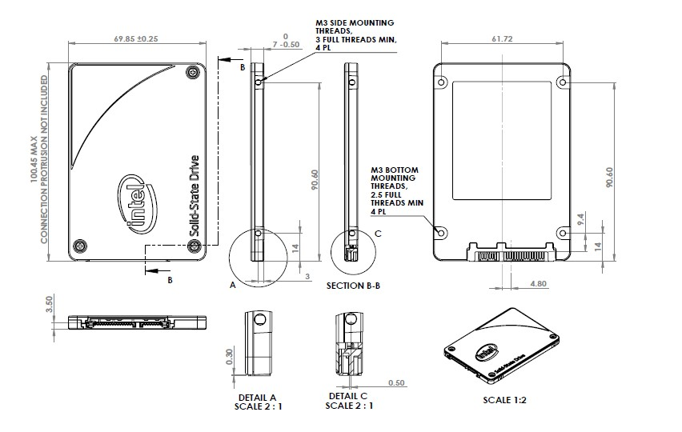

# Pin and Signal Descriptions

## Pin Locations

**Figure**

**2**

**:**

**Layout of Signal and Power Segment Pins**

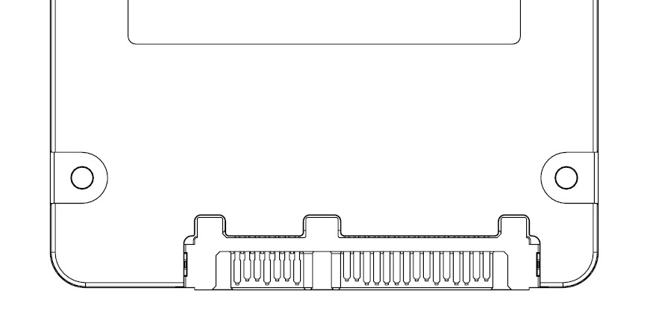

***Note:***

2.5-inch connector supports in-built latching capability.

## Signal Descriptions

### Connector Pin Signal Definitions

**Table 11: Serial ATA Connector Pin Signal Definitions**

|  |  |  |  |
| --- | --- | --- | --- |
| **Pin** | **Function** |  | **Definition** |
| S1 | Ground | 1st mate |  |
| S2 | A+ | Differential signal pair A |  |
|  |  |
| S3 | A- |  |  |
| S4 | Ground | 1st mate |  |
| S5 | B- | Differential signal pair B |  |
|  |  |
| S6 | B+ |  |  |
| S7 | Ground | 1st mate |  |

***Note:***

Key and spacing separate signal and power segments.

## Power Management

The Intel SSD 530 Series supports several power management feature sets as defined by the ATA specification: general Power Management feature set, Advanced Power Management feature set, and Power-Up in Standby (PUIS) feature set.

The Advanced Power Management and PUIS features can be enabled or disabled using the SET FEATURES command.

The Power Management feature set includes the following commands:

* CHECK POWER MODE
* IDLE
* IDLE IMMEDIATE
* SLEEP
* STANDBY
* STANDBY IMMEDIATE

## Security Mode Feature Set

The Intel SSD 530 Series supports the Security Mode command set, which consists of:

* SECURITY SET PASSWORD • SECURITY UNLOCK
* SECURITY ERASE PREPARE
* SECURITY ERASE UNIT
  + Normal Mode – Full NAND erase of user available space and spare area
  + Enhanced Mode – Cryptographically erase data
* SECURITY FREEZE LOCK
* SECURITY DISABLE PASSWORD

## SMART Command Set

The Intel SSD 530 Series supports the SMART command set, which consists of:

* SMART READ DATA
* SMART READ ATTRIBUTE THRESHOLDS
* SMART ENABLE/DISABLE ATTRIBUTE AUTOSAVE
* SMART SAVE ATTRIBUTE VALUES
* SMART EXECUTE OFF-LINE IMMEDIATE
* SMART READ LOG SECTOR
* SMART WRITE LOG SECTOR
* SMART ENABLE OPERATIONS
* SMART DISABLE OPERATIONS
* SMART RETURN STATUS

### SMART Attributes

Table 13 lists the SMART attributes supported by the Intel SSD 530 Series; Table 14 lists the corresponding status flags and threshold settings.

**Table 13: SMART Attributes**

|  |  |  |  |  |  |  |  |  |
| --- | --- | --- | --- | --- | --- | --- | --- | --- |
| **ID** | **Attribute** |  |  | **Status Flags** | | |  | **Threshold** |
| **SP** | **EC** | **ER** | **PE** | **OC** | **PW** |
| 05h | Re-allocated Sector Count  The raw value of this attribute shows the number of retired blocks since leaving the factory (grown defect count). | 1 | 1 | 0 | 0 | 1 | 0 | 0 (none) |
| 09h | Power-On Hours Count  The raw value reports two values: the first 4 bytes report the cumulative number of power-on hours over the life of the device, the remaining bytes report the number of milliseconds since the last hour increment.  The On/Off status of the Device Initiated Power Management (DIPM) feature will affect the number of hours reported. If DIPM is turned On, the recorded value for power-on hours does not include the time that the device is in a "slumber" state. If DIPM is turned Off, the recorded value for power-on hours should match the clock time, as all three device states are counted: active, idle and slumber. | 1 | 1 | 0 | 0 | 1 | 0 | 0 (none) |
| 0Ch | Power Cycle Count  The raw value of this attribute reports the cumulative number of power cycle events over the life of the device. | 1 | 1 | 0 | 0 | 1 | 0 | 0 (none) |
| AAh | Available Reserved Space | 1 | 1 | 0 | 0 | 1 | 1 | 10 |

|  |  |  |  |  |  |  |  |  |
| --- | --- | --- | --- | --- | --- | --- | --- | --- |
| **ID** | **Attribute** | **Status Flags** | | | | | | **Threshold** |
| **SP** | **EC** | **ER** | **PE** | **OC** | **PW** |
| ABh | Program Fail Count  The raw value of this attribute shows total count of program fails and the normalized value, beginning at 100, shows the percent remaining of allowable program fails. | 1 | 1 | 0 | 0 | 1 | 0 | 0 (none) |
| ACh | Erase Fail Count  The raw value of this attribute shows total count of erase fails and the normalized value, beginning at 100, shows the percent remaining of allowable erase fails. | 1 | 1 | 0 | 0 | 1 | 0 | 0 (none) |