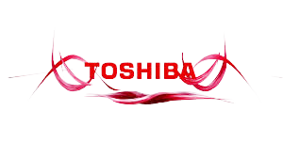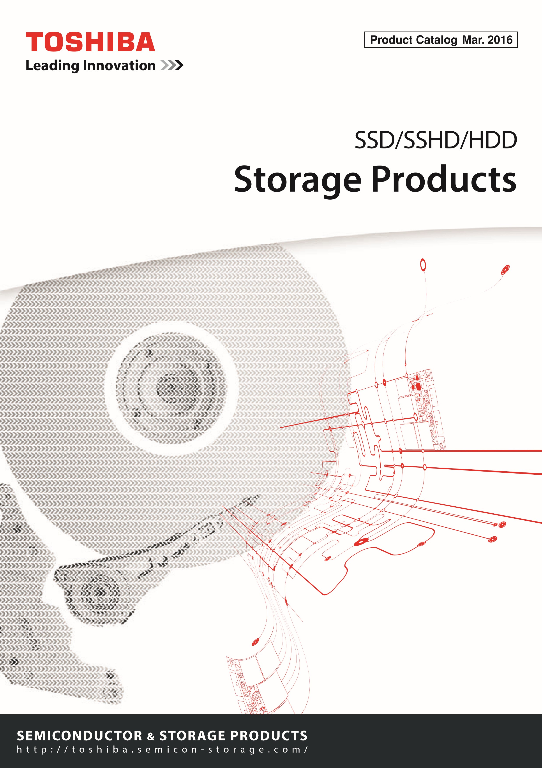

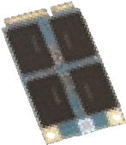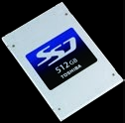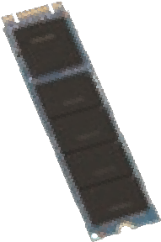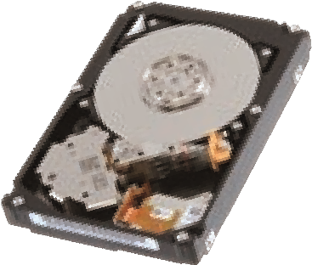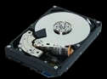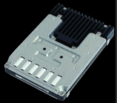

TOSHIBA Storage Products

**Enterprise SSD**

**•**

**Enterprise High Endurance SSD**

**•**

**Enterprise Mid Endurance SSD**

**•**

**Enterprise Value Endurance SSD**

**•**

**Enterprise Read Intensive SSD**

**Client SSD**

**•**

**Non-SED model**

**•**

**SED model**

**Enterprise HDD**

**•**

**Enterprise Performance HDD**

**•**

**Enterprise Capacity HDD**

**•**

**Enterprise Cloud HDD**

**p.7**

**p.4**

**p.10**

Toshiba Corporation

(

Toshiba

)

offers the comprehensive range of storage technologies,

from hard disk drives

(

HDDs

)

, solid state hybrid drives

(

SSHDs

)

, and solid state drives

(

SSDs

)

to NAND flash memories

(

NAND

)

*1

which are for the applications spanning such as the enterprise, mobile, factory

automation, consumer environments.



**SSD**

(

Solid State Drive

)

SSD is a storage product that uses semiconductor memory (NAND flash memory, NAND) as a storage element. Since SSDs have no mechanical moving parts, they are superior to HDDs in terms of: **1) read performance, 2) resistance to shock and vibration and 3) quiet operation.**

Additionally, Toshiba’s SSDs feature low power consumption in standby mode.

# Interface Connector

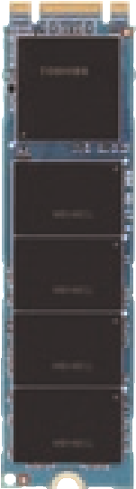

Toshiba’s Enterprise SSDs provide SAS, SATA, and PCIe*2 interfaces, and client SSDs have SATA, mSATA, M.2, and PCIe interfaces.

# Controller

The heart of an SSD that delivers fast read and write performance, prolonged write and erase cycle life and enhanced reliability.

# NAND Flash Memory

Data is stored in a NAND flash memory array, which features Toshiba's MLC (multi-level cell) NAND technology to achieve high storage capacities.



**HDD**

(

Hard Disk Drive

)

HDD is a storage product that magnetically stores data in a disk (recording medium platter). Data is written to and read from a disk, which rotates at high speeds, via a magnetic head that operates very close to the disk surface. Compared to SSDs, increasing storage capacities is easier for HDDs.

Additionally, Toshiba’s **HDDs provide higher cost performance (lower price per gigabyte) than SSDs.**

# Spindle Motor

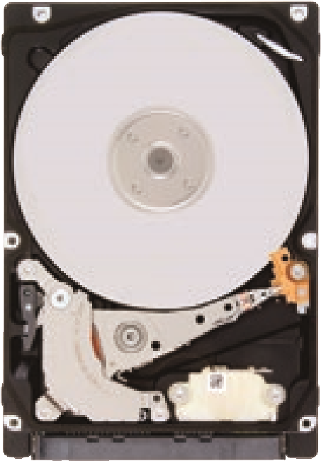

A key part for rotating a disk at high speed. Toshiba’s Enterprise HDDs feature an rpm of 15,000, and 3.5- and 2.5-inch*3 client HDDs typically have rpm's of 7,200 and 5,400 respectively.

Disk (Medium Platter)

Storage media that holds data. In Toshiba’s HDD, 2.5-inch HDDs have a capacity of up to 750 GB*4 per disk, and 3.5-inch HDDs have a capacity as high as 1 TB*4 per disk.

# Magnetic Head

Data is read from and written to a disk via magnetic head.

Interface Connector

Toshiba’s Enterprise HDDs provide SAS and SATA interfaces. Client HDDs have SATA interface.

(The photo shows an example of a double-sided client SSD M.2 module.)

(The photo shows an example of

2.5-inch client HDD.)

1984, Toshiba developed a new type of semiconductor memory called flash memory, leading the industry into the next generation ahead of its competitors. Some time later in 1987, NAND flash memory (NAND) was developed, and this has since been used in a variety of memory cards and electronic equipment. The NAND market has grown rapidly, with flash memory becoming an internationally standardized memory device. Toshiba, the inventor of flash memory, has carved out a path to a new era in which we are all able to carry videos, music and data with us wherever we go.



Invention

▲

**NAND Flash Memory**

▲

**Halogen-Free**

Environment

The built-in type SSD, SSHD, and HDD products in this catalog are classified as Halogen-Free. For the avoidance of doubt, Halogen-Free SSD, SSHD or HDD products may not be entirely free of bromine and chlorine, and may contain any other element of the halogen family. For the definitions of Halogen-Free of Toshiba Semiconductor & Storage Products Company, and details in each product series, please contact your TOSHIBA sales representative in the last page of this catalog.

# RoHS

▲

**Restriction of the use of certain Hazardous Substances**

(2011/65/EU)

The directive adopted by the European Union (EU) that restricts the use of six hazardous materials, lead, mercury, cadmium, hexavalent chromium, polybrominated biphenyls (PBB) and polybrominated diphenyl ether (PBDE), in the manufacture of computers, telecommunication equipment, home appliances, etc. The RoHS directive was recast in 2011 and has been enforced in January 2013. All the SSDs, SSHDs, and HDDs listed in this catalog are compatible with the RoHS directive. For the definitions of RoHS compatibility of Toshiba Semiconductor & Storage Products Company, and details in each product series, please contact your TOSHIBA sales representative in the last page of this catalog.

*1: NAND flash memory (NAND) is a nonvolatile semiconductor memory. *2: PCIe is a registered trademark of PCI-SIG. *3: “2.5-inch” and “3.5-inch” mean the form factors of HDDs or SSDs. They do not indicate drive’s physical size. *4: Definition of capacity: Toshiba defines a megabyte (MB) as 1,000,000 bytes, a gigabyte (GB) as 1,000,000,000 bytes and a terabyte (TB) as 1,000,000,000,000 bytes. A computer operating system, however, reports storage capacity using powers of 2 for the definition of 1GB = 230 = 1,073,741,824 bytes and therefore shows less storage capacity. Available storage capacity (including examples of various media files) will vary based on file size, formatting, settings, software and operating system, such as Microsoft Operating System and/or pre-installed software applications, or media content. Actual formatted capacity may vary.

# Enterprise SSD (eSSD)

Enterprise SSDs are suitable for high-performance Tier 0 computing, server and storage systems that require high level of performance and reliability. Toshiba Enterprise SSDs equip the NAND flash memory (NAND) and controller developed by Toshiba and offer high reliability, data protection incorporating power-loss-protection and encryption technology to support enterprise environments and applications. Light weight and low power consumption will make the systems more energy efficient.

## Enterprise High Endurance SSD

▲

High performance enterprise-class solid state storage providing higher level of endurance for write-intensive applications and systems, such as write caching, acceleration and OLTP (On-Line Transaction Process) services.

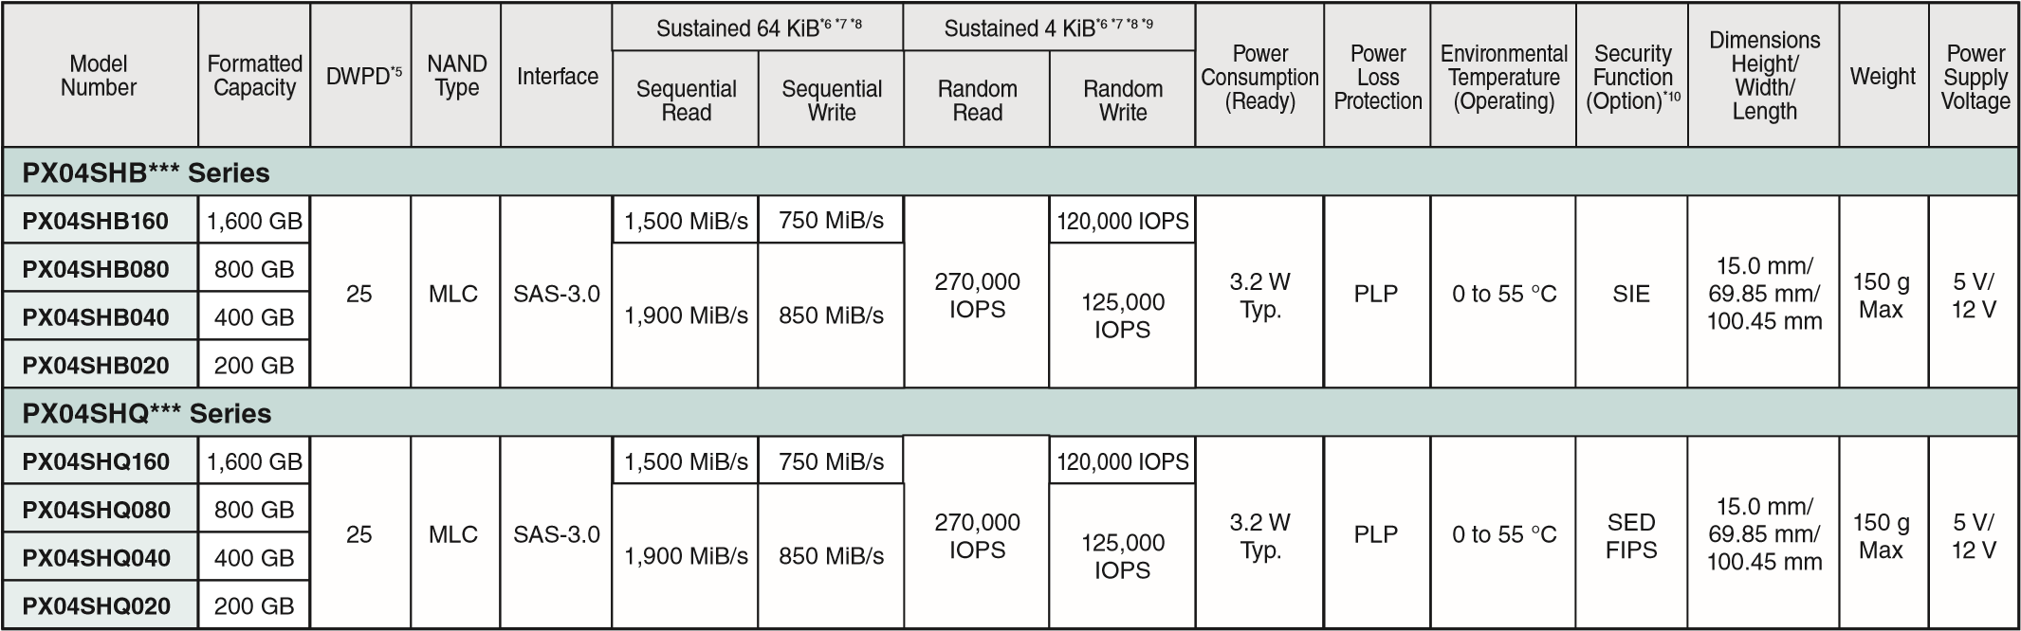

## Enterprise Mid Endurance SSD

▲

|  |  |  |  |  |  |  |  |  |  |  |  |  |  |  |  |
| --- | --- | --- | --- | --- | --- | --- | --- | --- | --- | --- | --- | --- | --- | --- | --- |
| High performance enterprise-class solid stat | Formatted Capacity | Rotation Speed | Interface | Interface  Speed | Logical Data | Block Length | Buffer Size*6 | Power  Supply  Voltage | Power Co | nsumption | Dimensions  Height/  Width/ Length | Weight | Environmental  Temperature  (Operating) | Shock  (Operating) | Remarks |
| HOST | DISK | Read  /Write | Low Power  Idle |
| **MD04ABA***V** | **Series** | *12 |  |  |  |  |  |  |  |  |  |  |  |  |  |
| **MD04ABA500V** | 5 TB | Low | SATA-2.6 | 6.0 Gbit/s | 512 B | 4,096 B | 128 | 5 V/ | 6.5 W | 3.5 W | 26.1 mm/ | 720 g | 0 to | 686 m/s2 |  |
| **MD04ABA400V** | 4 TB | spin | /3.0 | 3.0 Gbit/s  1.5 Gbit/s |  |  | MiB | 12 V | Typ. | Typ. | 101.6 mm/ 147 mm | Max | 70 °C | {70 G}(2 ms half sine) |  |
| **MD03ACA***V** | **Series** |  |  |  |  |  |  |  |  |  |  |  |  |  |  |
| **MD03ACA400V** | 4 TB |  |  | 6.0 Gbit/s |  |  |  |  |  |  | 26.1 mm/ |  |  | 686 m/s2 |  |
| **MD03ACA300V** | 3 TB | 7,200 rpm | SATA-2.6 /3.0 | 3.0 Gbit/s | 512 B | 512 B | 64  MiB | 5 V/ 12 V | 11.3 W Typ. | 6.0 W Typ. | 101.6 mm/ | 720 g Max | 0 to 70 °C | {70 G}(2 ms |  |
| **MD03ACA200V** | 2 TB |  |  | 1.5 Gbit/s |  |  |  |  |  |  | 147 mm |  |  | half sine) |  |

## Automotive HDD

▲

Ruggedized small form factor storage solutions for extreme environmental (temperature, vibration and altitude) applications.

|  |  |  |  |  |  |  |  |  |  |  |  |  |  |  |  |
| --- | --- | --- | --- | --- | --- | --- | --- | --- | --- | --- | --- | --- | --- | --- | --- |
| Model Number | Formatted Capacity | Rotation Speed | Interface | Interface  Speed | Logical Data | Block Length | Buffer Size*6 | Power  Supply  Voltage | Power Co | nsumption | Dimensions  Height/  Width/ Length | Weight | Environmental  Temperature  (Operating) | Shock  (Operating) | Remarks |
| HOST | DISK | Read  /Write | Low Power  Idle |
| **MQ01AAD\*\*\*** | **C Series** | *12 |  |  |  |  |  |  |  |  |  |  |  |  |  |
| **MQ01AAD032C** | 320 GB |  |  |  |  |  |  |  |  |  | 9.5 mm/ |  |  | 2,940 m/s2 |  |
| **MQ01AAD020C** | 200 GB | 4,200 rpm | SATA-2.6 /ATA8 | 3.0 Gbit/s  1.5 Gbit/s | 512 B | 4,096 B | 8 MiB | 5 V | 2.0 W Typ. | 0.8 W Typ. | 69.85 mm/ | 109 g Max | -30 to 85 °C | {300 G} (2 ms |  |
| **MQ01AAD010C** | 100 GB |  |  |  |  |  |  |  |  |  | 100.0 mm |  |  | half sine) |  |

**ba America Electronic Components, Inc.**

* Irvine, Headquarters

Tel: (949)462-7700 Fax: (949)462-2200

* Austin

Tel: (512)342-9041 Fax: (512)342-9414

* Buffalo Grove (Chicago)

Tel: (847)484-2400 Fax: (847)541-7287

* Duluth/Atlanta

Tel: (770)931-3363 Fax: (770)931-7602

* El Paso

Tel: (915)533-4242

* Houston

Tel: (281)655-2100 Fax: (281)655-2120

* Marlborough

Tel: (508)481-0034 Fax: (508)481-8828

* Parsippany

Tel: (973)541-4715 Fax: (973)541-4716

* San Jose

Tel: (408)324-5700 Fax: (408)324-5903

* Wixom (Detroit) Tel: (248)347-2607 Fax: (248)347-2602

**TOSHIBA América do Sul Ltda.**

Tel: (011)4083-7978

**Toshiba India Private Ltd.**

* New Delhi Office

Tel: (0124)499-6600 Fax: (0124)499-6611

* Bangalore Office Tel: (080)251-90800 Fax: (080)490-91945
* Mumbai Office

Tel: (022)619-11500 Fax: (022)619-11540

**Toshiba Electronics Europe GmbH**

* Düsseldorf Head Office

Tel: (0211)5296-0 Fax: (0211)5296-400

* France Branch

Tel: (1)47282181

* Italy Branch

Tel: (039)68701 Fax: (039)6870205

* Munich Office

Tel: (089)20302030 Fax: (089)203020310

* Spain Branch

Tel: (91)660-6798 Fax: (91)660-6799

* Sweden Branch

Tel: (08)704-0900 Fax: (08)80-8459

* U.K. Branch

Tel: (1932)841600

**Toshiba Vietnam Consumer Products Co.,Ltd.**

Tel: (043)776-5950 Fax: (043)776-5956

**Toshiba Electronics Asia (Singapore) Pte. Ltd.**

Tel: (6278)5252 Fax: (6271)5155

**Toshiba Electronics Service (Thailand) Co., Ltd.**

Tel: (02)835-3491 Fax: (02)835-3490

**Toshiba Electronics Trading (Malaysia)Sdn. Bhd.**

* Kuala Lumpur Head Office

Tel: (03)5631-6311 Fax: (03)5631-6307

* Penang Office

Tel: (04)226-8523 Fax: (04)226-8515

**Toshiba Electronics (China) Co., Ltd.**

* Shanghai Head Office

Tel: (021)6139-3888 Fax: (021)6190-8288

* Beijing Branch

Tel: (010)6590-8796

* Chengdu Branch

Tel: (028)8675-1773

* Hangzhou Office

Tel: (0571)8717-5004

* Huangpu Branch

Tel: (021)6135-3977

* Nanjing Office

Tel: (025)8689-0070

* Qingdao Branch

Tel: (532)8579-3328

* Shenzhen Branch

Tel: (0755)3686-0880

* Dalian Branch

Tel: (0411)8368-6882

* Chongqing Office Tel: 023-62946355
* Xiamen Branch

Tel: (0592)226-1398

* Dongguan Branch

Tel: (0769)8155-6858

**Toshiba Electronics Asia, Ltd.**

Tel: 2375-6111 Fax: 2375-0969 **Toshiba Electronics Korea Corporation**

Tel: (02)3484-4334 Fax: (02)3484-4302



Toshiba Corporation, and its subsidiaries and affiliates (collectively "TOSHIBA"), reserve the right to make changes to related hardware, software and systems (collectively "Product") without notice.

(

As of April 15,

2015)

**SUBSIDIARIES AND AFFILIATES**

Fax: (010)6590-8791

Fax: (028)8675-1065

Fax: (0571)8717-5013

Fax: (021)6135-3955

Fax: (025)8689-0125

Fax: (532)8579-3329

Fax: (0755)3686-0816

Fax: (0411)8369-0822

Fax: 023-62946356

Fax: (0592)226-1399

Fax: (0769)8155-6368

**Toshiba Electronic Components Taiwan Corporation**

Tel: (02)2508-9988 Fax: (02)2508-9999

**RESTRICTIONS ON PRODUCT USE**

Previous edition: BCE0106G

BCE0106H

**Storage Products**

SSD/SSHD/HDD

**Mar. 2016**

This document and any information herein may not be reproduced without prior written permission from TOSHIBA. Even with TOSHIBA's written permission, reproduction is permissible only if reproduction is without alteration/omission.

or incorporate the Product into their own applications, customers must also refer to and comply with (a) the latest versions of all relevant TOSHIBA information, including without limitation, this document, the specifications, the data sheets and application notes for Product and the precautions and conditions set forth in the "TOSHIBA Semiconductor Reliability Handbook" and (b) the instructions for the application with which the Product will be used with or for. Customers are solely responsible for all aspects of their own product design or applications, including but not limited to (a) determining the appropriateness of the use of this Product in such design or applications; (b) evaluating and determining the applicability of any information contained in this document, or in charts, diagrams, programs, algorithms, sample application circuits, or any other referenced documents; and (c) validating all operating parameters for such designs and applications. **TOSHIBA ASSUMES NO LIABILITY FOR CUSTOMERS' PRODUCT DESIGN OR APPLICATIONS.**

**PRODUCT IS NEITHER INTENDED NOR WARRANTED FOR USE IN EQUIPMENTS OR SYSTEMS THAT REQUIRE EXTRAORDINARILY HIGH LEVELS OF QUALITY AND/OR RELIABILITY, AND/OR A MALFUNCTION OR FAILURE OF WHICH MAY CAUSE LOSS OF HUMAN LIFE, BODILY INJURY, SERIOUS PROPERTY DAMAGE AND/OR**

**SERIOUS PUBLIC IMPACT ("UNINTENDED USE").** Except for specific applications as expressly stated in this document, Unintended Use includes, without limitation, equipment used in nuclear facilities, equipment used in the aerospace industry, medical equipment, equipment used for automobiles, trains, ships and other transportation, traffic signaling equipment, equipment used to control combustions or explosions, safety devices, elevators and escalators, devices related to electric power, and equipment used in finance-related fields. **IF YOU USE PRODUCT FOR UNINTENDED USE, TOSHIBA ASSUMES NO LIABILITY FOR PRODUCT.** For details, please contact your TOSHIBA sales representative.

Do not disassemble, analyze, reverse-engineer, alter, modify, translate or copy Product, whether in whole or in part.

Product shall not be used for or incorporated into any products or systems whose manufacture, use, or sale is prohibited under any applicable laws or regulations.

The information contained herein is presented only as guidance for Product use. No responsibility is assumed by TOSHIBA for any infringement of patents or any other intellectual property rights of third parties that may result from the use of Product. No license to any intellectual property right is granted by this document, whether express or implied, by estoppel or otherwise.

**ABSENT A WRITTEN SIGNED AGREEMENT, EXCEPT AS PROVIDED IN THE RELEVANT TERMS AND CONDITIONS OF SALE FOR PRODUCT, AND TO THE MAXIMUM EXTENT ALLOWABLE BY LAW, TOSHIBA (1) ASSUMES NO LIABILITY WHATSOEVER, INCLUDING WITHOUT LIMITATION, INDIRECT, CONSEQUENTIAL, SPECIAL, OR INCIDENTAL DAMAGES OR LOSS, INCLUDING WITHOUT LIMITATION, LOSS OF PROFITS, LOSS OF OPPORTUNITIES, BUSINESS INTERRUPTION AND LOSS OF DATA, AND (2) DISCLAIMS ANY AND ALL EXPRESS OR IMPLIED WARRANTIES AND CONDITIONS RELATED TO SALE, USE OF PRODUCT, OR INFORMATION, INCLUDING WARRANTIES OR CONDITIONS OF MERCHANTABILITY, FITNESS FOR A PARTICULAR PURPOSE, ACCURACY OF INFORMATION, OR NONINFRINGEMENT.**

Do not use or otherwise make available Product or related software or technology for any military purposes, including without limitation, for the design, development, use, stockpiling or manufacturing of nuclear, chemical, or biological weapons or missile technology products (mass destruction weapons). Product and related software and technology may be controlled under the applicable export laws and regulations including, without limitation, the Japanese Foreign Exchange and Foreign Trade Law and the U.S. Export Administration Regulations. Export and re-export of Product or related software or technology are strictly prohibited except in compliance with all applicable export laws and regulations.

Product may include products subject to foreign exchange and foreign trade control laws.

Please contact your TOSHIBA sales representative for details as to environmental matters such as the RoHS compatibility of Product. Please use Product in compliance with all applicable laws and regulations that regulate the inclusion or use of controlled substances, including without limitation, the EU RoHS Directive. **TOSHIBA ASSUMES NO LIABILITY FOR DAMAGES OR LOSSES OCCURRING AS A RESULT OF NONCOMPLIANCE WITH APPLICABLE LAWS AND REGULATIONS.**

**2016**

**Semiconductor & Storage Products Company**

### Website: http://www.toshibastorage.com