* 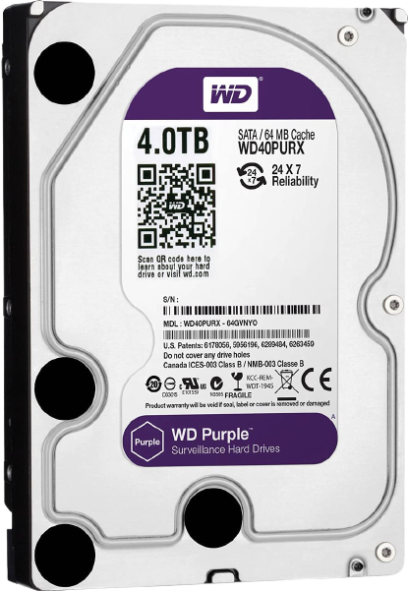Capacity up to 12TB

WD Purple™ drives are built for 24/7, always-on, high-definition security

systems. WD Purple™ surveillance storage feature Western Digital’s exclusive

AllFrame™ technology, so you can confidently create a security system tailored

to the needs of your business. Using AllFrame™ technology, WD Purple™

drives improve video capturing and helps to reduce errors, pixelation, and

video interruptions that could happen in a video recorder system. WD Purple

drives have an enhanced workload rating that supports systems designed for

x7 video recording with up to 64 cameras.

24

**Industry-leading storage. Surveillance you can trust.**

Western Digital is a worldwide leader in the hard drive industry. With WD Purple surveillance

storage, you have a drive engineered for high temperature, always-on surveillance systems

so you can rely on quality video playback when you need it most. Whether you’re protecting

loved ones or monitoring your business, WD Purple offers performance you can trust.



**DATA SHEET**

**SURVEILLANCE HARD DRIVES**

**WD Purple**

**™**

**Highlights**

* Support for up to 64 cameras per drive
* AllFrame™ technology
* Up to 16 AI channels for Deep Learning analytics on AI-enabled NVRs (10TB & 12TB capacities)
* MTBF of up to 1.5 million hours
* 3-year limited warranty

|  |  |
| --- | --- |
| **INTERFACE**  SATA 6 Gb/s  **FORM FACTOR**  3.5-inch | **PERFORMANCE CLASS**  5400 / 7200 RPM Class  **CAPACITIES**  1TB to 12TB |

**MODEL NUMBERS**

WD10PURZ WD40PURZ WD81PURZ

WD121PURZ WD20PURZ WD60PURZ WD100PURZ WD30PURZ WD80PURZ WD101PURZ

# THE WESTERN DIGITAL ADVANTAGE

Western Digital puts our products through extensive Functional Integrity Testing (F.I.T.) prior to any product launch. This testing ensures our products consistently meet the highest quality and reliability standards of the Western Digital brand.

Western Digital also has a detailed Knowledge Base with more than 1,000 helpful articles as well as software and utilities. Our customer support lines have long operational hours to ensure you get the help you need when you need it. Our toll-free customer support lines are here to help, or you can access our Western Digital Support site for additional details.

# Western Digital’s Exclusive AllFrame Technology

All WD Purple drives are equipped with AllFrame technology, which improves ATA streaming to help reduce frame loss, improve overall video playback, and increase the number of hard drive bays supported within a NVR. Help make your surveillance solution future-ready knowing that WD Purple drives are ready for ultra high definition cameras. WD Purple capacities up to 8TB feature AllFrame 4K technology enabling high quality recording for up to 64 cameras. WD Purple 10TB and 12TB capacities feature AllFrame AI technology that enables not only recording up to 64 cameras, but also an additional 32 streams for Deep Learning analytics within the system.

# Enhanced Workload Ratings

WD Purple drives with AllFrame 4K technology feature a workload rating of up to 180TB/year - up to three times that of desktop drives - to handle the unique demands of modern video surveillance DVR and NVR systems. WD Purple 10TB and 12TB drives with AllFrame AI feature a workload rating up to 360TB/year to support the Deep Learning analytics that are features in AI capable NVRs.

# Expand your view to 64

Each WD Purple drive is optimized to support up to 64 cameras. With so many options, you have the flexibility to upgrade or expand your security system in the future.

# Designed for Today’s and Tomorrow’s Surveillance Solutions

With an MTBF of up to 1.5 million hours¹, WD Purple drives are engineered for mainstream surveillance DVRs and NVRs that operate 24/7. With support for more than eight bays² and tarnish resistant components², WD Purple drives deliver reliable operation in large scale surveillance systems in harsh environments.

# Field-proven High Capacity

Now on its 4th generation and with more than 27 million drives shipped³, field-proven HelioSeal™ technology delivers trusted high-capacity WD Purple storage (8TB, 10TB, and 12TB) for the massive storage needs of 4K surveillance video.

**Wide Compatibility. Seamless Integration.**

WD Purple hard drives are built with compatibility in mind, so you can quickly and seamlessly add capacity to your surveillance system. With a wide range of industry-leading enclosures and chipsets supported, you’re sure to find the DVR or NVR configuration that’s right for you.

**Low Power. High efficiency.**

With our exclusive IntelliSeek™ technology, WD Purple drives are able to calculate optimum seek speeds. This keeps power consumption low so ambient noise and vibrations are at a minimum.

# Three Year Limited Warranty

As an industry-leading hard drive manufacturer, WD stands behind their surveillance storage solutions with a 3-year limited warranty included with every WD Purple drive.

|  |  |  |  |  |  |  |  |  |  |  |
| --- | --- | --- | --- | --- | --- | --- | --- | --- | --- | --- |
| Read/Write  Idle  Standby and Sleep | 6.6 5.6  0.6 | 6.3  5.2  0.5 | 6.2  5.0  0.5 | 9.0  8.12  0.8 | 6.4  5.7  0.7 | 5.3  4.9  0.4 | 5.1  4.5  0.4 | 4.4  4.1  0.4 | 4.4  4.1  0.4 | 3.3  2.9  0.4 |

# WD Purple™



**DATA SHEET**

**SURVEILLANCE HARD DRIVES**

|  |  |  |  |  |  |  |  |  |  |  |
| --- | --- | --- | --- | --- | --- | --- | --- | --- | --- | --- |
| **Specifications⁵** | **12TB** | **10TB** | **10TB** | **8TB** | **8TB** | **6TB** | **4TB** | **3TB** | **2TB** | **1TB** |
| **Model Number⁴** | WD121PURZ | WD101PURZ | WD100PURZ | WD81PURZ | WD80PURZ | WD60PURZ | WD40PURZ | WD30PURZ | WD20PURZ | WD10PURZ |

**Environmental Specifications11**

Temperature (°C, on the base casting)

Operating12 0 to 65 0 to 65 0 to 65 0 to 65 0 to 65 0 to 65 0 to 65 0 to 65 0 to 65 0 to 65

Non-operating -40 to 70 -40 to 70 -40 to 70 -40 to 70 -40 to 70 -40 to 70 -40 to 70 -40 to 70 -40 to 70 -40 to 70

Shock (Gs)

Operating (2 ms, read/write) 30 30 30 30 30 30 30 30 30 30