**Below are the screeshots of the cancer prediction Web application on local host**

Data provided for Malignant cancer --

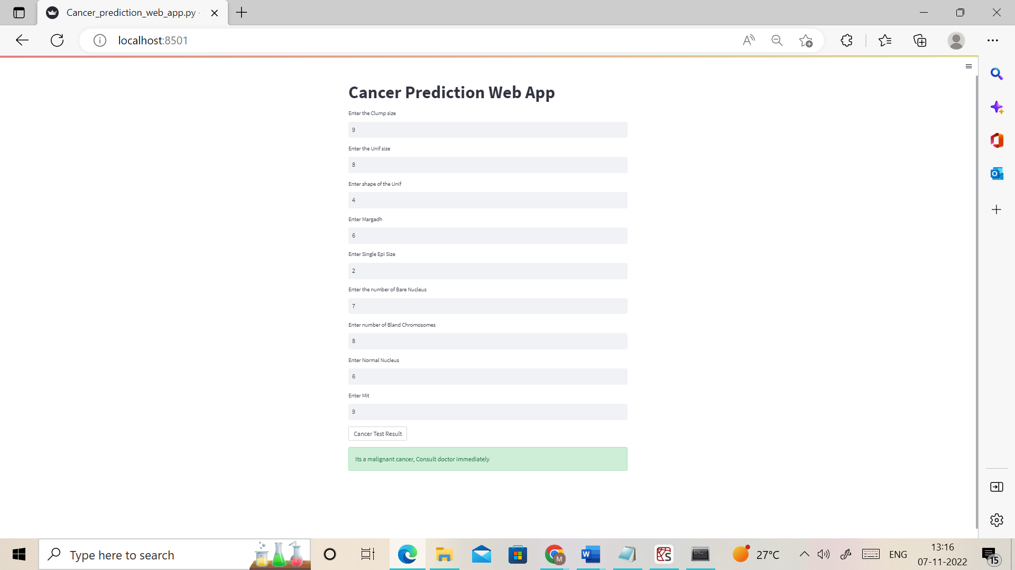

Data provided for Benin cancer – 