Citywheels Ride Booking Database

TABLE OF CONTENTS

- Introduction ------------------------------------------------------------------------------------ 2
- Executive Summary --------------------------------------------------------------------------- 4
- Database Design ------------------------------------------------------------------------------- 5
- Sample Data ------------------------------------------------------------------------------------ 8
- Business Queries ------------------------------------------------------------------------------ 10
- Conclusion -------------------------------------------------------------------------------------- 20

1. INTRODUCTION

1.1 Project Background
CityWheels is a burgeoning ride-hailing service operating in Pakistan, with ambitious plans for global expansion into GCC countries and beyond. In today's digital economy, data-driven decision-making and efficient management of transportation services require a robust, scalable, and secure database infrastructure. This documentation presents the complete database management system designed specifically for CityWheels's operational needs.

1.2 Purpose and Scope
The CityWheels Ride-Hailing Database System serves as the technological backbone for managing all aspects of the ride-hailing platform, including:
- Driver and passenger profile management
- Ride booking and history tracking
- Payment processing and financial records
- Customer ratings and feedback systems
- Promotional offer management
- Customer support ticketing

1.3 Objectives
This project aims to achieve the following objectives:
- Design a normalized, efficient database structure adhering to 3NF principles
- Implement complex business queries for data analysis and decision-making
- Ensure data integrity through proper constraints and relationships
- Address legal and ethical considerations for cross-border data sharing
- Provide a scalable architecture capable of supporting future growth

1.4 Document Structure
This documentation is organized into the following sections:
- Database Design - ER diagrams and relational schemas
- Schema Documentation - Detailed table structures
- Sample Data - Data population and statistics
- Business Queries - Analytical SQL implementations
- Legal Research - Cross-border data compliance analysis
- Implementation Guide - Installation and usage instructions

1.5 Target Audience
This documentation is intended for:
- Database administrators managing the CityWheels platform
- Developers integrating applications with the database
- Business analysts extracting insights for decision-making
- Legal and compliance teams reviewing data protection measures
- Academic evaluators assessing the database design

2. EXECUTIVE SUMMARY
The CityWheels Ride-Hailing Database System is a comprehensive MySQL-based solution designed to manage all operational aspects of a modern ride-hailing service. Developed as part of the Database Systems course, this project demonstrates professional database design principles, complex query implementation, and real-world business logic application.

Key Achievements:
- ✅ 12 normalized tables with proper relationships
- ✅ 500+ sample records across all entities
- ✅ 10 complex analytical business queries
- ✅ Complete ERD and relational schema diagrams
- ✅ Legal research on cross-border data compliance (PDPL & GDPR)

3. DATABASE DESIGN
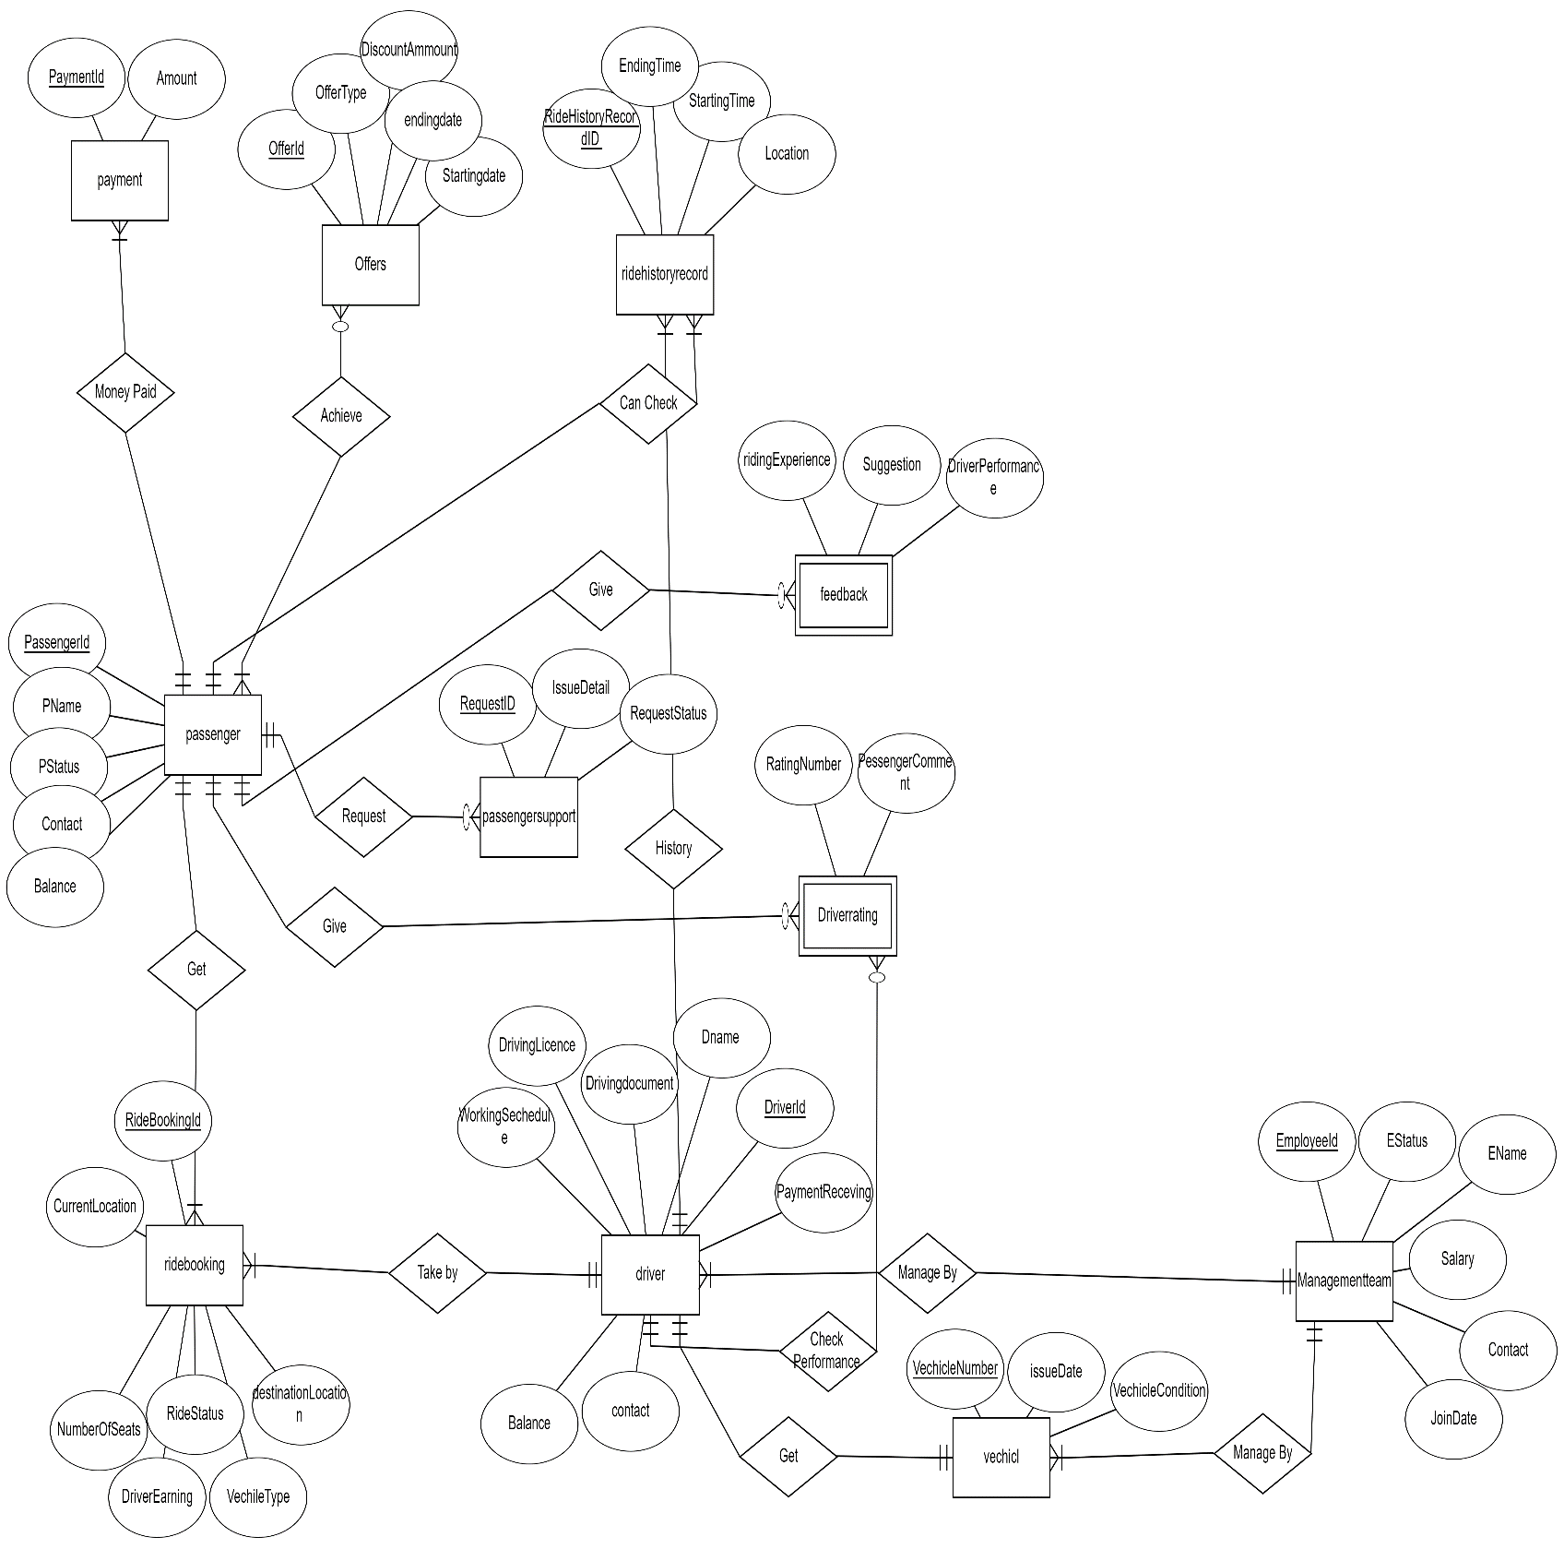
3.1 Entity Relationship Diagram (ERD)

Figure 1: Physical ERD showing all tables, attributes, and relationships
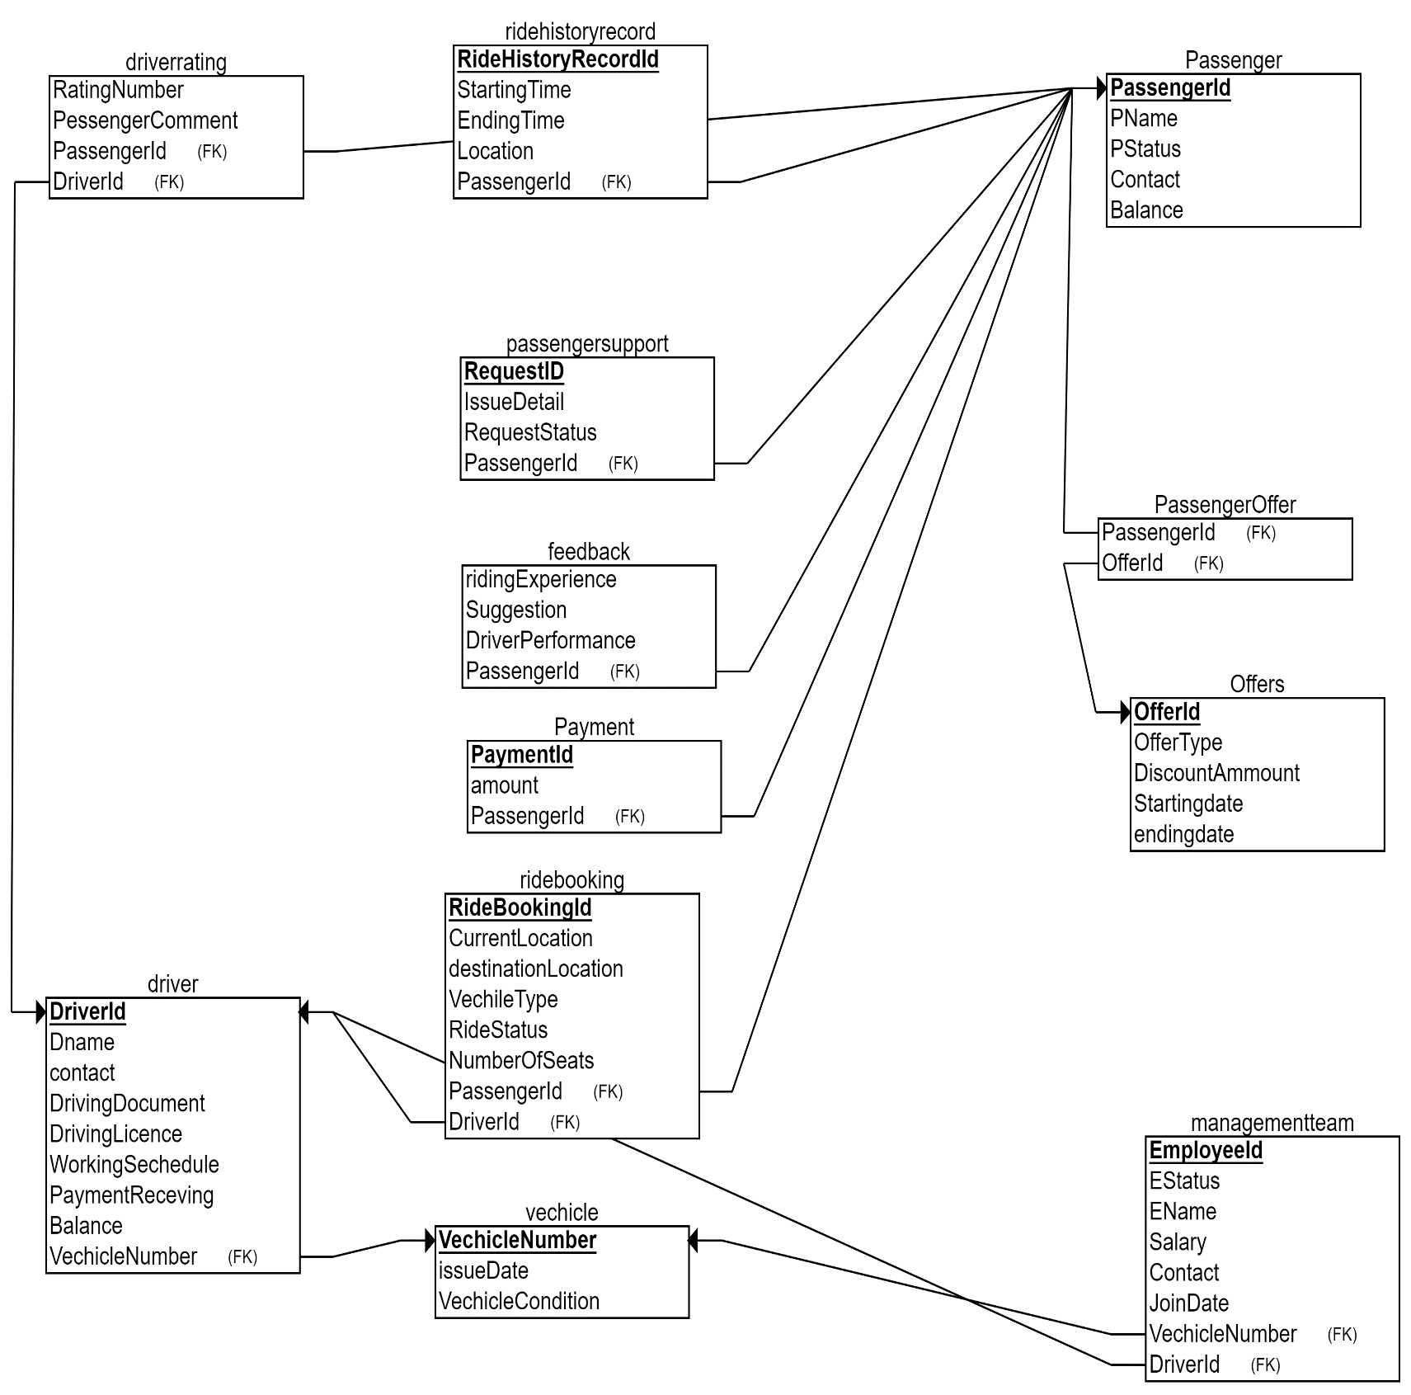
3.2 Relational Schema

Figure 2: Relational schema with primary and foreign key relationships

3.3 Design Methodology
The database follows these design principles:
- Normalization: 3NF compliance to eliminate redundancy
- Referential Integrity: Foreign key constraints across all relationships
- Data Types: Appropriate data types for efficient storage
- Naming Conventions: Consistent PascalCase for tables and columns
3.4 Relationships Overview
Relationship Type | Tables Involved | Description
One-to-Many | Driver → RideBooking | One driver can have many ride bookings
One-to-Many | Passenger → RideBooking | One passenger can have many ride bookings
One-to-Many | Driver → DriverRating | One driver can receive many ratings
One-to-Many | Passenger → PassengerSupport | One passenger can create many support tickets
Many-to-Many | Passenger ↔ Offers | Passengers can avail multiple offers, offers can be availed by multiple passengers (resolved through PassengerOffer junction table)

4. SAMPLE DATA

4.1 Data Population Statistics
Table | Record Count
Vehicle | 50
Driver | 50
Passenger | 50
DriverRating | 50
ManagementTeam | 50
RideBooking | 54
Feedback | 50
RideHistoryRecord | 50
PassengerSupport | 50
Offers | 50
PassengerOffer | 50
Payment | 50
Total Records: 600+ records

4.2 Sample Data Screenshots
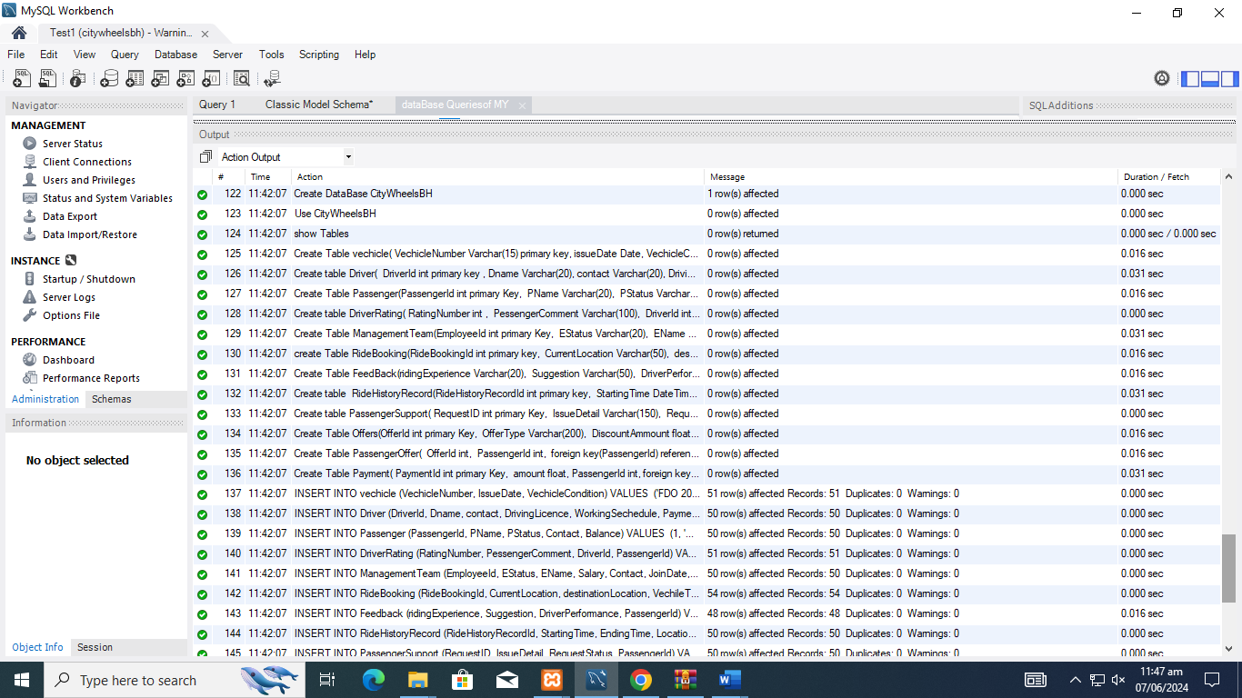
Figure 3: data insertion screenshots
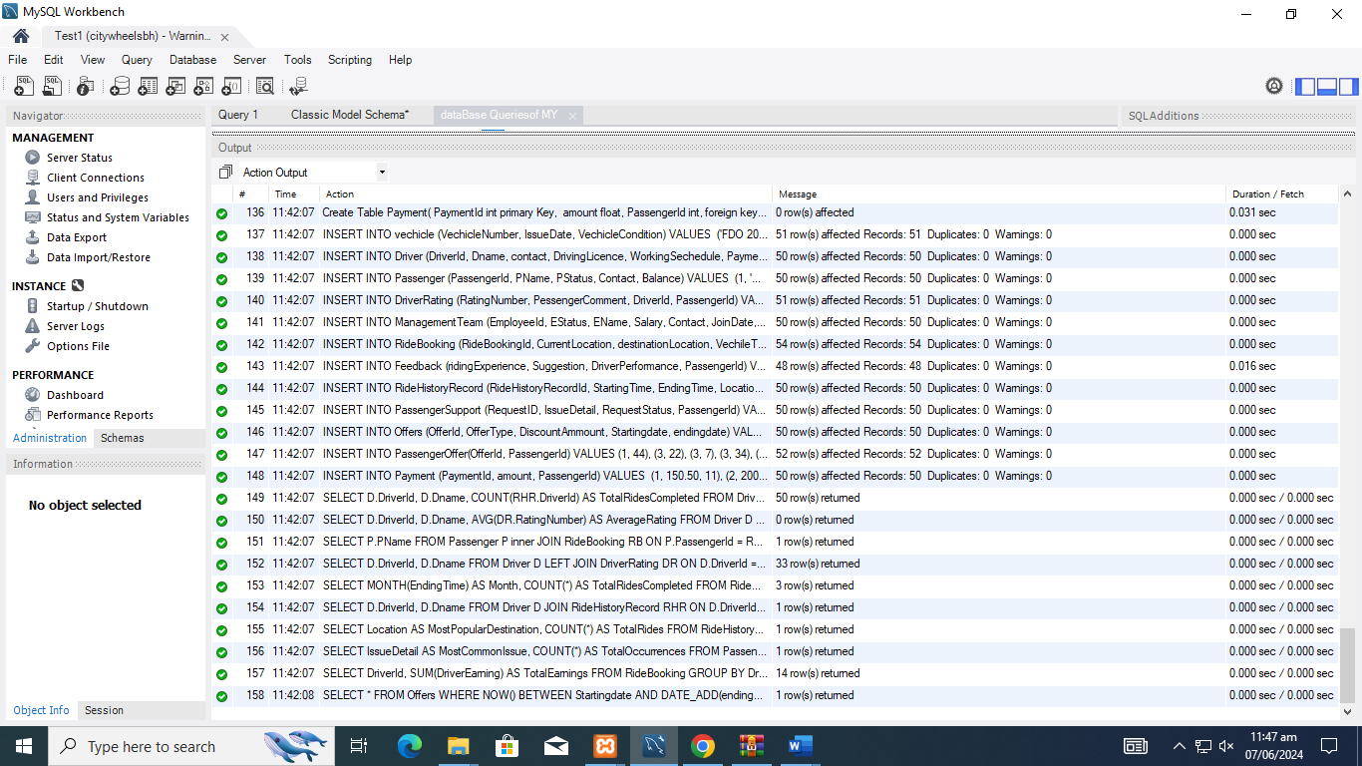
Figure 4: data insertion screenshots

5. BUSINESS QUERIES
5.1 Query 1: Driver Performance Analysis
Purpose: List drivers and the total number of rides they have completed.
SQL Query:
SELECT D.DriverId, D.Dname, COUNT(RHR.DriverId) AS TotalRidesCompleted
FROM Driver D
LEFT JOIN RideHistoryRecord RHR ON D.DriverId = RHR.DriverId
GROUP BY D.DriverId, D.Dname;
Business Value: Identifies top-performing drivers and those with low ride counts.
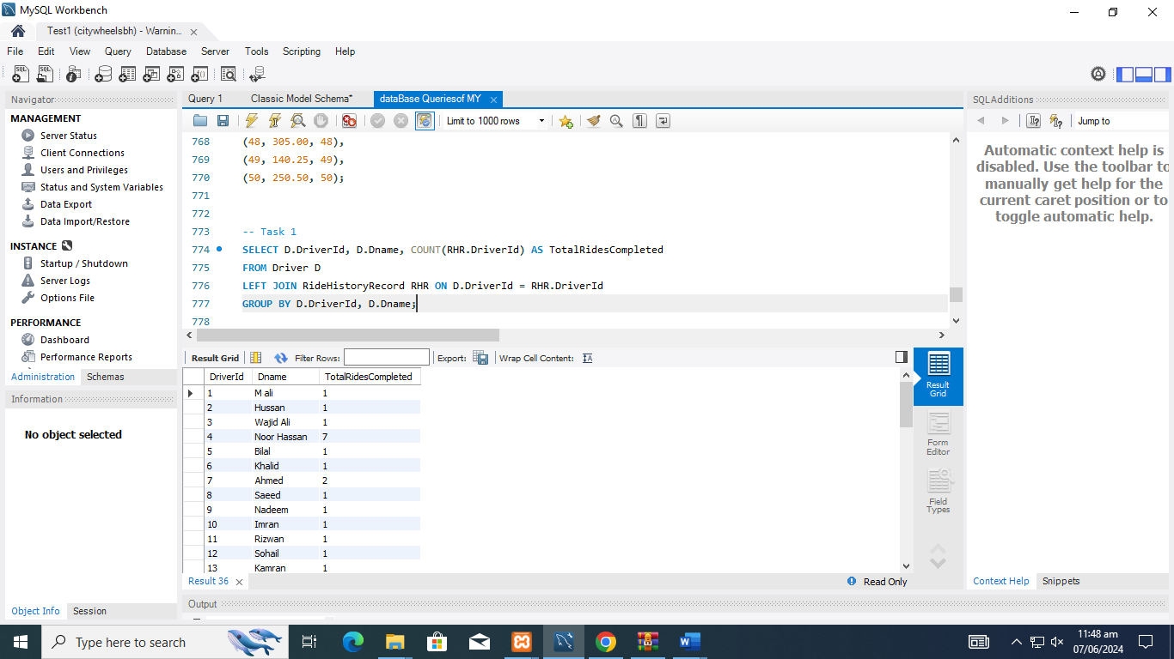

5.2 Query 2: High-Performance Driver Ratings
Purpose: Find the average rating of drivers who have completed more than 50 rides.
SQL Query:
SELECT D.DriverId, D.Dname, AVG(DR.RatingNumber) AS AverageRating
FROM Driver D
JOIN DriverRating DR ON D.DriverId = DR.DriverId
GROUP BY D.DriverId, D.Dname
HAVING COUNT(DR.DriverId) > 50;
Note: Returns no rows as no driver has completed 50+ rides in sample data.
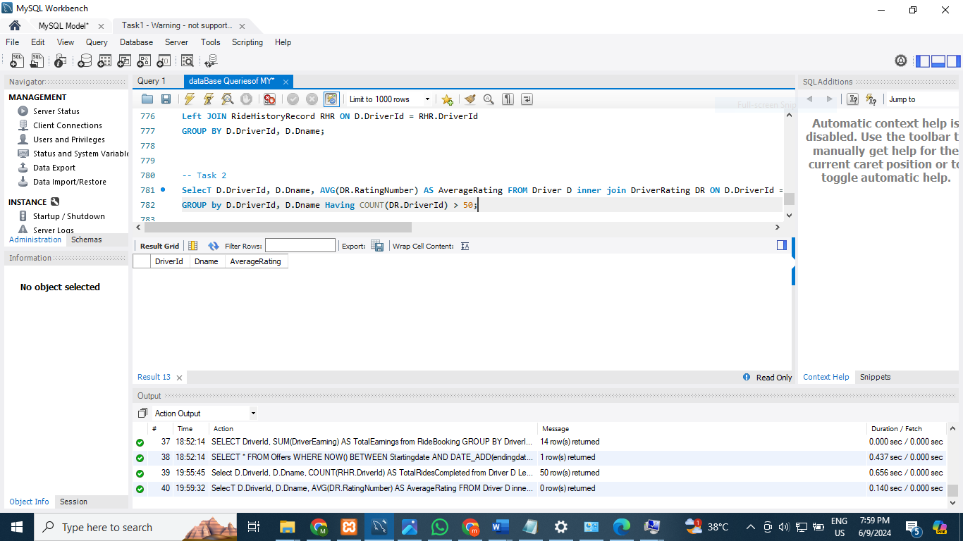

5.3 Query 3: Frequent Passengers
Purpose: List passengers who have used CityWheels more than 20 times.
SQL Query:
SELECT P.PName
FROM Passenger P
INNER JOIN RideBooking RB ON P.PassengerId = RB.PassengerId
GROUP BY P.PassengerId, P.PName
HAVING COUNT(RB.PassengerId) > 20;
Business Value: Identifies loyal customers for targeted marketing.
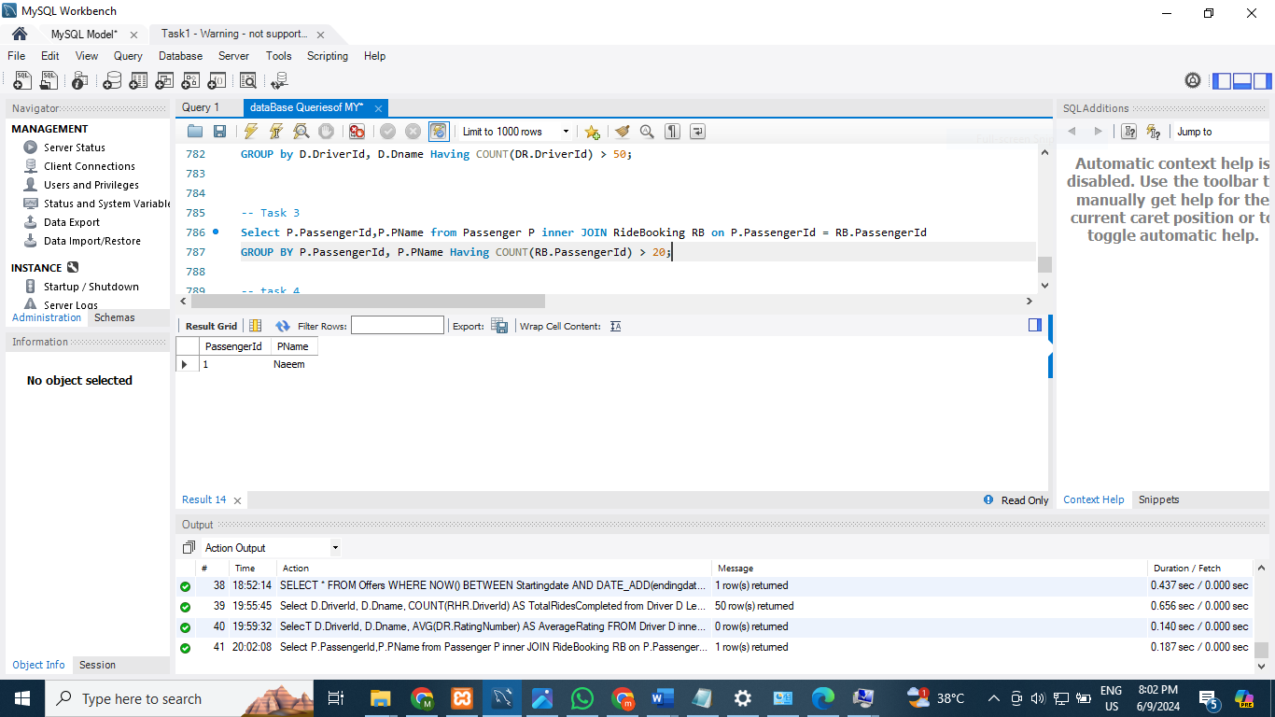

5.4 Query 4: Consistently High-Rated Drivers
Purpose: Identify drivers who have never received a rating below 4.
SQL Query:
SELECT D.DriverId, D.Dname
FROM Driver D
LEFT JOIN DriverRating DR ON D.DriverId = DR.DriverId
GROUP BY D.DriverId, D.Dname
HAVING COALESCE(MIN(DR.RatingNumber), 5) >= 4;
Business Value: Recognizes excellence for rewards and incentives.
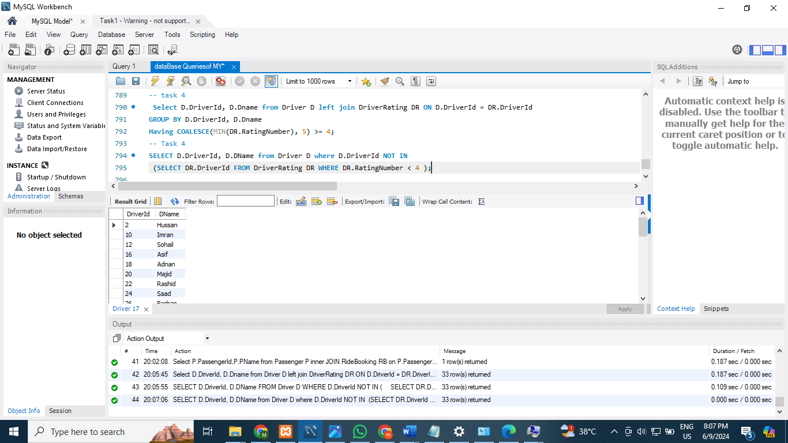

5.5 Query 5: Monthly Ride Trends
Purpose: Find the total number of rides completed in each month of the current year.
SQL Query:
SELECT MONTH(EndingTime) AS Month, COUNT(*) AS TotalRidesCompleted
FROM RideHistoryRecord
WHERE YEAR(EndingTime) = YEAR(CURRENT_DATE())
GROUP BY MONTH(EndingTime);
Business Value: Seasonal trend analysis for resource planning.
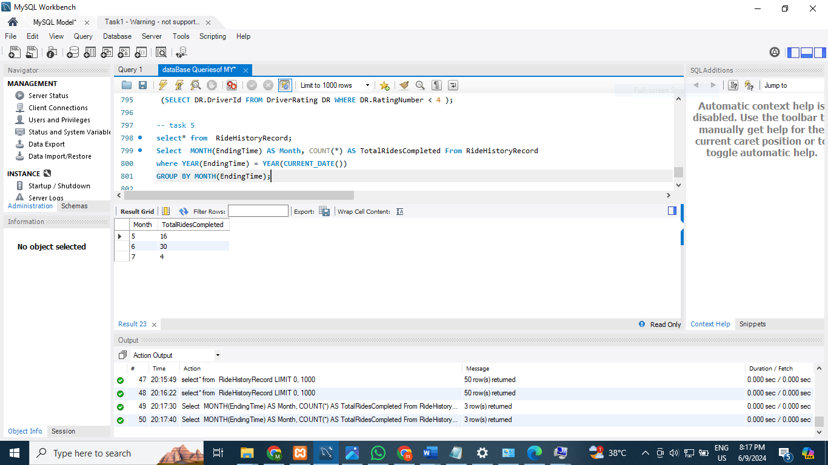

5.6 Query 6: Driver-Passenger Diversity
Purpose: Show drivers who have completed rides with at least three different passengers.
SQL Query:
SELECT D.DriverId, D.Dname
FROM Driver D
JOIN RideHistoryRecord RHR ON D.DriverId = RHR.DriverId
GROUP BY D.DriverId, D.Dname
HAVING COUNT(DISTINCT RHR.PassengerId) >= 3;
Business Value: Identifies drivers with broad customer reach.
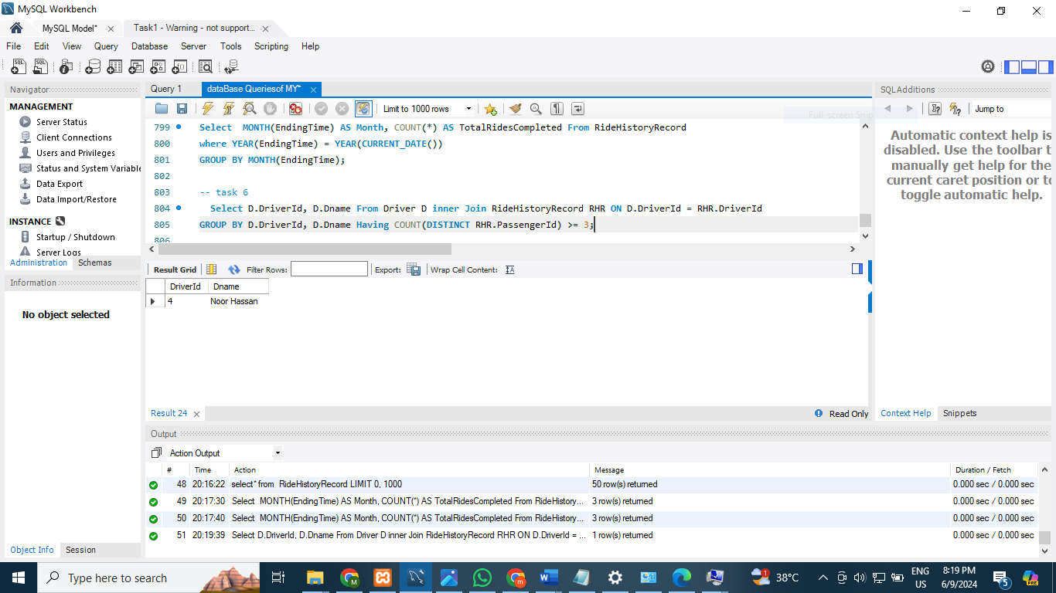

5.7 Query 7: Popular Destinations
Purpose: Determine the most popular destination among all rides.
SQL Query:
SELECT Location AS MostPopularDestination, COUNT(*) AS TotalRides
FROM RideHistoryRecord
GROUP BY Location
ORDER BY TotalRides DESC
LIMIT 1;
Business Value: Strategic planning for driver positioning and marketing.
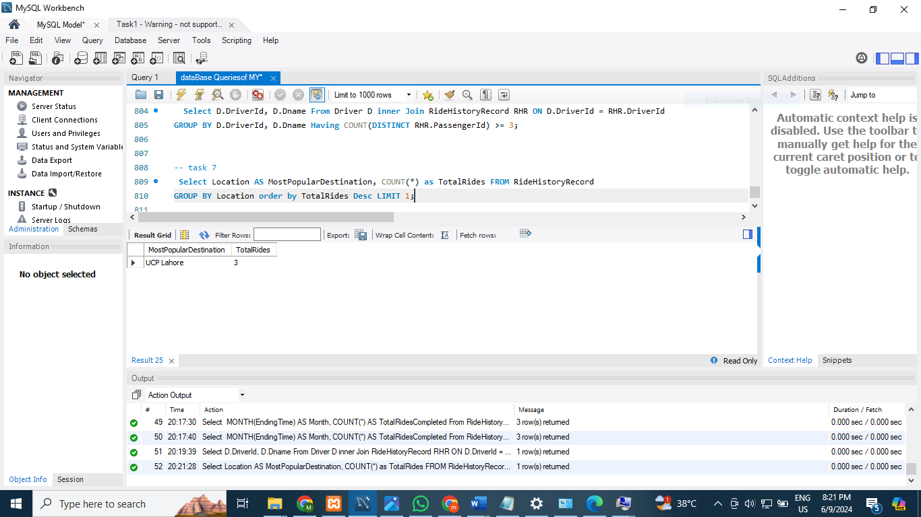

5.8 Query 8: Common Support Issues
Purpose: Identify the most common issue reported in support tickets.
SQL Query:
SELECT IssueDetail AS MostCommonIssue, COUNT(*) AS TotalOccurrences
FROM PassengerSupport
GROUP BY IssueDetail
ORDER BY TotalOccurrences DESC
LIMIT 1;
Business Value: Focus training and process improvements on frequent issues.
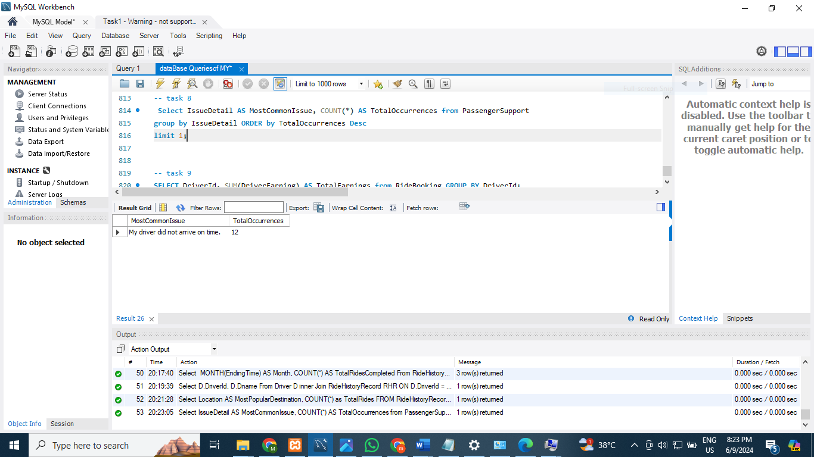

5.9 Query 9: Driver Earnings
Purpose: Show the total earnings for each driver in the current year.
SQL Query:
select D.DriverId,SUM(Rb.DriverEarning) AS TotalEarnings ,
(Rh.StartingTime) from Driver D Left join RideBooking Rb
on D.DriverId=RB.DriverId
Left join RideHistoryRecord RH on D.DriverId=Rh.DriverId
WHERE YEAR(RH.StartingTime) = YEAR(current_date())
GROUP BY DriverId;
Business Value: Financial reporting and driver compensation tracking.
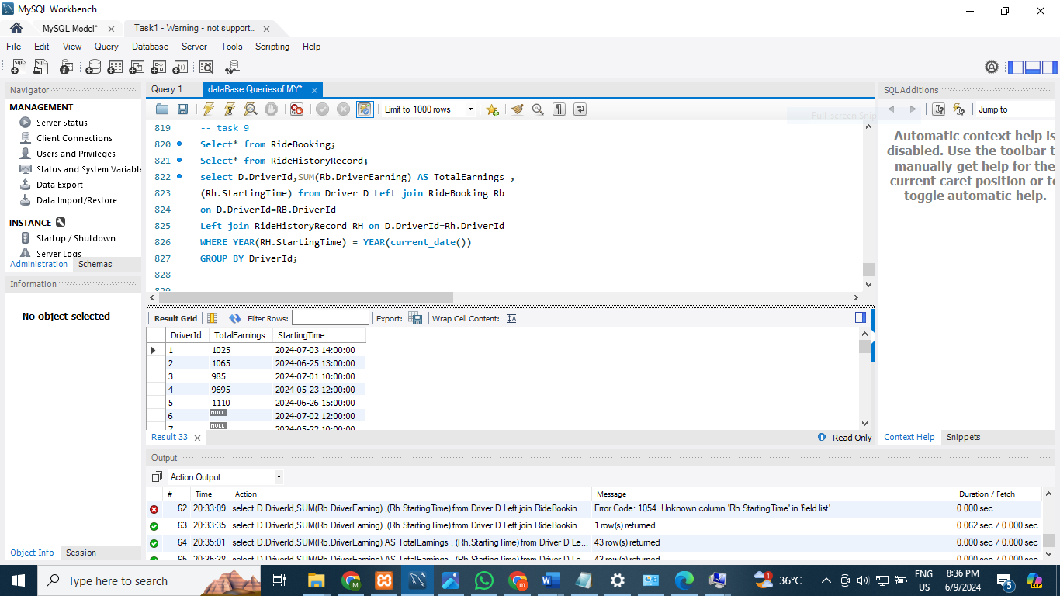

5.10 Query 10: Active Promotions
Purpose: Get a list of all promotions that are currently active and expire within the next 30 days.
SQL Query:
SELECT *
FROM Offers
WHERE NOW() BETWEEN Startingdate AND DATE_ADD(endingdate, INTERVAL 30 DAY);
Business Value: Marketing campaign management and promotion tracking.
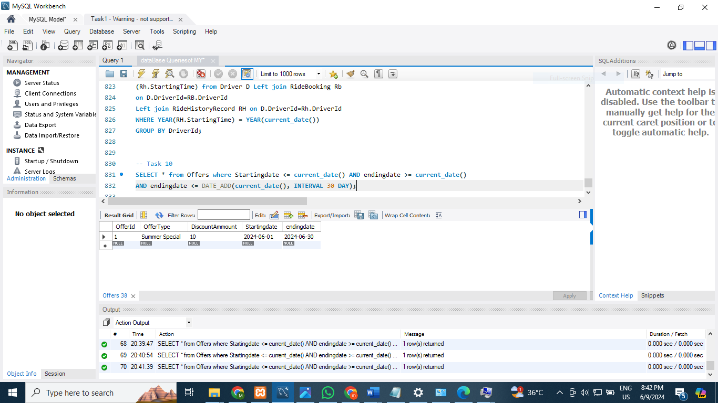

6. CONCLUSION

In conclusion, the CityWheels database project represents a successful application of database design principles to a real-world business scenario. The system effectively manages all core operations of a ride-hailing service while maintaining data integrity through proper normalization and relationship constraints.

The project's dual focus on technical implementation and legal compliance demonstrates understanding that modern database systems must operate within complex regulatory frameworks. The research on cross-border data sharing under PDPL and GDPR provides valuable insights for CityWheels's global expansion strategy.

This documentation, complete with ER diagrams, schema details, sample data, and analytical queries, provides all necessary information for deployment and maintenance. The system's scalability ensures it can grow with the business, supporting expansion from Pakistan to international markets.

Overall, this project successfully meets all course requirements while delivering practical value for a real-world business scenario, demonstrating both technical competence and awareness of broader legal and ethical considerations in database management.

