

**REF NO: DEVR897**

**DATE: 2025-12-30**

**To Whom It May Concern**

This is to certify that **M.Muzammil Bashir** has successfully completed a **5 months** internship in the Artificial Intelligence Department of DevRolin, from **2025-07-07** to **2025-12-31**.

During this period, M.Muzammil Bashir actively participated in our flagship Al projects, demonstrating strong analytical skills and a genuine enthusiasm for machine learning and data science. Key contributions include:

* **Model Development:** Assisted in developing and fine-tuning a convolutional neural network for image classification, achieving a 92% validation accuracy.
* **Data Preprocessing**: Designed and implemented data-cleaning pipelines that reduced feature-engineering time by 30%
* **Research & Documentation:** Conducted literature reviews on Transformer architectures and prepared concise technical reports that informed our experimental design
* **Team Collaboration:** Collaborated effectively with senior engineers, attended daily stand-ups, and presented weekly progress updates to the Al team.

Throughout the internship, M.Muzammil Bashir exhibited diligence, adaptability, and an eagerness to learn.

We appreciate M.Muzammil Bashir dedication during their tenure with DevRolin and wish them every success in their future academic and professional endeavors.

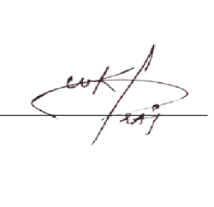Sincerely,

**Muhammad Bilal**

**Director, Devrolin**