ERTIFICATE



C

*of completíon*

P R O U D L Y P R E S E N T E D T O

*M.Muzammil Bashir*

has successfully completed the Web Development Intern Internship of 3 Months,

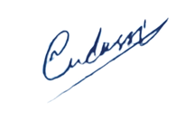conducted by

**DevRolin**

Mudassir Hussain

**CEO Dev Rolin**