**REF NO : DEVR897**

**DATE : 2025-10-06 Offer Letter**

**Dear M.Muzammil Bashir,**

We are pleased to extend to you an offer for the position of Business Development Intern at Devrolin for a period of 3 Months months, commencing on 2025-09-07.

You will be supervised by Mr. Mudassir Hussain and will support our business growth initiatives through tasks such as Frontend, Backend Integrations, Coding and Implementation.. This internship aims to provide practical industry exposure and enhance your communication, analytical, and strategic thinking skills in a real-world business environment.

Details of the Internship:

* Position: web Dev Intern



support@devrolin.com

+971 52 234 7966

Al Abraj Streets Dubai , UAE

* Department: Web Development
* Duration: September 07, 2025 to December 07, 2025
* Type: Onsit
* Location: Oric Pak Korea Building, Arid Agriculture University, Rawalpindi
* Supervisor: Mr. Mudassir Hussain

You are expected to maintain a professional attitude, observe company policies, and uphold strict confidentiality regarding internal projects and materials.

Please confirm your acceptance of this offer by signing and returning a copy of this letter by {{RESPONSEDATE}}. Should you have any questions, feel free to reach out to Mr. zohaibejaz@devrolin.com

We are excited about the opportunity to work with you and look forward to your positive impact at Devrolin.

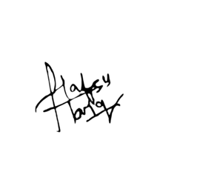

Sincerely,

**HR Manager**