

**REF NO: DEVR897**

**DATE: 2025-12-07**

**To Whom It May Concern**

This is to certify that **M.Muzammil Bashir** has successfullycompleted a 3 Months internship in the **Web Development** Department of **Devrolin, from 2025-09-07 to 2025-12-07.**

During this period, M.Muzammil Bashir actively contributed to our flagship web projects, demonstrating strong problem-solving skills and a genuine enthusiasm for front- end and back-end development. Key contributions include:

* **Front-End Development:** Assisted in building and optimizing responsive user interfaces using HTML, CSS, JavaScript, and React, improving page load speed by 25%.
* **Back-End Development:** Supported the integration of RESTful APIs and database management with Node.js and MongoDB, enhancing data retrieval efficiency.
* **Code Optimization:** Refactored existing code to improve maintainability and reduce bugs, resulting in smoother deployment cycles.
* **Team Collaboration:** Worked closely with senior developers, participated in daily stand-ups, and delivered weekly progress updates to the Web Development team.

Throughout the internship, M.Muzammil Bashir exhibited diligence, adaptability, and an eagerness to learn.

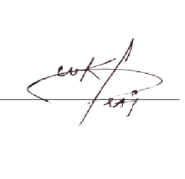We appreciate M.Muzammil Bashir dedication during their tenure with Devrolin and wish them every success in their future academic and professional endeavors.

Sincerely,

**Muhammad Bilal**

**Director, Devrolin**