BSSE FINAL PROJECT

SportWearXpress



Project Advisor

Anum Mustaqeem

Presented by:
Group ID: F24SE002

L1F21BSSE0564 Muahammad Muneeb Butt
L1S21BSSE0072 M Awais Akram
L1F21BSSE0476 Muahammad Qasim Abbas

Faculty of Information Technology & Computer Science

University of Central Punjab
Complete System
SDP Phase IV

SportsWearXpress
Advisor: Anum Mustaqeem
F24SE002
Member Name | Primary Responsibility
Muneeb Butt | Documentation + Implementation +Testing
Qasim Abbas | Documentation + Implementation +Testing
Awais Akram | Documentation + Implementation +Testing

Table of Contents
Table of Contents i
Revision History ii
Previous Phases Feedback ii
Abstract iv
1. Introduction 1
1.1 Product 1
1.2 Background 1
1.3 Objective(s)/Aim(s)/Target(s) 1
1.4 Scope 1
1.5 Business Goals 2
1.6 Document Conventions 2
1.7 Miscellaneous 2
2. Technical Architecture 4
2.1 Application and Data Architecture 4
2.2 Component Interactions and Collaborations 11
2.3 Design Reuse and Design Patterns 16
2.4 Technology Architecture 16
2.5 Architecture Evaluation 17
3. Detailed/Component Design 18
3.1 Component-Component Interface 18
3.2 Component-External Entities Interface 19
3.3 Component-Human Interface 21
4. Screenshots/Prototype 23
4.1 Workflow 23
4.2 Screens 24
4.3 Additional Information 30
5. Other Design Details 31
6. Test Specification and Results 33
6.2 Summary of Test Results 50
7. Project Completion Status 52
8. Deployment/Installation Guide 53
8.1.1 Prerequisites 53
8.1.2 Backend Installation (Node.js, Express, MongoDB) 53
8.1.3 Frontend Installation (React, Vite, Tailwind CSS) 54
8.1.4 Deployment Suggestions (Optional) 54
8.1.5 Final Notes 55
9. User Manual 56
10. References 62
11. Project Summary Form 62
Appendix A: Glossary 67
Appendix B: IV & V Report 68

Revision History
Name | Date | Reason For Changes | Version

Previous Phases Feedback

Idea Defence Feedback (Screenshot)
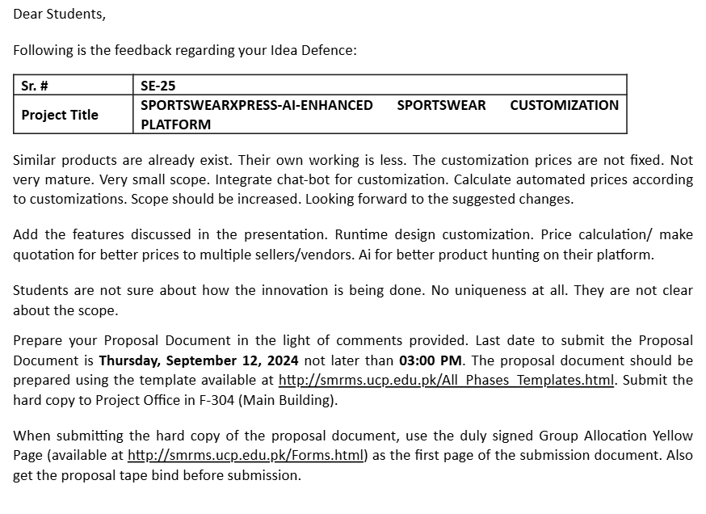

Phase 2 (SDS) Feedback (Screenshot)

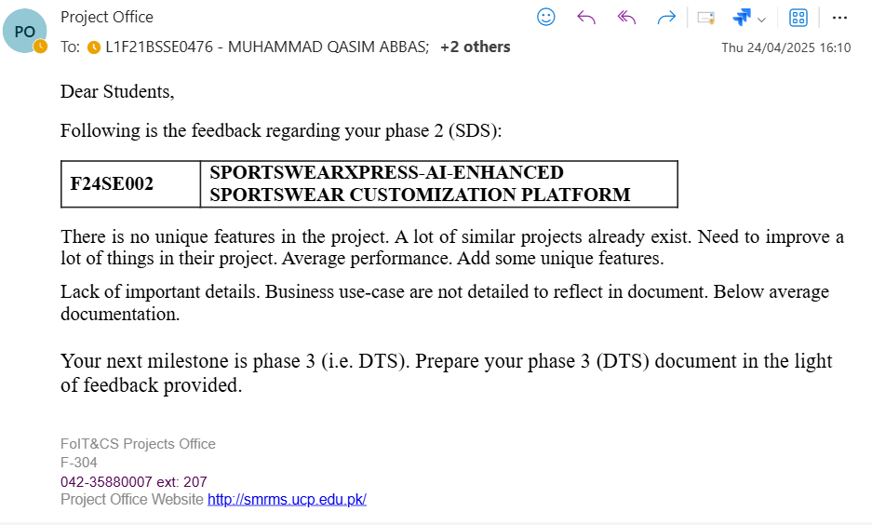

Abstract
The SportswearXpress project aims to address the challenges of personalized sportswear customization through an AI-enhanced e-commerce platform. Current solutions lack advanced tools for design precision, real-time communication, and dynamic pricing, leading to inefficiencies, miscommunication, and unmet customer expectations. This project is significant as it provides a streamlined, efficient approach to customization, improving both user satisfaction and seller operations.
The platform integrates AI-powered design tools to guide users step-by-step in creating custom designs, ensuring accuracy and reducing errors. Real-time communication features bridge the gap between customers and sellers, enabling seamless collaboration. A dynamic pricing algorithm calculates costs based on design complexity and tool usage, ensuring fair and transparent pricing.
Key knowledge areas include artificial intelligence for personalized design assistance, real-time communication systems for interaction, and database management for handling user data and transactions. The results of this project include a scalable, browser-based solution that optimizes the customization process, enhances user engagement, and sets a new standard for the sportswear industry.

Introduction

Product
SportswearXpress is an AI-powered e-commerce platform designed to solve the challenges associated with customizing sportswear. Traditional customization systems lack intuitive design guidance, real- time communication, and transparent pricing, leading to unmet customer expectations and inefficiencies. SportswearXpress leverages AI to provide users with step-by-step design recommendations, dynamic pricing based on customization complexity, and seamless real-time communication with sellers. This solution aims to enhance user satisfaction and streamline the customization process, setting a new standard for personalized sportswear shopping.

Background
The sportswear customization domain is rapidly evolving, driven by a growing demand for personalized products. However, current e-commerce platforms in this space often lack sophisticated design tools, dynamic pricing systems, and real-time communication features, resulting in customer dissatisfaction and operational inefficiencies. SportswearXpress aims to address these challenges by providing an AI-enhanced platform that allows for accurate and intuitive customization, improving customer experience and seller efficiency.

Objective(s)/Aim(s)/Target(s)
The objectives of SportswearXpress are to:

- Develop an AI-driven platform for sportswear customization.
- Integrate AI tools to guide users in personalizing sportswear designs.
- Implement a dynamic pricing model based on design complexity.
- Enable real-time, seamless communication between users and sellers.
- Improve customer satisfaction and operational efficiency.

Scope
The scope of SportswearXpress includes essential features aimed at enhancing the sportswear customization experience:

- User Customization Interface: A web platform for creating personalized sportswear designs with various options.
- AI-Powered Design Tools: Intelligent tools that guide users through the customization process.
- AI Chatbot: Real-time assistance and recommendations throughout the design journey.
- Dynamic Pricing Model: Automatic adjustments of prices based on customization complexity.
- Real-Time Communication: Direct interaction between customers and sellers for immediate support.
- User Account Management: Secure accounts for saving designs and tracking order history.
- Administrative Dashboard: Tools for sellers to manage products and analyze customer interactions.
- Testing and Deployment: Comprehensive testing before launch and ongoing maintenance for continuous improvement.

Business Goals
SportswearXpress aims to achieve the following business objectives:
- Enhancing Customer Satisfaction: Elevate customer satisfaction by providing intuitive and precise customization options that cater to individual preferences.
- Minimizing Design Errors: Decrease design errors and miscommunication through the implementation of AI-driven guidance and real-time communication tools.
- Optimizing Operational Efficiency: Streamline operations by automating design assistance and dynamic pricing adjustments, allowing for a more efficient workflow.
- Setting Industry Standards: Establish a competitive benchmark in the sportswear sector by delivering innovative, AI-powered e-commerce solutions that redefine customer engagement.

Document Conventions
This SRS follows the standard format for software requirements specifications. The document utilizes the following conventions: Font Styles: Section headings are in bold font of 14 Times, while subsection headings are in bold of size 12. Regular text is used for descriptions and content. Highlighting: Important terms or concepts may be highlighted using bold or italic font for emphasis. Numbering: Sections organization and reference purposes. and subsections are numbered sequentially Nomenclature: Where applicable, technical terms or acronyms are defined upon first use to ensure clarity and understanding throughout the document.

Miscellaneous
- Team Roles and Responsibilities
Clearly define roles for team members (if any), such as project manager, developer, tester, and designer, to ensure smooth collaboration and accountability.
- Technological Tools
List all the tools and frameworks used in the project, such as:
- Front-end Development: React.js for building user interfaces.
- Back-end Development: Node.js for server-side logic.
- AI Tools: TensorFlow, OpenCV, or other machine learning frameworks for implementing AI functionalities.
- Database Management: MySQL, MongoDB, or Firebase for storing data.
- Version Control: Git and GitHub for source code management.
- Project Timelines
Define a high-level timeline for project milestones, such as requirement gathering, development, testing, and deployment phases.
- Contingency Plans
Outline fallback mechanisms in case of system failures or delays. For example:
- Backup solutions for data.
- A plan to handle high traffic or server downtime.
- Training and User Guides
Provide training resources and user manuals for:
- Admin users to manage the system (e.g., inventory updates, analytics reports).
- End users to navigate the product customization and order placement processes.
- Collaboration Tools
Mention tools used for communication and collaboration, such as:
- Slack, Microsoft Teams, or Discord for team communication.
- Project management tools like Jira or Trello for task tracking.
- Future Enhancements
Outline possible future updates, such as:
- Introducing new AI-powered features.
- Expanding to support other sportswear categories.
- Integrating augmented reality (AR) for product visualization.

Technical Architecture
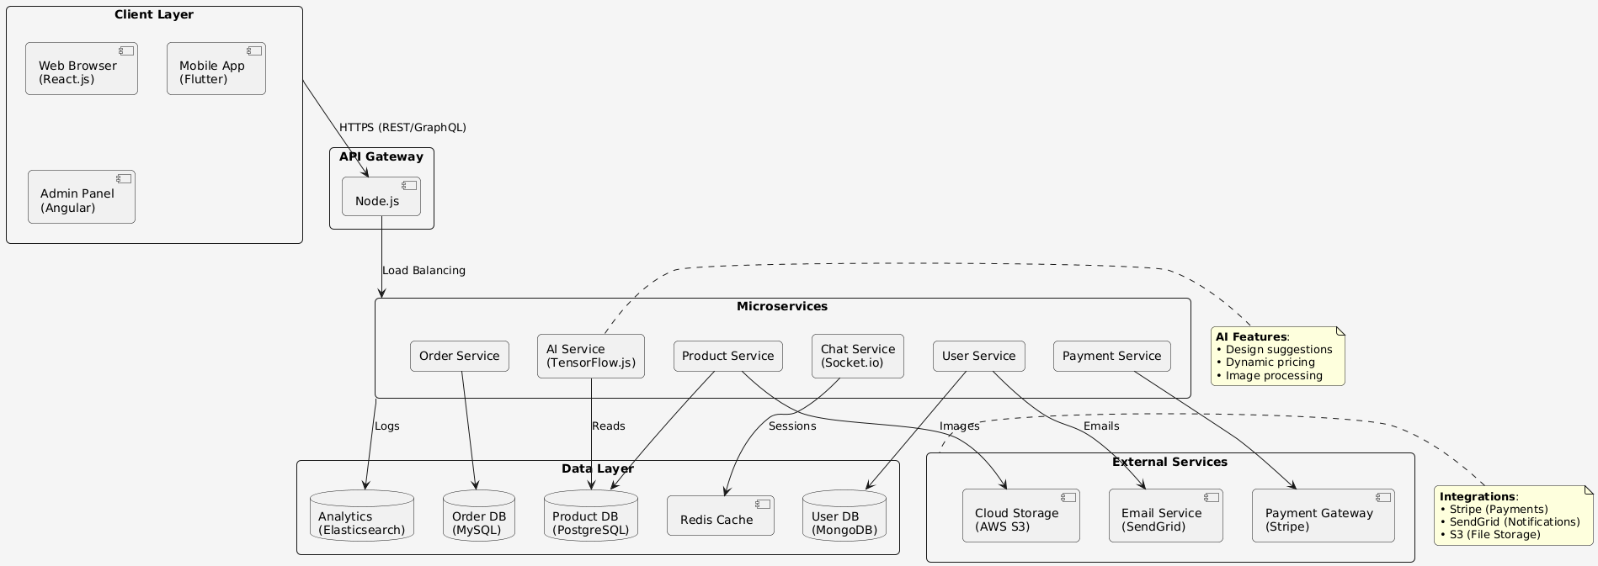

Application and Data Architecture
Component Diagram
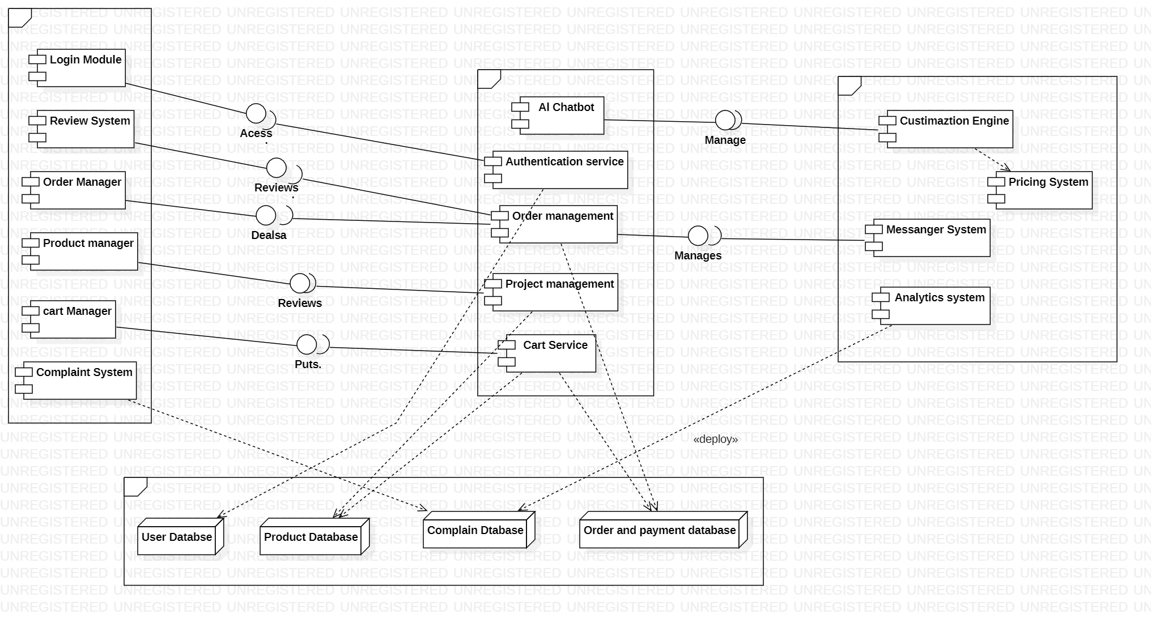

Class Diagram
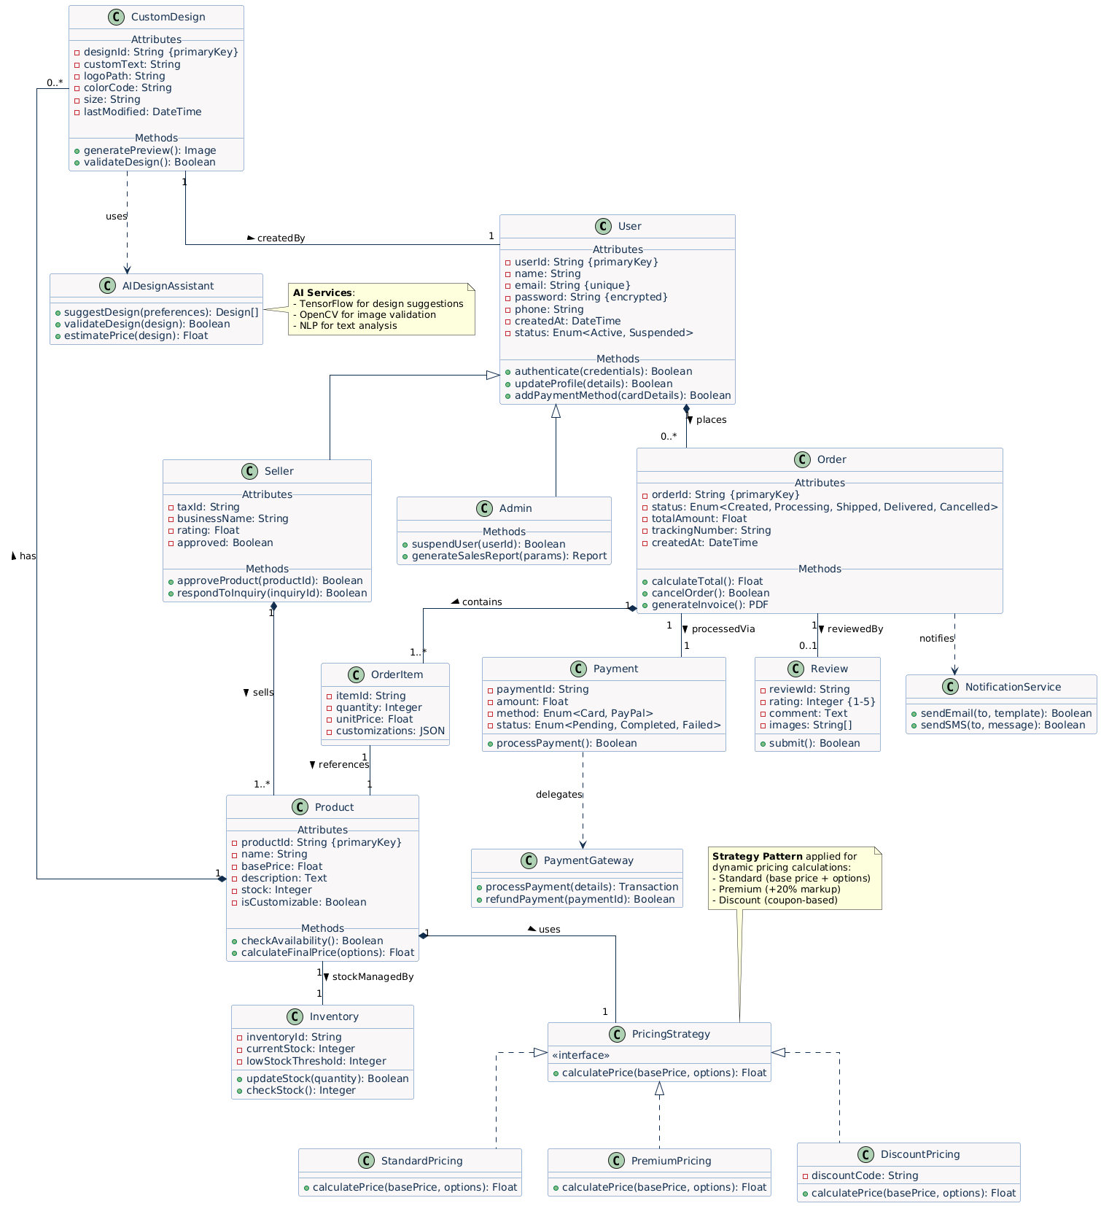
Erd Diagram
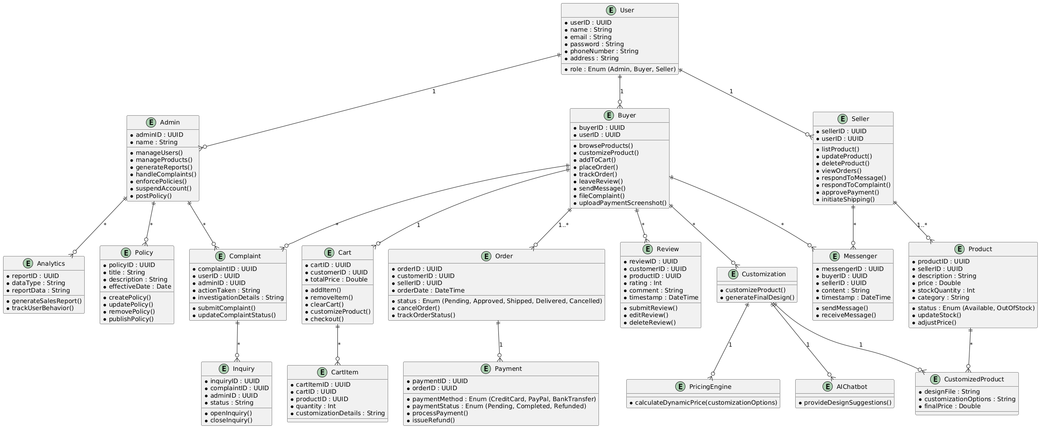

Activity Diagram for User
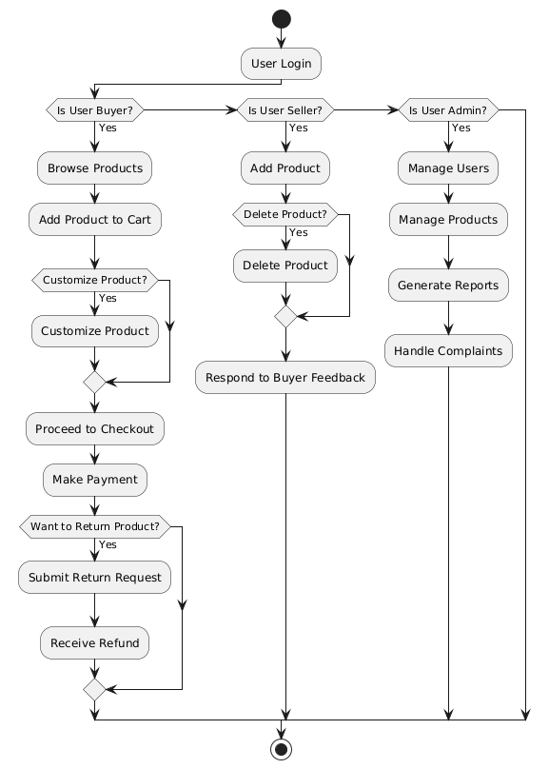

Activity Diagram for Seller
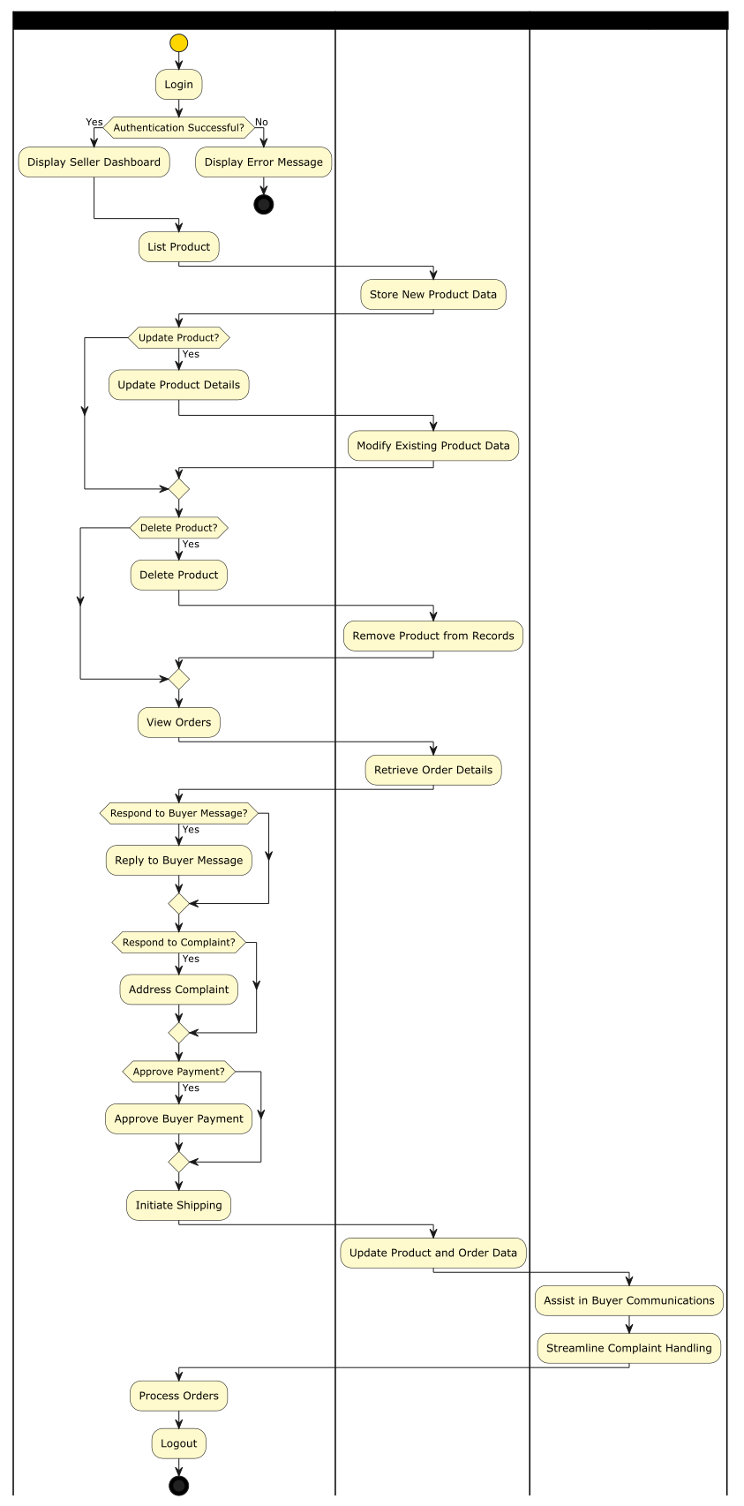

Sequence Diagram for Seller
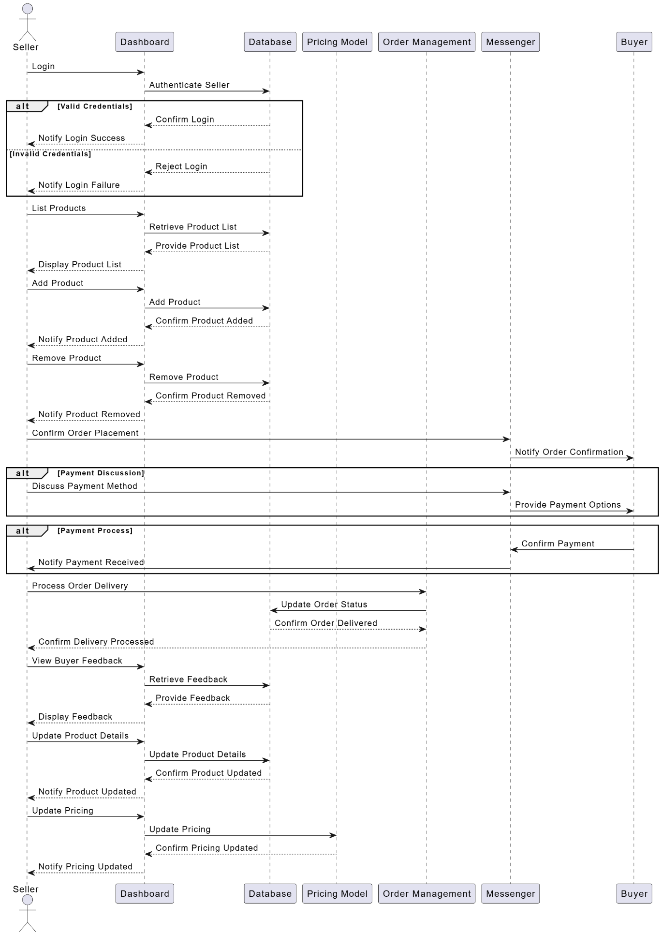

Sequence Diagram of Admin
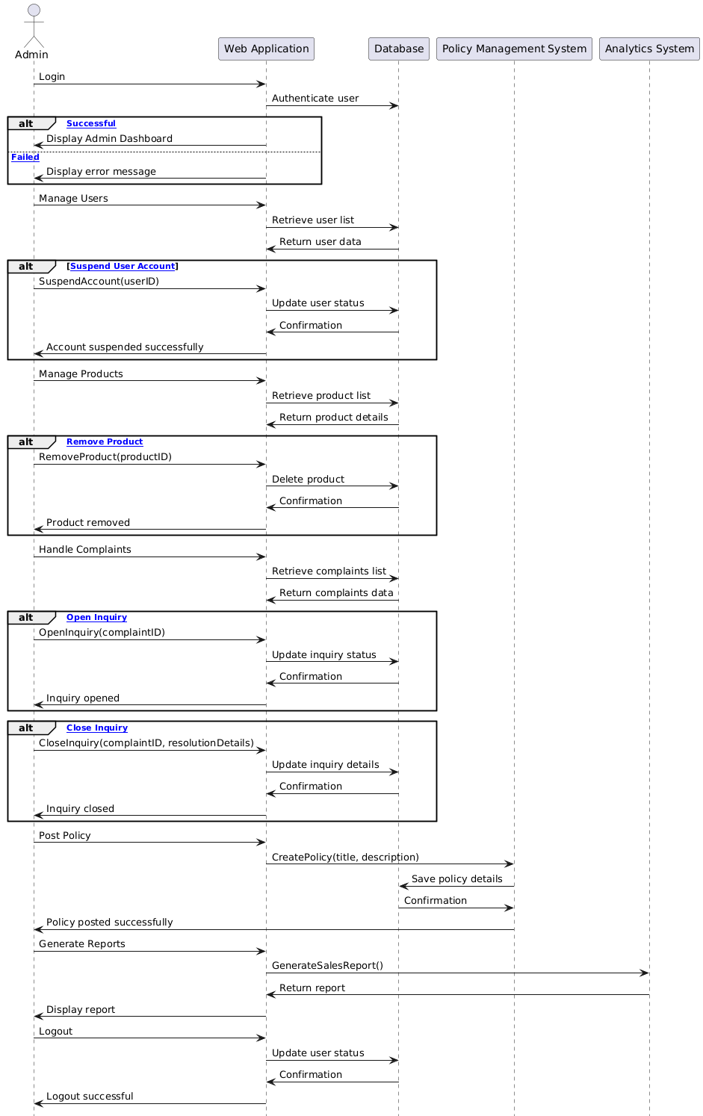

Component Interactions and Collaborations
Sequence Diagram order cancellation

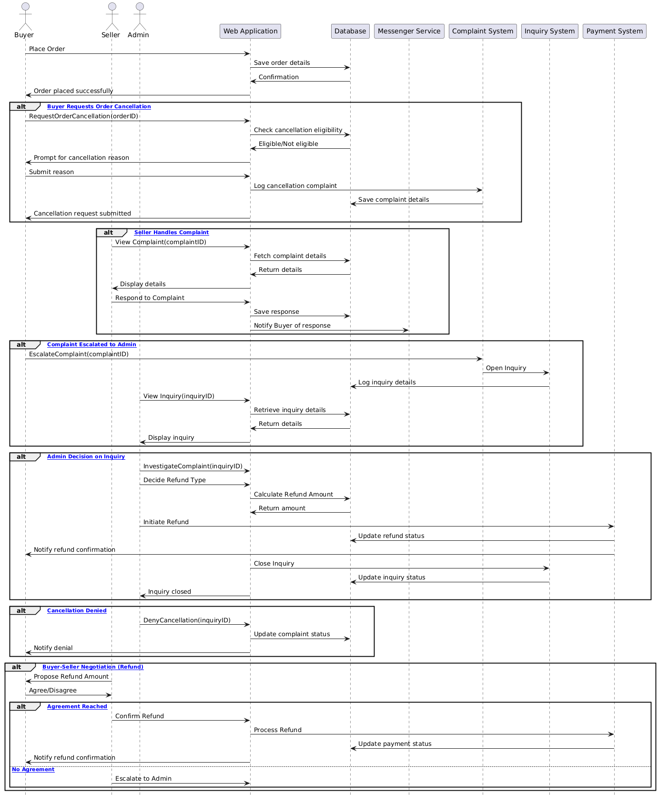

Dfd Diagram
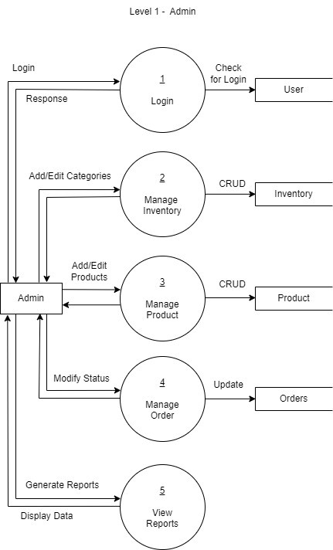

Dfd Diagram
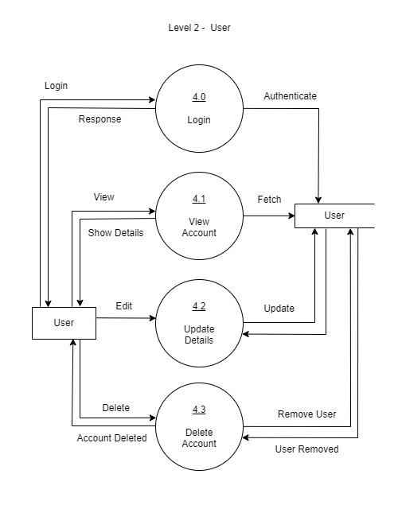
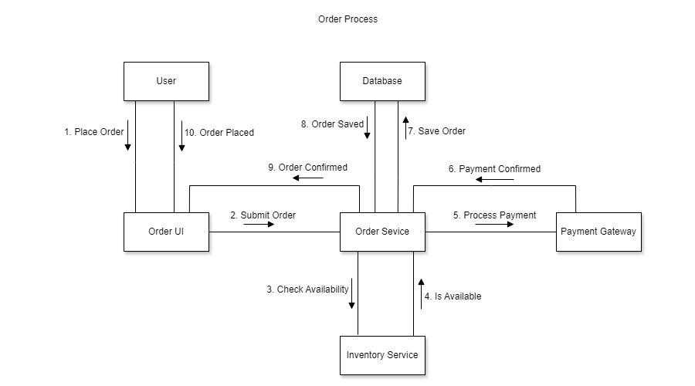

Event Traces
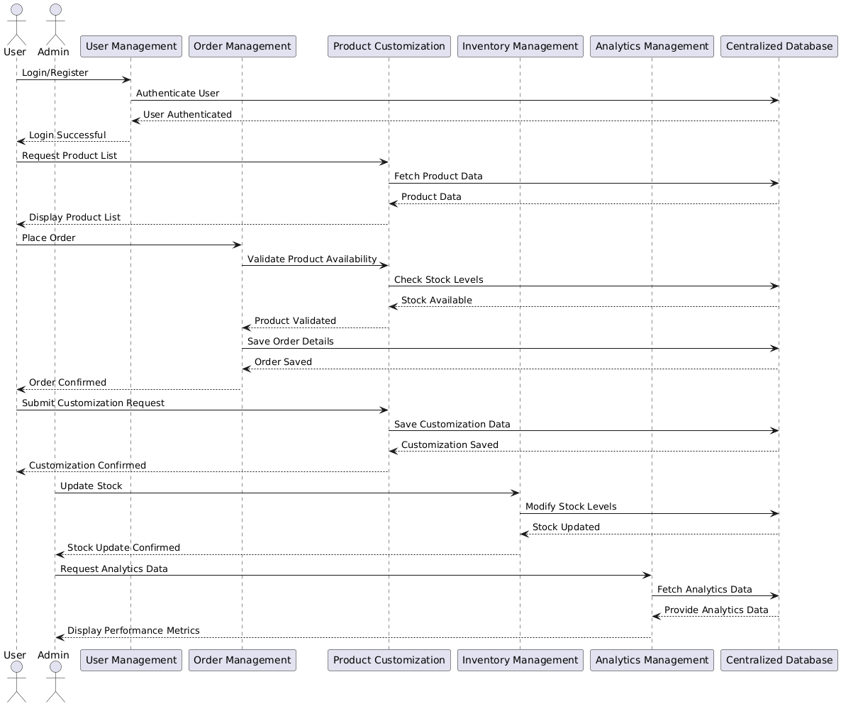

Design Reuse and Design Patterns

Technology Architecture
The technology architecture of SportswearXpress is designed to support real-time interaction, AI-driven customization, and scalable e-commerce features. While cloud hosting is a common option, this project will be hosted on a non-cloud infrastructure, possibly on a university server or a local deployment setup for demonstration and testing purposes.

1. Platform
Frontend: Built using React.js, HTML5, CSS3, and JavaScript for a modern, responsive user interface accessible via web browsers.

Backend: Developed using Node.js with the Express.js framework, which provides fast, event-driven server operations ideal for handling user interactions and real-time updates.

AI Functionality: Powered by TensorFlow.js and OpenCV.js to deliver client-side AI recommendations for product customization without relying on cloud-based AI services.

2. System Hosting
Local Hosting / On-Premise Server:
The system will be hosted on a local server (e.g., a university-managed environment or standalone deployment on physical hardware).
This setup supports local access for development and testing.
Suitable for prototype or proof-of-concept phases.
Simplifies infrastructure management during early-stage development.

3. Connectivity Requirements
Stable Local Network / Internet: Required to facilitate:
User login and session management.
Real-time messaging between buyer and seller via Socket.io.
AI interaction through in-browser computation.
API Connections (Optional): If needed, payment gateways like Stripe or PayPal can be integrated through external APIs, even in local setups.

4. Modes of Operation

Buyer Interface: Provides a customization UI, AI assistant, cart, and order management.
Seller Interface: Enables product upload, order tracking, and buyer communication.
Admin Panel: Facilitates system governance, analytics access, and user control.

5. Security
Local SSL (if applicable): Self-signed certificates may be used for encrypted communication in a local/test environment.
User Authentication: Implemented using OAuth 2.0 or session-based security models.
Data Management: Managed via MongoDB, with local database storage and access control.

Architecture Evaluation
Component | Chosen Technology | Reason for Selection
Frontend | React.js | Offers a component-based architecture, excellent state management, and fast UI rendering.
Backend | Node.js with Express.js | Non-blocking I/O, high performance, scalable for handling multiple real-time requests.
Database | MongoDB | NoSQL flexibility for storing varied product and customization data structures.
AI Customization | TensorFlow.js, OpenCV.js | Enables AI in-browser with fast performance and seamless integration into frontend.
Real-time Messaging | Socket.io | Enables bidirectional real-time communication between users (buyers, sellers).
Version Control | Git & GitHub | Industry standard for collaboration, version tracking, and code review.
Hosting | AWS (EC2, S3) / Vercel | Scalable, secure cloud infrastructure with deployment automation.

Pros of Selected Technologies
- React.js: Fast rendering, reusable components, vibrant ecosystem (e.g., Redux, Hooks).
- Node.js + Express: Handles asynchronous operations well, wide support for middleware.
- MongoDB: Schema-less flexibility supports varied and dynamic product customization formats.
- TensorFlow.js: In-browser AI processing avoids latency of server-based AI.
- Socket.io: Reliable real-time data transmission for messaging and status updates.
- AWS/Vercel: Highly available, scalable, and globally distributed infrastructure.

Cons and Challenges
- Node.js: Callback-heavy nature may lead to messy code if not properly structured (mitigated using async/await).
- MongoDB: Lacks complex joins and transactions compared to relational databases.
- TensorFlow.js: May have performance limitations on low-end devices.
- Socket.io: Real-time implementation requires careful resource management and security handling.

Detailed/Component Design

Component-Component Interface

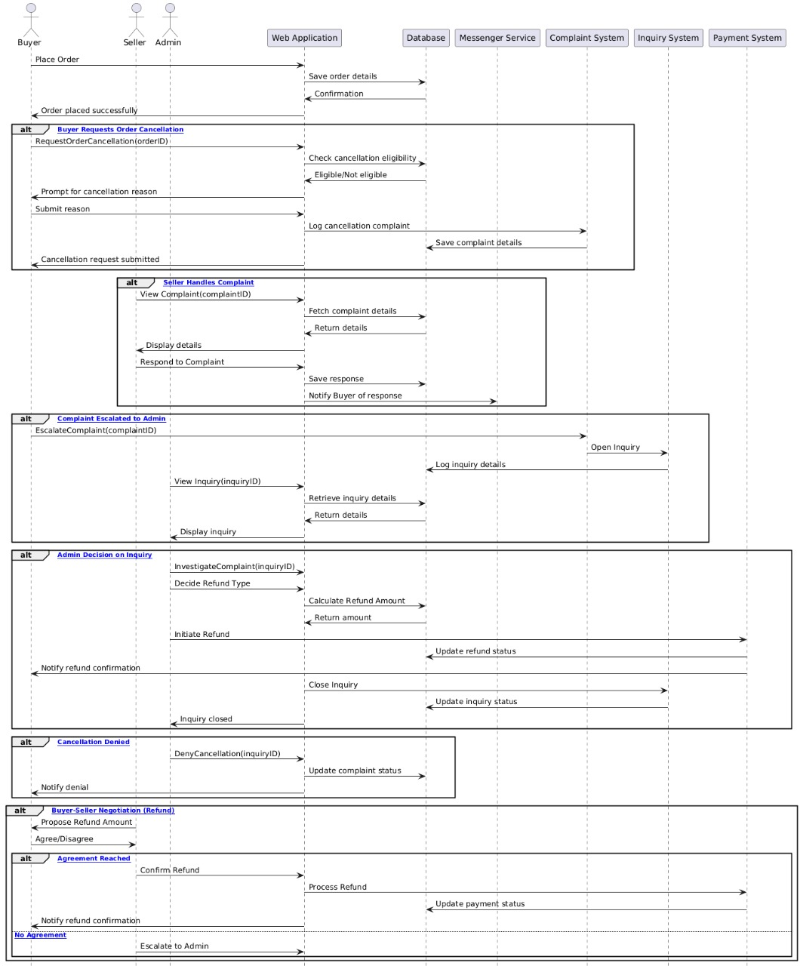

Component-External Entities Interface
Sign Up Page
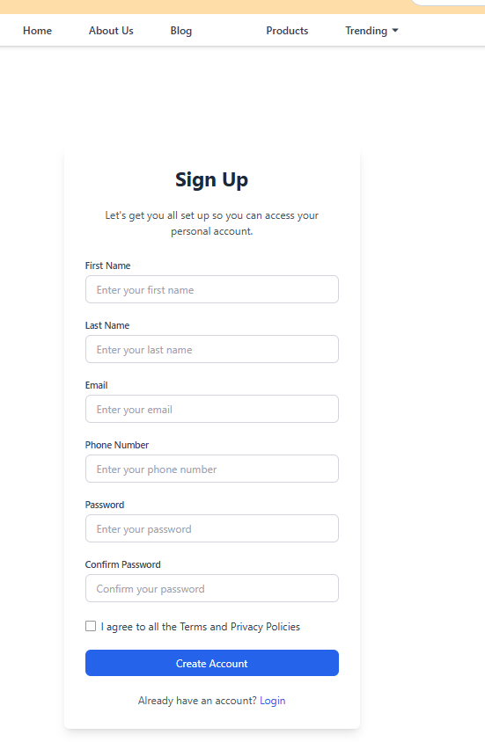

Add New Product

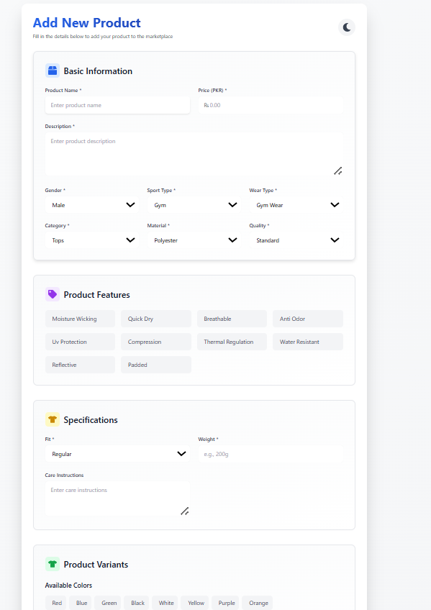

Component-Human Interface
SignIn Page:
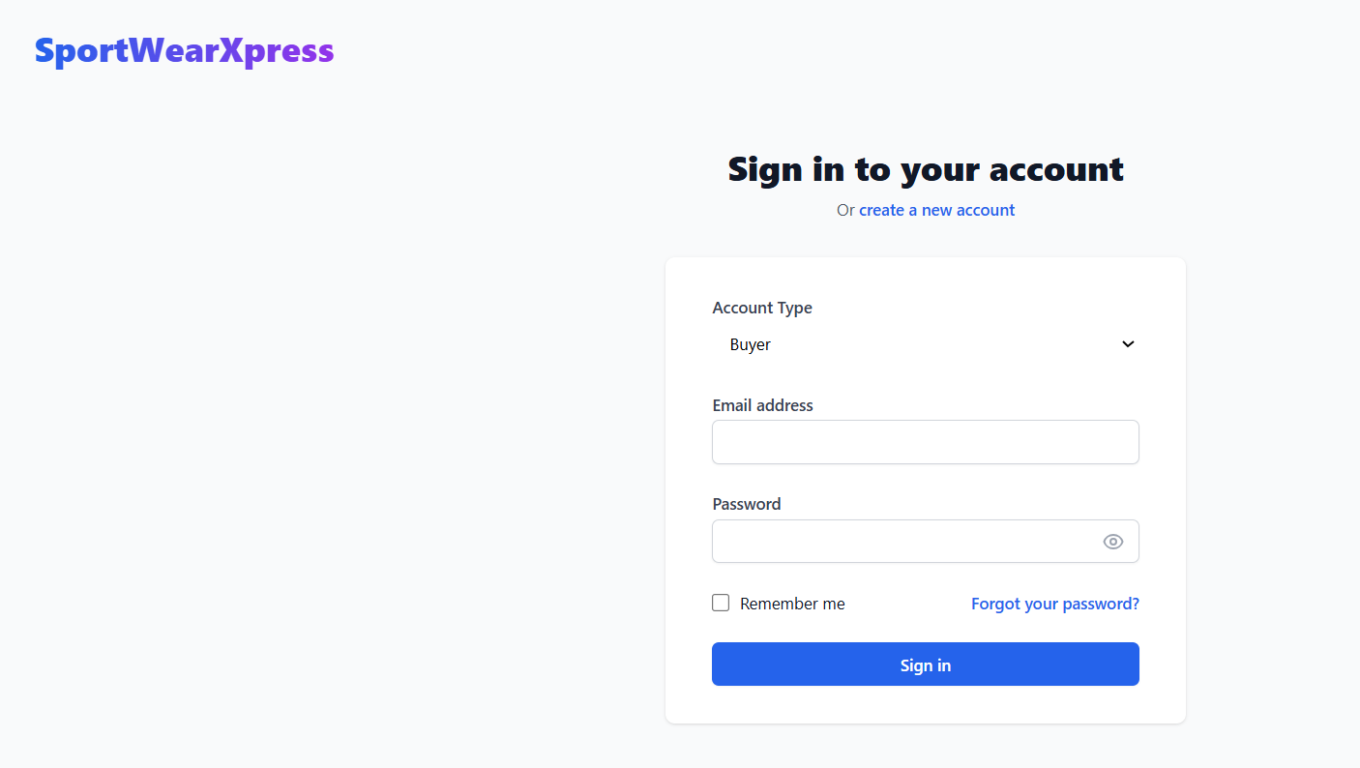

Checkout Page:
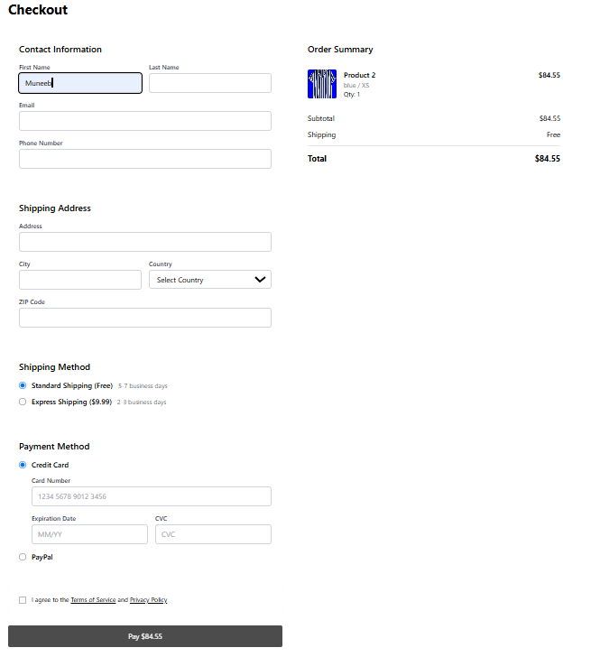

Screenshots/Prototype

Workflow
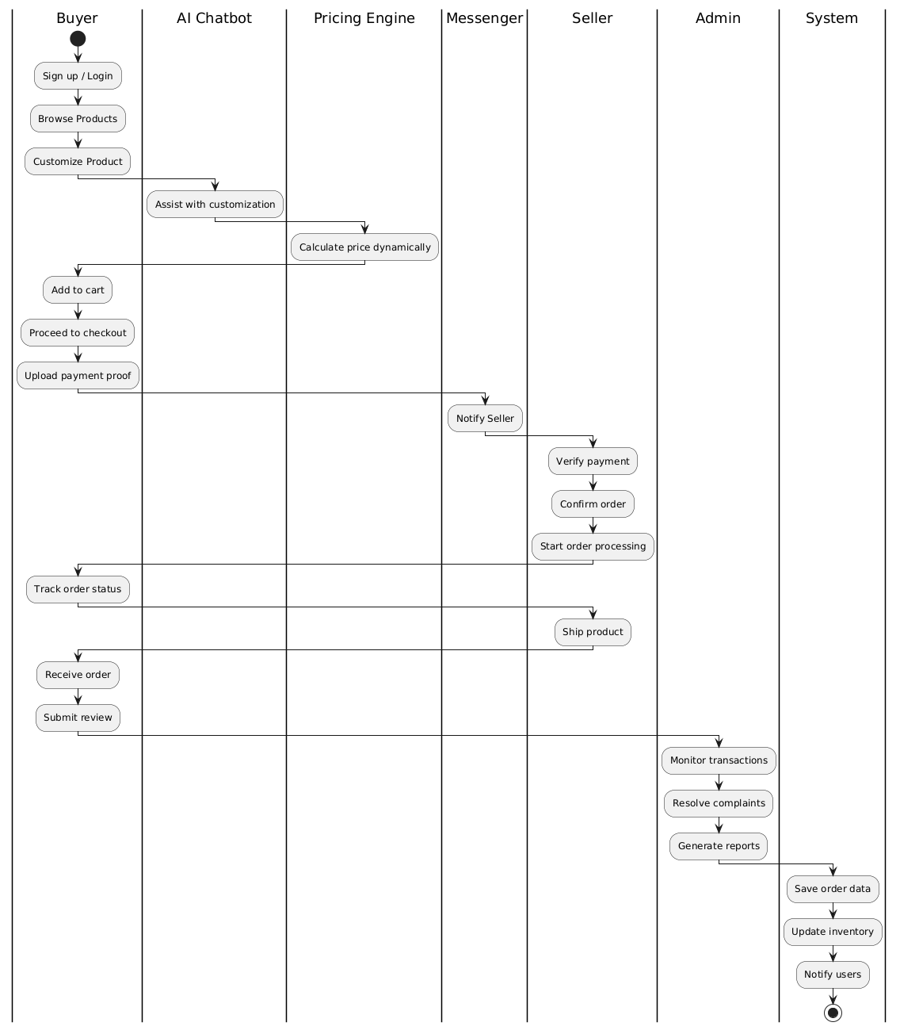

Screens

Dynamic Price Page

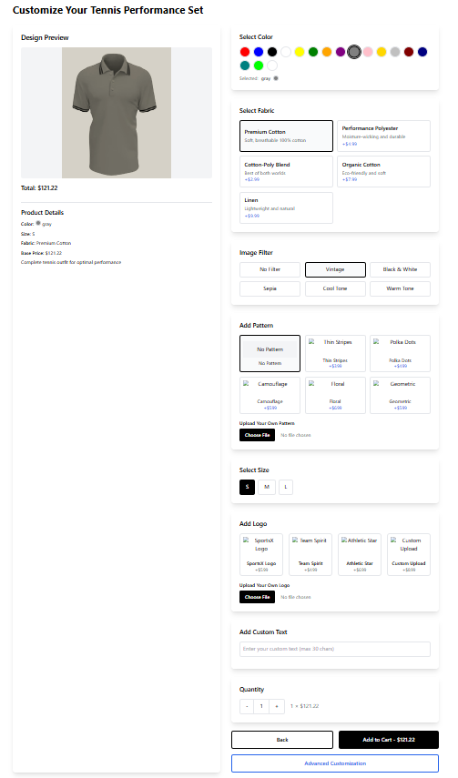

Advance customization Page

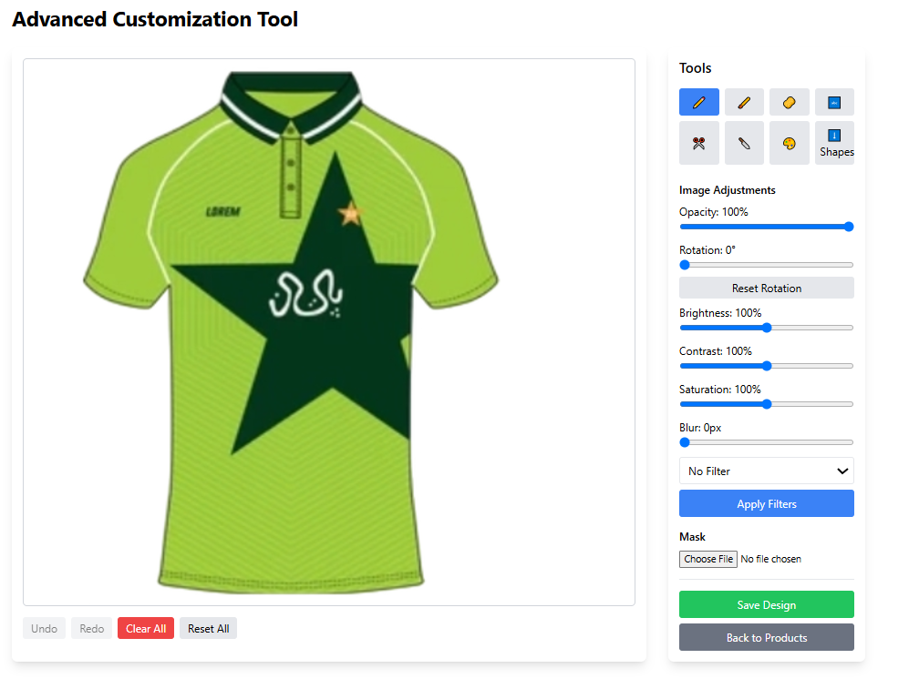

About us

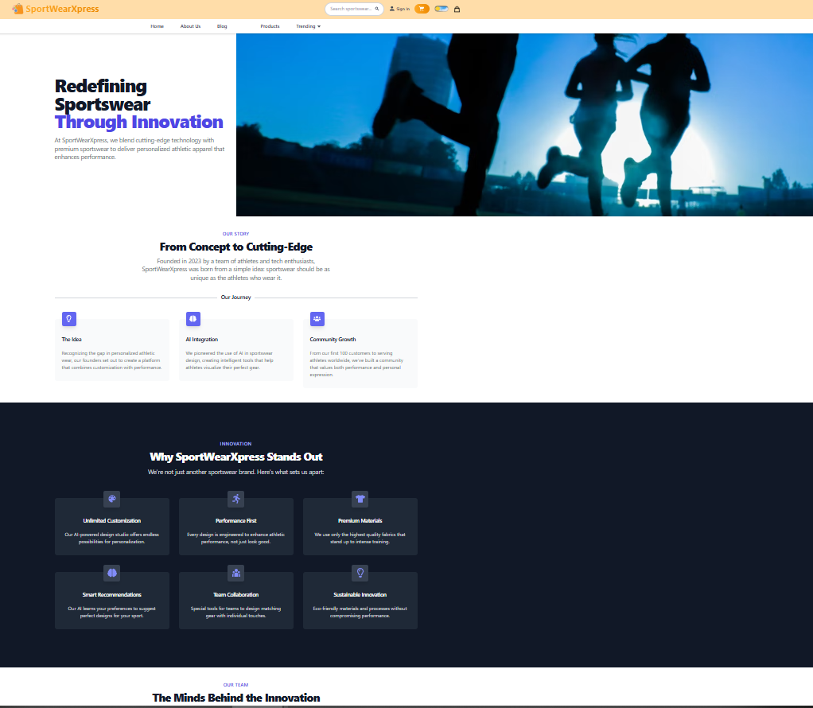

Blog Page
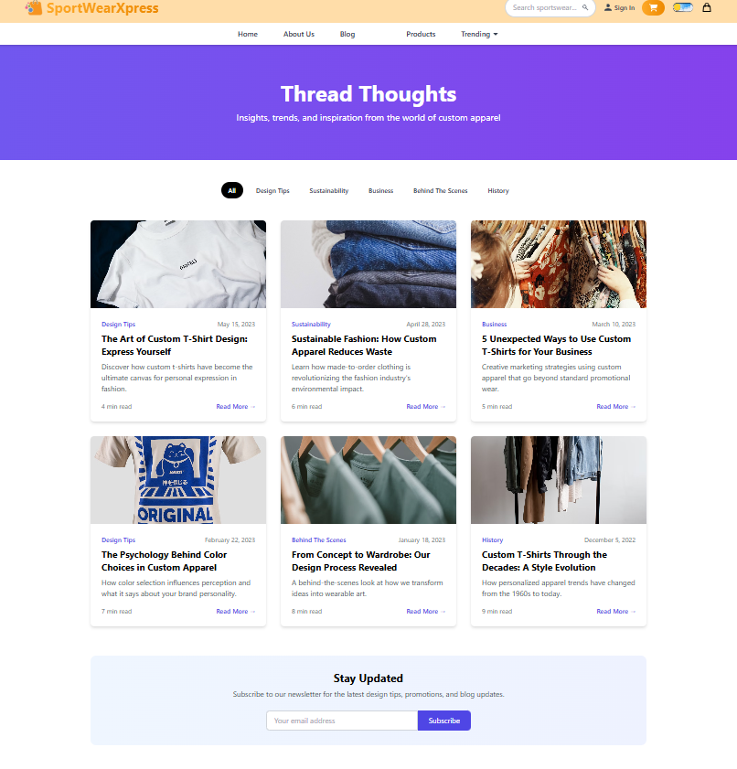

Product Details Page

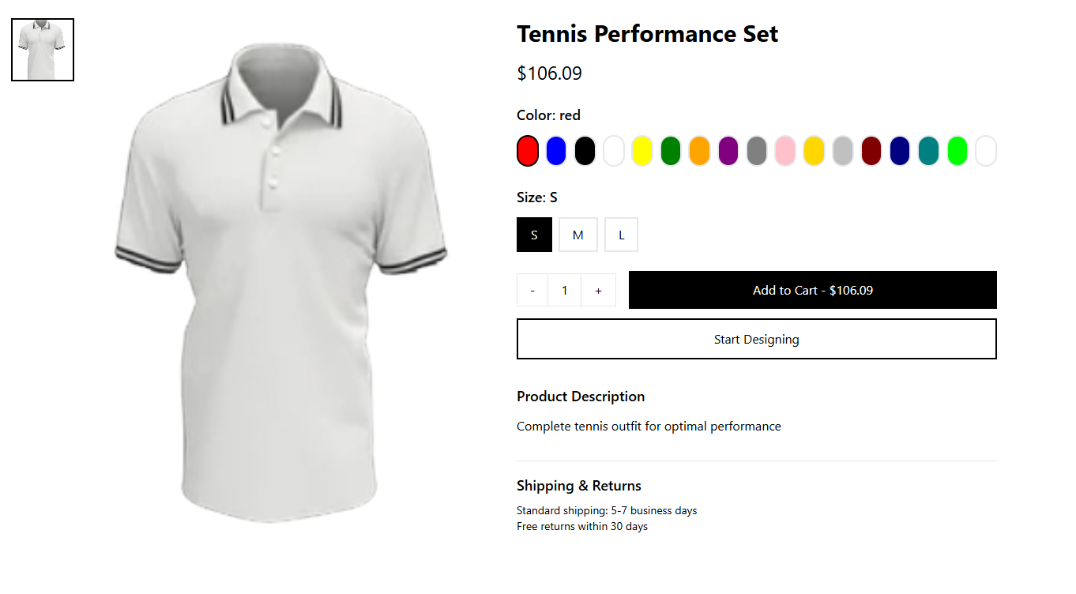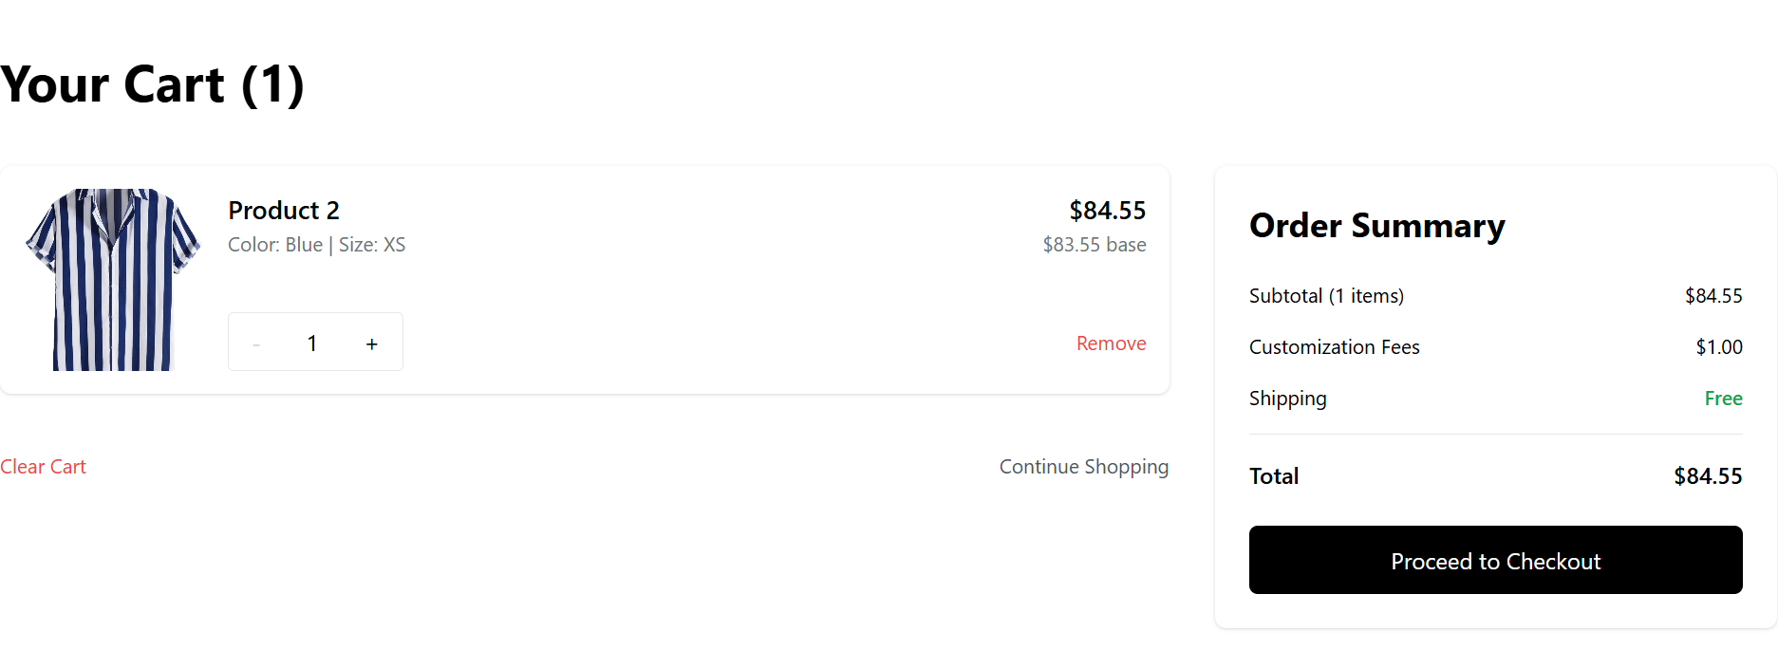

Checkout Page

Additional Information
Seller DashBoard

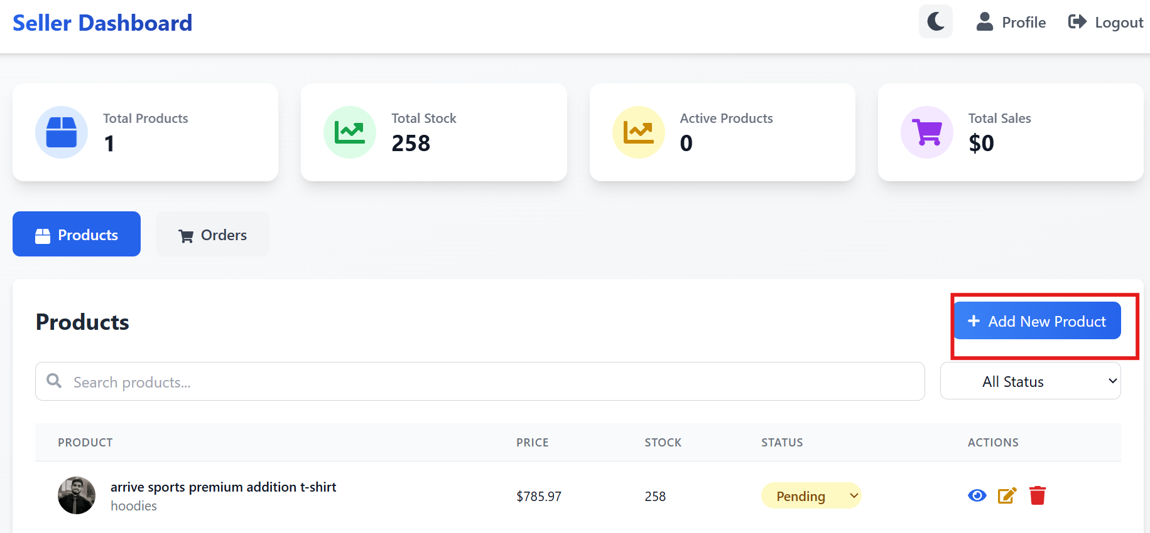

Other Design Details
Admin Dashboard
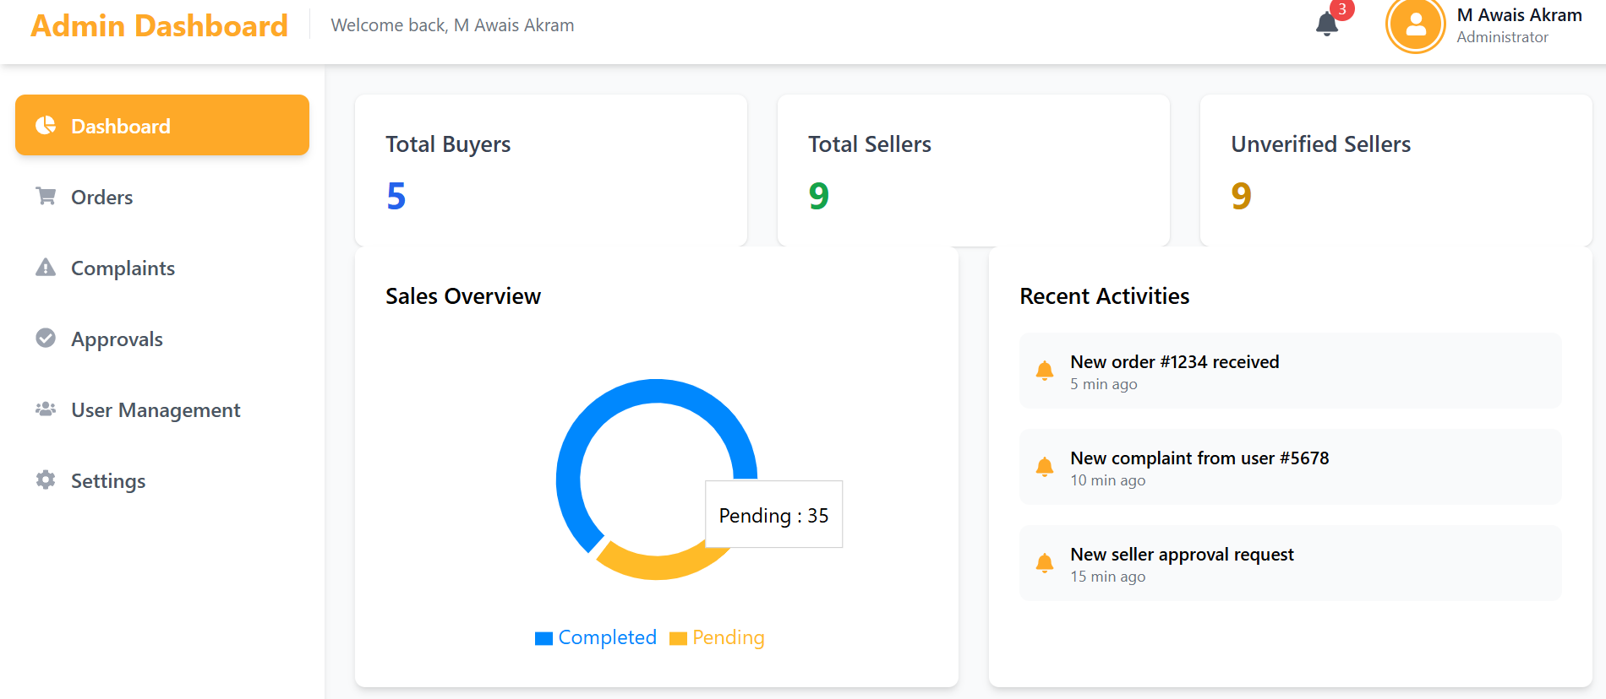

Verify Code

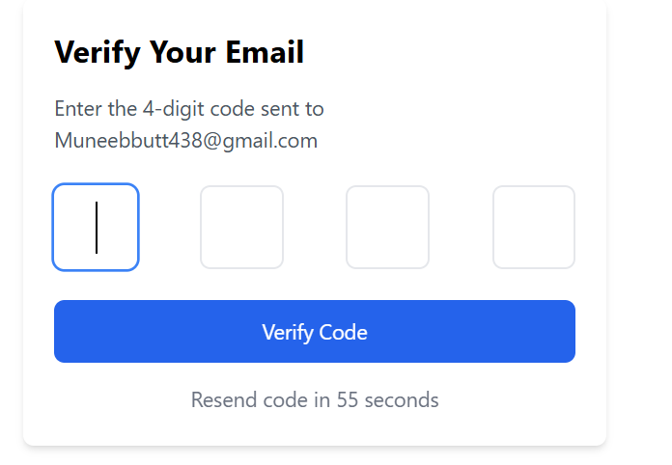

Forget Password
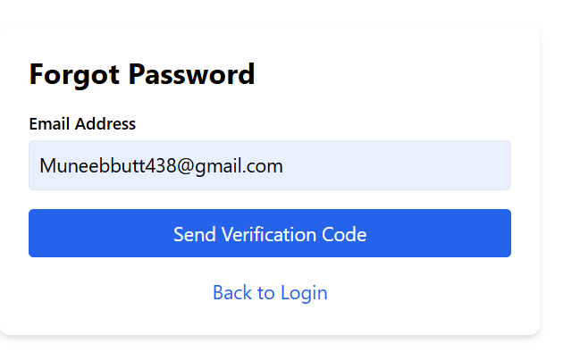

Test Specification and Results
Table 6.1: TC-1
Identifier | TC-1
Related requirements(s)
  Use Case: User Authentication and Profile Management (UC-1)
Short description
  Verify successful user login with valid credentials
Pre-condition(s)
  User has a registered account
Input data
  Email: validuser@example.com, Password: validPass123
Detailed steps
  1. Navigate to login page.
  2. Enter valid credentials.
  3. Click login button.
Expected result(s)
  User is successfully logged in and redirected to profile page
Post-condition(s)
  User session is created
Actual result(s) | Account is created
Test Case Result | pass

Table 6.2: TC-2
Identifier | TC-2
Related requirements(s)
  Use Case: User Authentication and Profile Management (UC-1)
Short description
  Verify login failure with wrong password
Pre-condition(s)
  User has a registered account
Input data
  Email: validuser@example.com, Password: wrongPass
Detailed steps
  1. Navigate to login page.
  2. Enter invalid credentials.
  3. Click login button.
Expected result(s)
  Error message "Incorrect credentials" displayed
Post-condition(s)
  User remains on login page
Actual result(s) | User remains on login page
Test Case Result | Pass

Table 6.3: TC-3
Identifier | TC-3
Related requirements(s)
  Use Case: Add to Cart (UC-2)
Short description
  Add an available item to cart
Pre-condition(s)
  Item is in stock, user logged in
Input data
  Item ID: 101, Quantity: 1
Detailed steps
  1. Select item.
  2. Click "Add to Cart".
Expected result(s)
  Item added to cart successfully
Post-condition(s)
  Cart updated
Actual result(s) | Product Add to cart
Test Case Result | Pass

Table 6.4: TC-4
Identifier | TC-4
Related requirements(s)
  Use Case: Add to Cart (UC-2)
Short description
  Attempt to add an out-of-stock item
Pre-condition(s)
  Item is out of stock
Input data
  Item ID: 102
Detailed steps
  1. Select item.
  2. Click "Add to Cart".
Expected result(s)
  Error message "Item out of stock"
Post-condition(s)
  No item added
Actual result(s) | Item is no added to cart
Test Case Result | Pass

Table 6.5: TC-5
Identifier | TC-5
Related requirements(s)
  Use Case: Product Customization (UC-3)
Short description
  Successfully customize a product
Pre-condition(s)
  User logged in, product supports customization
Input data
  Color: Red, Text: "Champion"
Detailed steps | 1. Open customization.  2. Set color and text.  3. Save.
Expected result(s)
  Customized product preview saved
Post-condition(s)
  Customized design linked
Actual result(s) | Product is successfully Customize
Test Case Result | Pass

Table 6.6: TC-6
Identifier | TC-6
Related requirements(s)
  Use Case: Product Customization (UC-3)
Short description
  Upload invalid file format during customization
Pre-condition(s)
  Customization tool open
Input data
  File format: .exe
Detailed steps
  1. Upload invalid file.
Expected result(s)
  Error "Invalid file format"
Post-condition(s)
  File not accepted
Actual result(s) | File has not been Accepted
Test Case Result | Pass
Table 6.7: TC-7
Identifier | TC-7
Related requirements(s)
  Use Case: Save Product Design (UC-4)
Short description
  Successfully save completed product design
Pre-condition(s)
  Design completed
Input data
  Design Name: "Summer Edition"
Detailed steps | 1. Complete design.  2. Click "Save Design".
Expected result(s)
  Design saved successfully
Post-condition(s)
  Design stored
Actual result(s) | Design have been saved
Test Case Result | Pass

Table 6.8: TC-8
Identifier | TC-8
Related requirements(s)
  Use Case: Save Product Design (UC-4)
Short description
  Save attempt without completing customization
Pre-condition(s)
  Incomplete design
Input data
  None
Detailed steps
  1. Open design.
  2. Click "Save" prematurely.
Expected result(s)
  Error "Customization incomplete"
Post-condition(s)
  No design saved
Actual result(s) | Design has not been Saved
Test Case Result | Pass

Table 6.9: TC-9
Identifier | TC-9
Related requirements(s)
  Use Case: Adjust Pricing (UC-5)
Short description
  Successfully apply a valid discount
Pre-condition(s)
  Admin logged in
Input data
  Discount: 15%
Detailed steps
  1. Select product.
  2. Apply 15% discount.
  3. Save changes.
Expected result(s)
  Discount applied successfully
Post-condition(s)
  New price displayed
Actual result(s) | New Price has been displayed
Test Case Result | Pass

Table 6.10: TC-10
Identifier | TC-10
Related requirements(s)
  Use Case: Adjust Pricing (UC-5)
Short description
  Attempt to set invalid discount below minimum
Pre-condition(s)
  Admin logged in
Input data
  New Price: 0
Detailed steps
  1. Select product.
  2. Set price to 0.
  3. Save changes.
Expected result(s)
  Error "Invalid price value"
Post-condition(s)
  Price remains unchanged
Actual result(s) | Price doesn’t change
Test Case Result | Pass

Table 6.11: TC-11
Identifier | TC-11
Related requirements(s)
  Use Case: Track Design Changes (UC-6)
Short description
  Track saved product design changes successfully
Pre-condition(s)
  Saved changes available
Input data
  Design ID: 001
Detailed steps
  1. Open saved designs.
  2. View change history.
Expected result(s)
  List of design changes displayed
Post-condition(s)
  Changes available for review
Actual result(s) | Track saved product design changes successfully
Test Case Result | Pass

Table 6.12: TC-12
Identifier | TC-12
Related requirements(s)
  Use Case: Track Design Changes (UC-6)
Short description
  Attempt to track changes without any saved designs
Pre-condition(s)
  No saved designs available
Input data
  -
Detailed steps
  1. Open track changes section.
Expected result(s)
  Error "No design changes available"
Post-condition(s)
  No change history shown
Actual result(s) | Error "No design changes available"
Test Case Result | Pass

Table 6.13: TC-13
Identifier | TC-13
Related requirements(s)
  Use Case: Place Order (UC-7)
Short description
  Successfully place an order
Pre-condition(s)
  Cart has at least one item
Input data
  Shipping address and payment info
Detailed steps
  1. Proceed to checkout.
  2. Enter shipping and payment.
  3. Confirm order.
Expected result(s)
  Order placed successfully with order ID generated
Post-condition(s)
  New order created
Actual result(s) | Order have been placed successfully and order ID is generated
Test Case Result | Pass

Table 6.14: TC-14
Identifier | TC-14
Related requirements(s)
  Use Case: Place Order (UC-7)
Short description
  Attempt to checkout with empty cart
Pre-condition(s)
  Cart is empty
Input data
  -
Detailed steps
  1. Proceed to checkout without adding any item.
Expected result(s)
  Error "Cart is empty"
Post-condition(s)
  No order placed
Actual result(s) | Cart is empty
Test Case Result | Pass

Table 6.15: TC-15
Identifier | TC-15
Related requirements(s)
  Use Case: Track Order (UC-8)
Short description
  Successfully track an existing order
Pre-condition(s)
  Order placed
Input data
  Order ID: 1234
Detailed steps
  1. Open "Track Order".
  2. Enter valid Order ID.
Expected result(s)
  Order status and tracking info displayed
Post-condition(s)
  Order information shown
Actual result(s) | Order information has been shown
Test Case Result | Pass

Table 6.16: TC-16
Identifier | TC-16
Related requirements(s)
  Use Case: Track Order (UC-8)
Short description
  Attempt to track an invalid/non-existent order
Pre-condition(s)
  No such order exists
Input data
  Invalid Order ID
Detailed steps
  1. Open "Track Order".
  2. Enter invalid ID.
Expected result(s)
  Error "Order not found"
Post-condition(s)
  No tracking shown
Actual result(s) | Order is not found
Test Case Result | Pass

Table 6.17: TC-17
Identifier | TC-17
Related requirements(s)
  Use Case: Interact with Seller (UC-9)
Short description
  Successfully send a message to seller
Pre-condition(s)
  Buyer logged in, seller messaging enabled
Input data
  Message: "Need size details"
Detailed steps
  1. Open seller chat.
  2. Type and send message.
Expected result(s)
  Message delivered successfully
Post-condition(s)
  Message received by seller
Actual result(s) | Message have been delivered successfully
Test Case Result | Pass

Table 6.18: TC-18
Identifier | TC-18
Related requirements(s)
  Use Case: Interact with Seller (UC-9)
Short description
  Failed to send message due to system error
Pre-condition(s)
  System issue
Input data
  Message
Detailed steps
  1. Open chat.
  2. Attempt to send message during outage.
Expected result(s)
  Error "Message could not be sent"
Post-condition(s)
  Message not delivered
Actual result(s) | Message could not be sent
Test Case Result | Pass

Table 6.19: TC-19
Identifier | TC-19
Related requirements(s)
  Use Case: Product Reviews and Ratings (UC-10)
Short description
  Successfully leave a review for a purchased product
Pre-condition(s)
  Product purchased
Input data
  Rating: 5 Stars, Review Text: "Excellent quality"
Detailed steps
  1. Select purchased product.
  2. Write review.
  3. Submit.
Expected result(s)
  Review saved and displayed
Post-condition(s)
  Review listed under product
Actual result(s)
  Review have been saved and displayed
Test Case Result | Pass

Table 6.20: TC-20
Identifier | TC-20
Related requirements(s)
  Use Case: Product Reviews and Ratings (UC-10)
Short description
  Attempt to review a non-purchased product
Pre-condition(s)
  No purchase record
Input data
  Review
Detailed steps
  1. Select product not bought.
  2. Try writing review.
Expected result(s)
  Error "Only purchased products can be reviewed"
Post-condition(s)
  No review submitted
Actual result(s) | Error "Only purchased products can be reviewed"
Test Case Result | Pass

Table 6.21: TC-21
Identifier | TC-21
Related requirements(s)
  Use Case: Analytics and Reporting (UC-11)
Short description
  Successfully view a sales report
Pre-condition(s)
  Admin logged in
Input data
  Report Type: Sales Report
Detailed steps
  1. Open Admin Dashboard.
  2. Click Analytics.
  3. Select "Sales Report".
Expected result(s)
  Sales report data displayed
Post-condition(s)
  Admin views report
Actual result(s) | Sales report data have been displayed
Test Case Result | Pass

Table 6.22: TC-22
Identifier | TC-22
Related requirements(s)
  Use Case: Analytics and Reporting (UC-11)
Short description
  Try viewing report with invalid date range
Pre-condition(s)
  Admin logged in
Input data
  Start Date: 01/01/2026, End Date: 01/01/2025
Detailed steps
  1. Open Analytics.
  2. Set invalid dates.
  3. Click Generate Report.
Expected result(s)
  Error "Invalid date range selected"
Post-condition(s)
  Report not generated
Actual result(s) | Invalid date range have been selected.Error!
Test Case Result | Pass

Table 6.23: TC-23
Identifier | TC-23
Related requirements(s)
  Use Case: Cancel Order (UC-12)
Short description
  Successfully cancel an order before shipping
Pre-condition(s)
  Order placed but not shipped
Input data
  Order ID: 5555
Detailed steps
  1. Open Orders.
  2. Select cancellable order.
  3. Click "Cancel Order".
Expected result(s)
  Order status changed to "Cancelled"
Post-condition(s)
  Order cancelled
Actual result(s) | Order have been Cancelled
Test Case Result | Pass

Table 6.24: TC-24
Identifier | TC-24
Related requirements(s)
  Use Case: Cancel Order (UC-12)
Short description
  Attempt to cancel a shipped order
Pre-condition(s)
  Order already shipped
Input data
  Order ID: 9999
Detailed steps
  1. Open Orders.
  2. Try cancelling a shipped order.
Expected result(s)
  Error "Order cannot be cancelled after shipping"
Post-condition(s)
  Order remains active
Actual result(s) | Order cannot be cancelled after shipping. Error!
Test Case Result | Pass

Table 6.25: TC-25
Identifier | TC-25
Related requirements(s)
  Use Case: Edit Profile (UC-13)
Short description
  Successfully edit profile with valid data
Pre-condition(s)
  User logged in
Input data
  New Email: user_new@example.com
Detailed steps | 1. Open Edit Profile.  2. Update email.  3. Save changes.
Expected result(s)
  Profile updated successfully
Post-condition(s)
  Updated user profile
Actual result(s)
Test Case Result | Pass

Table 6.26: TC-26
Identifier | TC-26
Related requirements(s)
  Use Case: Edit Profile (UC-13)
Short description
  Attempt to save profile with invalid email
Pre-condition(s)
  User logged in
Input data
  Email: invalidemail.com
Detailed steps
  1. Open Edit Profile.
  2. Enter invalid email.
  3. Save.
Expected result(s)
  Error "Invalid email format"
Post-condition(s)
  Profile not updated
Actual result(s) | email format Is Invalid
Test Case Result | Pass

Table 6.27: TC-27
Identifier | TC-27
Related requirements(s)
  Use Case: Remove From Cart (UC-14)
Short description
  Successfully remove item from cart
Pre-condition(s)
  Cart contains items
Input data
  Item ID: 4567
Detailed steps
  1. Open Cart.
  2. Click "Remove" next to item.
Expected result(s)
  Item removed from cart
Post-condition(s)
  Cart updated
Actual result(s) | Item have been removed from cart
Test Case Result | Pass

Table 6.28: TC-28
Identifier | TC-28
Related requirements(s)
  Use Case: Remove From Cart (UC-14)
Short description
  Attempt to remove from empty cart
Pre-condition(s)
  Cart empty
Input data
Detailed steps
  1. Open Cart.
  2. Try removing any item.
Expected result(s)
  Error "Your cart is empty"
Post-condition(s)
  No change
Actual result(s) | Your cart is empty. Error!
Test Case Result | Pass

Table 6.29: TC-29
Identifier | TC-29
Related requirements(s)
  Use Case: Create Profile (UC-15)
Short description
  Successfully create a new user profile
Pre-condition(s)
  User not registered
Input data
  Name: Sarah Khan, Email: sarahkhan@example.com, Password: SafePass123
Detailed steps
  1. Open Sign Up.
  2. Enter valid details.
  3. Submit form.
Expected result(s)
  Profile created successfully
Post-condition(s)
  User registered and logged in
Actual result(s) | new user profile have been created
Test Case Result | Pass

Table 6.30: TC-30
Identifier | TC-30
Related requirements(s)
  Use Case: Create Profile (UC-15)
Short description
  Attempt to create profile with duplicate email
Pre-condition(s)
  Email already registered
Input data
  Email: alreadyregistered@example.com
Detailed steps
  1. Open Sign Up.
  2. Enter duplicate email.
  3. Submit form.
Expected result(s)
  Error "Email already in use"
Post-condition(s)
  No new account created
Actual result(s) | Email already in use. Error!
Test Case Result | Pass

Table 6.31: TC-31
Identifier | TC-31
Related requirements(s)
  Use Case: Send Refund (UC-16)
Short description
  Successfully issue a refund for eligible order
Pre-condition(s)
  Order eligible for refund
Input data
  Order ID: 3333, Refund Amount: PKR 5000
Detailed steps
  1. Open Refund Section.
  2. Select eligible order.
  3. Confirm refund.
Expected result(s)
  Refund processed successfully
Post-condition(s)
  Refund status updated
Actual result(s) | issue have been refund for eligible order
Test Case Result | Pass

Table 6.32: TC-32
Identifier | TC-32
Related requirements(s)
  Use Case: Send Refund (UC-16)
Short description
  Attempt to issue refund for ineligible order
Pre-condition(s)
  Order not eligible for refund
Input data
  Order ID: 7777
Detailed steps
  1. Open Refund Section.
  2. Select ineligible order.
  3. Try confirming refund.
Expected result(s)
  Error "Refund not applicable for this order"
Post-condition(s)
  No refund processed
Actual result(s) | Refund is not applicable for this order
Test Case Result | Pass

Summary of Test Results

Table 6.2: Summary of Test Results
Module Name | Test cases run | Number of defects found | Number of defects corrected so far | Number of defects still need to be corrected
User Authentication and Profile Management | TC-1, TC-2 | 1 | 1 | 0
Add to Cart | TC-3, TC-4 | 1 | 1 | 0
Product  Customization | TC-5, TC-6 | 1 | 1 | 0
Save Product Design | TC-7, TC-8 | 1 | 1 | 0
Adjust Pricing | TC-9, TC-10 | 1 | 1 | 0
Track Design Changes | TC-11, TC-12 | 1 | 1 | 0
Place Order | TC-13, TC-14 | 1 | 1 | 0
Track Order | TC-15, TC-16 | 1 | 1 | 0
Interact with Seller | TC-17, TC-18 | 1 | 1 | 0
Product Reviews and Ratings | TC-19, TC-20 | 1 | 1 | 0
Analytics and Reporting | TC-21, TC-22 | 1 | 1 | 0
Cancel Order | TC-23, TC-24 | 1 | 1 | 0
Edit Profile | TC-25, TC-26 | 1 | 1 | 0
Remove From Cart | TC-27, TC-28 | 1 | 1 | 0
Create Profile | TC-29, TC-30 | 1 | 1 | 0
Send Refund | TC-31, TC-32 | 1 | 1 | 0
Complete System | TC-1 to TC-32 | 16 | 16 | 0

Project Completion Status

Table 7.1: Project Completion Status

Module Name | Status  (Complete, Partially Implemented, Not Implemented)
Module 1: User Authentication & Profile Management | Complete
Module 2: Add to Cart | Complete
Module 3: Product Customization | Complete
Module 4: Save Product Design | Complete
Module 5: Adjust Pricing | Complete
Module 6: Track Design Changes | Complete
Module 7: Place Order | Complete
Module 8: Track Order | Complete
Module 9: Interact with Seller (Messenger) | Complete
Module 10: Product Reviews and Ratings | Complete
Module 11: Analytics and Reporting | Complete
Module 12: Cancel Order | Complete
Module 13: Edit Profile | Complete
Module 14: Remove from Cart | Complete
Module 15: Create Profile | Complete
Module 16: Send Refund | Complete
Complete System | Completed

Table 7.2: Objective(s)/Target(s) Status
Target/Objective | Status | Reason(s)
Objective 1: Implement core modules | Completed | All core modules are fully developed and tested.
Objective 2: Ensure system stability | Completed | All test cases passed and all defects have been corrected.
Objective 3: Provide user-friendly interface | Completed | User feedback and test cases confirmed usability requirements were met.
Objective 4: Integrate reporting and analytics | Completed | Analytics module has been fully implemented and verified.
Objective 5: Enable secure payment and refund processing | Completed | Payment and refund features tested successfully with no pending defects.
Summary | Count | Summary
Number of Targets Completed | 5 | Number of Targets Completed
Number of Targets Partially Completed | 0 | Number of Targets Partially Completed
Number of Targets Not Completed | 0 | Number of Targets Not Completed

Deployment/Installation Guide

Prerequisites
Before starting the setup, ensure the following software is installed on your system:
- Node.js (version 18 or above)
- npm (Node Package Manager)
- MongoDB (can be local or cloud-based like MongoDB Atlas)
- Git (optional, for cloning repositories)

Backend Installation (Node.js, Express, MongoDB)
- Navigate to the backend folder of the project.
- Install all required backend dependencies using npm. The main backend libraries used include:
- express
- mongoose
- dotenv
- jsonwebtoken
- bcryptjs
- cors
- multer
- express-rate-limit
- express-fileupload
- ua-parser-js
- Create a .env file inside the backend folder and add the following environment variables:
  - PORT=5000
  - MONGO_URI=mongodb://localhost:27017/yourdbname
  - JWT_SECRET=your_jwt_secret_key
- Start the backend server using the script:
  - For development: npm run dev
  - For production: npm start
- Once started, the backend API will be accessible at http://localhost:5000.

Frontend Installation (React, Vite, Tailwind CSS)
- Navigate to the frontend folder of the project.
- Install all required frontend dependencies using npm. The main frontend libraries used include:
- react and react-dom
- react-router-dom
- axios
- redux toolkit
- tailwindcss
- react-toastify
- framer-motion
- chart.js and react-chartjs-2
- firebase
- sweetalert2
- aos, slick-carousel, react-slick
- and other UI libraries
- Create a .env file inside the frontend folder and add the following variable:
  - VITE_API_BASE_URL=http://localhost:5000
- Start the frontend development server using the command: npm run dev.
- Once started, the frontend will be available at http://localhost:5173.

Deployment Suggestions (Optional)
For deploying the project in a production environment:
- Frontend Deployment Platforms: Vercel, Netlify
- Backend Deployment Platforms: Render, Railway, or Heroku
- Database Hosting: MongoDB Atlas
Make sure to:
- Replace local URLs in .env files with production URLs.
- Enable CORS for your deployed frontend URL in the backend.
- Use secure environment variables in each hosting platform.

Final Notes
- Ensure MongoDB is running before starting the backend.
- Always keep sensitive keys (like JWT secret and DB URI) in environment variables.
- If using cloud services, configure your deployment settings accordingly.

User Manual
Seller Side:

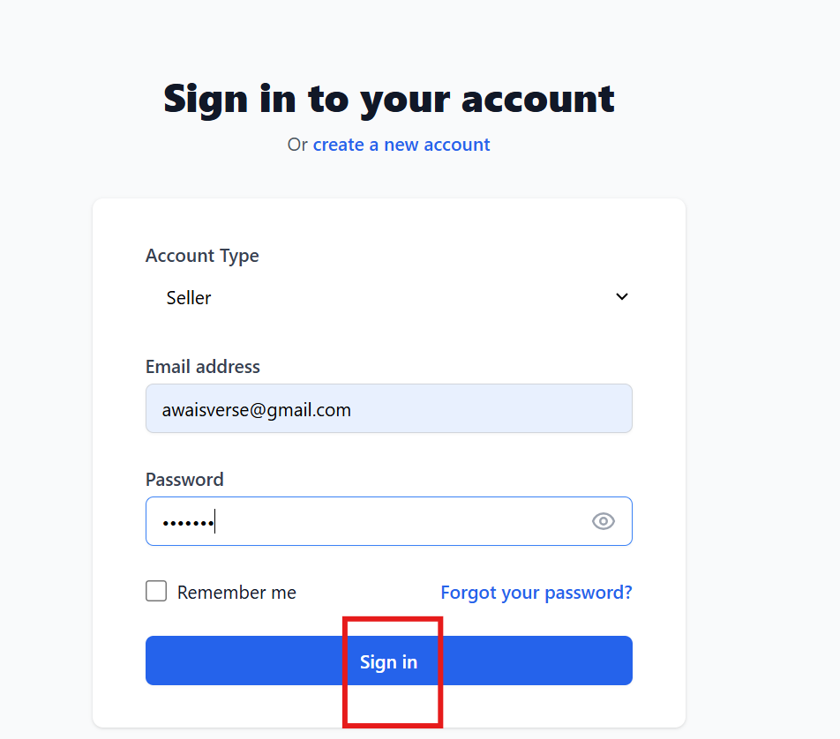

Admin Side:
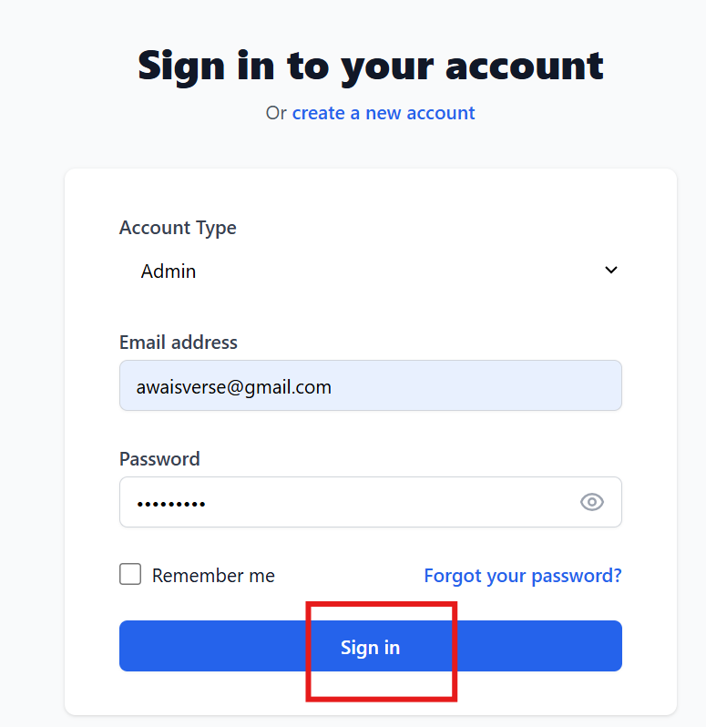

Buyer Side:
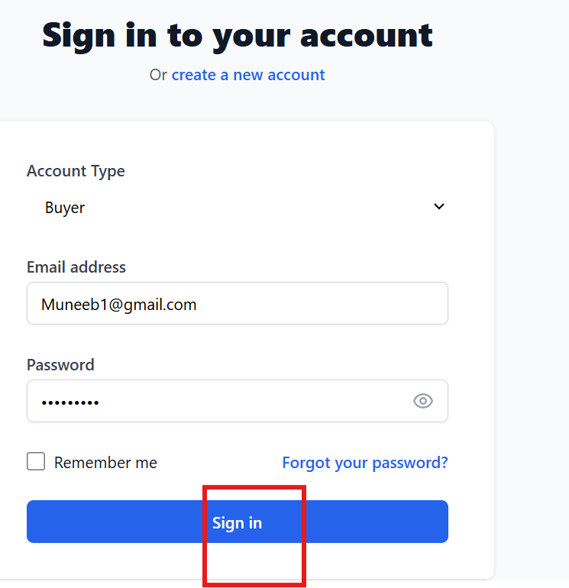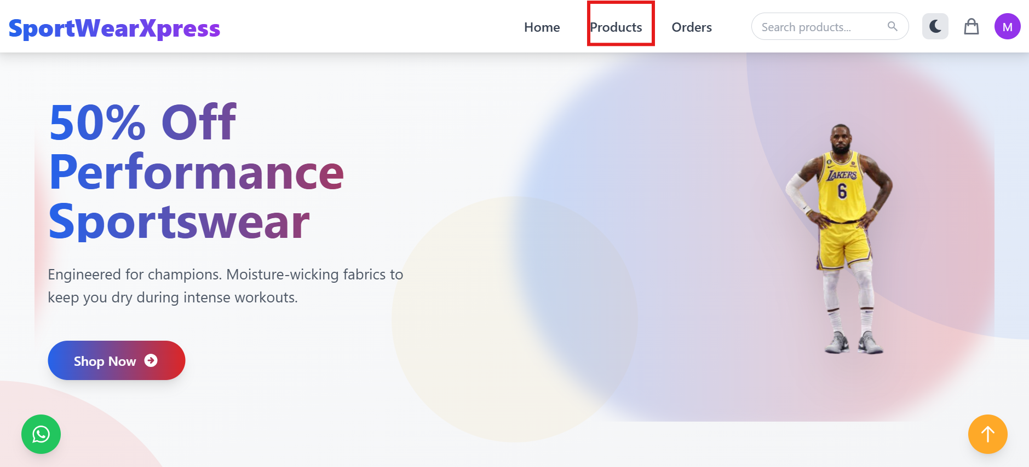

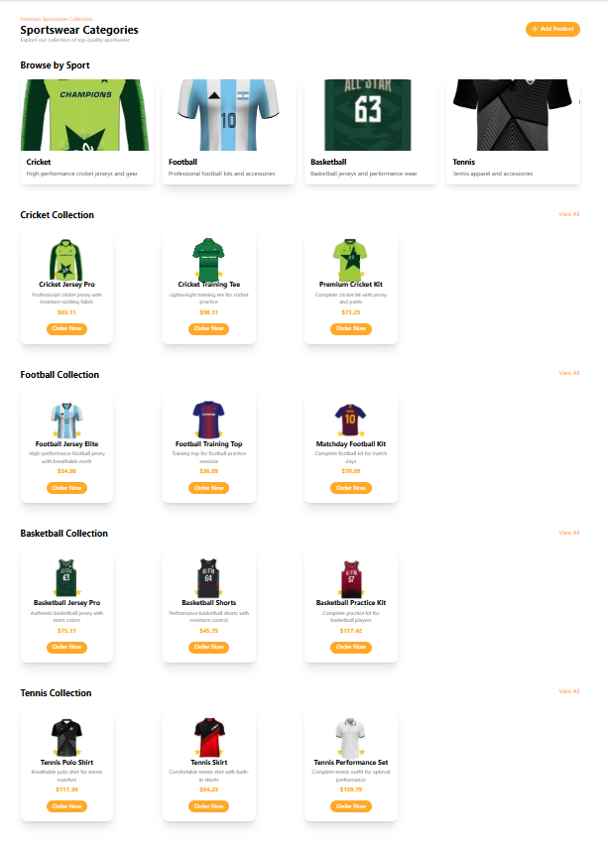

References
[1] Zazzle, “Zazzle - Customize Anything,” [Online]. Available: https://www.zazzle.com/. [Accessed: 26-
Nov-2024].
[2] Custom Ink, “Custom Ink - Custom T-shirts and More,” [Online]. Available:
https://www.customink.com/. [Accessed: 26-Nov-2024].

Project Summary Form
Name of Project | SportWearXpress
Project Type | E-commerce Platform with AI Customization
Department | Faculty of Information Technology & Computer Science
Start Date | October 2024
Completion Date | 25 June
Supervisor / Team Leader | Anum Mustaqeem
Team Members (if any) | Muhammad Muneeb Butt (L1F21BSSE0564), M Awais Akram (L1S21BSSE0072), Muhammad Qasim Abbas (L1F21BSSE0476)
Funding Agency (if any) | N/A
Amount of Funding (if any) | N/A
Assign SDGs to Project | SDG 9: Industry, Innovation, and Infrastructure
Motivation of Project | To address inefficiencies in sportswear customization by providing an AI-enhanced platform for personalized designs, real-time communication, and dynamic pricing.
Practical / Potential Application | The platform can be adopted by sportswear brands, small businesses, and e-commerce retailers to streamline customization and improve customer satisfaction.
Abstract | SportWearXpress is an AI-powered e-commerce platform designed to simplify sportswear customization. It integrates AI tools for design guidance, dynamic pricing, and real-time buyer-seller communication, setting a new standard for personalized shopping experiences.
Key Technical Features | - AI-driven design customization  - Real-time messaging  - Dynamic pricing model  - User/seller dashboards  - Secure authentication  - MongoDB database  - React.js frontend  - Node.js backend
Projects Images / Screenshots | 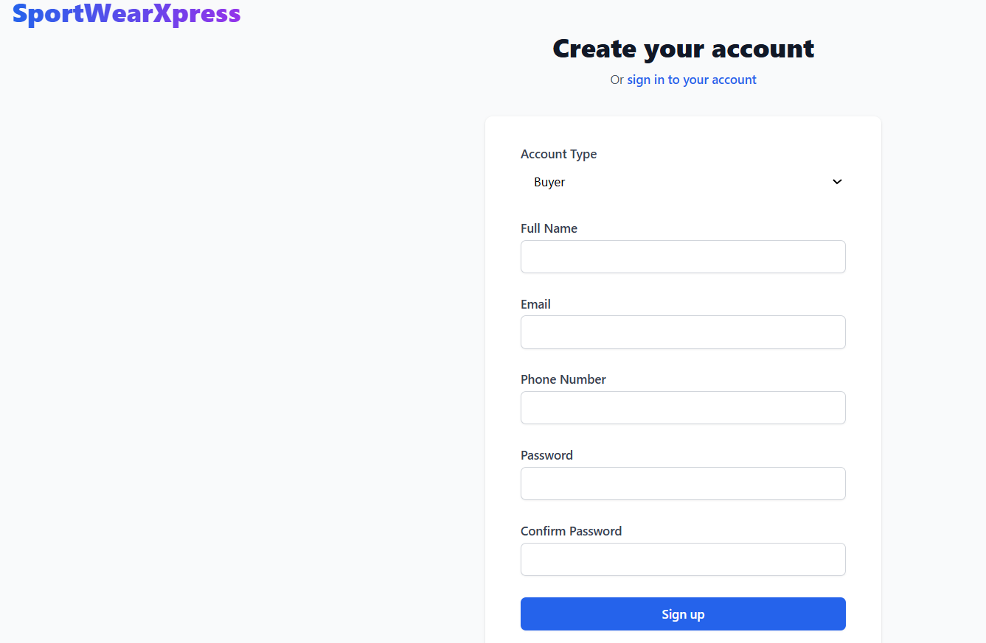  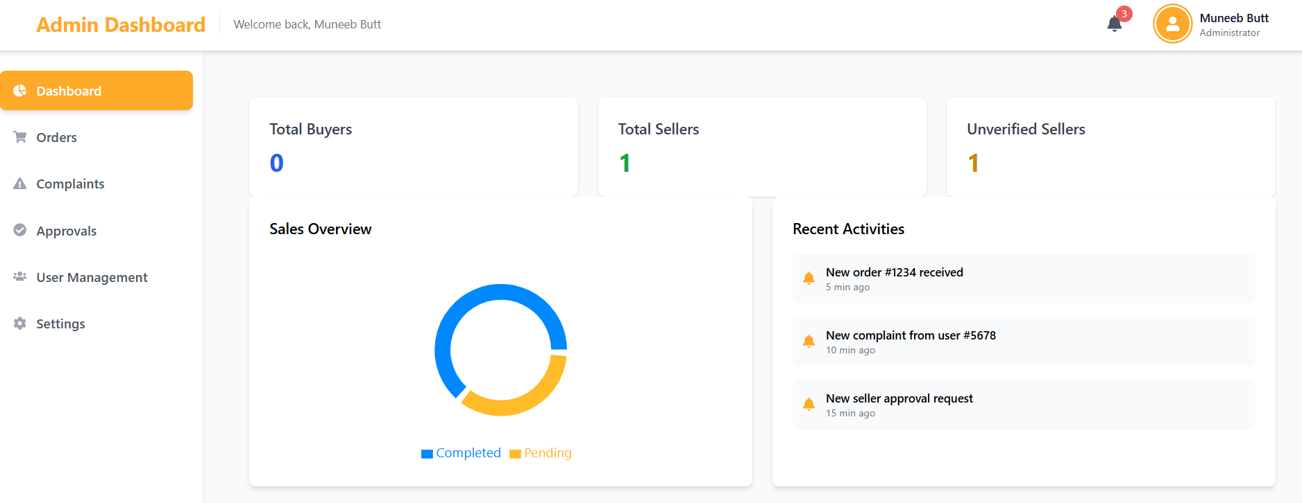
Appendix A: Glossary
Terms | Definition
AI | Artificial Intelligence
API | Application Programming Interface
AR | Augmented Reality
DB | Database
UI | User Interface
UX | User Experience
SDS | Software Design Specification
NLP | Natural Language Processing
IDE | Integrated Development Environment
AWS | Amazon Web Services
EC2 | Elastic Compute Cloud
S3 | Simple Storage Service
SQL | Structured Query Language
Appendix B: IV & V Report
(Independent verification & validation)
IV & V Resource

Name Signature

S# | Defect Description | Origin Stage | Status | Fix Time
 |  |  |  | Hours | Minutes
1
2
3
…
Table B.1: List of non-trivial defects

This document has been adapted from the following:
- Previous project templates at UCP
- High-level Technical Design, Centers for Medicare & Medicaid Services. (www.cms.gov)

