**COUPLING**

In our code coupling is present

The first type of coupling is data coupling, it is the one which is the most desirable

It is present for the communication between gui class and logical class

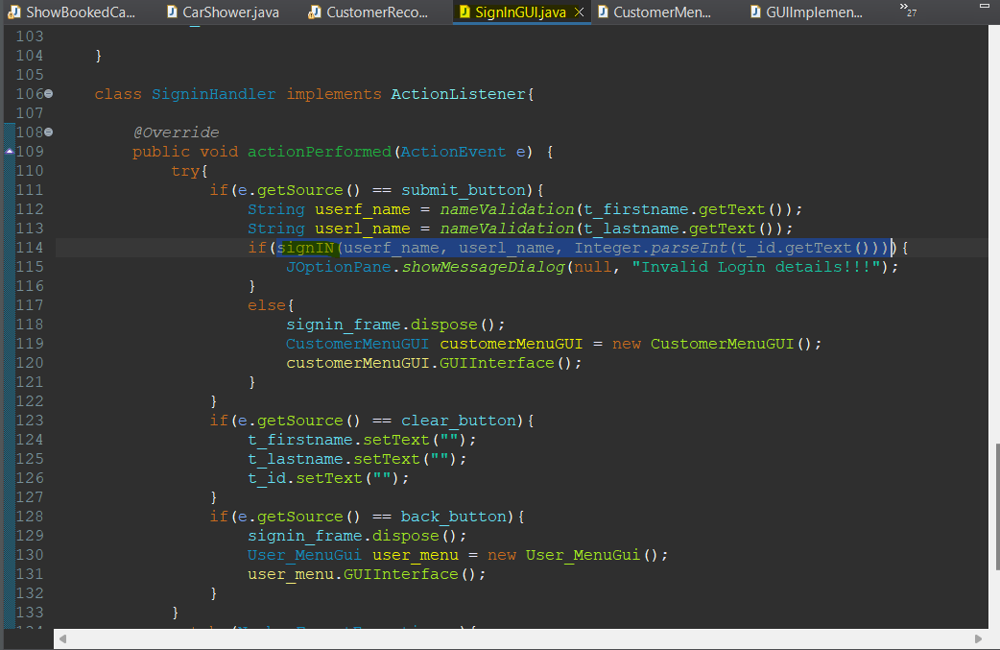

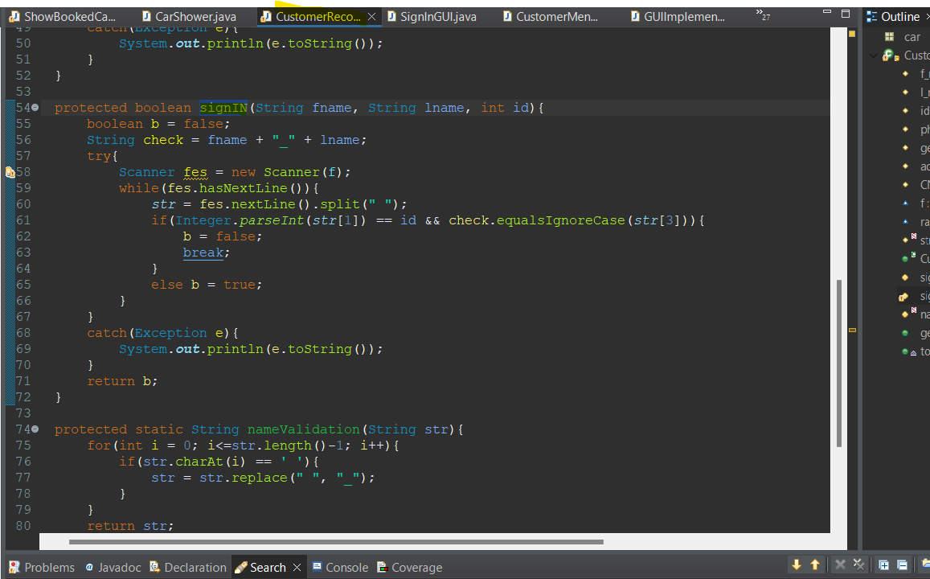

Here you can see the data is passed in the parameter to CustomerRecord class where they see if the Customer is present in the record and then the sign in happens

Which is better then the shared coupling where the entire data structure is passed in from one module to another.

SecondlyThere is External Coupling since the system read information through the external File, where the data is stored. I.E. the txt file.

For example:

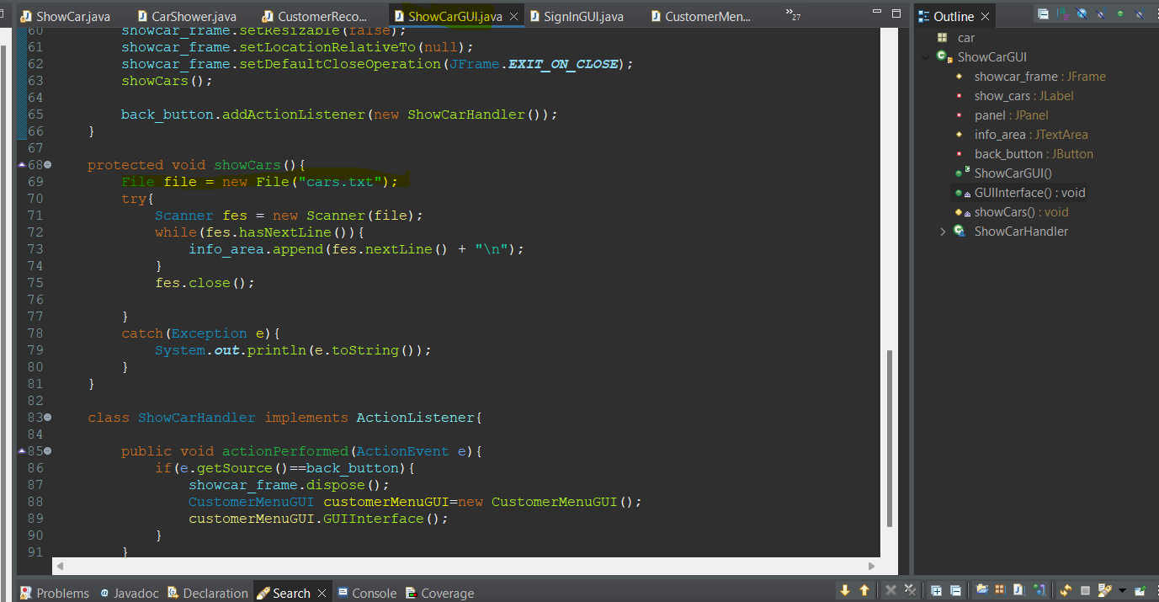

Here the show car gui is required to read data through the external file. Which is also important for the function to work. Yet its not dependent on any other function to extract data for it making it not tightly couple.

Similarly

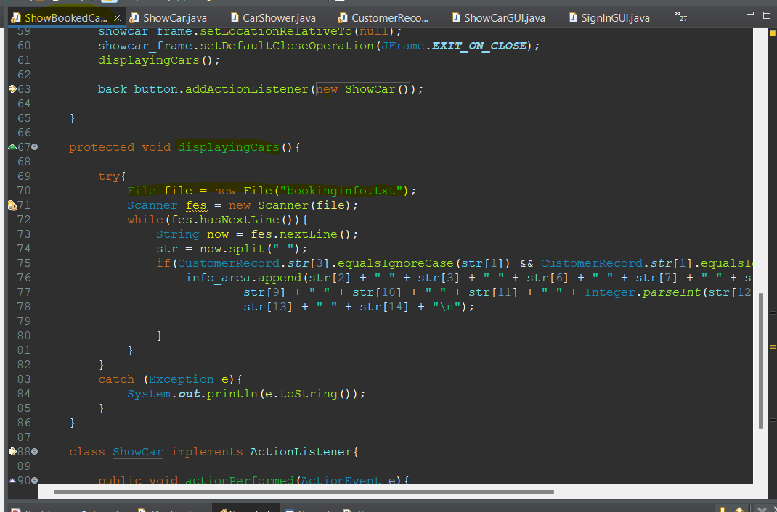

ShowBookedCarGui has the same approach, here external coupling is present. But still since its not depending on any other function to work, here they are loosely coupled.

Within the code there is also Control Coupling present within the system.

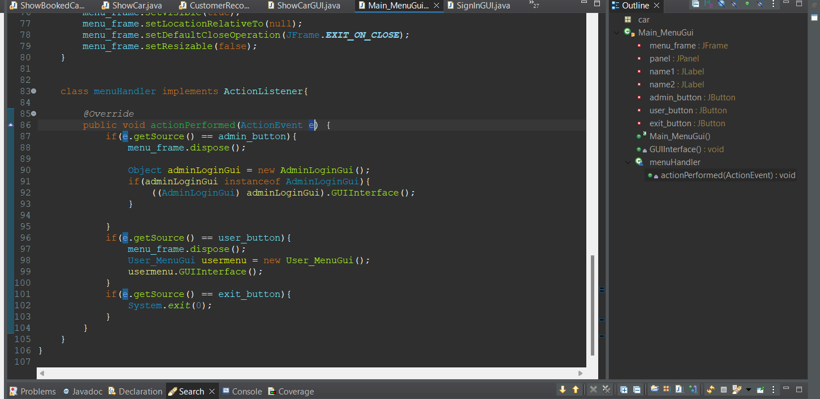

Here the ActionEvent e takes the action or button pressed in the gui which is passed in the ActionPerformed function and the action is performed based on what button was performed

Lastly there is content coupling present in the code as one module directly modify the data of another module.

