Woxsen University
School of Technology

PROJECT REPORT
on
EMPLOYEE PAYROLL AND STATUTORY DEDUCTION MANAGEMENT SYSTEM
Design and Implementation of a DBMS for Payroll Processing and Statutory Compliance
Name: Muneeb Siddiqui
Roll Number: 25WU0102265
Course: Database Management Systems (DBMS)
Faculty Name: Dr. Kiran Mayee
Academic Year: 2026–27

ABSTRACT
Payroll is one of the most sensitive activities in any organisation. Salaries must be calculated correctly, statutory deductions such as income tax, provident fund and health insurance must be applied in line with regulations, payments must be recorded and every figure must be traceable to an employee and a pay period. When these tasks are handled through spreadsheets, employee data is duplicated, deductions are miscalculated and audit trails are lost. This project presents the design and implementation of a relational database management system for employee payroll and statutory deduction management.
The database, named PayrollManagementDB, is implemented in MySQL and consists of seven tables: DEPARTMENTS, JOBS, EMPLOYEES, PAYROLL_RECORDS, STATUTORY_DEDUCTIONS, PAYMENT and ADMIN. The design is based on an entity-relationship model and is normalised to the third normal form. Primary keys, foreign keys, UNIQUE, NOT NULL and DEFAULT constraints enforce integrity, a one-to-one link separates statutory deductions from the payroll record they belong to, and the net salary is computed by the database itself as a generated column (gross salary minus total deductions), so it can never be out of step with the other two figures.
The report documents the objectives, requirements, ER diagram, relational schema, normalisation, data dictionary, DDL and DML commands, analytical queries with outputs, user-interface design, implementation details and testing. Constraint tests confirmed that duplicate e-mails, invalid foreign keys, duplicate deduction records, null mandatory fields, invalid status values and orphan deletions are all rejected by the database. The resulting system provides a centralised, accurate and auditable foundation for payroll processing.
Keywords: DBMS, MySQL, Entity-Relationship Model, Normalization, SQL, Payroll Management, Statutory Deductions, Generated Columns, Referential Integrity

TABLE OF CONTENTS
1. INTRODUCTION AND PROBLEM STATEMENT 1
1.1 Introduction 1
1.2 Problem Statement 1
2. OBJECTIVES AND SCOPE 1
2.1 Objectives 1
2.2 Scope 2
2.3 Limitations 2
3. SOFTWARE AND HARDWARE REQUIREMENTS 2
3.1 Software Requirements 2
3.2 Hardware Requirements 3
4. ER DIAGRAM 3
4.1 Entities and Relationships 3
5. RELATIONAL SCHEMA AND NORMALIZATION 4
5.1 Relational Schema 4
5.2 Normalization 5
5.2.1 First Normal Form (1NF) 5
5.2.2 Second Normal Form (2NF) 5
5.2.3 Third Normal Form (3NF) 5
5.2.4 Boyce-Codd Normal Form (BCNF) 5
6. DATA DICTIONARY 6
7. SQL COMMANDS USED (DDL AND DML) WITH SAMPLE OUTPUTS 8
7.1 Data Definition Language (DDL) 8
7.2 Data Manipulation Language (DML) 9
7.3 Sample Outputs 10
8. QUERIES WITH OUTPUTS 11
Query 1: Employees with department, job and status 11
Query 2: Payroll summary per employee (gross, deductions, net) 12
Query 3: Statutory deduction breakdown per employee 12
Query 4: Number of employees in each department 12
Query 5: Payroll cost by department 13
Query 6: Deduction percentage of gross salary 13
Query 7: Payments made to employees 13
Query 8: Consistency check: total deductions vs. their components 14
Query 9: Query given during Presentation-II (deductions of employee 1) 14
9. UI DESIGN AND SCREENSHOTS 15
9.1 Login Screen 15
9.2 Payroll Dashboard 15
9.3 Employee and Payroll Management 15
9.4 Payment Tracking 15
10. IMPLEMENTATION DETAILS 15
10.1 Technology Stack 15
10.2 Database Connectivity 15
10.3 Key Code Snippets 15
10.4 Integrity and Access Control 16
11. TESTING 16
11.1 Test Cases and Results 17
11.2 Observations 17
12. CONCLUSION AND FUTURE ENHANCEMENTS 17
12.1 Conclusion 17
12.2 Future Enhancements 18
13. REFERENCES 18
APPENDIX: GITHUB REPOSITORY LINK 18

1. INTRODUCTION AND PROBLEM STATEMENT

1.1 Introduction
Every organisation pays its employees on a regular cycle, and behind each pay cheque is a workflow in which employee records are maintained, gross salary is determined, statutory deductions are calculated, the net salary is paid and records are kept for audit. The volume of data in this workflow, which includes employee details, departments, job roles, pay periods, salary figures, deductions and payment transactions, grows with the size of the workforce and has to remain exact.
A database management system provides a reliable way to store this data once and use it consistently [1]. This project builds a relational database for employee payroll and statutory deduction management that follows the standard design process of conceptual modelling with an ER diagram [5], conversion to relational schemas [4], normalisation and implementation in SQL.

1.2 Problem Statement
Payroll teams that rely on spreadsheets and manual calculations face several problems:
- Employee, department and salary information is scattered and duplicated across files, which leads to inconsistencies
- Statutory deductions (income tax, provident fund, health insurance and others) are calculated by hand, so errors in the net salary are common and hard to trace
- There is no reliable link between an employee, a pay period, the deductions applied and the payment that was made
- Net salary can be edited independently of gross salary and deductions, so the three figures can disagree
- Salary and deduction data is sensitive, but there is no structured control over who can maintain it
The problem addressed is the design and implementation of a centralised relational database that stores all payroll data with integrity, supports the complete employee-to-payment workflow and can answer management queries on demand.

2. OBJECTIVES AND SCOPE

2.1 Objectives
- To provide a single unified platform for employee, department and job-role data.
- To record each pay period’s gross salary, total deductions and net salary for every employee.
- To store statutory deductions (income tax, provident fund, health insurance and other statutory items) against the payroll record they belong to.
- To compute net salary automatically in the database so it always equals gross salary minus total deductions.
- To record salary payments with the amount, mode, status and transaction reference.
- To guarantee data integrity through keys, constraints and normalisation.
- To generate payroll summaries, deduction breakdowns and department-wise headcount and cost on demand.

2.2 Scope
The scope covers the database design and implementation for an organisation with several departments and job roles, including employees, monthly payroll records, statutory deductions, payments and an administrator table. SQL queries produce the required reports. The user interface layer is described in Chapter 9.

2.3 Limitations
- The system stores deduction amounts as entered or calculated by the payroll administrator; it does not yet compute tax slabs automatically
- Each payroll record has exactly one statutory deduction record (one-to-one); itemised deductions per rule are not stored separately
- The ADMIN table is a standalone table of administrators; it is not yet linked by a foreign key to the payroll records they process (see Chapter 12)
- Currency is a single, unnamed unit; multi-currency payroll is outside the current schema

3. SOFTWARE AND HARDWARE REQUIREMENTS

3.1 Software Requirements
Component | Requirement
Database management system | MySQL (database: PayrollManagementDB)
Database client | MySQL command-line client
Operating system | Windows 10/11 / Linux / macOS
Front end / back end | [Technology used for the application layer — to be filled by the student]
ER diagram tool | [Tool used to draw the ER diagram — to be filled by the student]
Version control | Git and GitHub
Table 3.1: Software Requirements

3.2 Hardware Requirements
Component | Minimum requirement
Processor | Dual-core processor, 2 GHz or higher
Memory (RAM) | 4 GB (8 GB recommended)
Storage | 500 MB free disk space
Display | 1366 × 768 resolution or higher
Table 3.2: Hardware Requirements

4. ER DIAGRAM
The conceptual design is shown in Figure 4.1. It contains five entities, with relationships named in the diamonds. PK denotes a primary key, FK a foreign key, and net_salary is marked as a generated (derived) attribute. The PAYMENT and ADMIN entities that complete the implementation are shown in the relational schema in Chapter 5.
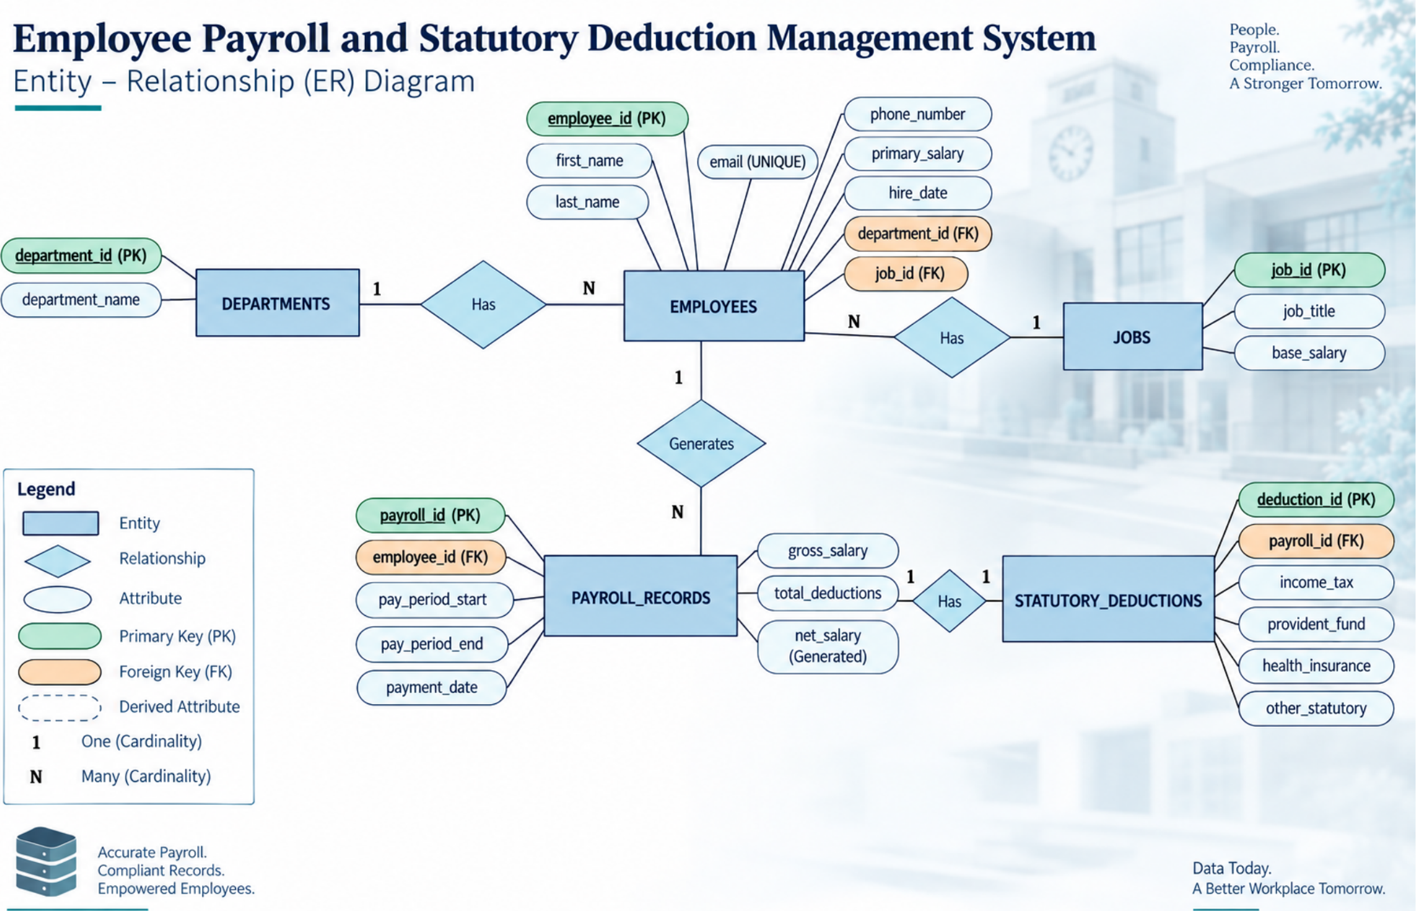
Figure 4.1: ER Diagram – Employee Payroll and Statutory Deduction Management System

4.1 Entities and Relationships
- DEPARTMENTS – EMPLOYEES: A department has many employees, and each employee belongs to one department (1:N).
- JOBS – EMPLOYEES: A job role (title and base salary) is held by many employees, and each employee has one job role (1:N).
- EMPLOYEES – PAYROLL_RECORDS: An employee generates many payroll records, one for each pay period, and each payroll record belongs to one employee (1:N).
- PAYROLL_RECORDS – STATUTORY_DEDUCTIONS: A payroll record has exactly one statutory-deduction record and each deduction record belongs to one payroll record (1:1).
- PAYROLL_RECORDS – PAYMENT: A payroll record can be settled by payments, and each payment refers to one payroll record (1:N, shown in the schema).
- ADMIN – PAYROLL_RECORDS: Administrators maintain the payroll data; the schema diagram shows this as a 1:N relationship at the conceptual level.

5. RELATIONAL SCHEMA AND NORMALIZATION

5.1 Relational Schema
The ER diagram was converted into the relations in Table 5.1. Primary keys are marked (PK) and foreign keys (FK). Figure 5.1 shows the same schema with data types and constraints.
Relation | Attributes | Foreign keys
DEPARTMENTS | department_id (PK), department_name (UNIQUE) | –
JOBS | job_id (PK), job_title (UNIQUE), base_salary | –
ADMIN | admin_id (PK), name, role, email | –
EMPLOYEES | employee_id (PK), first_name, last_name, email (UNIQUE), phone_number, primary_salary, hire_date, department_id (FK), job_id (FK), status | department_id → DEPARTMENTS; job_id → JOBS
PAYROLL_RECORDS | payroll_id (PK), employee_id (FK), pay_period_start, pay_period_end, payment_date, gross_salary, total_deductions, net_salary (generated) | employee_id → EMPLOYEES
STATUTORY_DEDUCTIONS | deduction_id (PK), payroll_id (FK, UNIQUE), income_tax, provident_fund, health_insurance, other_statutory | payroll_id → PAYROLL_RECORDS
PAYMENT | payment_id (PK), payroll_id (FK), amount, transaction_ref, status, payment_date, payment_mode | payroll_id → PAYROLL_RECORDS
Table 5.1: Relational Schema
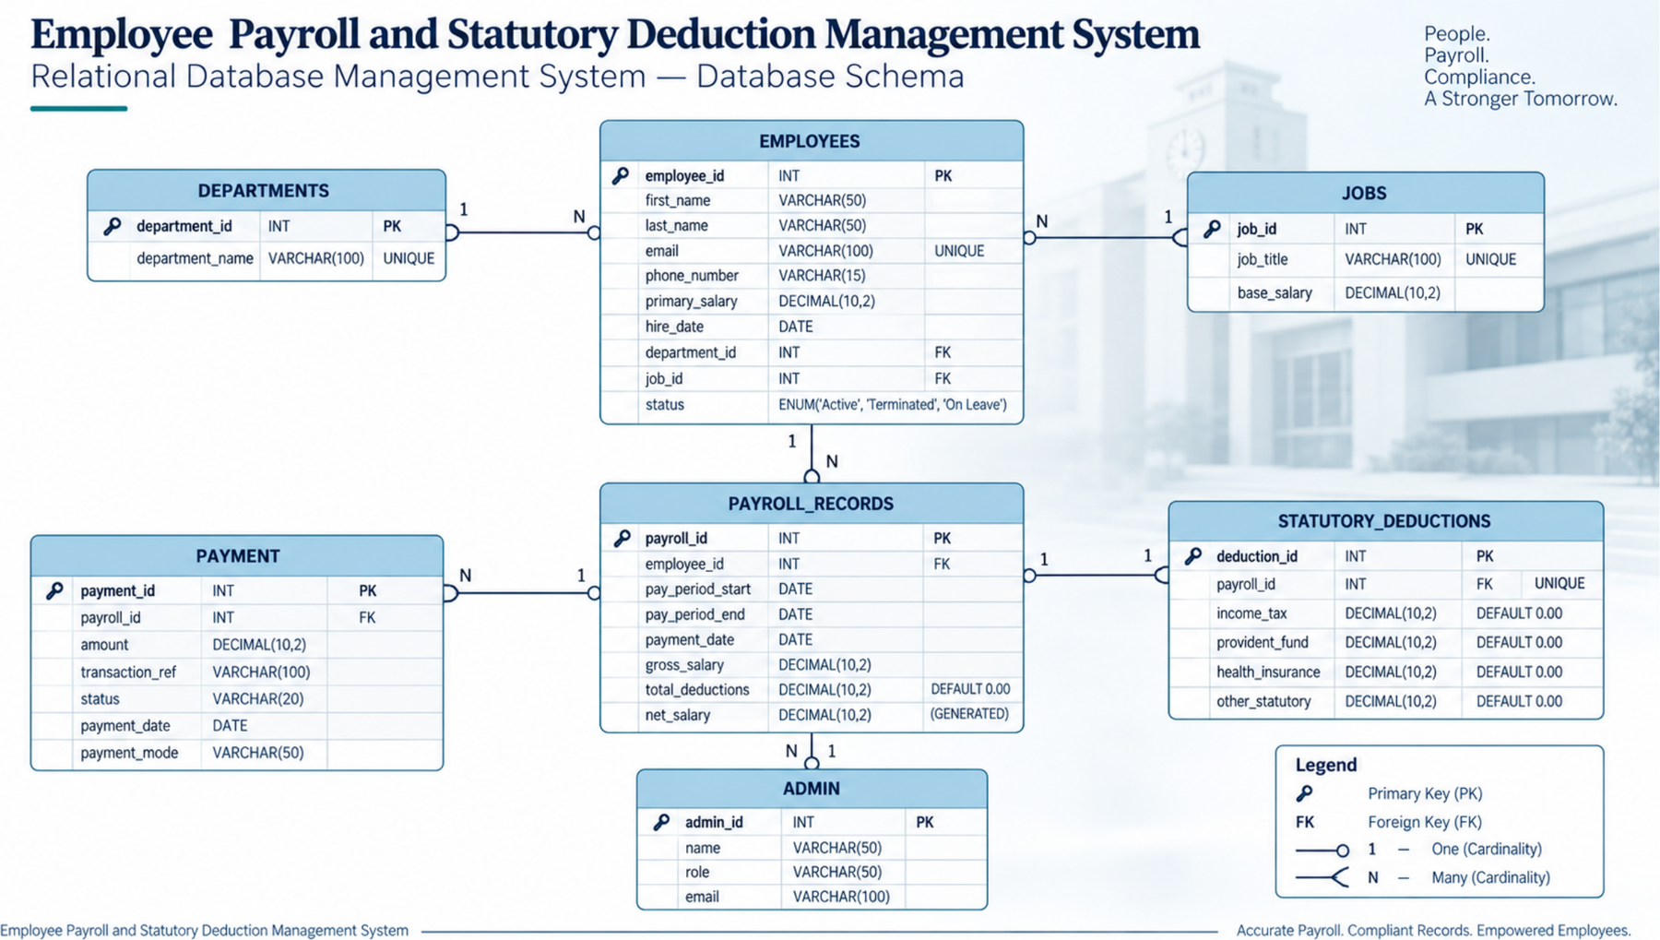
Figure 5.1: Relational Database Schema with Primary and Foreign Keys

5.2 Normalization
Normalisation removes redundancy and update anomalies by organising attributes into well-structured relations [4], [5]. The design was checked against the first three normal forms and Boyce-Codd normal form.

5.2.1 First Normal Form (1NF)
All attributes hold single, atomic values and every relation has a primary key. An employee’s name is split into first_name and last_name, and the deductions of a pay period are stored as separate numeric columns rather than as a combined text value.

5.2.2 Second Normal Form (2NF)
Every relation is in 1NF and no non-key attribute depends on only part of a composite key. All seven relations have a single-column primary key, so partial dependency cannot occur.

5.2.3 Third Normal Form (3NF)
No non-key attribute depends on another non-key attribute. Examples: department name is stored in DEPARTMENTS and referenced from EMPLOYEES by department_id, not repeated for every employee; job title and base salary are stored in JOBS and referenced by job_id; statutory deduction amounts are stored in STATUTORY_DEDUCTIONS and referenced from PAYROLL_RECORDS by payroll_id.

5.2.4 Boyce-Codd Normal Form (BCNF)
In every relation each determinant is a candidate key. In EMPLOYEES, email is an alternate candidate key enforced with UNIQUE; in DEPARTMENTS, department_name and in JOBS, job_title are alternate candidate keys; in STATUTORY_DEDUCTIONS, payroll_id is also a candidate key because each payroll record has only one deduction record.
Design note: total_deductions in PAYROLL_RECORDS equals the sum of income_tax, provident_fund, health_insurance and other_statutory, and could therefore be derived. It is kept as a stored attribute so that net salary can be generated directly from the payroll record, which is a deliberate trade-off between strict normalisation and query speed. Query 8 in Chapter 8 verifies that the stored total always matches its components.

6. DATA DICTIONARY
The data dictionary describes the structure of every table in PayrollManagementDB: column names, data types, constraints and meaning.
Column | Data Type | Constraints | Description
department_id | INT | PRIMARY KEY, AUTO_INCREMENT | Unique department identifier
department_name | VARCHAR(100) | NOT NULL, UNIQUE | Name of the department
Table 6.1: DEPARTMENTS
Column | Data Type | Constraints | Description
job_id | INT | PRIMARY KEY, AUTO_INCREMENT | Unique job identifier
job_title | VARCHAR(100) | NOT NULL, UNIQUE | Title of the job role
base_salary | DECIMAL(10,2) | – | Standard salary for the role
Table 6.2: JOBS
Column | Data Type | Constraints | Description
employee_id | INT | PRIMARY KEY, AUTO_INCREMENT | Unique employee identifier
first_name | VARCHAR(50) | NOT NULL | First name
last_name | VARCHAR(50) | NOT NULL | Last name
email | VARCHAR(100) | NOT NULL, UNIQUE | Contact e-mail address
phone_number | VARCHAR(15) | – | Contact number
primary_salary | DECIMAL(10,2) | – | Salary agreed with the employee
hire_date | DATE | NOT NULL | Date of joining
department_id | INT | FOREIGN KEY → DEPARTMENTS | Department of the employee
job_id | INT | FOREIGN KEY → JOBS | Job role of the employee
status | ENUM | DEFAULT 'Active' | Active, Terminated or On Leave
Table 6.3: EMPLOYEES
Column | Data Type | Constraints | Description
payroll_id | INT | PRIMARY KEY, AUTO_INCREMENT | Unique payroll record identifier
employee_id | INT | NOT NULL, FOREIGN KEY → EMPLOYEES | Employee being paid
pay_period_start | DATE | NOT NULL | First day of the pay period
pay_period_end | DATE | NOT NULL | Last day of the pay period
payment_date | DATE | – | Date salary is paid
gross_salary | DECIMAL(10,2) | NOT NULL | Salary before deductions
total_deductions | DECIMAL(10,2) | DEFAULT 0.00 | Sum of statutory deductions
net_salary | DECIMAL(10,2) | GENERATED (STORED) | gross_salary − total_deductions
Table 6.4: PAYROLL_RECORDS
Column | Data Type | Constraints | Description
deduction_id | INT | PRIMARY KEY, AUTO_INCREMENT | Unique deduction record identifier
payroll_id | INT | NOT NULL, UNIQUE, FOREIGN KEY → PAYROLL_RECORDS | Payroll record the deductions belong to
income_tax | DECIMAL(10,2) | DEFAULT 0.00 | Income tax deducted
provident_fund | DECIMAL(10,2) | DEFAULT 0.00 | Provident fund contribution
health_insurance | DECIMAL(10,2) | DEFAULT 0.00 | Health insurance premium
other_statutory | DECIMAL(10,2) | DEFAULT 0.00 | Any other statutory deduction
Table 6.5: STATUTORY_DEDUCTIONS
Column | Data Type | Constraints | Description
payment_id | INT | PRIMARY KEY, AUTO_INCREMENT | Unique payment identifier
payroll_id | INT | NOT NULL, FOREIGN KEY → PAYROLL_RECORDS | Payroll record being settled
amount | DECIMAL(10,2) | NOT NULL | Amount paid
transaction_ref | VARCHAR(100) | – | Bank or transaction reference
status | VARCHAR(20) | – | Payment status, for example Completed
payment_date | DATE | – | Date of payment
payment_mode | VARCHAR(50) | – | For example Bank Transfer
Table 6.6: PAYMENT
Column | Data Type | Constraints | Description
admin_id | INT | PRIMARY KEY, AUTO_INCREMENT | Unique administrator identifier
name | VARCHAR(50) | NOT NULL | Name of the administrator
role | VARCHAR(50) | – | Role of the administrator
email | VARCHAR(100) | – | Contact e-mail address
Table 6.7: ADMIN

7. SQL COMMANDS USED (DDL AND DML) WITH SAMPLE OUTPUTS

7.1 Data Definition Language (DDL)
The database and its seven tables were created with CREATE DATABASE and CREATE TABLE statements. Parent tables are created before the child tables that reference them.
CREATE DATABASE PayrollManagementDB;
USE PayrollManagementDB;

CREATE TABLE departments (
department_id INT AUTO_INCREMENT PRIMARY KEY,
department_name VARCHAR(100) NOT NULL UNIQUE
);

CREATE TABLE jobs (
job_id INT AUTO_INCREMENT PRIMARY KEY,
job_title VARCHAR(100) NOT NULL UNIQUE,
base_salary DECIMAL(10,2)
);

CREATE TABLE admin (
admin_id INT AUTO_INCREMENT PRIMARY KEY,
name VARCHAR(50) NOT NULL,
role VARCHAR(50),
email VARCHAR(100)
);

CREATE TABLE employees (
employee_id INT AUTO_INCREMENT PRIMARY KEY,
first_name VARCHAR(50) NOT NULL,
last_name VARCHAR(50) NOT NULL,
email VARCHAR(100) NOT NULL UNIQUE,
phone_number VARCHAR(15),
primary_salary DECIMAL(10,2),
hire_date DATE NOT NULL,
department_id INT,
job_id INT,
status ENUM('Active','Terminated','On Leave') DEFAULT 'Active',
FOREIGN KEY (department_id) REFERENCES departments(department_id),
FOREIGN KEY (job_id) REFERENCES jobs(job_id)
);
Listing 7.1: DDL for the database, independent tables and EMPLOYEES
CREATE TABLE payroll_records (
payroll_id INT AUTO_INCREMENT PRIMARY KEY,
employee_id INT NOT NULL,
pay_period_start DATE NOT NULL,
pay_period_end DATE NOT NULL,
payment_date DATE,
gross_salary DECIMAL(10,2) NOT NULL,
total_deductions DECIMAL(10,2) DEFAULT 0.00,
net_salary DECIMAL(10,2) GENERATED ALWAYS AS
(gross_salary - total_deductions) STORED,
FOREIGN KEY (employee_id) REFERENCES employees(employee_id)
);

CREATE TABLE statutory_deductions (
deduction_id INT AUTO_INCREMENT PRIMARY KEY,
payroll_id INT NOT NULL UNIQUE,
income_tax DECIMAL(10,2) DEFAULT 0.00,
provident_fund DECIMAL(10,2) DEFAULT 0.00,
health_insurance DECIMAL(10,2) DEFAULT 0.00,
other_statutory DECIMAL(10,2) DEFAULT 0.00,
FOREIGN KEY (payroll_id) REFERENCES payroll_records(payroll_id)
);

CREATE TABLE payment (
payment_id INT AUTO_INCREMENT PRIMARY KEY,
payroll_id INT NOT NULL,
amount DECIMAL(10,2) NOT NULL,
transaction_ref VARCHAR(100),
status VARCHAR(20),
payment_date DATE,
payment_mode VARCHAR(50),
FOREIGN KEY (payroll_id) REFERENCES payroll_records(payroll_id)
);
Listing 7.2: DDL for PAYROLL_RECORDS, STATUTORY_DEDUCTIONS and PAYMENT

7.2 Data Manipulation Language (DML)
Sample data was inserted with INSERT statements, again in parent-to-child order. The sample contains four departments, four job roles, four employees and one pay period (September 2026) for each employee.
USE PayrollManagementDB;
INSERT INTO departments (department_name) VALUES
('Finance'),('Engineering'),('Human Resources'),('Sales');
INSERT INTO jobs (job_title, base_salary) VALUES
('Accountant',4500.00),('Software Engineer',7500.00),
('HR Manager',6000.00),('Sales Executive',5000.00);
INSERT INTO admin (name, role, email) VALUES
('Muneeb Siddiqui','Payroll Administrator','admin@company.com');
INSERT INTO employees
(first_name,last_name,email,phone_number,primary_salary,
hire_date,department_id,job_id) VALUES
('Alice','Smith','alice.smith@company.com','555-0101',4500.00,'2024-03-15',1,1),
('Bob','Johnson','bob.johnson@company.com','555-0102',7500.00,'2023-07-01',2,2),
('Charlie','Brown','charlie.brown@company.com','555-0103',6000.00,'2022-11-20',3,3),
('Diana','Prince','diana.prince@company.com','555-0104',5000.00,'2024-01-10',4,4);
Listing 7.3: INSERT statements for the parent tables and EMPLOYEES
INSERT INTO payroll_records
(employee_id,pay_period_start,pay_period_end,payment_date,
gross_salary,total_deductions) VALUES
(1,'2026-09-01','2026-09-30','2026-09-30',4500.00,720.00),
(2,'2026-09-01','2026-09-30','2026-09-30',7500.00,1425.00),
(3,'2026-09-01','2026-09-30','2026-09-30',6000.00,1020.00),
(4,'2026-09-01','2026-09-30','2026-09-30',5000.00,810.00);
INSERT INTO statutory_deductions
(payroll_id,income_tax,provident_fund,health_insurance,other_statutory) VALUES
(1,450.00,180.00,90.00,0.00),
(2,900.00,375.00,150.00,0.00),
(3,700.00,200.00,120.00,0.00),
(4,540.00,180.00,90.00,0.00);
INSERT INTO payment (payroll_id,amount,transaction_ref,status,payment_date,
payment_mode) VALUES
(1,3780.00,'TXN-20260930-001','Completed','2026-09-30','Bank Transfer'),
(2,6075.00,'TXN-20260930-002','Completed','2026-09-30','Bank Transfer'),
(3,4980.00,'TXN-20260930-003','Completed','2026-09-30','Bank Transfer'),
(4,4190.00,'TXN-20260930-004','Completed','2026-09-30','Bank Transfer');
Listing 7.4: INSERT statements for payroll, deductions and payments

7.3 Sample Outputs
Figure 7.1 summarises the implementation workflow in MySQL, from creating the database and tables to inserting records and running queries. Table 7.1 lists the tables created in PayrollManagementDB, and Table 7.2 shows the structure of the EMPLOYEES table as returned by the DESC command.
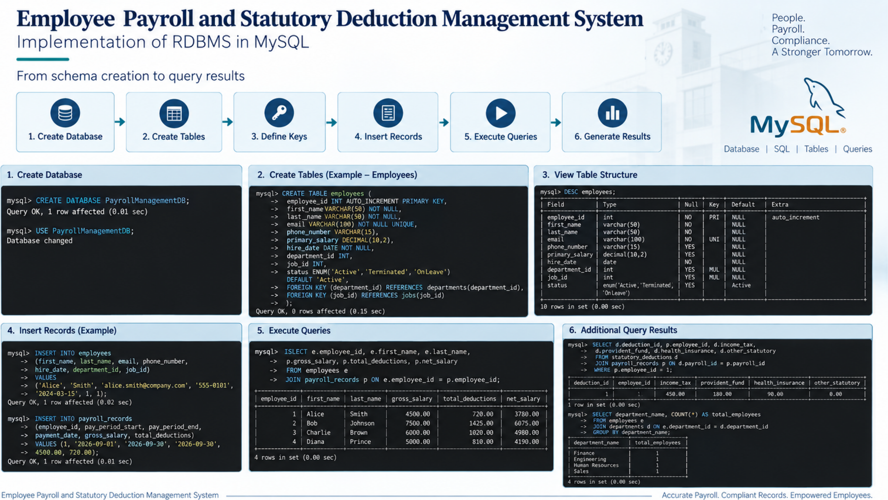
Figure 7.1: Implementation of the RDBMS in MySQL – from schema creation to query results
Tables_in_PayrollManagementDB
admin
departments
employees
jobs
payment
payroll_records
statutory_deductions
Table 7.1: SHOW TABLES output (7 rows)
Field | Type | Null | Key | Default | Extra
employee_id | int(11) | NO | PRI | NULL | auto_increment
first_name | varchar(50) | NO |  | NULL
last_name | varchar(50) | NO |  | NULL
email | varchar(100) | NO | UNI | NULL
phone_number | varchar(15) | YES |  | NULL
primary_salary | decimal(10,2) | YES |  | NULL
hire_date | date | NO |  | NULL
department_id | int(11) | YES | MUL | NULL
job_id | int(11) | YES | MUL | NULL
status | enum('Active','Terminated','On Leave') | YES |  | Active
Table 7.2: DESC employees output

8. QUERIES WITH OUTPUTS
This chapter lists the SQL queries used to retrieve and analyse the data, each with the output obtained on the sample data.

Query 1: Employees with department, job and status
SELECT e.employee_id,
CONCAT(e.first_name,' ',e.last_name) AS employee_name,
d.department_name, j.job_title, e.status
FROM employees e
JOIN departments d ON e.department_id = d.department_id
JOIN jobs j ON e.job_id = j.job_id;

employee_id | employee_name | department_name | job_title | status
1 | Alice Smith | Finance | Accountant | Active
2 | Bob Johnson | Engineering | Software Engineer | Active
3 | Charlie Brown | Human Resources | HR Manager | Active
4 | Diana Prince | Sales | Sales Executive | Active
Output 8.1: Employee overview

Query 2: Payroll summary per employee (gross, deductions, net)
SELECT e.employee_id, e.first_name, e.last_name,
p.gross_salary, p.total_deductions, p.net_salary
FROM employees e
JOIN payroll_records p ON e.employee_id = p.employee_id;

employee_id | first_name | last_name | gross_salary | total_deductions | net_salary
1 | Alice | Smith | 4500.00 | 720.00 | 3780.00
2 | Bob | Johnson | 7500.00 | 1425.00 | 6075.00
3 | Charlie | Brown | 6000.00 | 1020.00 | 4980.00
4 | Diana | Prince | 5000.00 | 810.00 | 4190.00
Output 8.2: Payroll summary

Query 3: Statutory deduction breakdown per employee
SELECT d.deduction_id, p.employee_id, d.income_tax,
d.provident_fund, d.health_insurance, d.other_statutory
FROM statutory_deductions d
JOIN payroll_records p ON d.payroll_id = p.payroll_id;

deduction_id | employee_id | income_tax | provident_fund | health_insurance | other_statutory
1 | 1 | 450.00 | 180.00 | 90.00 | 0.00
2 | 2 | 900.00 | 375.00 | 150.00 | 0.00
3 | 3 | 700.00 | 200.00 | 120.00 | 0.00
4 | 4 | 540.00 | 180.00 | 90.00 | 0.00
Output 8.3: Deduction breakdown

Query 4: Number of employees in each department
SELECT department_name, COUNT(*) AS total_employees
FROM employees e
JOIN departments d ON e.department_id = d.department_id
GROUP BY department_name;

department_name | total_employees
Engineering | 1
Finance | 1
Human Resources | 1
Sales | 1
Output 8.4: Headcount per department

Query 5: Payroll cost by department
SELECT d.department_name, SUM(p.gross_salary) AS total_gross,
SUM(p.total_deductions) AS total_deductions,
SUM(p.net_salary) AS total_net
FROM departments d
JOIN employees e ON e.department_id = d.department_id
JOIN payroll_records p ON p.employee_id = e.employee_id
GROUP BY d.department_id, d.department_name;

department_name | total_gross | total_deductions | total_net
Finance | 4500.00 | 720.00 | 3780.00
Engineering | 7500.00 | 1425.00 | 6075.00
Human Resources | 6000.00 | 1020.00 | 4980.00
Sales | 5000.00 | 810.00 | 4190.00
Output 8.5: Department-wise payroll cost

Query 6: Deduction percentage of gross salary
SELECT e.first_name, e.last_name,
ROUND(100 * p.total_deductions / p.gross_salary, 2) AS deduction_percent
FROM employees e
JOIN payroll_records p ON e.employee_id = p.employee_id;

first_name | last_name | deduction_percent
Alice | Smith | 16.00
Bob | Johnson | 19.00
Charlie | Brown | 17.00
Diana | Prince | 16.20
Output 8.6: Deduction percentage

Query 7: Payments made to employees
SELECT CONCAT(e.first_name,' ',e.last_name) AS employee_name,
pay.amount, pay.payment_mode, pay.status, pay.transaction_ref
FROM payment pay
JOIN payroll_records p ON pay.payroll_id = p.payroll_id
JOIN employees e ON p.employee_id = e.employee_id;

employee_name | amount | payment_mode | status | transaction_ref
Alice Smith | 3780.00 | Bank Transfer | Completed | TXN-20260930-001
Bob Johnson | 6075.00 | Bank Transfer | Completed | TXN-20260930-002
Charlie Brown | 4980.00 | Bank Transfer | Completed | TXN-20260930-003
Diana Prince | 4190.00 | Bank Transfer | Completed | TXN-20260930-004
Output 8.7: Payment details

Query 8: Consistency check: total deductions vs. their components
SELECT p.payroll_id, p.total_deductions,
(d.income_tax + d.provident_fund + d.health_insurance + d.other_statutory) AS component_sum,
IF(p.total_deductions = d.income_tax + d.provident_fund
+ d.health_insurance + d.other_statutory, 'Match', 'Mismatch') AS check_result
FROM payroll_records p
JOIN statutory_deductions d ON p.payroll_id = d.payroll_id;

payroll_id | total_deductions | component_sum | check_result
1 | 720.00 | 720.00 | Match
2 | 1425.00 | 1425.00 | Match
3 | 1020.00 | 1020.00 | Match
4 | 810.00 | 810.00 | Match
Output 8.8: Deduction consistency check

Query 9: Query given during Presentation-II (deductions of employee 1)
SELECT d.deduction_id, p.employee_id, d.income_tax,
d.provident_fund, d.health_insurance, d.other_statutory
FROM statutory_deductions d
JOIN payroll_records p ON d.payroll_id = p.payroll_id
WHERE p.employee_id = 1;

deduction_id | employee_id | income_tax | provident_fund | health_insurance | other_statutory
1 | 1 | 450.00 | 180.00 | 90.00 | 0.00
Output 8.9: Presentation-II query
Query 9 reproduces the deduction query demonstrated in the project presentation. If your Presentation-II query was a different one, replace the query and output above with it.

9. UI DESIGN AND SCREENSHOTS
The user interface gives the payroll administrator a view of the same database. The planned screens are described below; insert the screenshots of your application in the marked places.

9.1 Login Screen
The payroll administrator signs in; the system opens the payroll dashboard. [Insert screenshot of your login screen here.]

9.2 Payroll Dashboard
The dashboard shows total employees, departments, payroll processed for the current period, total deductions and net salary payable. [Insert screenshot here.]

9.3 Employee and Payroll Management
Administrators add and update employees, create payroll records for a pay period, enter statutory deductions and view the generated net salary. [Insert screenshot here.]

9.4 Payment Tracking
Administrators record and track salary payments with amount, mode, status and transaction reference. [Insert screenshot here.]

10. IMPLEMENTATION DETAILS

10.1 Technology Stack
Layer | Technology
Database | MySQL, database PayrollManagementDB, 7 tables
Query language | SQL (DDL and DML)
Front end | [Technology used — to be filled by the student]
Back end | [Technology used — to be filled by the student]
Version control | Git, GitHub
Table 10.1: Technology Stack

10.2 Database Connectivity
The application layer connects to MySQL using the database name PayrollManagementDB, a database user and a password, and sends SQL statements through a connector library. [Add the connection code of your application here, with credentials removed.]

10.3 Key Code Snippets
The following statements are central to the application. The first creates a payroll record; the generated column net_salary is filled in by the database:
INSERT INTO payroll_records
(employee_id, pay_period_start, pay_period_end,
payment_date, gross_salary, total_deductions)
VALUES (1, '2026-09-01', '2026-09-30', '2026-09-30', 4500.00, 720.00);

The second records the statutory deductions for that payroll record:
INSERT INTO statutory_deductions
(payroll_id, income_tax, provident_fund, health_insurance, other_statutory)
VALUES (1, 450.00, 180.00, 90.00, 0.00);

The third gives the payroll summary for the finance team:
SELECT e.employee_id, e.first_name, e.last_name,
p.gross_salary, p.total_deductions, p.net_salary
FROM employees e
JOIN payroll_records p ON e.employee_id = p.employee_id;

10.4 Integrity and Access Control
- Referential integrity: PRIMARY KEY and FOREIGN KEY constraints keep every employee, payroll record, deduction and payment linked to valid parents.
- Validation: UNIQUE on email, department_name, job_title and STATUTORY_DEDUCTIONS.payroll_id prevents duplicates; NOT NULL protects mandatory fields; the ENUM on status restricts it to valid values.
- Calculation integrity: net_salary is a generated column, so it is always gross_salary − total_deductions and cannot be edited independently.
- Administration: The ADMIN table records the administrators who maintain payroll data; role-based permissions can be built on it (Chapter 12).

11. TESTING
Testing covered structure creation, data loading, query results and constraint enforcement. The constraint tests were executed on a MySQL-compatible server (MariaDB 10.11) using the schema in Chapter 7, and the error codes below were returned by the server.

11.1 Test Cases and Results
ID | Test case | Expected result | Actual result | Status
T1 | Run SHOW TABLES on PayrollManagementDB | 7 tables listed | 7 tables listed | Pass
T2 | Insert sample data in all tables | Rows accepted (4, 4, 1, 4, 4, 4, 4) | All rows inserted and displayed | Pass
T3 | Join queries (Queries 1–9) | Correct joined and aggregated data | Outputs match the stored data | Pass
T4 | Insert an employee with an existing e-mail | Rejected by UNIQUE | ERROR 1062 (23000): Duplicate entry | Pass
T5 | Insert an employee with a non-existent department_id | Rejected by FOREIGN KEY | ERROR 1452 (23000): foreign key constraint fails | Pass
T6 | Insert a second deduction record for the same payroll record | Rejected by UNIQUE | ERROR 1062 (23000): Duplicate entry | Pass
T7 | Insert an employee with a NULL first_name | Rejected by NOT NULL | ERROR 1048 (23000): Column cannot be null | Pass
T8 | Delete a department that has employees | Blocked by FOREIGN KEY | ERROR 1451 (23000): foreign key constraint fails | Pass
T9 | Insert a department with an existing name | Rejected by UNIQUE | ERROR 1062 (23000): Duplicate entry | Pass
T10 | Insert an employee with status 'Retired' | Rejected by ENUM | ERROR 1265 (01000): Data truncated for column | Pass
T11 | Delete a payroll record that has deductions and payments | Blocked by FOREIGN KEY | ERROR 1451 (23000): foreign key constraint fails | Pass
T12 | Insert a payroll record for a non-existent employee | Rejected by FOREIGN KEY | ERROR 1452 (23000): foreign key constraint fails | Pass
Table 11.1: Test Cases and Results

11.2 Observations
All tests behaved as designed. The database correctly rejects invalid data and keeps related tables consistent, so errors are caught at the database level and not only in the application. Query 8 also confirmed that the stored total_deductions equals the sum of its components for every payroll record in the sample data.

12. CONCLUSION AND FUTURE ENHANCEMENTS

12.1 Conclusion
This project designed and implemented a relational database for employee payroll and statutory deduction management. The ER model was converted into seven normalised tables with proper keys and constraints, loaded with sample data and tested with analytical queries and constraint checks. The system centralises employee and salary data, separates statutory deductions from payroll records, computes net salary automatically, records payments and protects data quality at the database level. It reduces manual processing, improves accuracy and auditability, and can grow with the number of employees and pay periods.

12.2 Future Enhancements
- Link ADMIN to payroll: Add a processed_by foreign key from PAYROLL_RECORDS to ADMIN so every payroll record shows who prepared it, matching the relationship drawn in the schema diagram.
- Automatic total: Compute total_deductions with a trigger or generated column from the four deduction components so it can never disagree with them.
- Automatic tax calculation: Store tax slabs and compute income tax and provident fund from the gross salary.
- Constraints on amounts: Add CHECK constraints so salaries and deductions are never negative and pay_period_end is not before pay_period_start.
- Security and access: Add login accounts with hashed passwords and role-based permissions for payroll, HR and employees.
- Operations: Generate payslips, send e-mail alerts, add indexes for large data volumes and schedule regular backups.

13. REFERENCES
[1] R. Elmasri and S. B. Navathe, Fundamentals of Database Systems, 7th ed. Pearson, 2016.
[2] A. Silberschatz, H. F. Korth and S. Sudarshan, Database System Concepts, 7th ed. McGraw-Hill, 2019.
[3] MySQL 8.0 Reference Manual, Oracle Corporation. [Online]. Available: https://dev.mysql.com/doc/refman/8.0/en/
[4] E. F. Codd, "A relational model of data for large shared data banks," Communications of the ACM, vol. 13, no. 6, pp. 377-387, 1970.
[5] P. P. Chen, "The entity-relationship model: Toward a unified view of data," ACM Transactions on Database Systems, vol. 1, no. 1, pp. 9-36, 1976.

APPENDIX: GITHUB REPOSITORY LINK
The complete SQL scripts, application code and documentation are available at:
[GitHub repository: — add your repository link here]

