Student Name: Muneeb Ahmad Roll No.: 2025-CYS-156



Subject: OOP (Object Oriented Programming) LAB

Submitted to: Hafiz M.Mubashir Date: 30-04-2026

Terminal-Based Pacman Game
Project Report with Architecture and Source Code

Pacman Game
Project Report

1. Introduction
This report is about a Pacman game built in Java. The game runs in the terminal and is based on the classic Pacman arcade game. The player moves through a text-based maze, collects dots to earn points, avoids two ghost enemies, and tries to clear all the dots to win. The game was written using only Java's standard library with no extra tools or frameworks needed.

2. How the Game Works
When the program starts, a large PACMAN title made of text characters appears on the screen. After that, a blinking PRESS ENTER TO START message flashes a few times to give the player a moment to get ready. Then the board appears and the game begins.
The player types W, A, S, or D to move one step in that direction, then presses Enter. After the player moves, both ghosts each take one random step on their own. The board is then redrawn and the current score is shown below it. This repeats every turn until the game ends.
The game ends in one of two ways. If the player walks into a ghost, a GAME OVER screen appears. If the player collects all 156 dots on the board, a YOU WIN screen appears instead.

3. Controls
- W — move up
- S — move down
- A — move left
- D — move right
- E — quit the game

4. Game Features
- A 9-row by 30-column text maze with walls, dots, a player, and two ghosts.
- A live score shown after every move that counts how many dots have been collected.
- Two ghost enemies that each move in a random direction every turn, independently of each other.
- Wall detection — the player and ghosts cannot walk through walls.
- A win condition — collect all 156 dots to win the game.
- A game over condition — walk into a ghost and the game ends immediately.
- Three ASCII art screens: the PACMAN title at startup, YOU WIN when the board is cleared, and GAME OVER when caught.
- A blinking start prompt before the game begins.

5. Scoring
The score starts at zero when the game begins. Every time the player moves into a cell that has a dot in it, the score goes up by one. The score is printed below the board after every single turn. The highest possible score is 156, which is the total number of dots placed on the board at the start.

6. The ASCII Art Screens
The game has three special screens that appear at important moments. They are all drawn using normal keyboard characters arranged to look like large text.

- PACMAN title screen — this appears as soon as the program starts, before the board is shown.
- YOU WIN screen — this appears when the player has collected every dot on the board.
- GAME OVER screen — this appears when the player moves into a cell that has a ghost in it.

Each screen is stored in the code as a small set of text lines and printed to the terminal character by character.

7. Architecture Diagram
The diagram below shows how the four classes in the game are organised and how they connect to each other.

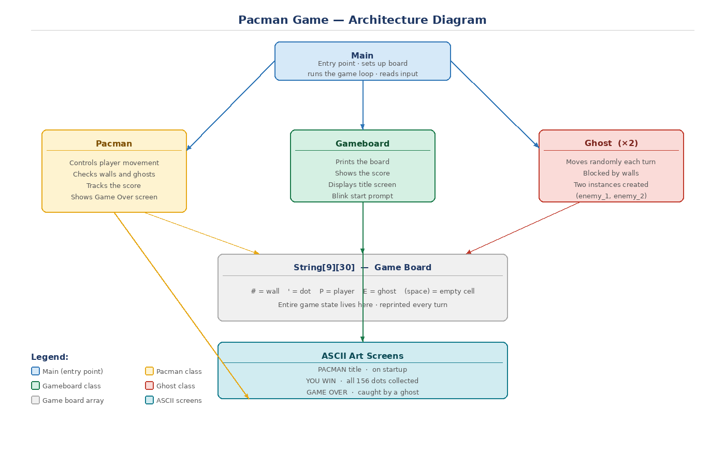

8. How the Classes Work
The game is made up of four classes, each with its own job.

Main is where the game starts. It builds the board, creates all the objects, and runs the loop that keeps the game going. It also reads the player's keyboard input each turn.
Pacman handles everything to do with the player. It moves the player in the chosen direction, checks if the new cell has a wall or a ghost, updates the score when a dot is collected, and shows the GAME OVER screen if the player is caught.
Ghost handles one enemy. Two Ghost objects are created at the start, called enemy_1 and enemy_2. Each one picks a random direction every turn and tries to move. If a wall is in the way it just stays still for that turn.
Gameboard takes care of what the player sees. It prints the board to the terminal after each move, shows the score line underneath, and displays the PACMAN title and blinking start message when the game first launches.

9. The Game Board
The board is stored as a grid of text — 9 rows and 30 columns. Every cell in the grid holds one character that represents what is in that spot. The outer edges are all walls, and there is a small block of walls in the middle too. Every other cell starts filled with a dot. As the player moves through the maze the dots are replaced with empty spaces, and the score goes up.

10. Summary
This Pacman game is a complete, working project built entirely in Java. It has a start screen, a live score, two ghost enemies, wall collision, a win condition, and three ASCII art screens. The code is split into four classes that each handle one part of the game. It covers all the main features of the original Pacman and is a solid example of a console game written from scratch in Java.

