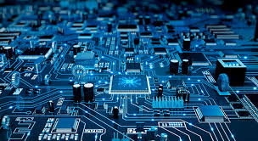

Digital Electronics Project

Submitted By:
Muneeb Ur Rehman

TABLE OF CONTENTS:

1 | Objectives
2 | Introduction
3 | Hardware Used
4 | Familiarization with software
5 | Procedure
6 | Working
7 | Implementation
8 | Conclusion
9 | Key Takeaways

“Digital clock using 4026 IC”

Project Overview:

The goal of this project is to design and implement a fully functional digital clock using only combinational and sequential logic components—without any microcontroller or programming. The clock is designed using CD4026 counter ICs, 7-segment displays, logic gates, switches, and buzzers, and is simulated on Proteus 8 Professional software.This digital clock project is structured around five progressive levels of complexity as described in the CEP (Complex Engineering Problem) framework provided in our project work. At each level, new features such as time setting, alarm activation, time zone adjustment, and even an optional calendar extension are added to enhance its real-world utility.
The final design is a robust, modular, and scalable digital clock system capable of keeping accurate time, receiving user input, triggering alarms, and adjusting to global time differences. It reflects the real-world application of logic design principles and reinforces our understanding of digital electronics, state transitions, and display interfacing.

Introduction:

In today’s digital world, timekeeping is an essential function found in almost every electronic system—from smartphones and watches to microwaves and industrial controllers. Most modern systems rely on microcontrollers or software for clock functions. However, this project focuses on building a digital clock using only hardware logic components, which not only improves understanding of how such systems work internally but also sharpens skills in digital circuit design and hardware simulation.

The digital clock is built using six CD4026 ICs, each of which drives a single digit on a 7-segment display. The displays are grouped to show hours, minutes, and seconds. Each section of the clock is carefully wired to ensure accurate time counting and rollover behavior—for example, when seconds reach 59, they reset to 00 and increment the minutes section. Logical AND gates help implement these control conditions. Beyond simply displaying time, the project introduces user interaction through buttons and switches. Users can manually set the time, activate or deactivate alarms, and even simulate time zone shifts. A buzzer is included to notify users when a pre-set alarm time is reached. The simulation environment—Proteus—lets us test and verify all these features before physical implementation.

Hardware Used:

Component | Quantity | Purpose and Function | Picture
CD4026 Decade Counter IC | 6 | This is the core IC used to count 0–9 and directly drive a 7-segment display. One IC is used for each digit of the clock (HH:MM: SS). | 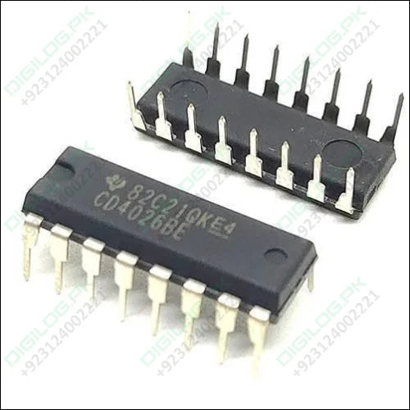
7-Segment Display (Common Cathode) | 6 | Displays each digit of the current time. Connected to the outputs of the 4026 ICs, which control the segments to show digits from 0–9. | 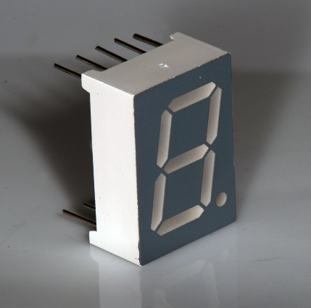
IC 7408 (Quad 2-Input AND Gate) | Multiple | Used to implement logic for reset conditions, ensuring that seconds reset after 59 and hours after 23. | 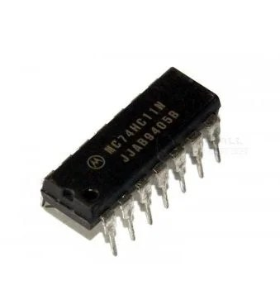
Push Button Switches | 3 | Used by the user to set minutes, hours, or alarm time. Each push sends a clock pulse to the corresponding counter. | 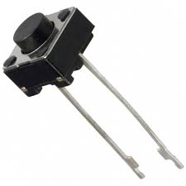
Resistors | As required | Used with the 555 timers to set the output frequency and to limit current in the circuit to prevent component damage. | 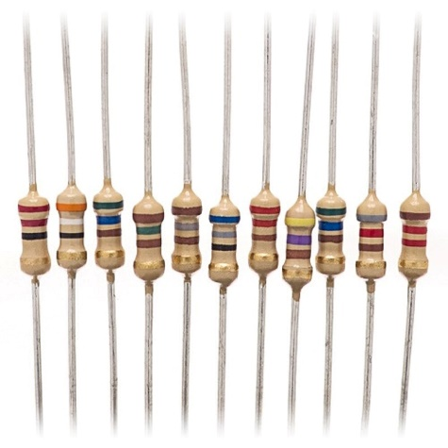
Buzzer | 1 | Acts as an output alarm signal. When the set alarm time matches the current time, the buzzer is activated using AND gate logic. | 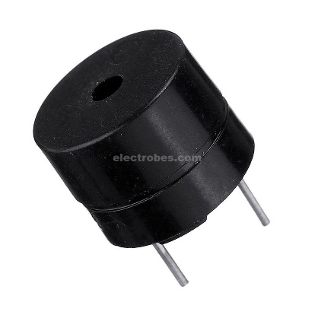
555 Timer IC | 1 | Used as a clock pulse generator to drive the second’s counter. It produces continuous pulses when configured in a stable mode. | 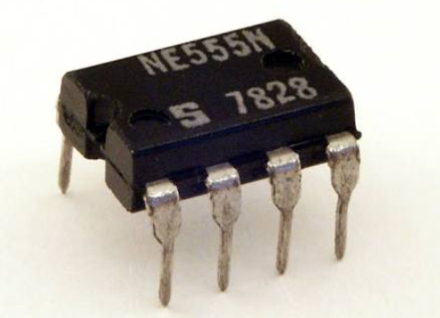
1.5 microfarad Capacitor | 1 | Paired with the 555 timers in the timing circuit to determine pulse width and frequency. Helps in smooth oscillation and stability of the clock signal. | 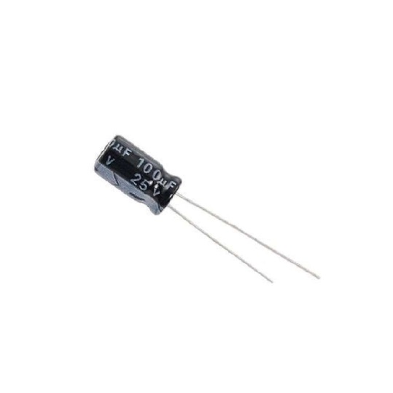
Analog Electronics Machine | 1 | Instead of using a 9V battery, we use this lab device to supply a stable DC voltage directly to the hardware, suitable for ICs and digital circuits. | 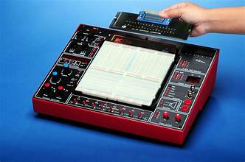

Familiarization with Software:
We used Proteus 8 Professional for designing and simulating our circuit.

What is Proteus?
Proteus is an advanced circuit simulation software widely used in electrical and electronics engineering. It allows both hardware simulation (using logic ICs, displays, buzzers, etc.) and microcontroller programming.

How We Used Proteus:
- Placed and connected all ICs, switches, gates, and displays.
- Simulated real-time changes in seconds, minutes, and hours.
- Observed carry outputs and digit rollovers.
- Created logical circuits to manage time setting and alarms.
- Debugged the circuit using the simulation run tool before physical implementation.

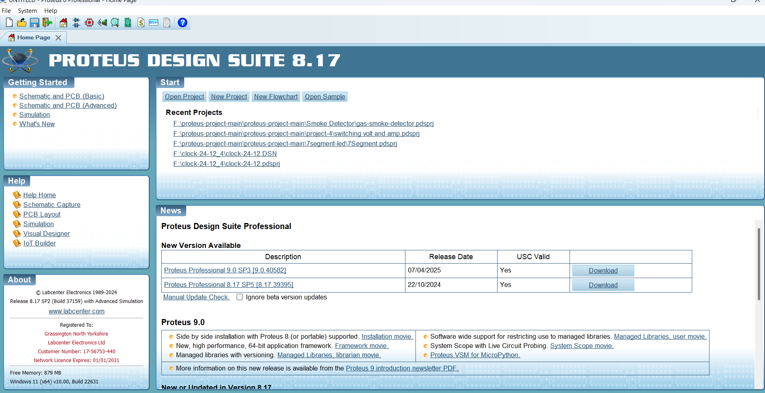

Procedure:

1. Circuit Design (Level 1):
- Each digit of time is driven by a CD4026 IC, connected in cascade using its “carry out” pin.
- First two ICs display seconds, next two minutes, and the last two hours.
- Logical reset conditions are built using AND gates when values exceed 59 seconds, 59 minutes, and 23 hours.

2. Time Setting (Level 2):
- Manual time setting switches are connected to inject clock pulses into selected counters (hours and minutes).
- Logic gates ensure correct functioning while adjusting time and avoid overlapping with real-time clock operation.

3. Alarm Functionality (Level 3):
- Additional logic switches are used to set alarm time.
- Comparison logic using AND gates checks if current time equals alarm time.
- When matched, the buzzer is activated.
- A separate switch can enable/disable the alarm.

4. Time Zone Adjustment (Level 4):
- Implemented using MUX logic or offset logic.
- A switch adds a fixed value (like +4 hours) to the current hour value to simulate a different time zone.
- Ensures clock flexibility for international time viewing.

5. Calendar Extension (Level 5 - Bonus):
- Optional extension includes counting dates and months using additional 4026 ICs.
- Can be extended further with leap-year logic using AND/OR gates for real-world calendar integration.

- Working:

The working of the circuit starts with the 555 timers where it was wired as a monostable Multivibrator. The 555 timers generate clock pulse after a second and output of 555 is connected to pin 1 of IC 4026 which is a seven-segment display decade counter which is used to drive a 7-segment display with input clock pulse. Here the clock pulse was obtained from the monostable multivibrator and fed into the pin 1 of first ic 4026. Pin 2 was usually grounded since giving high signal to this pin will inhibit the input clock signal to pin 1 and pin 3(Enable Clock) is always taken High. Initially when the circuit is switched ON the 7 segments will indicate "00:00:00" count and the negative trigger was given to 555 high pulses will be obtained from pin 3.

The high pulse was fed to first IC and therefore it increments its count with each clock, displaying 1 to 9 in its seven segments. As soon as 10 counts was incremented by IC a high to low signal was obtained from its pin 5 which indicates the completion of ten increments.
The pin 5 was connected to the clock pin of the next 4026 IC. Therefore whenever 10 counts were completed by the 7 segments, the high to low signal at the pin 5 will feed a single clock pulse input to the second IC and therefore the corresponding 7 segment will be incremented one value. For a digital clock we must reset second IC when it reaches to number 6 because we want seconds count up to "59” therefore we used IC 7411 (Three input AND Gate). In the same manner fourth IC will count from 0 to 6 and then value in the fifth IC will be incremented by one. This is all about for seconds and minute of clock. Now for hours we must reset fifth and sixth IC when number reached to “23” so we put one more three input AND gate.

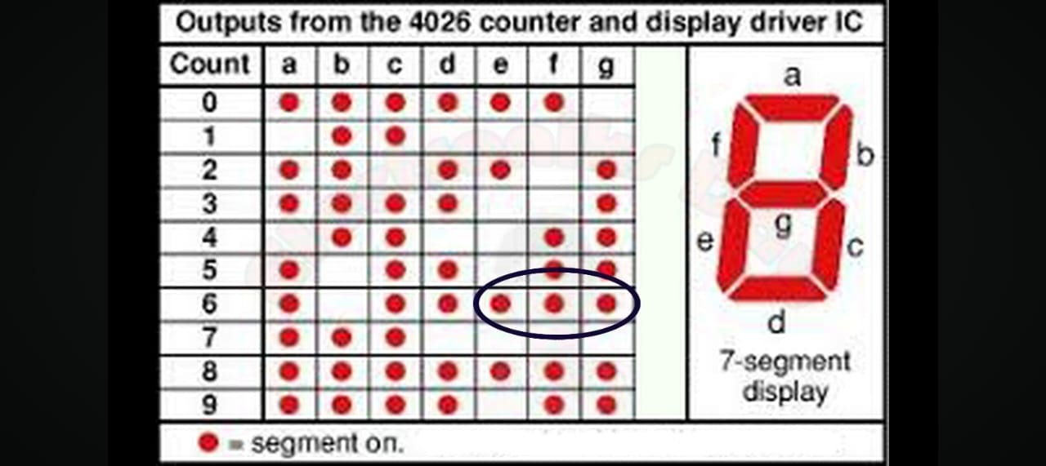

In 3rd 7 Segment Display , we AND (e, f, g) so that when it displays 5 , it automatically
resets to 0.

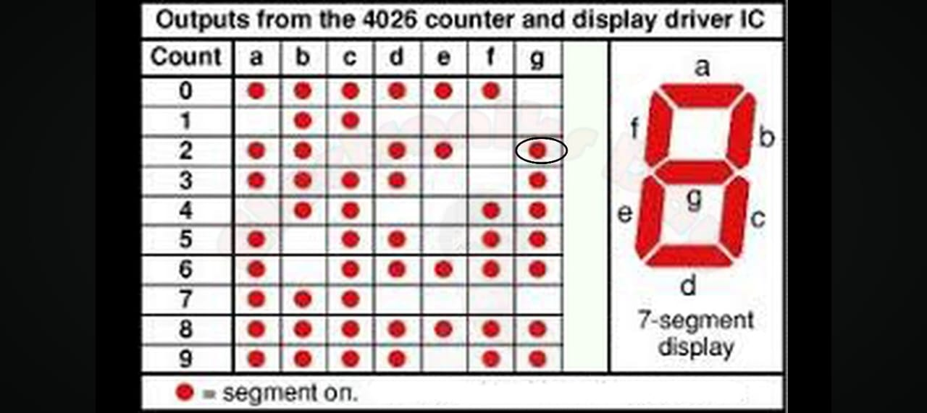

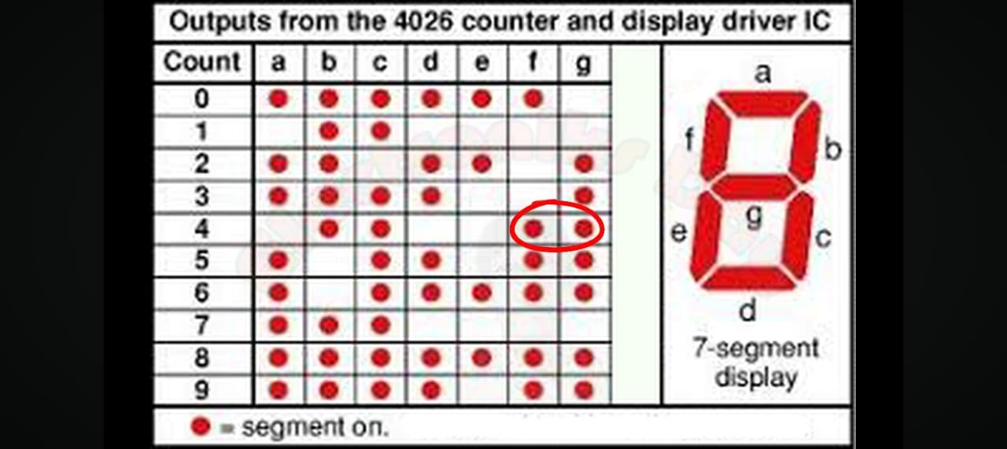

In 6th , 5th 7 Segment Display, we AND (g), (f, g) so that when it displays 2 and 4 , it automatically resets to 0.

- Implementation:

Hardware:

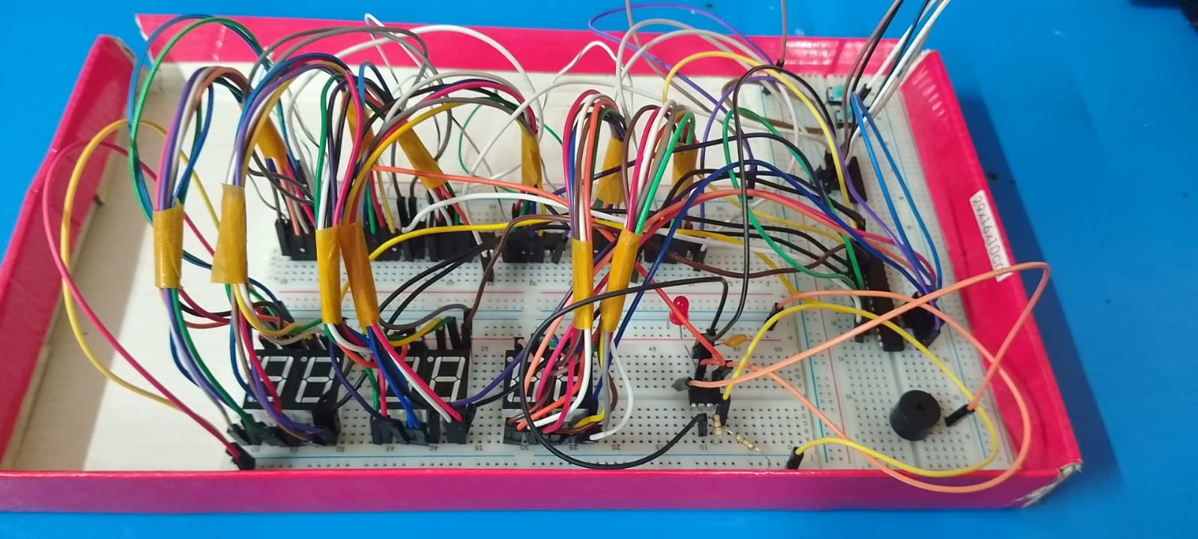
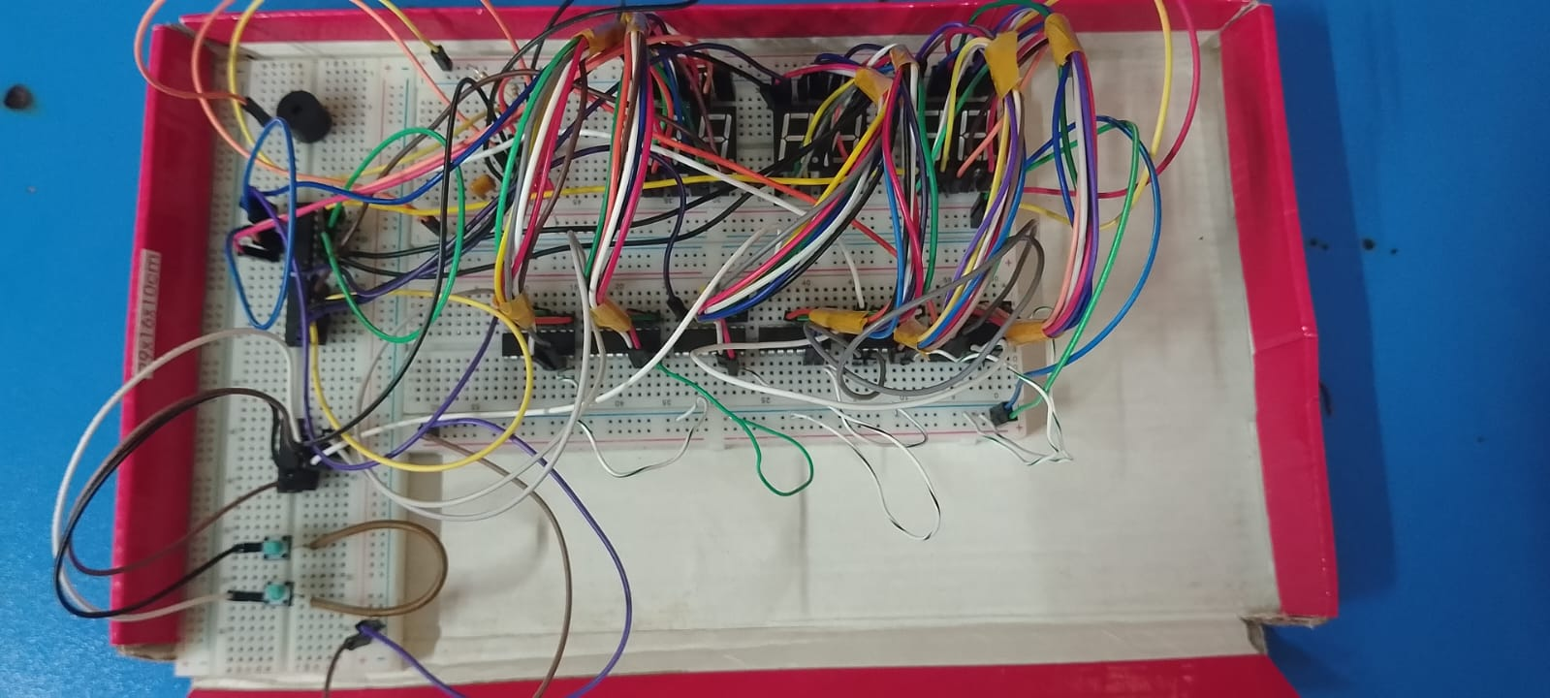

Simulation:

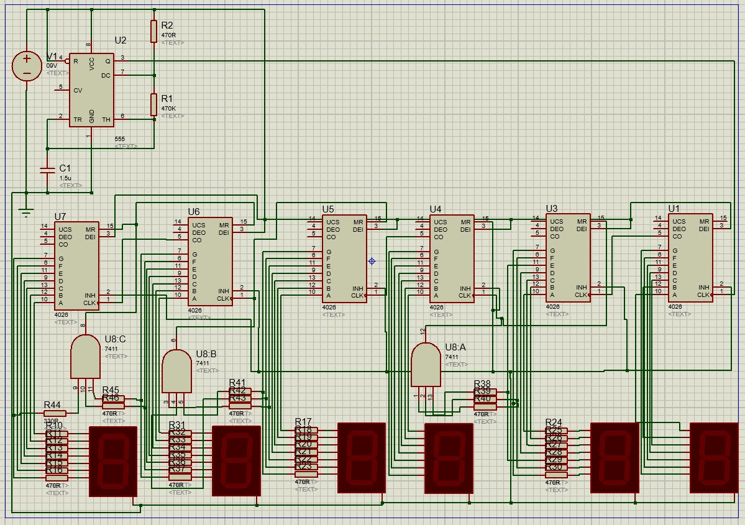

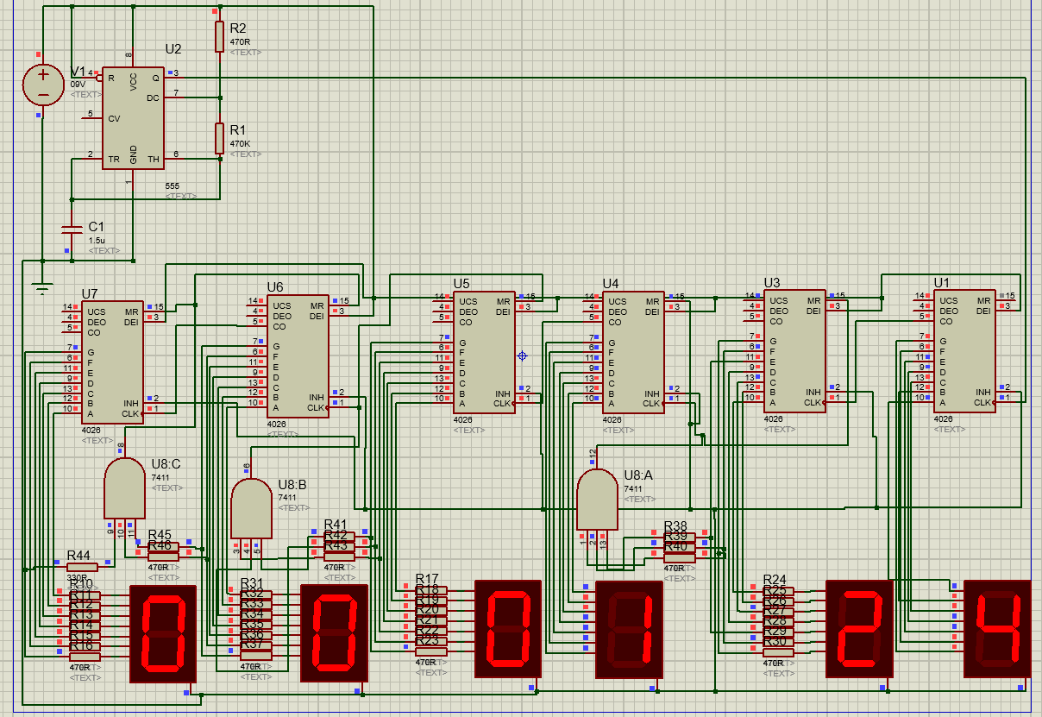

Conclusion:

Through the successful implementation of this project, we were able to design a fully functional digital clock using purely combinational and sequential logic circuits, without relying on any programming or microcontroller. This experience provided a practical application of concepts we have learned throughout the project work, such as counters, logic gates, timing control, and circuit cascading. The step-by-step development through multiple levels—from a basic timekeeping system to advanced features like alarm settings, user-configurable time inputs, and time zone adjustments—allowed us to deepen our understanding of how complex systems are broken down into manageable subsystems. The additional bonus level, which involved conceptualizing a calendar system, pushed our thinking beyond basic digital logic and into more advanced territory, encouraging creative design thinking.

We got to learn how to simulate and debug circuits using Proteus, which not only made the design process easier but also ensured accuracy before any physical hardware implementation. We also learned how to cascade ICs, use carry-out and reset logic efficiently, and incorporate real-world design challenges such as input switches, display rollovers, and user alarms.
Beyond technical skills, this project improved our collaboration, planning, and problem-solving abilities. Working in a group required clear communication and division of responsibilities. Each team member contributed to simulation, circuit design, testing, and documentation.

Overall, this project demonstrated how real-world electronic systems are not only a combination of theory and components but also require creativity, logic, and attention to detail. It bridged the gap between textbook learning and practical implementation and has prepared us for more complex design challenges in the future.

Key Takeaways:
- Understood working of CD4026 and 7-segment displays.
- Learned to simulate and verify real-time circuits using Proteus.
- Designed complex logic circuits using basic gates like AND, with real-world applications.
- Developed circuit modularity: seconds, minutes, and hours were managed in structured blocks.
- Practiced hardware-software integration principles.
- Gained a deeper appreciation for how digital clocks and timers work internally.

