*Assignment #1*

*TASKS:*

1. ***Retrieving Data from Multiple Tables:***

*Utilize SQL queries to retrieve all columns from the "Shipping" and "Order" tables.*

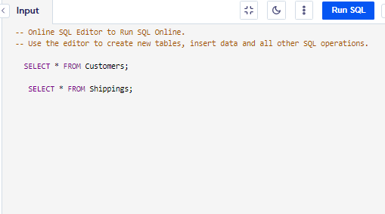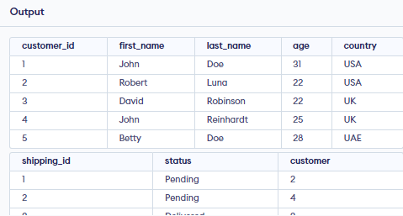***INPUT:***

***OUTPUT:***

1. ***Displaying Customer Information:***

*Present the "first_name," "age," and "last_name" columns from the "Customers" table.*

***INPUT:***

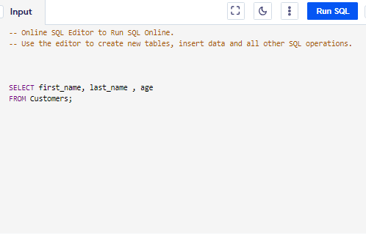

*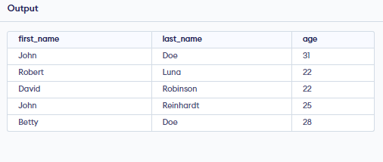****OUTPUT:***

1. ***Implementing Logical Operators:***

*Construct SQL queries using 'AND' and 'OR' logical operators to select columns where the item is 'keyboard,' the Customer ID is 3 (using 'OR'), and the AMOUNT equals 1200 (using 'AND').*

***INPUT:***

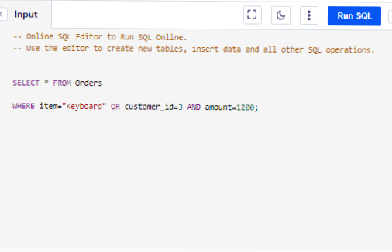

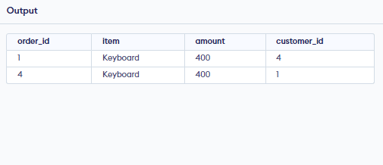***OUTPUT:***

1. ***Sorting Data in Ascending Order and Descending Order:***

*Use SQL queries to sort data from the "Order" table in ascending order.*

***ASCENDING ORDER***

***INPUT:***

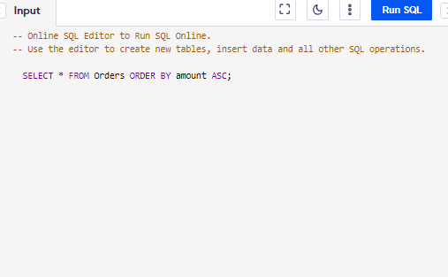

***OUTPUT:***

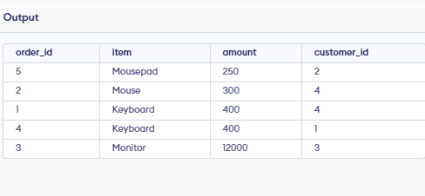

***DESCENDING ORDER***

***INPUT:***

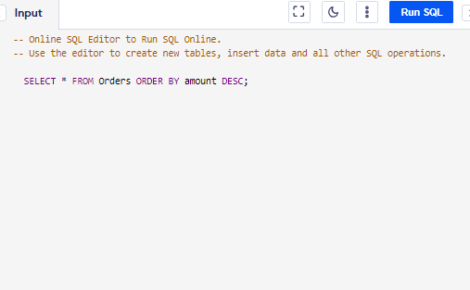

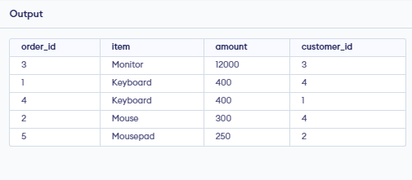***OUTPUT:***