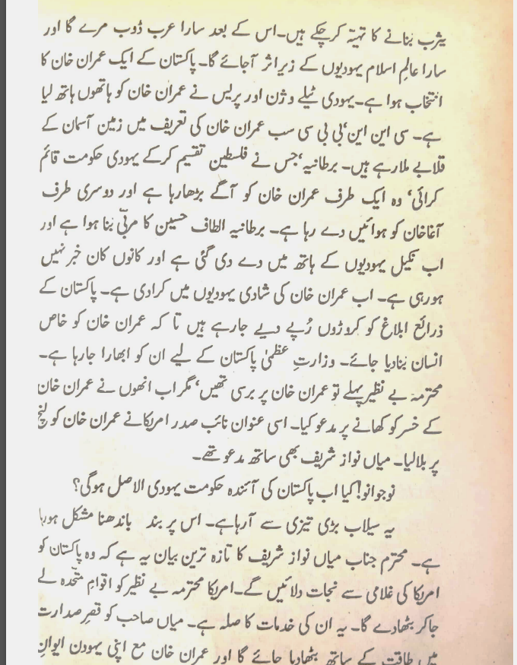

**Akalmand insaaan khud smjh jyy ga Hakim saeed kia kayhna chryy thyy**