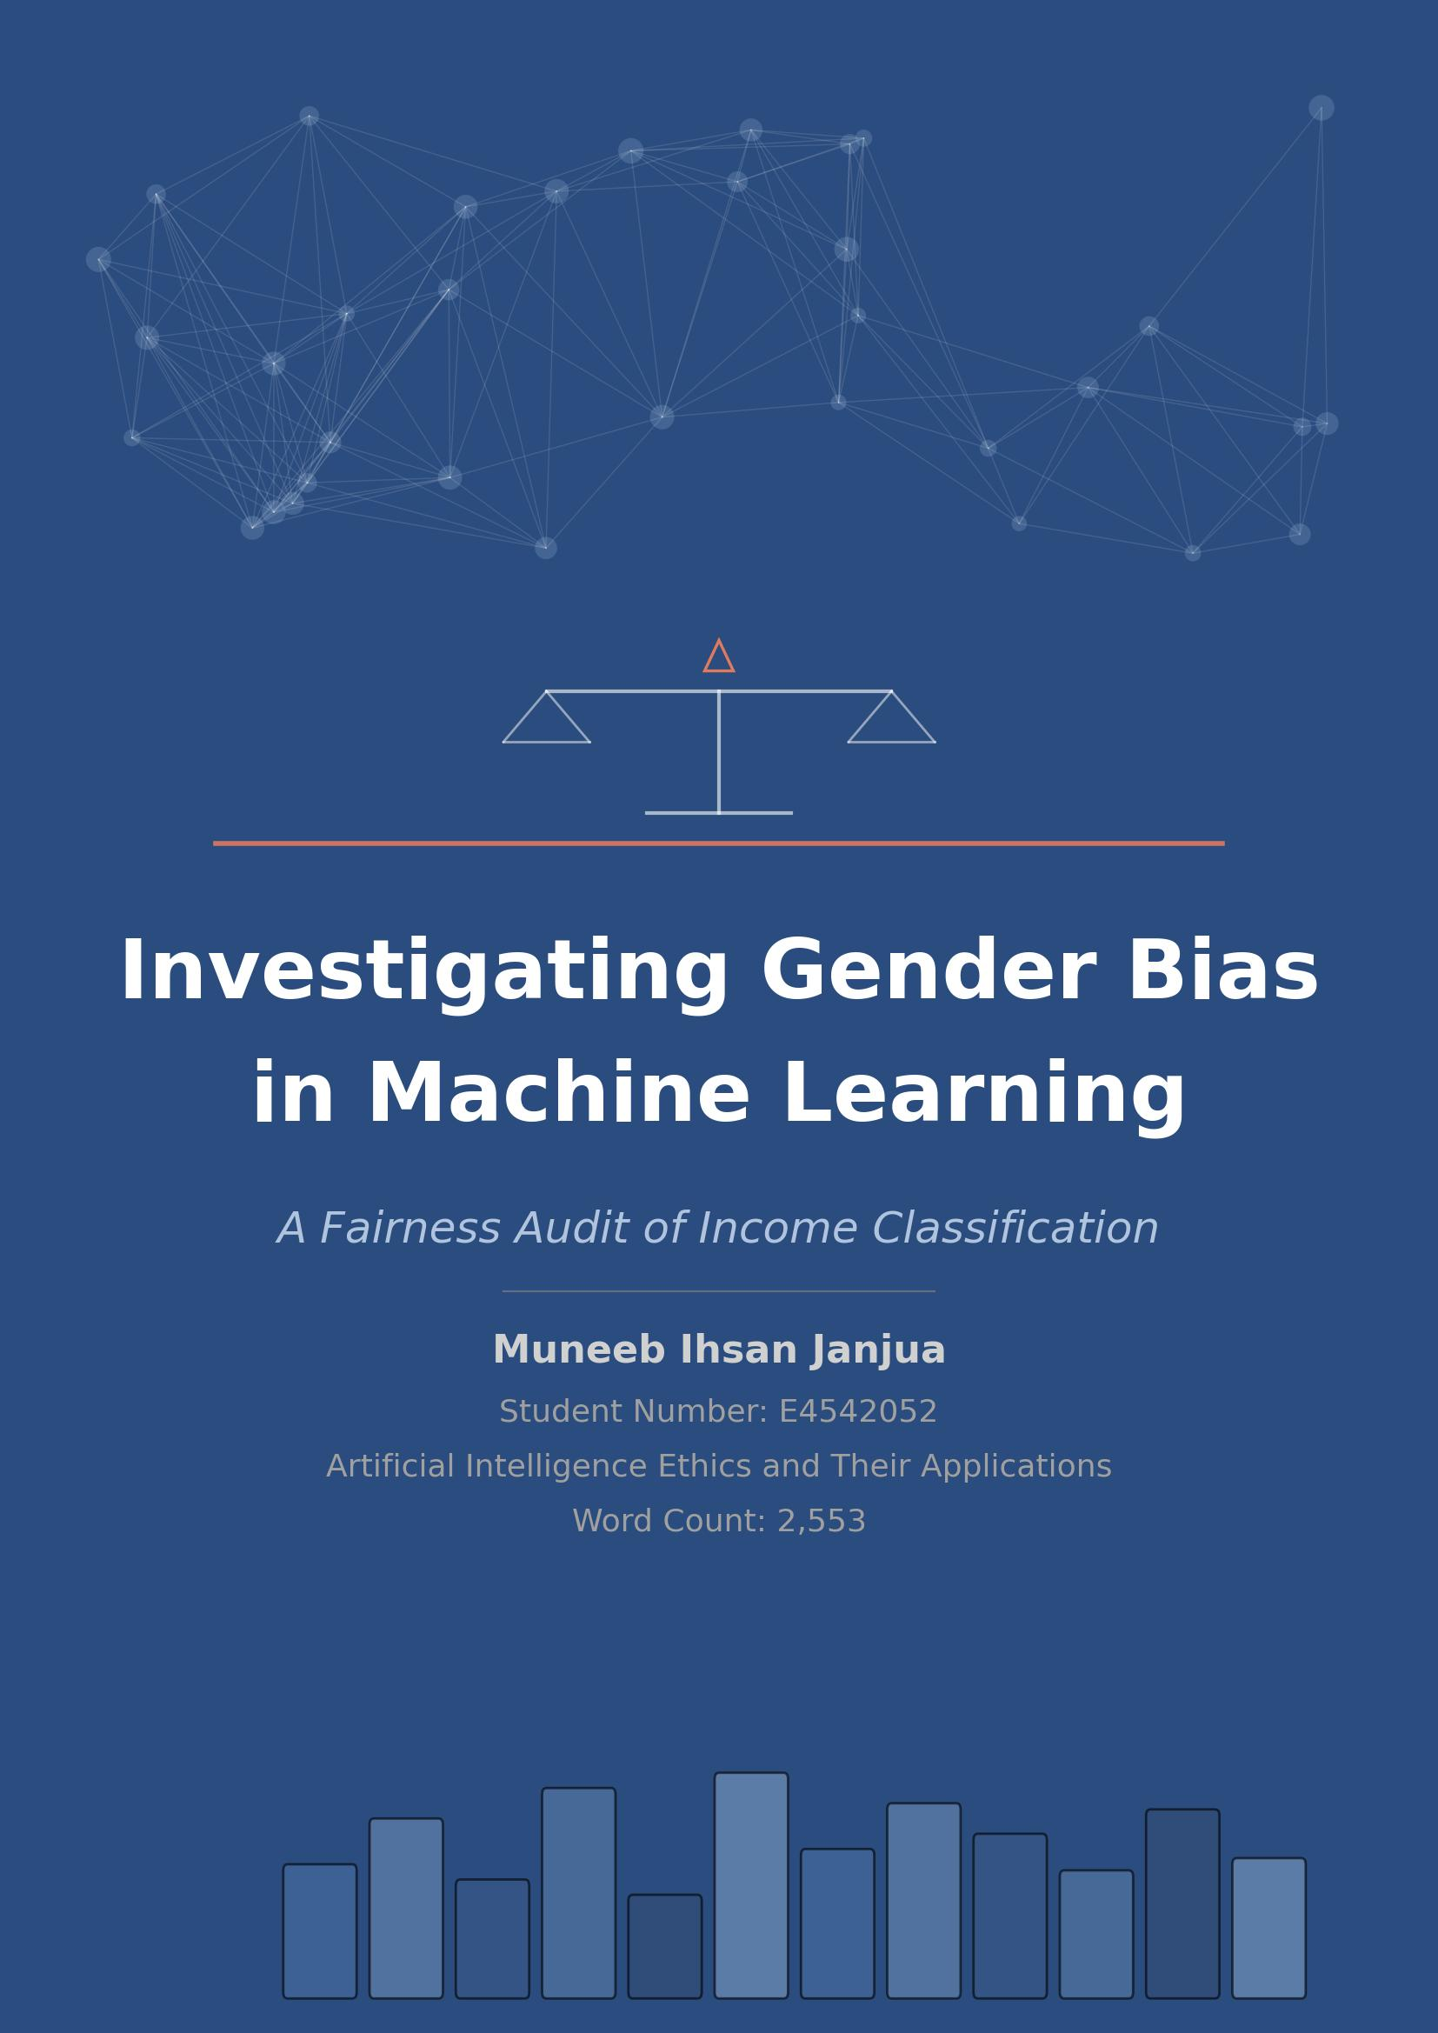
Table of Contents

1. Introduction
2. Model Development and Application of Fairness Criteria
2.1 Data Exploration
Descriptive Statistics
Data Visualisation
Correlation Analysis
Distribution Assessment
2.2 Data Pre processing
2.3 Model Development
2.4 Performance Evaluation
2.5 Fairness Audit
2.5.1 Equal Accuracy
2.5.2 Demographic Parity
2.5.3 Equal Opportunity
Fairness Audit Results
3. Findings
References
Appendix: Model Card

Acknowledgements
I would like to express my sincere gratitude to all those who supported me throughout the completion of this Project
First and foremost, I am deeply thankful to my supervisor, Jennifer Wilson, for their invaluable guidance, constructive feedback, and continuous encouragement. Their expertise and mentorship played a crucial role in shaping the direction and quality of this work.
I also extend my appreciation to the faculty and staff of the university for providing a stimulating academic environment and access to essential resources that enabled me to pursue this research effectively.
Muneeb Ihsan Janjua

1. Introduction
Machine learning models are increasingly deployed in high stakes domains such as hiring, credit scoring, and healthcare, yet growing evidence demonstrates that these systems can encode and amplify societal biases. Algorithms trained on historically biased data frequently inherit the prejudices of prior decision makers, producing outcomes that disproportionately disadvantage protected groups even without any explicit discriminatory intent. In income prediction specifically, models trained on census data have been shown to systematically underestimate the earning potential of women, reflecting historical gender pay gaps embedded in the training data. The real world consequences of such bias are significant. A widely used healthcare algorithm was found to exhibit racial bias affecting millions of patients, reducing the number of Black patients identified for additional care by more than half. In financial contexts, biased income classifiers could lead to qualified women being denied loans, credit, or employment opportunities, thereby perpetuating cycles of economic inequality.
This report investigates gender bias in a Random Forest classifier trained on the UCI Adult Census Income dataset to predict whether an individual earns above or below $50,000 per year. Sex is selected as the protected characteristic. The report summarises the data exploration and pre processing pipeline, evaluates overall model performance, and applies three fairness criteria, equal accuracy, demographic parity, and equal opportunity, to assess whether the model treats male and female groups equitably.

2. Model Development and Application of Fairness Criteria

2.1 Data Exploration
The UCI Adult Census Income dataset, originally extracted from the 1994 United States Census Bureau database, was used for this investigation. The dataset contains 32,537 records and 15 features, including six numerical columns (age, fnlwgt, education num, capital gain, capital loss, hours per week), eight categorical columns (workclass, education, marital status, occupation, relationship, race, sex, native country), and one binary target variable (income), where 0 represents an annual income of ≤50K and 1 represents >50K. Exploratory data analysis was conducted following the four pillars of EDA.

Descriptive Statistics
Descriptive statistics revealed that capital gain and capital loss exhibited substantial differences between their mean and median values, indicating heavy right skew, with the

majority of individuals recording zero for both features. The income distribution confirmed significant class imbalance, with 24,698 records (75.9%) in the ≤50K class and only 7,839 records (24.1%) in the >50K class.
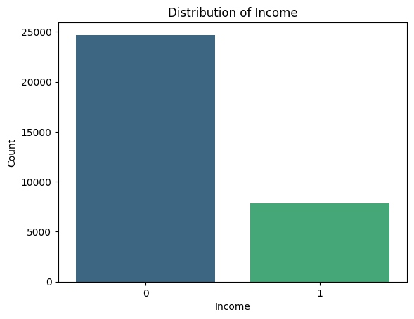
Figure 1: Distribution of Income Classes

Data Visualisation
Histograms highlighted that age was approximately normally distributed, while capital gain and capital loss were heavily zero inflated. The distribution of numerical features across the dataset is shown below.
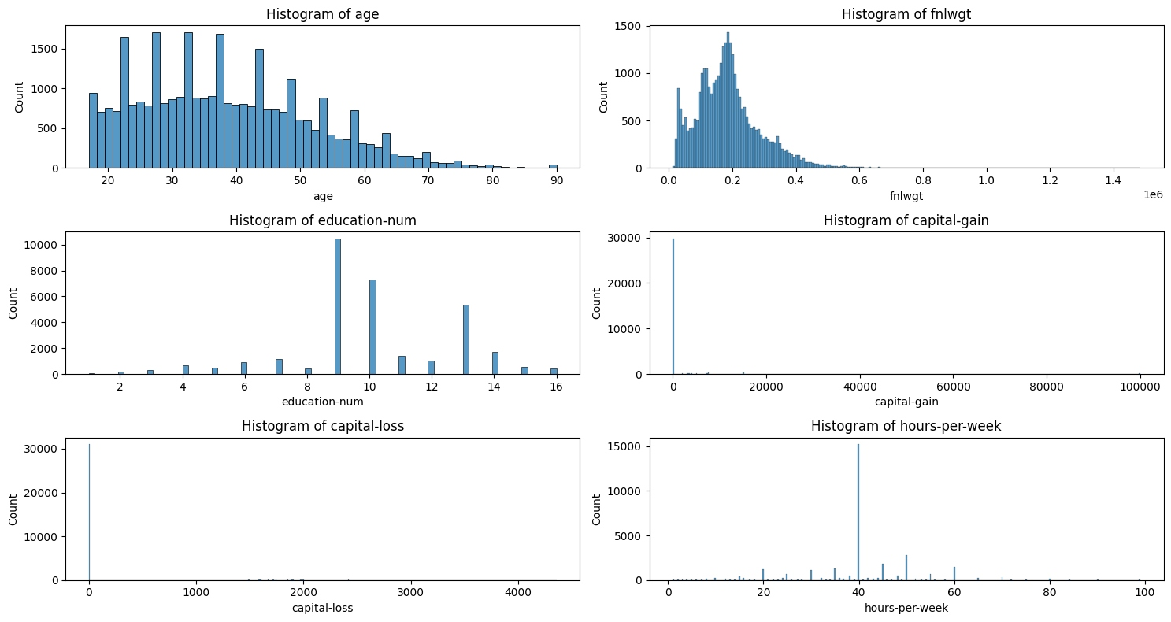
Figure 2: Histograms of Numerical Features

Boxplots further confirmed the presence of extreme outliers in capital gain and capital loss, while age and hours per week displayed more symmetric distributions with moderate outlier counts.
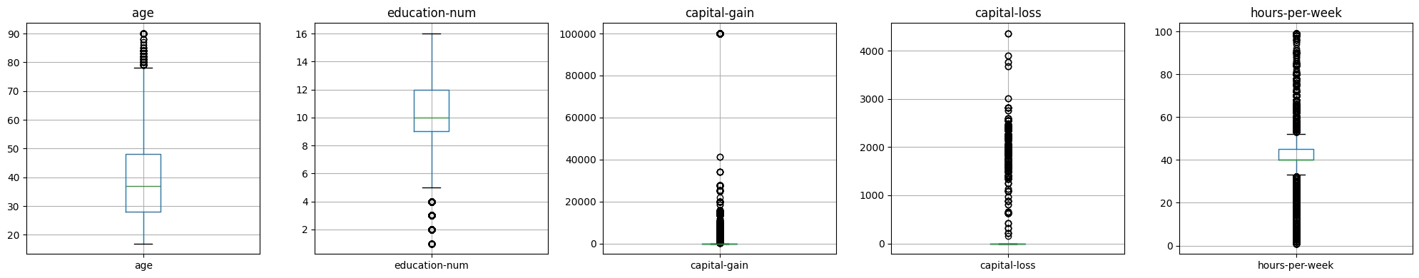
Figure 3: Boxplots of Numerical Features
Categorical analysis revealed that the dataset was predominantly composed of individuals from the United States, employed in the private sector, with high school or bachelor level education. Critically for this fairness investigation, the sex distribution showed a 2:1 male to female ratio, and among those earning >50K, approximately 30.6% were male compared to only 10.9% female, highlighting a pre existing representation disparity that the model could inherit.
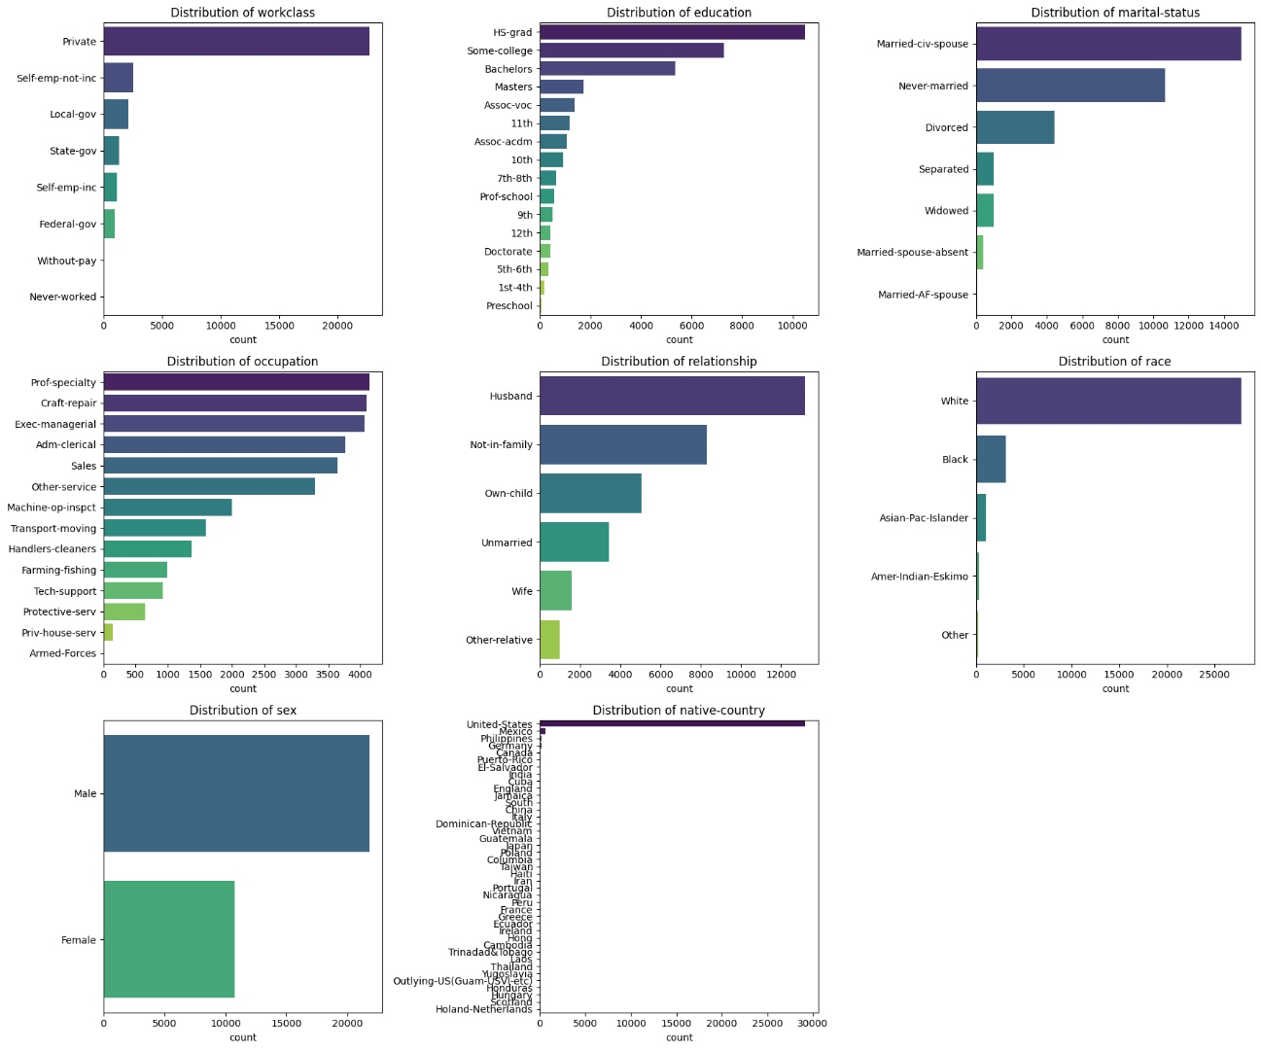
Figure 4: Distribution of Categorical Features

Correlation Analysis
Pearson correlation heatmaps were computed to identify linear relationships between features. The fnlwgt feature showed negligible correlation with all other variables, while education num displayed the strongest positive association with income.
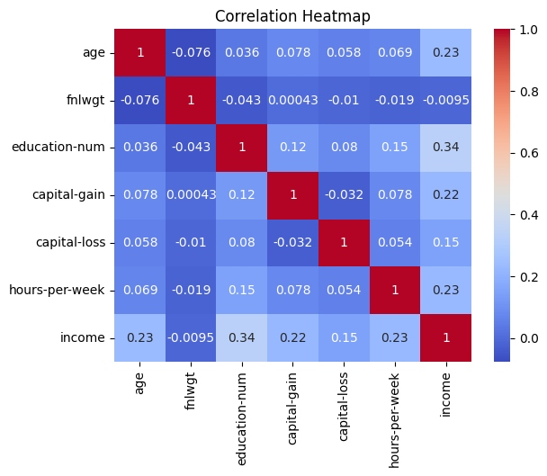
Figure 5: Pearson Correlation Heatmap
Spearman correlation analysis was also performed to capture monotonic relationships. The results confirmed the same patterns observed in the Pearson analysis, with education num and age showing the strongest associations with the target variable.
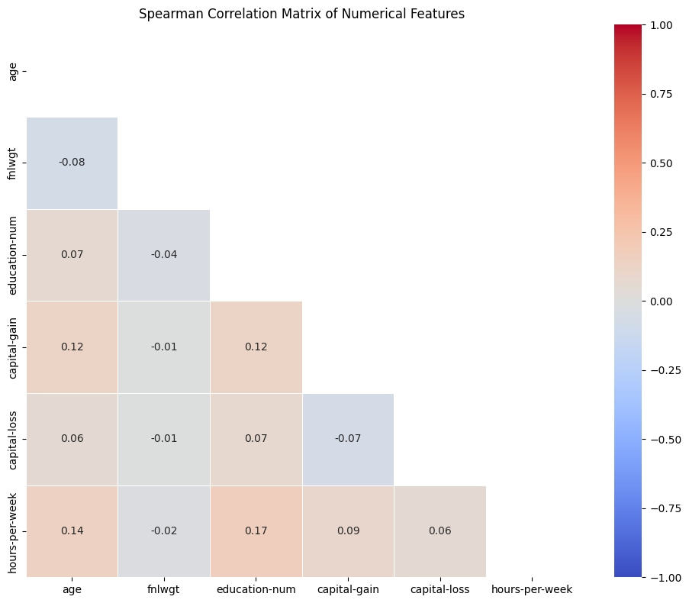
Figure 6: Spearman Correlation Heatmap

Distribution Assessment
Kernel density estimation plots and Quantile Quantile plots confirmed that most numerical features deviated from normality, with capital gain and capital loss showing particularly extreme departures due to their zero inflated distributions.
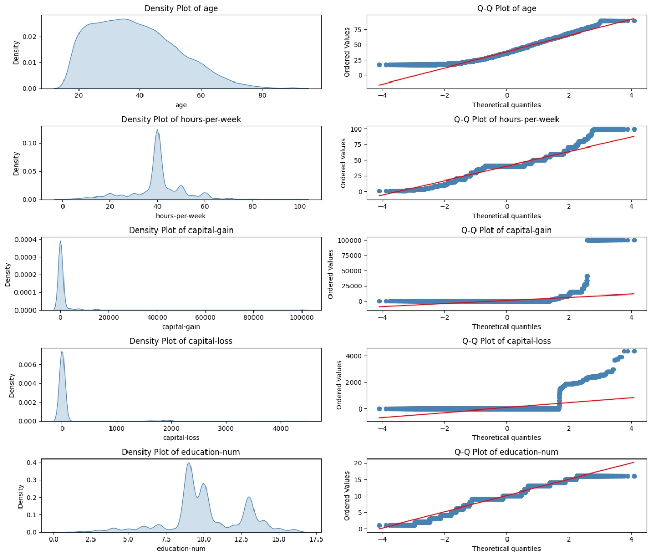
Figure 7: Density Plots and Q Q Plots

2.2 Data Pre processing
Data cleaning began with feature removal. The fnlwgt column was dropped because correlation analysis showed it had no meaningful relationship with the target variable or any other feature. The education column was also removed because its numerical equivalent, education num, already captured the same information as a correctly ordered ordinal variable, thus avoiding redundancy without losing predictive value.
Data types were then corrected to ensure categorical columns were stored as string types and numerical columns as integers, enabling the pipeline to apply appropriate transformations to each group. Missing values were identified in three categorical columns: occupation (5.66%), workclass (5.64%), and native country (1.79%). Since all missing values occurred in categorical variables and represented less than 6% of the total data, mode imputation was applied. Although advanced imputation techniques such as KNN and MICE exist, they were not appropriate for this dataset. Simple mode imputation is statistically robust for small proportions of categorical missingness, computationally efficient, and avoids introducing unnecessary model complexity that could itself bias the fairness audit. Duplicate rows were subsequently removed.
Outlier analysis was performed using Z scores on numerical features. While capital gain and capital loss contained extreme values, these were retained as legitimate data points reflecting real socio economic variation rather than measurement errors.
A scikit learn ColumnTransformer pipeline was constructed to handle all remaining transformations. MinMaxScaler was applied to numerical features to normalise values to a 0 to 1 range. One Hot Encoding was selected for all categorical variables to preserve interpretability and transparency, which is essential for a fairness focused audit. Alternative encoders such as frequency encoding, binary encoding, and ordinal encoding were intentionally avoided because they can collapse distinct categories, obscure the meaning of sensitive attributes, or introduce artificial ordinal relationships where none exist.

2.3 Model Development

The dataset after cleaning was split in to training (80%) set and testing (20%) set using a stratified train test split at random state 42. A stratification on target was essential since there was class imbalance in the dataset, with almost 75% records belonging to the ≤50K class. If the training and testing sets are not stratified, then it is possible that one or the other split is under or over represented. As a consequence, performance estimates may not be reliable, while other potential fairness issues may be masked. Before transforming the test set features (X_test_audit), a copy was made to preserve the original sex column for the fairness audit later on.

A Random Forest classifier was chosen as the modelling algorithm with 100 estimators with class_weight parameter set to balanced. Random Forest is an ensemble of decision trees that helps in the case of overfitting and can capture any complicated relationship present in the data. It constructs a number of trees. The balanced class weights option automatically assigns the sample weights inversely proportional to the class frequencies, giving greater significance to the under represented >50K class during training. This was a conscious decision made with the intent to avoid the model incorporating majority class predictions which would mask a low performance on the minority class while increasing accuracy.

The complete modelling workflow was contained in a scikit learn Pipeline where the ColumnTransformer (which contains MinMaxScaler and OneHotEncoder) was chained together with the Random Forest classifier. By doing this, we ensure that the pre-processing transformations we apply to our training data are also applied to the test data to prevent leakage.

2.4 Performance Evaluation
The trained Random Forest model was evaluated on the held out test set (5,794 records) using multiple complementary metrics. Table 1 summarises the overall results.
Table 1: Overall Model Performance
Metric | Value
Accuracy | 0.84
ROC AUC | 0.8813
F1 Score (≤50K) | 0.89
F1 Score (>50K) | 0.65

The model achieved an overall accuracy of 84% and a ROC AUC of 0.8813, indicating strong discriminative ability in distinguishing between the two income classes. The ROC curve confirms that the model performs substantially better than a random baseline across all classification thresholds.
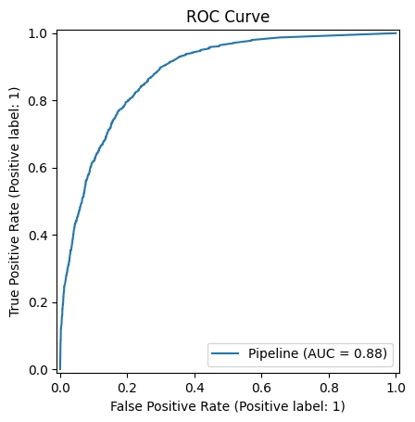
Figure 8: ROC Curve (AUC = 0.8813)
But there is quite a clear difference in F1 scores between the two groups. The larger class (≤50K) hits an F1 of 0.89, while the smaller class (>50K) gets only 0.65. This drop shows our model has a hard time spotting high earners, seeing worse precision and recall for them. We can largely blame this on our imbalanced dataset, since top earners make up just 25% of the records. The confusion matrix gives us more clues. Out of 4,353 people making ≤50K, the system rightly caught 3,947 (true negatives) and wrongly labeled 406 as wealthy (false positives). Looking at the 1,441 actual top earners, it successfully found 880 (true positives) but completely missed the other 561 (false negatives).
The confusion matrix provides further detail. Of the 4,353 individuals earning ≤50K, the model correctly classified 3,947 (true negatives), while misclassifying 406 as high income (false positives). Of the 1,441 individuals earning >50K, the model correctly identified 880 (true positives) but missed 561 (false negatives).
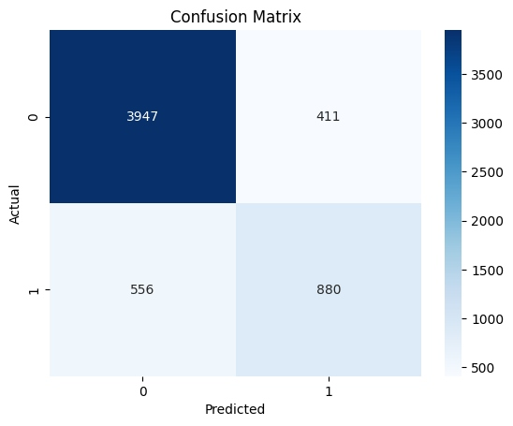
Figure 9: Confusion Matrix
The percentage confusion matrix further illustrates that 38.9% of genuinely high income individuals were incorrectly classified as low income. While the model demonstrates strong aggregate performance, an overall accuracy figure alone is insufficient for assessing fairness, as it may conceal disparate error rates across demographic groups. The following sections investigate this directly.
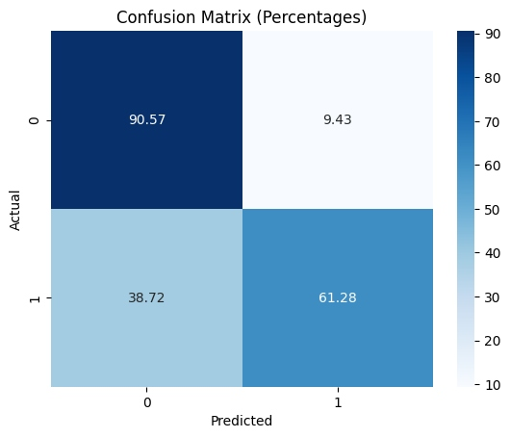
Figure 10: Confusion Matrix (Percentages)

2.5 Fairness Audit
To assess fairness, the test dataset was split into two groups based on the protected characteristic sex: a male group (n = 3,814) and a female group (n = 1,980). Separate confusion matrices and classification reports were generated for each group. Three fairness criteria were then applied. In fairness auditing practice, a common threshold of 5% is used: if the absolute difference between the two groups on any criterion exceeds this value, the model is considered to exhibit bias against the disadvantaged group.

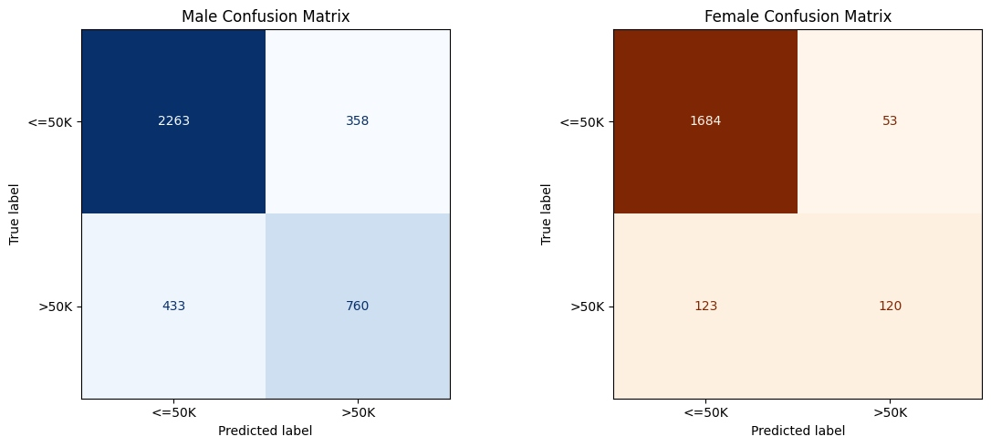
Figure 11: Confusion Matrices by Sex (Male and Female)

The matrix counts used to compute all three fairness criteria are summarised below. For the male group: TP = 760, FP = 358, FN = 433, TN = 2,263. For the female group: TP = 120, FP = 53, FN = 123, TN = 1,684.

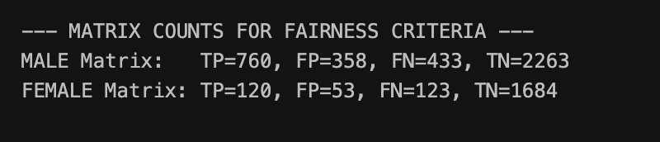

The Equality Act 2010 outlines nine protected characteristics, ranging from age and disability to religion and sexual orientation. For this specific audit, Sex was prioritized as the primary sensitive attribute. This decision was driven by a significant demographic skew within the dataset: roughly two-thirds of the records represent male subjects, while only one-third represent female subjects. When you pair this numerical imbalance with the historical gender pay gap a reality deeply embedded in this 1994 census data it becomes clear that Sex is the most critical variable for testing. The goal here is to determine whether the classifier is merely learning from the data or if it is actively amplifying systemic structural inequalities. The visual breakdown of this distribution is detailed below.

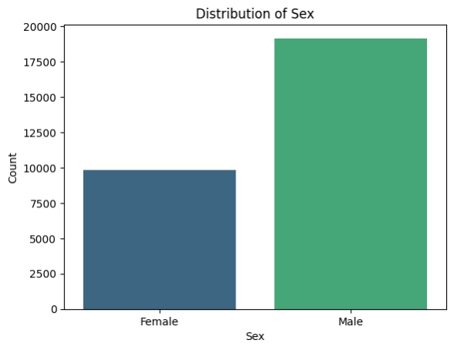

2.5.1 Equal Accuracy
Equal accuracy means the model should be just as reliable for one group as it is for another. On the surface, the numbers look skewed: the female group hit 91.11% accuracy while the male group sat at 79.26%. That 11.85% gap is way over the 5% limit we usually allow, which would normally mean the model is biased. But you can't just take those percentages at face value. The reality is that the female side of the data has far fewer high earners—only 12.3% compared to 31.3% for the men. In a lopsided setup like this, the model can "cheat" its way to a high score by just guessing that every woman earns less than 50K. It’s what we call the accuracy paradox, and it’s a clear reminder that a high accuracy score doesn't always mean a model is being fair.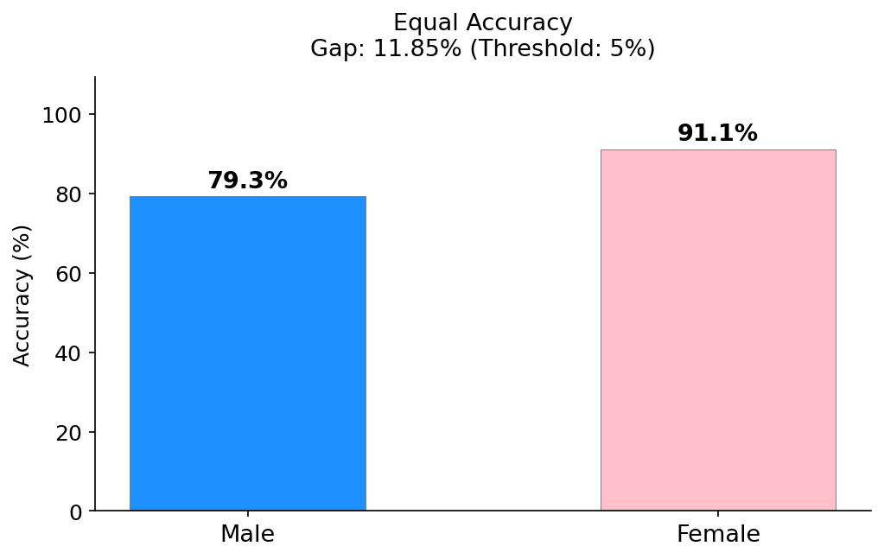
Figure 12: Equal Accuracy Comparison by Sex

CODE SNAP WITH FORMULA:
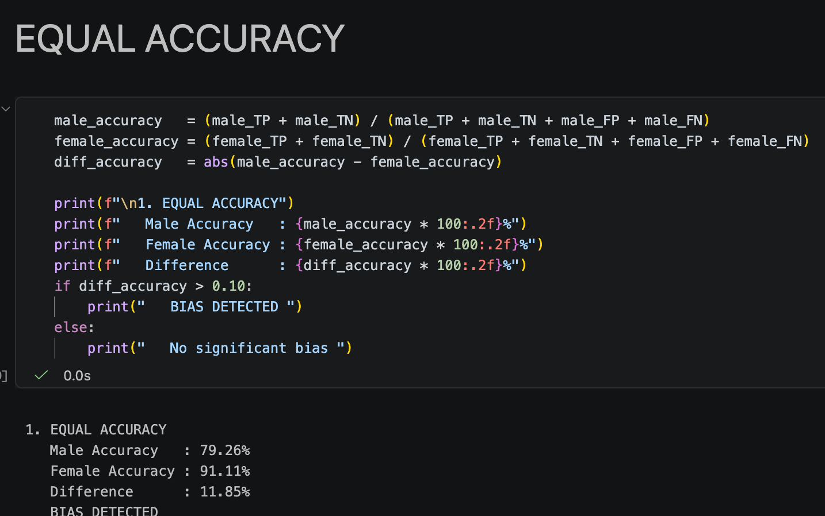

2.5.2 Demographic Parity
Demographic parity requires that the model predicts the positive outcome (>50K) at the same rate for both groups, regardless of the actual ground truth labels. The model predicts high income for males at more than three times the rate it does for females (29.31% versus 8.74%), producing a gap of 20.58%, the largest disparity observed across all three criteria. Bias is detected under this criterion. This result indicates that the model has learned to associate male demographic features with higher income far more readily than female ones. If such a model were deployed in a real world context such as loan approvals or hiring, women would be systematically less likely to receive favourable outcomes compared to equally situated men, constituting direct allocative harm. However, demographic parity does not account for base rate differences between groups. In the 1994 census data, women genuinely earned less than men due to historical labour market discrimination. Therefore, this criterion cannot distinguish between bias introduced by the model and inequality already present in the real world.
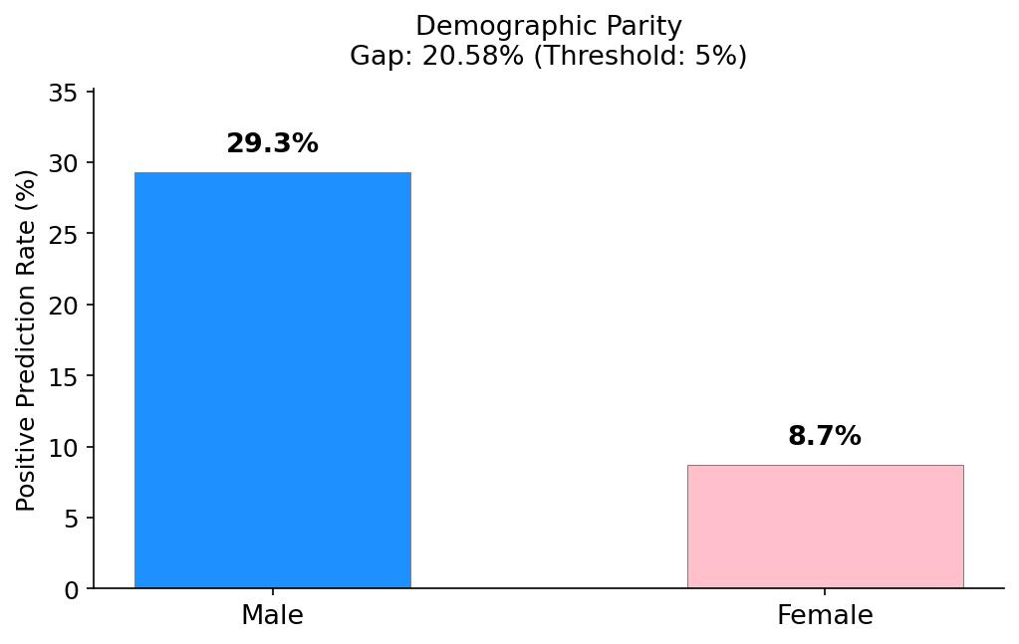
Figure 13: Demographic Parity Comparison by Sex
CODE SNAP WITH FORMULA:

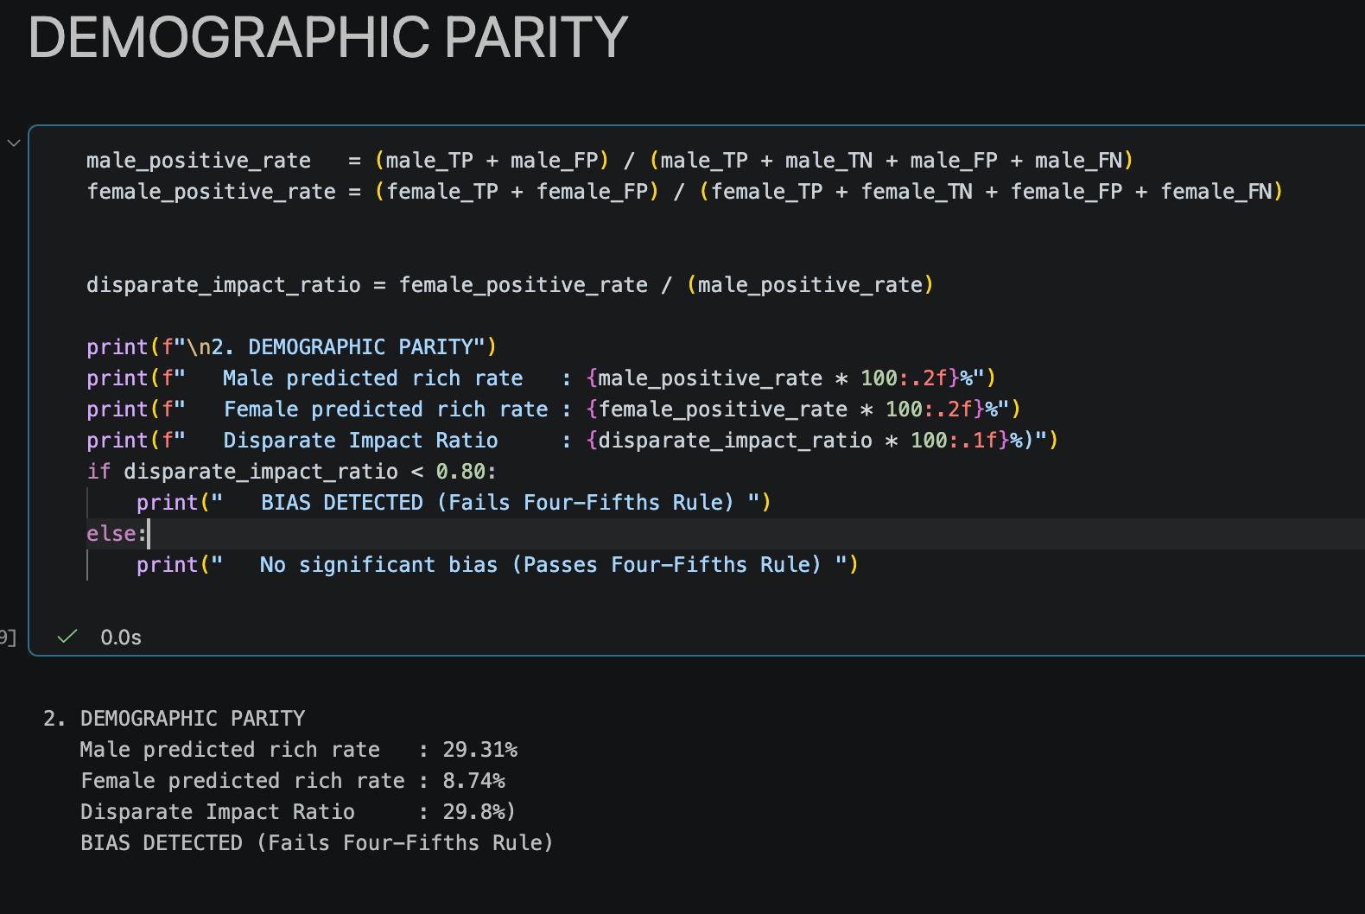

2.5.3 Equal Opportunity
Equal opportunity means the model should be just as good at spotting high earners in one group as it is in the other, which we measure through recall. Looking at the results, the model flags high income men 63.70% of the time, but that number drops to just 49.38% for women. That 14.32% gap is a huge red flag for bias. This is probably the biggest ethical mess found in the whole audit. It basically says that even when a woman is earning just as much as a man, the system is way less likely to actually recognize it. In the real world, this means about half of all high earning women are being wrongly labeled as low income, while only about a third of men face that same mistake. If this were used for something like bank loans or job applications, qualified women would be getting rejected far more often than men with the exact same credentials.
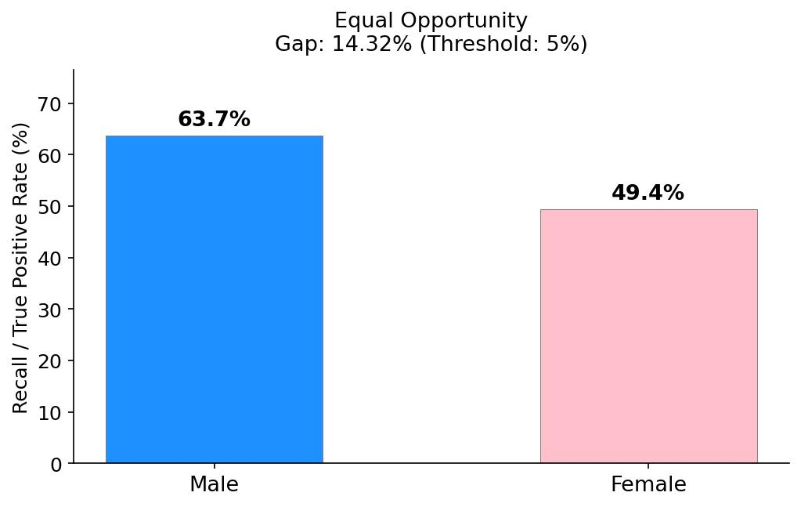
Figure 14: Equal Opportunity Comparison by Sex
CODE SNAP WITH FORMULA: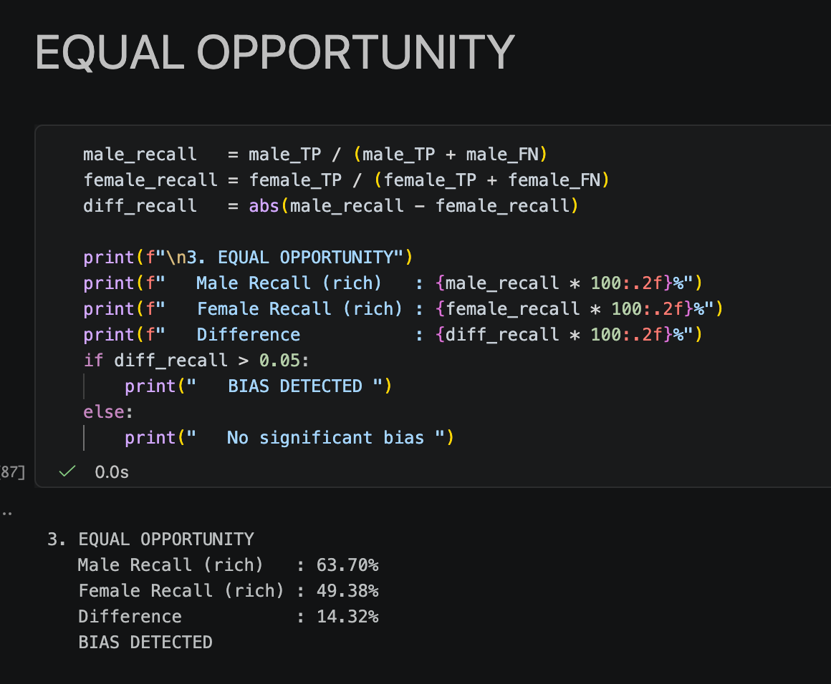

Fairness Audit Results
Table 2 consolidates the results of all three fairness criteria. All three criteria exceeded the 5% threshold, confirming systematic gender bias across every dimension of fairness assessed.
Table 2: Fairness Audit Results
Criterion | Male | Female | Gap | Result
Equal Accuracy | 79.26% | 91.11% | 11.85% | Bias Detected
Demographic Parity | 29.31% | 8.74% | 20.58% | Bias Detected
Equal Opportunity | 63.70% | 49.38% | 14.32% | Bias Detected

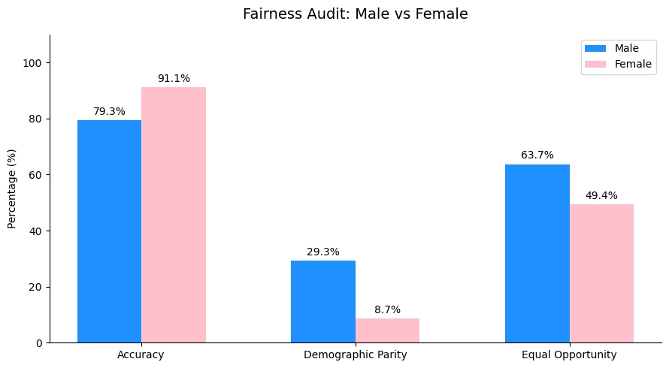
Figure 15: Fairness Audit Comparison — Male vs Female

3. Findings
The fairness audit confirmed the existence of systematic gender bias in the Random Forest income classifier across all three criteria. Equal accuracy revealed an 11.85% gap, demographic parity a 20.58% gap, and equal opportunity a 14.32% gap, each substantially exceeding the 5% threshold. The model consistently disadvantages women in high income prediction, with the most severe violation occurring in demographic parity, where males are predicted as high income at more than three times the rate of females.
However, each fairness criterion carries inherent limitations that must be acknowledged. Equal accuracy is susceptible to the accuracy paradox: when class distributions differ sharply between groups, a model can achieve artificially high accuracy by defaulting to majority class predictions. In this case, the female group's 91.11% accuracy is misleading because only 12.3% of females in the test set are genuinely high income. Demographic parity cannot distinguish between bias introduced by the model and real world historical inequality. In the 1994 census data, women genuinely earned less due to structural labour market discrimination, so enforcing equal prediction rates could result in predicting high income for individuals who do not actually earn it. Equal opportunity, while more robust because it conditions on the true label, cannot be satisfied simultaneously with demographic parity when base rates differ between groups. This is known as the fairness impossibility theorem, which demonstrates that these criteria are mathematically incompatible unless both groups share identical base rates. No single fairness criterion is therefore sufficient, and auditors must evaluate multiple criteria in combination.

References
Barocas, S. and Selbst, A.D. (2016) 'Big data’s disparate impact', California Law Review, 104(3), pp. 671–732. Available at: https://doi.org/10.2139/ssrn.2477899.
Becker, B. and Kohavi, R. (1996) Adult [Dataset]. UCI Machine Learning Repository. Available at: https://doi.org/10.24432/C5XW20.
Breiman, L. (2001) 'Random forests', Machine Learning, 45(1), pp. 5–32. Available at: https://doi.org/10.1023/A:1010933404324.
Mehrabi, N., Morstatter, F., Saxena, N., Lerman, K. and Galstyan, A. (2021) 'A survey on bias and fairness in machine learning', ACM Computing Surveys, 54(6), pp. 1–35. Available at: https://doi.org/10.1145/3457607.
Mitchell, M., Wu, S., Zaldivar, A., Barnes, P., Vasserman, L., Hutchinson, B., Spitzer, E., Raji, I.D. and Gebru, T. (2019) 'Model cards for model reporting', Proceedings of the Conference on Fairness, Accountability, and Transparency (FAT*), pp. 220–229. Available at: https://doi.org/10.1145/3287560.3287596.
Obermeyer, Z., Powers, B., Vogeli, C. and Mullainathan, S. (2019) 'Dissecting racial bias in an algorithm used to manage the health of populations', Science, 366(6464), pp. 447–453. Available at: https://doi.org/10.1126/science.aax2342.
Pedregosa, F., Varoquaux, G., Gramfort, A., Michel, V., Thirion, B., Grisel, O., Blondel, M., Prettenhofer, P., Weiss, R., Dubourg, V., Vanderplas, J., Passos, A., Cournapeau, D., Brucher, M., Perrot, M. and Duchesnay, E. (2011) 'Scikit learn: machine learning in Python', Journal of Machine Learning Research, 12, pp. 2825–2830.

Appendix: Model Card
Model Card — Income Classification Model, Version 1.0 — 2026
Author: Muneeb Ihsan Janjua | Student ID: E4542052

1. Model Details
Name: Random Forest Income Classifier
Version: 1.0
Model Type: Binary Classification
Algorithm: Random Forest (n_estimators=100, class_weight=balanced)
Framework: Scikit learn

2. Intended Use
Primary Use: Academic research to investigate bias in machine learning models.
Intended Users: Researchers and students studying AI fairness.
Out of Scope: Real world financial decisions, loan or credit approval, hiring or HR screening, any production deployment affecting real people.

3. Factors
Demographic Factors: Sex (Male/Female), Race, Age, Nationality.
Instrumentation Factors: Quality of self reported census data; missing value density in Occupation and Workclass columns.

4. Metrics
Performance Metrics: Accuracy, F1 Score, ROC AUC, Recall, Precision.
Fairness Metrics: Equal Accuracy, Demographic Parity, Equal Opportunity.

5. Evaluation Data
Dataset: UCI Adult Census Income Dataset. Size: 5,794 records (20% stratified test split, random_state=42). Class Distribution: ≤50K: 4,353 (75%) | >50K: 1,441 (25%). Sex Distribution: Male: 3,814 (65%) | Female: 1,980 (35%).

6. Training Data
Dataset: 80% of adult_cleaned.csv (23,176 records). Pre processing: Removed fnlwgt and education columns; mode imputation for missing categorical values; MinMaxScaler on numerical features; OneHotEncoder on categorical features; duplicates removed; outliers retained as real data points.
Known Biases: Historical 1994 gender pay gap; predominantly US population; underrepresentation of women in high income bracket.

7. Quantitative Analyses
Overall Performance:
Metric | Value
Accuracy | 0.84
ROC AUC | 0.8813
F1 (≤50K) | 0.89
F1 (>50K) | 0.65

Group Level Performance:
Metric | Acc. | Prec. | Recall | F1 | TP/FP | FN/TN
Male (3,814) | 79.3% | 0.68 | 0.64 | 0.66 | 760/358 | 433/2263
Female (1,980) | 91.1% | 0.69 | 0.49 | 0.58 | 120/53 | 123/1684

Fairness Results:
Criterion | Male | Female | Gap | Result
Equal Accuracy | 79.3% | 91.1% | 11.85% | Bias Detected
Demographic Parity | 29.3% | 8.7% | 20.58% | Bias Detected
Equal Opportunity | 63.7% | 49.4% | 14.32% | Bias Detected

8. Ethical Considerations
Bias Finding: Systematic bias against women across all three fairness criteria; most significant violation in Demographic Parity (20.58% gap).
Groups at Risk: Women in high income brackets systematically under identified; minority racial groups may face intersectional bias.
Potential Real World Harms: Loan approvals (rich women denied credit unfairly), hiring systems (high earning women filtered out), credit scoring (women underestimated financially).
Historical Bias: Model trained on 1994 data with significant gender pay gap; training on this data risks perpetuating discrimination.

9. Caveats and Recommendations
Data is from 1994 and does not reflect current income patterns. Limited primarily to US population. Intersectional bias (e.g., race and sex combined) not fully explored. Equal Accuracy is misleading on imbalanced datasets. The fairness impossibility theorem means all three criteria cannot be satisfied simultaneously when base rates differ between groups.
DO NOT DEPLOY IN ANY REAL WORLD APPLICATION
THIS MODEL CARD IS FOR ACADEMIC USE ONLY

