Always check the log messages in /var/log folder. Logs including various error, crash and other messages can be found here.

Also Check /var/log/syslog for all general logs.



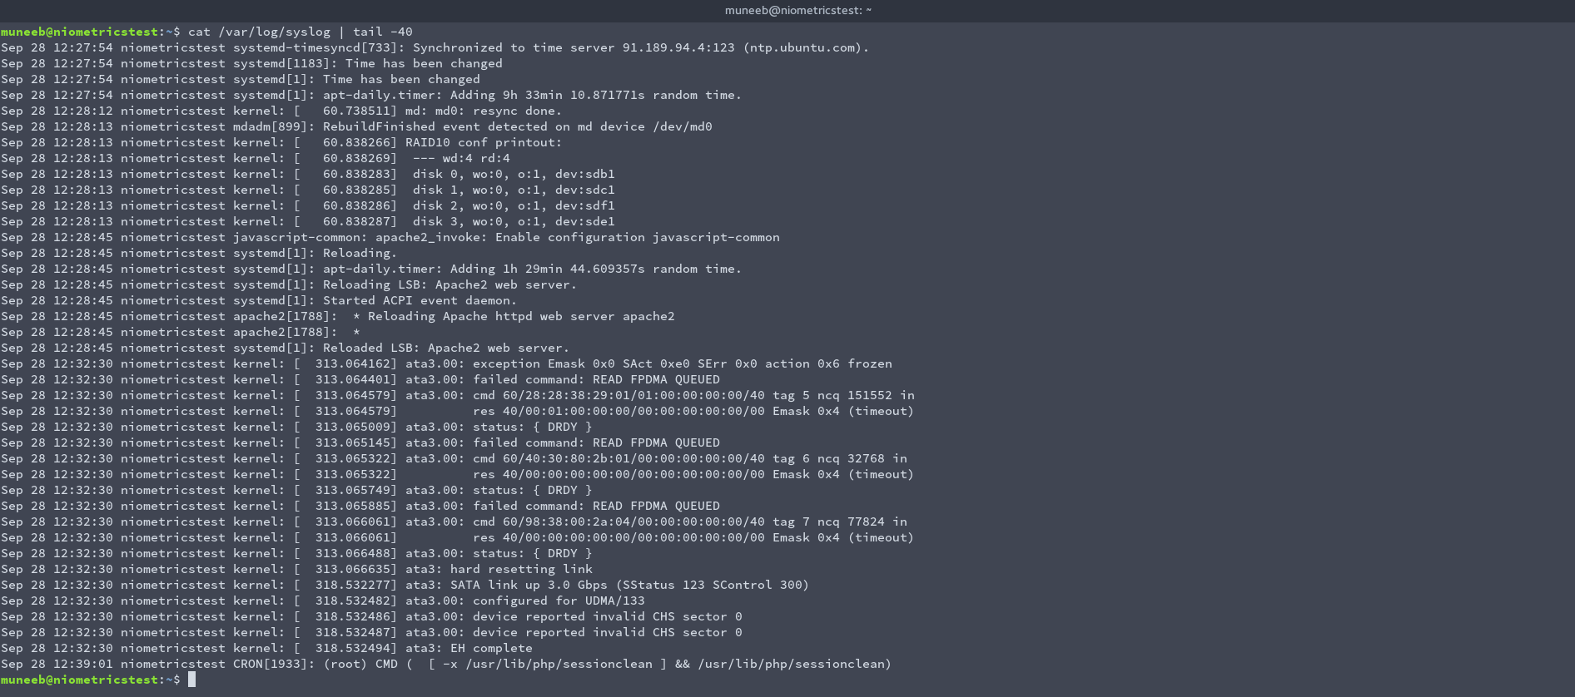

Another option is to take the core dump. For that, you need to enable ulimit. Default value of ulimit is 0, means disabled.

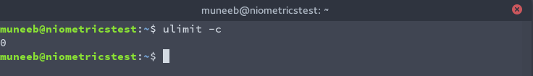

To enable, run *ulimit -c unlimited*. Unlimited is the size, we can specify a size such as 100M instead of unlimited.

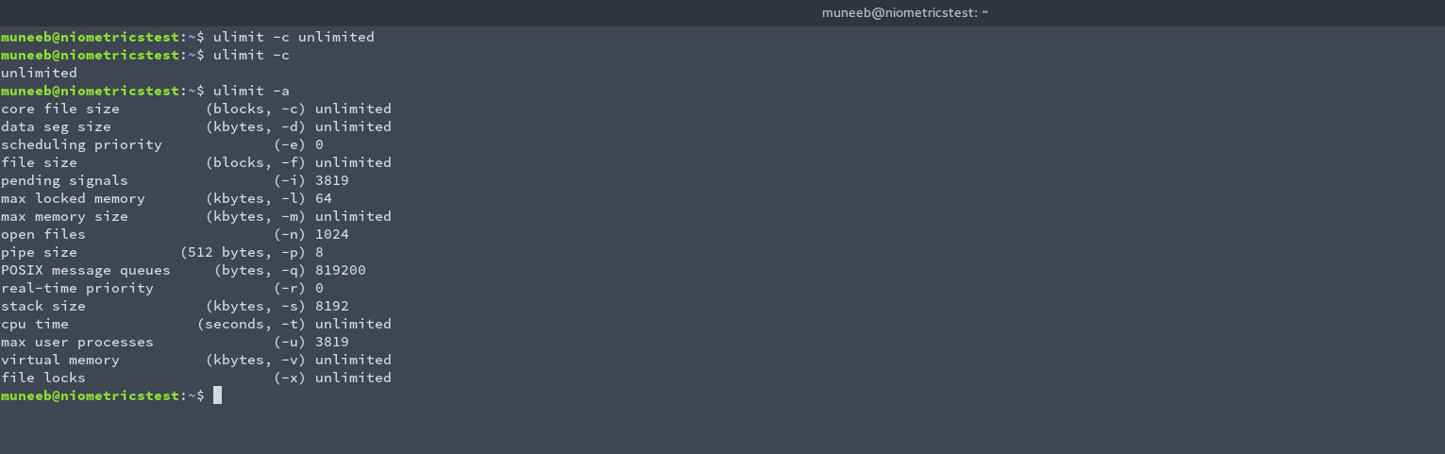

Now, I am writing a simple C program to divide 1 by 0. Compile this program and run the output. We will get an error. Next, list the files. We can see a core file is generated. Now we can send this core file to the developer for debugging the error using gdb or any similar tools.

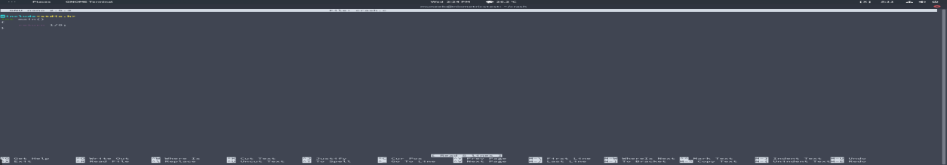

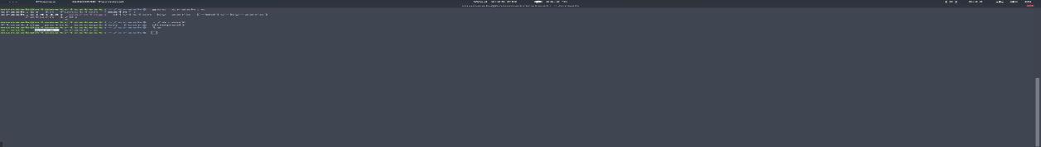

A simple debugging using gdb:-

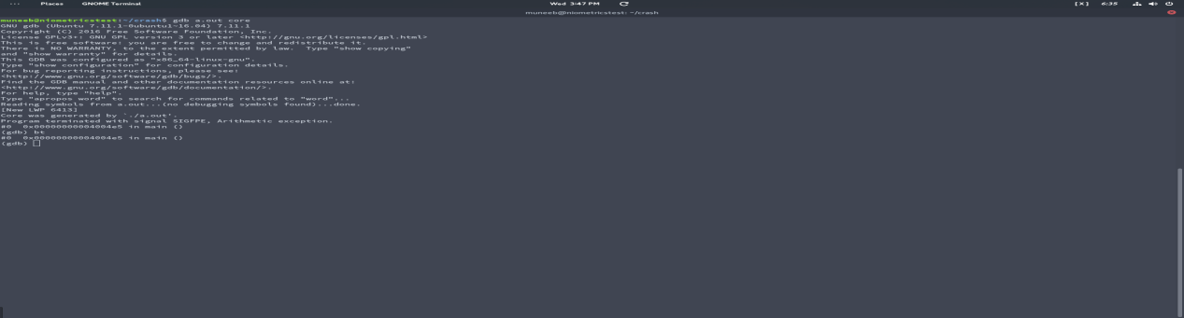

Packet analysis.

In this Packet. The first section defines that it is using Ipv4. Source address is 10.169.168.108 and destination address is 10.19.19.19. Both are private Ips.

Second Section defines port numbers of source and destination.