AgentIQ
AI Calling Agent for Customer Support in SMBs
Final Year Project – FYP-I Report
Session 2023-2027
A project submitted in partial fulfilment of the requirements
for the Degree of
BS in Software Engineering
Department of Computer Science
COMSATS University Islamabad (CUI), Lahore Campus

Project Registration
Project ID (for office use)
Type of project | [ ] Traditional [ ] Industrial [ ] Continuing
Nature of project | [ ] Development [ ] Research & Development
Sustainable Development Goals (SDGs) | [ ] Good Health and Well-Being [ ] Quality Education [ ] Industry, Innovation, and Infrastructure [ ] Decent Work and Economic Growth
Area of specialization | [ ] Artificial Intelligence (AI) [ ] Natural Language Processing (NLP) [ ] Web Development
Project Group Members
Sr.# | Reg. # | Student Name | Email ID | Signature
(i) | FA23-BSE-045 | Daoud Haroon (Group Leader) | FA23-BSE-045@cuilahore.edu.pk
(ii) | FA23-BSE-006 | Abdul Haseeb | FA23-BSE-006@cuilahore.edu.pk
(iii) | FA23-BSE-146 | Muneeb Ahmed | FA23-BSE-146@cuilahore.edu.pk
Declaration: The candidates confirm that the work submitted is their own and appropriate credit has been given where reference has been made to the work of others.
Plagiarism Free Certificate
This is to certify that, I am Abdul Haseeb S/o [Father's Name], a member of the FYP group under registration no CUI/FA23-BSE-006/LHR at the Computer Science Department, COMSATS University Islamabad, Lahore Campus. I declare that this FYP-I report is checked by our supervisor and the similarity index is [XX]% that is less than 20%, an acceptable limit by HEC. The report is attached herewith as Appendix A.
Name of Supervisor: Sir Junaid Anjum Co-Supervisor (if any): _____________________
Designation: _____________________ Designation: _____________________
Signature: _____________________ Signature: _____________________

Abstract
Customer support is a critical function for small and medium-sized businesses (SMBs), yet most rely on either costly, limited-availability human agents or rigid Interactive Voice Response (IVR) systems that cannot handle natural, multi-step conversations. Existing single-agent chatbot solutions also struggle when a single interaction requires several distinct actions — booking, information lookup, complaint handling — within one conversation. This project proposes AgentIQ, a multi-agent AI calling system built on a B2B2C model: SMB operators configure the system for their business, and their customers interact with it directly through voice or text. An orchestrator agent decomposes each customer interaction into subtasks and routes them to four specialized agents — a Booking Agent for reservation management, a Knowledge Agent using Retrieval-Augmented Generation (RAG) for document-grounded answers, a Sentiment and Complaint Agent for real-time escalation, and a Follow-Up Agent for autonomous post-interaction actions. The system integrates a voice pipeline (Twilio, Whisper, TTS) and an operator dashboard for multi-tenant configuration. This FYP-I report covers requirement analysis and system design; the expected outcome is a validated architecture and design ready for implementation, targeting measurable gains in task completion rate and response accuracy over traditional IVR and single-agent baselines.

Acknowledgement
We would like to express our sincere gratitude to our supervisor, Sir Junaid Anjum, for his continuous guidance, feedback, and support throughout the design and planning of this project. We are also thankful to the faculty of the Department of Computer Science, COMSATS University Islamabad, Lahore Campus, for their teaching and encouragement, which laid the foundation for this work. Finally, we thank our families and friends for their patience and support throughout this endeavor.

Table of Contents

List of Tables
[This list should be regenerated once all tables are finalized (Word: References > Insert Table of Figures > Caption label 'Table'). Table captions are already placed above every table throughout this document so Word can auto-build this list.]

List of Figures
[This list should be regenerated once all figures are finalized (Word: References > Insert Table of Figures > Caption label 'Figure'). Figure captions are already placed below every figure placeholder throughout this document so Word can auto-build this list.]

Chapter 1. Introduction

1.1 Introduction
Service-oriented small and medium-sized businesses — hotels, restaurants, clinics, and similar establishments — depend on timely, accurate customer communication to retain business and drive revenue. Handling reservations, answering policy questions, resolving complaints, and following up after an interaction are not peripheral tasks; they directly shape whether a customer returns. Yet most SMBs cannot resource this function well: hiring round-the-clock human support staff is expensive and inconsistent, while traditional IVR systems, though cheaper, force customers through rigid menu trees that break down the moment a request doesn't fit a predefined path.
Recent advances in Large Language Models (LLMs) and agentic AI frameworks make it possible to reimagine customer support as an autonomous, reasoning-capable operation rather than a scripted, reactive one. LLMs can now interpret natural language, hold context across a conversation, retrieve information from external sources, and call tools to complete tasks. However, a single LLM agent handling every type of request within one context tends to become unreliable and hard to extend as complexity grows — a customer asking about availability, then changing an existing booking, then registering a complaint, is really three distinct tasks that benefit from being handled by purpose-built agents rather than one generalist model. This project, AgentIQ, is built around that principle: an orchestrator that decomposes multi-intent conversations and delegates them to specialized agents, deployed as a configurable, B2B2C service that SMB operators can set up for their own business without custom engineering.

1.2 Problem Statement
Existing customer support solutions for small and medium-sized service businesses fall short in one of two ways. Human agents and traditional IVR systems remain costly and inflexible. Newer AI-based alternatives — including recent open-source, self-hosted tools — do offer multi-channel, tool-calling AI support at low cost, but rely on a single generalist LLM engine deciding which tool to invoke, rather than independently-reasoning specialist agents; use keyword- or category-based knowledge lookup rather than semantic retrieval, limiting answer accuracy on nuanced queries; provide generic ticketing rather than domain-specific booking and scheduling logic; and require a separate self-hosted instance per business rather than a single multi-tenant platform an operator can configure in minutes. AgentIQ addresses this gap with a true multi-agent architecture — an orchestrator decomposing multi-intent conversations across specialized Booking, Knowledge (RAG), Sentiment, and Follow-Up agents — deployed as a configurable, multi-tenant B2B2C service.

1.3 Proposed Solution
AgentIQ is designed as a B2B2C platform: SMB operators (the paying customers) configure and manage the system through an operator dashboard, while their end customers interact with it directly through voice calls or text. At the core is an Orchestrator (Supervisor) Agent that receives each customer interaction, identifies the intents involved, decomposes multi-intent requests into subtasks, and routes each subtask to the appropriate specialist: the Booking Agent for reservation creation, modification, and cancellation; the Knowledge Agent, which uses Retrieval-Augmented Generation (RAG) over a vector database to answer business-specific questions grounded in operator-uploaded documents; the Sentiment & Complaint Agent, which monitors conversational tone in real time and triggers escalation when negative sentiment or complaint conditions are detected; and the Follow-Up Agent, which autonomously dispatches confirmations, reminders, and feedback requests after an interaction concludes, without human intervention. The technical stack centers on LangGraph for stateful multi-agent orchestration, ChromaDB for vector-based retrieval, FastAPI and PostgreSQL for the backend, and a Twilio–Whisper–TTS pipeline for voice. Operator authentication is included as core scope, since the dashboard manages multi-tenant business data across operators.

1.4 Main Objectives
O1: Design a modular multi-agent architecture in which an orchestrator decomposes multi-intent customer interactions and delegates subtasks to specialized agents.
O2: Build a configurable business-profile layer enabling deployment across hotel, restaurant, and clinic domains without core-agent code changes.
O3: Implement a RAG-powered Knowledge Agent for accurate, document-grounded responses to business-specific queries.
O4: Build a Follow-Up Agent capable of autonomously determining and dispatching post-interaction actions.
O5: Integrate a voice pipeline to handle inbound customer calls without human intervention.
O6: Develop a secure, multi-tenant operator dashboard for business-profile configuration and monitoring.
O7: Evaluate the multi-agent system against IVR and single-agent baselines on task completion rate, response accuracy, and response time.

1.5 Assumptions & Constraints
Assumptions:
SMB operators will provide reasonably accurate and complete business knowledge documents for the Knowledge Agent. End customers have access to a phone line or internet connection to reach the system via voice or text. Third-party APIs (Twilio, the LLM provider, speech-to-text/text-to-speech services) remain available and within free/low-cost tier limits for prototype testing. English-language interactions are sufficient for this phase of evaluation.
Constraints:
The one-year FYP timeline limits the system to a prototype evaluated across three business domains rather than a production-ready commercial product. Cloud/API usage is bounded by student-tier budgets, which constrains the scale of load and latency testing possible. Voice-layer latency (STT → orchestration → TTS) must be kept low enough for a natural phone conversation, which is technically demanding within the available development time. Multi-tenant data must remain isolated between operators, adding authentication and data-partitioning requirements beyond a single-tenant system.

1.6 Project Scope
Included: the orchestrator and four specialized agents (Booking, Knowledge/RAG, Sentiment & Complaint, Follow-Up); a configurable business-profile layer supporting hotel, restaurant, and clinic domains; operator authentication and a web-based operator dashboard; a text-based testing interface; and a voice pipeline (Twilio, Whisper, TTS) for inbound calls.
Excluded: real payment processing; live integration with third-party production booking systems (e.g., actual hotel PMS or clinic EHR systems); support for languages other than English; and replacement of existing CRM tools. Given the difficulty of the voice layer and end-to-end integration, development will follow a text-first strategy — core agent logic will be built and validated over text before voice integration — with voice treated as the highest-risk component to be completed as time allows.

1.7 Software Development Lifecycle Model
AgentIQ follows an iterative, incremental development model suited to a project combining conventional software engineering with ML/agent experimentation. Each cycle moves through requirement refinement, design, implementation, and evaluation for one component (e.g., one agent) before integrating it with the rest of the system, rather than attempting a single waterfall pass across the whole architecture. This fits the project for two reasons: individual agents can be developed and unit-tested in isolation before orchestration is added, and the RAG/sentiment components benefit from iterative tuning against real evaluation data rather than a one-shot build. The high-level cycle is: (1) requirement analysis and business-profile schema design, (2) individual agent design and development, (3) orchestrator integration, (4) voice-layer integration, (5) cross-domain configuration and testing, (6) evaluation against baselines — with feedback from later phases looping back to refine earlier ones where needed.
[Insert Software Development Lifecycle here]
Figure 1 – Software Development Lifecycle

Chapter 2. Requirement Analysis

2.1 Literature Review
Recent progress in large language models (LLMs) has enabled a shift from single-turn chatbot systems toward agentic architectures capable of multi-step reasoning and tool use [1], [3]. Wu et al. [3] introduced AutoGen, an open framework in which specialized LLM-powered agents collaborate through structured conversations, showing that dividing complex tasks among agents produces more reliable outcomes than a single generalist model. Wang et al. [2] surveyed LLM-based autonomous agent architectures and identified task decomposition and agent specialization as the primary design principles for reliable, maintainable systems — directly supporting the orchestrator–subagent pattern this project adopts. Park et al. [5] demonstrated that LLM-powered agents can maintain persistent state and behave contextually across extended interactions, while Fourney et al. [6] presented Magentic-One, a generalist multi-agent system that assigns subtasks to purpose-built agents through a central orchestrator — the same coordination pattern used by AgentIQ's Supervisor Agent. Guo et al. [4] surveyed advances in LLM-based multi-agent systems and specifically flagged the lack of affordable, domain-configurable multi-agent systems for real-world deployment as an open gap — the gap this project targets directly.
On the retrieval side, Gao et al. [8] showed that Retrieval-Augmented Generation (RAG) substantially improves grounding accuracy for knowledge-intensive question answering, and Ji et al. [9] demonstrated that grounding LLM responses in retrieved documents reduces hallucination — the basis for AgentIQ's Knowledge Agent design. Shen et al. [7] proposed HuggingGPT, in which a central LLM orchestrates specialized models to complete complex tasks, reinforcing the same orchestration-based specialization principle applied here.
Among commercial voice-AI platforms, four are directly comparable to AgentIQ's target use case. Vapi is a developer-first platform offering programmable voice pipelines with a “Squad” feature for multi-agent call routing, but advanced workflows such as multi-agent chaining or tool calling require JSON configuration and backend integration, with no GUI for multi-step chaining or error-recovery logic. Retell AI provides node-based conversation flows with a built-in knowledge base using streaming RAG, but its architecture centers on a single configurable voice agent per flow rather than multiple cooperating specialist agents with independent responsibilities. Bland AI targets enterprise deployments with voice cloning and detailed call analytics, using a proprietary “Pathways” scripting system to map conversation flows — a single-agent conversational-pathway model, not an orchestrator delegating to independently specialized agents. Synthflow is a no-code platform offering a drag-and-drop visual flow builder with a proprietary telephony network, but off-script handling reverts to canned responses when callers deviate from the expected flow.
Beyond commercial vendors, two open-source projects are directly relevant. Databricks' agentic-customer-support reference implementation uses a supervisor agent coordinating domain-specialized sub-agents (account, billing, tech support, product) with vector search for unstructured retrieval and tool-calling for structured data — architecturally the closest published system to AgentIQ's orchestrator-and-specialists pattern. However, it is built as a co-pilot for human support staff rather than an autonomous customer-facing system, has no voice channel, and is tightly coupled to a single vendor's infrastructure. Owly, a self-hosted, MIT-licensed SMB support tool, is closer still in target market and channel coverage — it connects WhatsApp, email, and phone using the same Twilio–Whisper pairing proposed here, and lets its AI autonomously create tickets, route issues, and schedule follow-ups. Its architecture, however, is a single generalist LLM engine invoking a shared tool set rather than independently-reasoning specialist agents; its knowledge base is keyword/category-based rather than semantically retrieved; and it is single-tenant per deployment, requiring a separate self-hosted instance per business.
Across all six comparators, the common pattern is a single configurable conversational agent (or a shallow routing layer) rather than a true multi-agent architecture with independently reasoning, purpose-built agents for booking, knowledge retrieval, sentiment-driven escalation, and autonomous follow-up. None combine this with a low-cost, SMB-oriented, multi-tenant, voice-first configuration model — Table 1 summarizes this gap.
Table 1 - Detailed Comparison Between the Proposed System and Related Literature / Commercial Work
Feature / Capability | Vapi | Retell AI | Bland AI | Synthflow | Databricks Agentic CS | Owly | Proposed System
Multi-agent orchestration | Partial | ✗ | ✗ | ✗ | ✓ | ✗ | ✓
Voice channel | ✓ | ✓ | ✓ | ✓ | ✗ | ✓ | ✓
RAG-based (semantic) knowledge retrieval | ✗ | ✓ | ✗ | ✗ | ✓ | ✗ | ✓
Domain-specific booking/scheduling logic | ✗ | ✗ | ✗ | ✗ | ✗ | ✗ | ✓
Sentiment-based escalation | ✗ | ✗ | ✗ | ✗ | ✗ | Partial | ✓
Proactive follow-up automation | ✗ | ✗ | Partial | Partial | ✗ | ✓ | ✓
Multi-tenant / multi-operator | ✗ | ✓ | ✓ | ✓ | ✗ | ✗ | ✓
Human-in-the-loop free (fully autonomous) | ✓ | ✓ | ✓ | ✓ | ✗ | ✓ | ✓
Affordable for SMBs | ✗ | Partial | ✗ | ✓ | ✗ | ✓ | ✓

2.2 Stakeholders List
Primary Stakeholders:
SMB Operators — configure and manage the system for their business (hotel, restaurant, or clinic) via the operator dashboard. End Customers — interact with the deployed agents through voice calls or text to make bookings, ask questions, or raise complaints.
Secondary Stakeholders:
AgentIQ Development Team (Daoud Haroon, Muneeb Ahmed, Abdul Haseeb) — design, build, and evaluate the system. Project Supervisor, Sir Junaid Anjum — provides technical guidance and evaluates project milestones. FYP Committee, COMSATS University Islamabad — evaluates project deliverables and viva performance.
External Stakeholders:
LLM API providers (e.g., OpenAI) — supply the reasoning capability each agent depends on. Telephony provider (Twilio) — routes inbound/outbound voice calls to the system. Prospective future SMB clients or industry partners — potential adopters of a production version beyond the FYP scope.

2.3 Requirements Elicitation
Requirements were gathered through three complementary methods: (1) a structured literature and competitor review of commercial voice-AI platforms and open-source reference systems to identify feature gaps relevant to SMB customer support; (2) analysis of the proposed system's own architecture as defined in the project proposal, decomposing the four specialist agents and orchestrator into discrete, testable capabilities; and (3) iterative consultation with the project supervisor, Sir Junaid Anjum, to validate scope boundaries — particularly the inclusion of operator authentication as core scope, given that the operator dashboard manages multi-tenant business data.

2.3.1 Functional Requirements
FR-01: Operator Authentication
Table 2 - FR-01: Operator Authentication
Req. No. | Requirement
FR-01-01 | System shall provide a secure access point for authorized administrative personnel.
FR-01-02 | System shall authenticate administrators using unique credentials and restrict administrative functions to authorized sessions.
FR-01-03 | System shall notify administrators of failed authentication attempts without exposing sensitive account information.
FR-01-04 | System shall allow administrators to terminate their active sessions securely.
FR-02: Voice Pipeline & Speech Processing
Table 3 - FR-02: Voice Pipeline & Speech Processing
Req. No. | Requirement
FR-02-01 | System shall receive inbound English voice calls through the configured telephony interface and establish an active customer interaction session.
FR-02-02 | System shall accept supported text-message input and forward the message content to the AgentIQ processing pipeline.
FR-02-03 | System shall accept supported email input and extract the subject and message body for processing.
FR-02-04 | System shall convert incoming English speech into text using the configured speech-to-text service/model.
FR-02-05 | System shall convert generated text responses into speech using the configured text-to-speech service/model.
FR-02-06 | System shall record voice interaction response latency for performance evaluation.
FR-03: AI Orchestrator (Supervisor Agent)
Table 4 - FR-03: AI Orchestrator (Supervisor Agent)
Req. No. | Requirement
FR-03-01 | System shall normalize supported customer inputs into a common request representation before processing.
FR-03-02 | System shall identify customer intents for the supported AgentIQ tasks.
FR-03-03 | System shall decompose supported multi-intent requests into separate actionable subtasks.
FR-03-04 | System shall route each identified subtask to the appropriate specialized agent.
FR-03-05 | System shall execute independent supported subtasks concurrently where no dependency exists.
FR-03-06 | System shall maintain conversation and task state throughout an active multi-turn interaction.
FR-04: Booking Agent
Table 5 - FR-04: Booking Agent
Req. No. | Requirement
FR-04-01 | System shall capture and store the information required to create a booking for a configured business.
FR-04-02 | System shall verify availability against the internal booking database before confirming a new or modified booking.
FR-04-03 | System shall allow customers to create supported bookings after confirmation of the interpreted booking details.
FR-04-04 | System shall allow customers to modify supported attributes of an existing booking.
FR-04-05 | System shall allow customers to cancel an existing booking according to configured cancellation rules.
FR-04-06 | System shall persist booking creation, modification, and cancellation records for later retrieval.
FR-05: Knowledge Agent (RAG)
Table 6 - FR-05: Knowledge Agent (RAG)
Req. No. | Requirement
FR-05-01 | System shall allow authorized operators to upload supported business knowledge documents.
FR-05-02 | System shall process uploaded documents into text chunks and vector embeddings for semantic retrieval.
FR-05-03 | System shall retrieve relevant business knowledge for supported customer information queries.
FR-05-04 | System shall generate knowledge responses using retrieved business information as supporting context.
FR-05-05 | System shall indicate insufficient information when relevant knowledge cannot be retrieved from the configured knowledge base.
FR-05-06 | System shall allow authorized operators to update supported business knowledge documents and their retrieval index.
FR-06: Sentiment & Complaint Agent
Table 7 - FR-06: Sentiment & Complaint Agent
Req. No. | Requirement
FR-06-01 | System shall classify customer input into the configured sentiment categories using the selected sentiment analysis model.
FR-06-02 | System shall identify supported complaint conditions using sentiment and conversational context.
FR-06-03 | System shall associate sentiment results with the corresponding customer interaction.
FR-06-04 | System shall trigger an escalation workflow when configured complaint or negative-sentiment conditions are satisfied.
FR-06-05 | System shall maintain sentiment records for evaluated interactions to support analysis of sentiment progression.
FR-07: Follow-Up Agent
Table 8 - FR-07: Follow-Up Agent
Req. No. | Requirement
FR-07-01 | System shall determine whether a supported post-interaction action is required based on the interaction outcome.
FR-07-02 | System shall automatically generate a booking confirmation when a supported booking is successfully created or modified.
FR-07-03 | System shall dispatch reminders for upcoming supported bookings according to configured reminder rules.
FR-07-04 | System shall send a feedback request after a supported interaction when feedback collection is enabled.
FR-08: Operator Dashboard
Table 9 - FR-08: Operator Dashboard
Req. No. | Requirement
FR-08-01 | System shall provide a web-based interface for business-profile configuration and management.
FR-08-02 | System shall provide a text-based testing interface for submitting supported customer scenarios.
FR-08-03 | System shall display relevant interaction logs, task outcomes, and escalation information for monitoring and evaluation.
FR-08-04 | System shall allow authorized administrators to create business profiles containing supported services, policies, booking rules, escalation rules, and knowledge resources.
FR-08-05 | System shall validate mandatory business-profile information before saving a profile.
FR-08-06 | System shall allow authorized administrators to view and modify existing business-profile settings.
FR-08-07 | System shall support the same core agent workflow for hotel, restaurant, and clinic profiles through configuration rather than domain-specific core-agent changes.
FR-09: Backend & Data Services
Table 10 - FR-09: Backend & Data Services
Req. No. | Requirement
FR-09-01 | System shall store supported operational data, including bookings and interaction records, in a structured relational database.
FR-09-02 | System shall associate stored operational records with the relevant business profile and interaction where applicable.
FR-09-03 | System shall maintain vector embeddings for supported business knowledge in the configured vector database.
FR-09-04 | System shall expose REST API endpoints required by the operator dashboard and testing interface.
FR-09-05 | System shall maintain active session information required for multi-turn agent interactions and may use caching to reduce repeated data access.
FR-10: System Integration
Table 11 - FR-10: System Integration
Req. No. | Requirement
FR-10-01 | System shall record whether the supported subtasks in each evaluated scenario were completed correctly to calculate task completion rate.
FR-10-02 | System shall measure and record response time for supported text and voice interactions using a consistent evaluation procedure.
FR-10-03 | System shall measure knowledge retrieval/answer accuracy against a manually prepared ground-truth dataset for supported knowledge scenarios.
FR-10-04 | System shall measure overall response accuracy as a separate metric covering the correctness of agent replies and task outcomes.
FR-10-05 | Project shall implement a single-agent baseline using a comparable LLM capability and supported task set for controlled comparison.
FR-10-06 | System shall support comparative evaluation of the multi-agent architecture, single-agent baseline, and defined IVR/human-agent baselines using selected evaluation metrics.
FR-10-07 | System shall be evaluated for usability through structured testing sessions with real participants using representative prototype scenarios.
FR-10-08 | Project shall provide a documented and reproducible deployment/configuration guide for configuring AgentIQ for a new supported business profile.

2.3.2 Non-Functional Requirements
NFR01: Performance
Table 12 - NFR01: Performance
Req. No. | Requirement
NFR01-01 | The end-to-end voice response latency (end of caller speech to start of system response) shall remain within a range acceptable for natural phone conversation, with a specific target set after baseline latency profiling.
NFR01-02 | Text-based interactions shall return a system response within an acceptable time for a synchronous chat/testing interface.
NFR01-03 | The knowledge retrieval component shall return relevant document chunks within a time budget that does not introduce perceptible additional delay in the voice pipeline.
NFR02: Usability
Table 13 - NFR02: Usability
Req. No. | Requirement
NFR02-01 | The operator dashboard shall allow a new operator to create and activate a business profile without requiring developer assistance.
NFR02-02 | Error messages and escalation notices shown to operators shall be clear enough to act on without consulting technical documentation.
NFR02-03 | The system shall be evaluated for usability with real participants and shall target a System Usability Scale (SUS) score consistent with acceptable usability.
NFR03: Security
Table 14 - NFR03: Security
Req. No. | Requirement
NFR03-01 | Operator credentials shall be stored using industry-standard hashing and shall never be stored or transmitted in plaintext.
NFR03-02 | Business data belonging to one operator (bookings, documents, logs) shall not be accessible to another operator's account.
NFR03-03 | All administrative and API endpoints shall require an authenticated session before granting access to operational data.
NFR04: Reliability
Table 15 - NFR04: Reliability
Req. No. | Requirement
NFR04-01 | The system shall handle a failed or unavailable external service (LLM API, STT/TTS, telephony) by returning a graceful fallback response rather than terminating the interaction abruptly.
NFR04-02 | Booking and interaction records shall not be lost in the event of a transient backend failure during an active session.
NFR04-03 | The orchestrator shall correctly recover conversation state after a brief interruption within the same active session.
NFR05: Maintainability
Table 16 - NFR05: Maintainability
Req. No. | Requirement
NFR05-01 | Each specialized agent shall be implemented as an independently testable module so that changes to one agent do not require changes to the others.
NFR05-02 | Business-domain-specific behavior (hotel, restaurant, clinic) shall be expressed through business-profile configuration rather than modifications to core agent code.
NFR05-03 | The codebase shall follow a consistent project structure and documentation standard to support onboarding and future extension by new contributors.

2.3.3 Requirements Traceability Matrix
Table 17 - Requirements Traceability Matrix
Req. No. | Summary | Use Case Fig. | Sequence Fig. | Activity Fig.
FR-01-01 | Secure admin access point | UC-01 | Seq-01 | Act-01
FR-01-02 | Credential-based admin authentication | UC-01 | Seq-01 | Act-01
FR-01-03 | Failed-login notification, no data leak | UC-01 | Seq-01 | Act-01
FR-01-04 | Secure session termination | UC-01 | Seq-01 | Act-01
FR-02-01 | Receive inbound voice call, open session | UC-02 | Seq-02 | Act-02
FR-02-02 | Accept text-message input | UC-02 | Seq-02 | Act-02
FR-02-03 | Accept email input, extract subject/body | UC-02 | Seq-02 | Act-02
FR-02-04 | Speech-to-text conversion | UC-02 | Seq-02 | Act-02
FR-02-05 | Text-to-speech conversion | UC-02 | Seq-02 | Act-02
FR-02-06 | Record voice latency for evaluation | UC-02 | Seq-02 | Act-02
FR-03-01 | Normalize input into common request format | UC-03 | Seq-03 | Act-03
FR-03-02 | Identify customer intent(s) | UC-03 | Seq-03 | Act-03
FR-03-03 | Decompose multi-intent requests into subtasks | UC-03 | Seq-03 | Act-03
FR-03-04 | Route subtasks to specialized agents | UC-03 | Seq-03 | Act-03
FR-03-05 | Execute independent subtasks concurrently | UC-03 | Seq-03 | Act-03
FR-03-06 | Maintain multi-turn conversation/task state | UC-03 | Seq-03 | Act-03
FR-04-01 | Capture booking information | UC-04 | Seq-04 | Act-04
FR-04-02 | Verify availability before confirming | UC-04 | Seq-04 | Act-04
FR-04-03 | Create booking after confirmation | UC-04 | Seq-04 | Act-04
FR-04-04 | Modify existing booking | UC-04 | Seq-04 | Act-04
FR-04-05 | Cancel booking per cancellation rules | UC-04 | Seq-04 | Act-04
FR-04-06 | Persist booking records | UC-04 | Seq-04 | Act-04
FR-05-01 | Upload business knowledge documents | UC-05 | Seq-05 | Act-05
FR-05-02 | Chunk & embed documents into vectors | UC-05 | Seq-05 | Act-05
FR-05-03 | Retrieve relevant knowledge for queries | UC-05 | Seq-05 | Act-05
FR-05-04 | Generate grounded responses from retrieved context | UC-05 | Seq-05 | Act-05
FR-05-05 | Indicate insufficient information | UC-05 | Seq-05 | Act-05
FR-05-06 | Update documents & retrieval index | UC-05 | Seq-05 | Act-05
FR-06-01 | Classify sentiment of customer input | UC-06 | Seq-06 | Act-06
FR-06-02 | Identify complaint conditions | UC-06 | Seq-06 | Act-06
FR-06-03 | Associate sentiment with interaction | UC-06 | Seq-06 | Act-06
FR-06-04 | Trigger escalation workflow | UC-06 | Seq-06 | Act-06
FR-06-05 | Maintain sentiment records | UC-06 | Seq-06 | Act-06
FR-07-01 | Determine if follow-up action is required | UC-07 | Seq-07 | Act-07
FR-07-02 | Auto-generate booking confirmation | UC-07 | Seq-07 | Act-07
FR-07-03 | Dispatch booking reminders | UC-07 | Seq-07 | Act-07
FR-07-04 | Send feedback request | UC-07 | Seq-07 | Act-07
FR-08-01 | Web interface for business-profile config | UC-08 | Seq-08 | Act-08
FR-08-02 | Text-based testing interface | UC-08 | Seq-08 | Act-08
FR-08-03 | Display logs, outcomes, escalations | UC-08 | Seq-08 | Act-08
FR-08-04 | Create business profile (policies, rules, resources) | UC-08 | Seq-08 | Act-08
FR-08-05 | Validate mandatory profile fields | UC-08 | Seq-08 | Act-08
FR-08-06 | View/modify existing profile settings | UC-08 | Seq-08 | Act-08
FR-08-07 | Same core workflow across domains via config | UC-08 | Seq-08 | Act-08
FR-09-01 | Store operational data relationally | UC-09 | Seq-09 | Act-09
FR-09-02 | Associate records with profile/interaction | UC-09 | Seq-09 | Act-09
FR-09-03 | Maintain vector embeddings | UC-09 | Seq-09 | Act-09
FR-09-04 | Expose REST API endpoints | UC-09 | Seq-09 | Act-09
FR-09-05 | Maintain session state / caching | UC-09 | Seq-09 | Act-09
FR-10-01 | Record subtask completion for task-completion rate | UC-10 | Seq-10 | Act-10
FR-10-02 | Measure response time (text & voice) | UC-10 | Seq-10 | Act-10
FR-10-03 | Measure knowledge retrieval accuracy vs. ground truth | UC-10 | Seq-10 | Act-10
FR-10-04 | Measure overall response accuracy | UC-10 | Seq-10 | Act-10
FR-10-05 | Implement single-agent baseline | UC-10 | Seq-10 | Act-10
FR-10-06 | Support comparative evaluation vs. baselines | UC-10 | Seq-10 | Act-10
FR-10-07 | Usability testing with real participants | UC-10 | Seq-10 | Act-10
FR-10-08 | Provide reproducible deployment guide | UC-10 | Seq-10 | Act-10

2.4 Use Case Description
The system involves three actor types: the Customer, who interacts with a deployed AgentIQ instance via voice, text, or email to make bookings, ask questions, or raise complaints; the Operator, who configures and monitors a business profile through the dashboard; and the System, representing internal automated behavior (the orchestrator and specialist agents) that executes without direct human triggering once configured. The ten use cases below correspond to the ten functional requirement modules in Section 2.3.1 and are visualized as use case diagrams in Chapter 3.

2.4.1 Operator Authentication
Table 18 - Use Case Description: Operator Authentication
Use Case ID: | 01 | Use Case Name: | Operator Authentication
Actors: | Operator, System
Priority: | High
Use Case Summary: | Allows an operator to securely log into the operator dashboard to manage their business profile.
Pre-Conditions: | Operator has a registered account with valid credentials.
Normal Flow of Events |  |  | Alternative Path
1. Operator navigates to the login page. 2. Operator enters credentials. 3. System validates credentials against stored records. 4. System grants access and creates an authenticated session. |  |  | Operator requests password reset if credentials are forgotten; System sends a reset link.
Exception/Alerts
Invalid credentials → System displays a generic “invalid login” message without indicating whether the username or password was incorrect. Repeated failures may trigger a temporary lockout.
Post Conditions
Operator has an active authenticated session and can access dashboard features.
Use Case Cross References
FR-01-01, FR-01-02, FR-01-03, FR-01-04

2.4.2 Voice Pipeline & Speech Processing
Table 19 - Use Case Description: Voice Pipeline & Speech Processing
Use Case ID: | 02 | Use Case Name: | Voice Pipeline & Speech Processing
Actors: | Customer, System
Priority: | High
Use Case Summary: | Converts an inbound customer call into text for processing and converts the generated response back into speech.
Pre-Conditions: | Business phone line is configured and active; telephony provider is reachable.
Normal Flow of Events |  |  | Alternative Path
1. Customer places a call to the business number. 2. System answers and opens an interaction session. 3. System streams caller audio to the speech-to-text service. 4. Transcribed text is forwarded to the Orchestrator. 5. System converts the Orchestrator's text response to speech. 6. System plays the response back to the caller. |  |  | Customer sends a text message instead of calling; System skips STT/TTS and forwards the message directly.
Exception/Alerts
STT/TTS service unavailable → System falls back to a pre-recorded apology message and, where configured, offers to escalate to a human channel.
Post Conditions
Caller's speech is available as text to the Orchestrator; system's text reply has been delivered as audio.
Use Case Cross References
FR-02-01 through FR-02-06

2.4.3 AI Orchestrator (Supervisor Agent)
Table 20 - Use Case Description: AI Orchestrator (Supervisor Agent)
Use Case ID: | 03 | Use Case Name: | AI Orchestrator (Supervisor Agent)
Actors: | System
Priority: | High
Use Case Summary: | Interprets a normalized customer request, splits it into subtasks, and routes each to the correct specialist agent.
Pre-Conditions: | A customer request has been received and normalized from voice, text, or email.
Normal Flow of Events |  |  | Alternative Path
1. Orchestrator receives the normalized request. 2. Orchestrator identifies one or more customer intents. 3. Orchestrator decomposes multi-intent requests into subtasks. 4. Orchestrator routes each subtask to the relevant agent (Booking, Knowledge, Sentiment, Follow-Up). 5. Independent subtasks are executed concurrently. 6. Orchestrator aggregates agent responses into a single reply. |  |  | If a subtask depends on the output of another, Orchestrator sequences execution instead of running concurrently.
Exception/Alerts
Intent cannot be classified confidently → Orchestrator asks a clarifying question rather than guessing.
Post Conditions
All identified subtasks have been dispatched and their results merged into a coherent customer-facing response.
Use Case Cross References
FR-03-01 through FR-03-06

2.4.4 Booking Agent
Table 21 - Use Case Description: Booking Agent
Use Case ID: | 04 | Use Case Name: | Booking Agent
Actors: | Customer, System
Priority: | High
Use Case Summary: | Allows a customer to create, modify, or cancel a reservation for a configured business.
Pre-Conditions: | Orchestrator has routed a booking-related subtask to this agent; business profile defines booking rules.
Normal Flow of Events |  |  | Alternative Path
1. Agent captures booking details (date, time, service, party size, etc.) from the conversation. 2. Agent checks availability against the booking database. 3. Agent confirms the interpreted details with the customer. 4. Agent creates the booking record. 5. Agent returns a confirmation to the Orchestrator. |  |  | Customer modifies or cancels an existing booking instead of creating a new one; Agent looks up the existing record first.
Exception/Alerts
Requested slot unavailable → Agent proposes the nearest available alternatives. Cancellation outside allowed window → Agent informs the customer of the applicable policy.
Post Conditions
Booking database reflects the new/modified/cancelled state; a record exists for later retrieval.
Use Case Cross References
FR-04-01 through FR-04-06

2.4.5 Knowledge Agent (RAG)
Table 22 - Use Case Description: Knowledge Agent (RAG)
Use Case ID: | 05 | Use Case Name: | Knowledge Agent (RAG)
Actors: | Customer, Operator, System
Priority: | High
Use Case Summary: | Answers customer information queries using content retrieved from operator-uploaded business documents.
Pre-Conditions: | Operator has uploaded at least one business knowledge document; documents have been indexed.
Normal Flow of Events |  |  | Alternative Path
1. Operator uploads a knowledge document via the dashboard. 2. System chunks the document and generates vector embeddings. 3. Customer asks a policy/information question. 4. Agent retrieves the most relevant chunks from the vector store. 5. Agent generates a response grounded in the retrieved content. 6. Response is returned to the Orchestrator. |  |  | Operator updates an existing document; System re-indexes only the changed content.
Exception/Alerts
No relevant content found → Agent explicitly indicates it cannot answer rather than fabricating a response.
Post Conditions
Customer receives a document-grounded answer, or an honest “insufficient information” response.
Use Case Cross References
FR-05-01 through FR-05-06

2.4.6 Sentiment & Complaint Agent
Table 23 - Use Case Description: Sentiment & Complaint Agent
Use Case ID: | 06 | Use Case Name: | Sentiment & Complaint Agent
Actors: | Customer, System
Priority: | High
Use Case Summary: | Monitors customer tone during an interaction and escalates when negative sentiment or a complaint is detected.
Pre-Conditions: | An active customer interaction session exists.
Normal Flow of Events |  |  | Alternative Path
1. Agent classifies each customer message into a sentiment category. 2. Agent evaluates conversational context for complaint conditions. 3. Agent associates the sentiment result with the interaction record. 4. If configured escalation conditions are met, Agent triggers the escalation workflow. |  |  | Sentiment stays neutral/positive throughout; Agent logs results without triggering escalation.
Exception/Alerts
Sentiment model returns low confidence → Agent defers to conservative (non-escalating) default and flags the interaction for review.
Post Conditions
Interaction has an associated sentiment record; escalation has been triggered if applicable.
Use Case Cross References
FR-06-01 through FR-06-05

2.4.7 Follow-Up Agent
Table 24 - Use Case Description: Follow-Up Agent
Use Case ID: | 07 | Use Case Name: | Follow-Up Agent
Actors: | Customer, System
Priority: | Medium
Use Case Summary: | Autonomously dispatches post-interaction communications (confirmations, reminders, feedback requests) without a human trigger.
Pre-Conditions: | An interaction has concluded with a determinable outcome (e.g., booking created).
Normal Flow of Events |  |  | Alternative Path
1. Agent evaluates the interaction outcome. 2. Agent determines whether a follow-up action is required. 3. Agent generates and sends a booking confirmation (if applicable). 4. Agent schedules reminders per configured rules. 5. Agent sends a feedback request post-interaction if enabled. |  |  | Interaction outcome requires no follow-up (e.g., a general inquiry); Agent takes no action.
Exception/Alerts
Delivery channel (SMS/email) fails → Agent logs the failure and, where feasible, retries once.
Post Conditions
Applicable follow-up messages have been dispatched and logged.
Use Case Cross References
FR-07-01 through FR-07-04

2.4.8 Operator Dashboard
Table 25 - Use Case Description: Operator Dashboard
Use Case ID: | 08 | Use Case Name: | Operator Dashboard
Actors: | Operator, System
Priority: | High
Use Case Summary: | Provides operators a web interface to configure business profiles, test the system, and monitor interactions.
Pre-Conditions: | Operator is authenticated.
Normal Flow of Events |  |  | Alternative Path
1. Operator creates or edits a business profile (services, policies, booking/escalation rules, knowledge resources). 2. System validates mandatory fields before saving. 3. Operator uses the text-based testing interface to run sample scenarios. 4. Operator views interaction logs, task outcomes, and escalation records. |  |  | Operator switches an existing profile between domains (e.g., hotel → restaurant) via configuration only, without core-agent changes.
Exception/Alerts
Mandatory fields missing → System blocks save and highlights the incomplete fields.
Post Conditions
Business profile is saved and immediately usable by the live agents; logs are viewable by the operator.
Use Case Cross References
FR-08-01 through FR-08-07

2.4.9 Backend & Data Services
Table 26 - Use Case Description: Backend & Data Services
Use Case ID: | 09 | Use Case Name: | Backend & Data Services
Actors: | System
Priority: | High
Use Case Summary: | Persists operational data and exposes the API layer that connects the dashboard, agents, and databases.
Pre-Conditions: | Backend services (API, relational DB, vector DB, cache) are running and reachable.
Normal Flow of Events |  |  | Alternative Path
1. An agent or dashboard action generates operational data (booking, log, sentiment record). 2. Backend stores the record in the relational database, associated with the relevant business profile and interaction. 3. Vector embeddings for knowledge content are maintained in the vector database. 4. REST API endpoints serve dashboard and testing-interface requests. 5. Session state is cached for active multi-turn interactions. |  |  | High-frequency session reads are served from cache rather than the relational database to reduce load.
Exception/Alerts
Database write fails → System retries per NFR04-02 and logs the failure rather than silently dropping the record.
Post Conditions
Operational data is durably stored and accessible via API for the dashboard and agents.
Use Case Cross References
FR-09-01 through FR-09-05

2.4.10 System Integration
Table 27 - Use Case Description: System Integration
Use Case ID: | 10 | Use Case Name: | System Integration
Actors: | System, Development Team
Priority: | High
Use Case Summary: | Runs evaluation scenarios across the integrated system to measure task completion, accuracy, response time, and compares results against baselines.
Pre-Conditions: | All agents and the orchestrator are integrated; a single-agent baseline and evaluation dataset exist.
Normal Flow of Events |  |  | Alternative Path
1. Evaluator runs a predefined scenario against the multi-agent system. 2. System records subtask completion, response time, and response accuracy. 3. Same scenario is run against the single-agent baseline. 4. Results are compared across multi-agent, single-agent, and IVR/human baselines. 5. Usability testing is conducted with real participants. |  |  | Knowledge-specific scenarios are additionally scored against a manually prepared ground-truth answer set.
Exception/Alerts
Scenario produces an incomplete or ambiguous outcome → Evaluator manually adjudicates and documents the judgment call.
Post Conditions
Comparative evaluation results exist and are documented in the final report.
Use Case Cross References
FR-10-01 through FR-10-08

Chapter 3. System Design

3.1 Use Case Design
[Overview paragraph describing the full use case diagram, actors, and the modules covered]
Use Case Diagrams

3.1.1 Operator Authentication
[Briefly describe what the Use Case diagram for Operator Authentication shows]
[Insert Use Case Diagram: Operator Authentication here]
Figure 2 – Use Case Diagram: Operator Authentication

3.1.2 Voice Pipeline & Speech Processing
[Briefly describe what the Use Case diagram for Voice Pipeline & Speech Processing shows]
[Insert Use Case Diagram: Voice Pipeline & Speech Processing here]
Figure 3 – Use Case Diagram: Voice Pipeline & Speech Processing

3.1.3 AI Orchestrator (Supervisor Agent)
[Briefly describe what the Use Case diagram for AI Orchestrator (Supervisor Agent) shows]
[Insert Use Case Diagram: AI Orchestrator (Supervisor Agent) here]
Figure 4 – Use Case Diagram: AI Orchestrator (Supervisor Agent)

3.1.4 Booking Agent
[Briefly describe what the Use Case diagram for Booking Agent shows]
[Insert Use Case Diagram: Booking Agent here]
Figure 5 – Use Case Diagram: Booking Agent

3.1.5 Knowledge Agent (RAG)
[Briefly describe what the Use Case diagram for Knowledge Agent (RAG) shows]
[Insert Use Case Diagram: Knowledge Agent (RAG) here]
Figure 6 – Use Case Diagram: Knowledge Agent (RAG)

3.1.6 Sentiment & Complaint Agent
[Briefly describe what the Use Case diagram for Sentiment & Complaint Agent shows]
[Insert Use Case Diagram: Sentiment & Complaint Agent here]
Figure 7 – Use Case Diagram: Sentiment & Complaint Agent

3.1.7 Follow-Up Agent
[Briefly describe what the Use Case diagram for Follow-Up Agent shows]
[Insert Use Case Diagram: Follow-Up Agent here]
Figure 8 – Use Case Diagram: Follow-Up Agent

3.1.8 Operator Dashboard
[Briefly describe what the Use Case diagram for Operator Dashboard shows]
[Insert Use Case Diagram: Operator Dashboard here]
Figure 9 – Use Case Diagram: Operator Dashboard

3.1.9 Backend & Data Services
[Briefly describe what the Use Case diagram for Backend & Data Services shows]
[Insert Use Case Diagram: Backend & Data Services here]
Figure 10 – Use Case Diagram: Backend & Data Services

3.1.10 System Integration
[Briefly describe what the Use Case diagram for System Integration shows]
[Insert Use Case Diagram: System Integration here]
Figure 11 – Use Case Diagram: System Integration

3.2 Activity Diagram

3.2.1 Operator Authentication
[Briefly describe what the Activity diagram for Operator Authentication shows]
[Insert Activity Diagram: Operator Authentication here]
Figure 12 – Activity Diagram: Operator Authentication

3.2.2 Voice Pipeline & Speech Processing
[Briefly describe what the Activity diagram for Voice Pipeline & Speech Processing shows]
[Insert Activity Diagram: Voice Pipeline & Speech Processing here]
Figure 13 – Activity Diagram: Voice Pipeline & Speech Processing

3.2.3 AI Orchestrator (Supervisor Agent)
[Briefly describe what the Activity diagram for AI Orchestrator (Supervisor Agent) shows]
[Insert Activity Diagram: AI Orchestrator (Supervisor Agent) here]
Figure 14 – Activity Diagram: AI Orchestrator (Supervisor Agent)

3.2.4 Booking Agent
[Briefly describe what the Activity diagram for Booking Agent shows]
[Insert Activity Diagram: Booking Agent here]
Figure 15 – Activity Diagram: Booking Agent

3.2.5 Knowledge Agent (RAG)
[Briefly describe what the Activity diagram for Knowledge Agent (RAG) shows]
[Insert Activity Diagram: Knowledge Agent (RAG) here]
Figure 16 – Activity Diagram: Knowledge Agent (RAG)

3.2.6 Sentiment & Complaint Agent
[Briefly describe what the Activity diagram for Sentiment & Complaint Agent shows]
[Insert Activity Diagram: Sentiment & Complaint Agent here]
Figure 17 – Activity Diagram: Sentiment & Complaint Agent

3.2.7 Follow-Up Agent
[Briefly describe what the Activity diagram for Follow-Up Agent shows]
[Insert Activity Diagram: Follow-Up Agent here]
Figure 18 – Activity Diagram: Follow-Up Agent

3.2.8 Operator Dashboard
[Briefly describe what the Activity diagram for Operator Dashboard shows]
[Insert Activity Diagram: Operator Dashboard here]
Figure 19 – Activity Diagram: Operator Dashboard

3.2.9 Backend & Data Services
[Briefly describe what the Activity diagram for Backend & Data Services shows]
[Insert Activity Diagram: Backend & Data Services here]
Figure 20 – Activity Diagram: Backend & Data Services

3.2.10 System Integration
[Briefly describe what the Activity diagram for System Integration shows]
[Insert Activity Diagram: System Integration here]
Figure 21 – Activity Diagram: System Integration

3.3 Sequence Diagram

3.3.1 Operator Authentication
The sequence diagram traces an operator's login request from the dashboard UI through the Auth Service to the database, showing credential verification and session-token issuance.
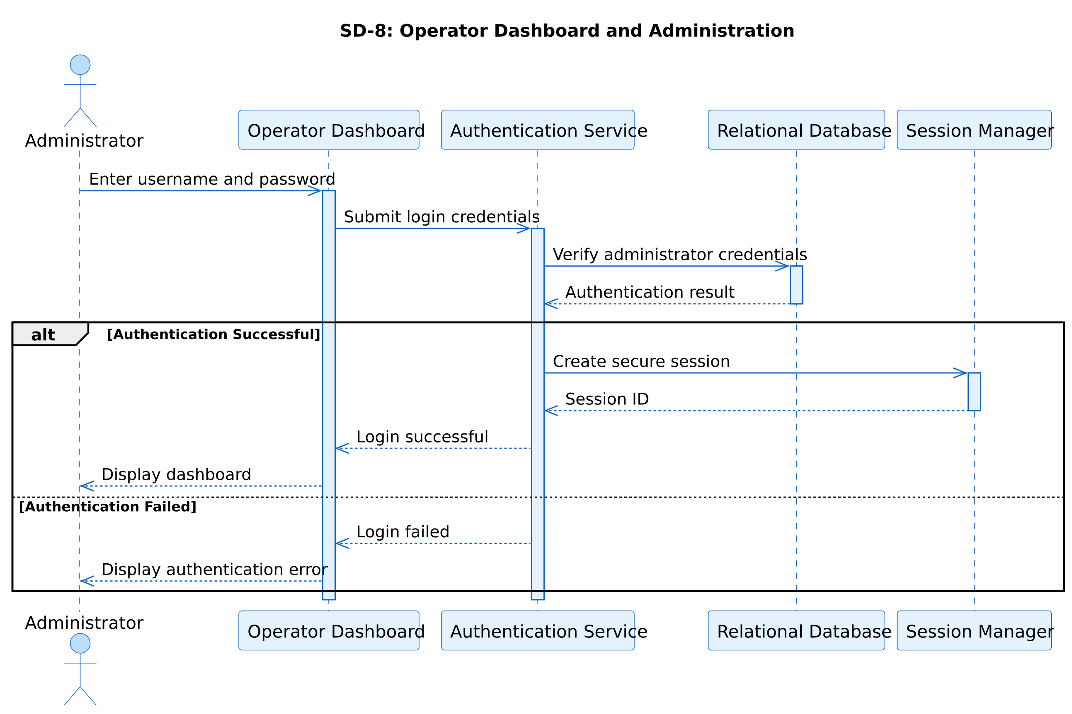
Figure 22 – Sequence Diagram: Operator Authentication

3.3.2 Voice Pipeline & Speech Processing
The sequence diagram traces an inbound voice call from the Voice Gateway through the Speech-to-Text service, the AgentIQ Backend, the Orchestrator, and Text-to-Speech synthesis back to the customer, including the alt block for a failed speech-recognition attempt.
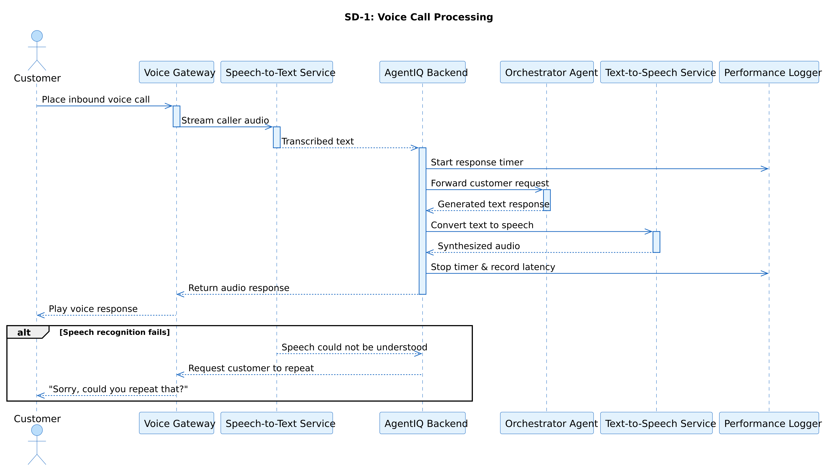
Figure 23 – Sequence Diagram: Voice Pipeline & Speech Processing

3.3.3 AI Orchestrator (Supervisor Agent)
The sequence diagram shows the Orchestrator receiving a normalized request, classifying intent, and dispatching subtasks to the relevant specialist agents before aggregating their responses.
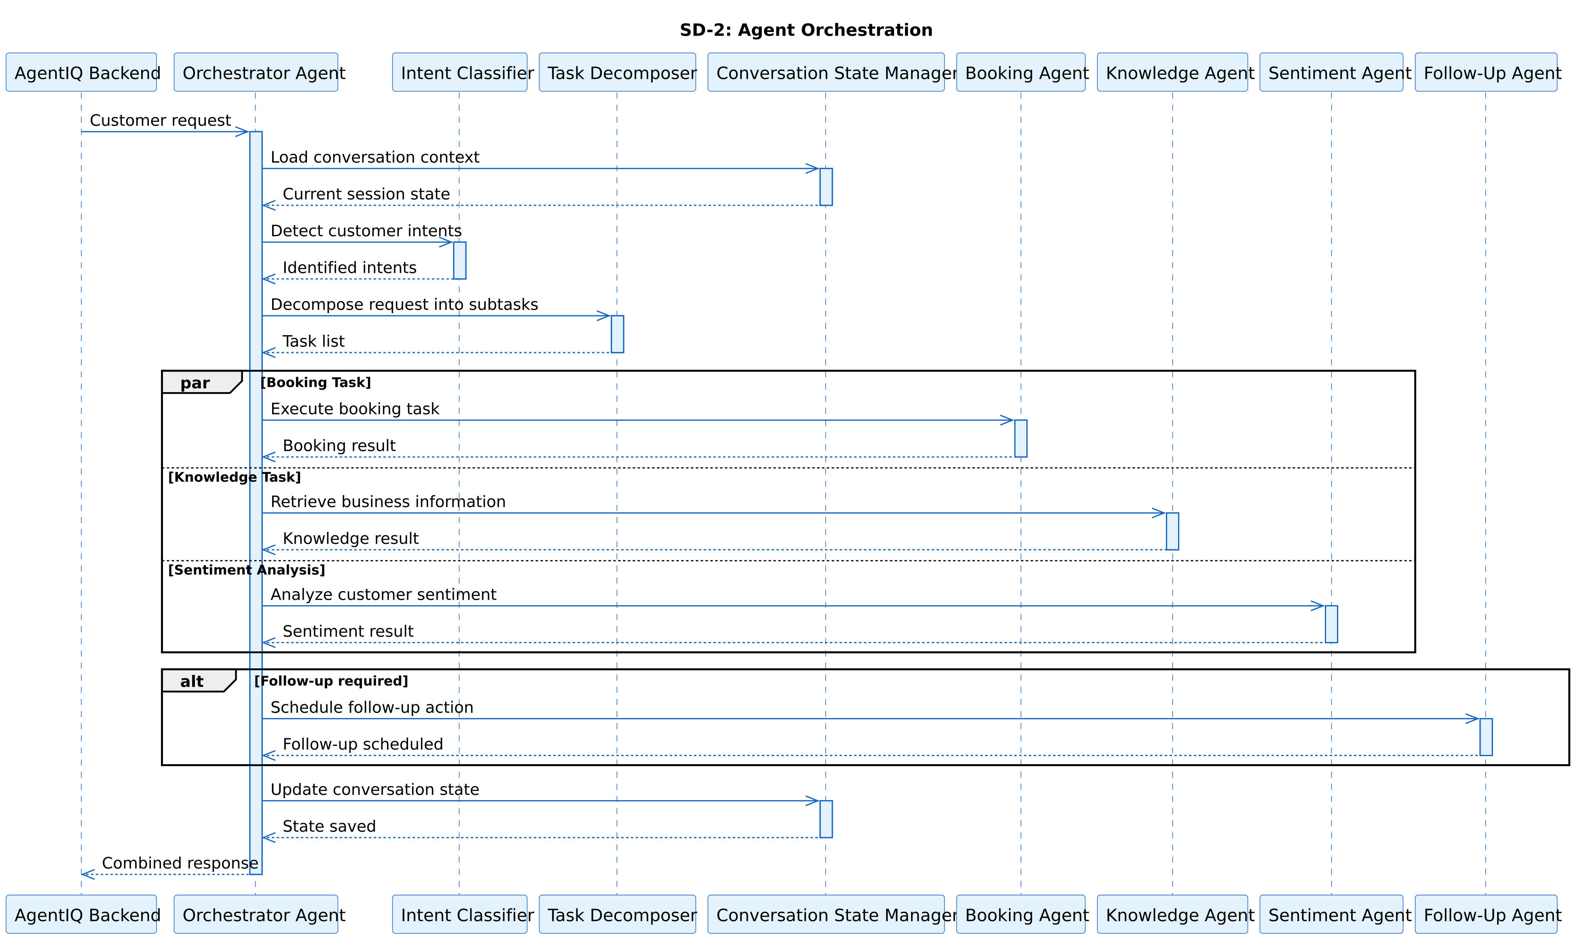
Figure 24 – Sequence Diagram: AI Orchestrator (Supervisor Agent)

3.3.4 Booking Agent
The sequence diagram covers the three booking operations — creation, modification, and cancellation — showing the availability check against the booking database at each step.
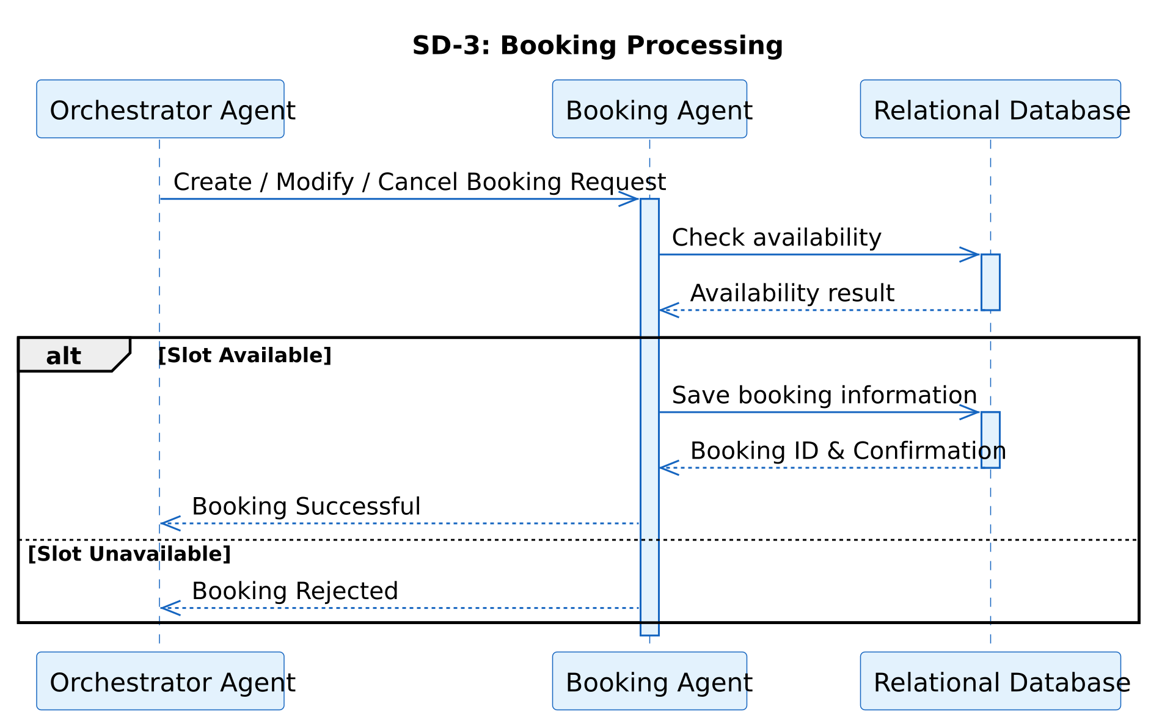
Figure 25 – Sequence Diagram: Booking Agent

3.3.5 Knowledge Agent (RAG)
The sequence diagram shows a customer knowledge query flowing through the Knowledge Agent to the vector database for similarity search, and the grounded response being generated from the retrieved chunks.
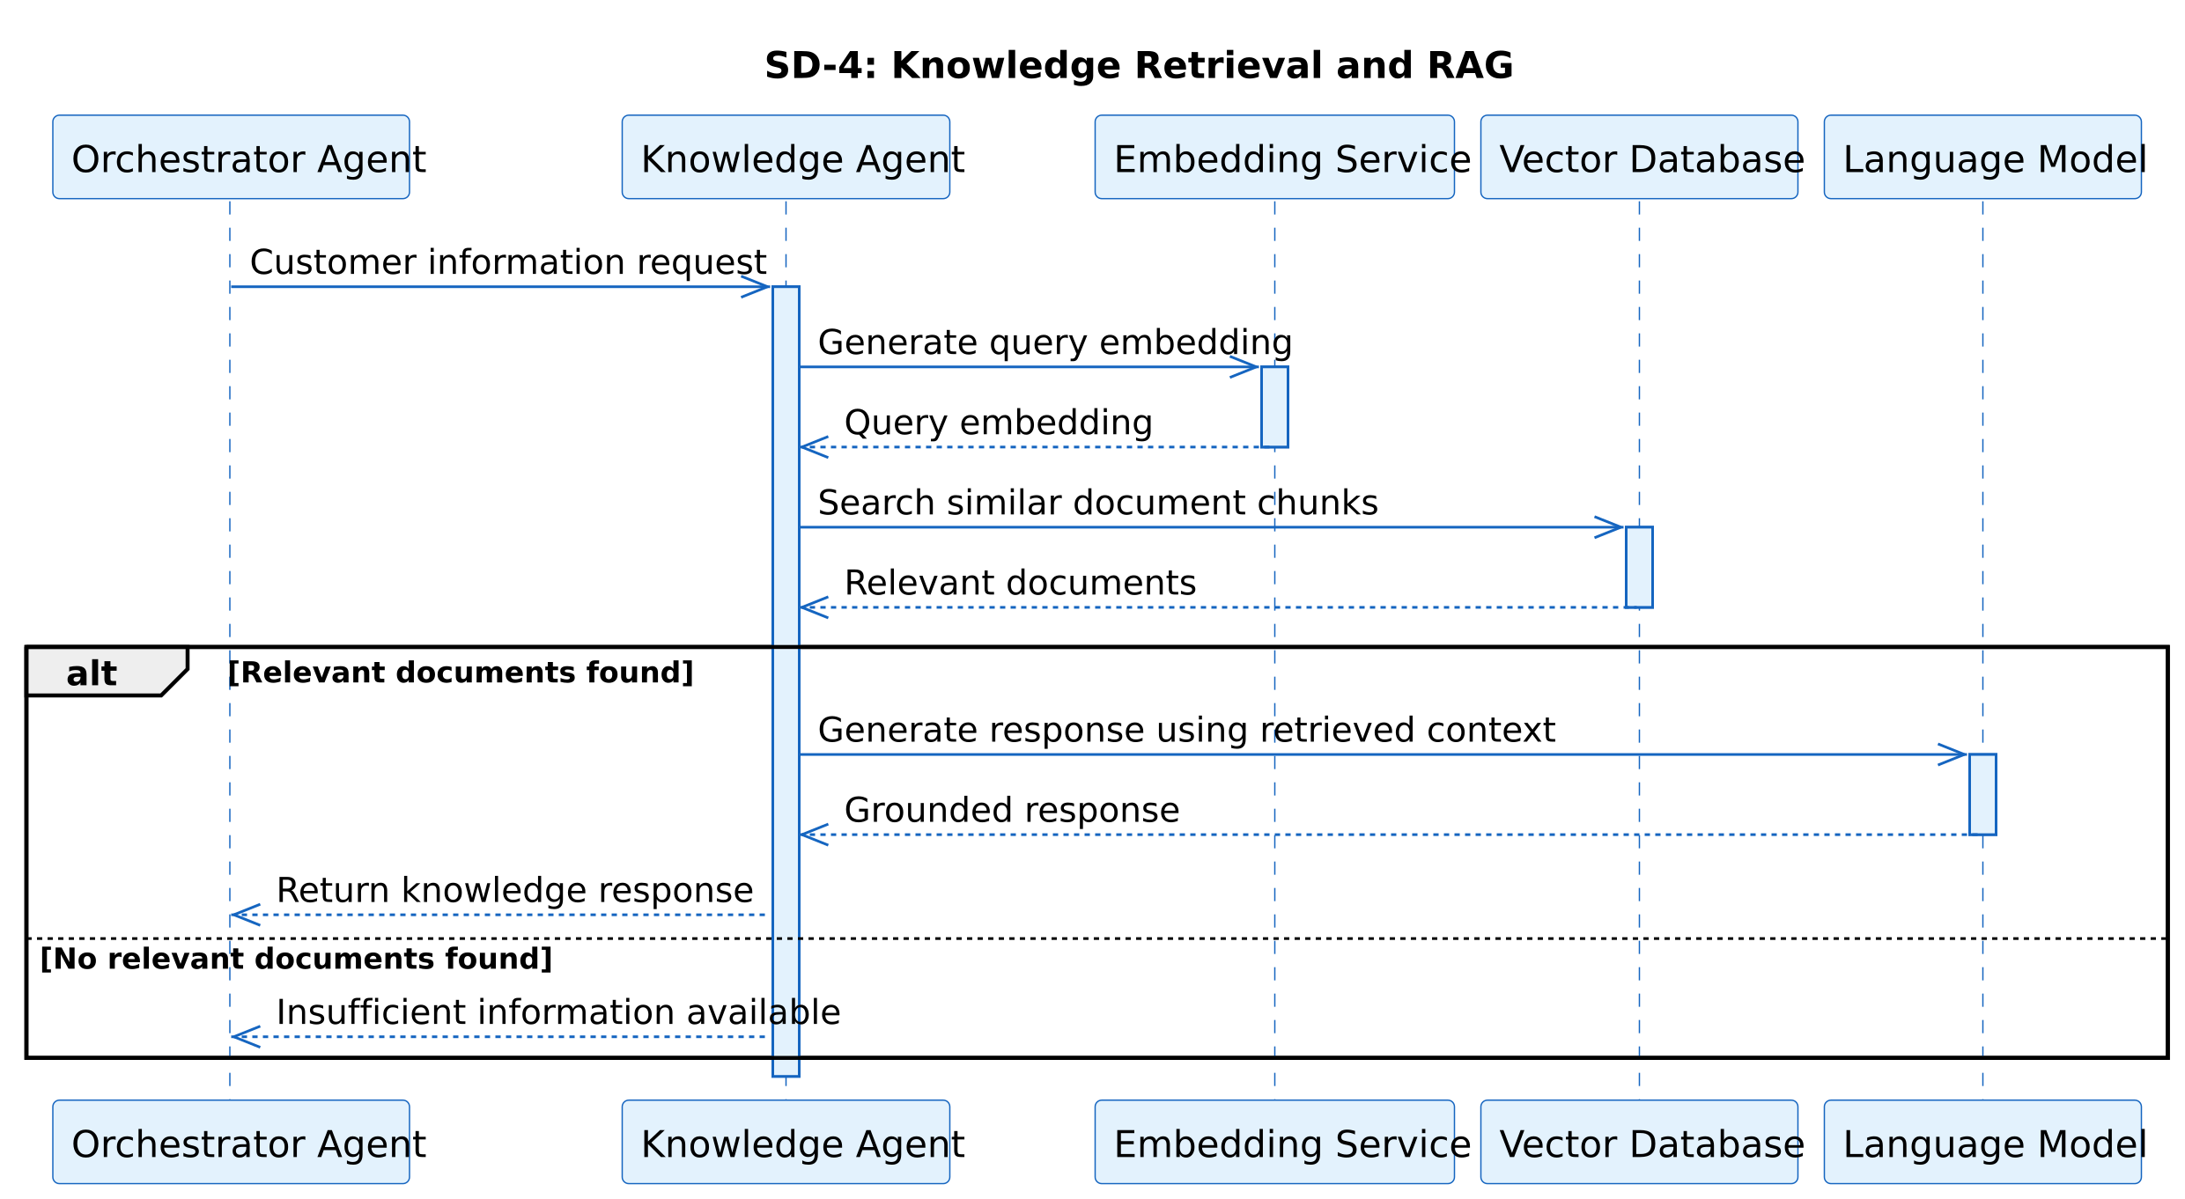
Figure 26 – Sequence Diagram: Knowledge Agent (RAG)

3.3.6 Sentiment & Complaint Agent
The sequence diagram shows customer input being scored by the sentiment classifier and, when the escalation threshold is met, the interaction being routed to the escalation workflow.
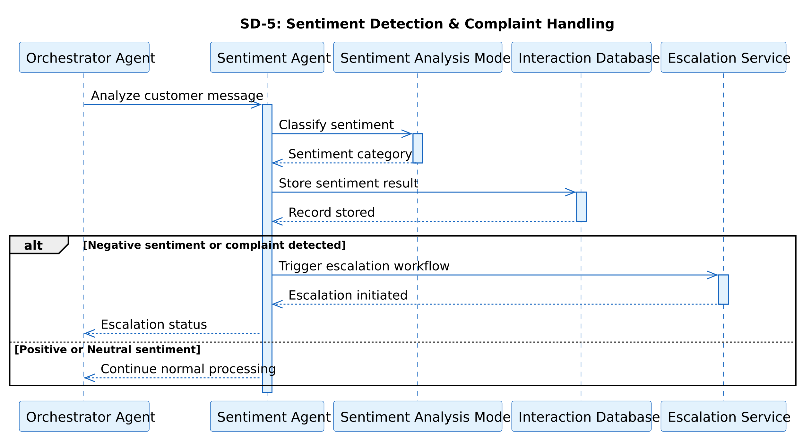
Figure 27 – Sequence Diagram: Sentiment & Complaint Agent

3.3.7 Follow-Up Agent
The sequence diagram shows the Follow-Up Agent evaluating an interaction outcome and dispatching confirmation, reminder, and feedback-request notifications through the notification service.
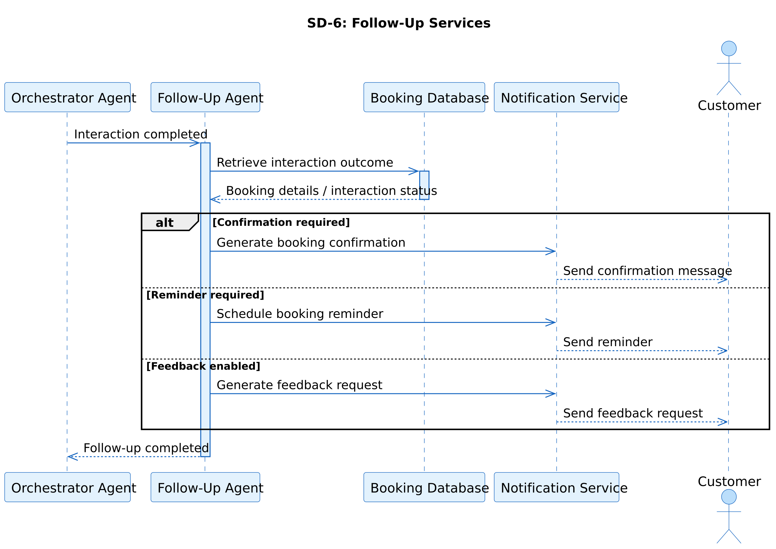
Figure 28 – Sequence Diagram: Follow-Up Agent

3.3.8 Operator Dashboard
The sequence diagram shows an operator configuring a business profile through the dashboard UI, including field validation and persistence through the backend API.
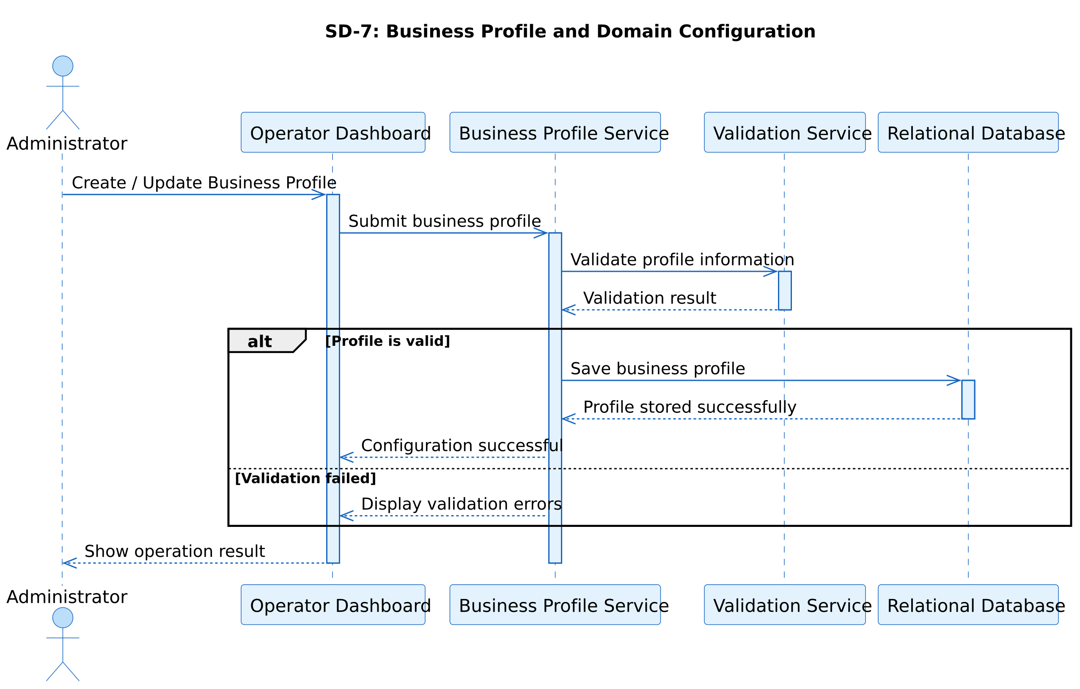
Figure 29 – Sequence Diagram: Operator Dashboard

3.3.9 Backend & Data Services
A standalone sequence diagram for this module was not produced separately: its behavior (persisting records, querying the vector store, reading/writing session state) already appears as the backend/database steps inside the other nine sequence diagrams above (e.g., Figures 22, 25, 26, 29). It is included as a full participant swimlane in Figure 32 (Software Architecture Diagram) and Figure 35 (Collaboration Diagram) instead.
(Not applicable for this module — see explanation above)
Figure 30 – Sequence Diagram: Backend & Data Services

3.3.10 System Integration
The sequence diagram shows an evaluation scenario being run against both the AgentIQ multi-agent system and the single-agent baseline in parallel, with results recorded to the metrics store for comparison.
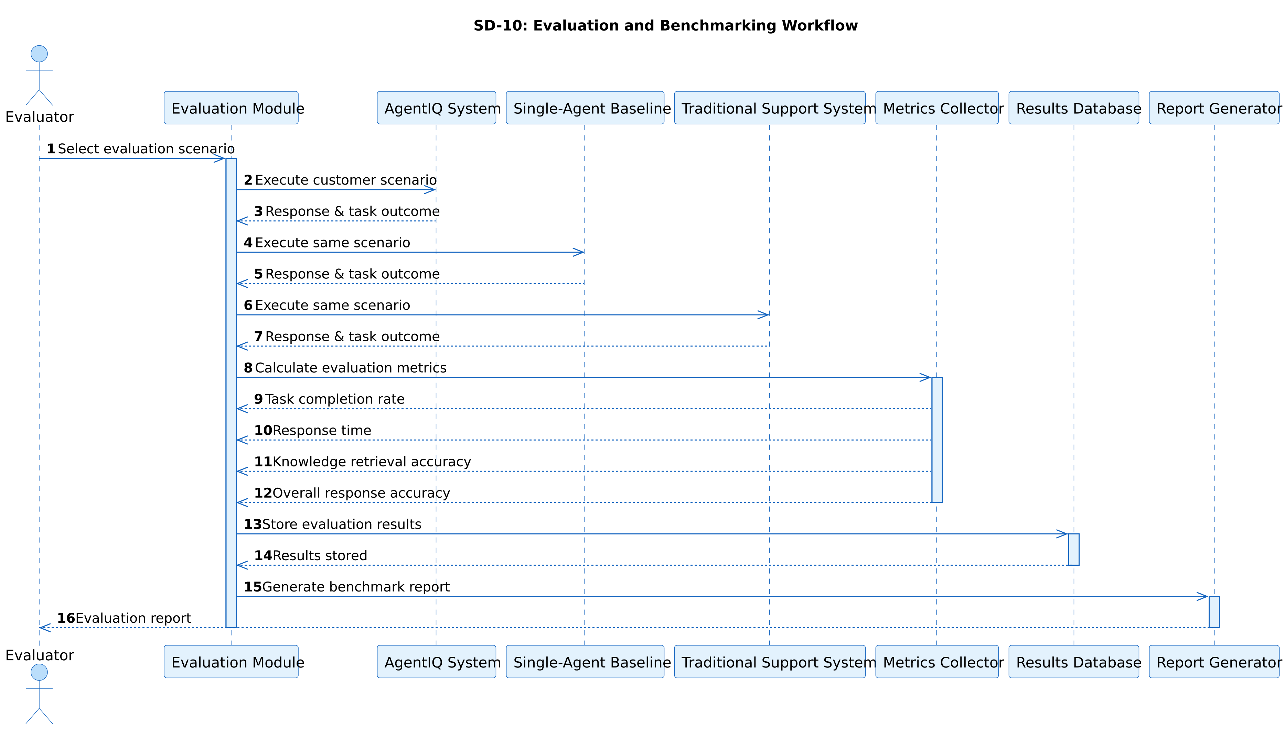
Figure 31 – Sequence Diagram: System Integration

3.4 Software Architecture Diagram
[Describe AgentIQ's layered architecture: Communication + Speech layer (Twilio/Whisper/TTS), AI Orchestrator layer, AI Agents layer (Booking, Knowledge, Sentiment, Follow-Up), and Backend & Data layer (FastAPI, PostgreSQL, ChromaDB)]
[Insert Software Architecture Diagram: AgentIQ here]
Figure 32 – Software Architecture Diagram: AgentIQ

3.5 Class Diagram
[Describe the static class structure — entities such as Operator, Customer, Conversation, Booking, KnowledgeDocument, ComplaintTicket, FollowUpTask]
[Insert Class Diagram: AgentIQ here]
Figure 33 – Class Diagram: AgentIQ

3.6 Database Diagram
[Describe the ER diagram — PostgreSQL relational schema for operators/tenants, bookings, conversations, and the ChromaDB vector store for the Knowledge Agent]
[Insert Database Diagram: AgentIQ here]
Figure 34 – Database Diagram: AgentIQ

3.7 Collaboration Diagram
[Describe how the Orchestrator, sub-agents, and backend services collaborate and exchange messages to fulfil a customer request]
[Insert Collaboration Diagram: AgentIQ here]
Figure 35 – Collaboration Diagram: AgentIQ

Chapter 4. System Testing

4.1 Test Cases Design
Since this is an FYP-I submission, no working system exists yet — these are planned test cases, designed directly from the functional requirements in Chapter 2, to be executed once each module is implemented in FYP-II. Each of the 10 modules gets one representative test case; Actual Result and Status columns are intentionally left blank (—) and will be filled in during execution.

4.1.1 Operator Authentication
Table 28 - Test Case-TC-01: Operator Authentication
Test Case ID: | TC-01 | Author: | Abdul Haseeb
Test Case Name: | Operator Authentication | Executed by: | —
Priority: | High | Dated: | —
Description: | Verifies that an operator can log in with valid credentials and is denied access with invalid ones.
Pre-Condition: | A registered operator account exists in the database.
Step | Test Step Details | Test Data | Expected Result | Actual Result | Status
1 | Navigate to login page and enter valid credentials | email: op1@test.com, password: Valid@123 | System authenticates and redirects to dashboard | — | —
2 | Enter an incorrect password for the same account | password: Wrong@123 | System rejects login with a generic error, no account details revealed | — | —
3 | Log out from an active session | Active session token | Session is invalidated; dashboard is no longer accessible | — | —
Post-Condition: | Operator has either an active authenticated session (Step 1) or no session (Step 3).

4.1.2 Voice Pipeline & Speech Processing
Table 29 - Test Case-TC-02: Voice Pipeline & Speech Processing
Test Case ID: | TC-02 | Author: | Syeda/Team
Test Case Name: | Voice Pipeline & Speech Processing | Executed by: | —
Priority: | High | Dated: | —
Description: | Verifies inbound call handling, correct speech-to-text transcription, and text-to-speech playback.
Pre-Condition: | Twilio number is configured; STT/TTS services are reachable.
Step | Test Step Details | Test Data | Expected Result | Actual Result | Status
1 | Place a test call to the configured number | Sample audio: “I'd like to book a table for two tomorrow at 7pm” | Call is answered and an interaction session opens | — | —
2 | System transcribes the spoken input | Same audio clip | Transcribed text matches spoken input with acceptable accuracy | — | —
3 | System converts a sample text reply to speech | Reply text: “Your table is confirmed for 7pm tomorrow.” | Audio is played back clearly and intelligibly to the caller | — | —
Post-Condition: | Interaction session contains a transcribed request and a delivered audio response.

4.1.3 AI Orchestrator (Supervisor Agent)
Table 30 - Test Case-TC-03: AI Orchestrator (Supervisor Agent)
Test Case ID: | TC-03 | Author: | Daoud Haroon
Test Case Name: | AI Orchestrator (Supervisor Agent) | Executed by: | —
Priority: | High | Dated: | —
Description: | Verifies correct intent decomposition and routing for a multi-intent request.
Pre-Condition: | Booking Agent and Knowledge Agent are both reachable by the orchestrator.
Step | Test Step Details | Test Data | Expected Result | Actual Result | Status
1 | Submit a multi-intent request | “Can you tell me your opening hours, and also book me a table for 4 at 8pm?” | Orchestrator identifies two intents: knowledge query + booking | — | —
2 | Verify subtask routing | Same request | Knowledge subtask routed to Knowledge Agent; booking subtask routed to Booking Agent | — | —
3 | Verify response aggregation | Agent outputs from Step 2 | Orchestrator returns one coherent combined reply | — | —
Post-Condition: | Both subtasks are completed and merged into a single customer-facing response.

4.1.4 Booking Agent
Table 31 - Test Case-TC-04: Booking Agent
Test Case ID: | TC-04 | Author: | Muneeb Ahmed
Test Case Name: | Booking Agent | Executed by: | —
Priority: | High | Dated: | —
Description: | Verifies booking creation, availability checking, and rejection when the slot is unavailable.
Pre-Condition: | Business profile has defined booking capacity for the configured domain.
Step | Test Step Details | Test Data | Expected Result | Actual Result | Status
1 | Request a booking for an available slot | Table for 2, tomorrow 7pm | Booking is created and confirmed | — | —
2 | Request a booking for a fully booked slot | Same slot, already at capacity | System declines and proposes alternative times | — | —
3 | Cancel the booking created in Step 1 | Booking ID from Step 1 | Booking status updates to “cancelled” | — | —
Post-Condition: | Booking database reflects the final state (created then cancelled).

4.1.5 Knowledge Agent (RAG)
Table 32 - Test Case-TC-05: Knowledge Agent (RAG)
Test Case ID: | TC-05 | Author: | Abdul Haseeb
Test Case Name: | Knowledge Agent (RAG) | Executed by: | —
Priority: | High | Dated: | —
Description: | Verifies document-grounded answers and correct “insufficient information” handling.
Pre-Condition: | At least one business knowledge document has been uploaded and indexed.
Step | Test Step Details | Test Data | Expected Result | Actual Result | Status
1 | Ask a question answerable from the uploaded document | “What is your cancellation policy?” | Agent returns an answer grounded in the document content | — | —
2 | Ask a question not covered by any document | “Do you offer valet parking on weekends?” | Agent explicitly states it cannot find relevant information | — | —
3 | Update the document and re-ask a related question | Updated policy text | Agent's answer reflects the updated content | — | —
Post-Condition: | Retrieval index reflects the latest uploaded document version.

4.1.6 Sentiment & Complaint Agent
Table 33 - Test Case-TC-06: Sentiment & Complaint Agent
Test Case ID: | TC-06 | Author: | Muneeb Ahmed
Test Case Name: | Sentiment & Complaint Agent | Executed by: | —
Priority: | High | Dated: | —
Description: | Verifies sentiment classification and correct triggering of the escalation workflow.
Pre-Condition: | Escalation rules are configured in the active business profile.
Step | Test Step Details | Test Data | Expected Result | Actual Result | Status
1 | Submit a clearly negative message | “This is the third time my booking has been wrong, I'm furious.” | Message is classified as strongly negative sentiment | — | —
2 | Verify escalation trigger | Same message | Escalation workflow is triggered per configured rules | — | —
3 | Submit a neutral message | “What time do you close today?” | Message is classified as neutral; no escalation triggered | — | —
Post-Condition: | Interaction record contains sentiment label(s) and escalation status.

4.1.7 Follow-Up Agent
Table 34 - Test Case-TC-07: Follow-Up Agent
Test Case ID: | TC-07 | Author: | Daoud Haroon
Test Case Name: | Follow-Up Agent | Executed by: | —
Priority: | Medium | Dated: | —
Description: | Verifies automatic dispatch of a booking confirmation and a scheduled reminder.
Pre-Condition: | A booking was successfully created in a prior interaction.
Step | Test Step Details | Test Data | Expected Result | Actual Result | Status
1 | Complete a booking interaction | Booking created via TC-04 Step 1 | Confirmation message is dispatched automatically, without human trigger | — | —
2 | Advance system clock to the configured reminder window | Reminder rule: 24h before booking | Reminder message is dispatched automatically | — | —
3 | Complete interaction with feedback collection enabled | Feedback flag = true | Feedback request is sent after interaction ends | — | —
Post-Condition: | All applicable follow-up messages are logged as sent.

4.1.8 Operator Dashboard
Table 35 - Test Case-TC-08: Operator Dashboard
Test Case ID: | TC-08 | Author: | Abdul Haseeb
Test Case Name: | Operator Dashboard | Executed by: | —
Priority: | High | Dated: | —
Description: | Verifies business-profile creation, field validation, and log visibility.
Pre-Condition: | Operator is authenticated.
Step | Test Step Details | Test Data | Expected Result | Actual Result | Status
1 | Create a new business profile with all mandatory fields | Domain: Restaurant; policies; booking rules | Profile is saved successfully | — | —
2 | Attempt to save a profile missing a mandatory field | Domain field left blank | System blocks save and highlights missing field | — | —
3 | View interaction logs after a test scenario | Logs from TC-03 run | Logs display outcome and any escalation flags | — | —
Post-Condition: | Business profile exists and is usable by the live agents.

4.1.9 Backend & Data Services
Table 36 - Test Case-TC-09: Backend & Data Services
Test Case ID: | TC-09 | Author: | Daoud Haroon
Test Case Name: | Backend & Data Services | Executed by: | —
Priority: | High | Dated: | —
Description: | Verifies data persistence, API availability, and session-state handling.
Pre-Condition: | Backend services (API, PostgreSQL, ChromaDB, cache) are running.
Step | Test Step Details | Test Data | Expected Result | Actual Result | Status
1 | Create a booking record via the API | Booking payload | Record is persisted in PostgreSQL and retrievable | — | —
2 | Query a REST endpoint for dashboard data | GET /api/profiles/{id} | API returns correct data with expected schema | — | —
3 | Simulate a brief backend interruption mid-session | Kill and restart backend process during active session | Session state is recovered without data loss | — | —
Post-Condition: | All operational data remains consistent after the test sequence.

4.1.10 System Integration
Table 37 - Test Case-TC-10: System Integration
Test Case ID: | TC-10 | Author: | Full Team
Test Case Name: | System Integration | Executed by: | —
Priority: | High | Dated: | —
Description: | Verifies end-to-end evaluation scenario execution and comparison against the single-agent baseline.
Pre-Condition: | All agents are integrated; single-agent baseline and evaluation dataset are ready.
Step | Test Step Details | Test Data | Expected Result | Actual Result | Status
1 | Run a predefined multi-intent scenario on AgentIQ | Standard evaluation scenario set | Task completion, accuracy, and latency are recorded | — | —
2 | Run the same scenario against the single-agent baseline | Same scenario set | Comparable metrics are recorded for the baseline | — | —
3 | Compare results across both systems | Metrics from Steps 1–2 | Comparative report is generated | — | —
Post-Condition: | Comparative evaluation results are documented for the final report.

Chapter 5. Implementation

5.1 Work Breakdown Structure (WBS)
The WBS decomposes the project into six phases: (1) Requirement Gathering & Analysis, (2) System Design, (3) Core Agent Development (Booking, Knowledge, Sentiment, Follow-Up — built and validated over text first), (4) Orchestrator Integration, (5) Voice-Layer Integration, and (6) Evaluation, Testing & Documentation.
[Insert Work Breakdown Structure (WBS) here]
Figure 36 – Work Breakdown Structure (WBS)

5.2 Team Roles and Responsibilities
Table 38 - Roles and Responsibilities
Team Member | Activity | Tentative Date
Daoud Haroon (Group Leader) | Orchestrator design & implementation (LangGraph state graph, intent decomposition, routing logic) | FYP-II, Months 1–3
Daoud Haroon (Group Leader) | System integration, evaluation framework, and comparative benchmarking against single-agent baseline | FYP-II, Months 4–6
Abdul Haseeb | Knowledge Agent (RAG pipeline, ChromaDB integration) and Operator Authentication module | FYP-II, Months 1–3
Abdul Haseeb | Operator Dashboard (business-profile configuration UI, logs view) | FYP-II, Months 3–5
Muneeb Ahmed | Booking Agent and Sentiment & Complaint Agent implementation | FYP-II, Months 1–3
Muneeb Ahmed | Follow-Up Agent and voice-pipeline integration (Twilio, Whisper, TTS) | FYP-II, Months 4–6

5.3 Tools and Technologies
Table 39 - Tools and Technologies
Category | Tool / Technology | Purpose / Justification
Frontend | React.js, Tailwind CSS | Operator dashboard UI
Backend | FastAPI | REST API layer connecting orchestrator, agents, and dashboard
AI / Agent Orchestration | LangGraph / LangChain | Supervisor multi-agent pattern implementation
Vector Database | ChromaDB | RAG-based document retrieval for the Knowledge Agent
Relational Database | PostgreSQL | Multi-tenant operator, booking, and conversation data
Voice Pipeline | Twilio, Whisper, TTS (OpenAI tts-1-hd) | Telephony, speech-to-text, text-to-speech
ML / NLP | HuggingFace (DistilBERT) | Sentiment analysis
Containerization | Docker | Service packaging and deployment
Version Control | Git, GitHub | Source code management and collaboration
Design | Python (matplotlib), PlantUML | System/UML diagrams

5.4 Implementation Details
Development follows the text-first strategy established in Section 1.6: each module below will be built and validated over a text interface before voice integration is attempted, since the voice layer is the highest-risk, most technically demanding component.
Module 1: Operator Authentication
FastAPI endpoints for login/logout, credential hashing (bcrypt), and session-token issuance (JWT). Data flow: dashboard → /auth/login → PostgreSQL operators table → signed token returned to client.
Module 2: Voice Pipeline & Speech Processing
Twilio webhook receives inbound calls; audio is streamed to Whisper for STT; generated replies are passed to a TTS engine before being played back via Twilio's <Say>/<Play> verbs. Built and tested last, after all agents work reliably over text.
Module 3: AI Orchestrator (Supervisor Agent)
Implemented as a LangGraph state graph; each node represents either an intent-classification step or a specialist-agent call, with conditional edges handling routing and concurrent branches for independent subtasks.
Module 4: Booking Agent
LangChain tool-calling agent with structured functions (check_availability, create_booking, modify_booking, cancel_booking) backed by PostgreSQL queries.
Module 5: Knowledge Agent (RAG)
Document ingestion pipeline chunks uploaded files, embeds them (OpenAI embeddings), and stores vectors in ChromaDB; retrieval uses cosine-similarity search with a configurable top-k.
Module 6: Sentiment & Complaint Agent
Fine-tuned DistilBERT classifier scores each customer turn; scores and a small rule set (keyword + score threshold) determine whether the escalation workflow fires.
Module 7: Follow-Up Agent
Runs as a scheduled/event-driven task (booking-created event → confirmation; time-based trigger → reminder) using a lightweight task queue.
Module 8: Operator Dashboard
React SPA consuming the FastAPI REST layer; forms for business-profile CRUD, a testing console for text-based scenarios, and a logs/analytics view.
Module 9: Backend & Data Services
FastAPI app exposing REST endpoints, PostgreSQL for operational data, ChromaDB for embeddings, Redis for session-state caching.
Module 10: System Integration
Evaluation harness that runs the same scenario set against AgentIQ and a single-agent baseline, logging task completion, accuracy, and latency for comparison.

5.5 Screenshots of Prototype / System
5.5.1 Screen 1 — Operator Authentication
[Brief description of the Operator Authentication screen/interface]
[Insert Screenshot: Operator Authentication here]
Figure 37 – Screenshot: Operator Authentication
5.5.2 Screen 2 — Voice Pipeline & Speech Processing
[Brief description of the Voice Pipeline & Speech Processing screen/interface]
[Insert Screenshot: Voice Pipeline & Speech Processing here]
Figure 38 – Screenshot: Voice Pipeline & Speech Processing
5.5.3 Screen 3 — AI Orchestrator (Supervisor Agent)
[Brief description of the AI Orchestrator (Supervisor Agent) screen/interface]
[Insert Screenshot: AI Orchestrator (Supervisor Agent) here]
Figure 39 – Screenshot: AI Orchestrator (Supervisor Agent)
5.5.4 Screen 4 — Booking Agent
[Brief description of the Booking Agent screen/interface]
[Insert Screenshot: Booking Agent here]
Figure 40 – Screenshot: Booking Agent
5.5.5 Screen 5 — Knowledge Agent (RAG)
[Brief description of the Knowledge Agent (RAG) screen/interface]
[Insert Screenshot: Knowledge Agent (RAG) here]
Figure 41 – Screenshot: Knowledge Agent (RAG)
5.5.6 Screen 6 — Sentiment & Complaint Agent
[Brief description of the Sentiment & Complaint Agent screen/interface]
[Insert Screenshot: Sentiment & Complaint Agent here]
Figure 42 – Screenshot: Sentiment & Complaint Agent
5.5.7 Screen 7 — Follow-Up Agent
[Brief description of the Follow-Up Agent screen/interface]
[Insert Screenshot: Follow-Up Agent here]
Figure 43 – Screenshot: Follow-Up Agent
5.5.8 Screen 8 — Operator Dashboard
[Brief description of the Operator Dashboard screen/interface]
[Insert Screenshot: Operator Dashboard here]
Figure 44 – Screenshot: Operator Dashboard
5.5.9 Screen 9 — Backend & Data Services
[Brief description of the Backend & Data Services screen/interface]
[Insert Screenshot: Backend & Data Services here]
Figure 45 – Screenshot: Backend & Data Services
5.5.10 Screen 10 — System Integration
[Brief description of the System Integration screen/interface]
[Insert Screenshot: System Integration here]
Figure 46 – Screenshot: System Integration

5.6 Challenges During Implementation
Anticipated challenges for FYP-II, based on the design work completed so far: Voice-layer latency — chaining Twilio → Whisper → Orchestrator → TTS introduces multiple network hops; keeping round-trip time low enough for natural conversation will likely require streaming STT/TTS rather than batch processing. Multi-agent handoff reliability — ensuring the orchestrator correctly preserves context when a subtask's output feeds into another agent's input. Multi-tenant data isolation — enforcing strict separation of one operator's business data from another's across both PostgreSQL and ChromaDB. RAG hallucination mitigation — tuning the Knowledge Agent to reliably say “I don't know” rather than generating a plausible but ungrounded answer when retrieval confidence is low. Team coordination on a 3-person team — parallelizing independent agent modules while keeping interfaces to the orchestrator consistent enough to integrate without major rework.

Chapter 6. References
[1] M. U. Hadi, R. Qureshi, A. Shah, M. Irfan, A. Zafar, M. B. Shaikh, N. Akhtar, J. Wu, and S. Mirjalili, “Large language models: A comprehensive survey of its applications, challenges, limitations, and future prospects,” Authorea Preprints, 2023.
[2] L. Wang, C. Ma, X. Feng, Z. Zhang, H. Yang, J. Zhang, Z.-Y. Chen, J. Tang, X. Chen, Y. Lin, W. X. Zhao, Z. Wei, and J.-R. Wen, “A survey on large language model based autonomous agents,” Frontiers of Computer Science, vol. 18, no. 6, 2024.
[3] Q. Wu, G. Bansal, J. Zhang, Y. Wu, S. Zhang, E. Zhu, B. Li, L. Jiang, X. Zhang, and C. Wang, “AutoGen: Enabling next-gen LLM applications via multi-agent conversation framework,” arXiv preprint arXiv:2308.08155, 2023.
[4] T. Guo, X. Chen, Y. Wang, R. Chang, S. Pei, N. V. Chawla, O. Wiest, and X. Zhang, “Large language model based multi-agents: A survey of progress and challenges,” in Proc. 33rd Int. Joint Conf. Artificial Intelligence (IJCAI), 2024.
[5] J. S. Park, J. C. O'Brien, C. J. Cai, M. R. Morris, P. Liang, and M. S. Bernstein, “Generative agents: Interactive simulacra of human behavior,” in Proc. 36th Annual ACM Symp. User Interface Software and Technology (UIST), 2023.
[6] A. Fourney, G. Bansal, H. Mozannar, C. Tan, E. Salinas, E. Zhu, F. Niedtner, G. Proebsting, G. Bassman, J. Gerrits, J. Alber, P. Chang, R. Loynd, R. West, V. Dibia, A. Awadallah, E. Kamar, R. Hosn, and S. Amershi, “Magentic-One: A generalist multi-agent system for solving complex tasks,” arXiv preprint arXiv:2411.04468, 2024.
[7] Y. Shen, K. Song, X. Tan, D. Li, W. Lu, and Y. Zhuang, “HuggingGPT: Solving AI tasks with ChatGPT and its friends in Hugging Face,” in Advances in Neural Information Processing Systems 36 (NeurIPS), 2023.
[8] Y. Gao, Y. Xiong, X. Gao, K. Jia, J. Pan, Y. Bi, Y. Dai, J. Sun, and H. Wang, “Retrieval-augmented generation for large language models: A survey,” arXiv preprint arXiv:2312.10997, 2023.
[9] Z. Ji, N. Lee, R. Frieske, T. Yu, D. Su, Y. Xu, E. Ishii, Y. Bang, A. Madotto, and P. Fung, “Survey of hallucination in natural language generation,” ACM Computing Surveys, vol. 55, no. 12, pp. 1–38, 2023.
[10] A. Radford, J. W. Kim, T. Xu, G. Brockman, C. McLeavey, and I. Sutskever, “Robust speech recognition via large-scale weak supervision,” arXiv preprint arXiv:2212.04356, 2022.
[11] Vapi Inc., “Vapi: Voice AI agents platform.” [Online]. Available: https://vapi.ai. [Accessed: Sep. 2026].
[12] Retell AI, “Retell AI: Conversational voice AI platform.” [Online]. Available: https://www.retellai.com. [Accessed: Sep. 2026].
[13] Bland AI, “Bland AI: Enterprise voice AI platform.” [Online]. Available: https://www.bland.ai. [Accessed: Sep. 2026].
[14] Synthflow AI, “Synthflow: No-code AI voice agent platform.” [Online]. Available: https://synthflow.ai. [Accessed: Sep. 2026].
[15] Databricks Solutions, “agentic-customer-support: A multi-agent customer support reference implementation,” GitHub repository. [Online]. Available: https://github.com/databricks-solutions/agentic-customer-support. [Accessed: Sep. 2026].
[16] Hesper-Labs, “Owly: AI-powered customer support agent with WhatsApp, email and phone channels,” GitHub repository. [Online]. Available: https://github.com/Hesper-Labs/owly. [Accessed: Sep. 2026].
[17] Twilio Inc., “Twilio Programmable Voice documentation.” [Online]. Available: https://www.twilio.com/docs/voice. [Accessed: Sep. 2026].
[18] OpenAI, “Text to speech API documentation.” [Online]. Available: https://platform.openai.com/docs/guides/text-to-speech. [Accessed: Sep. 2026].

Appendix A
[Insert the first page of the Turnitin similarity report here]

Appendix B
[Insert the first page of the Turnitin AI report here]

