AGENTIQ:
An Intelligent Multi-Agent LLM System for Autonomous Customer Support and Voice-Based Interaction
Final Year Project Proposal
Session 2023-2027
A 4th Year Student

A project submitted in partial fulfilment of the requirements for the Degree
of
BSc. (Hons.) BS in Computer Science / Software Engineering / Artificial Intelligence



Department of Computer Science
COMSATS University Islamabad (CUI), Lahore

Project Registration
Project ID (for office use)
Type of project |  |  | [✓] Traditional
Nature of project |  |  | [✓] Research & Development
Sustainable Development Goals (SDGs) |  |  | [✓] Industry, Innovation, and Infrastructure
Area of specialization |  |  | [✓] Artificial Intelligence (AI)  [✓] Data Science and Analytics  [✓] Natural Language Processing (NLP)  [✓] Web Development
Project Group Members
Sr.# | Reg. # | Student Name |  | Email ID | Phone # | Signature
(i) | FA23-BSE-045 | Daoud Haroon |  | Fa23-bse-045@cuilahore.edu.pk | +92 302 4021294 | Daoud
(ii) | FA23-BSE-146 | Muneeb Ahmed |  | Fa23-bse-146@cuilahore.edu.pk | +92 313 2471870 | Muneeb
(iii) | FA23-BSE-006 | Abdul Haseeb |  | Fa23-bse-006@cuilahore.edu.pk | +92 310 6307841 | Abdul  Haseeb
Declaration: FYP group members have cleared all prerequisite courses for FYP-I as per their degree requirements.
For BS (Computer Science), BS (Software Engineering), and BS (Artificial Intelligence)
(CSC241 Object Oriented Programming, CSC291 Software Engineering Concepts, CSC270 Database Systems, HUM102 Report Writing Skills)
Plagiarism Free Certificate
This is to certify that, I am Daoud Haroon S/D/o Haroon Ameer, group leader of FYP under registration no CUI /FA23-BSE-006/LHR at the Computer Science Department, COMSATS Institute of Information Technology, Lahore. I declare that my FYP proposal is checked by my supervisor and the similarity index is 2% that is less than 20%, an acceptable limit by HEC. The report is attached herewith as Appendix A.
Date: 3/12/2026 Name of Group Leader: Daoud Haroon Signature: Daoud
Name of Supervisor: Muhammad Junaid Anjum Co-Supervisor (if any): _________________
Designation: Lecturer Designation: _____________________
Signature: _____________________ Signature: _____________________

Abstract
Customer support is a critical operational function in service-oriented businesses such as hotels, restaurants, and clinics. In these industries, the speed and quality of communication directly affect customer satisfaction and revenue. However, the customer support solutions currently available have several limitations. Though flexible, the cost of human customer support agents is high, and they are not always available around the clock. Interactive Voice Response (IVR) systems help reduce the cost of customer support but are often rigid and frustrating to use. Chatbots powered by a single Large Language Model (LLM) agent are also ineffective for situations where a customer request involves multiple tasks to be handled within the same conversation. To address these limitations, this project proposes a modular multi-agent AI-based customer calling system for small and medium-sized businesses (SMBs). In this system, an orchestrator agent analyzes incoming customer requests and breaks them into smaller tasks handled by specialized sub-agents. These include the Booking Agent for managing reservations, the Knowledge Agent for extracting information from business documents using Retrieval-Augmented Generation (RAG), the Sentiment and Complaint Agent for analyzing customer tone, and the Follow-Up Agent for post-interaction tasks. The system includes a configurable business profile feature that allows the same architecture to be deployed across different service domains without major code changes. The proposed system will function as a voice-enabled AI calling agent using speech-to-text and text-to-speech technologies to process inbound calls. It will be evaluated against conventional IVR systems and human call agents based on task completion rate, response accuracy, and cross-domain adaptability across three business sectors.

Introduction
Service-oriented businesses like hotels, restaurants, clinics, and similar establishments rely heavily on timely and accurate communication with their customers to maintain their business. Handling customer reservations, queries, complaints, and follow-ups are not secondary functions, but they are central to keeping a customer loyal or driving him/her to a competitor. For small and medium-sized businesses that form most of the business population within this industry segment, the problem of providing effective customer service has never been solved.
The traditional solution to this challenge has been to employ human support staff or to implement IVR systems. Human support staff are limited by their working hours, prone to inconsistency, and involve high operating costs that most SMBs cannot afford. IVR systems minimize the cost factor but introduce the factor of rigidity. IVR systems guide the customer through a series of menus, fail to operate if the customer input is not part of the pre-defined sequence, and are generally seen as a source of customer frustration rather than satisfaction. Many small and medium-sized businesses continue to employ the services of manual telephone support or IVR systems. These systems do not satisfy the customer since they are not capable of understanding conversations.
This gap between what customers need and what these systems can deliver is narrowing due to rapid advances in Large Language Models (LLMs) and agentic AI frameworks [1]. Today, LLMs can understand natural language, maintain context across a conversation, retrieve information from external sources, and execute tasks through tool-calling interfaces [3]. However, relying on a single LLM agent to handle the full range of customer support tasks introduces complexity that is hard to manage, debug, and scale. Research shows that single-agent models suffer from lower reliability and poor task isolation when handling varied, multi-step interactions [4].

1. Motivation and Significance of the Project
Currently, small and medium-sized service enterprises rely on two main customer support approaches, each with clear limitations. Human agents offer flexibility but are expensive to maintain, unavailable around the clock, and difficult to scale during peak demand. IVR systems are widely deployed but fail to handle natural, multi-intent conversations due to their rigid decision-tree structure [5]. LLMs offer a more capable alternative, but most implementations use a single-agent setup where one model handles all interaction types within a single context, making it hard to isolate failures or extend functionality [4].
This project addresses both concerns at once. By assigning each type of task to a dedicated agent, the system becomes easier to manage, test, and extend. Enterprise tools like Salesforce Einstein or IBM Watson Assistant offer similar capability but are financially and technically out of reach for most SMBs. On the other end, basic packaged chatbots lack the multi-step reasoning and post-interaction follow-up that real service businesses need [8]. This project aims to bridge that gap by building a system powerful enough to replace an IVR or a human support team, yet simple enough to configure for any service domain without engineering effort.

2. Scope of the Project
The major goal of this research is to design a modular multi-agent AI system that can easily be configured to meet the needs of different service-oriented business domains without changing the underlying architecture of the agents. As a matter of evaluation, the system has been deliberately focused on the hotel, restaurant, and clinical domains. However, the scope of this research does not contemplate the replacement of existing business management tools, such as customer relationship management (CRM) tools. Moreover, the system has not been designed to use actual API connections to external databases
The system processes customer calls through an integrated voice interface that transcribes spoken language into text using automatic speech recognition [13], processes the interaction through a multi-agent framework, and finally provides real-time response output as synthesized speech. Voice telephony is handled via a programmable communications API [12]. The system can handle customer interactions that involve multiple requests by dividing them into smaller tasks handled by different agents. It retrieves relevant business information from stored documents using a retrieval-augmented pipeline, detects negative customer sentiment to trigger escalation when needed, and manages follow-up interactions based on the outcomes of previous conversations.
The scope of the project is limited to prototype implementation for the purpose of research evaluation. The system will not process actual payment transactions, will not interface with actual third-party online booking sites for a production environment, and will not support languages other than English. These constraints allow for the evaluation of the feasibility of the proposed modular multi-agent system for the purpose of automated customer support, given the time constraints of an undergraduate final year project.

3. Proposed Solution
The proposed system is an AI-powered customer support platform built on a multi-agent architecture. It uses natural language understanding to receive and interpret customer queries, which are then broken down into subtasks and handled by specialized agents responsible for bookings, information retrieval, sentiment monitoring, and follow-up communication. The system retrieves relevant information from business documents using semantic search techniques and monitors the emotional tone of conversations to detect complaints and escalate when necessary. A configurable business profile allows the same system to be deployed across different service domains without changing the core logic. The platform supports both voice and text input by converting speech to text and back, enabling fully automated customer interactions.

4. Results and Outcomes
The expected outcome of this project is a working multi-agent AI calling agent prototype that can be deployed across hotel, clinic, and restaurant domains through a configurable business profile layer, without any domain-specific code changes. The system will handle inbound calls, manage bookings, retrieve policy information, detect customer sentiment, and carry out post-interaction follow-up actions with minimal human involvement.
System performance will be benchmarked against two traditional approaches: IVR-based systems and human-handled interactions. The final deliverable will be a multi-agent architecture that demonstrates measurably better task completion, flexibility, and cost-efficiency compared to these baselines for SMB customer support.

Problem Statement
Small and medium-sized service businesses currently lack an affordable customer support solution capable of reliably handling multi-intent interactions; customer sessions that simultaneously require booking management, policy retrieval, complaint handling, and post-interaction follow-up. Existing approaches fail this requirement in distinct ways: IVR systems are too rigid to manage natural, multi-step conversations; human agents are costly and unavailable around the clock; and single-agent LLM chatbots degrade in reliability when managing multiple concurrent tasks within a single context.

Project Objectives
The following objectives define the research and development goals of this project, outlining the key technical components to be designed, implemented, and evaluated.

- Design a modular multi-agent architecture using an LLM orchestration framework in which an orchestrator decomposes multi-intent customer interactions and delegates subtasks to specialized agents, including Booking, Knowledge, Sentiment and Complaint, and Follow-Up agents.
- Build a configurable business layer in which the same agent architecture will be used to deploy all the business domains like hotels, restaurants, clinics by just configuring the domain policies without code changes.
- Implement a RAG-powered Knowledge Agent using a vector database to enable accurate, document-grounded responses to business-specific customer queries.
- Build a Follow-Up Agent capable of autonomously determining and dispatching appropriate post-interaction communications based on conversation outcomes without a human trigger.
- Integrate a voice module which handle all the inbound customer calls without human intervention.
- Evaluate the Multi agent system against the traditional IVR and human agent approaches for Task completion rate, Response time, Response accuracy and to demonstrate a more cost effective and reliable solution for SMB customer support.
- Demonstrate a working prototype across at least three business verticals and document the configuration process as a reproducible deployment guide for SMB operators.

Related Work
This section reviews research directly relevant to the proposed system, covering three areas: LLM-based multi-agent systems, RAG for customer support, and existing commercial platforms. It concludes with a comparison table identifying the gap this project addresses.
Wu et al. [4] introduced AutoGen, an open framework that enables developers to build multi-agent applications where LLM-powered agents collaborate through structured conversations. The framework showed that dividing complex tasks among specialized agents produced more reliable outcomes than relying on a single model. This work established the foundation for agent specialization and inter-agent coordination, which are core principles in the proposed system. Wang et al. [5] conducted a comprehensive survey of LLM-based autonomous agent architectures and identified task decomposition and agent specialization as the primary design principles for building reliable and maintainable systems. Their findings directly support the orchestrator-subagent design adopted in this project. Park et al. [10] demonstrated that LLM-powered agents can simulate autonomous, contextually aware behavior in dynamic environments, showing the viability of agents that maintain persistent state across interactions. Fourney et al. [11] presented Magentic-One, a generalist multi-agent system that assigns subtasks to purpose-built agents via a central orchestrator, validating the same orchestration pattern adopted in this project. Chen et al. [14] provide a more recent survey of LLM-based multi-agent systems, reviewing advances in agent communication protocols, memory management, and tool use. They highlight the lack of affordable, domain-configurable multi-agent systems for real-world deployment as an open research gap, which is precisely the gap this project targets.
Xu et al. [2] demonstrated that combining RAG with a structured knowledge graph significantly improves retrieval accuracy for customer support question answering, showing that structure-aware retrieval outperforms plain text search. Ji et al. [7] surveyed hallucination in natural language generation and showed that grounding LLM responses in retrieved documents, as RAG does, substantially reduces factual errors. These findings justify the use of a RAG-powered Knowledge Agent as the information retrieval component in the proposed system. Shen et al. [18] proposed HuggingGPT, a framework in which a central LLM orchestrates specialized AI models to complete complex tasks, demonstrating that delegating subtasks to purpose-built models yields higher accuracy than a single generalist model. This principle of orchestration-based specialization is directly reflected in the multi-agent architecture of the proposed system.
Among existing commercial platforms, Intercom [15] is a widely used customer messaging platform that supports LLM-powered chatbots for handling support queries. However, its architecture is single-agent and does not support multi-step task decomposition or cross-domain configuration. Drift [16] is a conversational marketing and support platform that uses AI to qualify leads and answer questions. Like Intercom, it operates with a single agent model and is designed for enterprise-level deployment, making it financially and technically out of reach for most SMBs. Zendesk Answer Bot [17] is an AI-powered support tool integrated into the Zendesk helpdesk suite. It can suggest knowledge base articles to customers but lacks the ability to take autonomous actions such as creating bookings, detecting sentiment, or sending follow-up messages without human involvement. None of these platforms support a configurable multi-agent architecture that can be adapted to different service domains at low cost.
Table 3. Comparison of Related Systems and Proposed Solution
Feature | Intercom | Drift | Zendesk Answer Bot | Proposed System
Multi-agent architecture | ✗ | ✗ | ✗ | ✓
RAG-powered knowledge retrieval | ✗ | ✗ | Partial | ✓
Sentiment detection & escalation | Partial | ✗ | ✗ | ✓
Autonomous follow-up actions | ✗ | ✗ | ✗ | ✓
Cross-domain configurability | ✗ | ✗ | ✗ | ✓
Voice call integration | ✗ | ✗ | ✗ | ✓
Affordable for SMBs | ✗ | ✗ | Partial | ✓

Proposed Methodology and Architecture

Proposed Methodology
The project follows a phased development from system design to implementation to evaluation.
Phase 1 — System Design and Domain Configuration:
A business profile module is designed to provide the domain specific context to each individual sub agent. The Domain specific context includes the services offered by the business, Policies, Escalation rules and business knowledge documents. Primarily three business domains are specified: hotel, restaurants and clinics. We also design the how inbounds calls and txt messages will receives, how speech to text and text to speech is performed with latency minimal latency so the conservation looks natural. The interface between the input layer and orchestration layer will also be designed here.
Phase 2 — Agent Development:
Multiple agents will be built and tested independently before integration. Each agent will handle a single specified task like reservations or booking handling, knowledge retrieval from business documents, Sentiment analysis and post interaction follow up actions.
Phase 3 — Voice Layer Integration:
Speech to text and text to speech modules will be implemented and connected to the backend. Communication channel like Twilio will be configured to receive the inbounds calls. SST models like open Ai whispers will be used to convert the audio stream form audio to text and then passed to the agent which generate the response in text which will be converted into speech using another TTS Model and returns the speech to the customer. Here we will try to minimize the response latency.
Phase 4 — System Integration:
Multiple sub-Agents will communicate and coordinate through an Orchestrator framework. It will receive the incoming messages, identifies the task and route the task to each relevant sub agent. If the tasks don’t have any dependency on each other than the multiple tasks will be executed simultaneously. All the Task and conservation states will be maintained. Fast-Api will provide the Restful Api to connect the frontend and backend modules.
Phase 5 — Cross-Domain Deployment:
The system will be primarily deployed across three domains defined in phase 1 and will ensure that switching domains require configuration changes only with minimal agentic logic or backend modifications.

Phase 6 — Evaluation:
System will be evaluated on standard set of customer interactions scenarios across all three domains
Evaluation covers the response time, response accuracy, Information retiral accuracy. User experience is also looked by usability testing through group of real participants.

System Architecture
The system architecture contains Multiple layers.
The customer input layer which handles the customers input which may be a voice call, text message or email. The voice calls are received through a communication channel like Twilio, caller audio is transcribed to text through any speech to text Model (STT) like OpenAI whisper. Then the text is passed to an orchestrator. Agent will response back to speech using Text to speech model (TTS) and communicate the response to the Customer through the communication channel.
Orchestration Layer which maintains the communication between the multiple agents working to achieve particular goal. This layer contains the multiple agents, each agent is specified to a specific task. Agents are given the domain specific Knowledge For different business domains.
Data is handled by PostgreSQL Database for bookings, reservations, Conservation logs, session details. RAG is used to handle the Domain specifics knowledge so Vector embeddings will be stored in vector databases used by the Knowledge agents.
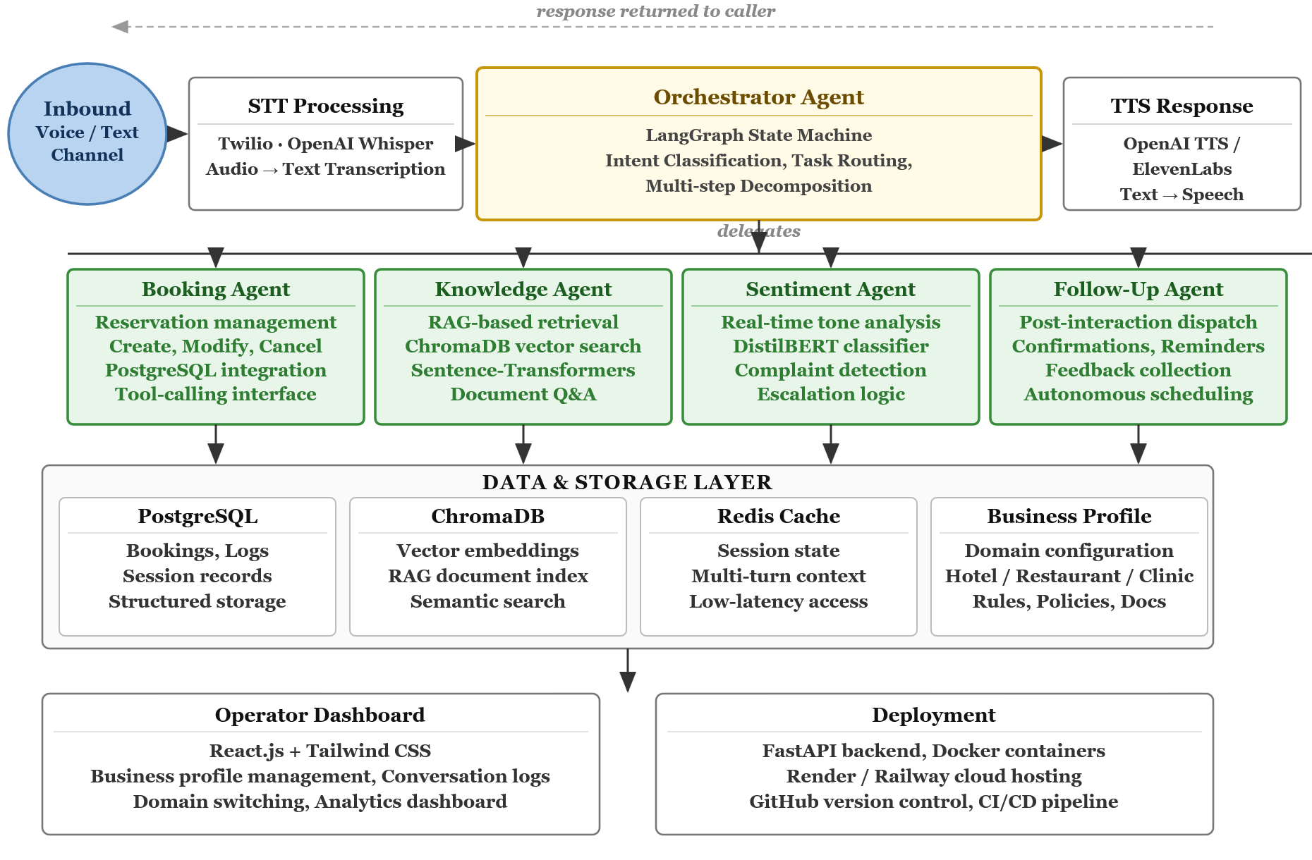
Figure 1. System Architecture of the Multi-Agent AI Customer Support System

Success Criterion
The following criteria define the expected outcomes for this project. The numeric benchmarks listed are indicative targets set prior to system development and will be finalized after baseline profiling is complete, ensuring they reflect observed performance gaps rather than assumed difficulty.
Task Completion Rate: The multi-agent system should achieve a task completion rate of at least 70% across the evaluation scenario set, where task completion is defined as the correct execution of all subtasks identified in a given interaction. This should demonstrate a meaningful improvement over the IVR and human agent baselines.
Knowledge Retrieval Accuracy: The knowledge retrieval component will be evaluated based on how accurately it retrieves relevant information from business documents. Performance will be assessed by comparing system responses with manually verified ground-truth answers.
Voice Response Latency: The end-to-end latency from end of caller speech to start of system response should remain within a range acceptable for a live phone interaction. Specific targets will be set after measuring baseline pipeline latency during development.
Baseline Comparison: The multi-agent system should outperform the IVR and human agent baselines on at least three of the primary evaluation metrics. If this is not achieved, the project will still be considered a valid research contribution provided results are fully documented and an analysis of the conditions under which multi-agent decomposition does and does not provide benefit is included in the final report.

Team Roles and Responsibilities
Table 1 outlines the project tasks and tentative timelines distributed across the team, covering the research, development, and evaluation phases of the project.
Table 1. Individual Tasks
Team Member | Activity | Tentative Date
Daoud Haroon | Literature review on multi-agent AI systems, LLM-based customer support, IVR limitations, and voice AI frameworks | Mar 2026 – Apr 2026
Muneeb Ahmed, Abdul Haseeb | Formulate research problem, define objectives, and finalize system design and voice channel architecture | Apr 2026 – May 2026
Daoud Haroon, Abdul Haseeb | Develop Booking Agent and Follow-Up Agent with tool-calling interfaces and post-interaction dispatch logic | May 2026 – Jul 2026
Muneeb Ahmed | Implement RAG pipeline using ChromaDB and Sentence-Transformers; develop Knowledge Agent | Jun 2026 – Aug 2026
Muneeb Ahmed, Abdul Haseeb | Develop Sentiment and Complaint Agent with fine-tuned DistilBERT classifier and escalation logic | Jul 2026 – Sep 2026
Abdul Haseeb | Implement and test voice layer integration: Twilio call routing, Whisper STT, and TTS response delivery | Aug 2026 – Oct 2026
Daoud Haroon | Build system integration layer: implement Orchestrator Agent and LangGraph state management | Sep 2026 – Nov 2026
Abdul Haseeb, Daoud Haroon | Build operator dashboard and customer-facing interface using React.js and Tailwind CSS | Sep 2026 – Nov 2026
Abdul Haseeb, Muneeb Ahmed | Deploy system across all three business domains (hotel, restaurant, clinic); construct single-agent baseline | Oct 2026 – Dec 2026
Muneeb Ahmed | Conduct comparative evaluation against IVR and human agent baselines; perform benchmark analysis | Nov 2026 – Jan 2027
Muneeb Ahmed, Abdul Haseeb | Manage performance testing, latency benchmarking | Dec 2026 – Feb 2027
Daoud Haroon, Abdul Haseeb, Muneeb Ahmed | Document system design, architecture decisions, and evaluation findings; prepare final report | Feb 2027 – Apr 2027
Daoud Haroon, Abdul Haseeb, Muneeb Ahmed | Prepare final presentation, viva materials, and deployment guide for SMB operators | Apr 2027 – May 2027

Table 2 illustrates the project schedule from March 2026 to May 2027, organized by phase, showing task durations and overlapping workstreams.
Table 2. Project Gantt Chart (Mar 2026 – May 2027)
Phase | Activity | Mar '26 | Apr '26 | May '26 | Jun '26 | Jul '26 | Aug '26 | Sep '26 | Oct '26 | Nov '26 | Dec '26 | Jan '27 | Feb '27 | Mar '27 | Apr '27 | May '27
Phase 1 | System design & profile schema
Phase 2 | Agent development & unit testing
Phase 3 | Voice layer integration
Phase 4 | Orchestration & system integration
Phase 5 | Cross-domain deployment & baselines
Phase 5 | Evaluation & user testing
Phase 6 | Performance benchmarking
Reporting | Report writing & final presentation

Tools and Technologies
Table 4 presents the key tools and technologies selected for this project, chosen to support scalability, modularity, and smooth integration of NLP and multi-agent components with the web-based interface.
Category | Tool / Technology | Purpose
Programming Languages | Python, JavaScript (React.js) | Backend and NLP pipeline; interactive frontend dashboard
Agent Orchestration | LangGraph, LangChain [6][8] | Stateful multi-agent workflow management and tool-calling abstraction
Large Language Model | GPT-4 via OpenAI API | Agent reasoning, intent classification, and response generation
Voice Layer | Twilio, OpenAI Whisper, OpenAI TTS | Inbound call routing, speech-to-text transcription, and text-to-speech response
Knowledge Retrieval (RAG) | ChromaDB, Sentence-Transformers [9] | Vector storage and semantic document retrieval for the Knowledge Agent
Sentiment Analysis | DistilBERT (fine-tuned classifier) | Real-time emotional tone detection and complaint escalation
Backend and API | FastAPI, PostgreSQL, Redis | REST API layer, structured data storage, and session caching
Frontend | React.js, Tailwind CSS | Operator configuration dashboard and web-based testing interface
Version Control and Deployment | GitHub, Docker, Render | Code collaboration, containerized deployment, and cloud hosting
Development Environment | VS Code | Primary code editor for all development

References
[1] M. U. Hadi et al., “Large Language Models: A Comprehensive Survey of its Applications, Challenges, Limitations, and Future Prospects,” TechRxiv, 2023. [Online]. Available: https://doi.org/10.36227/techrxiv.23589741.v4
[2] Z. Xu et al., “Retrieval-Augmented Generation with Knowledge Graphs for Customer Service Question Answering,” arXiv:2404.17723, Apr. 2024. [Online]. Available: https://arxiv.org/abs/2404.17723
[3] S. Yao et al., “ReAct: Synergizing Reasoning and Acting in Language Models,” in Proc. ICLR, 2023. [Online]. Available: https://arxiv.org/abs/2210.03629
[4] Q. Wu et al., “AutoGen: Enabling Next-Gen LLM Applications via Multi-Agent Conversation,” arXiv:2308.08155, Aug. 2023. [Online]. Available: https://arxiv.org/abs/2308.08155
[5] L. Wang et al., “A Survey on Large Language Model based Autonomous Agents,” arXiv:2308.11432, 2023. [Online]. Available: https://arxiv.org/abs/2308.11432
[6] H. Chase, “LangChain: Building Applications with LLMs through Composability,” GitHub, 2023. [Online]. Available: https://github.com/langchain-ai/langchain
[7] Z. Ji et al., “Survey of Hallucination in Natural Language Generation,” ACM Comput. Surv., vol. 55, no. 12, pp. 1–38, 2023. [Online]. Available: https://dl.acm.org/doi/10.1145/3571730
[8] LangChain Inc., “LangGraph: Build Stateful, Multi-Actor Applications with LLMs,” GitHub, 2024. [Online]. Available: https://github.com/langchain-ai/langgraph
[9] T. Guo et al., “Large Language Model based Multi-Agents: A Survey of Progress and Challenges,” arXiv:2402.01680, Feb. 2024. [Online]. Available: https://arxiv.org/abs/2402.01680
[10] J. S. Park et al., “Generative Agents: Interactive Simulacra of Human Behavior,” in Proc. ACM UIST, 2023. [Online]. Available: https://arxiv.org/abs/2304.03442
[11] A. Fourney et al., “Magentic-One: A Generalist Multi-Agent System,” arXiv:2411.04468, 2024. [Online]. Available: https://arxiv.org/abs/2411.04468
[12] Twilio Inc., “Twilio Voice API Documentation,” Twilio, 2024. [Online]. Available: https://www.twilio.com/docs/voice. [Accessed: Mar. 2025].
[13] A. Radford et al., “Robust Speech Recognition via Large-Scale Weak Supervision,” in Proc. ICML, 2023. [Online]. Available: https://arxiv.org/abs/2212.04356
[14] S. Chen et al., “A Survey on LLM-based Multi-Agent System: Recent Advances and New Frontiers in Application,” arXiv:2412.17481, Dec. 2024. [Online]. Available: https://arxiv.org/abs/2412.17481
[15] Intercom, Inc., “Intercom: The Complete AI-First Customer Service Platform,” Intercom, 2024. [Online]. Available: https://www.intercom.com. [Accessed: Mar. 2025].
[16] Salesloft (formerly Drift), “Drift: AI-Powered Conversational Marketing and Sales Platform,” Drift, 2024. [Online]. Available: https://www.drift.com. [Accessed: Mar. 2025].
[17] Zendesk, Inc., “Zendesk Answer Bot: Automated Resolutions Powered by AI,” Zendesk, 2024. [Online]. Available: https://www.zendesk.com/service/answer-bot. [Accessed: Mar. 2025].
[18] Y. Shen et al., “HuggingGPT: Solving AI Tasks with ChatGPT and its Friends in Hugging Face,” in Proc. NeurIPS, 2023. [Online]. Available: https://arxiv.org/abs/2303.17580

Appendix A

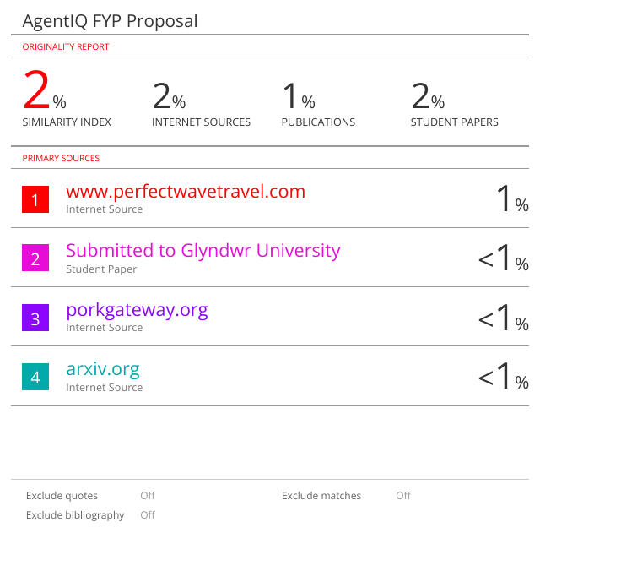

Appendix B

