Online

Shop.4

DVDS

PROJECT

GROUP MEMBERS

|  |  |
| --- | --- |
| **NAME** | **ENROLLMENT** |
|  |  |
| Arbab Ali Khan | 1312189 |
| Ibadullah | 1310986 |
| Asadullah | 1288912 |
| Sanaullah | 1310985 |

CURRICULUM

**“OV-ACCP Prime-6740-ACE**”

**BATCH**

**“2103C2”**

**FACULTY**

“Miss.Muniba Khan”

**CO-ORDINATOR**

“Miss.Ariba”

**Introduction:**

Music, Game, Movie is an important part of our life. Nowadays, listening to music online is hobby of most modern people. So you need to build website where users will get relevant information about the latest music, game, movie releases in the market.

This website has web pages that give information about the new releases in the field of music, game, and movie in the National market.

The site will allow users to view all kinds of music, game, movie - includes National and International, listen to some music, see trailers game, movie, and download them for free some but not full, vote for an album, game, movie and send feedback about the site, etc. In addition, this website also provides a forum that users could discuss. The website has search and browse functions too.

When users need to know information about recent releases of music, game, movie they can open this website to see or search some information, and naturally, they can buy some DVDs if they want.

If users want to know information regarding music, game, movie or they wish to buy a new DVDs, they need not visit a shop at all. Instead of this, they can just open the website to refer to information about music displayed on the web pages and place an order.

Finally, what’s thing that we want customers: come to see, and buy new releases albums.

**Acknowledgement:**

The success and final outcome of this project required a lot of guidance and assistance from many people and I am extremely privileged to have got this all along the completion of my project. All that I have done is only due to such supervision and assistance and I would not forget to thank them.

I respect and thank Aptech for providing me an opportunity to do the project work in ACE and giving us all support and guidance, which made me complete the project duly. I am extremely thankful to Aptech for providing such a nice support and guidance.

I owe my deep gratitude to our project guide **Ms. Muniba Khan**, who took keen interest on our project work and guided us all along, till the completion of our project work by providing all the necessary information for developing a good system.

**DataBase Design:**

* **User:**

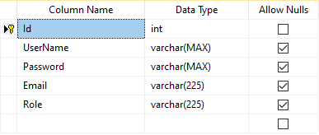

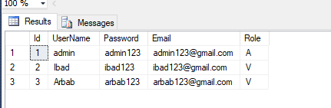

**DataBase Design:**

* **Category:**

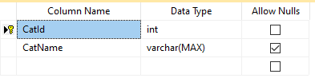

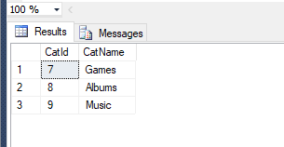

**DataBase Design:**

* **SubCategory:**

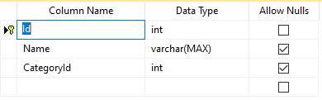

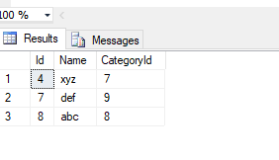

**DataBase Design:**

* **Product:**

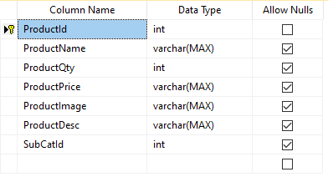

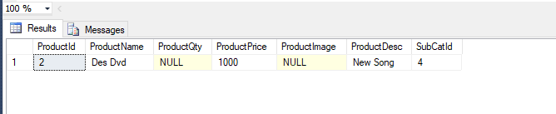

**DataBase Design:**

* 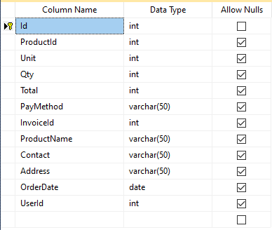**Order:**

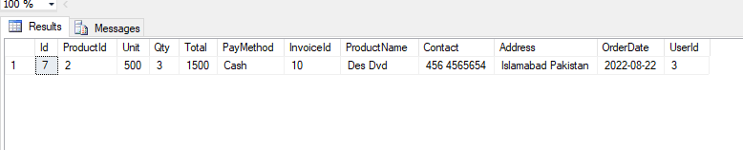

**DataBase Design:**

* **Invoice:**

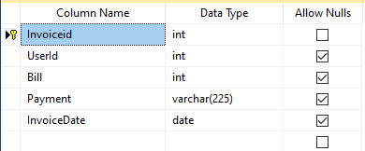

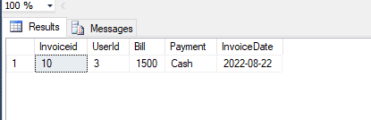

**DataBase Daigram:**

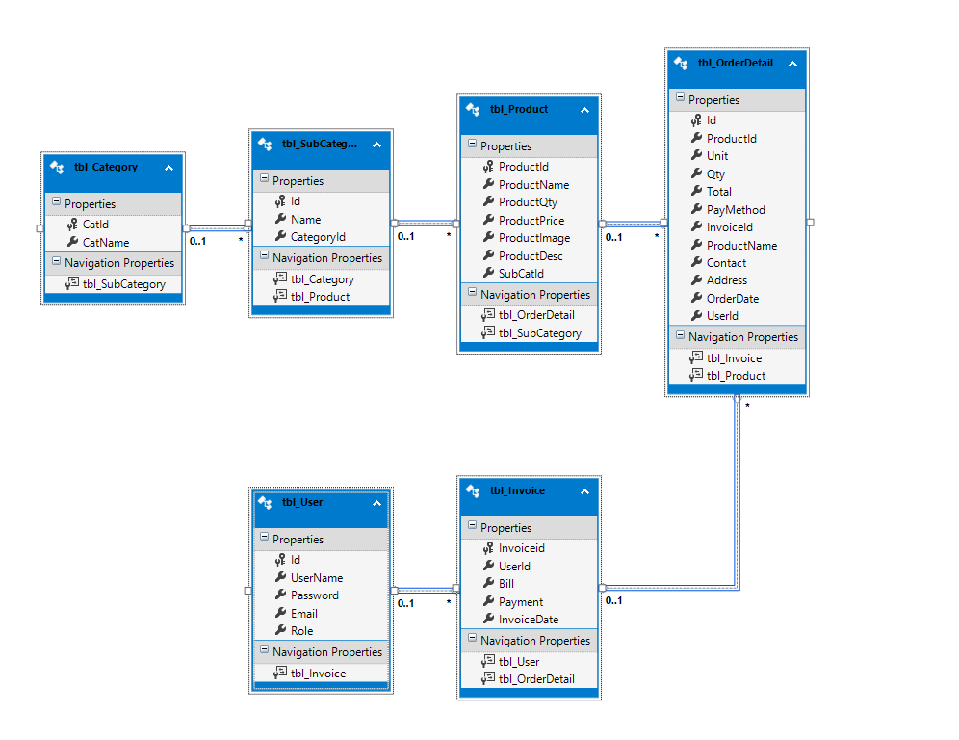

**Hardware Requirement:**

The most common set of requirements defined by any operating system or software application is the physical computer resources, also known as hardware. A hardware requirements list is often accompanied by a hardware compatibility list (HCL), especially in case of operating systems. An HCL lists tested, compatibility and sometimes incompatible hardware devices for a particular operating system or application. The following sub-sections discuss the various aspects of hardware requirements.

**HARDWARE REQUIREMENTS FOR PRESENT PROJECT**:

PROCESSOR : Intel Core, i7

RAM : 8 GB

HARD DISK : 500 GB

**Software Requirement:**

Software Requirements deal with defining software resource requirements and pre-requisites that need to be installed on a computer to provide optimal functioning of an application. These requirements or pre-requisites are generally not included in the software installation package and need to be installed separately before the software is installed.

**SOFTWARE REQUIREMENTS FOR PRESENT PROJECT:**

OPERATING SYSTEM : Windows / 10

SOFTWARE : Visual Studio - 2022

FRONT END : ASP.NET MVC, C#

DATABASE : SQL Server

**Flow Chart:**

A flowchart is a type of diagram that represents a workflow or process. A flowchart can also be defined as a diagrammatic representation of an algorithm, a step-by- step approach to solving a task. The flowchart shows the steps as boxes of various kinds, and their order by connecting the boxes with arrows

**Admin**

**Add to New Permossion**

**Delete Product**

**Add to New Product**

**Check User Detail**

**Check to details**

**Order Place**

**Login**

**Create Account**

**User**

**Flow Chart:**

|  |  |  |  |
| --- | --- | --- | --- |
| S# | Task | Team Member Name | Status |
| 1. | Analysis | Arbab Ali khan  Ibadullah  Sanaullah | ✔ |
| 2. | Design | Arbab Ali Khan  Asadullah | ✔ |
| 3. | Development | Arbab Ali khan  Ibadullah | ✔ |
| 4. | Documentation | Ibadullah  Sanaullah | ✔ |
| 5. | Finalization | Arbab Ali khan  Ibadullah  Asadullah  Sanaullah | ✔ |