BOOK
concept from Object oriented programing 2nd edition
Virtual destructor
the pure virtual destructor follows the rule of pure virtual inheritance but unlike pure virtual function they must be define in the base class also
when the destructor of the drive class is called by the pointer of abstract class
then the destructor of drive class called the first and after that it will call the destructor of base class or abstract class
so, it sometime causes the leak in memory because according to the rule of destructor it will called when the variable did it’s all function so it’s free its memory so it causes the leak in memory
CODE
#include<iostream>
using namespace std;
class base
{
public:
virtual ~base(){
cout << "base destructor";
}
};

class derived:public base
{
public:
~derived(){
cout<< "derived destructor";
}
};

int main()
{
base* b = new derived;
delete b;
}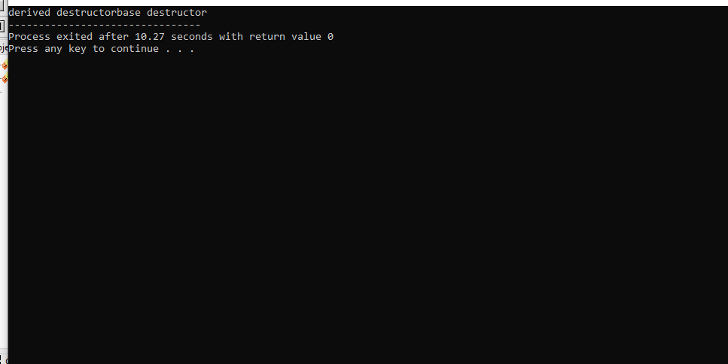
Virtual Class
The virtual class is use in the multiple inheritance of the class . When the a class is driven form the two or more pass in their inheritance which have the same base class if causes the error of function handling because the compiler can not decide to which class they called the function as the both class’s have the same class (base class) this causes the diamond problem in the inheritance so in order to overcome these problem we use virtual class
Code
#include<iostream>
using namespace std;
class base{
public:
base(){
cout<<"This is base class";
}
};
class a:virtual public base{
public:
a(){
cout<<"this is A class";
}
};
class b:virtual public base{
public:
b(){
cout<<"this is b class";
}
};
class multi:public a,public b{
public:
multi (){
cout<<"Multi class";
}
};
int main(){
multi a;
}