

FAST National University of  
Computer and Emerging Sciences

# Artificial Intelligence Assignment 3:

Name: Muneel Haider

Roll no: 21i-0640

Section: G

Question 1 Code Output:

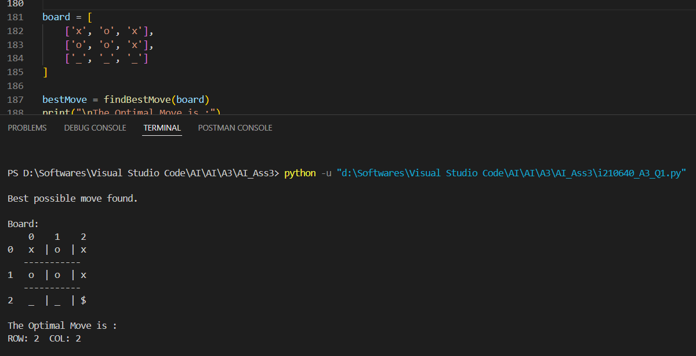

Question 2 Code Output:

* Part 1 Code Output:
  + Case 1:

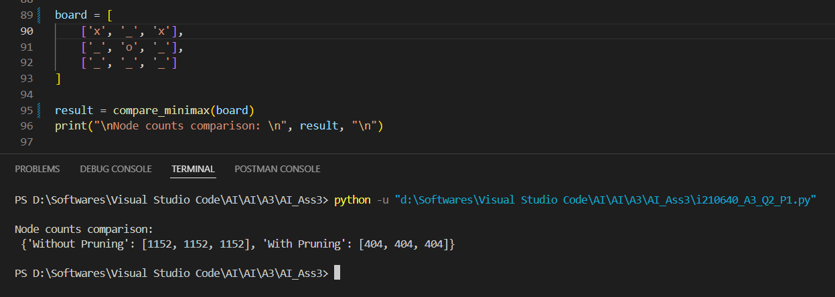

* + Case 2:

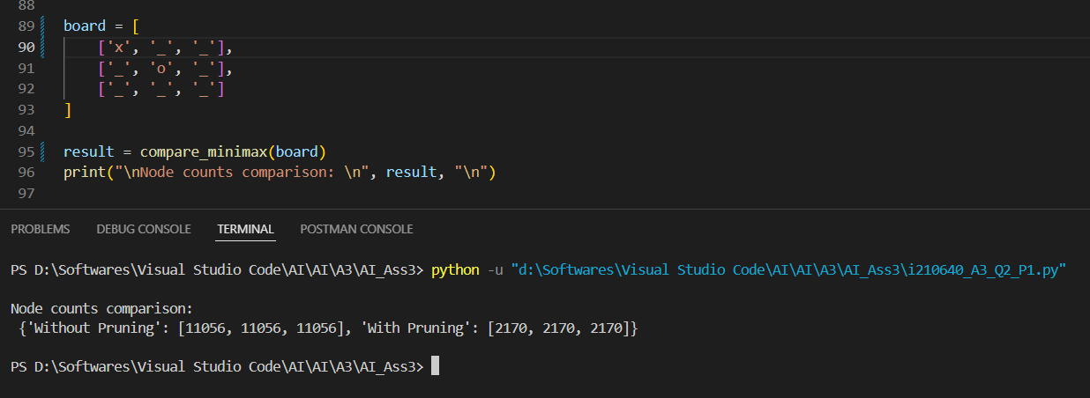

* + Case 3:

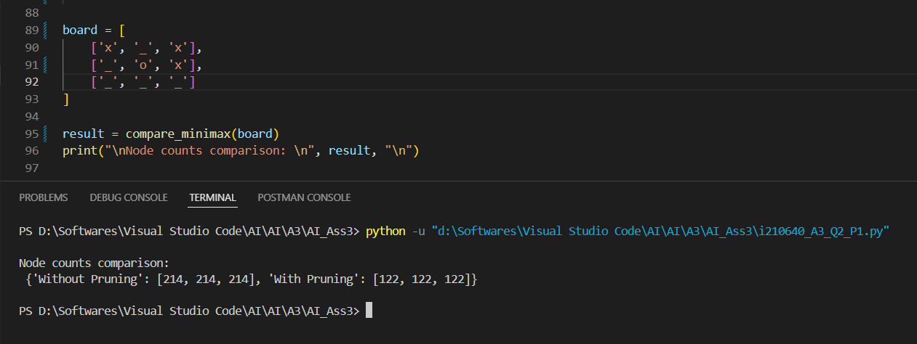

* Part 2 Code Output
  + Case 1:

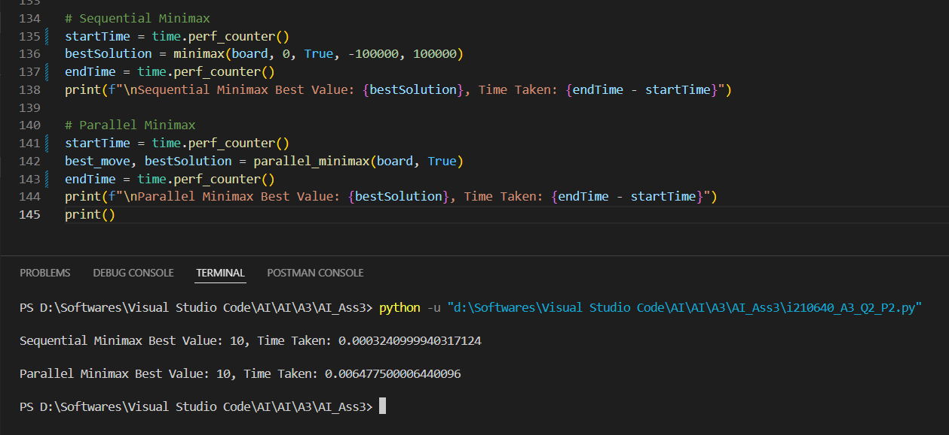

* + Case 2:

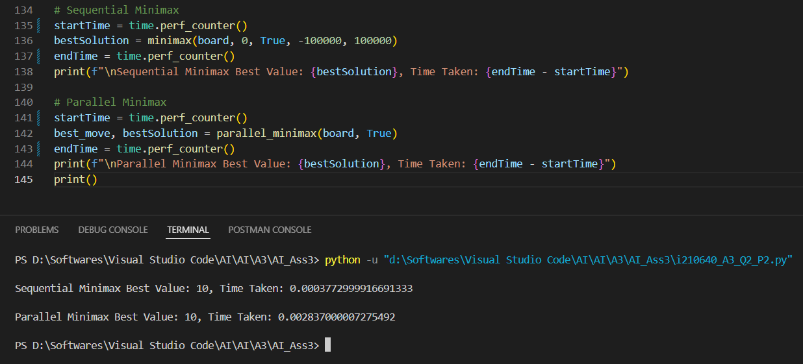

* + Case 3:

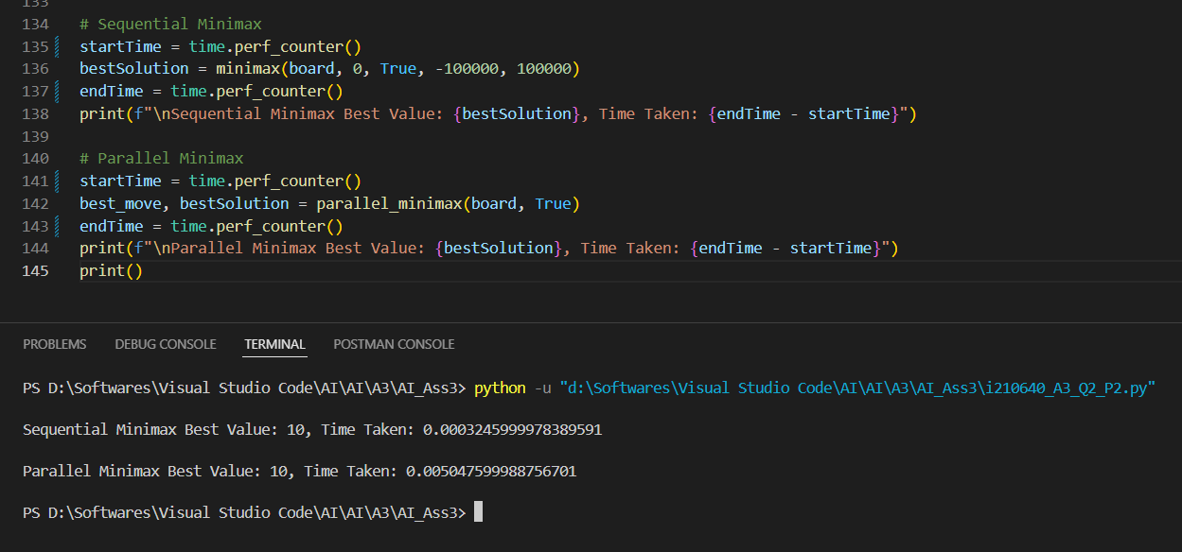

* Part 3 Code output:
  + Case 1:

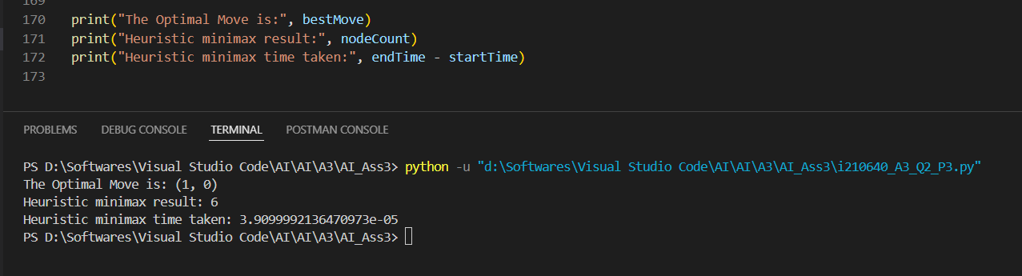

* + Case 2:

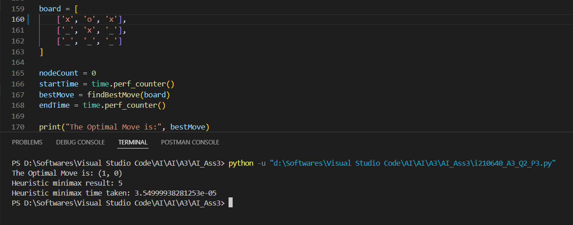

* + Case 3:

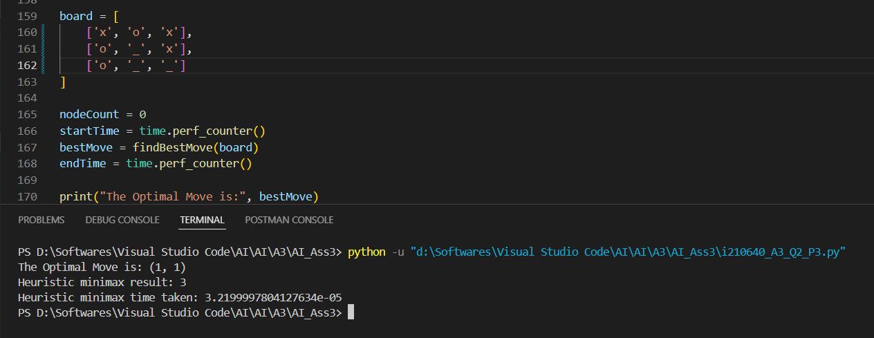

* Part 4 Code Output:
  + Case 1:

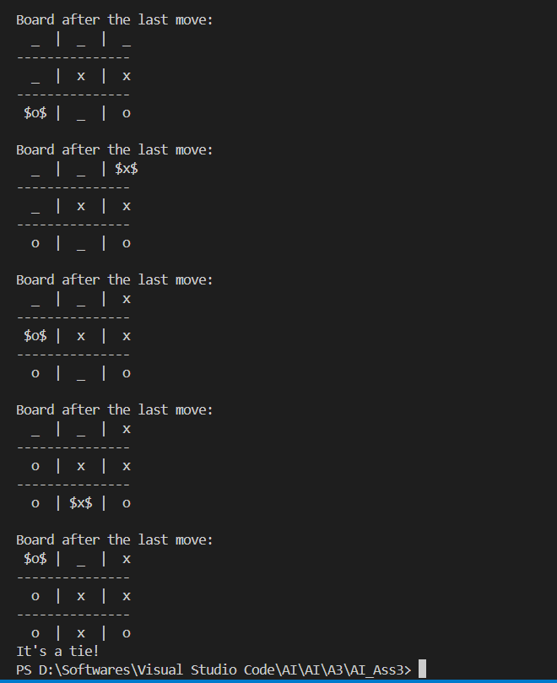

* + Case 2:

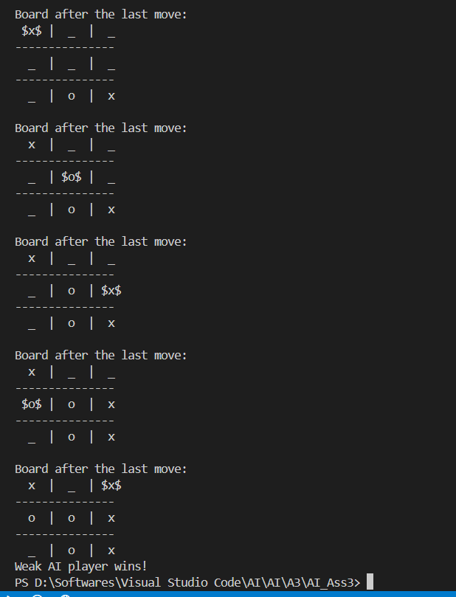

* + Case 3:

