**Assignment 1 – Computer Networks**

**Basic Topology:**

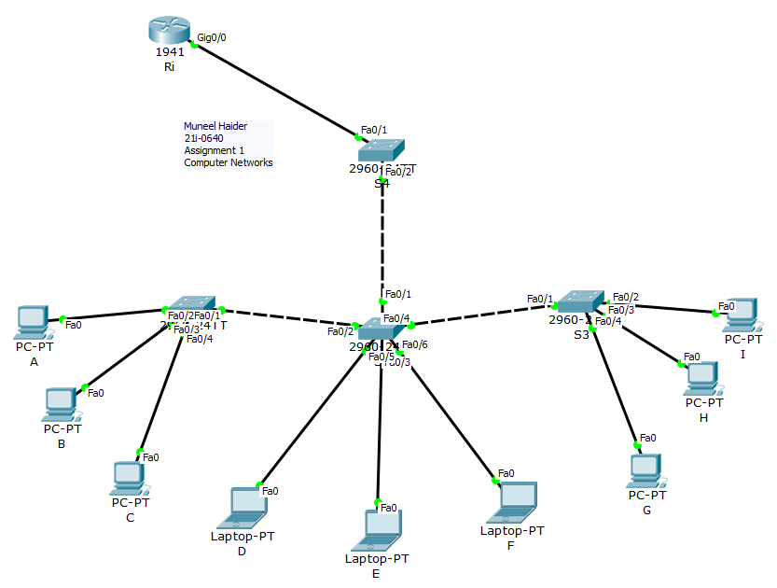

**Task 1:**

ARP Tables after pinging:

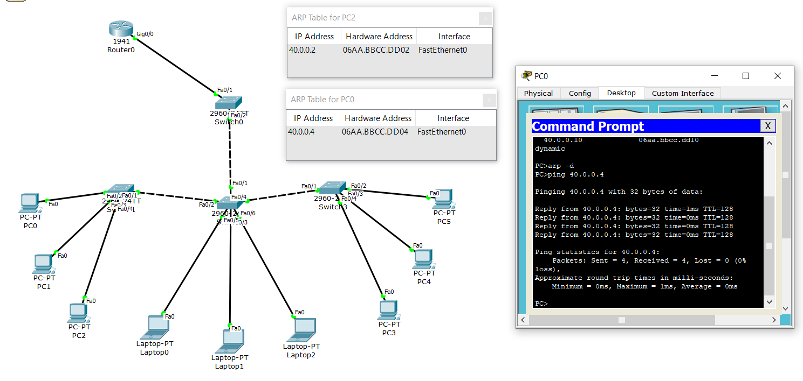

MAC Tables of Switches:

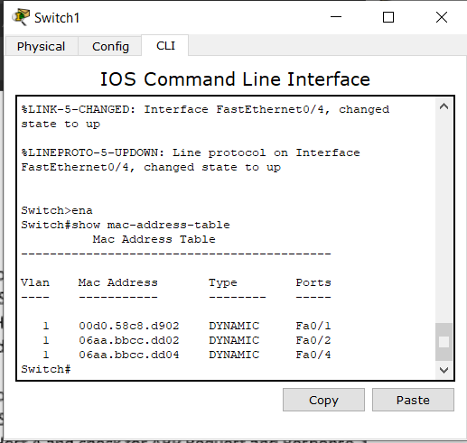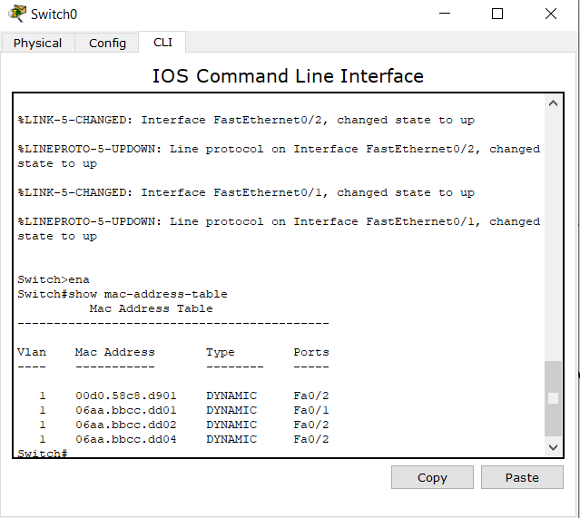

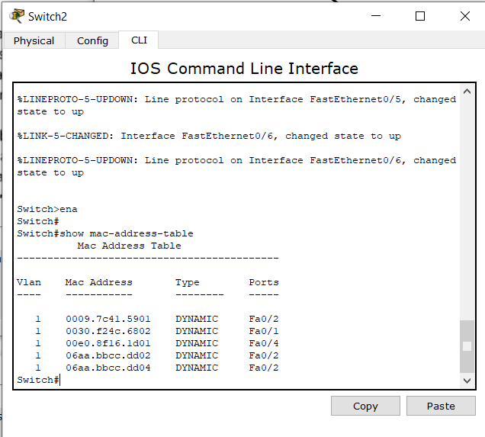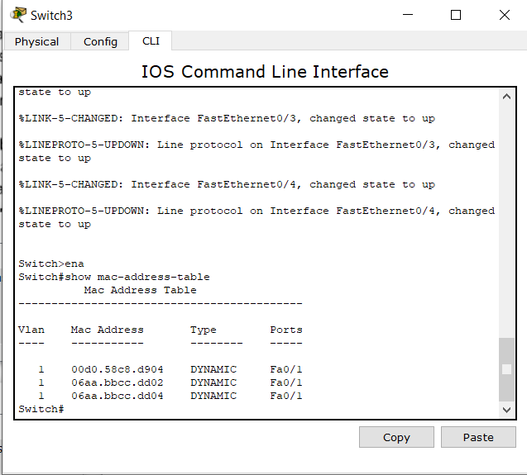

SIMULATION:

ARP Request and Responses Simulation:

Step 1: The message is initiated via command prompt of Host A (PC0). Host A pings Host C. Initially the ARP table of Host C is empty since it has not established any communication. Here the packet is being transferred to the switch.

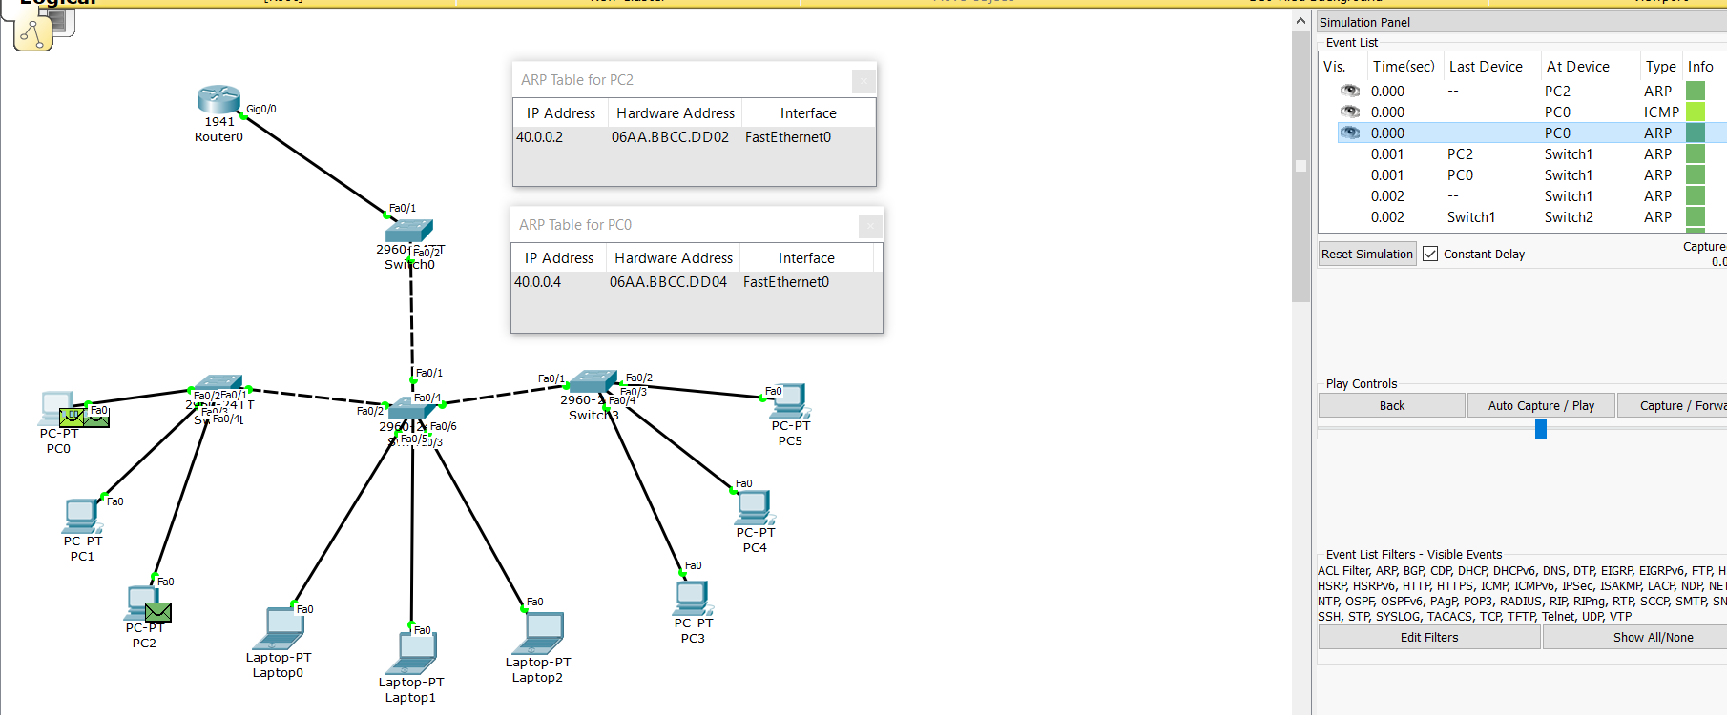

Step 2: The packet has been transferred to the switch, where it will now send it packets further until it find the desired computer with IP address.

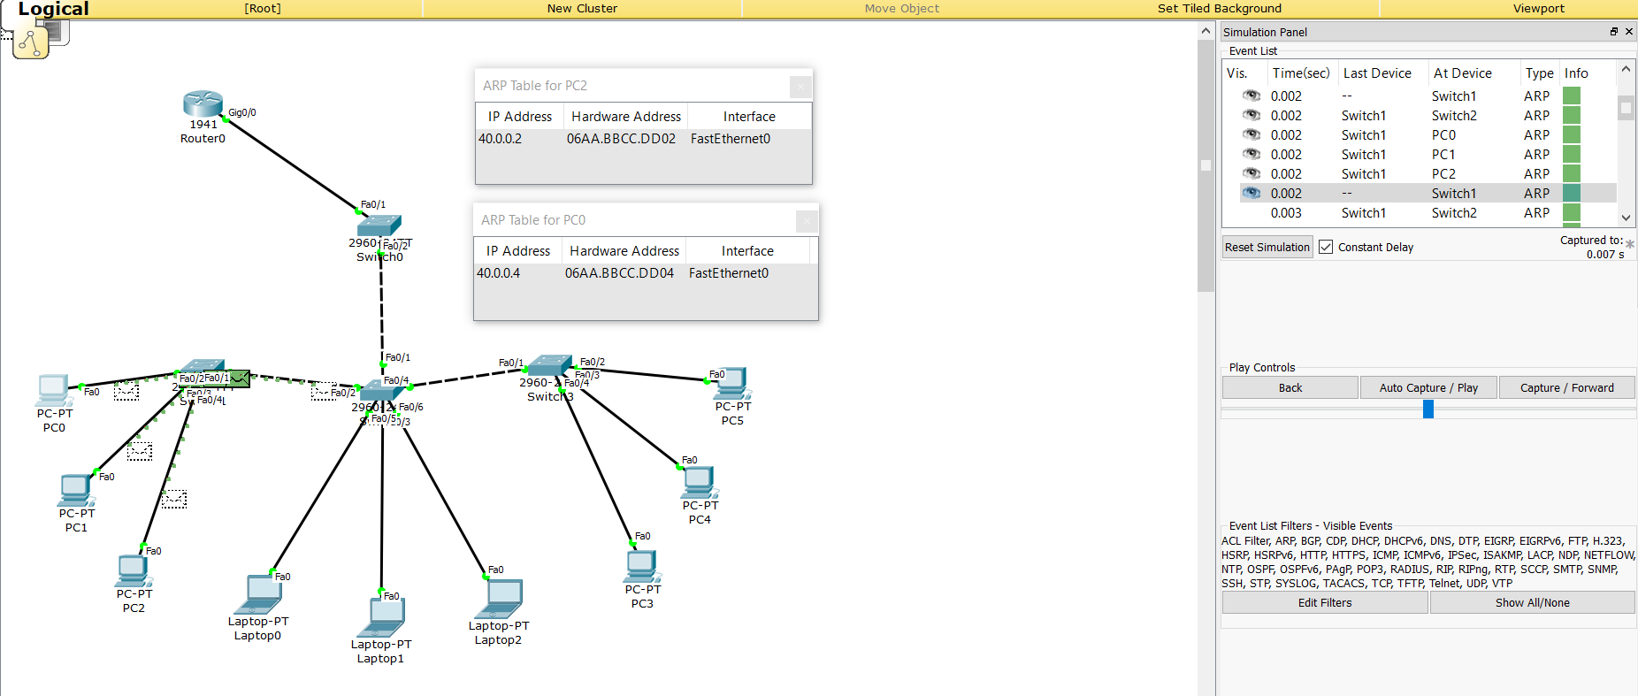

Step 3: The packet has now reached its destination Host C (PC2). The ARP table of PC2 has also been updated with the necessary details of PC0. The simulation tool shows us that the message (ARP Packet) has successfully been transferred.

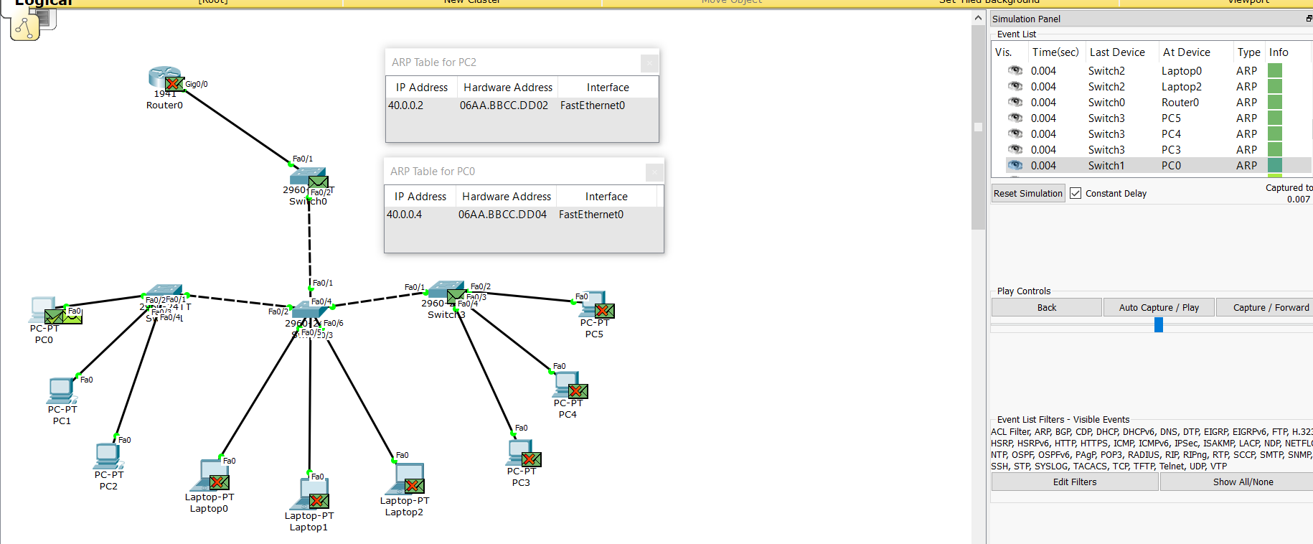

**Task 2:**

ARP Tables after pinging:

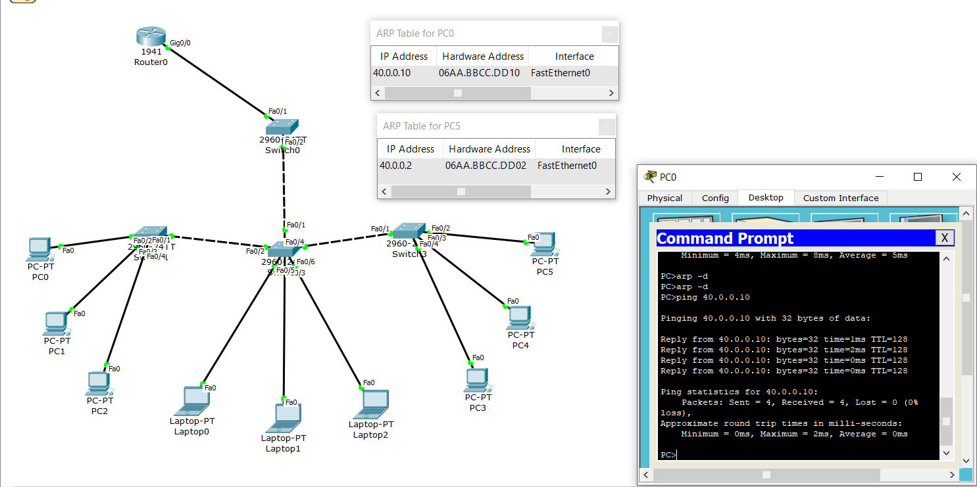

MAC Tables of Switches:

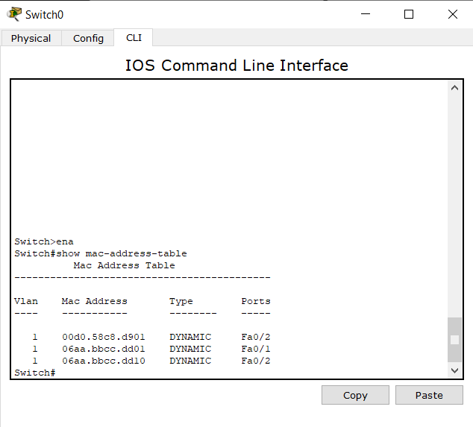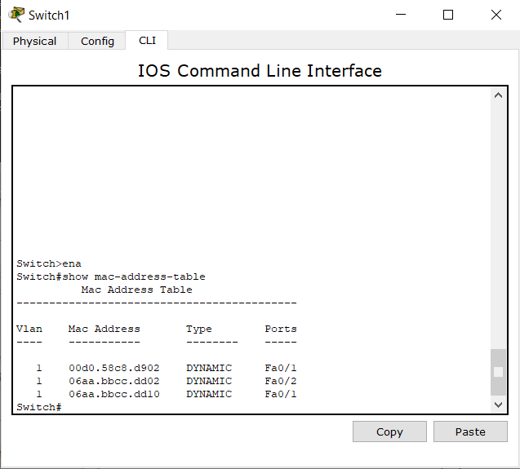

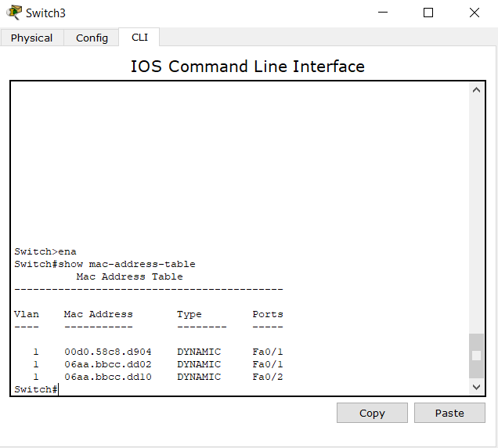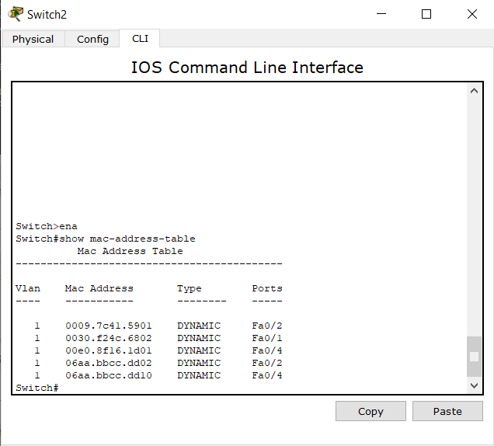

ARP Request and Responses Simulation:

Step 1: The message is initiated via the command prompt of Host A (PC0). Host A pings Host I. Initially the ARP table of Host I is empty since it has not established any communication. Here the packet is being transferred to the switch.

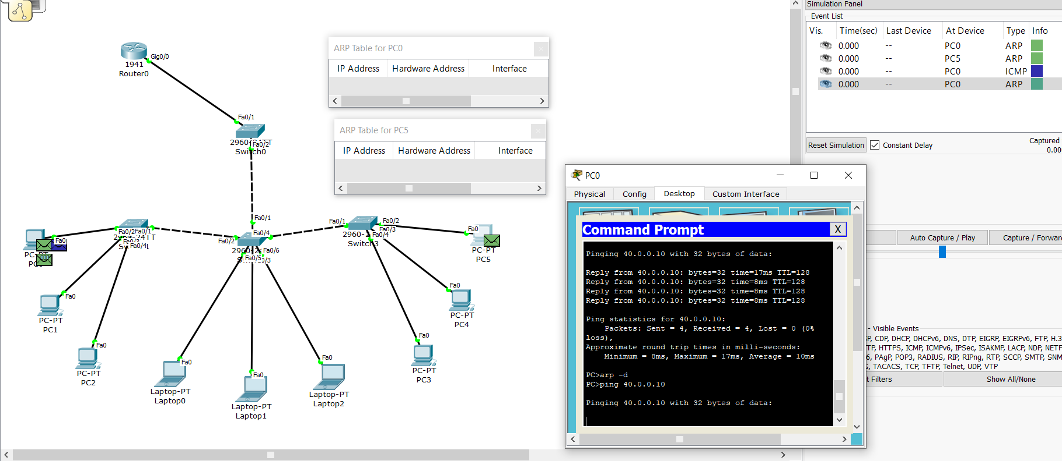

Step 2: The packet has been transferred to the switch, where it will now send it packets further until it find the desired computer with IP address.

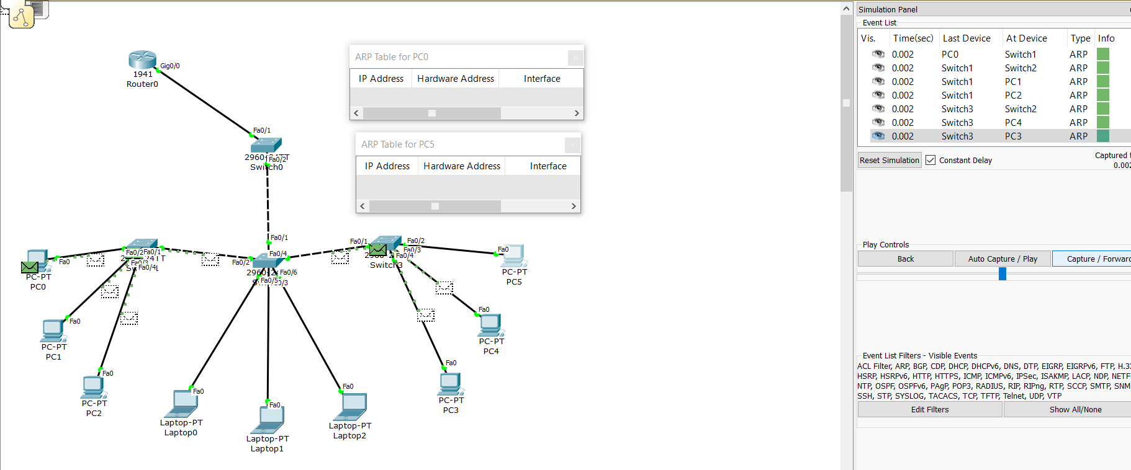

Step 3: The packet has now reached its destination Host I (PC5). The ARP table of PC5 has also been updated with the necessary details of PC0. The simulation tool shows us that the message (ARP Packet) has successfully been transferred.

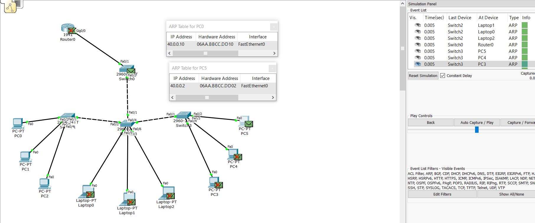

**Task 3:**

ARP Tables after pinging:

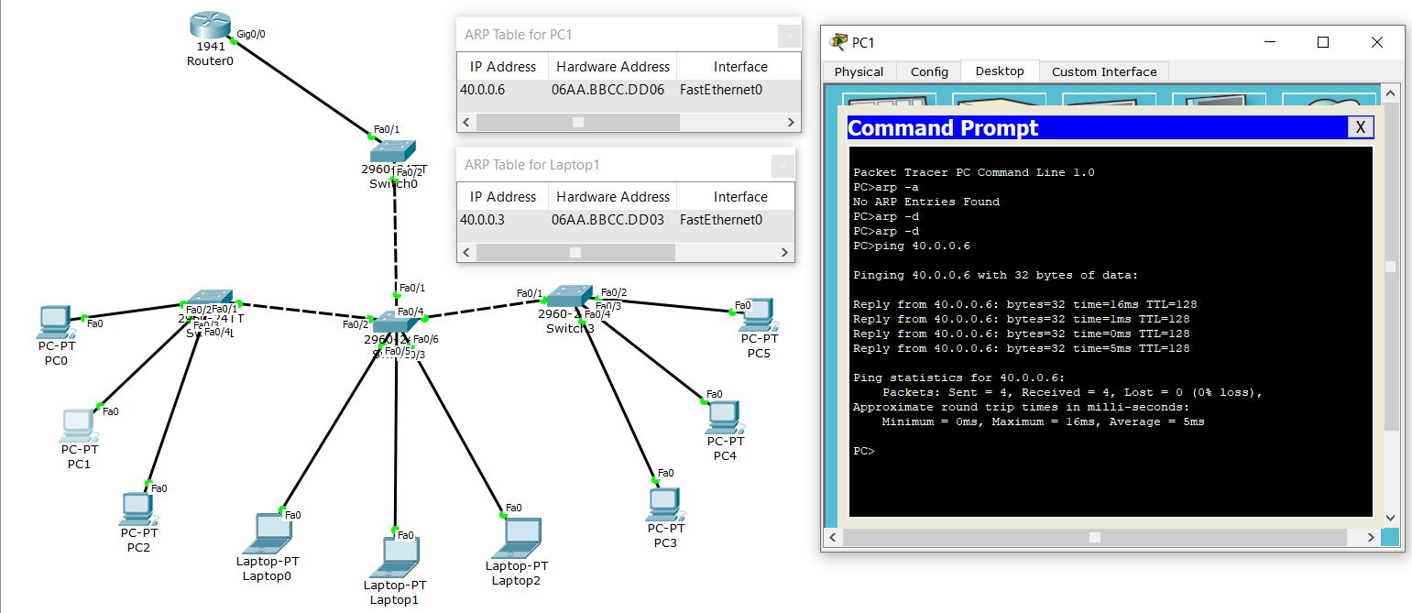

MAC Tables of Switches:

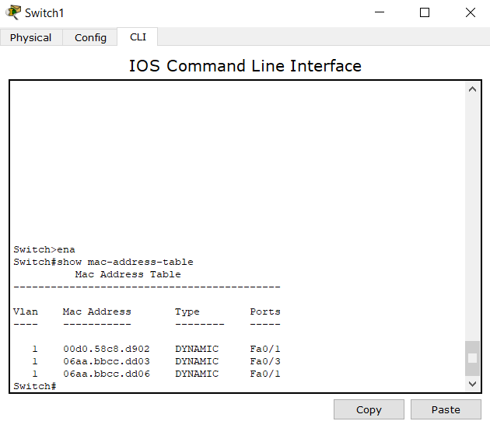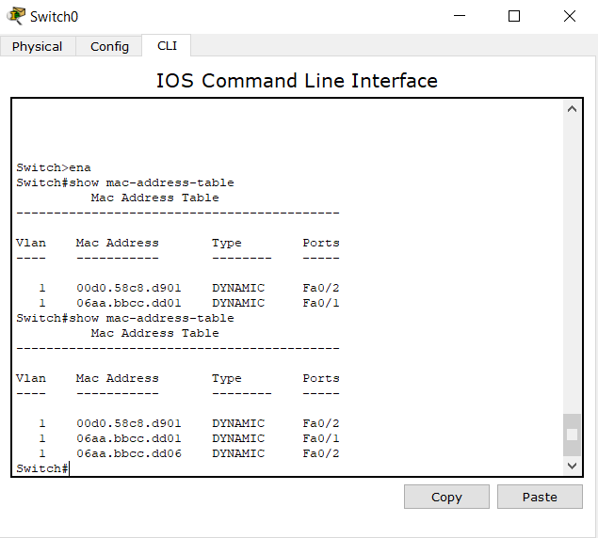

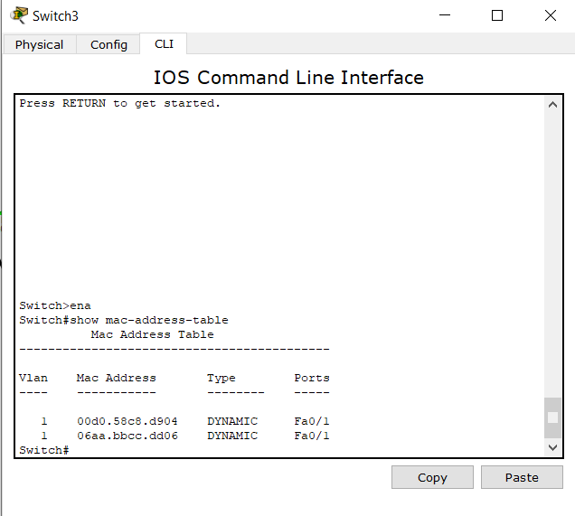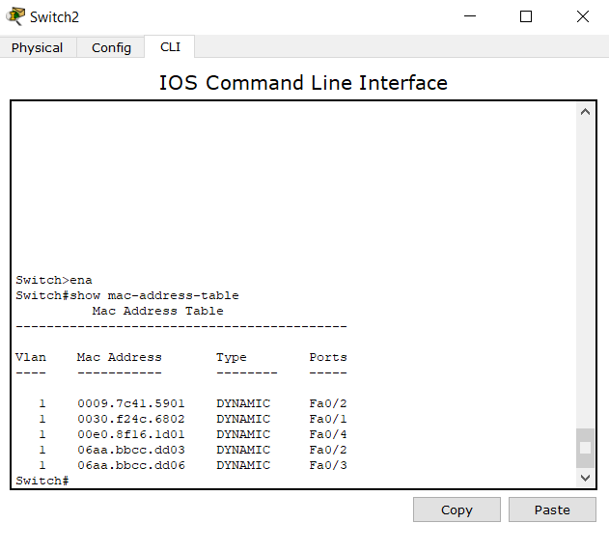

ARP Request and Responses Simulation:

Step 1: The message is initiated via command prompt of Host B (PC1). Host B pings Host E. Initially the ARP table of Host E is empty since it has not established any communication. Here the packet is being transferred to the switch.

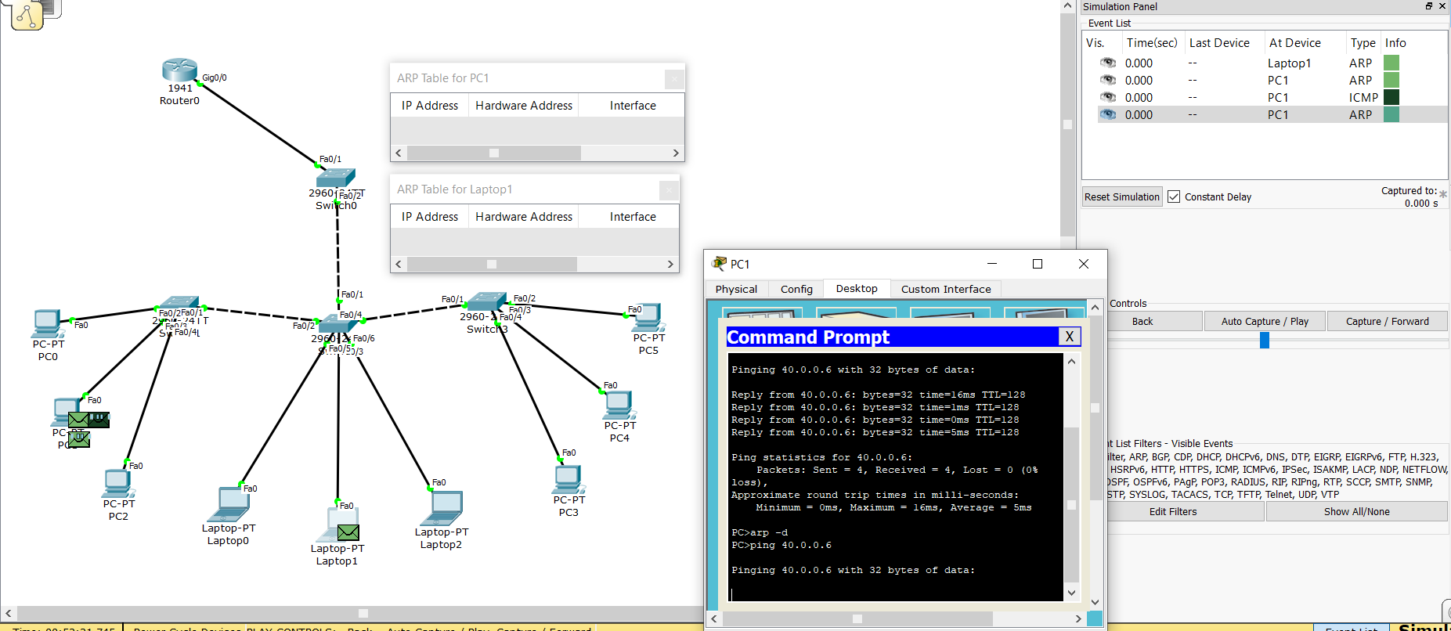

Step 2: The packet has been transferred to the switch, where it will now send it packets further until it find the desired computer with IP address.

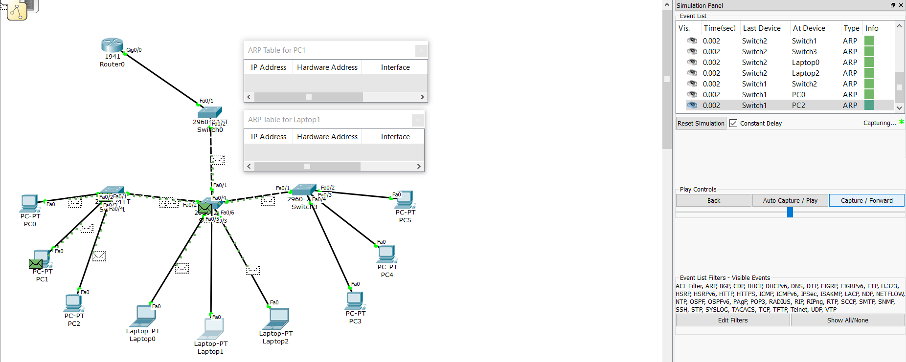

Step 3: The packet has now reached its destination Host E (Laptop1). The ARP table of Laptop1 has also been updated with the necessary details of PC1. The simulation tool shows us that the message (ARP Packet) has successfully been transferred.

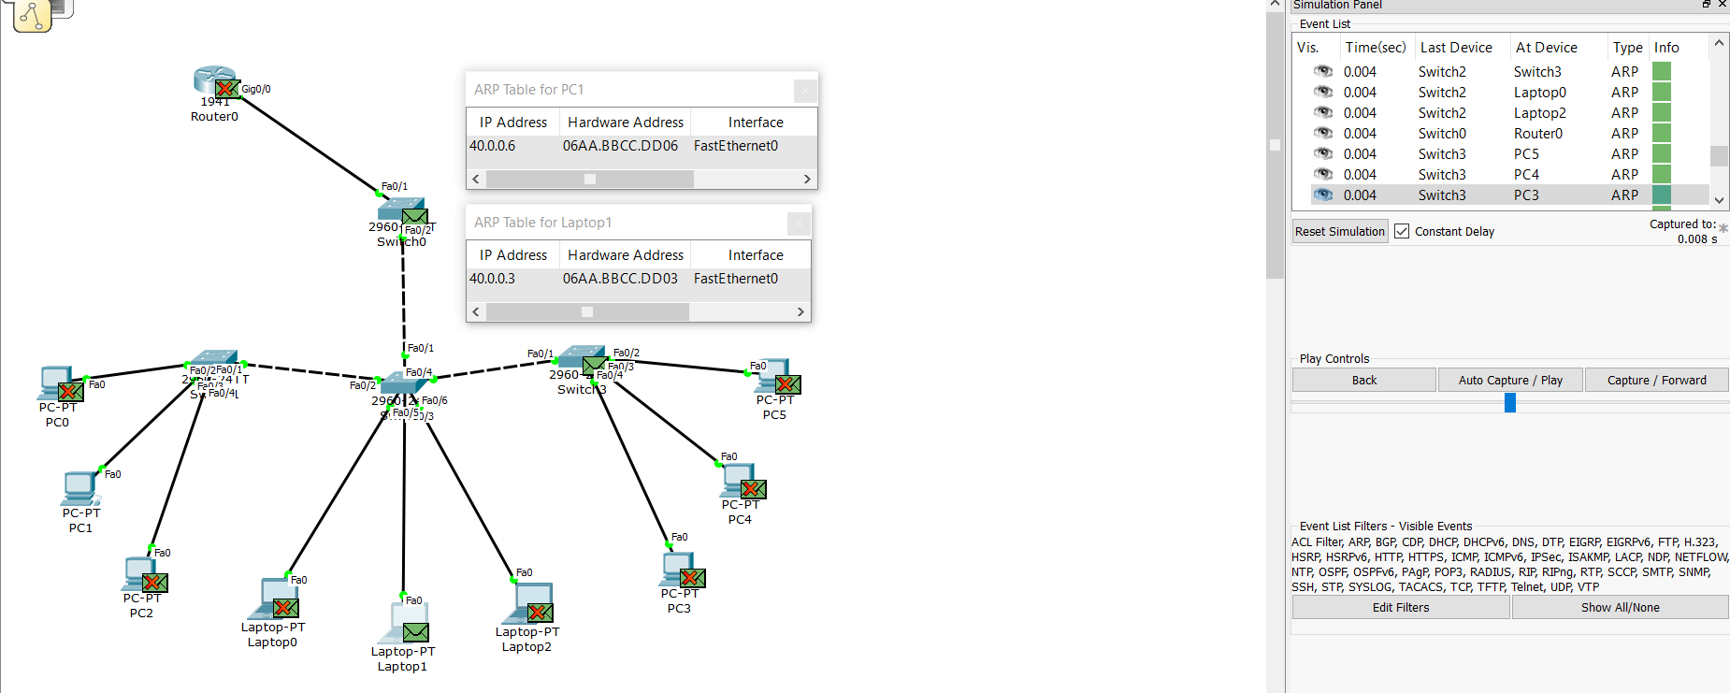

**Task 4:**

ARP Tables after pinging:

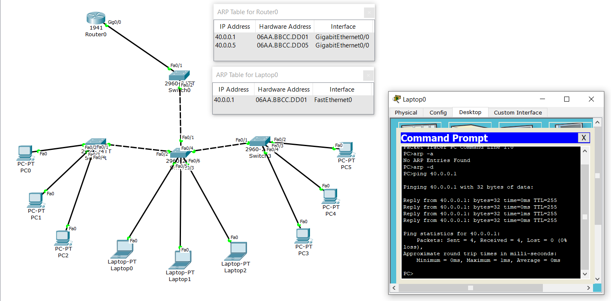

MAC Tables of Switches:

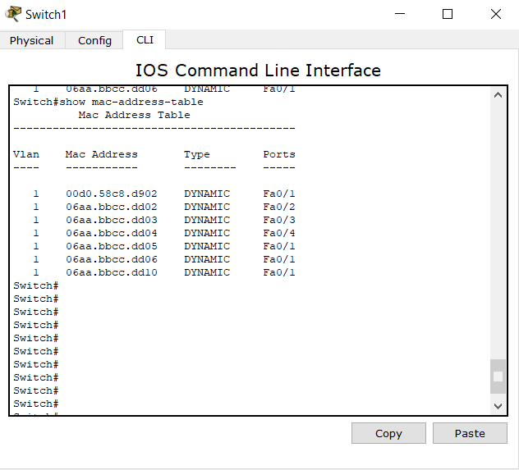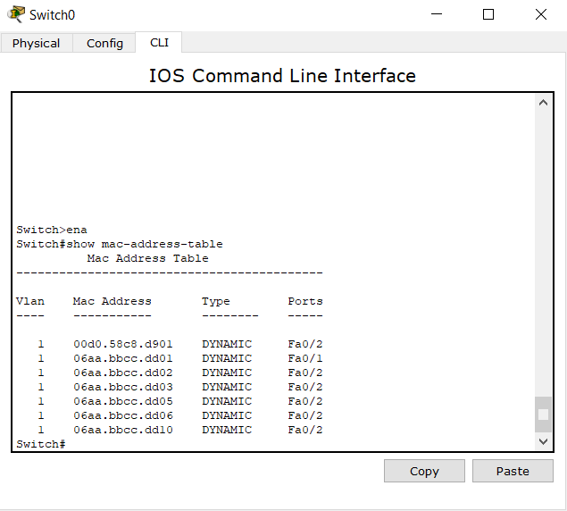

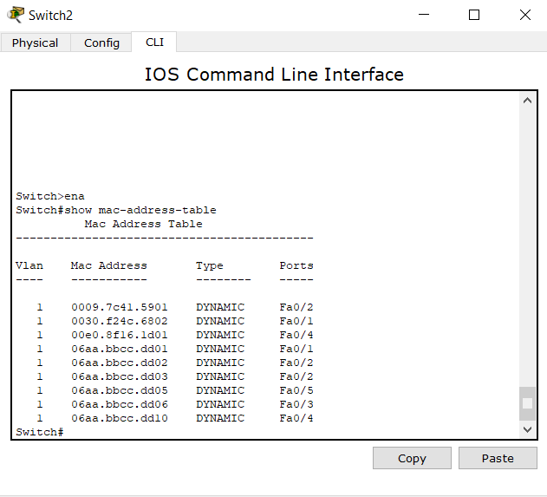

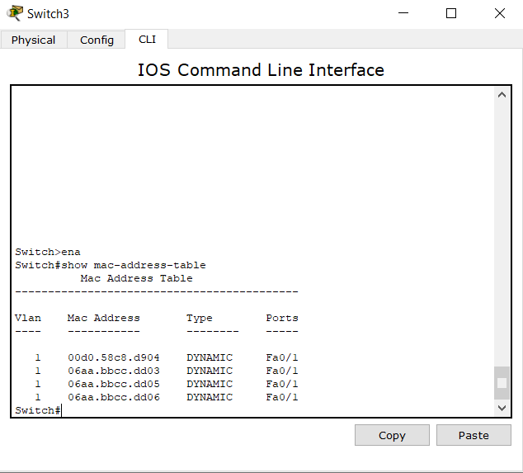

ARP Request and Responses Simulation:

Step 1: The message is initiated via command prompt of Host D (Laptop0). Host D pings Ri (Router0). Here the packet is being transferred to the switch.

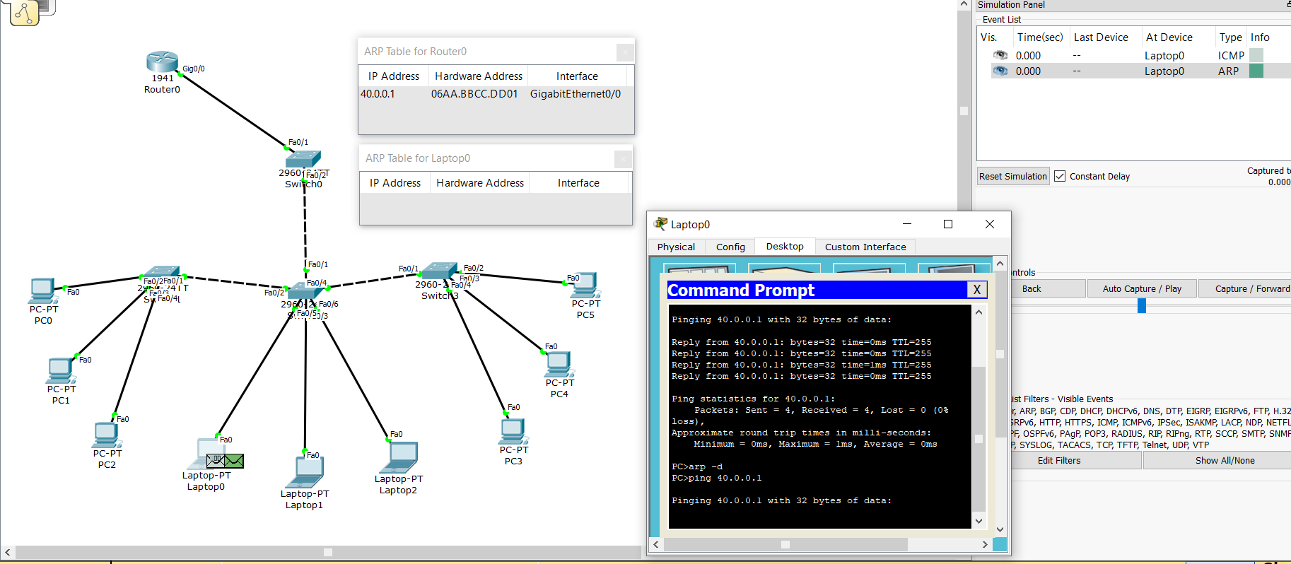

Step 2: The packet has been transferred to the switch, where it will now send it packets further until it find the desired computer with IP address.

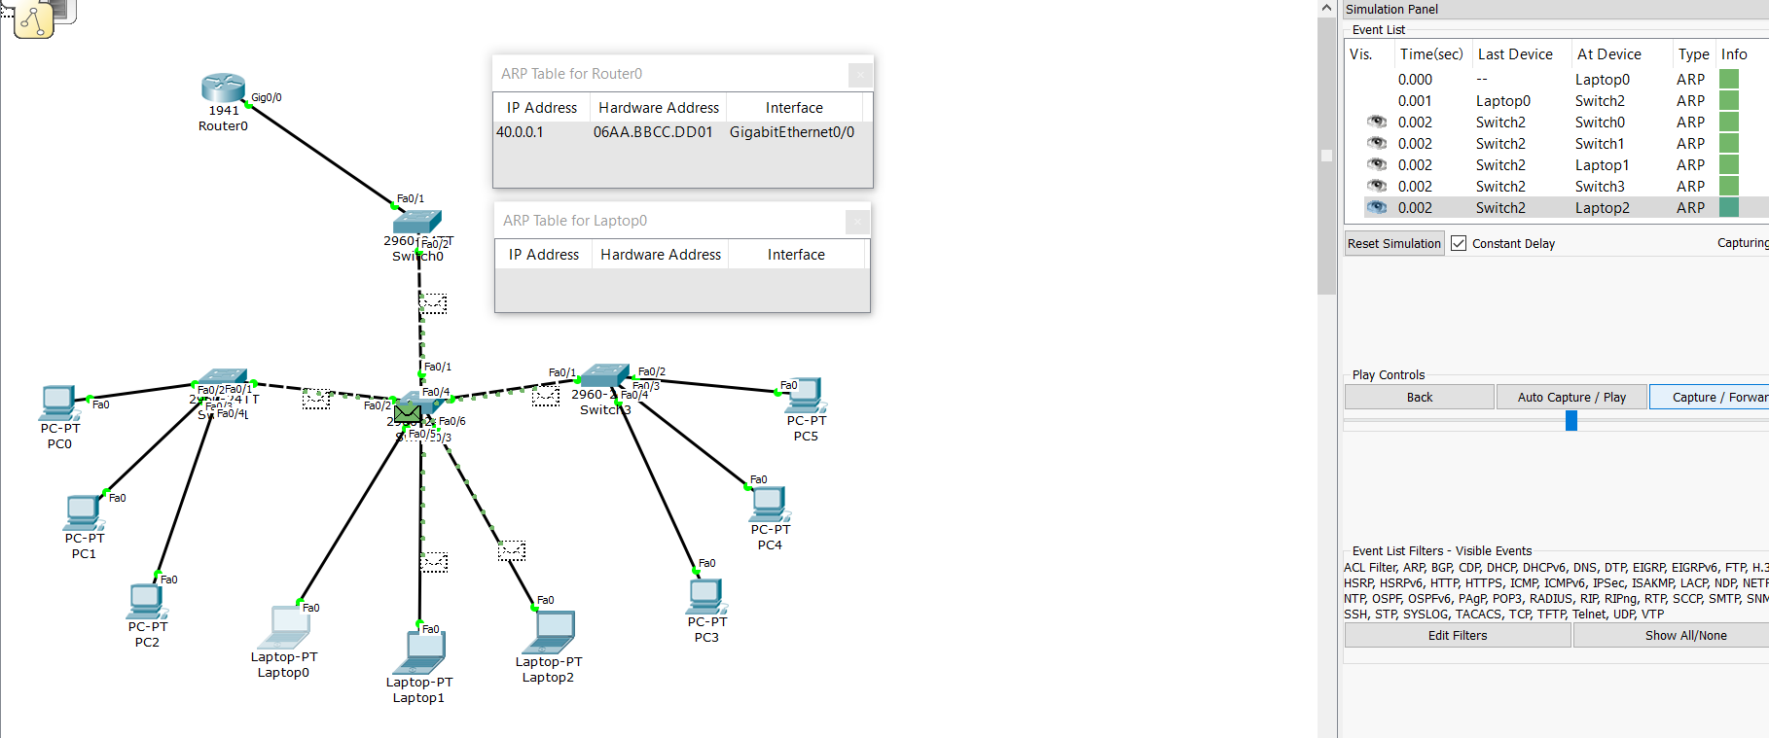

Step 3: The packet has now reached its destination Ri (Router0). The ARP table of Ri (Router0) has also been updated with the necessary details of Host D (Laptop0). The simulation tool shows us that the message (ARP Packet) has successfully been transferred.

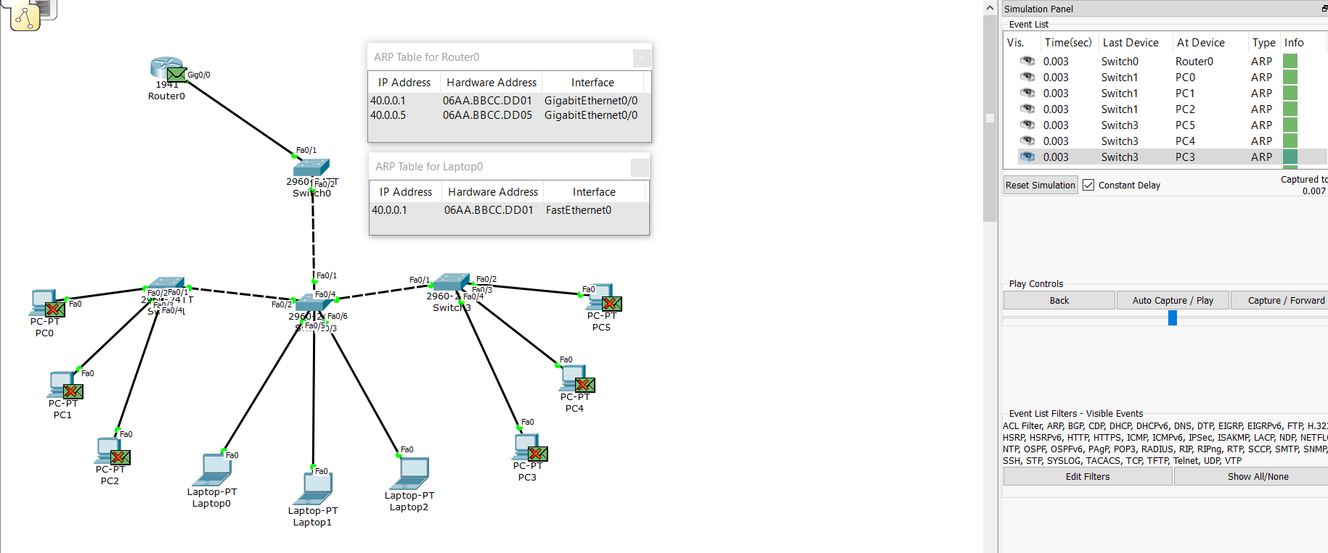

**Task 5:**

ARP Tables after pinging:

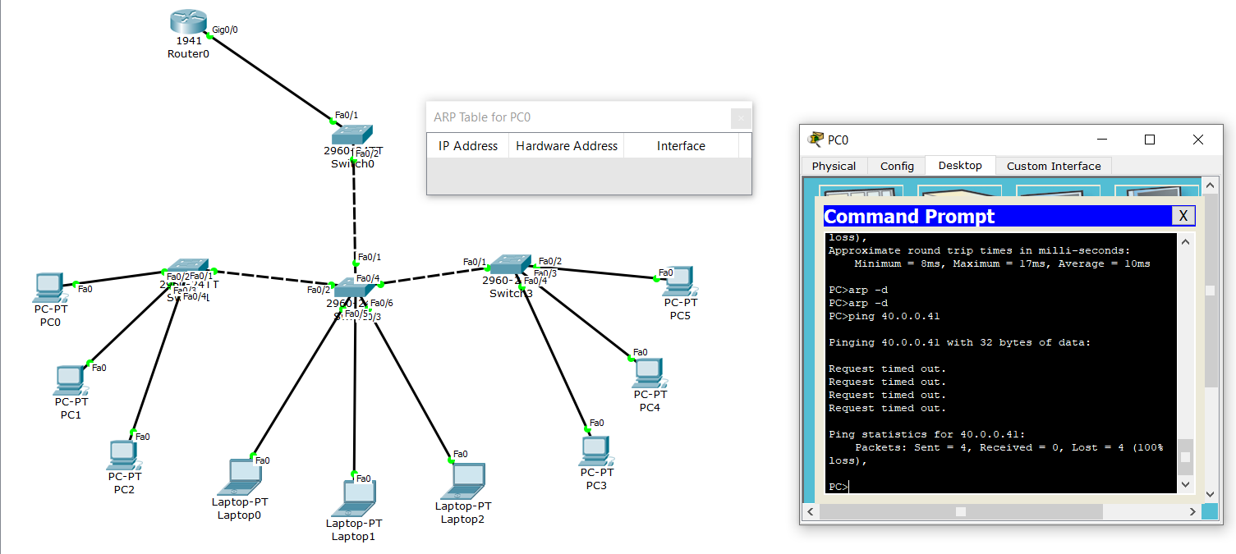

MAC Tables of Switches:

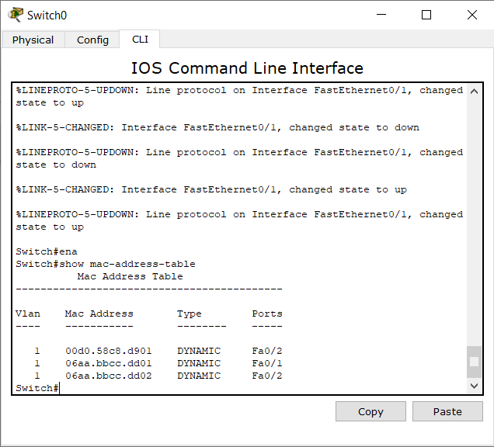

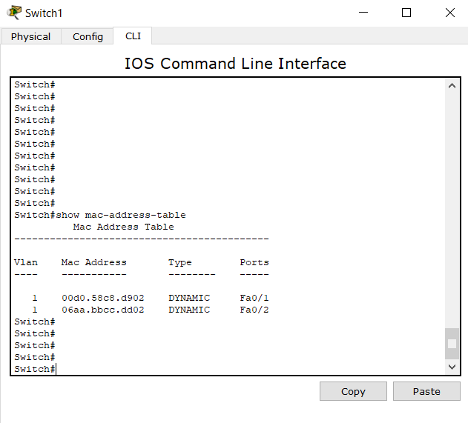

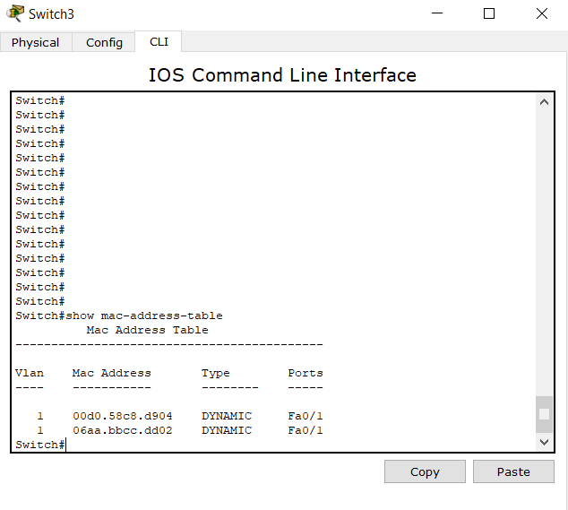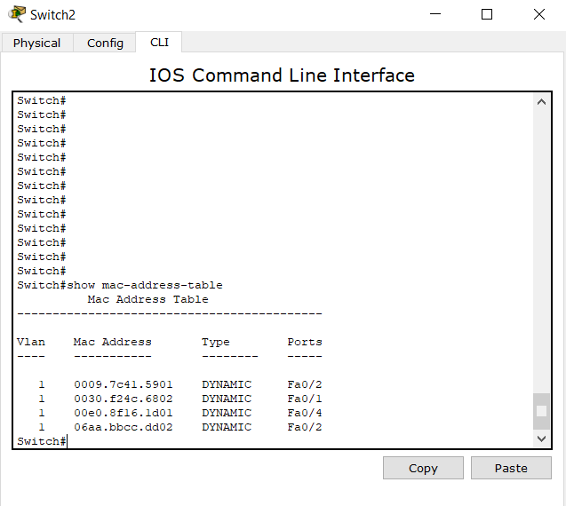

ARP Request and Responses Simulation:

Step 1: The message is initiated via the command prompt of Host A (PC0). Host A pings 40.0.0.41. Here the packet is being transferred to the switch.

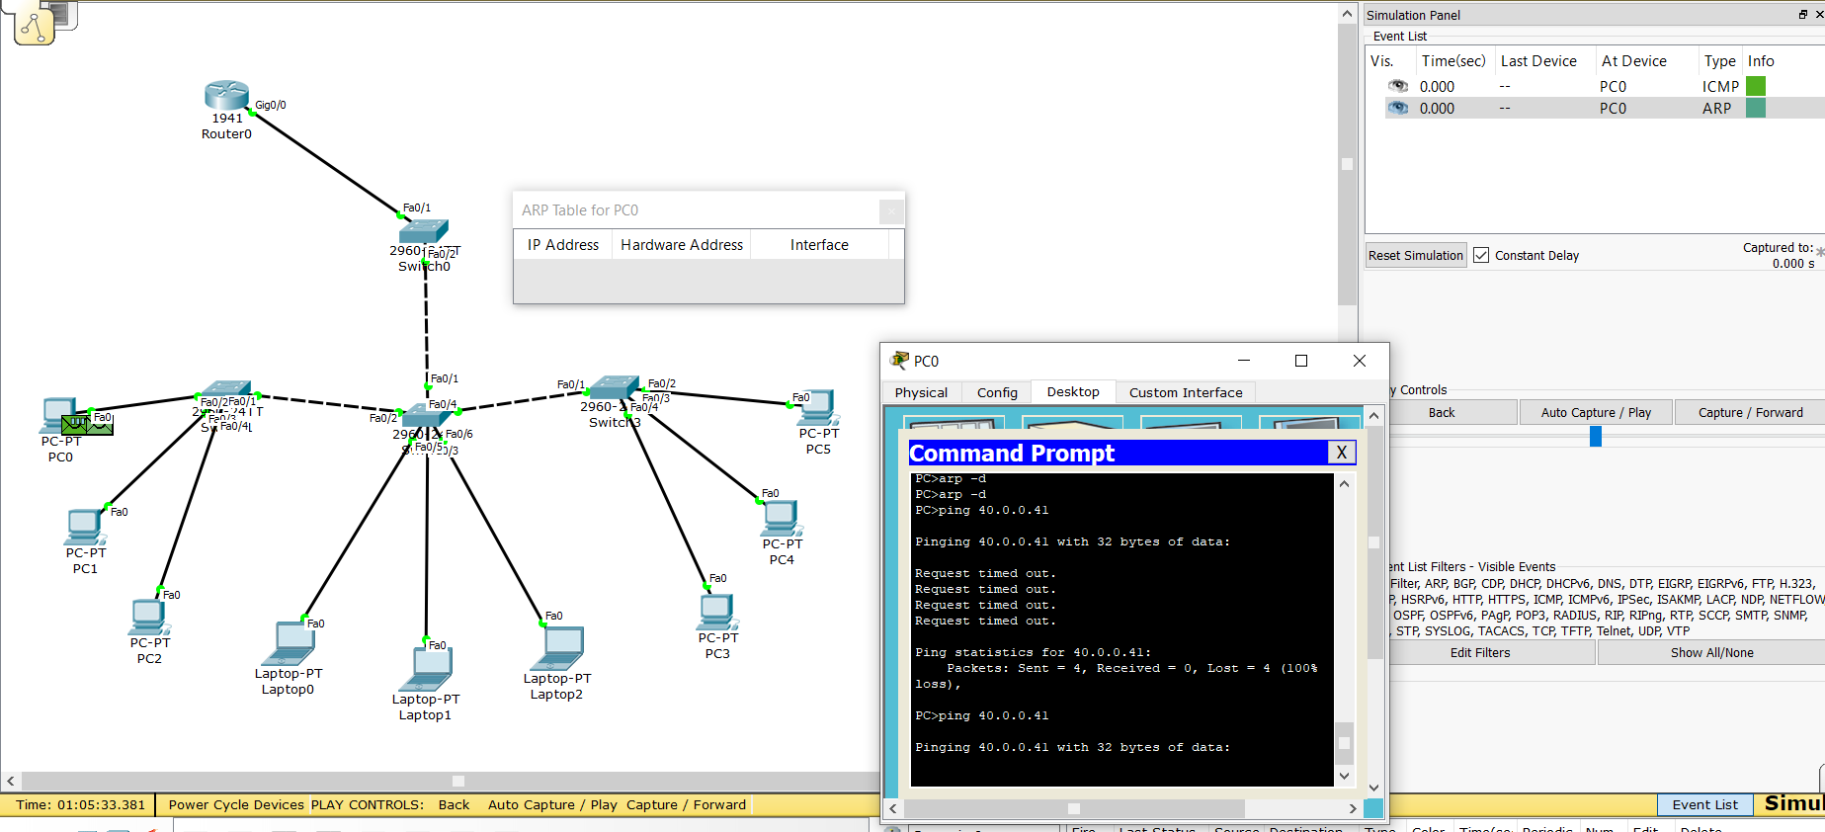

Step 2: The packet has been transferred to the switch, where it will now send its packets further until it finds the desired computer with IP address.

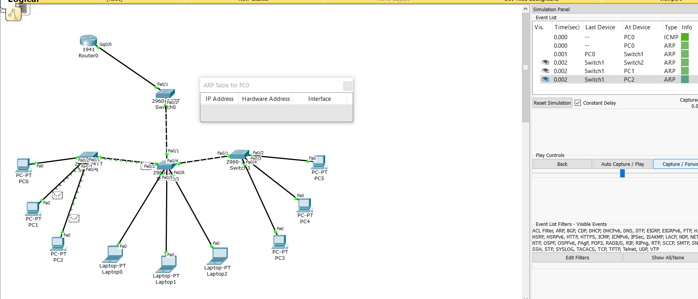

Step 3: The packet was never able to reach its destination since a computer on that ip address (40.0.0.41) does not exist in this network. The simulation shows that the packet has traversalled through the entire network, but was unable to find the desired ip address. The message was not successfully pinged.

