Database Systems

Table of Content

Detailed Functional Requirements 3

ERD 4

EERD 5

Relational Schema with Normalization 6

User Documentation and Help 7

Screenshots of Implemented Project 8

# **Detailed Functional Requirements:**

##### **Admin Module:**

##### The system shall allow admins to add new admin accounts.

##### Admins can enter new admin details and save them to the system.

##### The system shall not allow admins to remove other admin accounts.

##### The system shall enable admins to add new courses. Admins can enter course details such as course name, associated faculty, etc.

##### The system shall enable admins to remove existing courses.

##### The system shall enable admins to add faculty members. Admins can input faculty details including department and contact information.

##### The system shall enable admins to remove faculty members.

##### **Faculty Module:**

##### The system shall allow faculty members to view feedback for TAs and LDs.

##### The system shall enable faculty members to assign tasks to TAs and labs to LDs.

##### The system shall allow faculty members to add new TAs and LDs.

##### The system shall allow faculty members to remove existing TAs and LDs.

##### The system shall allow faculty members to track the completion status of assigned tasks and labs.

##### **TA Module:**

##### The system shall allow TAs to update the status of their tasks upon completion.

##### The system shall allow TAs to provide feedback to faculty members.

##### **LD Module:**

##### The system shall allow LDs to update the status of conducted labs.

##### The system shall allow LDs to provide feedback to faculty members.

## 

## **ERD:**

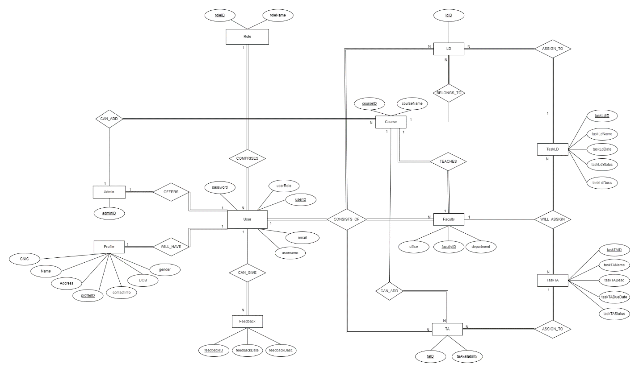

### **EERD:**

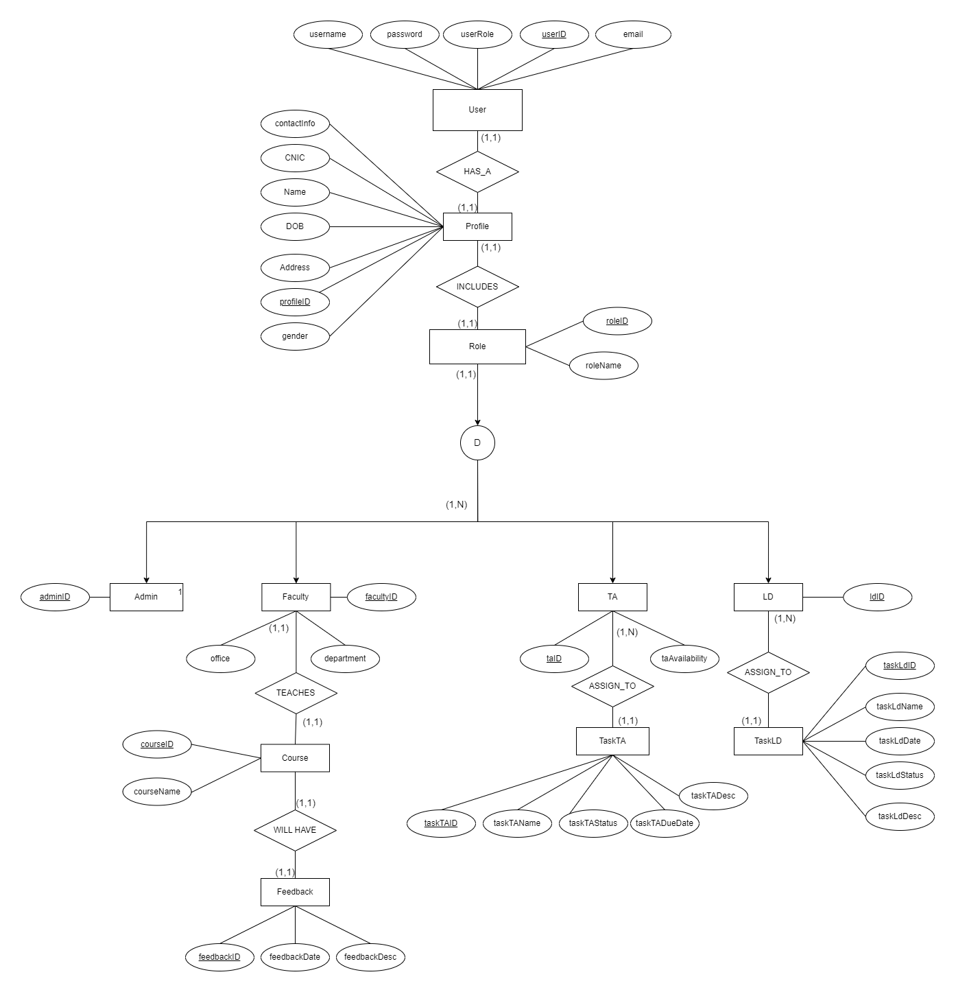

#### 

#### **Relational Schema with Normalization:**

##### 

##### **User Documentation and Help:**

**1. Introduction:**

TDA (Teacher Demo Assistant) is a comprehensive educational management system designed to facilitate the administrative and academic operations of educational institutions. This platform provides tailored functionalities for administrators, faculty members, teaching assistants (TAs), and lab details (LDs), streamlining the process of course management, task assignments, feedback dissemination, and academic scheduling. By integrating various educational processes into a single interface, TDA aims to enhance efficiency, improve communication, and foster a collaborative educational environment.

**2. Interface Overview:**

TDA features a user-friendly interface that caters to four primary user roles:

**Admin:** Responsible for the overarching management tasks such as adding new admins, courses, and faculty members.

**Faculty:** Engages with the system to view feedback, assign tasks or labs, manage TAs and LDs, and monitor the completion of academic duties.

**Teacher Assistant (TA):** Uses the system to view and update the status of assigned tasks and provide feedback to faculty members.

**Lab Demonstrator (LD):** Interacts with the system to conduct labs, update lab statuses, and give feedback to faculty.

Each user role has access to a customized dashboard that provides quick access to the features and functionalities relevant to their responsibilities.

###### **Screenshots of Implemented Project:**

1. **Starting Screen (LOGIN):**

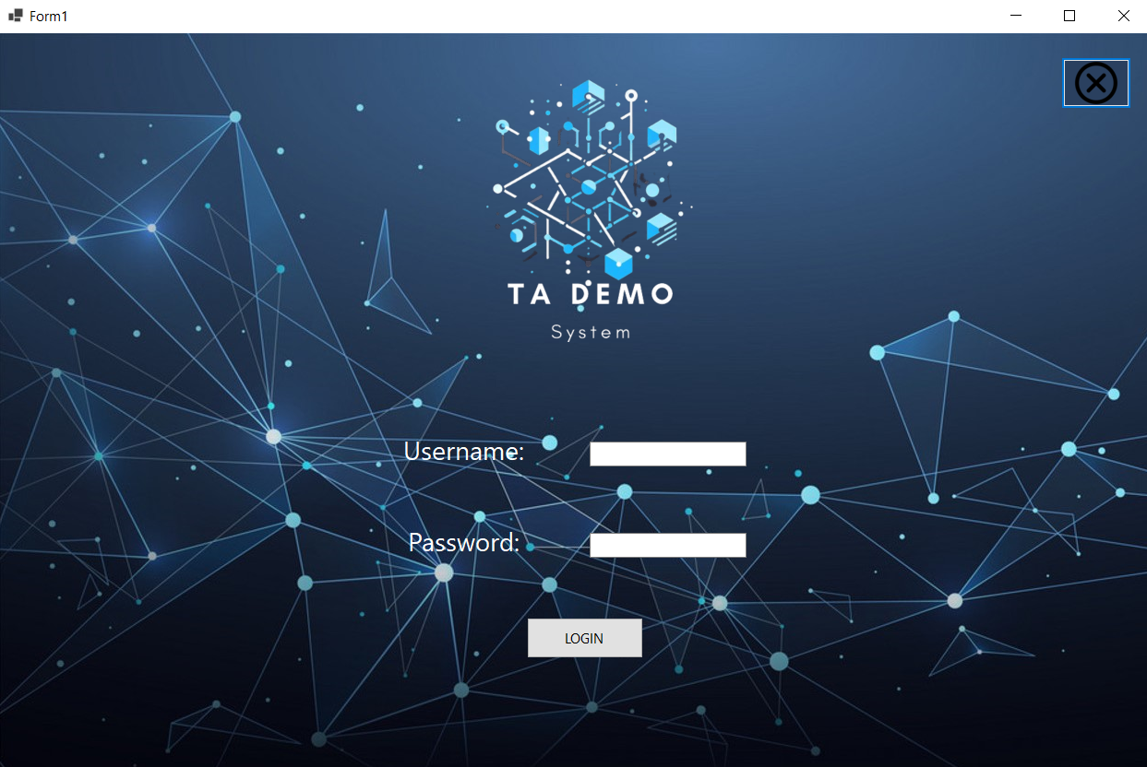

1. 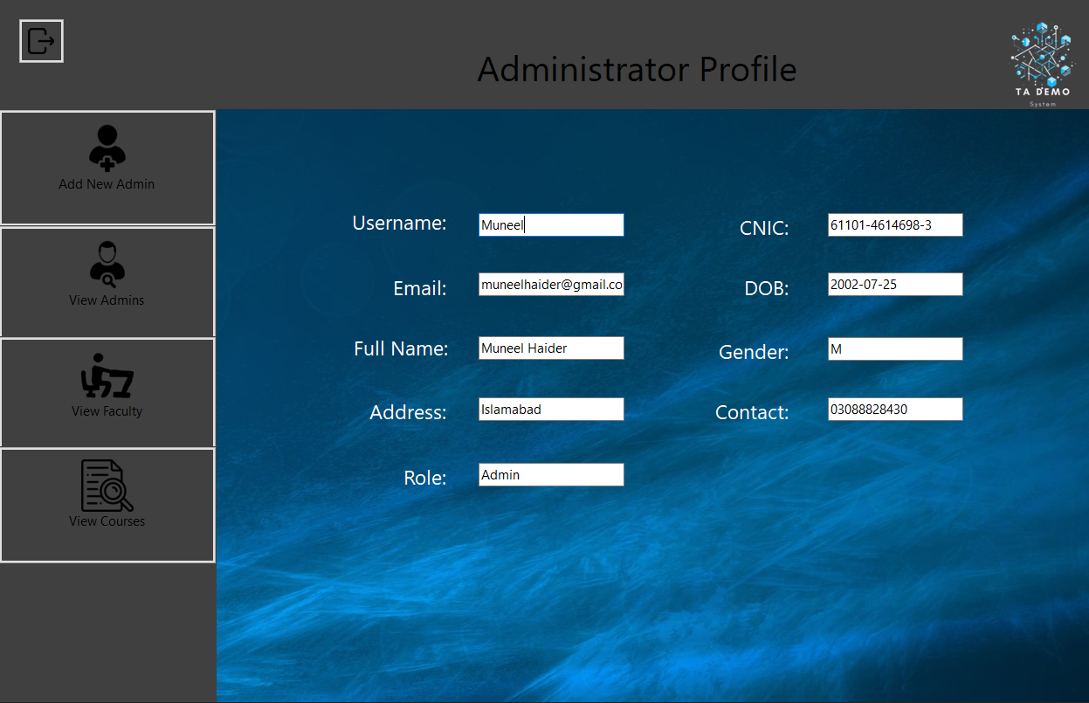**Admin Main Page:**
2. **Faculty Main Page:**

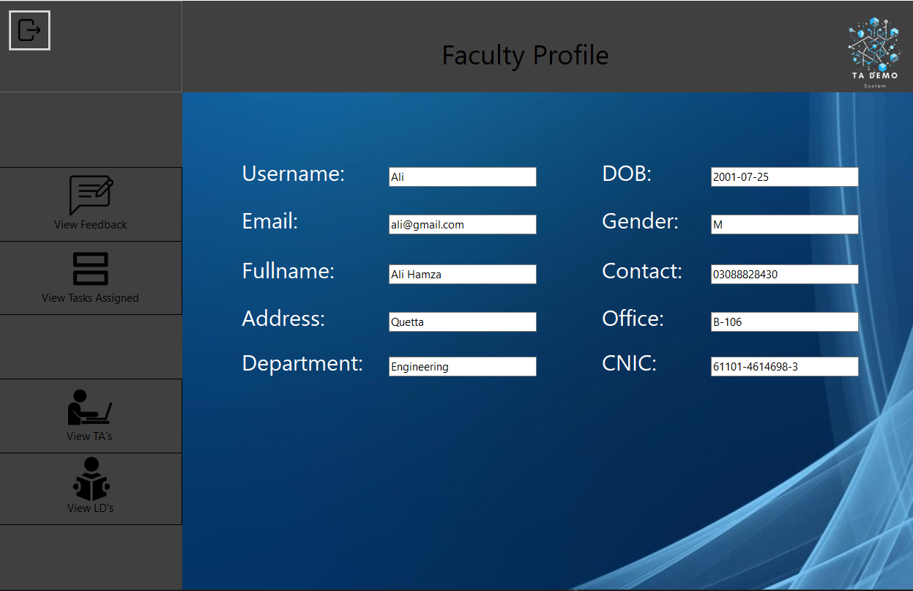

1. 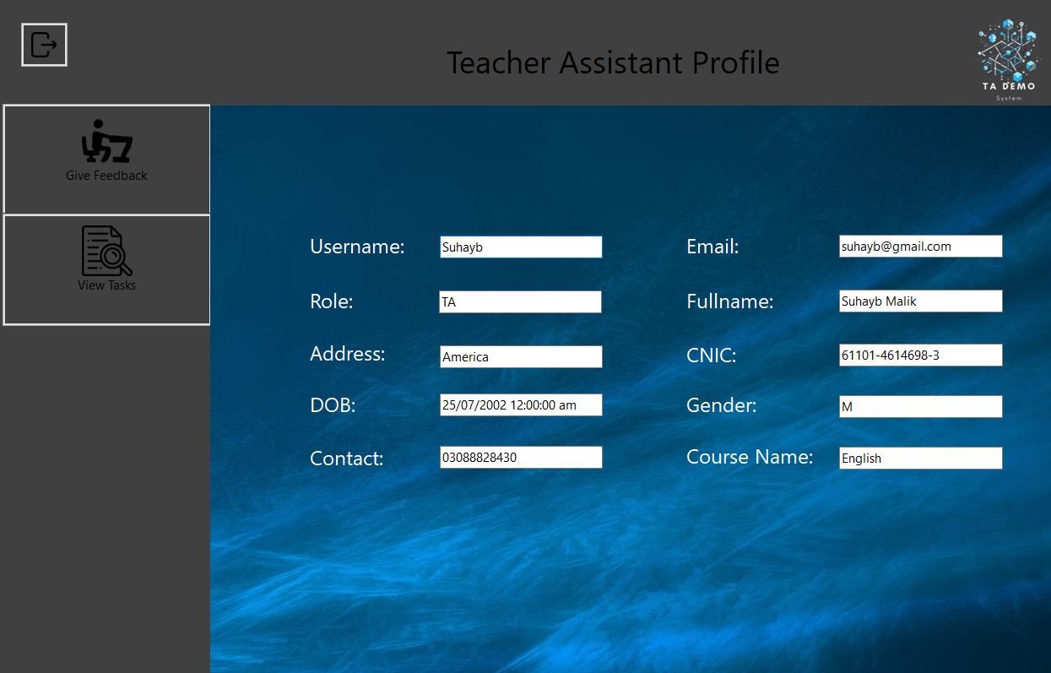**TA Main Page:**
2. 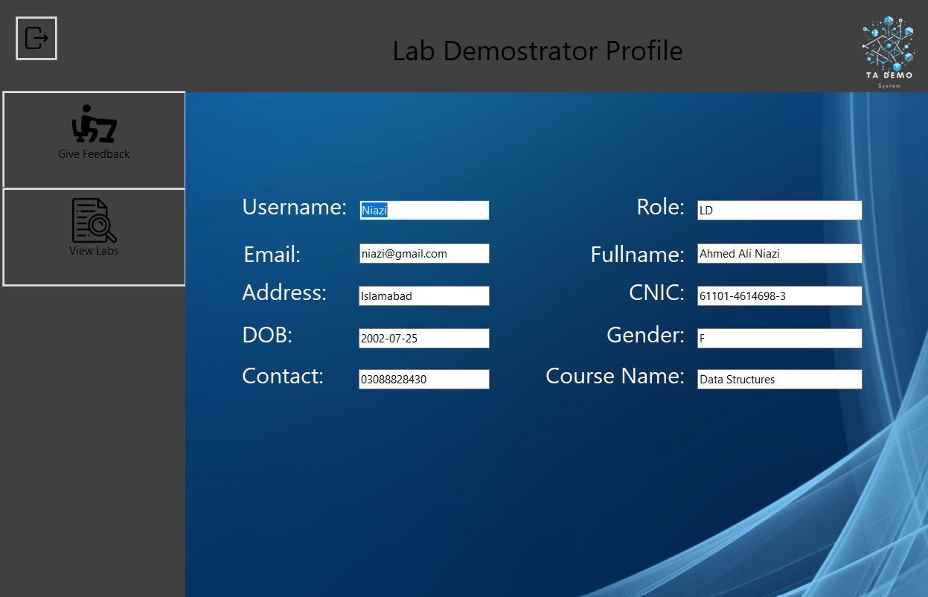**LD Main Page:**