GitHub: https://github.com/MuneelHaider/BloodHub

BACKEND:

1. Launching EC2 Instance:

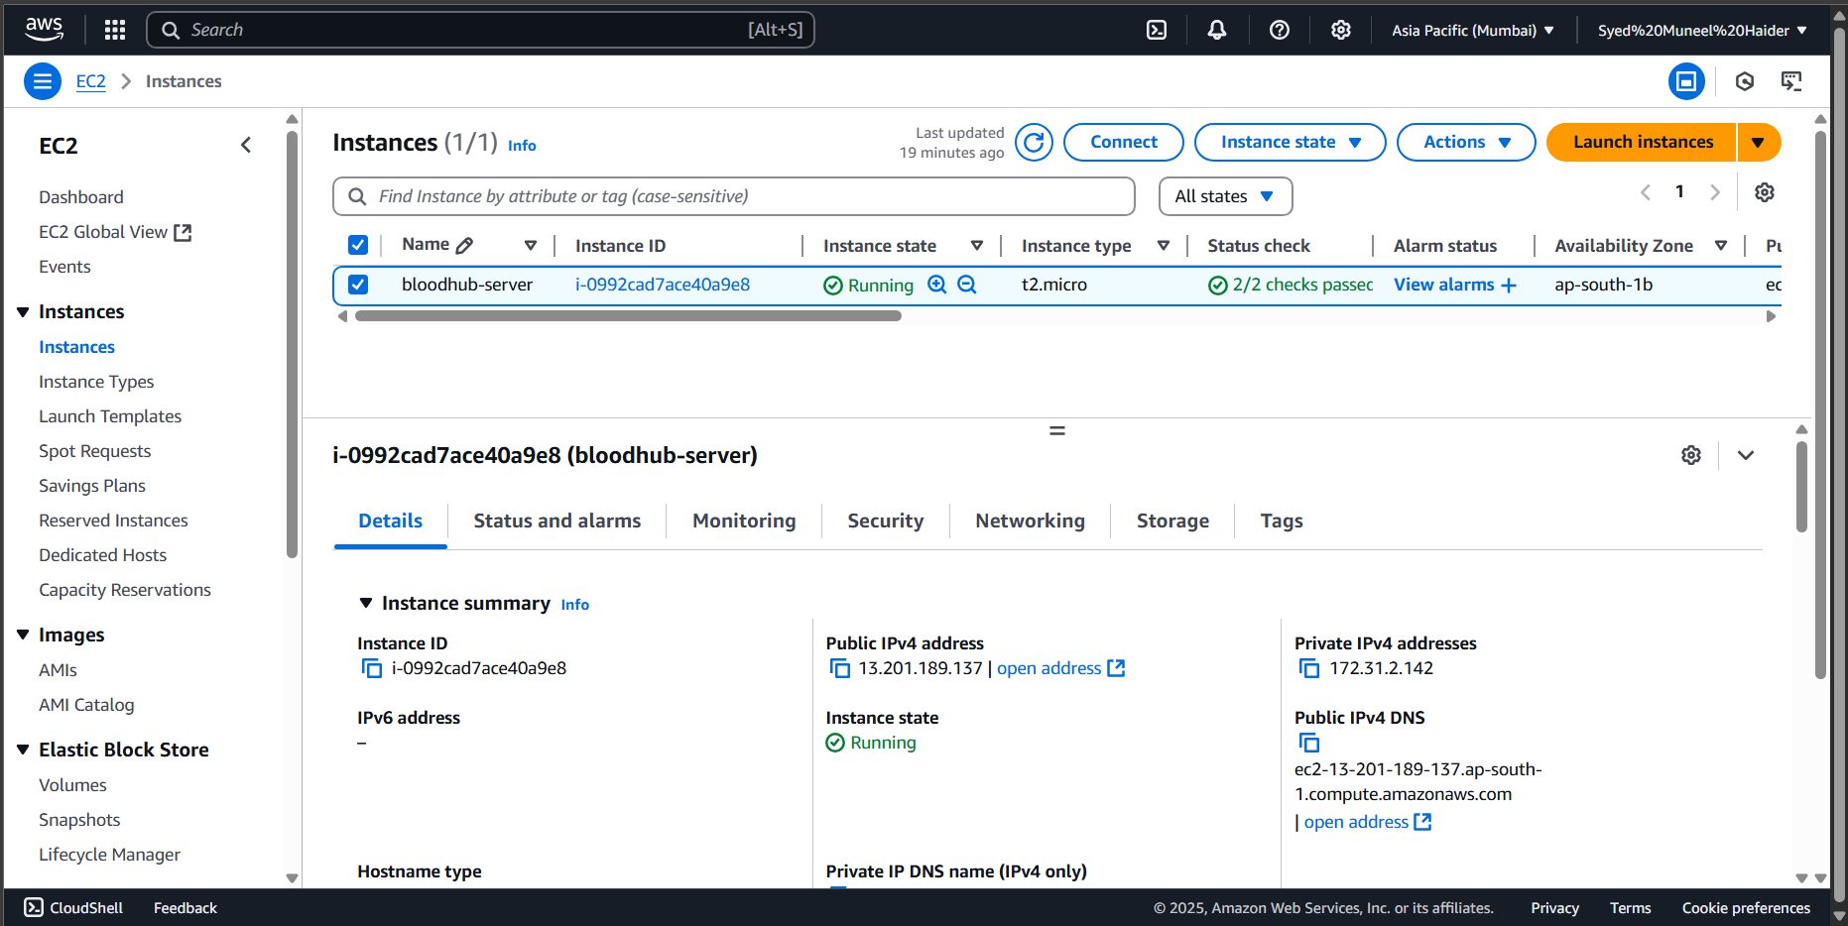

1. Connecting to EC2 Machine:

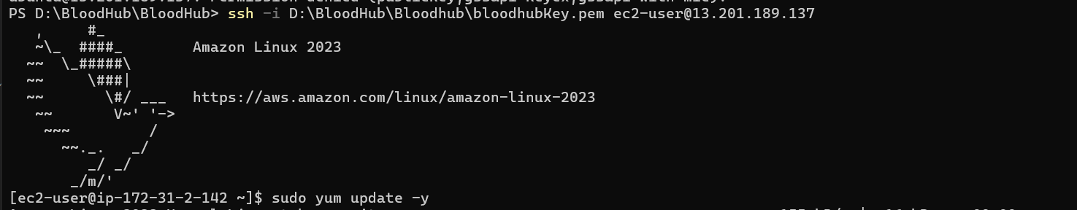

1. Using Docker to build the images and up the containers:

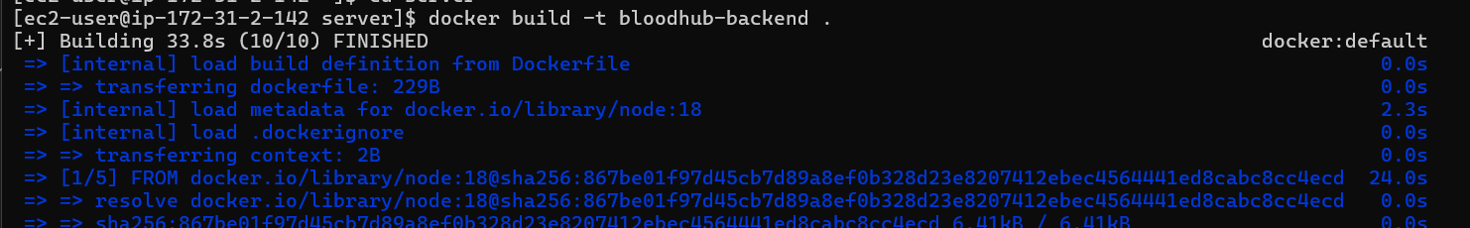

1. Checking and confirmation if containers are up.

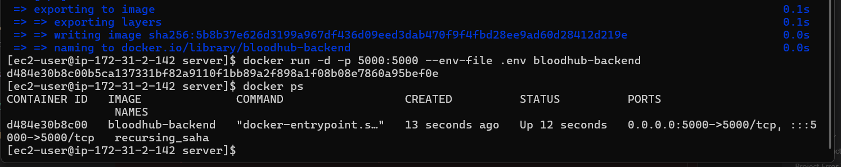

1. Security group created for EC2 Instance.

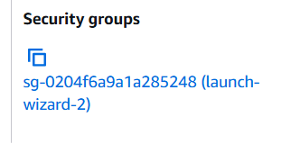

FRONTEND:

1. Created new IAM role for Elastic Beanstalk Instance:

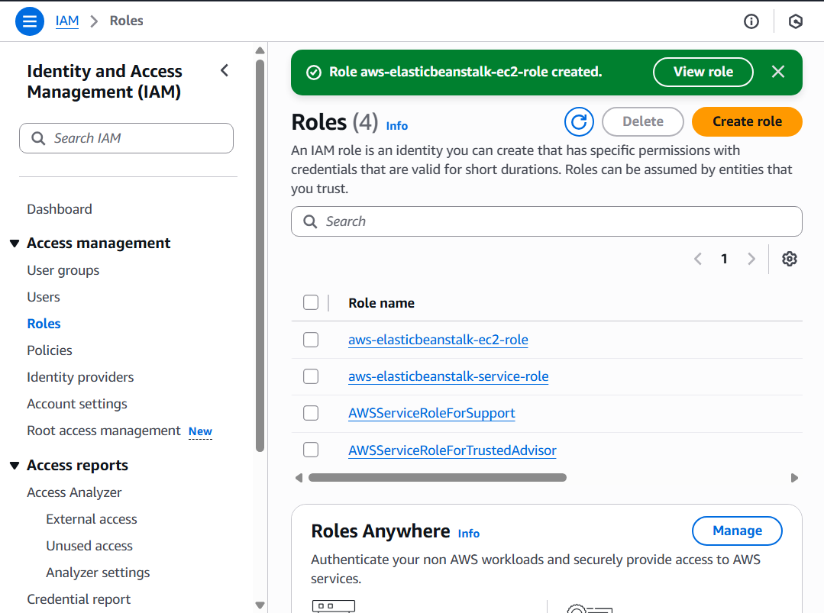

1. New environment and application created:

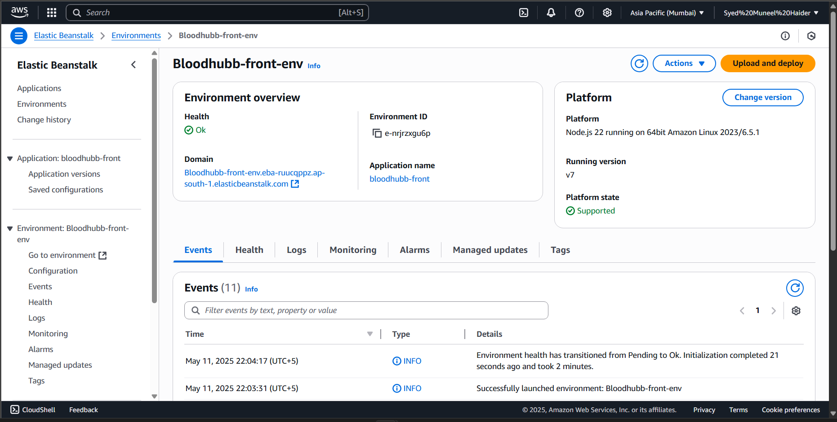

1. Proof that everything is working:

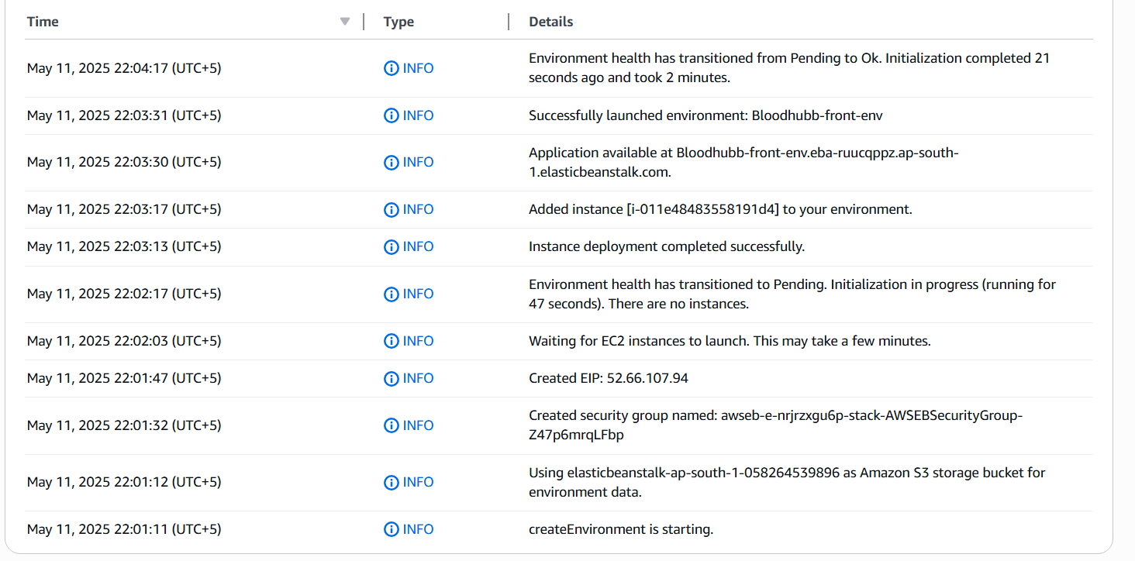

1. Project Folder Structure:

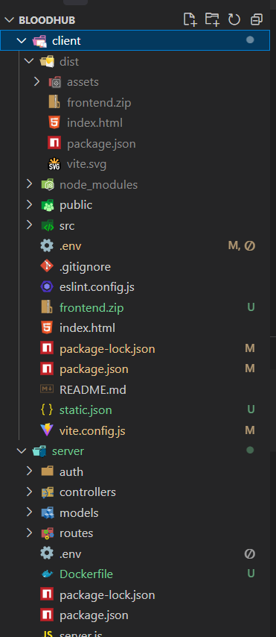

WEBSITE:

1. The Website is fully functional:

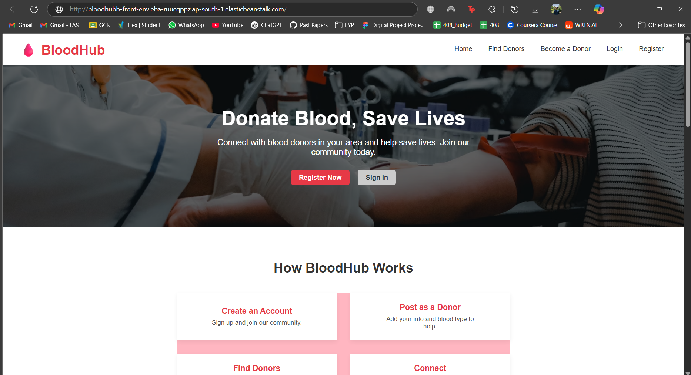

1. All CRUD operation are functional.
2. Diagram:

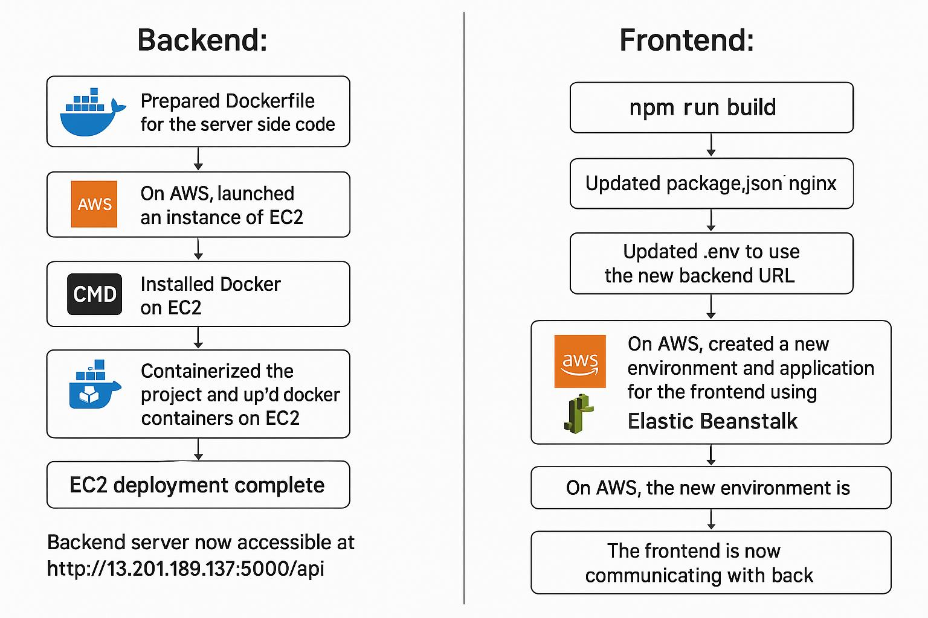

1. Diagram:

