JAVA PROGRAMMING LAB (BCS-351)

B.Tech CSE 3rd SEMESTER

SUBMITTED TO:
SUBMITTED BY:

MR. UNWAN KHAN
MOHAMMAD MUNEER
Roll No: BCS2025418

SN. | PROGRAM NAME | PAGE | DATE | SIGNATURE
1. | Hello World, Variables and Arithmetic | 3
2. | Decisions and Loops with Numbers | 8
3. | Star and Number Patterns | 13
4. | Writing Functions (Factorial, nCr, nPr, maxOf) | 18
5. | Arrays: Traversal, Sum, Max &Counting | 22
6. | Arrays: Reverse Order &Duplicates | 26
7. | Counting Steps and Time Complexity | 30
8. | Matrices: Transpose and Row Sums | 34
9. | Matrices: Row Boundaries & Column Sums | 38
10. | Switch Statement and ArrayList | 42
11. | Bubble Sort and Selection Sort | 46
12. | Insertion Sort & Shift Counting | 50
13. | Strings: Methods, Reverse &Palindromes | 54
14. | Characters: Vowels & Frequency Counting | 59
15. | StringBuilder Methods (append, insert, delete) | 63

Assignment Aim / Objective: Print text, store values in variables and calculate with arithmetic operators.
Assignment 1: Hello World, Variables and Arithmetic
Problem Statement: Print Hello World on one line. Then print Welcome to Java on the next line.
Question 1

Source Code (Main.java):

public class Main {
public static void main(String[] args) { System.out.println("Hello World"); System.out.println("WelcometoJava");
}
}

Execution Output Screenshot:

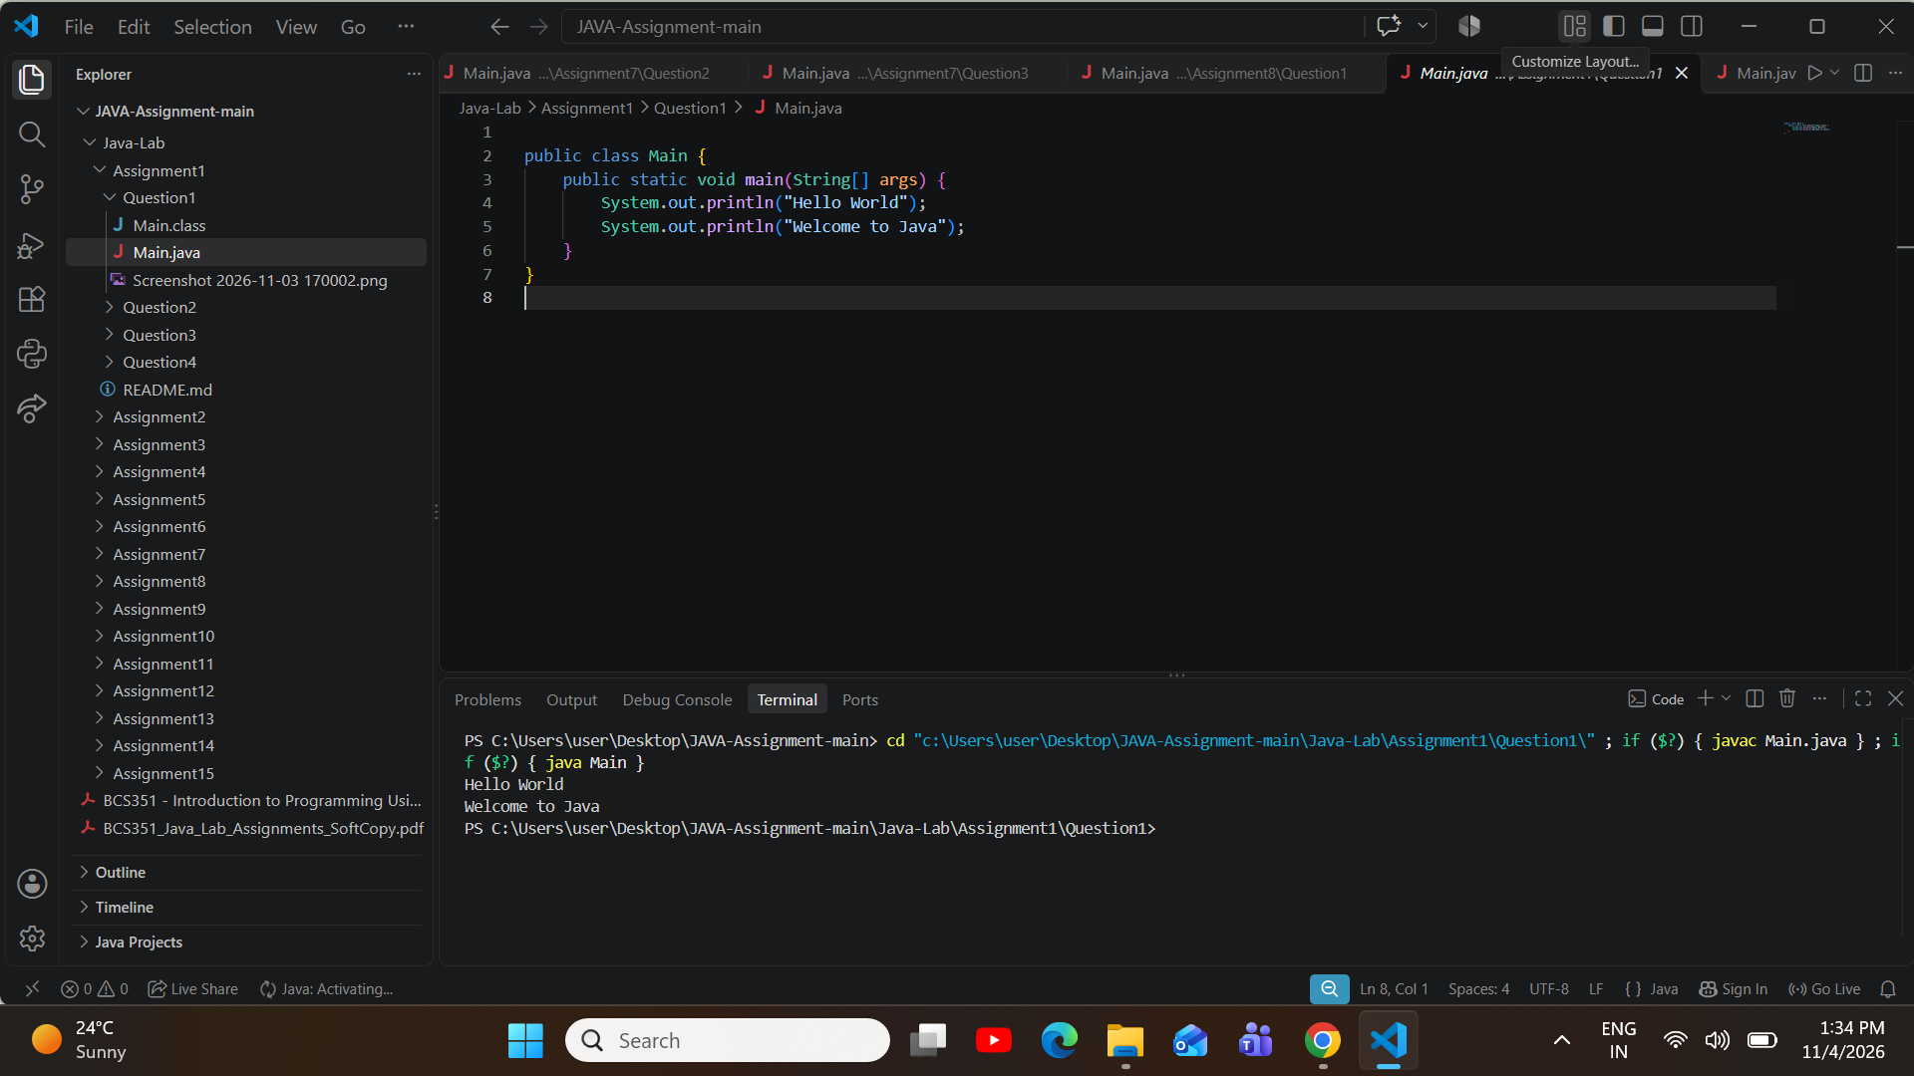

Problem Statement: Create int roll = 101, double percentage = 84.5, char section = 'B' and String name = "Asha".Printeachvalueonitsownline,afterthelabelsRoll:,Percentage:,Section:andName:inthatorder.
Question 2

Source Code (Main.java):

public class Main {
publicstaticvoidmain(String[]args){ int roll = 101;
doublepercentage=84.5; char section = 'B'; String name = "Asha";

System.out.println("Roll: " + roll); System.out.println("Percentage:"+percentage); System.out.println("Section: " + section); System.out.println("Name: " + name);
}
}

Execution Output Screenshot:

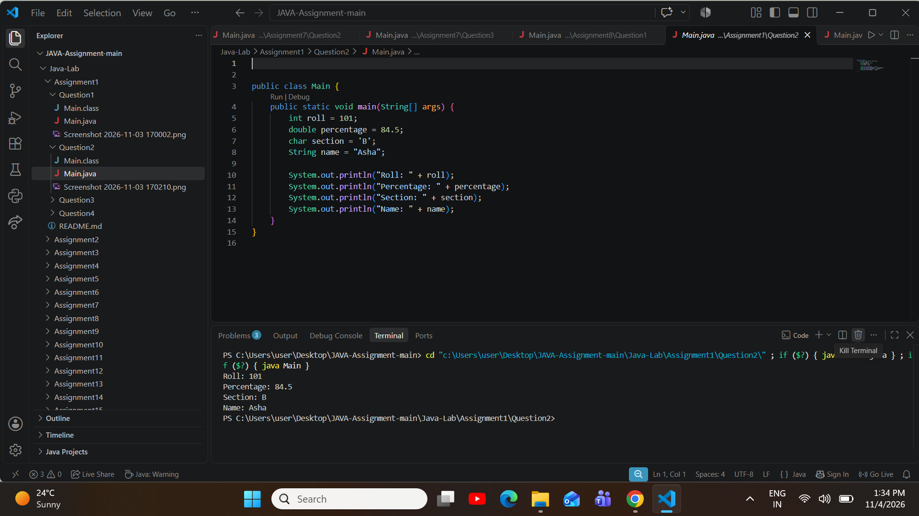

ProblemStatement:Createintvariablesa=17andb=5.PrintSum:,Difference:,Product:,Quotient:and Remainder:, each followed by its result for a + b, a - b, a * b, a / b and a % b.
Question 3

Source Code (Main.java):

public class Main {
publicstaticvoidmain(String[]args){ int a = 17;
int b = 5;

System.out.println("Sum: " + (a + b)); System.out.println("Difference:"+(a-b)); System.out.println("Product: " + (a * b)); System.out.println("Quotient: " + (a / b)); System.out.println("Remainder: " + (a % b));
}

}

Execution Output Screenshot:

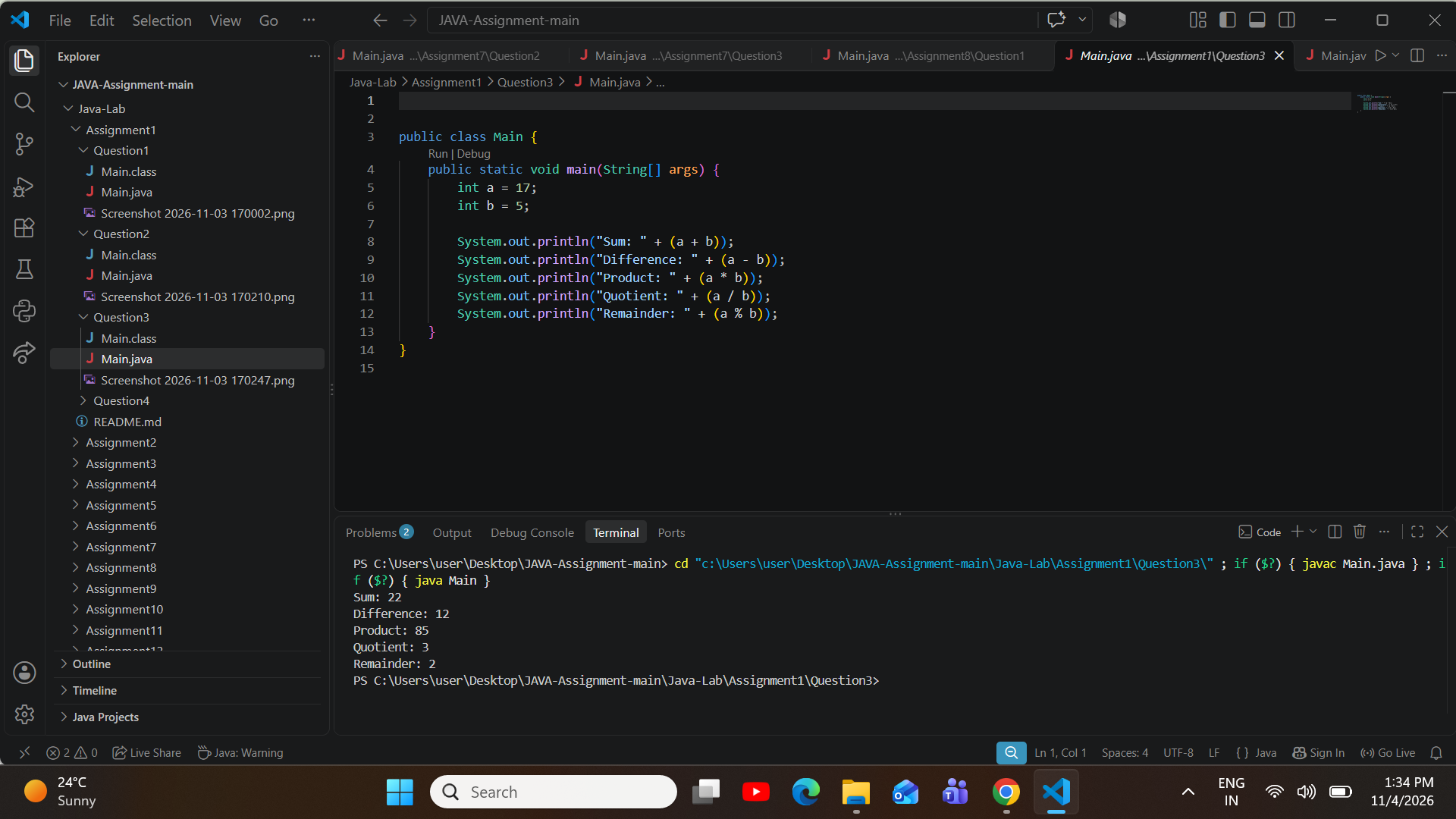
/*
* Student Name: Kartikeya Singh
* Roll Number: BCS2025378
* Course: B.Tech CSE
* Subject: Introduction to Programming Using Java Lab (BCS351)
* Assignment: 1, Question: 4
*/

blic class Main {
publicstaticvoidmain(String[]args){ final double PI = 3.14;
double radius = 7;

doublearea=PI*radius*radius; double perimeter = 2 * PI * radius;
ProblemStatement:CreateaconstantnamedPIwiththefinalkeywordandthevalue3.14.Foracirclewith radius 7, print Area: followed by the area and Perimeter: followed by the perimeter, using PI.
Question 4

Source Code (Main.java):

System.out.println("Area: " + area); System.out.println("Perimeter:"+perimeter);
}
}

Execution Output Screenshot:

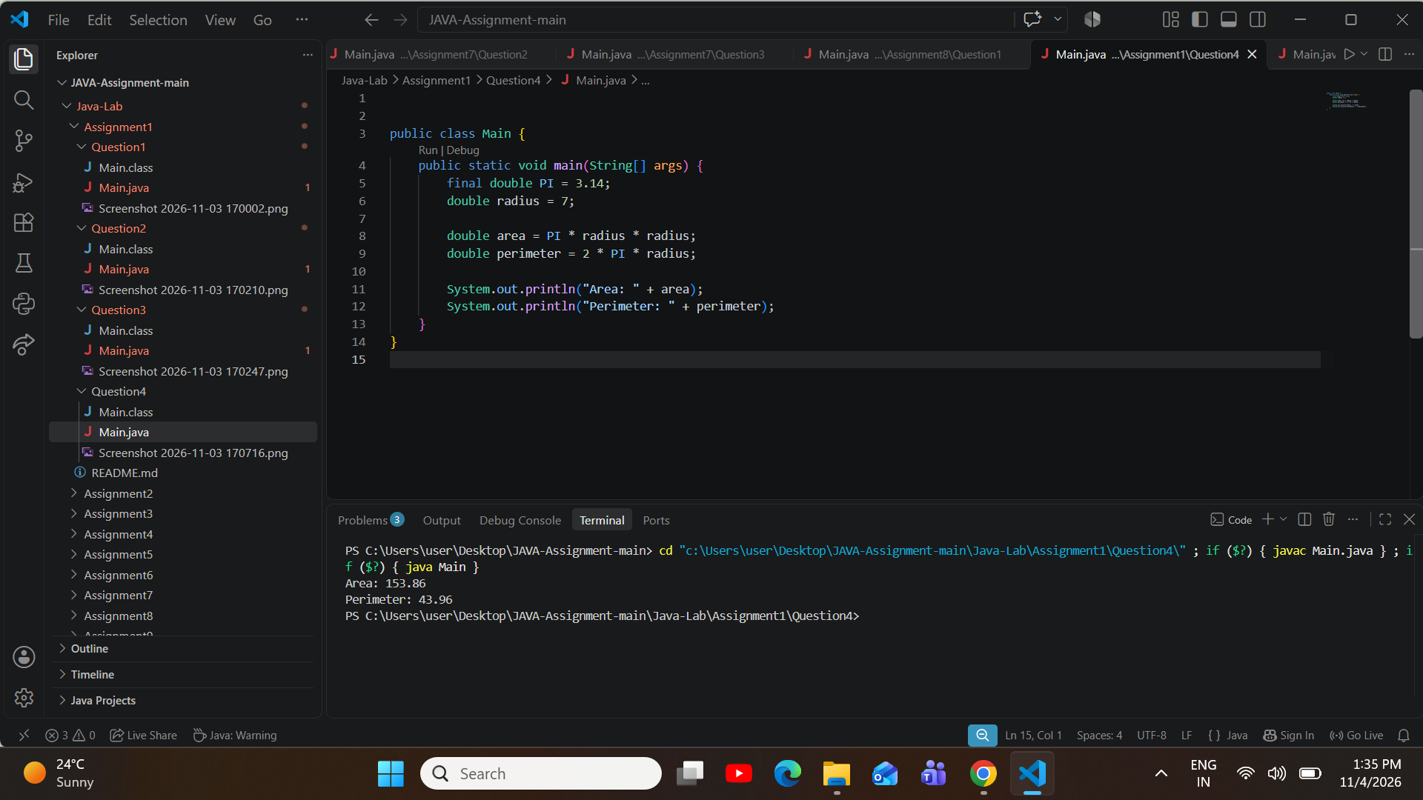

AssignmentAim/Objective:Useif,elseifandloopstomakedecisionsandrepeatstepswithwhole numbers.
Assignment 2: Decisions and Loops with Numbers
ProblemStatement:Store27inanintnamedn.Printthevalueofnfollowedbyisevenorisodd,usingthe% operator and an if-else statement.
Question 1

Source Code (Main.java):

public class Main {
publicstaticvoidmain(String[]args){ int n = 27;

if (n % 2 == 0) {
System.out.println(n + " is even");
} else {
System.out.println(n + " is odd");
}
}
}

Execution Output Screenshot:

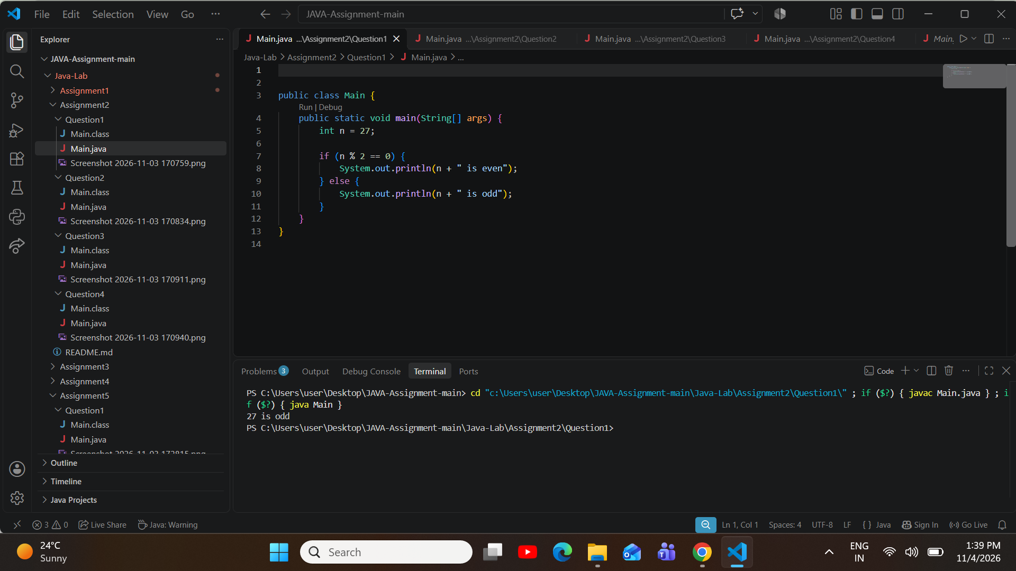
ProblemStatement:Store83inanintnamedmarks.PrintGrade:followedbyAfor90ormore,Bfor75to89, and C for less than 75. Use an else-if ladder.
Question 2

Source Code (Main.java):

public class Main {
publicstaticvoidmain(String[]args){ int marks = 83;

if (marks >= 90) { System.out.println("Grade:A");
} else if (marks >= 75) { System.out.println("Grade:B");
} else {
System.out.println("Grade: C");
}

}
}

Execution Output Screenshot:

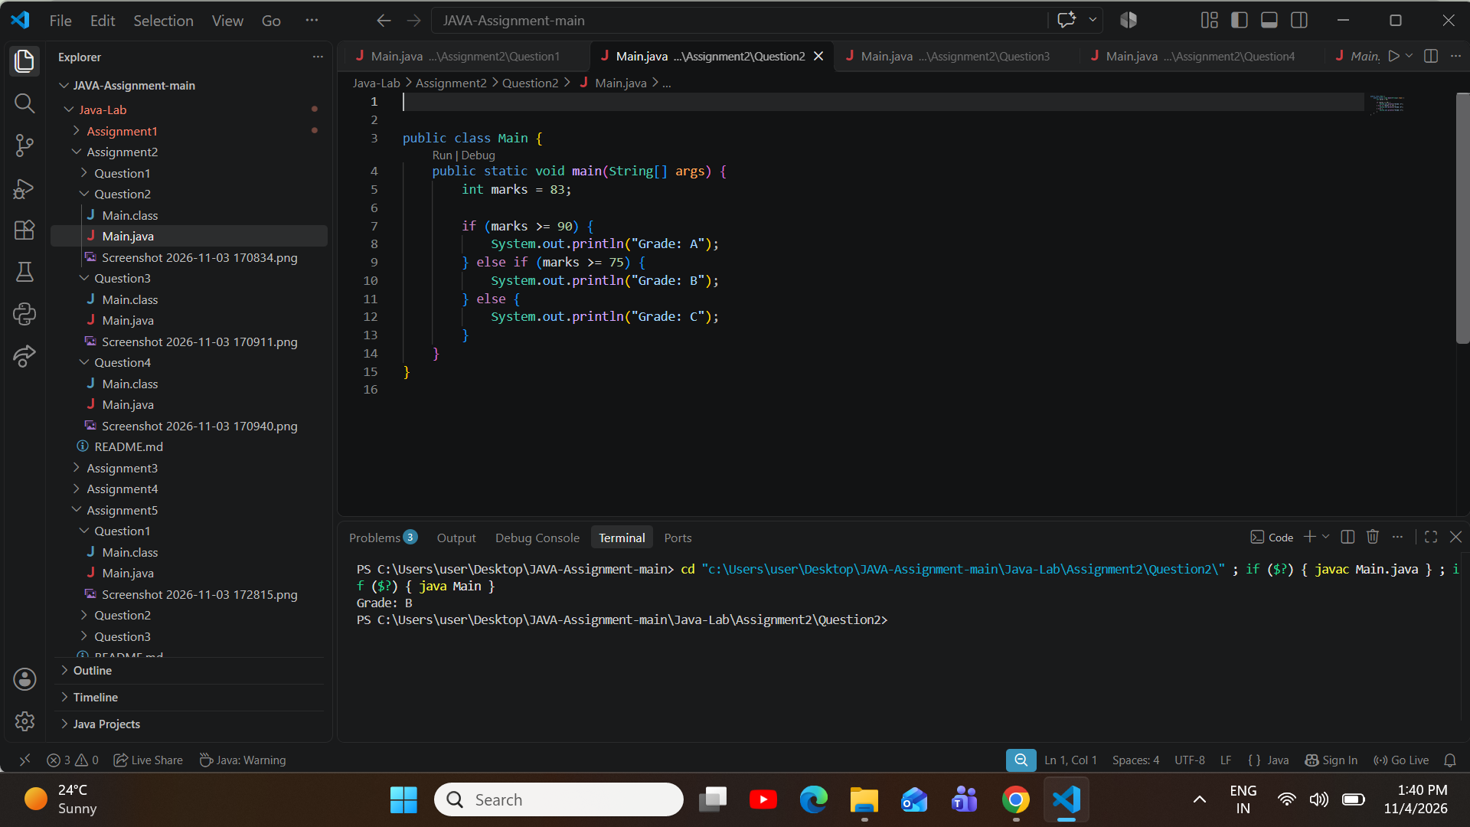
Problem Statement: Store 2024 in an int named year. A leap year is divisible by 4 but not by 100, or divisible by
400. Print Leap year for a leap year, otherwise Not a leap year.
Question 3

Source Code (Main.java):

public class Main {
publicstaticvoidmain(String[]args){ int year = 2024;

if((year%4==0&&year%100!=0)||(year%400==0)){ System.out.println("Leap year");
} else {

System.out.println("Not a leap year");
}
}
}

Execution Output Screenshot:

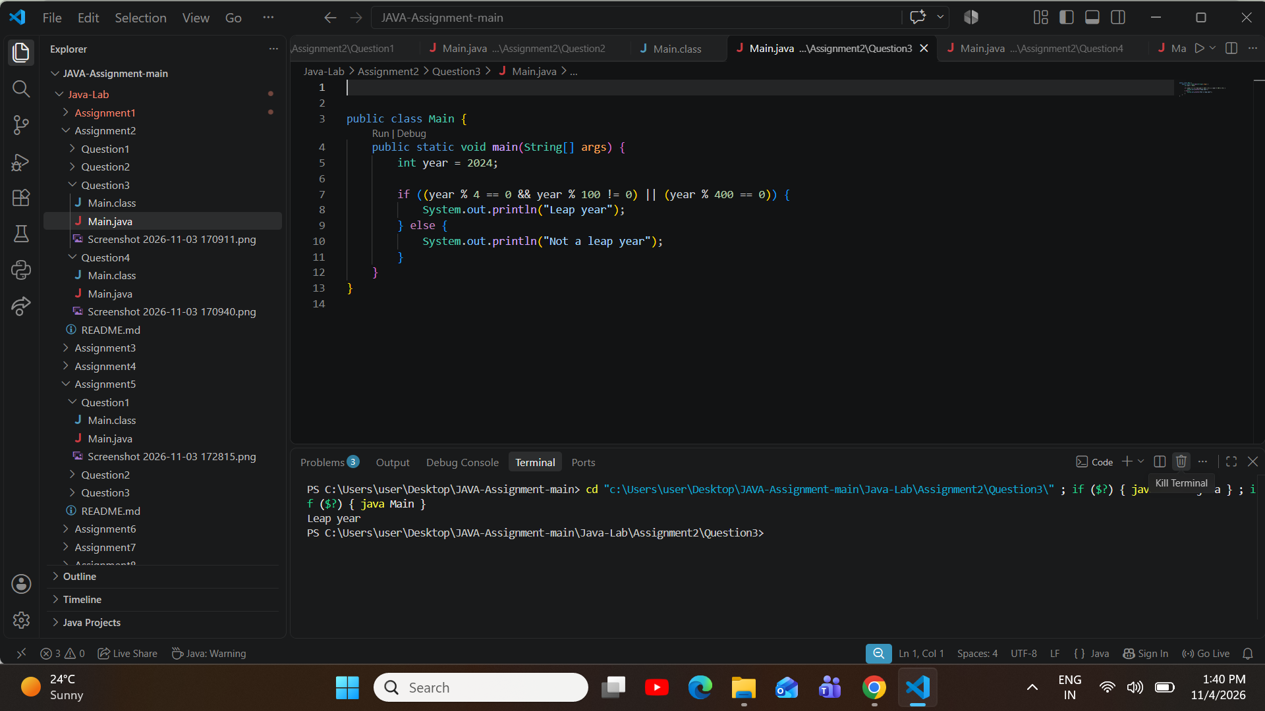
Problem Statement: Use a for loop to find the factorial of 5. Print Factorial of 5 is followed by the value.
Question 4

Source Code (Main.java):

public class Main {
publicstaticvoidmain(String[]args){ int n = 5;
int fact = 1;

for (int i = 1; i <= n; i++) {

fact *= i;
}

System.out.println("Factorial of " + n + " is " + fact);
}
}

Execution Output Screenshot:
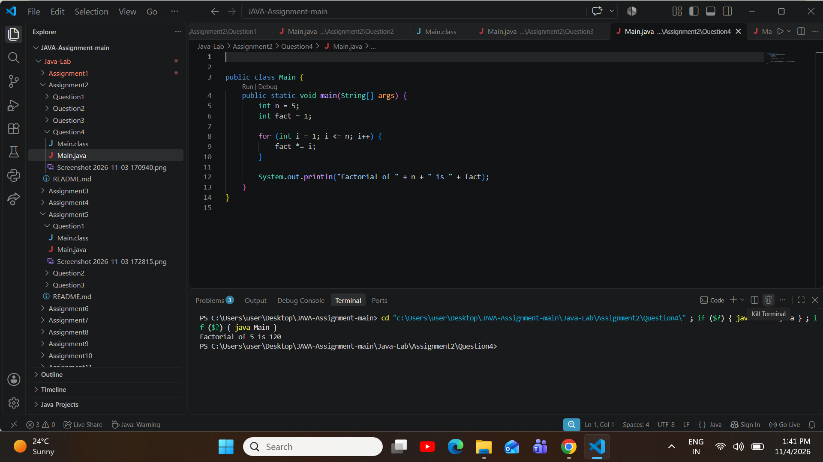

Assignment Aim / Objective: Use a loop inside another loop to print stars and numbers in rows.
Assignment 3: Star and Number Patterns
Problem Statement: Print a square of stars with 4 rows and 4 columns. Use one loop inside another loop.
Question 1

Source Code (Main.java):

public class Main {
publicstaticvoidmain(String[]args){ for (int i = 1; i <= 4; i++) {
for(intj=1;j<=4;j++){ System.out.print("*");
}
System.out.println();
}
}
}

Execution Output Screenshot:

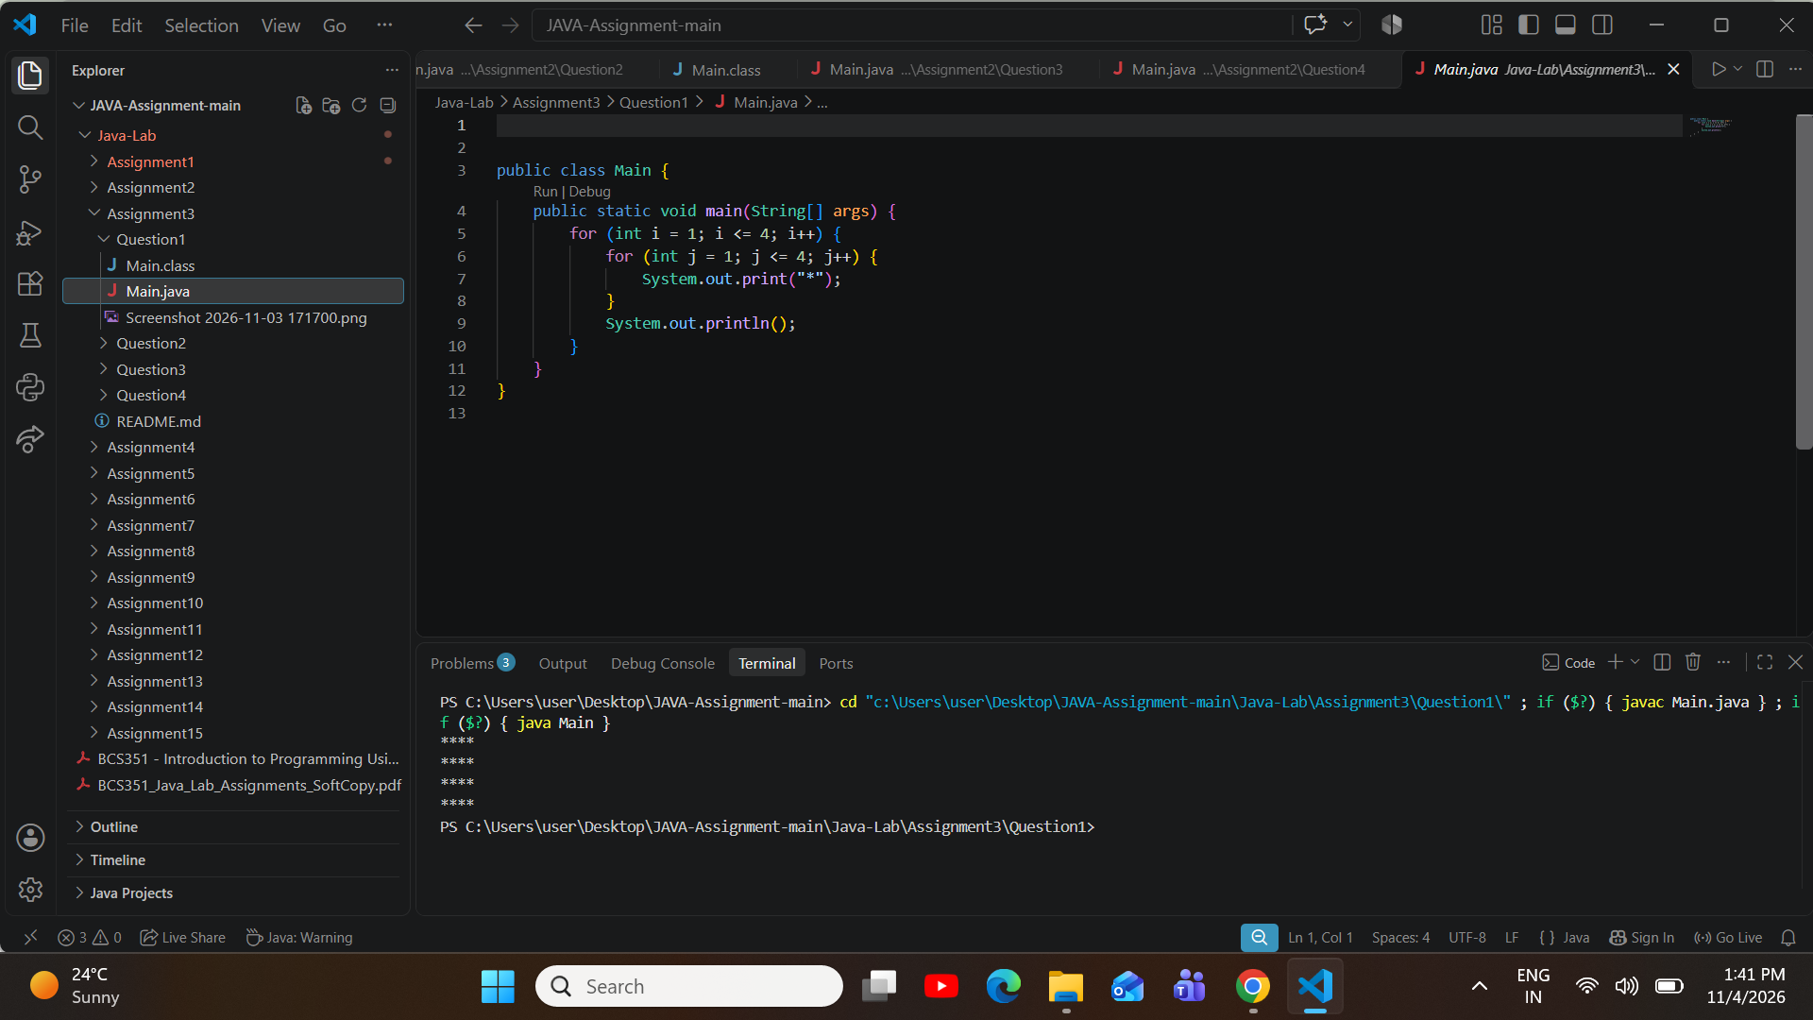
ProblemStatement:Printarighttriangleofstarswith4rows.Row1hasonestar,row2hastwostars,andso on.
Question 2

Source Code (Main.java):

public class Main {
publicstaticvoidmain(String[]args){ for (int i = 1; i <= 4; i++) {
for(intj=1;j<=i;j++){ System.out.print("*");
}
System.out.println();
}
}
}

Execution Output Screenshot:
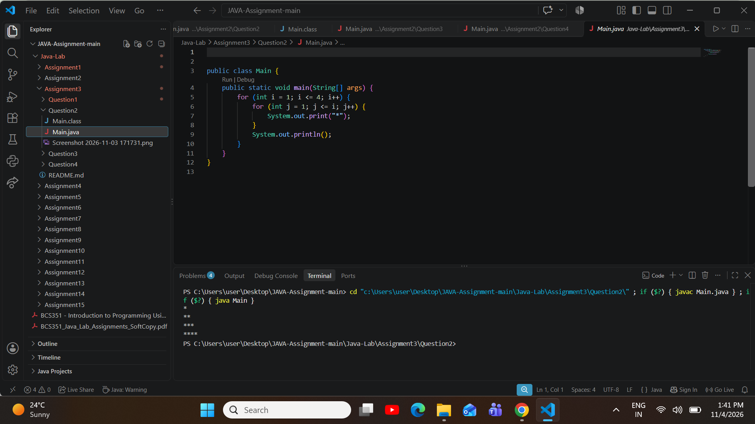
ProblemStatement:Printanumbertrianglewith4rows.Row1prints1.Row2prints12.Row3prints123, and so on. Put a space after each number.
Question 3

Source Code (Main.java):

public class Main {
publicstaticvoidmain(String[]args){ for (int i = 1; i <= 4; i++) {
for(intj=1;j<=i;j++){ System.out.print(j + "");
}
System.out.println();
}
}
}

Execution Output Screenshot:
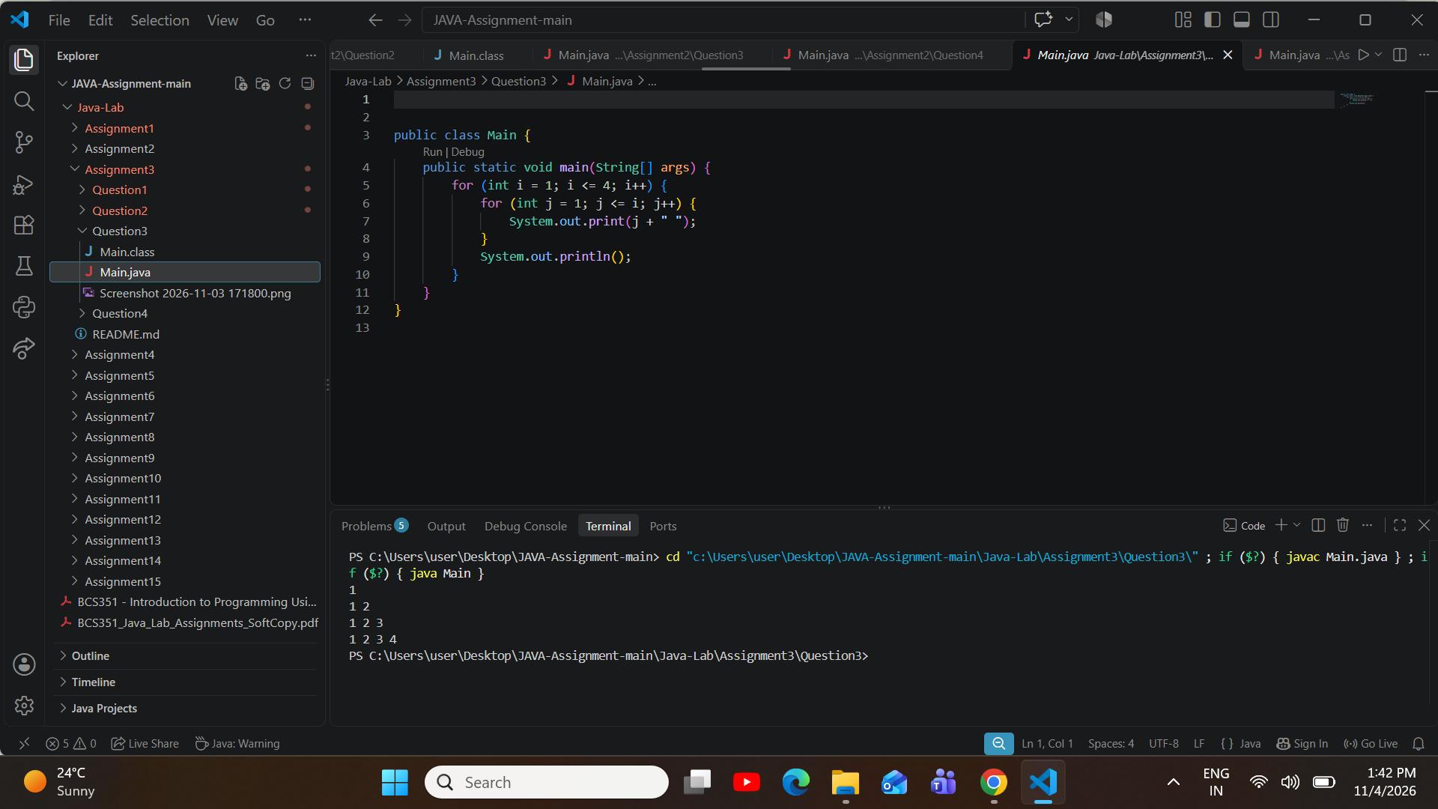
ProblemStatement:Printanupside-downtriangleofstarswith4rows.Row1hasfourstars,row2hasthree stars, and so on, down to one star in row 4.
Question 4

Source Code (Main.java):

public class Main {
publicstaticvoidmain(String[]args){ for (int i = 4; i >= 1; i--) {
for(intj=1;j<=i;j++){ System.out.print("*");
}
System.out.println();
}
}

}

Execution Output Screenshot:
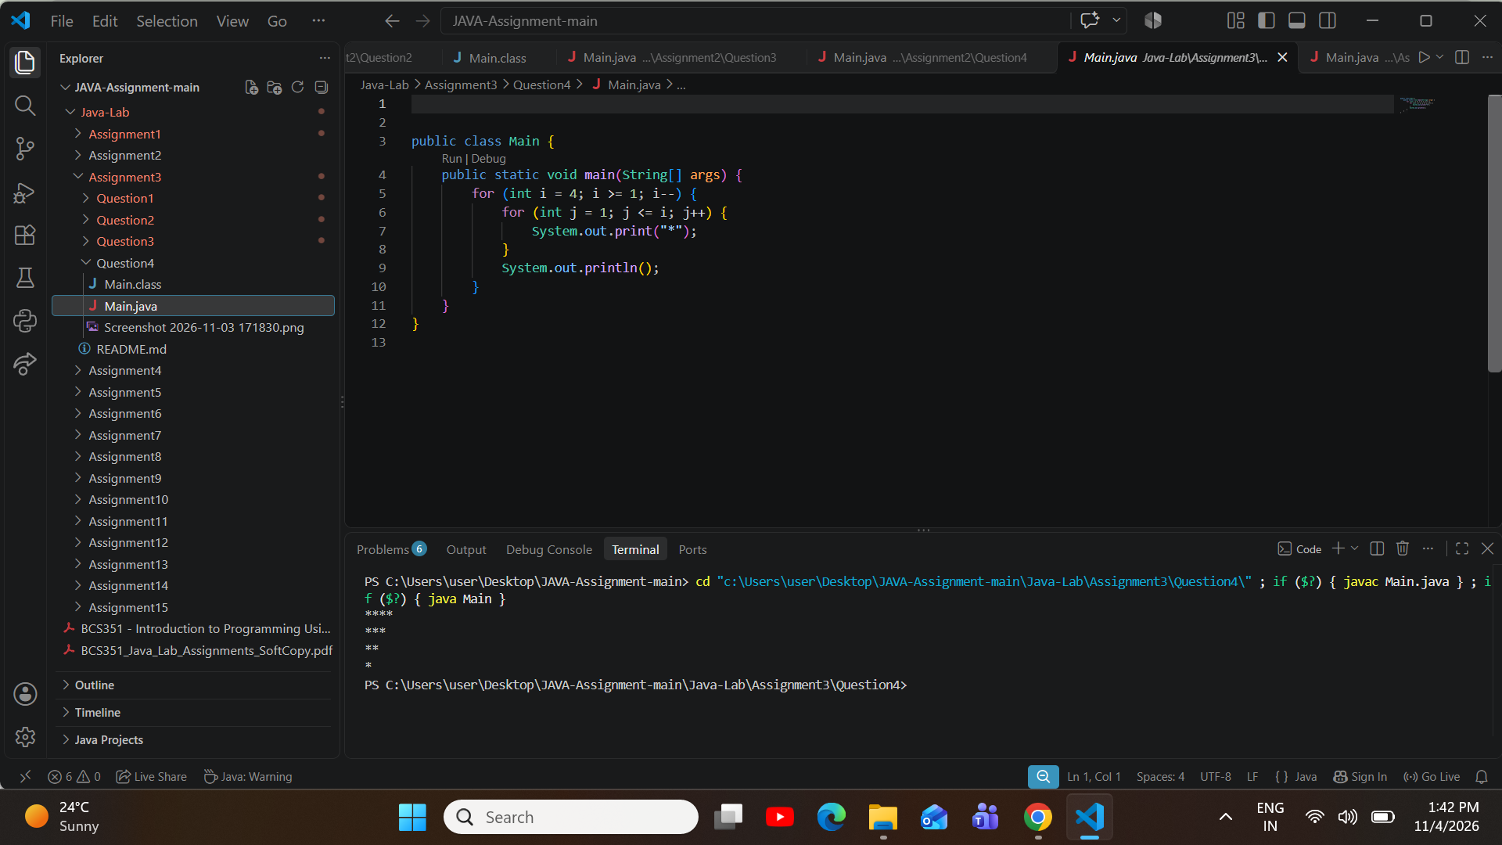

AssignmentAim/Objective:Writefunctionswithparametersandreturnvalues,andcallthemfrommain.
Assignment 4: Writing Functions
ProblemStatement:Writeafunctionfact(intn)thatreturnsnfactorial,usingaloop,andafunctionnCr(intn,int r) that returns n C r, using fact. In main, print 5C2 = followed by the result of nCr(5, 2).
Question 1

Source Code (Main.java):

public class Main {
publicstaticintfact(intn){ int f = 1;
for(inti=1;i<=n;i++){ f *= i;
}
return f;
}

public static int nCr(int n, int r) {
return fact(n) / (fact(r) * fact(n - r));
}

public static void main(String[] args) { System.out.println("5C2="+nCr(5,2));
}
}

Execution Output Screenshot:

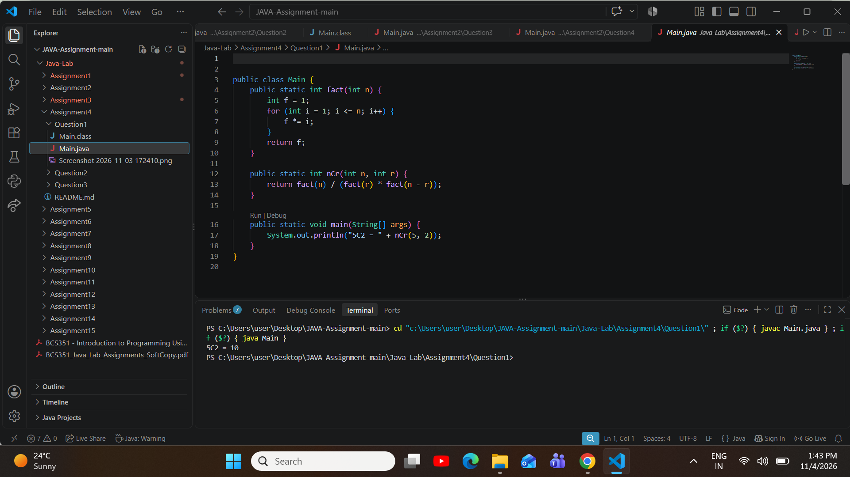
ProblemStatement:Writefact(intn)thatreturnsnfactorialusingaloop,andnPr(intn,intr)thatreturnsnPr using fact. In main, print 5P2 = followed by the result of nPr(5, 2).
Question 2

Source Code (Main.java):

public class Main {
publicstaticintfact(intn){ int f = 1;
for(inti=1;i<=n;i++){ f *= i;
}
return f;
}

publicstaticintnPr(intn,intr){ return fact(n) / fact(n - r);

}

public static void main(String[] args) { System.out.println("5P2="+nPr(5,2));
}
}

Execution Output Screenshot:
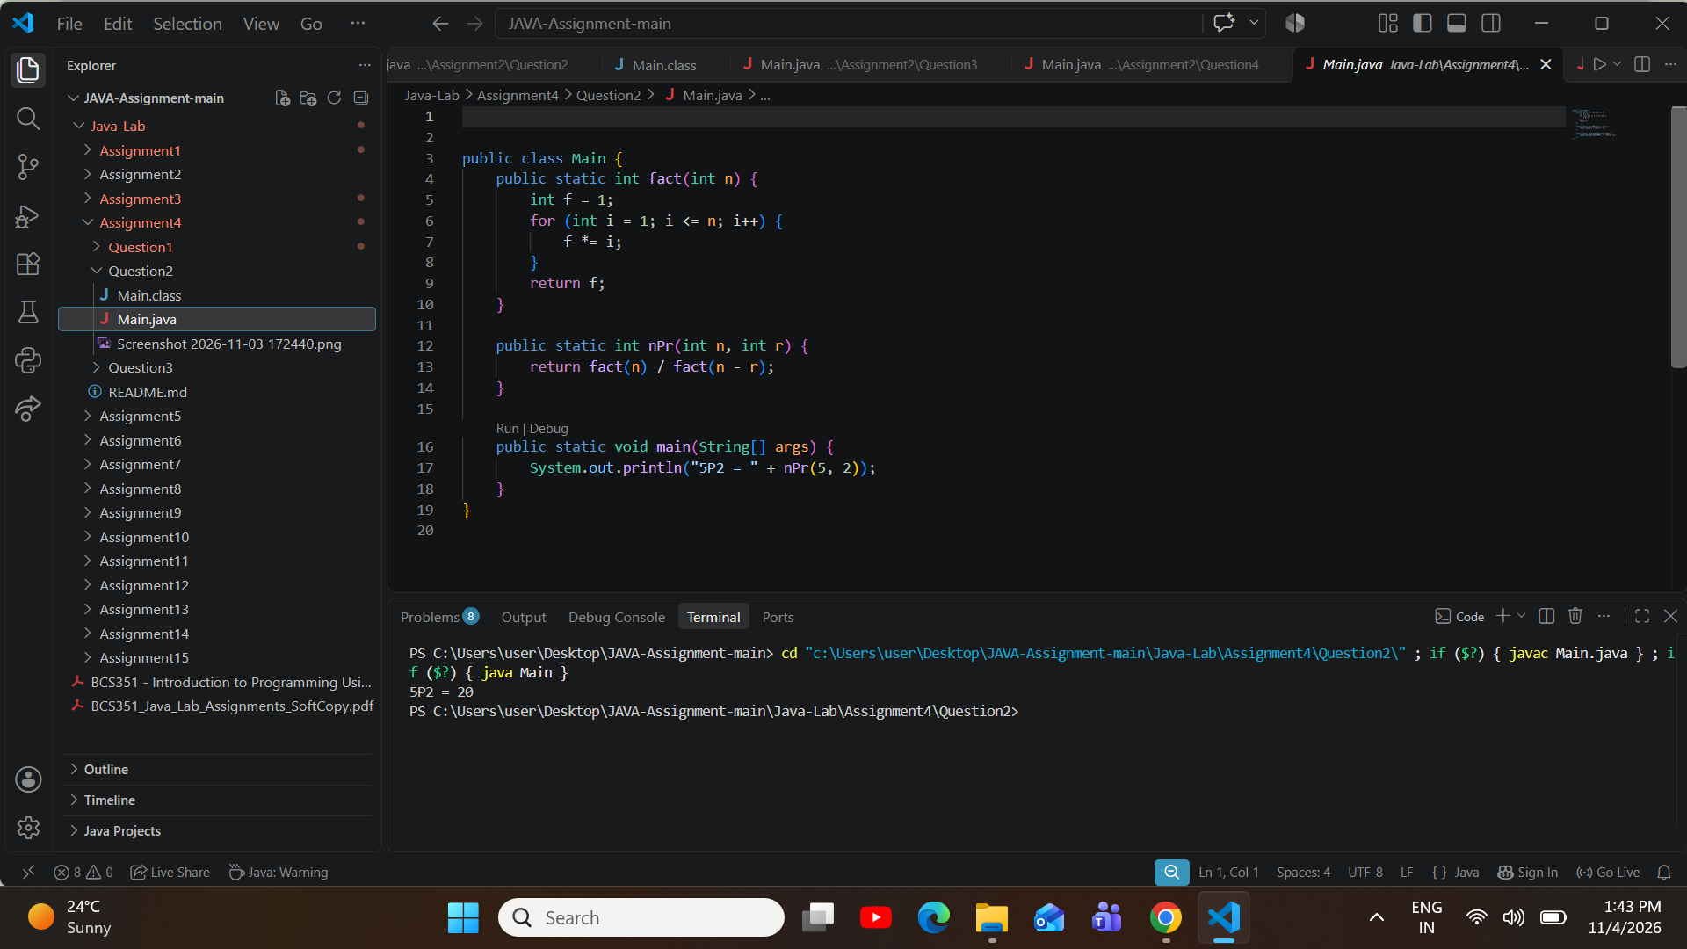
ProblemStatement:WritemaxOf(inta,intb)thatreturnsthelargerofitstwointvalues.Inmain,printLarger: followed by the result of maxOf(14, 9).
Question 3

Source Code (Main.java):

public class Main {
publicstaticintmaxOf(inta,intb){ if (a > b) {

return a;
} else {
return b;
}
}

public static void main(String[] args) { System.out.println("Larger:"+maxOf(14,9));
}
}

Execution Output Screenshot:
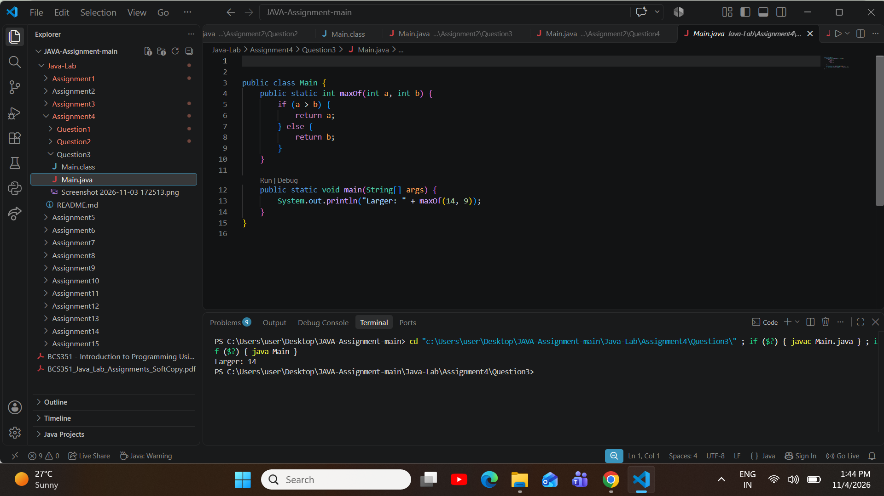

AssignmentAim/Objective:Createanarray,visiteveryelementwithaloop,andadduporcountthe values.
Assignment 5: Arrays: Traversal and Counting
ProblemStatement:Createanintarraynamedarrwiththevalues3,4and5.Useaforloopwitharr.lengthto print one line for each element: the label Index, the index number, a colon and the element value.
Question 1

Source Code (Main.java):

public class Main {
publicstaticvoidmain(String[]args){ int[] arr = {3, 4, 5};

for (int i = 0; i < arr.length; i++) { System.out.println("Index"+i+":"+arr[i]);
}
}
}

Execution Output Screenshot:

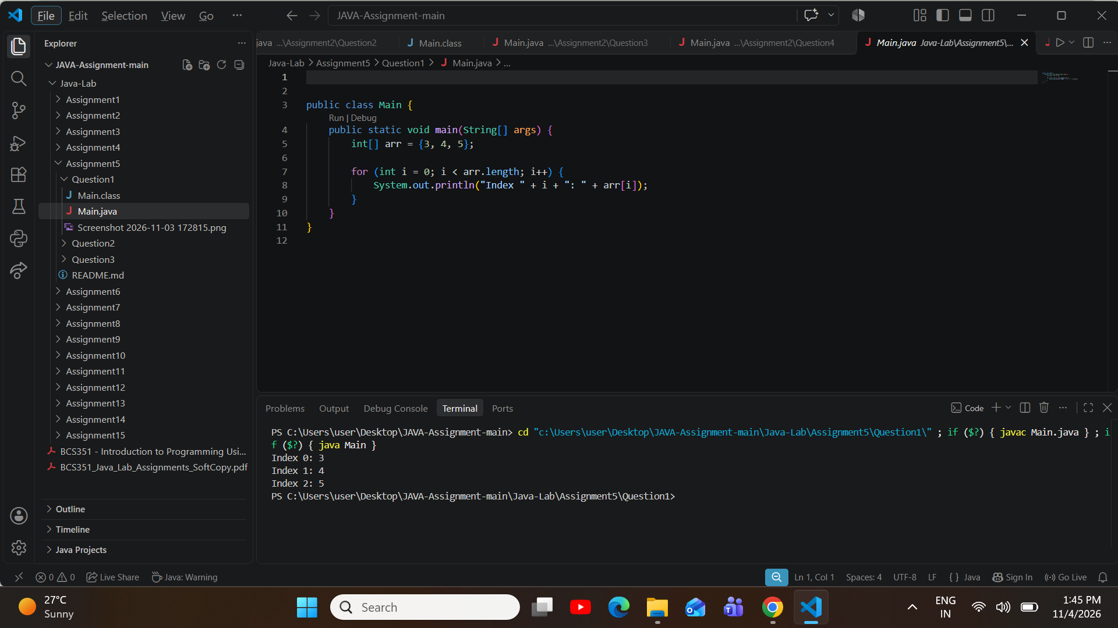
ProblemStatement:Createanintarraywiththevalues12,45,7,33and21.Usealooptofindthesumandthe largest value. Print Sum: followed by the sum, then Largest: followed by the largest value.
Question 2

Source Code (Main.java):

public class Main {
publicstaticvoidmain(String[]args){ int[] arr = {12, 45, 7, 33, 21};
int sum = 0;
int largest = arr[0];

for(inti=0;i<arr.length;i++){ sum += arr[i];
if(arr[i]>largest){ largest = arr[i];
}

}

System.out.println("Sum: " + sum); System.out.println("Largest:"+largest);
}
}

Execution Output Screenshot:
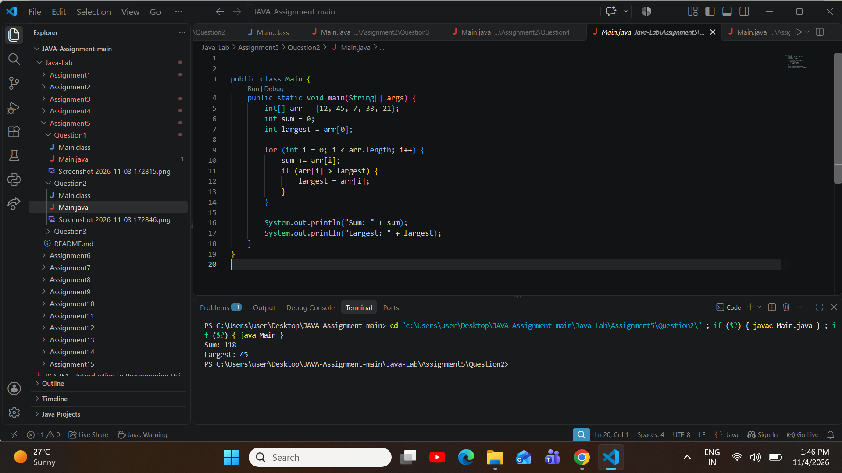
ProblemStatement:Createanintarraywiththevalues5,12,2,14and7.Usealooptocountthevaluesgreater than 10. Print Count greater than 10: followed by the count.
Question 3

Source Code (Main.java):

public class Main {
publicstaticvoidmain(String[]args){ int[] arr = {5, 12, 2, 14, 7};

int count = 0;

for(inti=0;i<arr.length;i++){ if (arr[i] > 10) {
count++;
}
}

System.out.println("Count greater than 10: " + count);
}
}

Execution Output Screenshot:
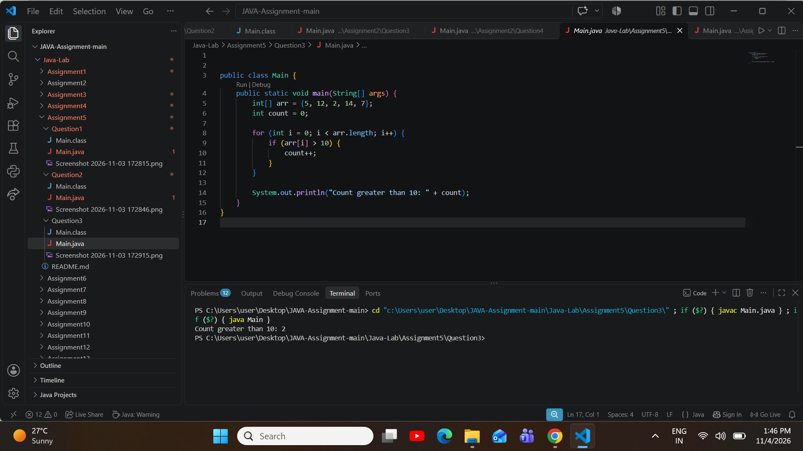

AssignmentAim/Objective:Printanarrayinreverseorder,findthesmallestvalue,andcheckanarray for repeated values.
Assignment 6: Arrays: Reverse and Duplicates
ProblemStatement:Createanintarraywiththevalues10,20,30,40and50.Printthevaluesinreverseorder, one value on each line, starting with the last value.
Question 1

Source Code (Main.java):

public class Main {
publicstaticvoidmain(String[]args){ int[] arr = {10, 20, 30, 40, 50};

for(inti=arr.length-1;i>=0;i--){ System.out.println(arr[i]);
}
}
}

Execution Output Screenshot:

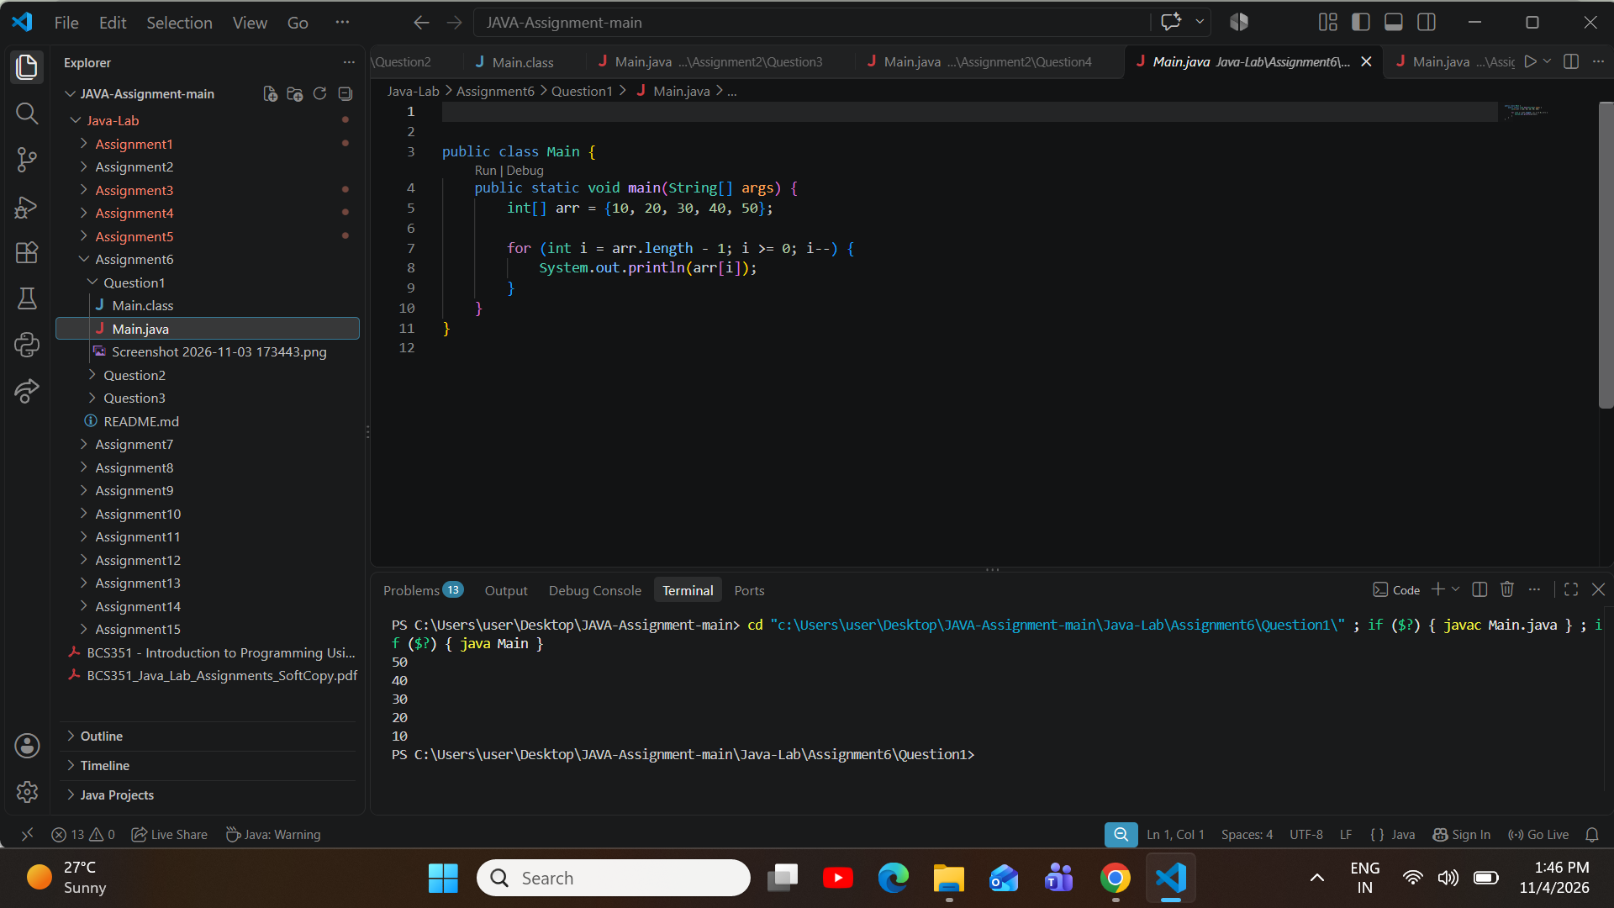
ProblemStatement:Createanintarraywiththevalues2,5,1,8,3and4.Usealooptofindthesmallestvalue and its index. Print Smallest: followed by the value, then the words at index and the index.
Question 2

Source Code (Main.java):

public class Main {
publicstaticvoidmain(String[]args){ int[] arr = {2, 5, 1, 8, 3, 4};
intsmallest=arr[0]; int index = 0;

for(inti=1;i<arr.length;i++){ if (arr[i] < smallest) {
smallest=arr[i]; index = i;
}

}

System.out.println("Smallest: " + smallest + " at index " + index);
}
}

Execution Output Screenshot:
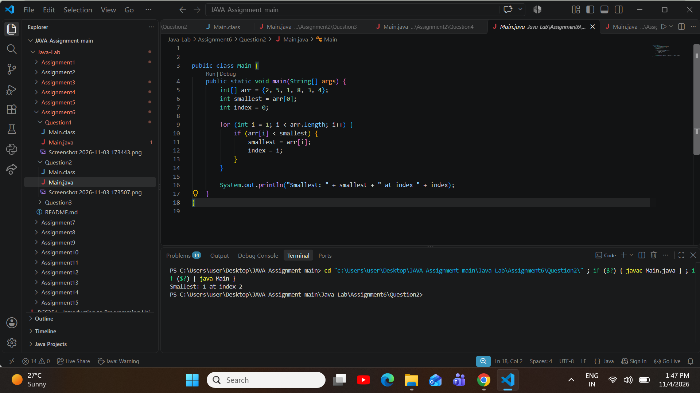
ProblemStatement:Createanintarraywiththevalues4,9,2,9and7.Usenestedloopstocheckfora repeated value. Print Repeated value: followed by it, or print No repeated value if none is repeated.
Question 3

Source Code (Main.java):

public class Main {
publicstaticvoidmain(String[]args){ int[] arr = {4, 9, 2, 9, 7};
boolean found = false;

int repeated = 0;

for (int i = 0; i < arr.length; i++) {
for(intj=i+1;j<arr.length;j++){ if (arr[i] == arr[j]) {
repeated=arr[i]; found = true; break;
}
}
if(found){ break;
}
}

if (found) {
System.out.println("Repeated value: " + repeated);
} else {
System.out.println("No repeated value");
}
}
}

Execution Output Screenshot:
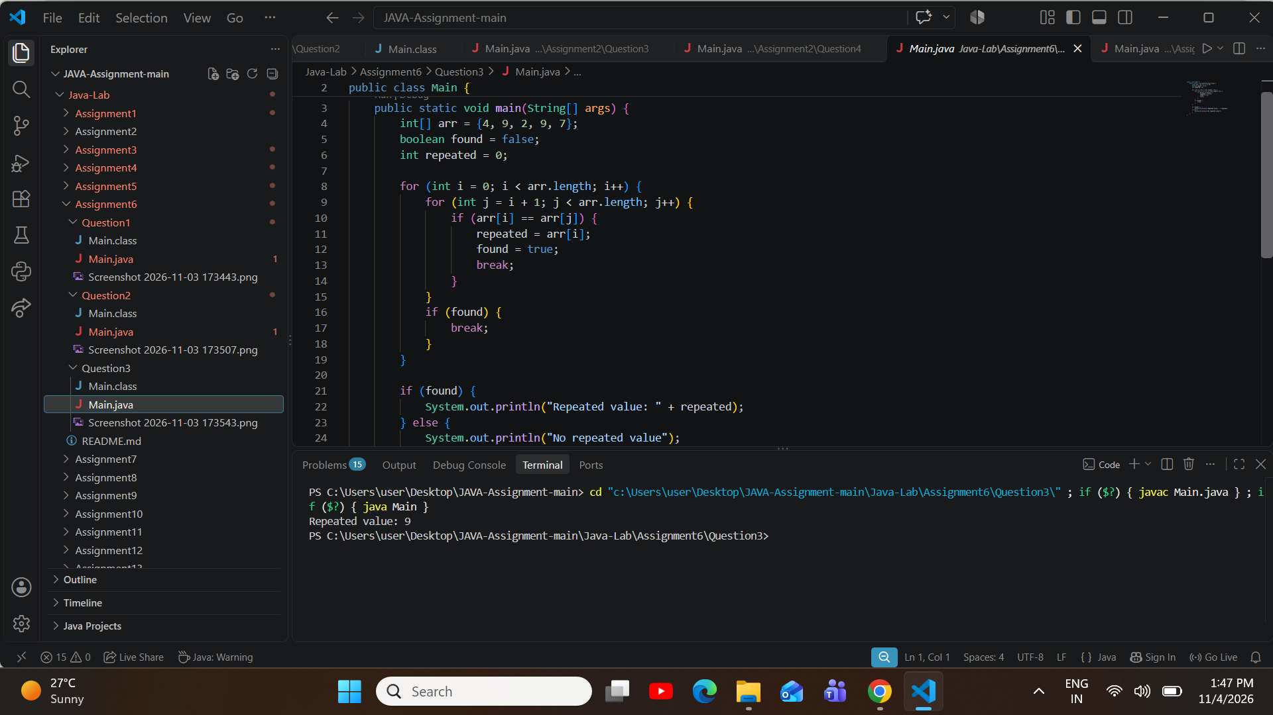

AssignmentAim/Objective:Countthestepsaprogramtakes,andwriteitstimecomplexityasa comment.
Assignment 7: Counting Steps and Complexity
ProblemStatement:Useoneloopthatrunsfrom1to10,andcountitssteps.Abovetheloop,writeacomment with its time complexity. Print Steps: followed by the number of steps.
Question 1

Source Code (Main.java):

public class Main {
publicstaticvoidmain(String[]args){ int steps = 0;

// Time Complexity: O(n)
for(inti=1;i<=10;i++){ steps++;
}

System.out.println("Steps: " + steps);
}
}

Execution Output Screenshot:

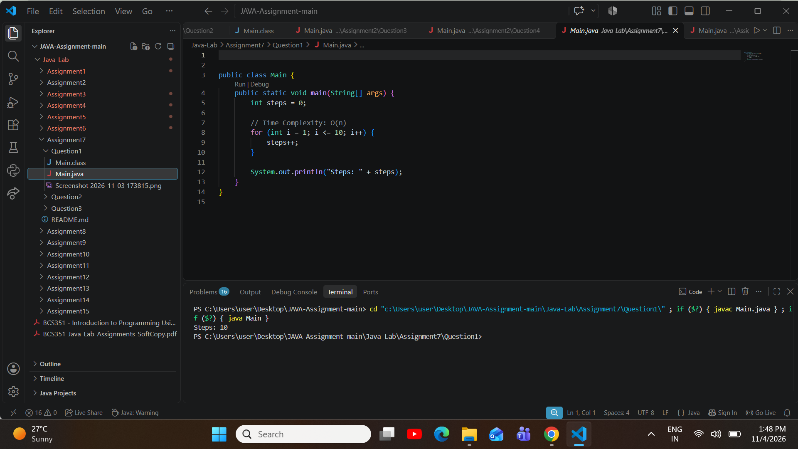
ProblemStatement:Usetwoloops,oneinsidetheother,thatbothrunfrom1to10.Counthowmanytimesthe inner loop body runs. Above the loops, write a comment with their time complexity. Print Steps: followed by the total.
Question 2

Source Code (Main.java):

public class Main {
publicstaticvoidmain(String[]args){ int steps = 0;

// Time Complexity: O(n^2)
for (int i = 1; i <= 10; i++) {
for(intj=1;j<=10;j++){ steps++;
}
}

System.out.println("Steps: " + steps);
}
}

Execution Output Screenshot:
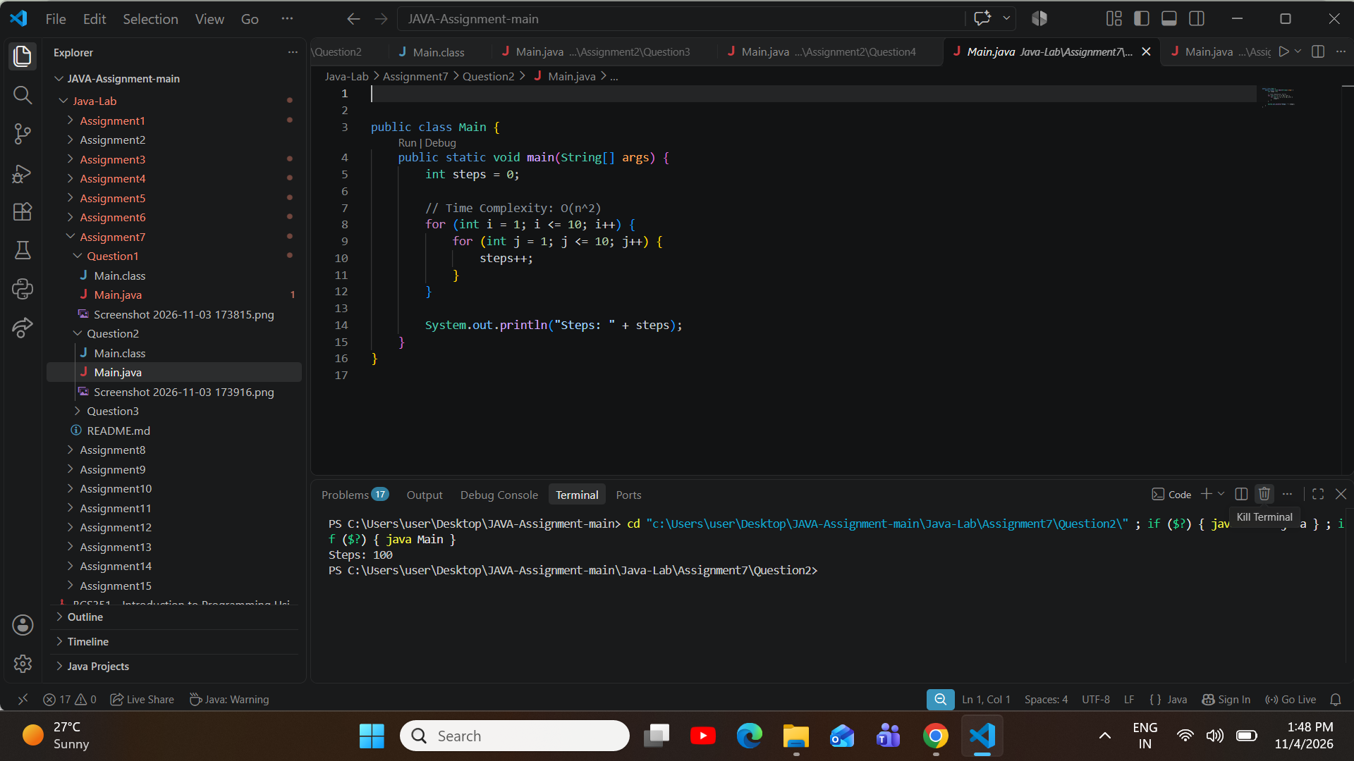
Problem Statement: Store 1024 in an int named n. Use a while loop that halves n until n is 1, and count the divisions.Abovetheloop,writeacommentwithitstimecomplexity.PrintHalvingsteps:followedbythecount.
Question 3

Source Code (Main.java):

public class Main {
publicstaticvoidmain(String[]args){ int n = 1024;
int count = 0;

//TimeComplexity:O(logn) while (n > 1) {
n=n/2; count++;
}

System.out.println("Halving steps: " + count);
}
}

Execution Output Screenshot:
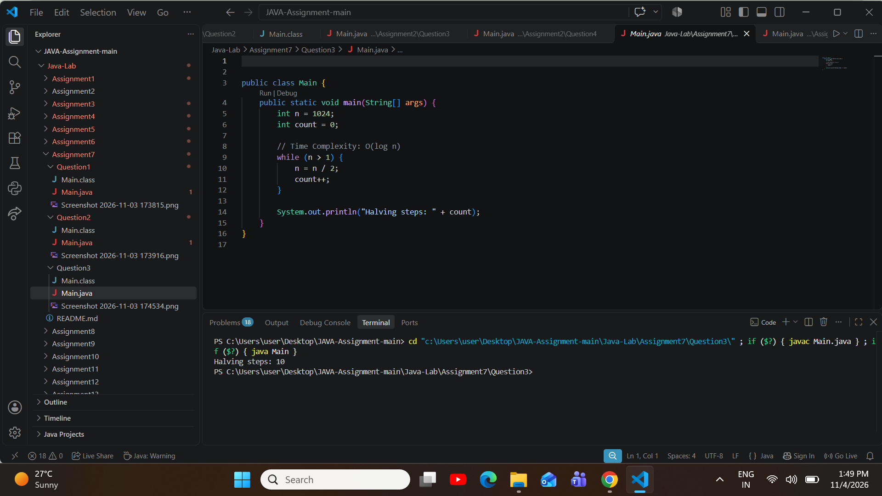

AssignmentAim/Objective:Createtwo-dimensionalarrays,visitthemrowbyrow,andbuildanew matrix from one.
Assignment 8: Matrices: Transpose and Row Sums
ProblemStatement:Createamatrixnamedmwith3rowsand4columns.Fillitwiththevalues1to12,rowby row, using nested loops. Print the matrix one row per line, with a space after each number.
Question 1

Source Code (Main.java):

public class Main {
publicstaticvoidmain(String[]args){ int[][] m = new int[3][4];
int val = 1;

for (int i = 0; i < 3; i++) {
for(intj=0;j<4;j++){ m[i][j] = val++;
}
}

for (int i = 0; i < 3; i++) {
for (int j = 0; j < 4; j++) { System.out.print(m[i][j]+"");
}
System.out.println();
}
}
}

Execution Output Screenshot:

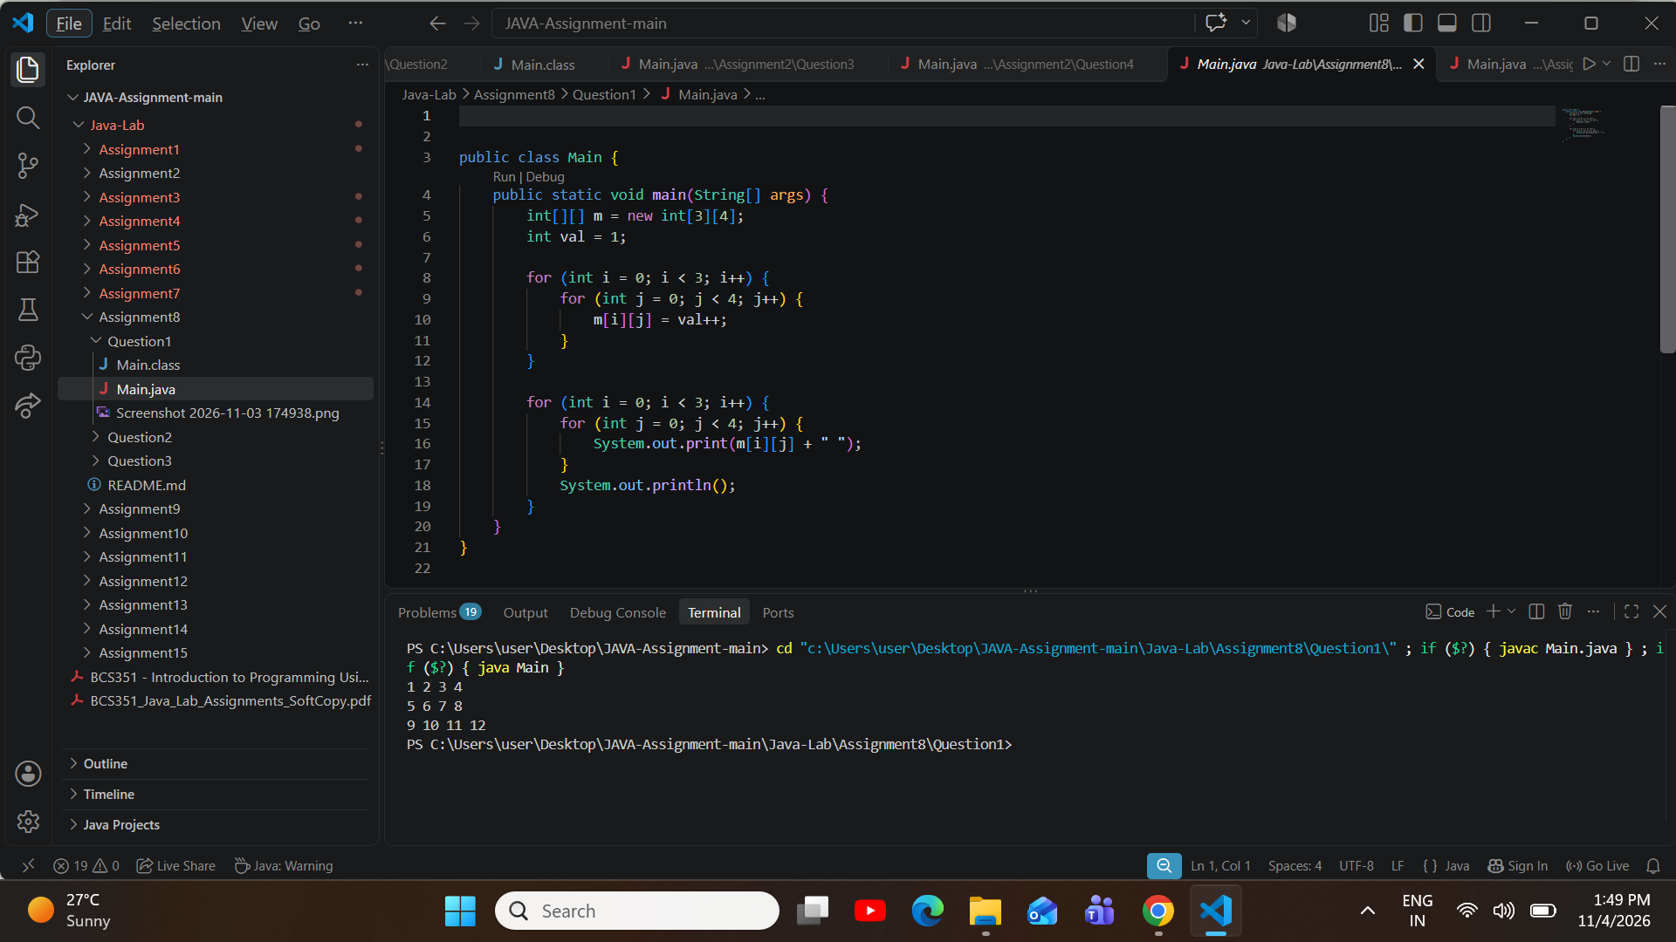
ProblemStatement:Createthe3by3matrixwiththerows123,456and789.Createitstranspose(rowsand columns swapped). Print the transpose one row per line, with a space after each number.
Question 2

Source Code (Main.java):

public class Main {
publicstaticvoidmain(String[]args){ int[][] matrix = {
{1, 2, 3},
{4, 5, 6},
{7, 8, 9}
};

int[][] transpose = new int[3][3];

for (int i = 0; i < 3; i++) {

for (int j = 0; j < 3; j++) { transpose[j][i]=matrix[i][j];
}
}

for (int i = 0; i < 3; i++) {
for (int j = 0; j < 3; j++) { System.out.print(transpose[i][j]+"");
}
System.out.println();
}
}
}

Execution Output Screenshot:
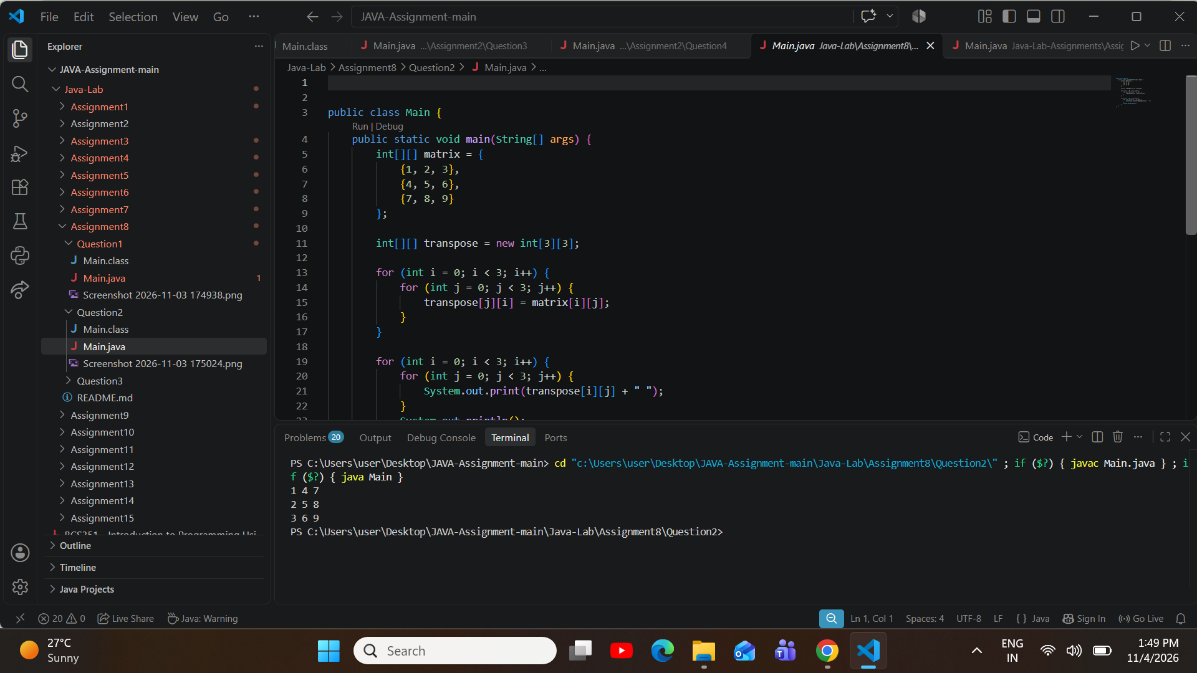
ProblemStatement:Usethe3by3matrixwiththerows123,456and789.Printthesumofeachrow,one line per row, in the form Row 1 sum: followed by the total.
Question 3

Source Code (Main.java):

public class Main {
publicstaticvoidmain(String[]args){ int[][] matrix = {
{1, 2, 3},
{4, 5, 6},
{7, 8, 9}
};

for(inti=0;i<matrix.length;i++){ int rowSum = 0;
for(intj=0;j<matrix[i].length;j++){ rowSum += matrix[i][j];
}
System.out.println("Row " + (i + 1) + " sum: " + rowSum);
}
}
}

Execution Output Screenshot:
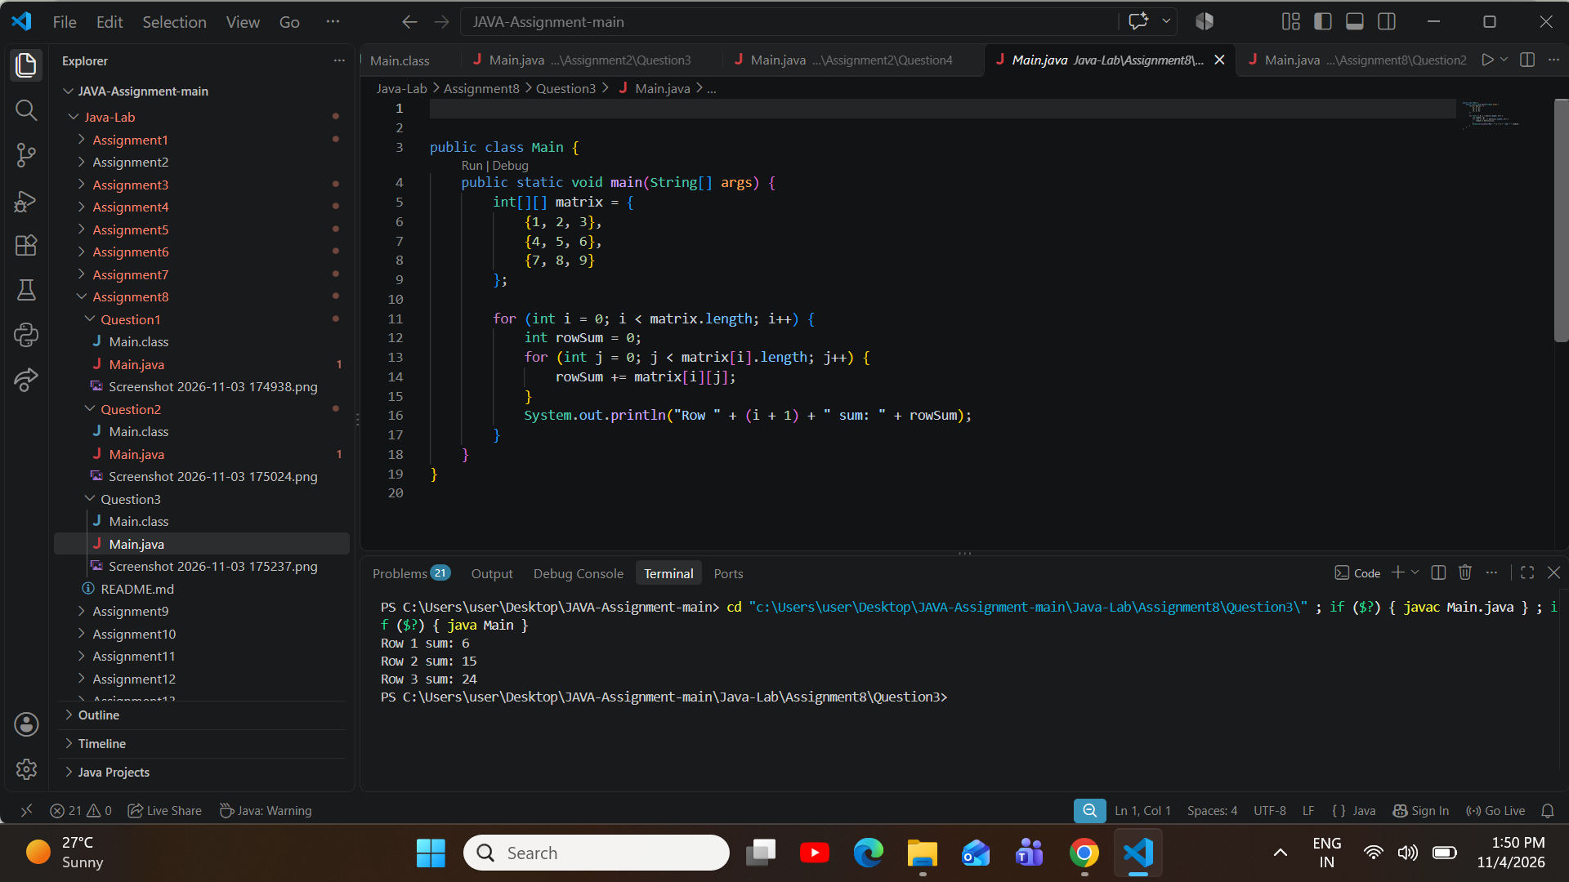

AssignmentAim/Objective:Visittherowsandcolumnsofamatrixwithnestedloopstoprint,addand count its values.
Assignment 9: Matrices: Rows and Columns
ProblemStatement:Usethe3by3matrixwithrows123,456and789.PrintFirstrow:anditsvalues,then Last row: and its values, with a space between values.
Question 1

Source Code (Main.java):

public class Main {
publicstaticvoidmain(String[]args){ int[][] matrix = {
{1, 2, 3},
{4, 5, 6},
{7, 8, 9}
};

System.out.print("First row:");
for(intj=0;j<matrix[0].length;j++){ System.out.print("" + matrix[0][j]);
}
System.out.println();

System.out.print("Last row:");
for(intj=0;j<matrix[matrix.length-1].length;j++){ System.out.print("" + matrix[matrix.length - 1][j]);
}
System.out.println();
}
}

Execution Output Screenshot:

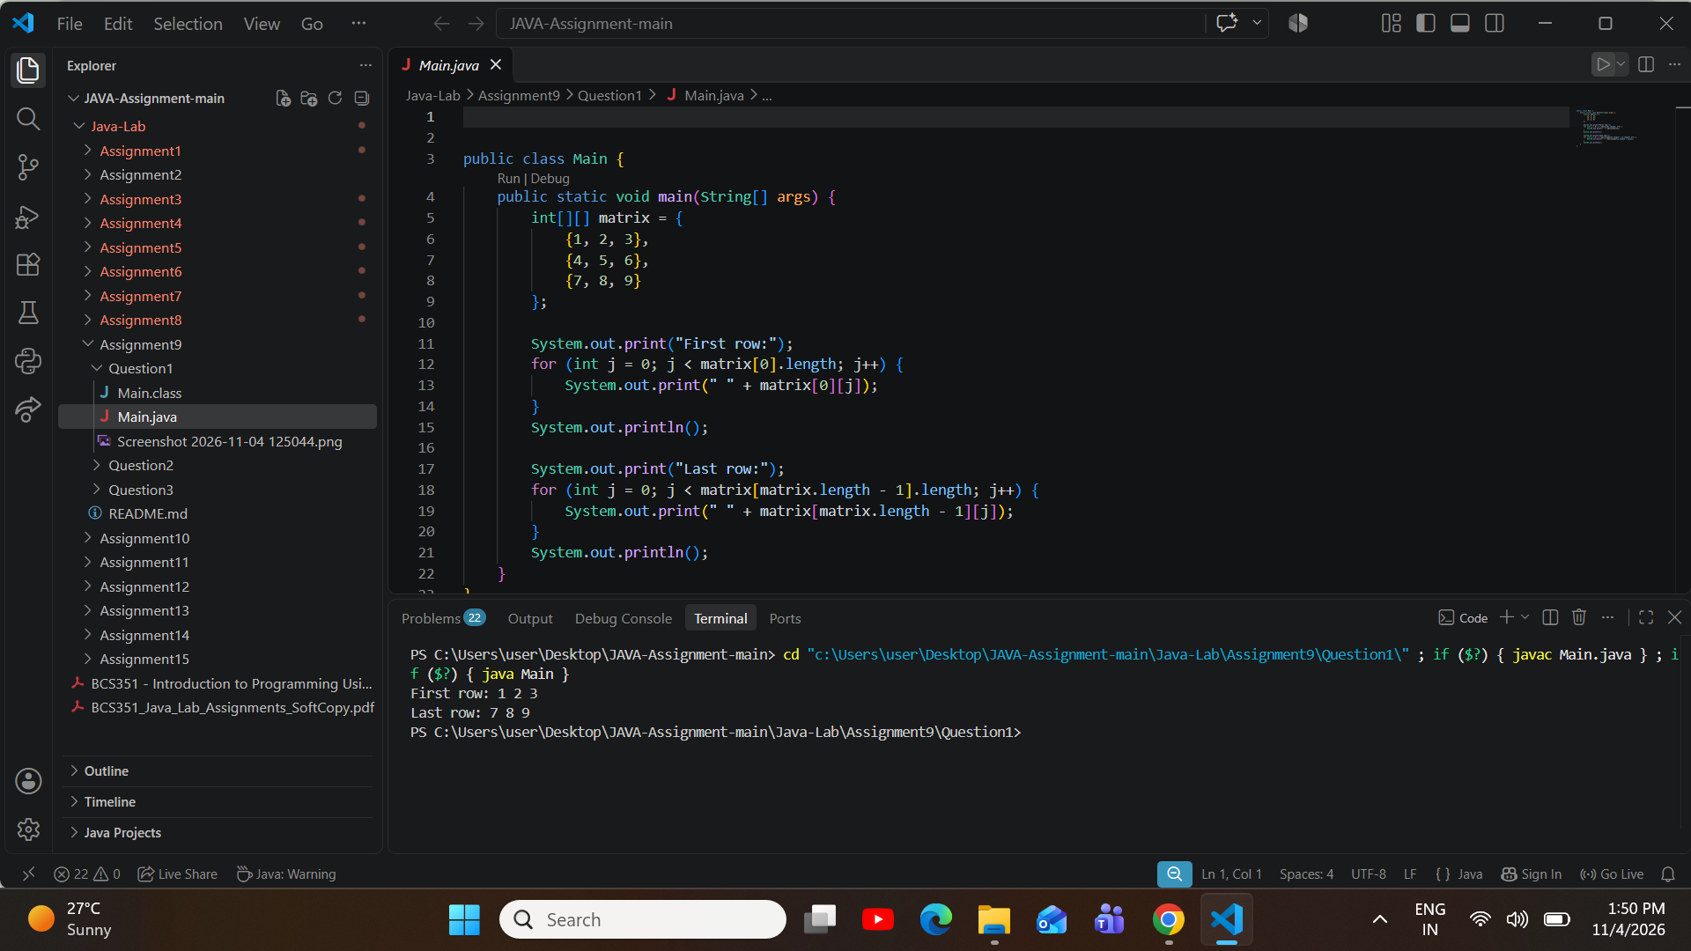

ProblemStatement:Usethe3by3matrixwiththerows123,456and789.Printthesumofeachcolumn, one line per column, in the form Column 1 sum: followed by the total.
Question 2

Source Code (Main.java):

public class Main {
publicstaticvoidmain(String[]args){ int[][] matrix = {
{1, 2, 3},
{4, 5, 6},
{7, 8, 9}
};

for(intj=0;j<matrix[0].length;j++){ int colSum = 0;
for (int i = 0; i < matrix.length; i++) {

colSum += matrix[i][j];
}
System.out.println("Column " + (j + 1) + " sum: " + colSum);
}
}
}

Execution Output Screenshot:
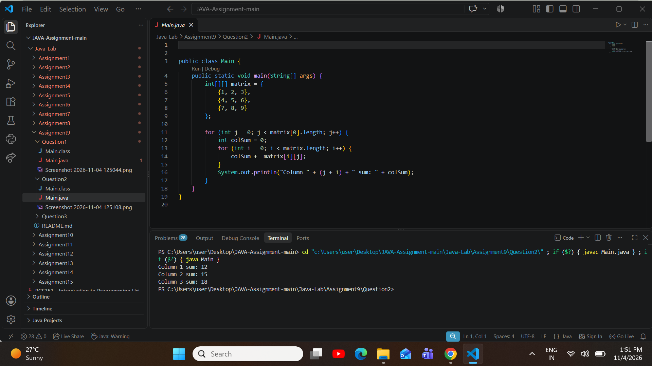
ProblemStatement:Usethe3by3matrixwiththerows123,456and789.Countthevaluesgreaterthan5 and print Values greater than 5: followed by the count.
Question 3

Source Code (Main.java):

public class Main {
publicstaticvoidmain(String[]args){ int[][] matrix = {

{1, 2, 3},
{4, 5, 6},
{7, 8, 9}
};

int count = 0;
for (int i = 0; i < matrix.length; i++) {
for(intj=0;j<matrix[i].length;j++){ if (matrix[i][j] > 5) {
count++;
}
}
}

System.out.println("Values greater than 5: " + count);
}
}

Execution Output Screenshot:
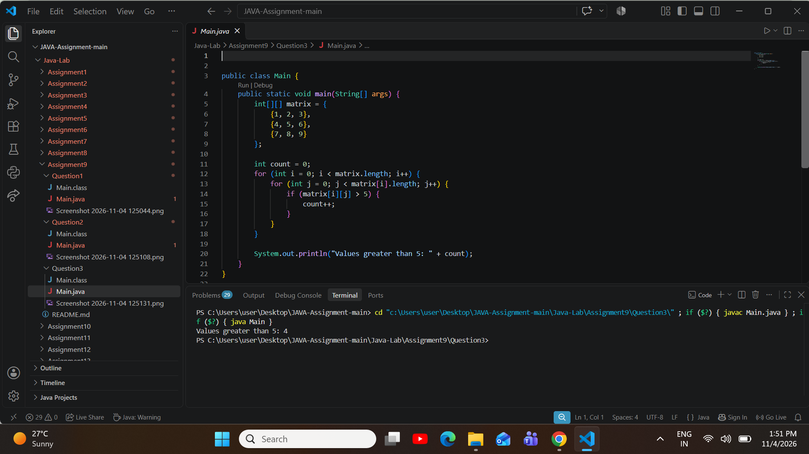

AssignmentAim/Objective:Chooseabranchwithaswitchstatement,andstoreandchangealistof numbers in an ArrayList.
Assignment 10: Switch and ArrayList
ProblemStatement:Store3inanintnamedday.Useaswitchstatementtoprintthenameoftheday:1is Monday, 2 is Tuesday and 3 is Wednesday. For any other number, print Invalid day.
Question 1

Source Code (Main.java):

public class Main {
publicstaticvoidmain(String[]args){ int day = 3;

switch(day){ case 1:
System.out.println("Monday"); break;
case 2:
System.out.println("Tuesday"); break;
case 3:
System.out.println("Wednesday"); break;
default:
System.out.println("Invalidday"); break;
}
}
}

Execution Output Screenshot:

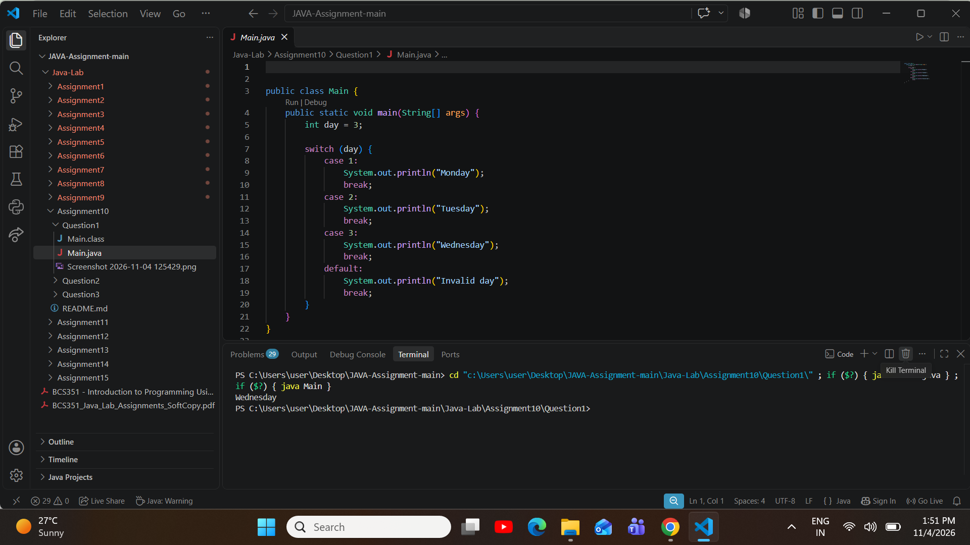
ProblemStatement:CreateanArrayListofIntegernamedlist.Addthevalues10,20,30and40.Printthewhole list. Then print Size: followed by its size, and Item at index 2: followed by the value at index 2.
Question 2

Source Code (Main.java):

import java.util.ArrayList;

public class Main {
public static void main(String[] args) { ArrayList<Integer>list=newArrayList<Integer>(); list.add(10);
list.add(20);
list.add(30);
list.add(40);

System.out.println(list);

System.out.println("Size: " + list.size()); System.out.println("Itematindex2:"+list.get(2));
}
}

Execution Output Screenshot:
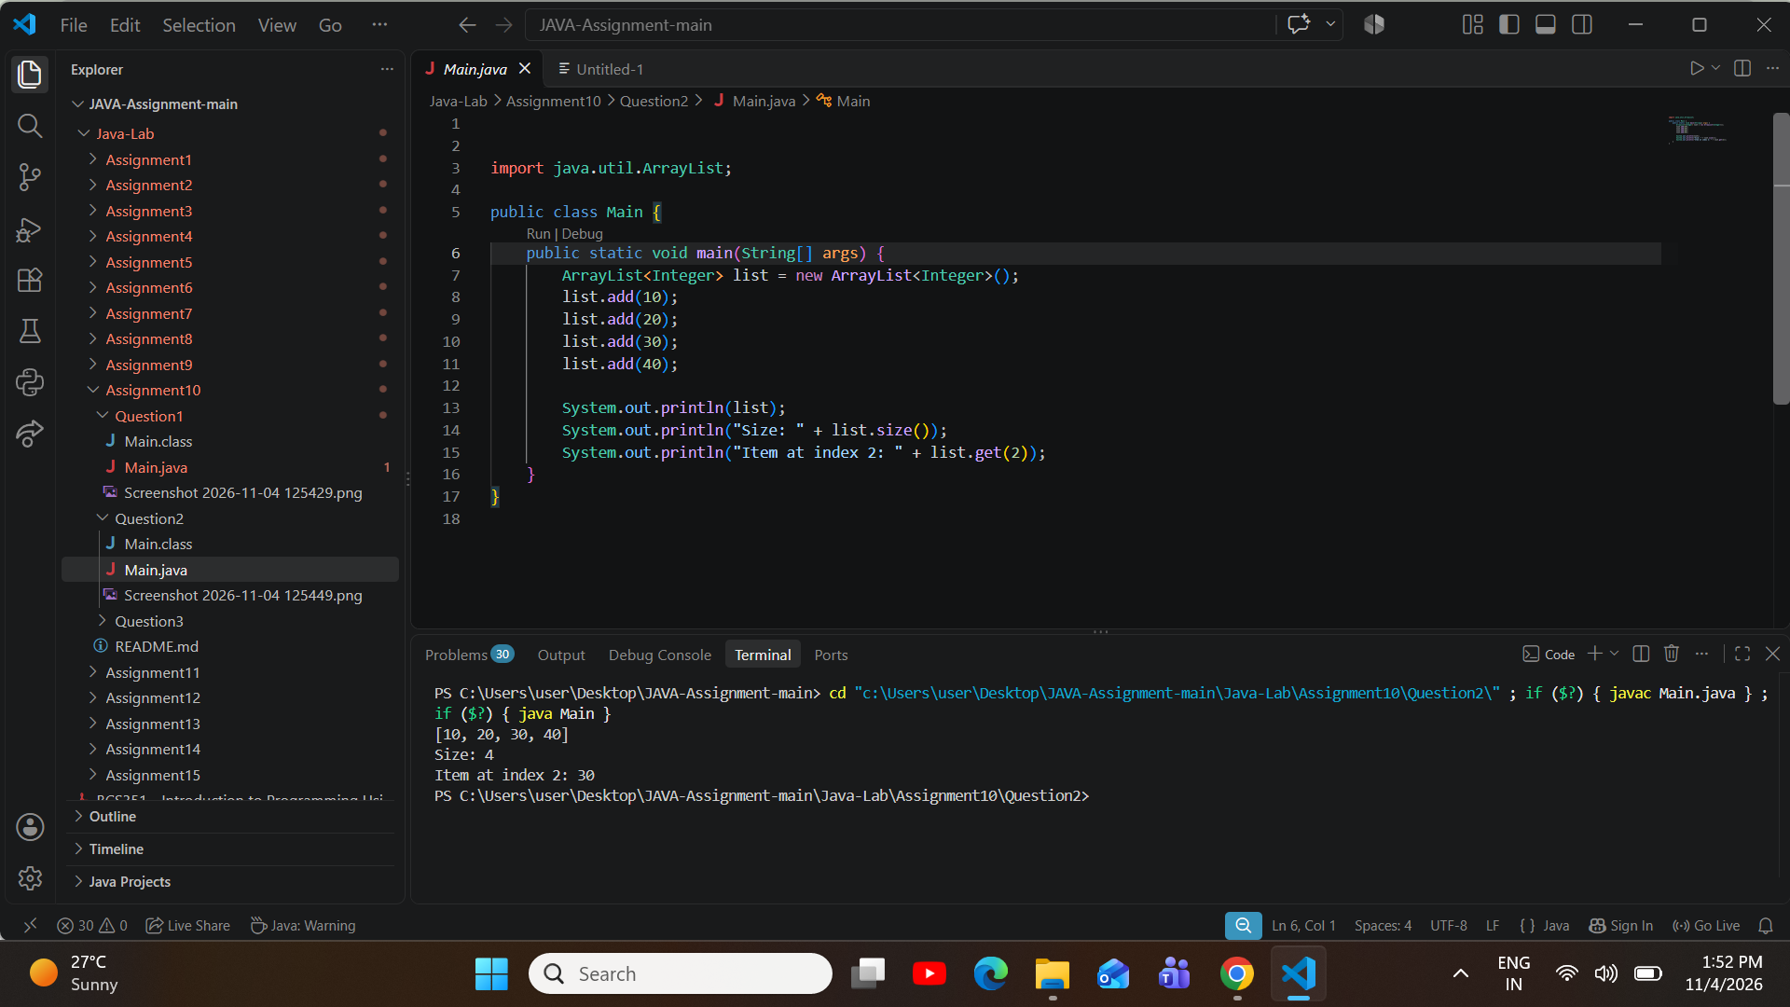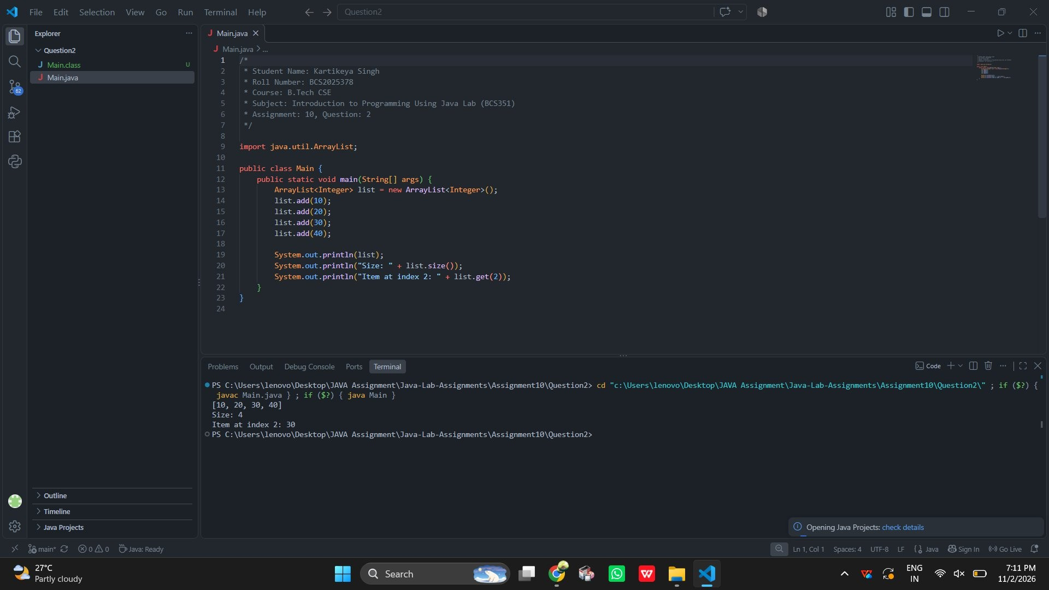
ProblemStatement:CreateanArrayListofIntegernamedlistwiththevalues10,20,30and40.Usesetto change index 1 to 25, and remove to delete index 3. Print the list and Size: followed by its size.
Question 3

Source Code (Main.java):

import java.util.ArrayList;

public class Main {
public static void main(String[] args) { ArrayList<Integer>list=newArrayList<Integer>();

list.add(10);
list.add(20);
list.add(30);
list.add(40);

list.set(1,25); list.remove(3);

System.out.println(list); System.out.println("Size:"+list.size());
}
}

Execution Output Screenshot:
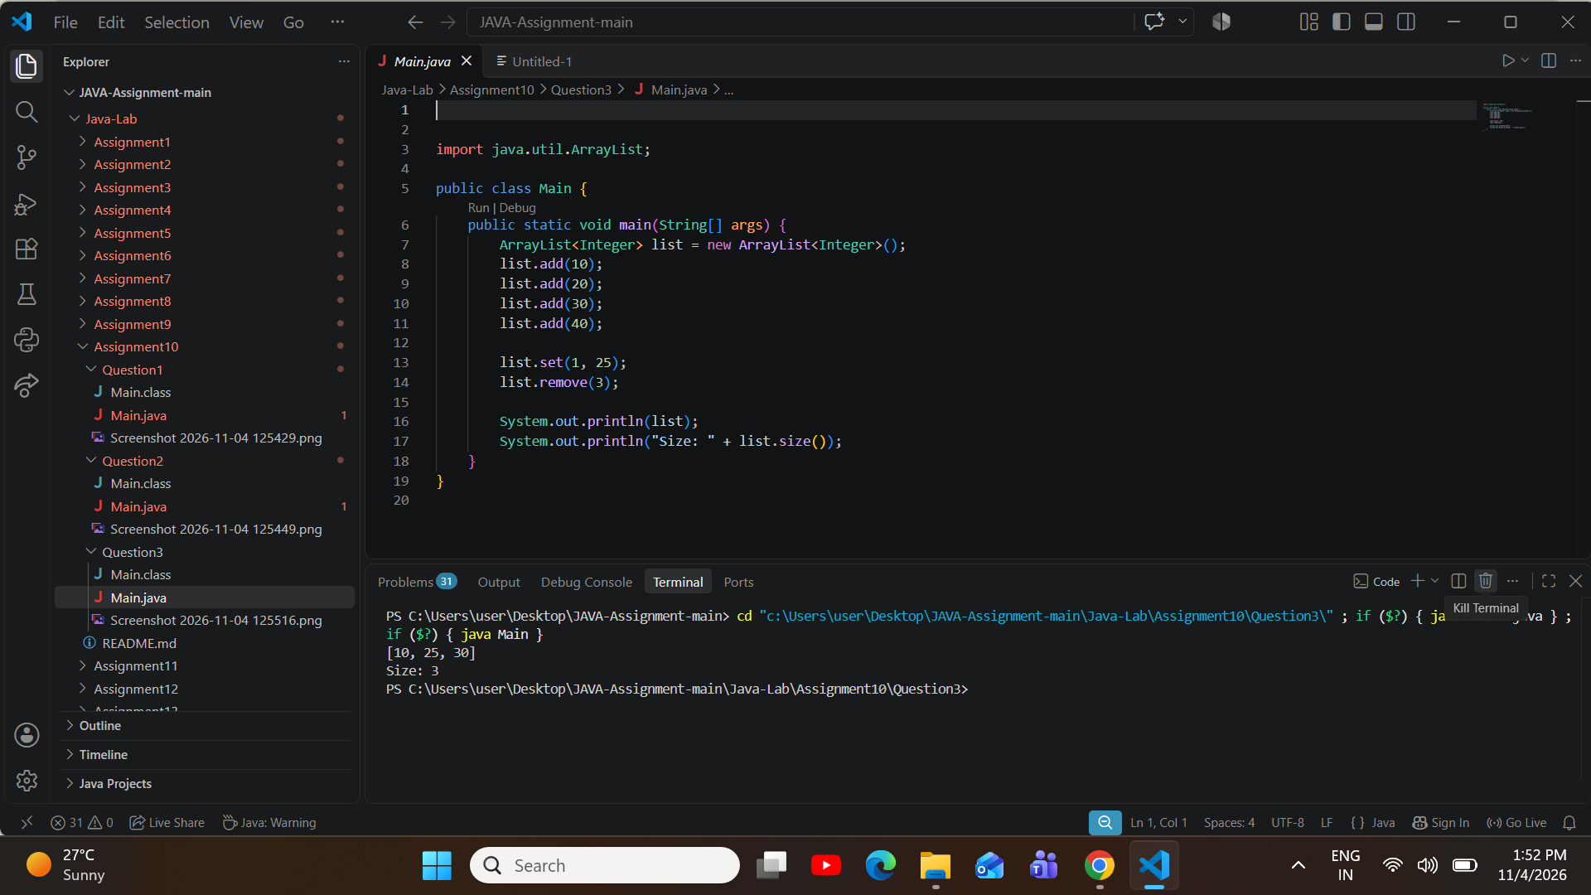

Assignment Aim / Objective: Sort small arrays with bubble sort and selection sort, and count the swaps.
Assignment 11: Bubble Sort and Selection Sort
ProblemStatement:Createtheintarray5,1,4,2,8.Sortitinincreasingorderwithbubblesort.PrintSorted: followed by the sorted values in square brackets, separated by commas.
Question 1

Source Code (Main.java):

import java.util.Arrays;

public class Main {
publicstaticvoidmain(String[]args){ int[] arr = {5, 1, 4, 2, 8};

for (int i = 0; i < arr.length - 1; i++) {
for(intj=0;j<arr.length-1-i;j++){ if (arr[j] > arr[j + 1]) {
int temp = arr[j]; arr[j]=arr[j+1]; arr[j + 1] = temp;
}
}
}

System.out.println("Sorted: " + Arrays.toString(arr));
}
}

Execution Output Screenshot:

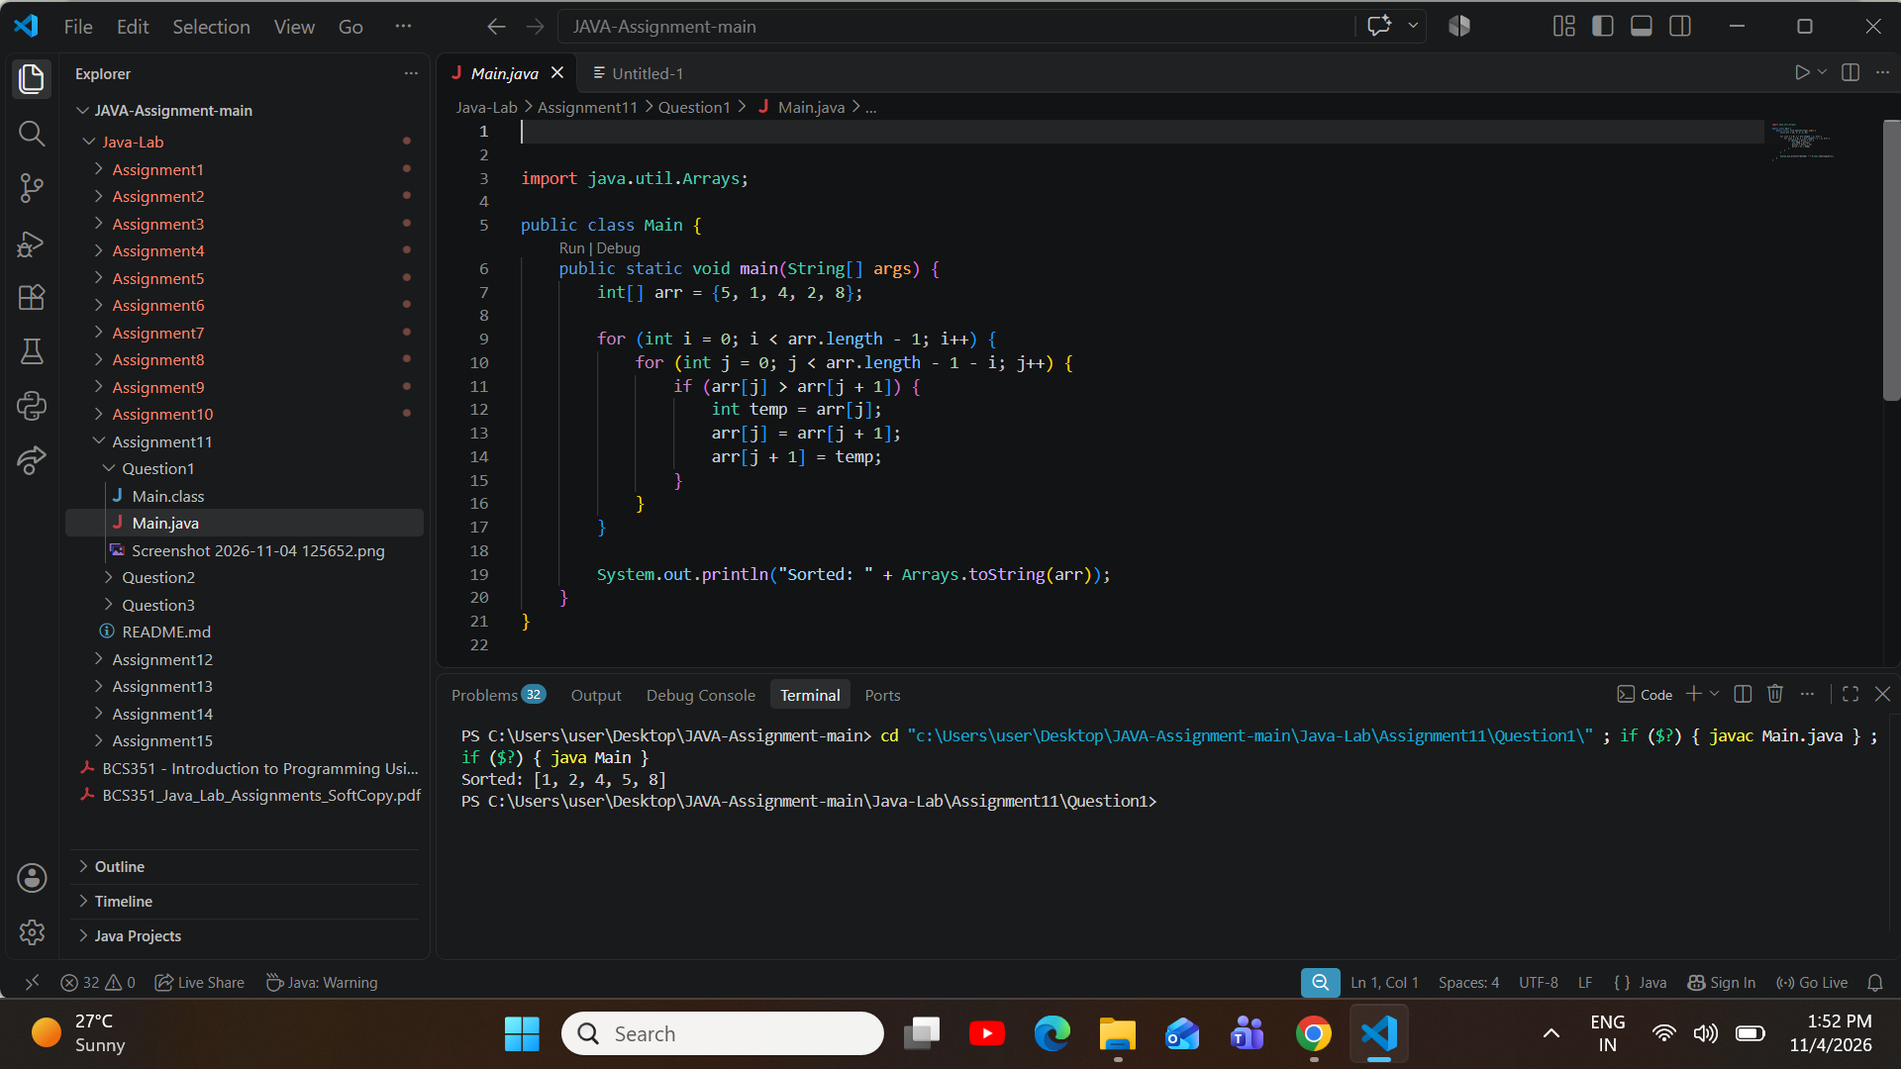
ProblemStatement:Createtheintarray64,25,12,22,11.Sortitinincreasingorderwithselectionsort.Print Sorted: followed by the sorted values in square brackets, separated by commas.
Question 2

Source Code (Main.java):

import java.util.Arrays;

public class Main {
publicstaticvoidmain(String[]args){ int[] arr = {64, 25, 12, 22, 11};

for(inti=0;i<arr.length-1;i++){ int minIdx = i;
for(intj=i+1;j<arr.length;j++){ if (arr[j] < arr[minIdx]) {
minIdx = j;

}
}
inttemp=arr[minIdx]; arr[minIdx] = arr[i]; arr[i] = temp;
}

System.out.println("Sorted: " + Arrays.toString(arr));
}
}

Execution Output Screenshot:
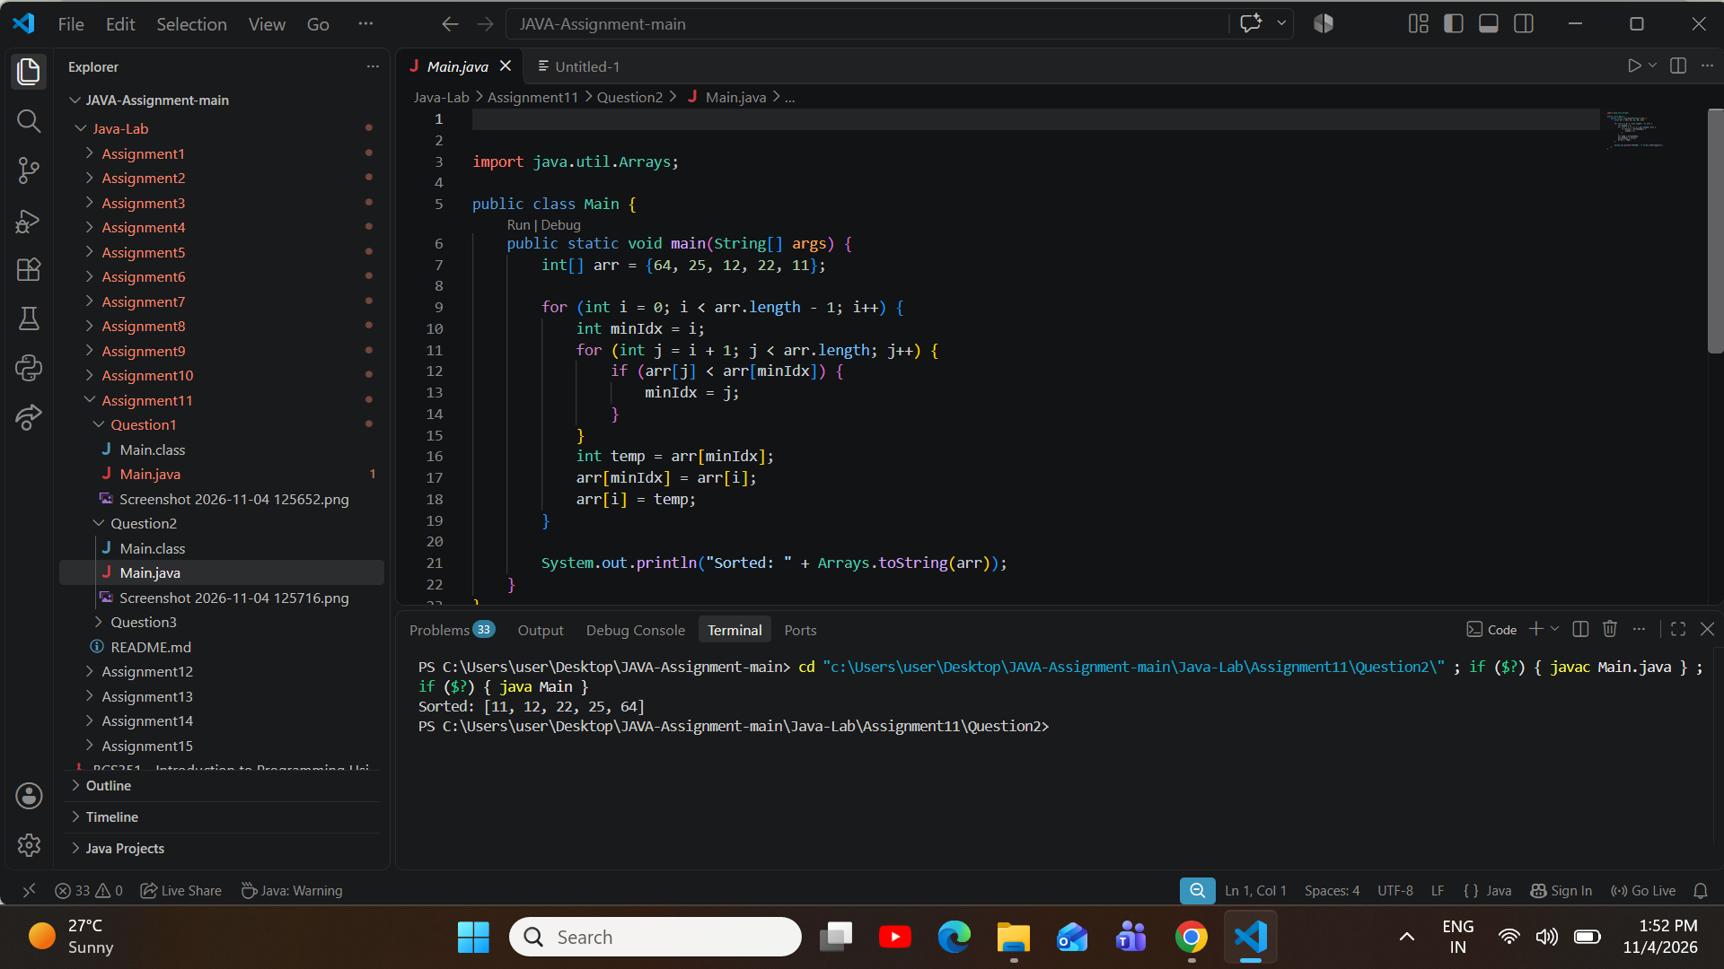
ProblemStatement:Usethearray5,1,4,2,8andsortitwithbubblesort.Counttheswaps(eachtimetwo values change places). Print Swaps: followed by the count.
Question 3

Source Code (Main.java):

public class Main {
publicstaticvoidmain(String[]args){ int[] arr = {5, 1, 4, 2, 8};
int swaps = 0;

for (int i = 0; i < arr.length - 1; i++) {
for(intj=0;j<arr.length-1-i;j++){ if (arr[j] > arr[j + 1]) {
int temp = arr[j]; arr[j]=arr[j+1]; arr[j + 1] = temp; swaps++;
}
}
}

System.out.println("Swaps: " + swaps);
}
}

Execution Output Screenshot:
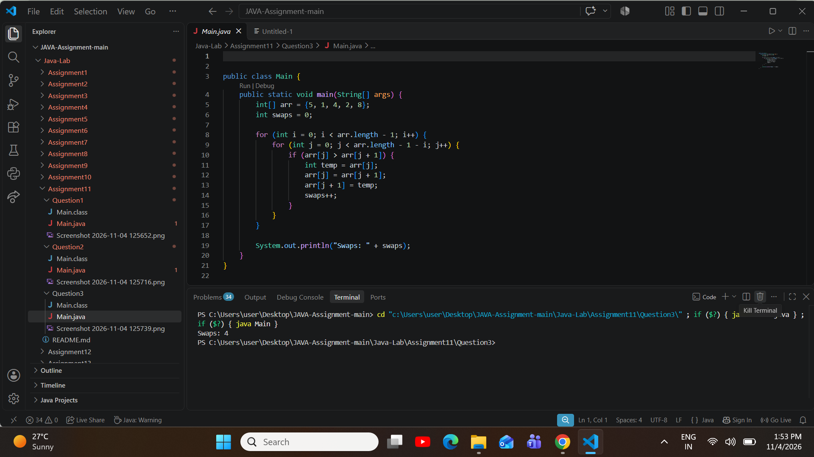

Assignment Aim / Objective: Sort small arrays with insertion sort and count how many values are shifted.
Assignment 12: Insertion Sort
ProblemStatement:Createtheintarray7,3,5,1.Sortitinincreasingorderwithinsertionsort.PrintSorted: followed by the sorted values in square brackets, separated by commas.
Question 1

Source Code (Main.java):

import java.util.Arrays;

public class Main {
publicstaticvoidmain(String[]args){ int[] arr = {7, 3, 5, 1};

for(inti=1;i<arr.length;i++){ int key = arr[i];
int j = i - 1;
while(j>=0&&arr[j]>key){ arr[j + 1] = arr[j];
j--;
}
arr[j + 1] = key;
}

System.out.println("Sorted: " + Arrays.toString(arr));
}
}

Execution Output Screenshot:

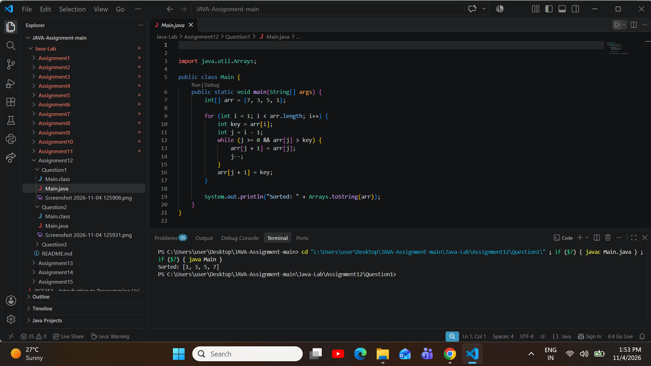
ProblemStatement:Createtheintarray14,3,9,21,6.Sortitinincreasingorderwithinsertionsort.Print Sorted: followed by the sorted values in square brackets, separated by commas.
Question 2

Source Code (Main.java):

import java.util.Arrays;

public class Main {
publicstaticvoidmain(String[]args){ int[] arr = {14, 3, 9, 21, 6};

for(inti=1;i<arr.length;i++){ int key = arr[i];
int j = i - 1;
while(j>=0&&arr[j]>key){ arr[j + 1] = arr[j];

j--;
}
arr[j + 1] = key;
}

System.out.println("Sorted: " + Arrays.toString(arr));
}
}

Execution Output Screenshot:
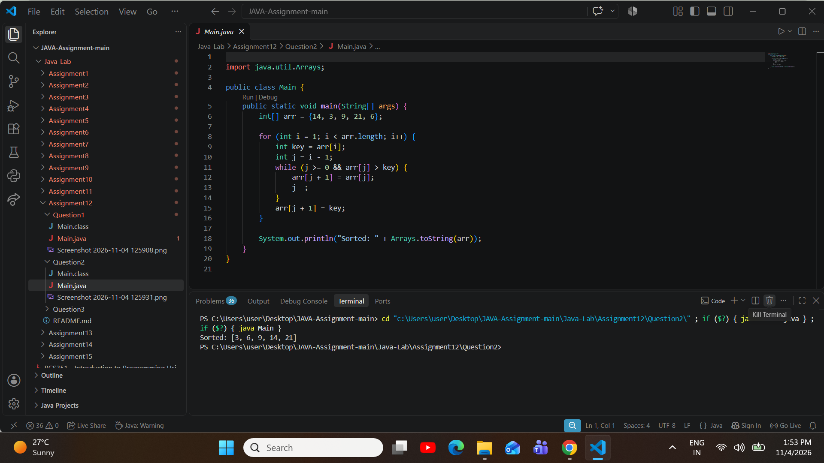
ProblemStatement:Createtheintarray6,5,4,3,2,1.Sortitinincreasingorderwithinsertionsort.Countthe shifts (each time one value moves one place to the right). Print Shifts: followed by the count.
Question 3

Source Code (Main.java):

public class Main {

publicstaticvoidmain(String[]args){ int[] arr = {6, 5, 4, 3, 2, 1};
int shifts = 0;

for(inti=1;i<arr.length;i++){ int key = arr[i];
int j = i - 1;
while(j>=0&&arr[j]>key){ arr[j + 1] = arr[j]; shifts++;
j--;
}
arr[j + 1] = key;
}

System.out.println("Shifts: " + shifts);
}
}

Execution Output Screenshot:
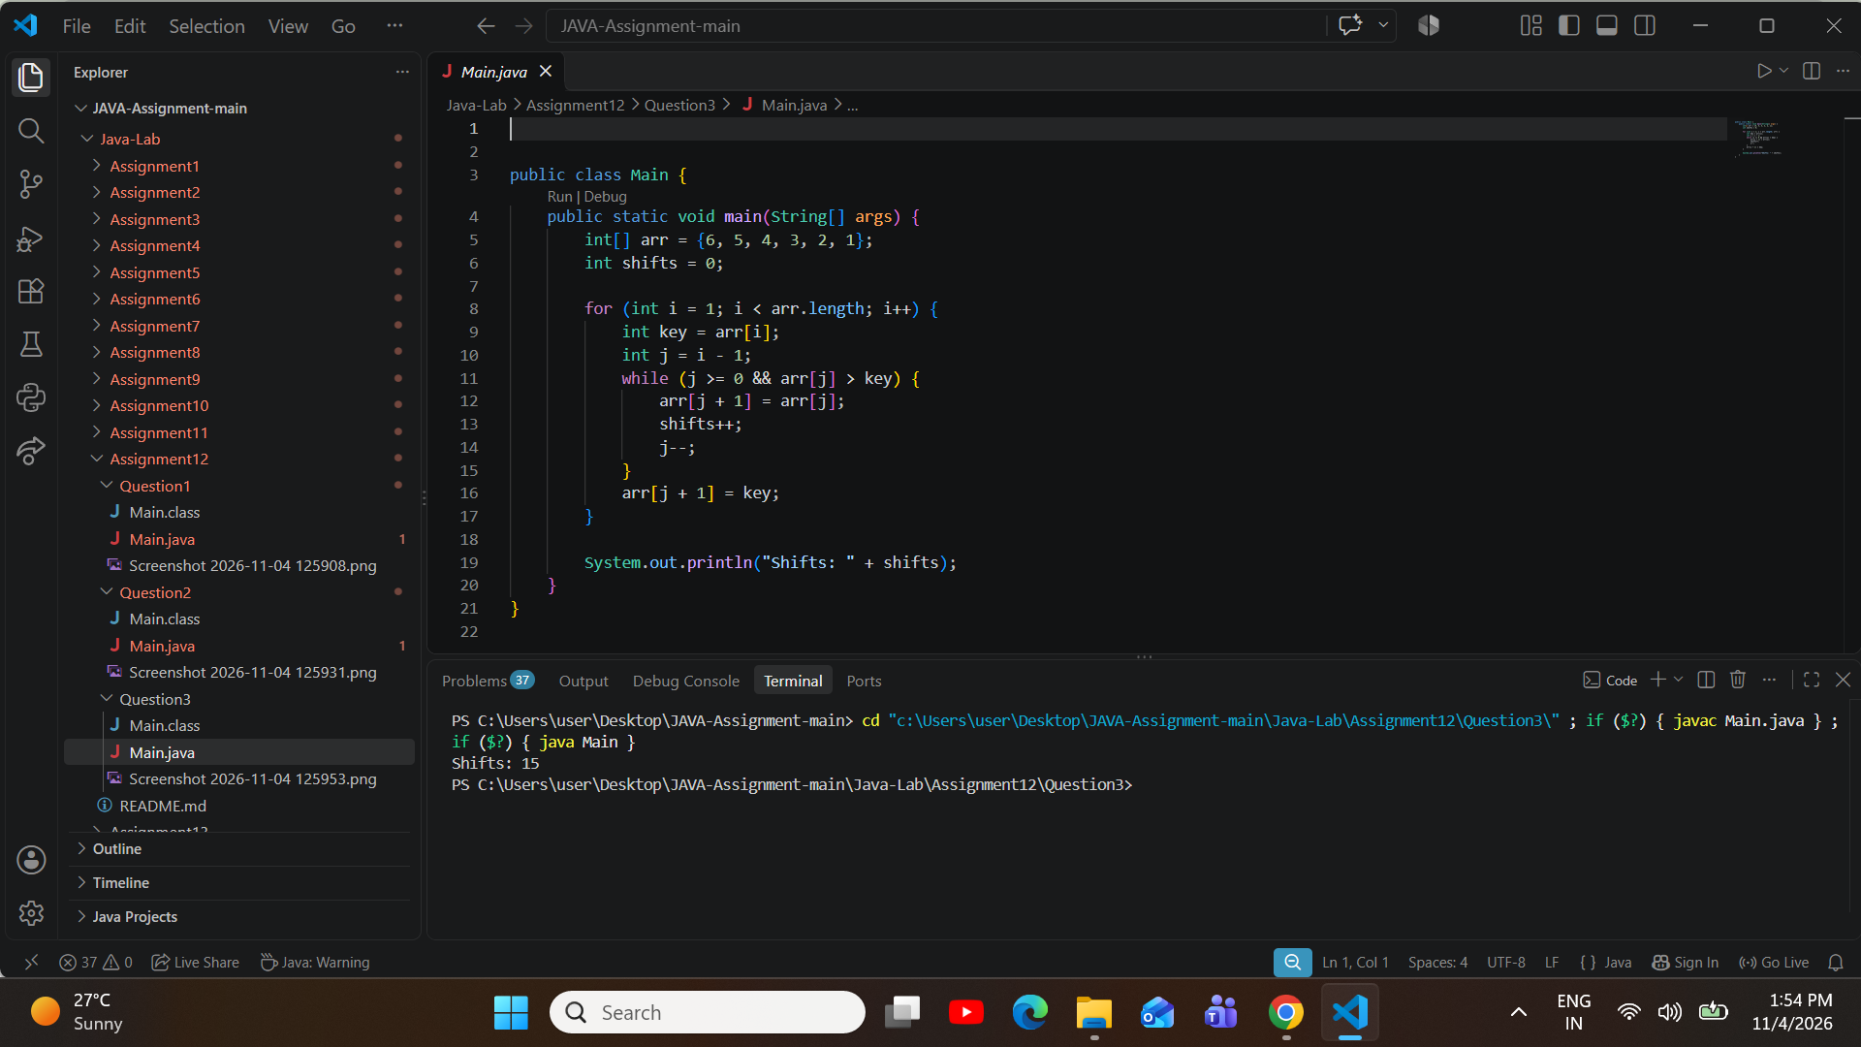

AssignmentAim/Objective:UsecommonStringmethods,reverseaword,checkapalindromeandprint substrings.
Assignment 13: Strings: Methods and Palindromes
ProblemStatement:UsethewordProgramming.PrintLength:followedbyitslength,Positionofg:followedby the position of the first g (counting from 0), and Upper case: followed by the word in capital letters, using toUpperCase().
Question 1

Source Code (Main.java):

public class Main {
publicstaticvoidmain(String[]args){ String str = "Programming";

System.out.println("Length: " + str.length()); System.out.println("Positionofg:"+str.indexOf('g')); System.out.println("Upper case: " + str.toUpperCase());
}
}

Execution Output Screenshot:

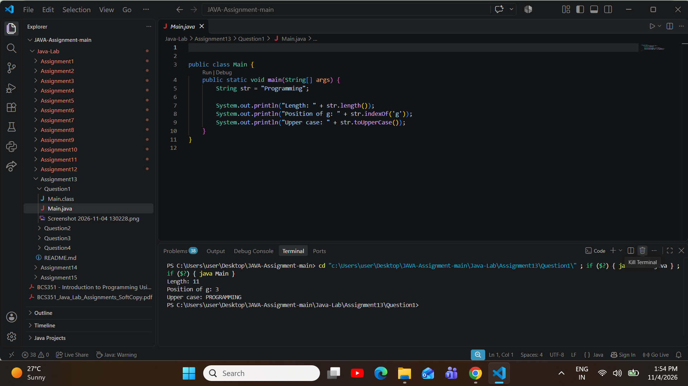
ProblemStatement:ReversethewordJava.Buildthereversedwordoneletteratatime,usingcharAtand+ina loop. Print Reversed: followed by the result.
Question 2

Source Code (Main.java):

public class Main {
publicstaticvoidmain(String[]args){ String word = "Java";
String reversed = "";

for(inti=word.length()-1;i>=0;i--){ reversed += word.charAt(i);
}

System.out.println("Reversed: " + reversed);
}

}

Execution Output Screenshot:
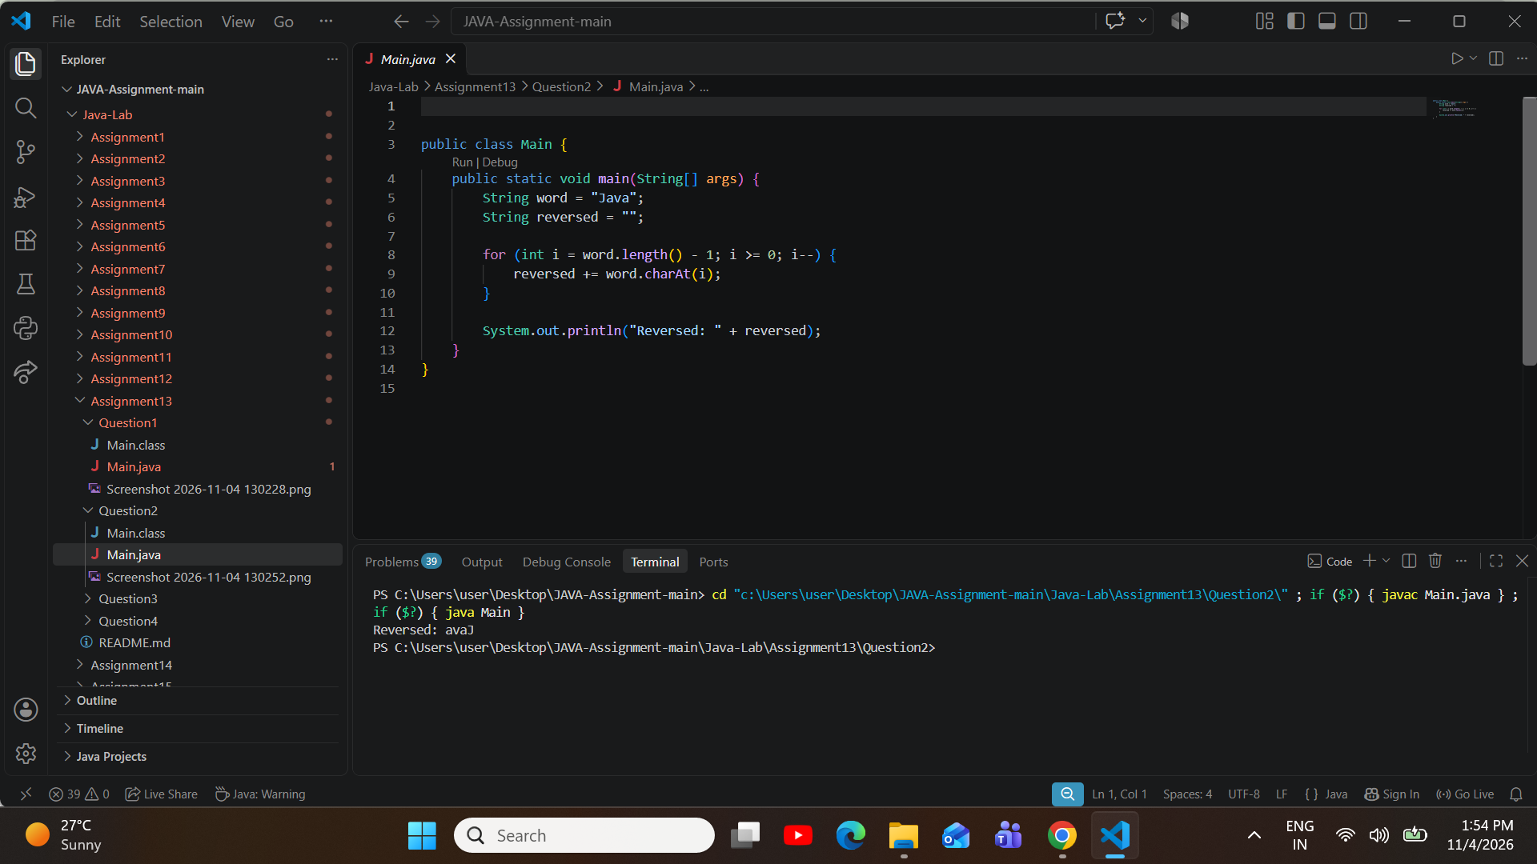
ProblemStatement:Usethewordracecar.Checkwhetheritisapalindrome,whichmeansitreadsthesame from both ends. Print the word followed by is a palindrome, or followed by is not a palindrome.
Question 3

Source Code (Main.java):

public class Main {
publicstaticvoidmain(String[]args){ String word = "racecar";
boolean isPalindrome = true;

int left = 0;
intright=word.length()-1; while (left < right) {

if(word.charAt(left)!=word.charAt(right)){ isPalindrome = false;
break;
}
left++; right--;
}

if (isPalindrome) {
System.out.println(word + " is a palindrome");
} else {
System.out.println(word + " is not a palindrome");
}
}
}

Execution Output Screenshot:
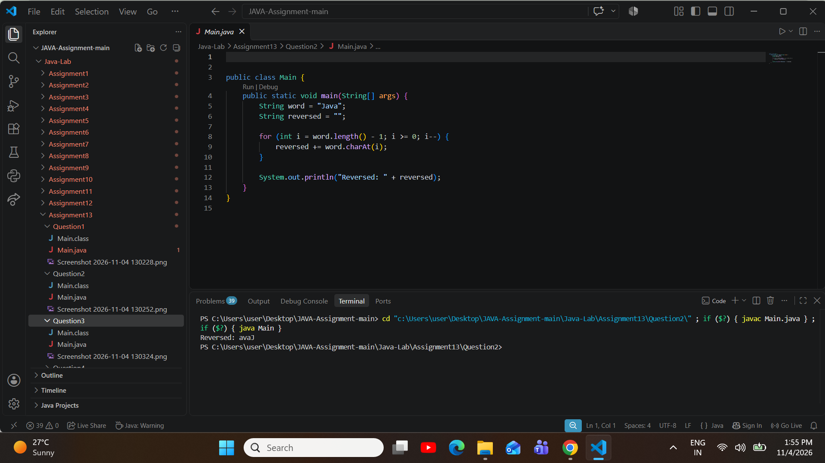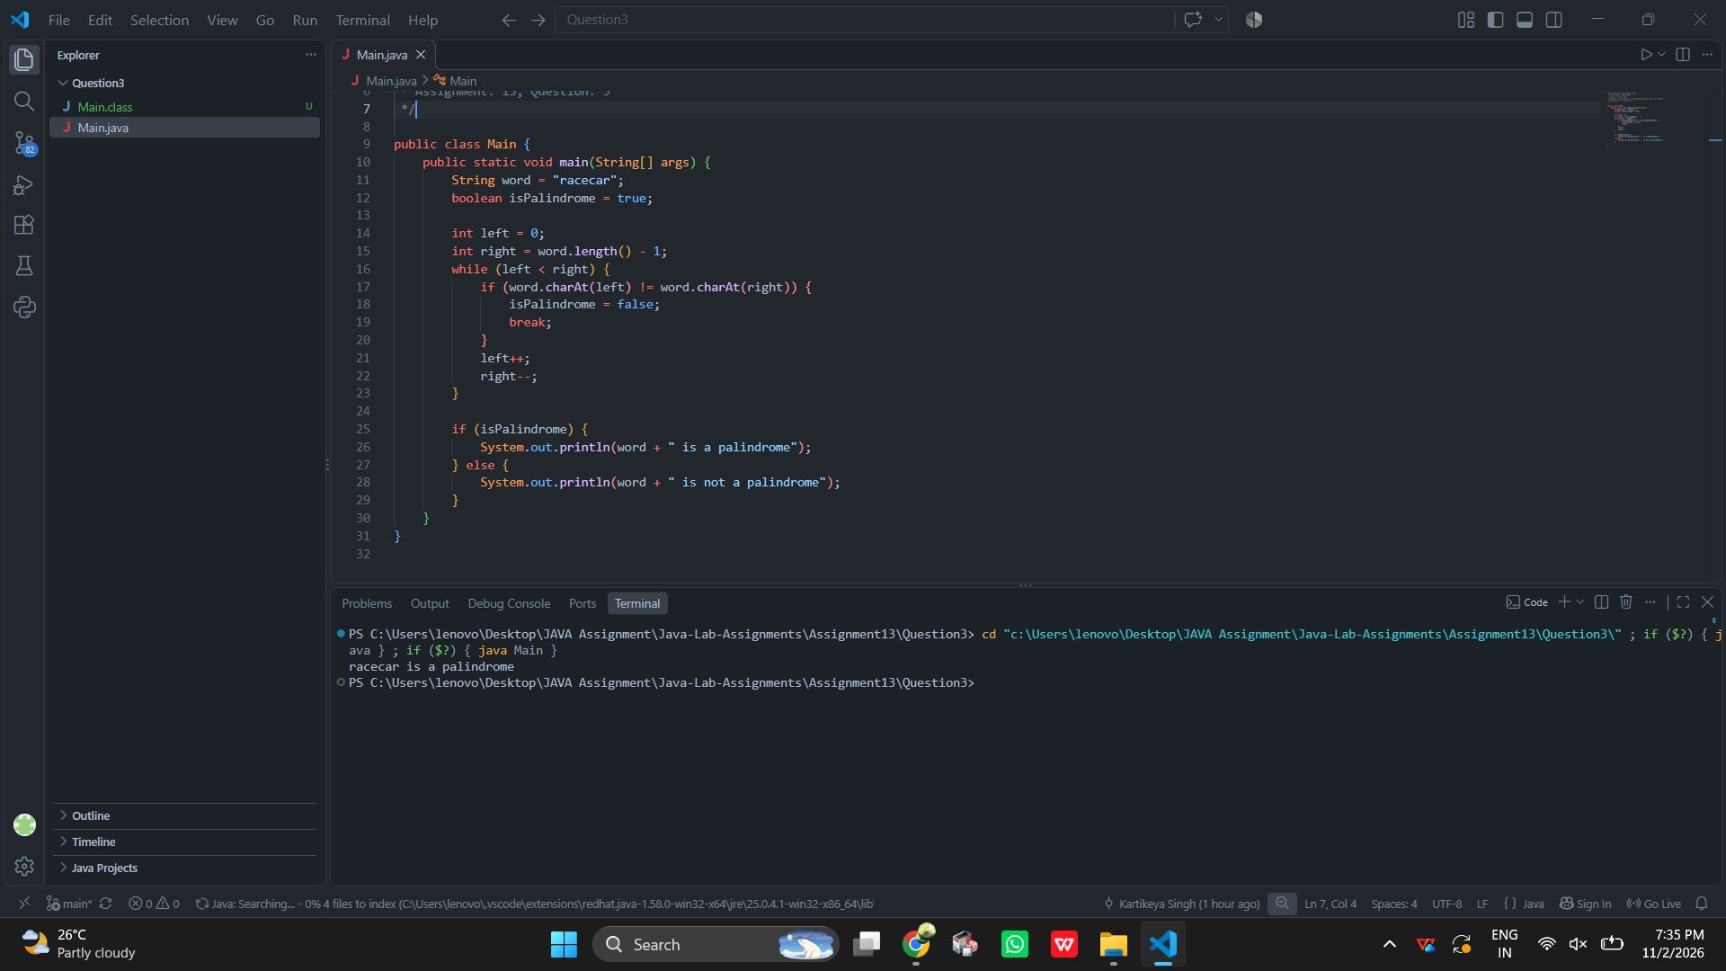
ProblemStatement:Usethewordabc.Printeverysubstringofit,oneoneachline,usingsubstring().Foreach starting letter from left to right, print its parts from shortest to longest.
Question 4

Source Code (Main.java):

public class Main {
publicstaticvoidmain(String[]args){ String str = "abc";

for (int i = 0; i < str.length(); i++) {
for(intj=i+1;j<=str.length();j++){ System.out.println(str.substring(i, j));
}
}
}
}

Execution Output Screenshot:
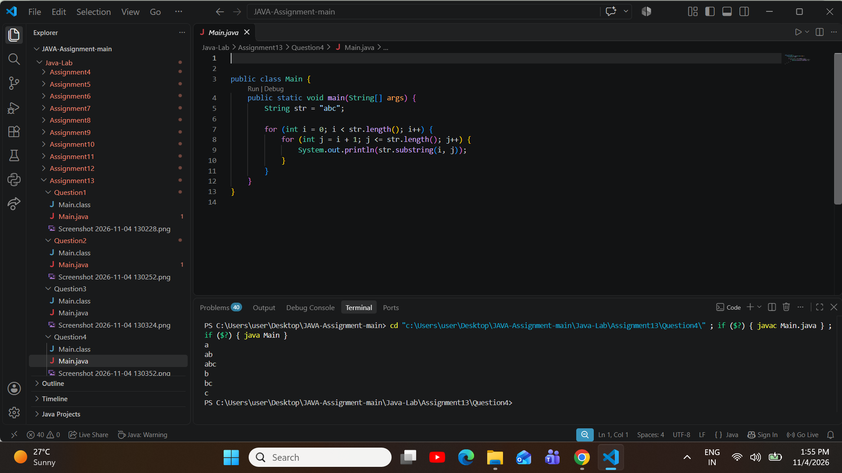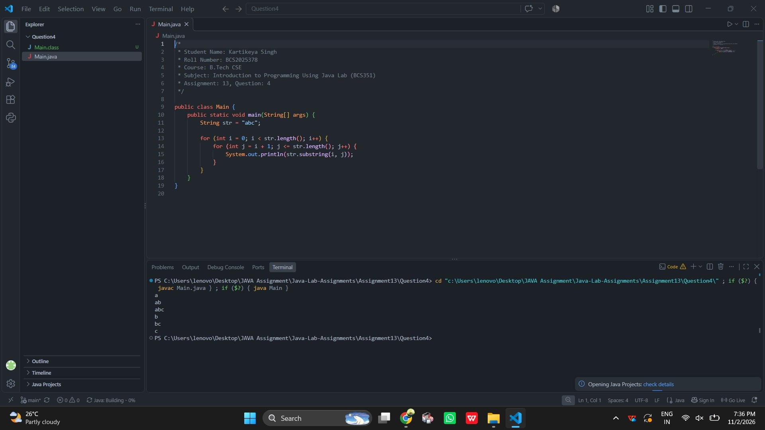

AssignmentAim/Objective:UsecharAttocountvowelsandaletter,andprinteachletterwithits position.
Assignment 14: Characters: Counting and Positions
ProblemStatement:StoreprogramminginaStringnameds.Countitsvowels(a,e,i,oandu).PrintVowels: followed by the count.
Question 1

Source Code (Main.java):

public class Main {
publicstaticvoidmain(String[]args){ String s = "programming";
int vowels = 0;

for (int i = 0; i < s.length(); i++) {
char ch = Character.toLowerCase(s.charAt(i));
if(ch=='a'||ch=='e'||ch=='i'||ch=='o'||ch=='u'){ vowels++;
}
}

System.out.println("Vowels: " + vowels);
}
}

Execution Output Screenshot:

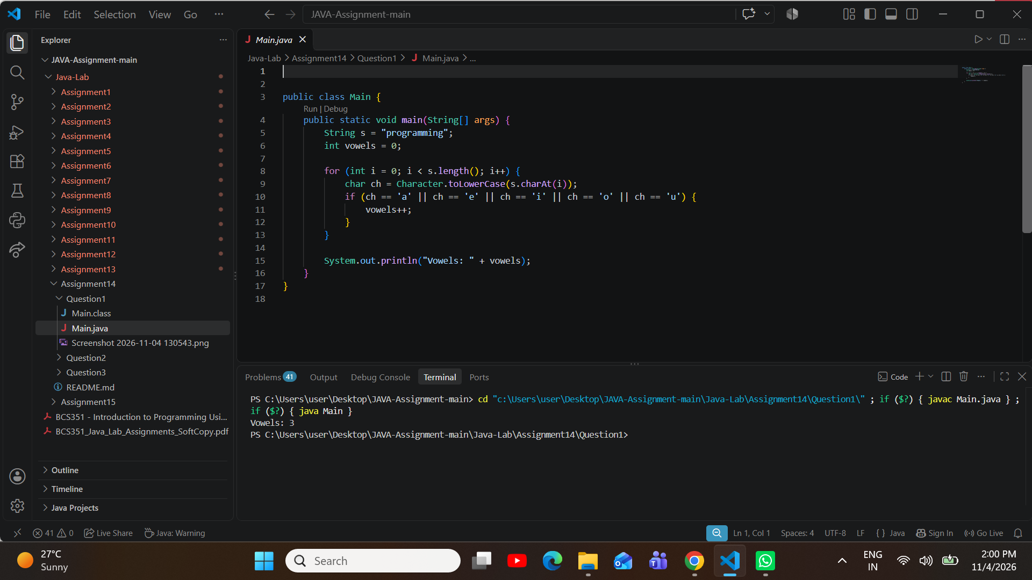
ProblemStatement:StoreprogramminginaStringnameds.Counthowmanytimesthelettergappears.Print Count of g: followed by the count.
Question 2

Source Code (Main.java):

public class Main {
publicstaticvoidmain(String[]args){ String s = "programming";
int count = 0;

for(inti=0;i<s.length();i++){ if (s.charAt(i) == 'g') {
count++;
}
}

System.out.println("Count of g: " + count);
}
}

Execution Output Screenshot:
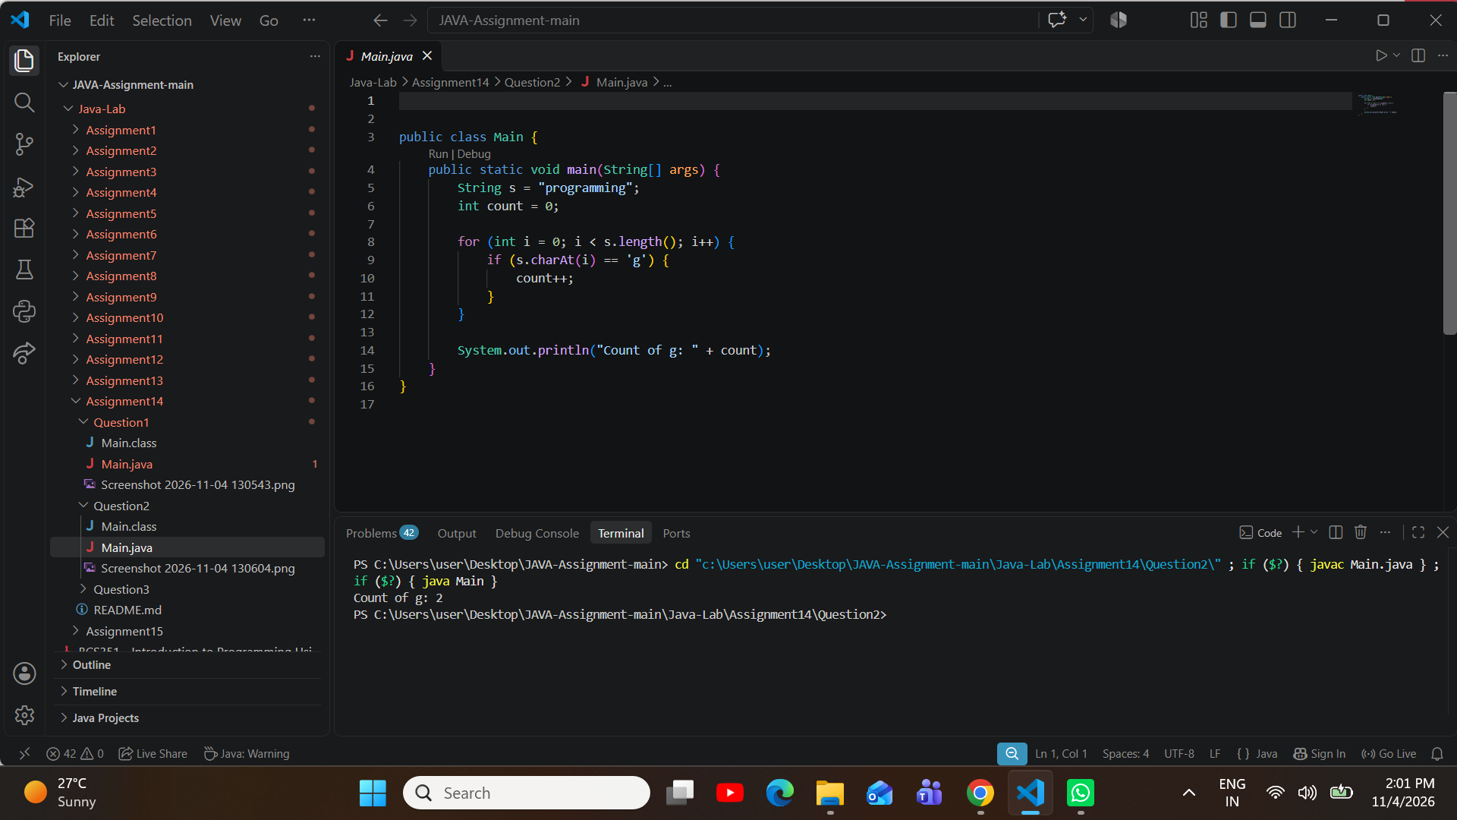
ProblemStatement:StorehelloinaStringnameds.Printeachletteronitsownlineasitsposition,acolon,a space and the letter. Positions start at 0.
Question 3

Source Code (Main.java):

public class Main {
publicstaticvoidmain(String[]args){ String s = "hello";
for (int i = 0; i < s.length(); i++) { System.out.println(i+":"+s.charAt(i));

}
}
}

Execution Output Screenshot:
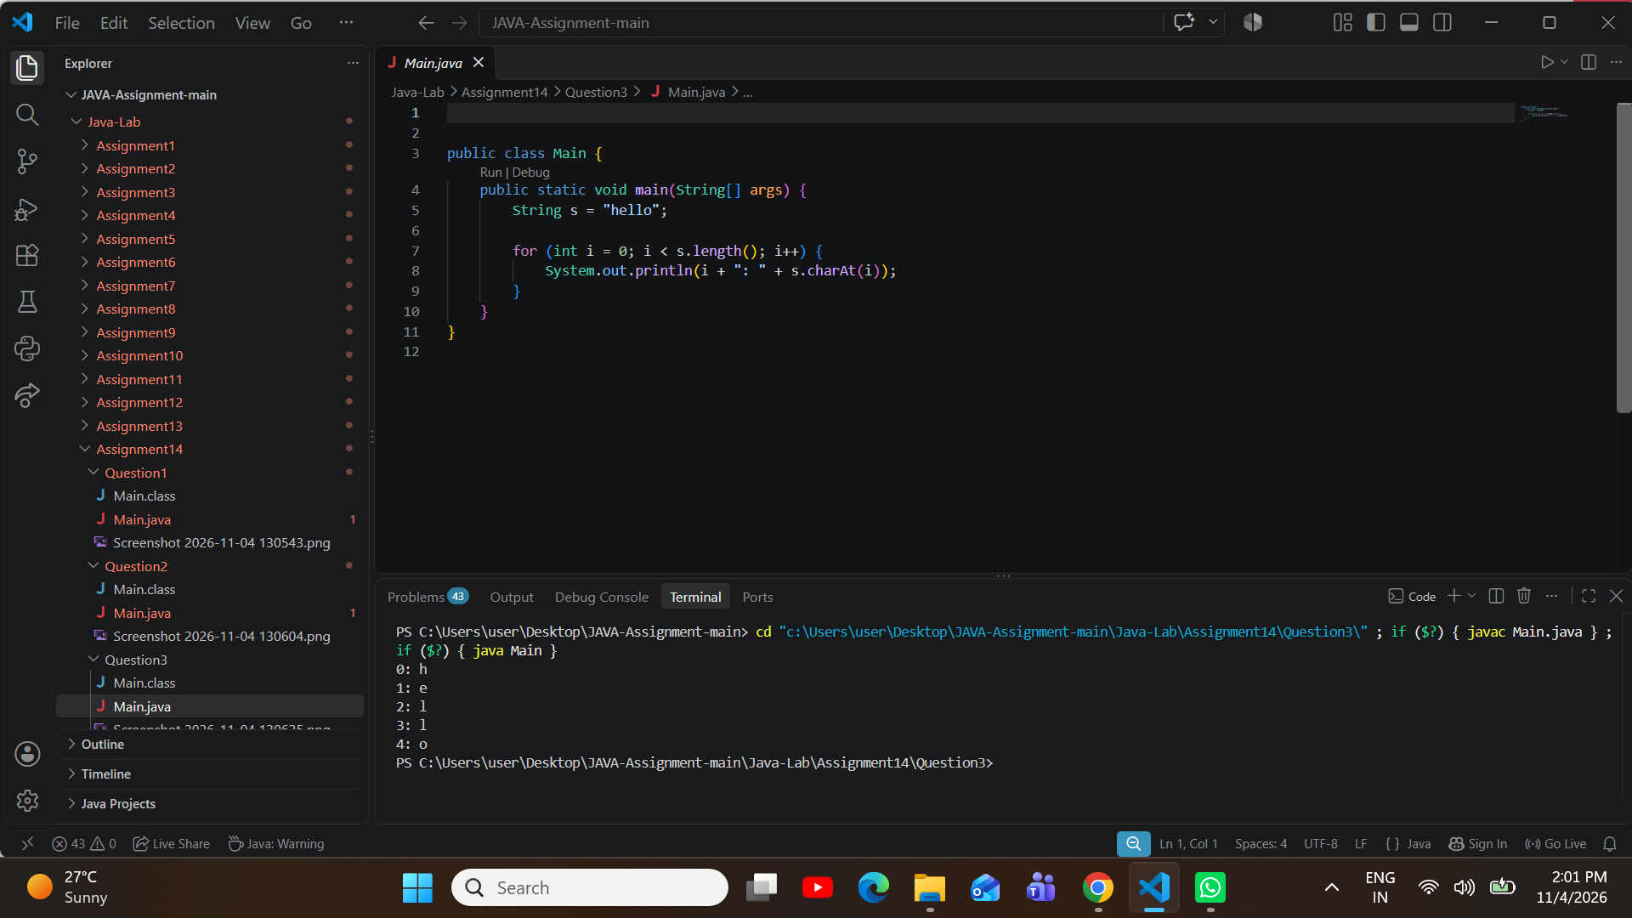

AssignmentAim/Objective:BuildandchangetextwithStringBuilder,usingappend,insertand deleteCharAt.
Assignment 15: StringBuilder Methods
ProblemStatement:CreateaStringBuilderthatstartswiththetextHello.Appendthetext"World"toit.Printthe StringBuilder, then print Length: followed by its length.
Question 1

Source Code (Main.java):

public class Main {
public static void main(String[] args) { StringBuildersb=newStringBuilder("Hello"); sb.append(" World");

System.out.println(sb); System.out.println("Length:"+sb.length());
}
}

Execution Output Screenshot:

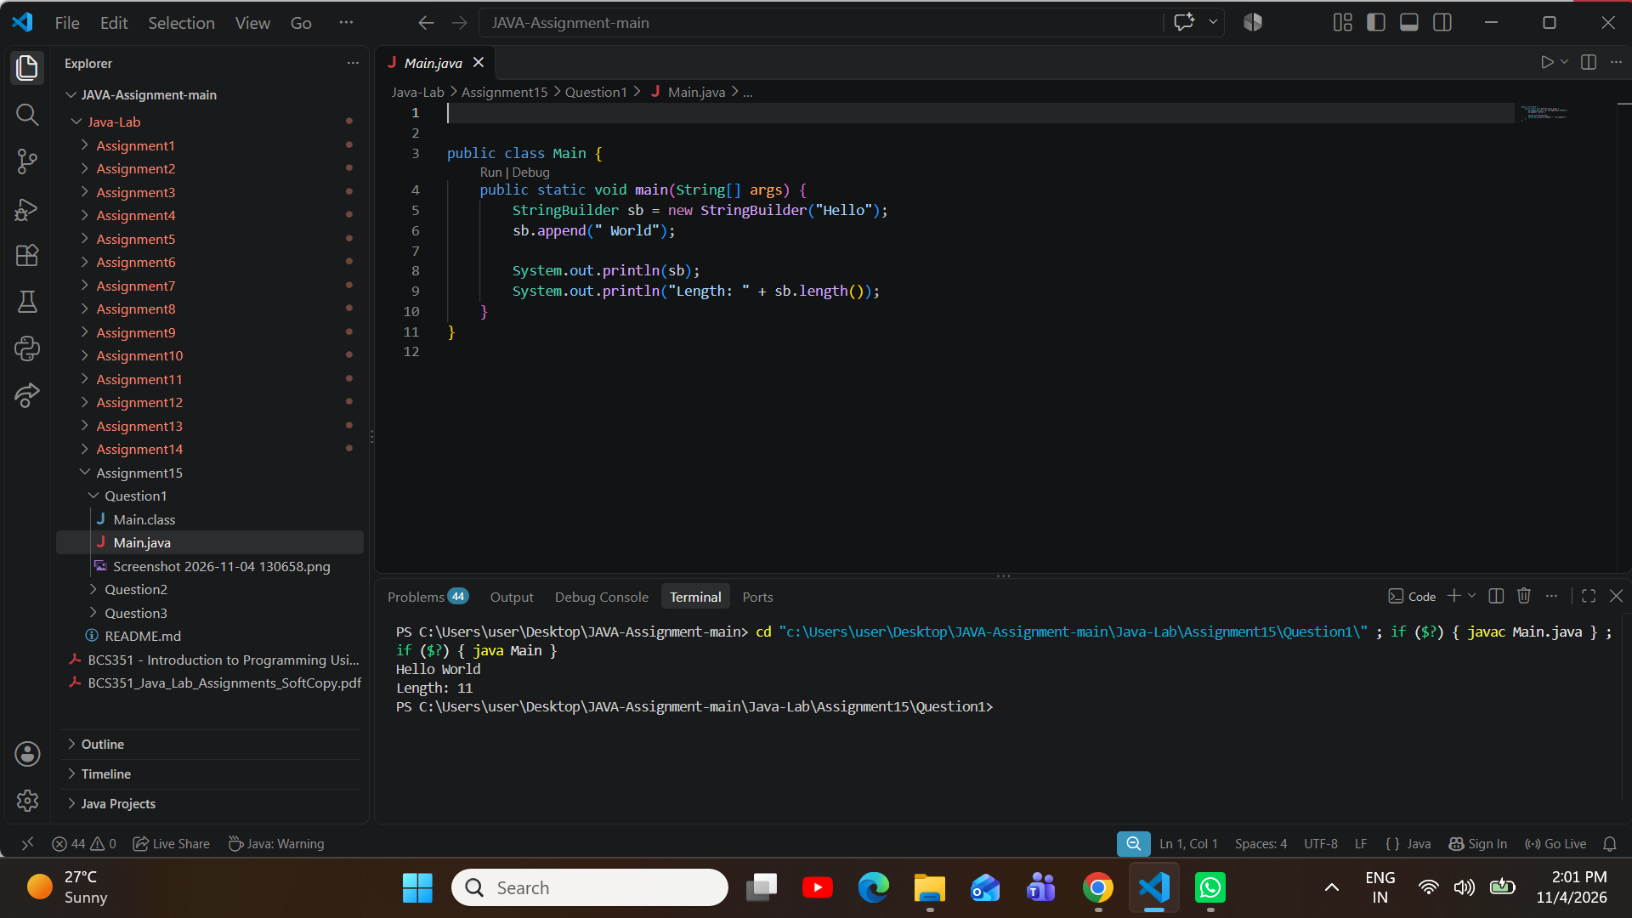
ProblemStatement:UseaStringBuilder.Appendeachnumberfrom1to5,followedbyacomma.Thenremove the last comma with deleteCharAt. Print the result.
Question 2

Source Code (Main.java):

public class Main {
public static void main(String[] args) { StringBuildersb=newStringBuilder();

for(inti=1;i<=5;i++){ sb.append(i).append(",");
}

sb.deleteCharAt(sb.length() - 1);

System.out.println(sb);

}
}

Execution Output Screenshot:

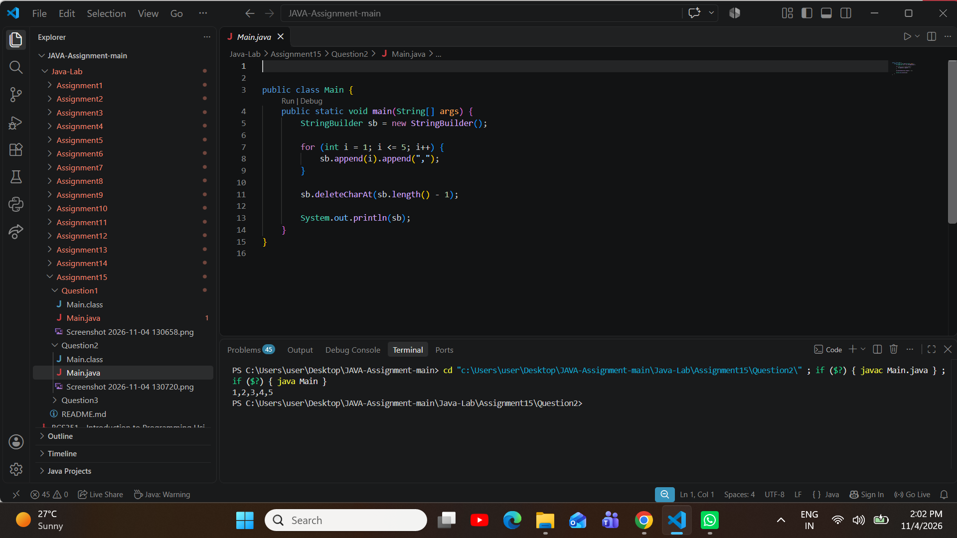
ProblemStatement:CreateaStringBuilderthatstartswiththetextJava.UseinserttoaddthetextHellofollowed by a space at index 0. Print the StringBuilder.
Question 3

Source Code (Main.java):

public class Main {
public static void main(String[] args) { StringBuildersb=newStringBuilder("Java"); sb.insert(0, "Hello ");

System.out.println(sb);
}

}

Execution Output Screenshot:


