Employee Attrition Prediction System

Name | ID
moneer ali naji
mohammed ahmed saeed

Introduction
This project aims to build a machine learning model capable of analyzing employee data and predicting employee attrition. The model relies on a wide range of demographic and functional characteristics, such as age, job level, salary, years of experience, and job satisfaction, to understand the factors contributing to employee turnover. By processing the data, identifying missing or anomalous values, analyzing relationships between variables, and then training various algorithms, the project seeks to provide a tool that helps management make better decisions to improve employee retention and reduce turnover rates.
Methodology
Dataset: IBM HR Analytics Employee Attrition & Performance
This dataset represents employee data in a company, and its purpose is often to analyze the reasons that make an employee resign (attrition), as well as to build a predictive model that helps the company identify the employees most likely to leave the job.
Column Structure
In this dataset, the data typically consists of a set of columns representing employee characteristics, and can be divided into main categories as follows:
- Personal Information
  - Age
  - Gender
  - MaritalStatus
  - Over18
  - Education
  - EducationField
- Job-related information
  - Department
  - JobRole
  - JobLevel
  - JobInvolvement
  - JobSatisfaction
  - EnvironmentSatisfaction
  - RelationshipSatisfaction
  - WorkLifeBalance
  - BusinessTravel

- Employment History
  - TotalWorkingYears
  - YearsAtCompany
  - YearsInCurrentRole
  - YearsSinceLastPromotion
  - YearsWithCurrManager
- Working conditions (ظروف العمل)
  - OverTime
  - BusinessTravel
  - YearsAtCompany
  - TotalWorkingYears
  - DistanceFromHome
- Compensation (التعويضات و الراتب)
  - MonthlyIncome
  - HourlyRate
  - DailyRate
  - MonthlyRate
  - PercentSalaryHike
  - StockOptionLevel
- Performance & Training
  - PerformanceRating
  - TrainingTimesLastYear
  - WorkLifeBalance
- HR Administrative Data
  - EmployeeCount
  - EmployeeNumber
  - StandardHours
- Target variable
  - Attrition
Dataset Composition:
- Number of samples: 1470 employees
- Number of columns (features): 35 Features + 1 Target
- Number of Numerical Features: 19 Features
- Number of Categorical Features: 16 Features

Preprocessing
Data preprocessing constitutes a critical step for preparing raw network flow data for machine learning algorithms. Several preprocessing operations were applied systematically:
Missing Value and Duplication Handling:
- No values ​​are missing
- No duplicate values
Feature Engineering:
- Constant features (single unique value across all samples) were removed as they provide no discriminative information, they are ['EmployeeCount', 'EmployeeNumber', 'Over18', 'StandardHours', 'DailyRate', 'MonthlyRate', 'HourlyRate']
- Final feature count: 27 features

Data Encoding:
- Target variable (Attrition) was converted from categorical to numeric:
The employee is still employed by the company. = 0,
The employee left the company = 1
- Some feature values were converted to numeric type using One-Hot Encoding
- Final feature after Encoding: 48 features

Outliers Handling:
- Some features contain outliers, they are ['MonthlyIncome', 'TotalWorkingYears' ,'YearsAtCompany', 'YearsInCurrentRole' ,'YearsSinceLastPromotion'] and Outliers were processed using the IQR method
Skewness handling:
- There are there columns contain Skewness values, they are ['JobLevel', 'MonthlyIncome', 'YearsSinceLastPromotion']
Train-Test Split:
- Test proportion: 20%
- Training proportion: 80%

Models and Algorithms
Logistic regression
It is a linear statistical classification model, despite its name, used to estimate the probability of an event occurring (in your case, predicting "attrition" or "not attrition") by applying a sigmoid function to the linear outcome of the features. This model is simple, easy to interpret, and effective for linearly separable data.

- Features: All processed columns in the dataset were used, except for the Attrition column.
- Handling imbalance using Class Weights parameter
- Preprocessing: StandardScaler was applied to the training and testing data to ensure that all features contribute equally to the model, which is crucial for linear regression models.
Result:
Accuracy: 0.7755
This indicates that 77.55% of all cases (both leaving and not leaving) were correctly classified. This accuracy is considered high, but due to the imbalance in categories, other metrics should be considered to confirm performance.AUC is 1.0000, indicating an almost perfect separation between benign and malicious traffic over all thresholds.​​
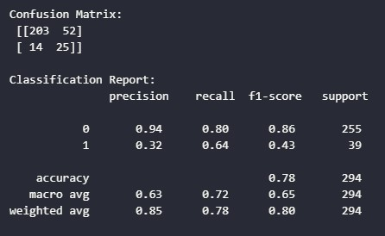

KNN
Nearest Neighbors (KNN) is a non-parametric machine learning algorithm used for classification and regression. This algorithm is based on the idea that similar data points are located close to each other in feature space. When classifying a new data point, KNN finds $k$ of its nearest neighbors, and the new point's class is assigned based on the majority of those neighbors' classes.

- For KNN, the data were transformed to zero mean and one standard deviation. This ensures that features with large values ​​(such as salary) do not dominate the distance calculation at the expense of other features.
- The SMOTE technique was applied to address the apparent imbalance in the target categories. This step is necessary to avoid model bias towards the majority category (no-leaving).
- The default value for the number of neighbors ($n_neighbors=5) was used to determine the category.

The model's performance was evaluated on an Unseen Test Set, which contained 255 employees who did not leave the job (Class 0) and 39 employees who left the job (Class 1).
Result:
Accuracy: %67.01

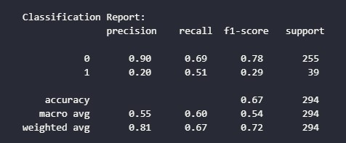
- The recall for the quit prediction (Category 1) is 0.51: This means the model successfully identified 51% of employees who actually quit. This indicates that addressing the imbalance using SMOTE was effective in improving the model's ability to detect positive quits.

- The precision for the quit prediction (Category 1) is low at 0.20: This suggests that 80% of the employees the model predicted would quit did not actually leave (False Positives = 78). In other words, the model is generating a large number of false positives.

- Trade-off: The SMOTE process improved recall at the expense of precision. In quit prediction projects, the priority is often to increase recall (to reduce unpredicted quits – False Negatives), even if this leads to an increase in false positives.

- General note: The overall performance of the model (Accuracy: 67.01%) suggests that the KNN algorithm may be a mid-performance choice for this project, especially considering the low accuracy challenges of the Turk class.

Decision Tree
A decision tree is a supervised machine learning algorithm that uses a tree structure to make decisions. It starts from a root node and iteratively divides the data based on the value of a specific feature that best achieves a measure of impurity reduction, such as Gain Ratio or Gini Impurity. The goal is to generate leaves that are as pure as possible, with each leaf representing the final classification decision (in this case: leave or not leave).

- The tree was allowed to grow until the leaves were completely pure or contained very few samples. This may increase the risk of overfitting the training data.
- Standard division for evaluating model performance on data not used during training.

The performance of the decision tree model was evaluated on the test group, which contained 255 employees who did not leave the job (Category 0) and 39 employees who left the job (Category 1).
Results:
Accuracy: %77.22
- Overall classification accuracy: 77.22%: The tree performs well overall, exceeding the performance of the KNN algorithm (67.01%).
- Recall for quit prediction (Class 1) is 0.38: This means the model correctly identified only 38% of employees who actually quit. This indicates that 24 employees who quit were incorrectly classified as staying (False Negatives). This is a significant weakness because the company misses an opportunity to intervene to prevent their departure.
- Precision for quit prediction (Class 1) is 0.28: This indicates that approximately 72% of the employees the model predicted would leave actually stayed (False Positives = 40). This could lead to inefficient resource allocation for interventions with employees who do not intend to leave.
- Performance Note: Although overall accuracy is relatively high, performance on the minority class (Turk, Class 1) is poor (F1-Score: 0.32). This is often due to the code not using imbalance handling (such as SMOTE) or not adjusting the tree parameters to address this challenge.
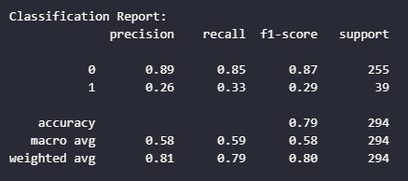

Model results comparison
Model | Type | Accuracy | Main comment
Logistic Regression | Supervised | 0.7755 | Not bad
KNN | Supervised | ≈0.6700 | worst performance
Decision Tree | Supervised | 0.7908 | Best performance, very few errors

